## Appendix N: Field Interviewer Scripts for In Person Contacting and Locating

Script 1: Mask and Interview Setting Script

|  |
| --- |
| “As you can see, I’m wearing a mask to cover my mouth and nose. I would like to encourage you to wear a mask as well as part of your participation in the study, but it is not required. You can wear a mask of your own if you like. If you do not have a mask of your own but would like to wear one, I can provide you with a new disposable mask. We also recommend conducting the interview outside on a porch, deck, or steps outside of your home that allows for sufficient privacy. If you want to do the interview at another outdoor space, we can accommodate that as well. We just need a location where no one will be able to hear or see your answers.” |

Script 2. Gaining Cooperation Script

|  |
| --- |
| **IF AVAILABLE**: “Hello, [RESPONDENT] my name is [NAME] and I am from RTI International. We recently sent you a letter in the mail about the Young Adult Services Study. If you don’t remember seeing it, that’s okay, I can go over this with you or you can visit our website to learn more. This is a 35-minute survey. The survey involves questions about the services you have received while in foster care, as well as questions about education and work, places you have lived, and relationships with family and friends. We ask that you participate three different times—one survey now, a second survey in 12 months, and a third survey in 24 months. This will help us understand changes over time. You will receive a $25 gift card for the first survey and $50 for the second and third surveys for sharing your input with us. The interview works best when we schedule during a time where a private setting can be established. We recommend conducting the interview outside on a porch, deck, or anywhere outside of your home that allows for sufficient privacy. A private setting allows you more privacy when answering questions, minimizes distractions, and allows you to focus on the questions. Before we begin, I need to review information about COVID-19 with you and discuss how taking part in this study may increase your risk of exposure.” |

Script 3. Locating Scripts

|  |
| --- |
| “Hello, I am looking for [RESPONDENT’S NAME], are they available? My name is [NAME].  **If asked who you are**: I am from RTI International. [RESPONDENT] was selected to participate in a survey where they can receive a $25 gift card and we wanted to see if this is something they are interested in. Are they available?”  **IF UNAVAILABLE**: “When is a good time for me to stop by to talk to them? Do you know their phone number? I’d love to give them more details about this important study and see if they’re interested in receiving a $25 gift card for taking part.” |

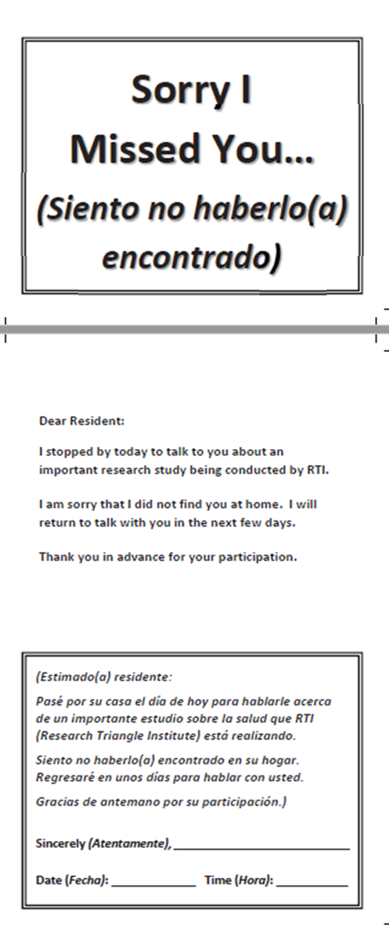Appendix O: Sorry I Missed You Card

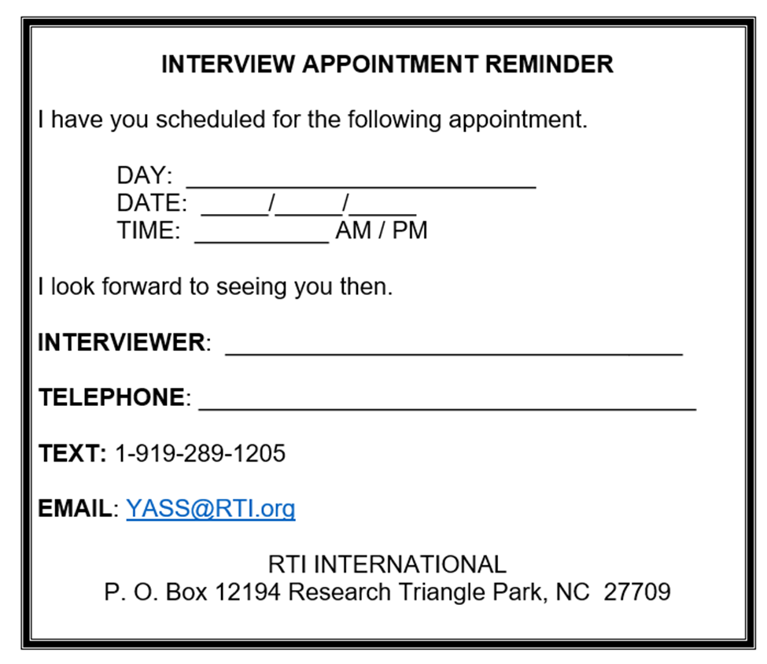Appendix P: Appointment Card

Appendix Q: COVID Risk Information Form

**Important Information about COVID-19 and Your Participation in Young Adult Services Study (YASS)**

This document contains important information about COVID-19 and how participating in face-to-face research may impact you. COVID-19 is the disease caused by a virus called SARS-CoV-2. Study participation will include visiting with a YASS interviewer. Having an interviewer come into your home may increase the risk of being exposed to COVID-19.

If the interviewer who conducts the interview tests positive for COVID-19 in the days after the interview, you may be considered a close contact of the interviewer. A close contact is someone who was less than 6 feet away from an infected person for 15 minutes or more. If this occurs, the state or local health department or their agents may reach out to your household for the purpose of contact tracing.

Please be assured that the research team will only share with the health department or their agents the address of this household and the time and dates of the interviewer’s visits. None of the answers you provide during the interview will be shared. It is also possible that the contact tracers may use the address shared by the research team to find other means to contact this household such as by phone or email.

**How is COVID-19 spread?**  People can catch COVID-19 from other people who have the virus. The disease spreads mainly from person to person through small droplets from the nose or mouth, which are spread when a person with COVID-19 coughs, sneezes, or speaks. It is also possible that people can contract COVID-19 by touching a surface or object that has the virus on it, then touching their mouth, nose, or eyes.

**What are the symptoms of COVID-19?** Symptoms of COVID-19 may include:

|  |  |
| --- | --- |
| * Fever or chills * Cough * Shortness of breath * Fatigue * Muscle or body aches | * Headache * New loss of taste or smell * Sore throat * Congestion or runny nose * Nausea or vomiting * Diarrhea |

Symptoms typically appear 2-14 days after exposure to the virus. It is possible that individuals with the COVID-19 virus will not display any of these symptoms. You can find more information at <https://www.cdc.gov/coronavirus/2019-ncov/symptoms-testing/symptoms.html>.

**What are some ways to reduce the risk of getting or spreading COVID-19?**

* Regularly wash your hands for at least 20 seconds with soap and water or alcohol-based hand sanitizer.
* Maintain at least 6 feet between yourself and others.
* Avoid going to crowded places where you are more likely to come into close contact with someone who has COVID-19, and it is more difficult to maintain physical distance.
* Wear a mask that covers your mouth and nose when you go out in public or have in-person contact with someone from outside of your household.
* Avoid touching your eyes, nose, and mouth. Your hands can transfer the virus to your eyes, nose, or mouth. From there, the virus can enter your body.
* If you are not wearing a mask and need to cough or sneeze, cover your mouth and nose with a bent elbow or tissue.

**What happens if someone gets COVID-19?** People with COVID-19 may have a wide range of symptoms– ranging from mild symptoms to severe illness. **Older adults and people who already have serious medical conditions** **like heart or lung disease or diabetes seem to be at higher risk for developing complications or dying from COVID-19.** Although vaccines and limited treatment options have been identified, they may not be readily available in your community or to all individuals. We want to provide you this information because your choice about whether to participate in this study or to invite an interviewer into your home might be informed by whether there is someone in your household who is older or has a medical condition that increases the risk of becoming severely ill because of COVID-19.

**How do I know a YASS interviewer does not have COVID-19?** Unfortunately, there is no guarantee that an interviewer does not have COVID-19. This is because individuals can have the virus but only have mild symptoms or even no symptoms of COVID-19 at all. However, interviewers are required to take their temperature every day and are not allowed to work if they have a fever. Interviewers have promised not to conduct in-person data collection if they or any members of their household show symptoms of or have been diagnosed with COVID-19.

**What steps are interviewers required to take to keep me and others safe?**

* The research team strongly recommends conducting the interview outside in a private setting to reduce the risk of getting or spreading COVID-19.
* Our interviewer is required to use hand sanitizer frequently and wear a mask during the interview to help reduce the likelihood that he or she could give you COVID-19.
* The interviewer will practice social distancing, which means he or she will sit or stand at least 6 feet from you and other persons when possible, during the interview.
* The interviewer will not have physical contact with you or other members of your household.

Risk of infection cannot be completely eliminated. Conducting the interview in person may increase your risk of being exposed to COVID-19.

**Do I have to wear a mask if I want to participate?** Participants are strongly encouraged to wear a mask during the interview, but it is not required for participation. You can wear a mask of your own or the interviewer can provide a disposable mask at your request. Interviewers are required to wear a mask during all interviews.

**Do we have to do the interview inside my home?** The YASS interview can be conducted inside your home or outside—on a porch or steps, in your yard, or in some nearby public outdoor space that allows sufficient privacy. The interview can also be conducted by telephone. If you want to do the interview at another location, you and the interviewer will have to maintain social distance from each other as well as other people. We must keep our interviews private so we need a location where no one will be able to hear or see your answers.

**Do I have to touch anything to participate in the interview?** Yes, but objects you will touch during the study will be sanitized prior to your use. For example, computer equipment is cleaned with a disinfecting wipe before each interview. Cards the interviewer might use to show you information are laminated and sanitized between interviews. Other paper forms are single-use and have not been touched by other participants.

**If you have additional questions about your participation in YASS, please call 1-800-334-8571 extension 26306.**

## Appendix R: Field Interviewer COVID Risk Information Form Talking Points

**FI Talking Points:**

**COVID Information Form**

**HAND COVID FORM TO RESPONDENT**

It’s important that before participating we review information about COVID-19 and discuss how taking part in this study may increase the risk of exposure for you and those living here.

This document explains how COVID-19 spreads from person to person, the different symptoms of COVID-19, and that symptoms typically appear 2-14 days after exposure. There is also a link to the CDC’s web site for more information.

There are several ways to reduce getting or spreading COVID-19 which include washing hands regularly, maintaining social distance of at least 6 feet and wearing a mask. We also recommend conducting the interview outside of your home, on a deck or porch, to reduce your risk of getting or spreading COVID-19. Risk of infection cannot be completely eliminated. Conducting the interview in person may increase your risk of being exposed to COVID-19.

**ASK RESPONDENT TO TURN FORM OVER**

It is important you have this information before agreeing to participate, especially if there is someone living here who is older or who already has a serious medical condition.

Before working, I took my temperature today and did not have a fever. I do not have any current symptoms, but I cannot guarantee I do not have COVID-19.

If I were to test positive for COVID-19 following this visit, you may be contacted by state or local health departments as part of required contact tracing. However, the only information they will have is your address and the dates I visited your home. They will receive no information about answers you provide as part of this study.

While working, I am required to:

* Use hand sanitizer frequently.
* Wear a mask when conducting an interview.
* Practice social distancing and have no physical contact with you or anyone in this household.

If you agree to participate in an interview:

* We strongly encourage you to wear a mask during the interview, but it is not required for participation. You can wear your own or I can provide you with a new disposable mask.
* We do not have to conduct the interview inside. If you’re comfortable doing so, we can find a private location somewhere outside instead. We can also conduct the interview by telephone.
* I will clean the computer and headphones with a disinfecting wipe before you begin.
* Any paper materials are single use and have not been touched by other participants.

If you have questions, I can answer those now. I am not trained medical personnel, so for specific questions about COVID-19 you should refer to other sources such as the CDC web site or your doctor.

Before we get started, I want to make sure you understand the risks associated with participating and the steps we are taking to minimize risk. This is a way for me to review with you anything where you still might have questions.

1) First, please tell me what steps we are taking to minimize the risk of infection with participation in the survey?

Correct Response: conducting interview outdoors, wearing a mask, social distancing, not working with symptoms or a fever

2) Do these steps completely eliminate the risk of infection?

Correct Response: No. These steps reduce the risk of infection but do not completely eliminate the risk of getting or spreading COVID-19.

**ANSWER ALL QUESTIONS, THEN PROCEED WITH INTERVIEW**

## Appendix S: Baseline Youth Survey Showcard Booklet

Young Adult Services Study

SHOWCARD BOOKLET

February 2022

**CARD 1**

1 = OWN PLACE WITHOUT HOUSING VOUCHER (APARTMENT, HOUSE, TRAILER, ETC.)

2 = OWN A PLACE WITH A HOUSING VOUCHER

3 = OWN ROOM IN MOTEL, HOTEL, OR SRO

4 = IN THE HOME OF BIRTH PARENT(S)

5 = IN THE HOME OF ADOPTIVE PARENT(S)

6 = IN THE HOME OF OTHER RELATIVE(S)

7 = IN THE HOME OF CURRENT RESOURCE/FOSTER PARENT(S)

8 = IN THE HOME OF FORMER RESOURCE/FOSTER PARENT(S)

9 = IN THE HOME OF SPOUSE/PARTNER

10 = IN THE HOME OF FRIEND(S)

11 = IN A TRANSITIONAL LIVING PROGRAM (MAY BE REFERRED TO AS ADOLESCENT HOUSING HUB OR INDEPENDENT LIVING PROGRAM)

12 = GROUP QUARTERS (DORMITORY, MILITARY BARRACKS, ETC.)

13 = HOSPITAL, TREATMENT OR REHAB FACILITY

14 = HOMELESS: (YOU HAVE NO REGULAR PLACE TO STAY)

15 = OTHER

## Appendix T: Baseline Youth Survey Gift Card Receipt

