July 19, 2022

Note to Reviewer of 1220-0079

After the Office of Management and Budget’s (OMB’s) approval of the FY2023 Labor Market Information (LMI) Cooperative Agreement the following updates were necessary:

- An OEWS deliverable was inadvertently left off out of the Files Summary by Panel list on page 116.

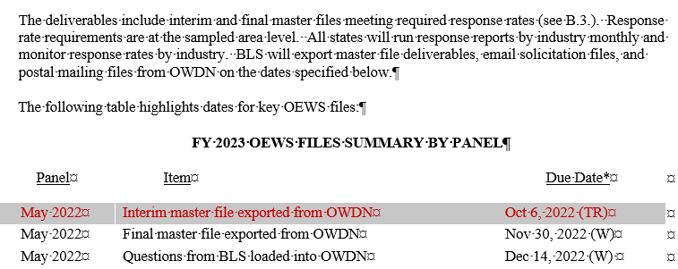

- The last deliverable needed to be removed from the OEWS Files Summary by Panel list on page 117.

May 2023 | Interim master file exported from OWDN | Jan 2September 29, 2023 (F)

This non-substantive change is being submitted to update the public record for the LMI Cooperative Agreement accordingly.

