Permits Online (PONL) Screen Related to Power of Attorney (1513–0014)

Respondents complete the data fields and follow the instructions on the following screens. Respondents then print the PONL-generated TTB F 5000.8, originally sign that form, and then upload a scanned copy of the form to their PONL application and mail the signed form to TTB.

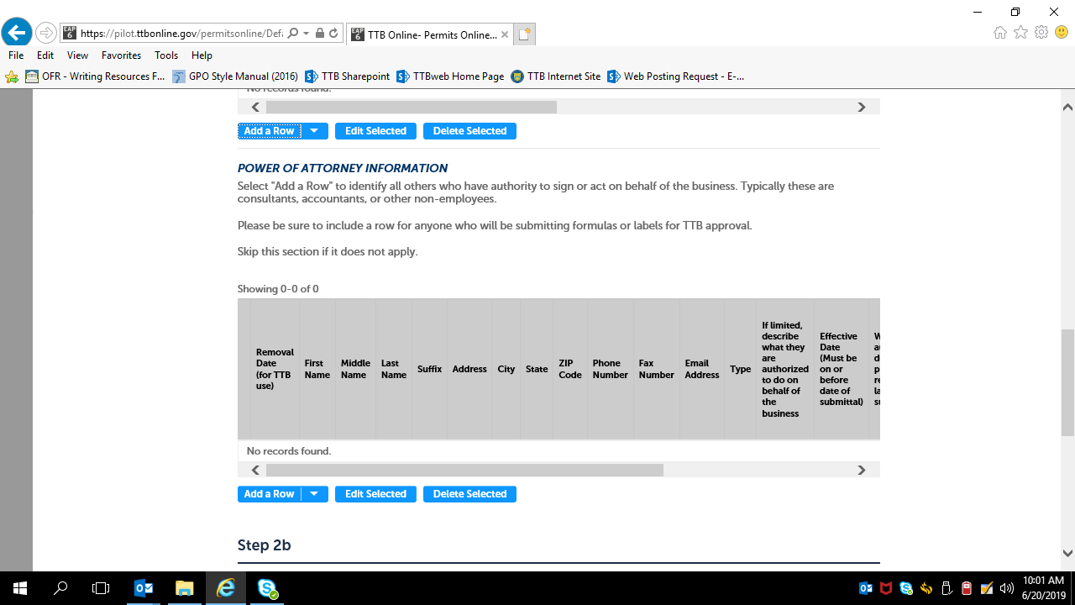
Clicking “Add a Row” brings up the following screen:
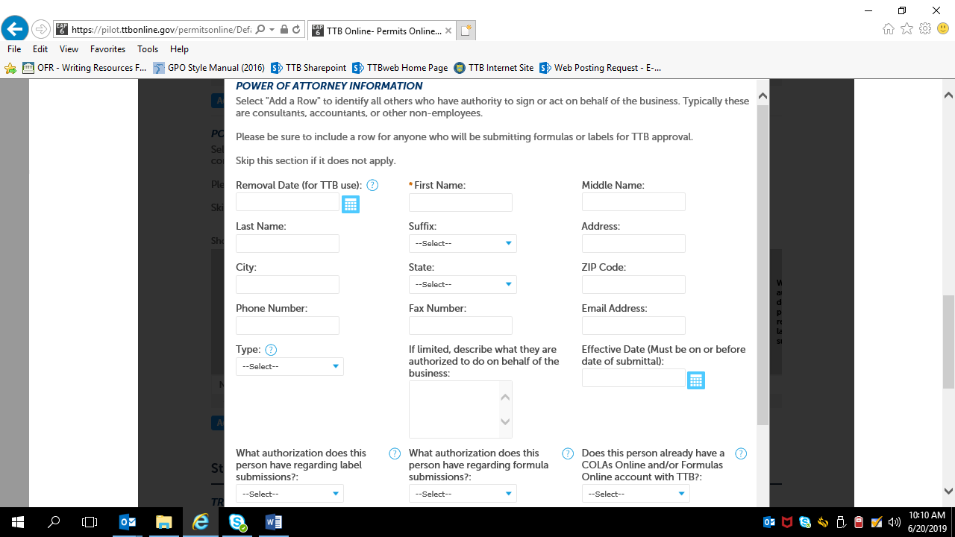

Remainder of the above screen:
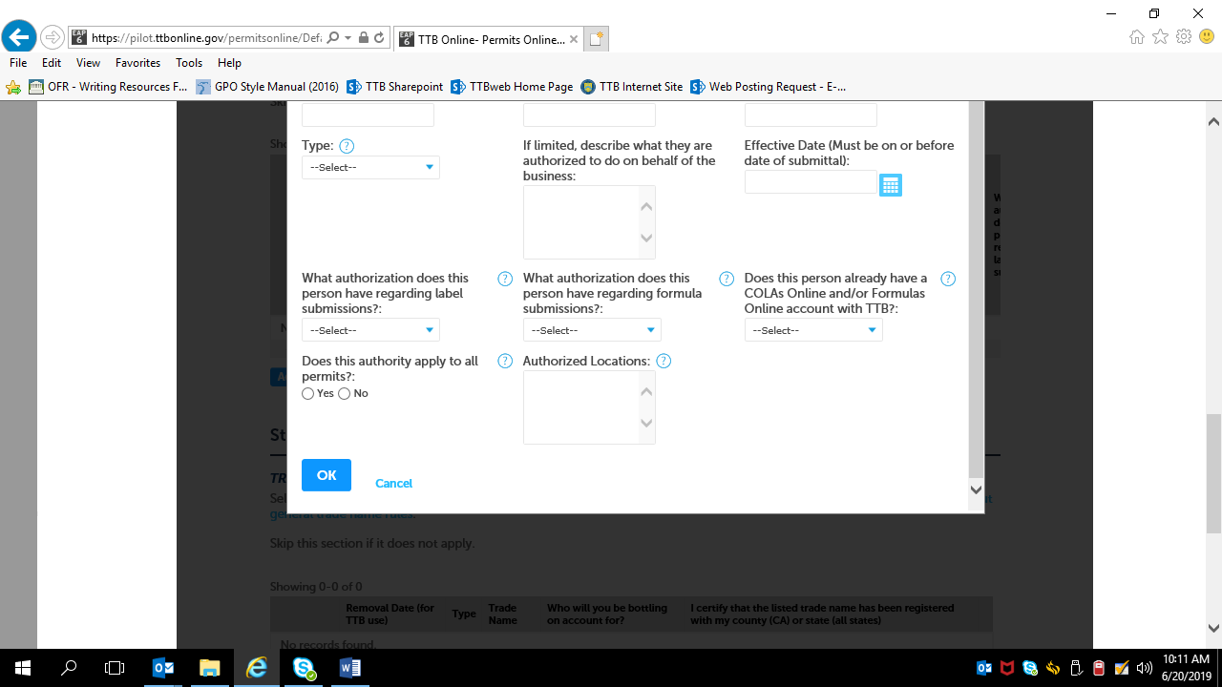

Required Document Checklist will show Power of Attorney Form:

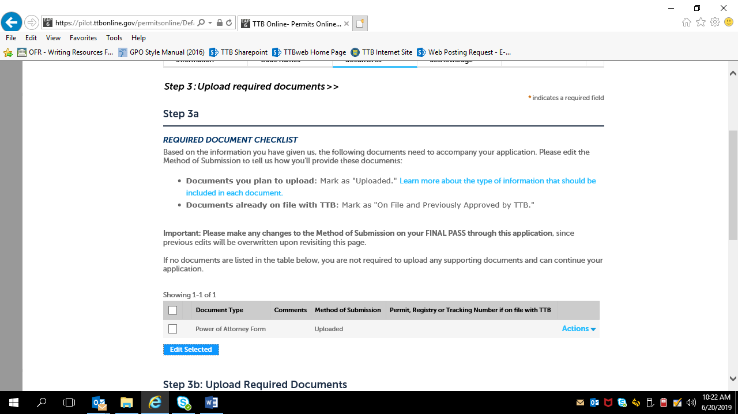

Respondent uploads printed and signed TTB F 5000.8, Power of Attorney, form:

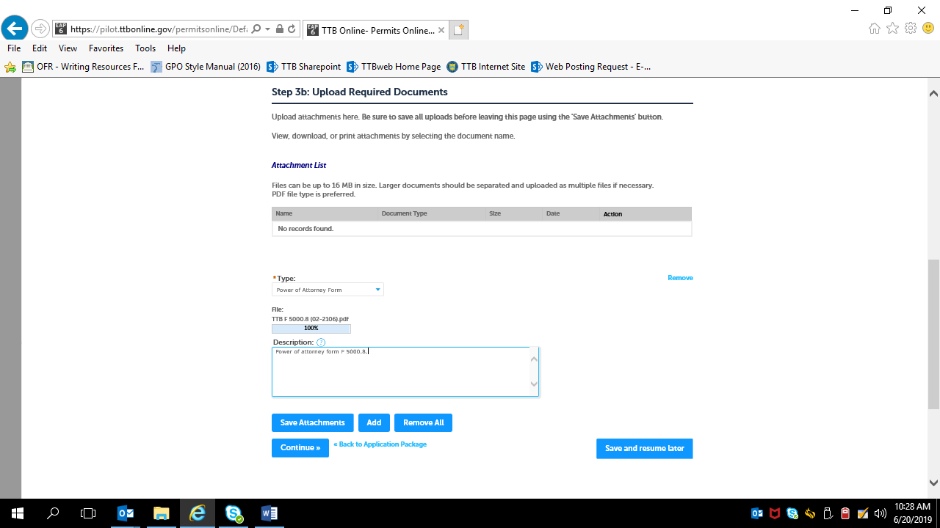

Upload shown as successful:

