TTB G 2022–1, Taxpayer Relief – Payment Options
https://www.ttb.gov/tax-audit/taxpayer-relief-payment-options

Introductory Page:
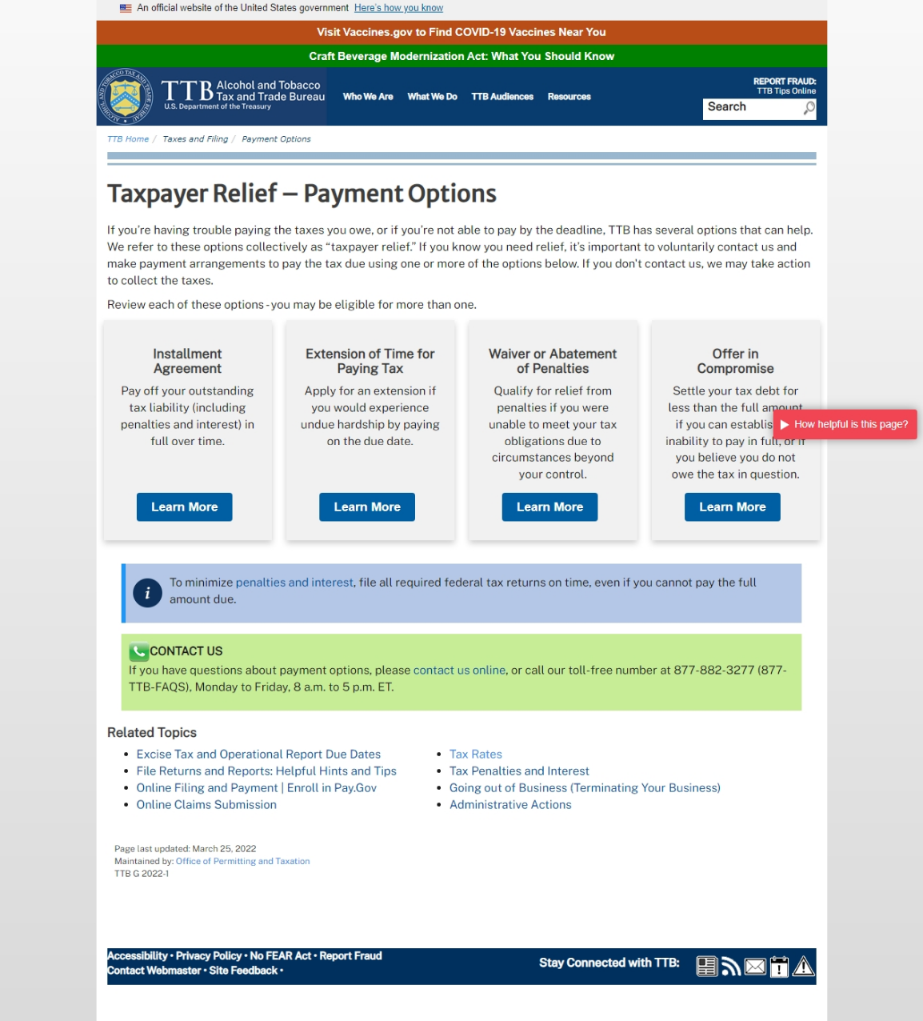

Installment Agreement “Learn More” Page:
(Page continued below)

Extension of Time for Paying Tax “Learn More” Page:
(Page continued below)

Waiver or Abatement of Penalties “Learn More” Page:
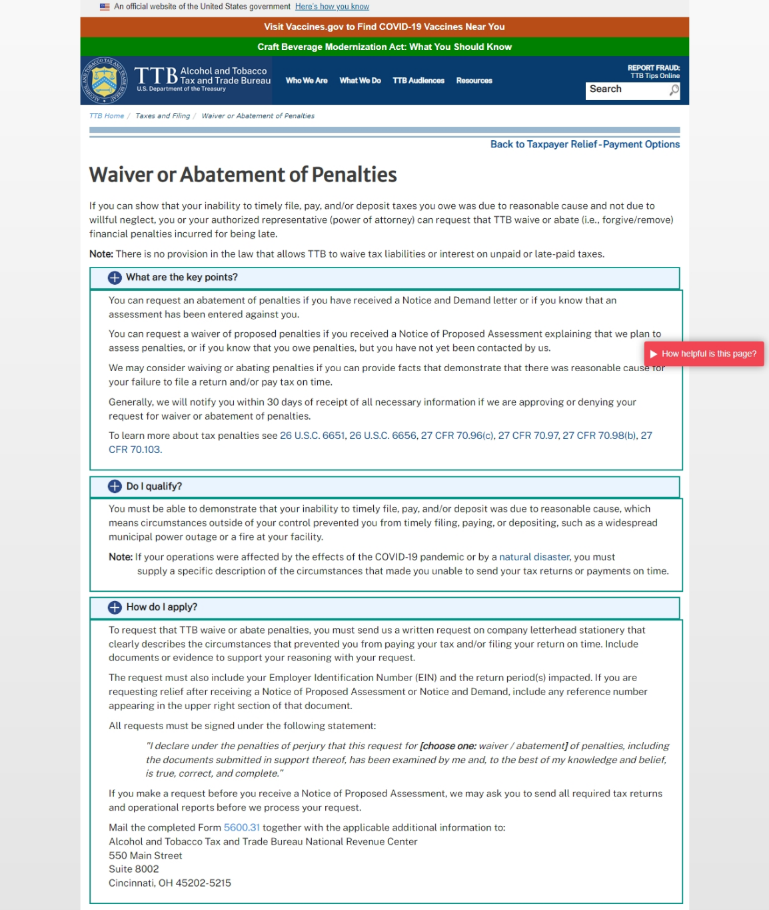
(Page continued below)

(Guidance continues below)

Offer in Compromise “Learn More” Page:
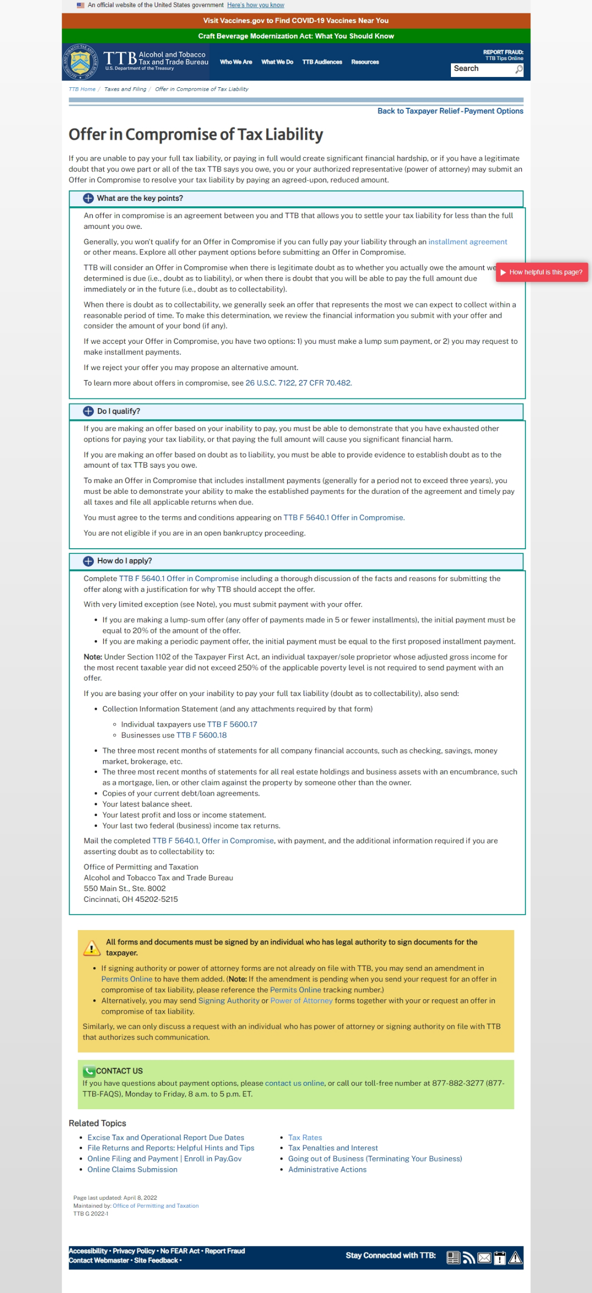
(Page continues below)
(Guidance document ends.)

