U.S. Department of Education

Office of Elementary and Secondary Education

Expanding Opportunity Through Quality Charter Schools Program

Washington, D.C. 20202-5970

**Fiscal Year 2022**

**Application for New Awards Under the**

**Expanding Opportunity Through Quality Charter Schools Program (CSP) –** **Grants to Charter School Developers for the Replication and Expansion of**

**High-Quality Charter Schools**

**ALN 84.282B/E**



**Dated Material - Open Immediately**

**Closing Date: [Insert Date], 2022**

**Approved OMB Number: 1810-NEW**

**Expiration Date: [Insert Date]**

Paperwork Burden Statement

According to the Paperwork Reduction Act of 1995, no persons are required to respond to a collection of information unless such collection displays a valid OMB control number. The valid OMB control number for this information collection is: 1810-New. Public reporting burden for this collection of information is estimated to average 60 hours per response, including the time for reviewing instructions, searching existing data resources, gathering and maintaining the data needed, and completing and reviewing the collection of information. The obligation to respond to this collection is *required to obtain or retain benefit* (Elementary and Secondary Education Act of 1965, as amended by the Every Student Succeeds Act (ESEA) (20 U.S.C. 7221-7221j)). If you have any comments concerning the accuracy of the time estimate, suggestions for improving this individual collection, or if you have comments or concerns regarding the status of your individual form, application or survey, please contact (Charter School Programs, U.S. Department of Education, OESE, 400 Maryland Ave SW Washington, DC [20202/charterschools@ed.gov](mailto:20202/charterschools@ed.gov)) directly.

**If you have comments or concerns regarding the status of your individual submission of this form, write directly to:** Charter School Programs, U.S. Department of Education, 400 Maryland Avenue, SW, Washington D.C. 20202-5970. [Note: Please do not return the completed application to this address.]

Table of Contents

Dear Applicant 4

Program Background Information 6

Program Overview 6

Competition Highlights 7

Application Submission Procedures 10

Application Transmittal Instructions 10

Grants.gov Submission Procedures and Tips for Applicants 12

Submitting Applications with Adobe Reader Software 16

Application Instructions 18

Electronic Application Format 18

Electronic Application Submission Checklist 19

Part 1: Preliminary Documents 20

Part 2: Budget Information 35

Part 3: ED Abstract Form 39

Part 4: Project Narrative Attachment Form 40

Page Limits 41

FY 2022 Priorities 41

Selection Criteria for Program Narrative 44

Application Requirements 49

Part 5: Budget Narrative 54

Important Information Regarding Indirect Costs 59

Part 6: Other Attachment Form 61

Part 7: Assurances and Certifications 66

Part 8: Intergovernmental Review of Federal Programs (Executive Order 12372) 76

Reporting and Accountability 77

Legal and Regulatory Information 79

Notice Inviting Applications 79

**United States Department of Education**

Office of Elementary and Secondary Education

Charter Schools Program

# Dear Applicant

Dear Applicant:

Thank you for your interest in applying for a fiscal year (FY) 2022 grant under the U.S. Department of Education’s (Department’s) Expanding Opportunity Through High-Quality Charter Schools Program (CSP)—Grants to Charter School Developers for the Opening of New Charter Schools and for the Replication and Expansion of High-Quality Charter Schools (Developer Grants) competition. For FY 2022, up to $440 million is available to support the continued development of high-quality charter schools and the dissemination of charter school best practices throughout the nation. Approximately $15 million of these funds are dedicated to this grant competition. The CSP is authorized under Title IV, Part C of the ESEA, as amended by the Every Student Succeeds Act (ESSA) (20 U.S.C. 7221–7221j).

The purpose of the Developer Grants competition (Assistance Listing Numbers (ALNs) 84.282B and 84.282E) is to support charter schools that serve early childhood, elementary school, or secondary school students by providing grant funds to eligible applicants to open and prepare for the operation of new charter schools (ALN 84.282B) and replicated or expanded high-quality charter schools (ALN 84.282E).

Please read the document in the attached application package entitled *Grants.gov Submission Procedures and Tips for Applicants,* which describes the submission procedures to ensure that your application is received in a timely and acceptable manner. Applications for funds under the FY 2022 Developer Grants competition (ALNs 84.282B and 84.282E) must be submitted electronically using the governmentwide Grants.gov Apply site at [www.Grants.gov](http://www.Grants.gov) on or before the deadline date. The electronic submission of applications is required; therefore, you must submit an electronic application unless you follow the procedures in the Common Instructions for Applicants to Department of Education Discretionary Grant Programs (common instructions) that was published in the Federal Register and is available at <https://www.federalregister.gov/documents/2021/12/27/2021-27979/common-instructions-for-applicants-to-department-of-education-discretionary-grant-programs>.

Please note that the deadline for submission of a grant application under this competition is **11:59:59 p.m., Eastern Time, on [Insert Date], 2022. Applications submitted late will not be accepted.** The Grants.gov site works differently than the Department’s e-Application System. We strongly encourage you to familiarize yourself with Grants.gov and strongly recommend that you register and submit several days before the deadline. Please note that prospective applicants must register with Grants.gov and the System for Award Management (SAM) as well as obtain several authorizations in order to submit an application. This registration process can take weeks, so we recommend that you begin the process well in advance of the application deadline date.

If you have any questions about the program after reviewing the application package, please call or email charterschools@ed.gov. For questions or problems in navigating the Grants.gov system, please call the Grants.gov helpdesk at **1-800-518-4726**.

We look forward to receiving your application and appreciate your efforts in increasing the national understanding of the charter school model and expanding the number of high-quality charter schools across the Nation.

Sincerely,

/s/

Anna Hinton, PhD

Director

Charter School Programs

# Program Background Information

## Program Overview

**Program Office:** Office of Elementary and Secondary Education (OESE)

**Program:** Expanding Opportunity Through Quality Charter Schools Program (CSP)—Grants to Charter School Developers for the Opening of New Charter Schools and the Replication and Expansion of High-Quality Charter Schools

**ALNs:** ALN 84.282B (Grants to Charter School Developers for the Opening of New Charter Schools) and ALN 84.282E (Grants to Charter School Developers for the Replication and Expansion of High-Quality Charter Schools)

**Program Type:** Discretionary/Competitive Grants

**Also Known As:** Developer Grants

**Program Description:** The purpose of Developer Grants is to support charter schools that serve early childhood, elementary school, or secondary school students by providing grant funds to eligible applicants to open and prepare for the operation of new charter schools (ALN 84.282B) and replicated or expanded high-quality charter schools (ALN 84.282E). Under this competition, each ALN, 84.282B and 84.282E, constitutes its own funding category. The Secretary intends to award grants under each ALN for applications that are of sufficiently high quality.

CSP Developer grants are used to support one or more of the following activities:

(1) Preparing teachers, school leaders, and specialized instructional support personnel, including through paying costs associated with--

(A) Providing professional development; and

(B) Hiring and compensating, during the applicant’s planning period specified in the application for funds, one or more of the following:

(i) Teachers.

(ii) School leaders.

(iii) Specialized instructional support personnel.

(2) Acquiring supplies, training, equipment (including technology), and educational materials (including developing and acquiring instructional materials).

(3) Carrying out necessary renovations to ensure that a new school building complies with applicable statutes and regulations, and minor facilities repairs (excluding construction).

(4) Providing one-time, startup costs associated with providing transportation to students to and from the charter school.

(5) Carrying out community engagement activities, which may include paying the cost of student and staff recruitment.

(6) Providing for other appropriate, non-sustained costs related to the opening of new charter schools, or the replication or expansion of high-quality charter schools, as applicable, when such costs cannot be met from other sources.

**Eligible Applicants:** Eligible applicants are developers that have--

(a) Applied to an authorized public chartering authority to operate a charter school; and

(b) Provided adequate and timely notice to that authority. (Section 4310(6) of the ESEA).

Additionally, the charter school must be located in a State with a State statute specifically authorizing the establishment of charter schools (section 4310(2) of the ESEA) and in which a State entity currently does not have a CSP State Entity grant (ALN 84.282A) under section 4303 of the ESEA (Section 4305(a)(2) of the ESEA). Eligibility in a State with a CSP State Educational Agency (SEA) grant (ALN 84.282A) under the ESEA, as amended by the No Child Left Behind Act of 2001 (NCLB), is limited to grants for replication and expansion (ALN 84.282E), and only if the Department has not approved an amendment to the SEA’s approved grant application authorizing the SEA to make subgrants for replication and expansion.

As a general matter, the Secretary considers charter schools that have been in operation for more than five years to be past the initial implementation phase and, therefore, ineligible to receive CSP funds under ALN 84.282B to support the opening of a new charter school or under ALN 84.282E for the replication of a high-quality charter school; however, such schools may receive CSP funds under ALN 84.282E for the expansion of a high-quality charter school.

To review previously successful applications, go to: <https://oese.ed.gov/offices/office-of-discretionary-grants-support-services/charter-school-programs/charter-schools-program-non-state-educational-agencies-non-sea-planning-program-design-and-initial-implementation-grant/awards/>

To review the legislation authorizing the use of federal funds under the Charter Schools Program, in addition to guidance documents, go to: <https://oese.ed.gov/offices/office-of-discretionary-grants-support-services/charter-school-programs/charter-schools-program-non-state-educational-agencies-non-sea-planning-program-design-and-initial-implementation-grant/funding-and-legislation/>

## Competition Highlights

**Purpose:** To support charter schools that serve early childhood, elementary school, or secondary school students by providing grant funds to eligible applicants to open and prepare for the operation of new charter schools (ALN 84.282B) and replicaed or expanded high-quality charter schools (ALN 84.282E).

**Application available:** [Insert Date]

**Webinar for potential applicants:** The CSP intends to hold a webinar designed to provide technical assistance to interested applicants. Detailed information regarding this webinar will be provided at <https://oese.ed.gov/offices/office-of-discretionary-grants-support-services/charter-school-programs/charter-schools-program-non-state-educational-agencies-non-sea-planning-program-design-and-initial-implementation-grant/applicant-info-and-eligibility/>.

**Deadline for transmittal of applications:** [Insert Date]

**Awards expected to be announced by:** September 30, 2022

The full text of the Notice Inviting Applications (NIA) for new awards for the FY 2022 Developer Grants competition was published in the Federal Register on [Insert Date], 2022 (__ FR __). In the same issue of the Federal Register, the Department published a notice of final priorities, requirements, definitions, and selection criteria (2022 NFP) for use in this and future Developer Grants competitions (__ FR __). The FY 2022 NIA and 2022 NFP can be found on the Federal Register website at the following URLs:

[Insert](https://www.govinfo.gov/content/pkg/FR-2019-07-03/pdf/2019-14267.pdf) NIA PDF (PDF)

Insert NIA link (text)

Insert NFP link (text)

**Applicants should be sure to review the full text of the NIA as they complete their applications, as additional information, which is not included in this application package and is necessary for submission is included in the NIA.**

**Electronic Submission:**

All applications for grants under this competition must be received on or before **11:59:59 p.m. on [Insert Date], 2022, Eastern Time.** Your application must be fully uploaded and submitted and must be date and time stamped by the Grants.gov system no later than 11:59:59 p.m., Eastern Time, on the application deadline date. Late applications will not be accepted. The Department is required to enforce the established deadline to ensure fairness to all applicants. No changes or additions to an application will be accepted after the deadline date and time.

An applicant may check the status of its application(s), any time after submission, by using the "Track My Application" feature available from the upper navigation on the Grants.gov site. Applicants may also check the status of a submission by logging into their Grants.gov account using the Applicant Login. After logging in, an applicant should click on the "Check Application Status" link on the left-hand menu. **Applicants should be careful that they download the correct application package for FY 2022 CSP Grants to Charter School Developers for the Opening of New Charter Schools (ALN 84.282B) or for the Replication and Expansion of High-Quality Charter Schools (84.282E) and that they submit their applications under the correct CSP grant competition (ALN 84.282B or 84.282E).** Your application will be reviewed for the competition under which it is submitted, and only applications that are successfully submitted by the established deadline will be submitted for peer review.

**FY 2022 CSP Developer Grants Application Package**

Please note that the application package for FY 2022 CSP Grants to Charter School Developers for the Opening of New Charter Schools and for the Replication and Expansion of High-Quality Charter Schools (ALN 84.282B and 84.282E) is for applicants to download and use as a guide only. **Applicants should reference the NIA for complete information.**

**Pre-application Technical Assistance Webinar:** The Department will hold a webinar to provide technical assistance to interested applicants. Detailed information regarding this webinar will be provided on the Charter School Programs, Developer webpage at: <https://oese.ed.gov/offices/office-of-discretionary-grants-support-services/charter-school-programs/charter-schools-program-non-state-educational-agencies-non-sea-planning-program-design-and-initial-implementation-grant/>. A recording of this webinar will also be available on this webpage following the session. Pre-recorded technical assistance webinars on various topics (e.g., budget, logic models, performance measures) will also be posted to this webpage.

**Apply: All applications must be submitted electronically via Grants.gov.**

To submit an application on the Grants.gov website, hover over the “Applicant” tab. Select the “Apply for Grants” option, then click on “Download a Grant Application Package.” Type in the ALN (84.282) or the Funding Opportunity Number [to be updated]. Click “Download Package.” For assistance with the use of the Grants.gov system, please contact the Grants.gov help desk, at (800) 518-4726, or email support@grants.gov.

# Application Submission Procedures

**The deadline for submission of applications for CSP Grants to Charter School Developers for the Opening of New Charter Schools and Replication and Expansion of High-Quality Charter Schools through Grants.gov is [Insert Date], 2022, at 11:59:59 p.m. Eastern Time.**

## Application Transmittal Instructions

Attention Applicants: This program **requires** the electronic submission of applications. Specific requirements and instructions can be found in the Federal Register notice announcing this grant competition. Please note that you **must** follow the Application Submission Instructions as described in the Federal Register notice for this competition.

We will reject your application if you submit it in paper format unless, as described in the common instructions, you follow the procedures outlined for a paper submission, which requires submission of a written notification to the Department no later than 14 calendar days before the application deadline date.

Applications Submitted Electronically

Applications for grants under this program must be submitted electronically using the Governmentwide Grants.gov Apply site at <http://www.Grants.gov>. Through this site, you will be able to download a copy of the application package, complete it offline, and then upload and submit your application. You may **not** e-mail an electronic copy of a grant application to us.

Your application must be fully uploaded and submitted and must be date and time stamped by the Grants.gov system **no later than 11:59:59 p.m., Eastern Time, on the application deadline date.** Except as otherwise noted in Federal Register notice for this competition, we will not consider your application if it is date and time stamped by the Grants.gov system later than 11:59:59 p.m., Eastern Time, on the application deadline date.

You should review and follow the Grants.gov Submission Procedures and Tips for Applicants for submitting an application through Grants.gov that are included in this application package to ensure that you submit your application in a timely manner to the Grants.gov system.

On December 31, 2017, *Grants.gov* retired the Legacy PDF format for submitting grant applications. A *Grants.gov* applicant must apply online using Workspace, a shared environment where members of a grant team may simultaneously access and edit different web forms within an application. An applicant can create an individual Workspace for each application notice and establish for that application a collaborative application package that allows more than one person in the applicant’s organization to work concurrently on an application. The *Grants.gov* system also enables the applicant to reuse forms from previous submissions, check them in and out to complete them, and submit the application package. For access to further instructions on how to apply using *Grants.gov*, refer to: *www.grants.gov/web/grants/applicants/apply-for-grants.html.*

You may access the electronic grant applications at *www.Grants.gov.* You must search for the downloadable application package for this competition by the ALN. Do not include the ALN’s alpha suffix in your search (*e.g.,* search for 84.282 not 84.282B).

**Please note the following:**

* You must attach any narrative sections of your application as files in either **.pdf** (Portable Document Format) or Microsoft Word. Although applicants have the option of uploading any narrative sections and all other attachments to their application in either PDF or Microsoft Word, we recommend applicants submit all documents as read-only flattened PDFs, meaning any fillable PDF files must be saved and submitted as non-fillable PDF files and not as interactive or fillable PDF files, to better ensure applications are processed in a more timely, accurate, and efficient manner. If you choose to submit your application in Microsoft Word, you may do so using any version of Microsoft Word (i.e., a document ending in a .doc or .docx extension).
* Grants.gov cannot process an application that includes two or more files that have the same name within a grant submission.
* When attaching files, applicants should limit the size of their file names. Lengthy file names could result in difficulties with opening and processing your application. We recommend your file names be less than 50 characters. The amount of time it can take to upload an application will vary depending on a variety of factors, including the size of the application and the speed of your Internet connection. Therefore, we strongly recommend that you do not wait until the application deadline date to begin the submission process through Grants.gov.
* If you are experiencing problems submitting your application through Grants.gov, please contact the Grants.gov Support Desk, toll free, at 1-800-518-4726. You must obtain a Grants.gov Support Desk Case Number and must keep a record of it.

**According to the instructions found in the Federal Register notice, only those that follow the procedures for an exception to the electronic submission requirement may submit an application via U.S. mail, commercial carrier or by hand delivery.**

Submission of Paper Applications by Mail:

If you follow the procedures for an exception to the electronic submission requirement, you may mail (through the U.S. Postal Service or a commercial carrier) your application to the Department. You must mail the original and two copies of your application, on or before the application deadline date, to the Department at the following address:

U.S. Department of Education

OFO/G5 Functional Application Team

Mail Stop 5C231

Attention: (ALN 84.282B/E)

400 Maryland Avenue SW

Washington, DC 20202-4260

You must show proof of mailing consisting of one of the following:

(1) A legibly dated U.S. Postal Service postmark.

(2) A legible mail receipt with the date of mailing stamped by the U.S. Postal Service.

(3) A dated shipping label, invoice, or receipt from a commercial carrier.

(4) Any other proof of mailing acceptable to the Secretary of the U.S. Department of Education.

If you mail your application through the U.S. Postal Service, we do not accept either of the following as proof of mailing:

(1) A private metered postmark.

(2) A mail receipt that is not dated by the U.S. Postal Service.

If your application is postmarked after the application deadline date, we will not consider your application.

Note: The U.S. Postal Service does not uniformly provide a dated postmark. Before relying on this method, you should check with your local post office.

Note for Mail Delivery of Paper Applications:

If you mail your application to the Department--

(1) You must indicate on the envelope and in Item 11 of the SF 424 the ALN, including suffix letter, if any, of the competition under which you are submitting your application; and

(2) The G5 Functional Application Team will mail to you a notification of receipt of your grant application. If you do not receive this notification within 15 business days from the application deadline date, you should contact the person listed in the FOR FURTHER INFORMATION CONTACT section of the NIA.

Grants.gov Submission Procedures and Tips for Applicants

To facilitate your use of Grants.gov, this document includes important submission procedures you need to be aware of to ensure your application is received in a timely manner and accepted by the Department.

**Browser Support**

The latest versions of Microsoft Internet Explorer (IE), Mozilla Firefox, Google Chrome, and Apple Safari are supported for use with Grants.gov. However, these web browsers undergo frequent changes and updates, so we recommend you have the latest version when using Grants.gov. Legacy versions of these web browsers may be functional, but you may experience issues.

For additional information or updates, please see the Grants.gov Browser information in the Applicant FAQs: <http://www.grants.gov/web/grants/applicants/applicant-faqs.html#browser>

**ATTENTION – Workspace, Adobe Forms and PDF Files Required**

Grants.gov applicants can apply online using Workspace. Workspace is a shared, online environment where members of a grant team may simultaneously access and edit different web forms within an application. For each funding opportunity announcement (FOA), you can create individual instances of a workspace.

Below is an overview of applying on Grants.gov. For access to complete instructions on how to apply for opportunities, refer to: <https://www.grants.gov/web/grants/applicants/workspace-overview.html>

1. Create a Workspace: Creating a workspace allows you to complete it online and route it through your organization for review before submitting.
2. Complete a Workspace: Add participants to the workspace to work on the application together, complete all the required forms online or by downloading PDF versions, and check for errors before submission. The Workspace progress bar will display the state of your application process as you apply. As you apply using Workspace, you may click the blue question mark icon near the upper-right corner of each page to access context-sensitive help.

a. Adobe Reader: If you decide not to apply by filling out web forms you can download individual PDF forms in Workspace. The individual PDF forms can be downloaded and saved to your local device storage, network drive(s), or external drives, then accessed through Adobe Reader. NOTE: Visit the Adobe Software Compatibility page on Grants.gov to download the appropriate version of the software at: https://www.grants.gov/web/grants/applicants/adobe-software-compatibility.html

b. Mandatory Fields in Forms: In the forms, you will note fields marked with an asterisk and a different background color. These fields are mandatory fields that must be completed to successfully submit your application.

c. Complete SF-424 Fields First: The forms are designed to fill in common required fields across other forms, such as the applicant name, address, and UEI Number. Once it is completed, the information will transfer to the other forms.

1. Submit a Workspace: An application may be submitted through workspace by clicking the Sign and Submit button on the Manage Workspace page, under the Forms tab. Grants.gov recommends submitting your application package at least 24-48 hours prior to the close date to provide you with time to correct any potential technical issues that may disrupt the application submission.
2. Track a Workspace Submission: After successfully submitting a workspace application, a Grants.gov Tracking Number (GRANTXXXXXXXX) is automatically assigned to the application. The number will be listed on the Confirmation page that is generated after submission. Using the tracking number, access the Track My Application page under the Applicants tab or the Details tab in the submitted workspace.

For additional training resources, including video tutorials, refer to <https://www.grants.gov/web/grants/applicants/applicant-training.html>

**Helpful Reminders**

1. **REGISTER EARLY** – Grants.gov registration involves many steps including registration on SAM ([www.sam.gov](http://www.sam.gov)) which may take approximately one week to complete, but could take upwards of several weeks to complete, depending upon the completeness and accuracy of the data entered into the SAM database by an applicant. You may begin working on your application while completing the registration process, but you cannot submit an application until all of the Registration steps are complete. Please note that once your SAM registration is active, it will take 24-48 hours for the information to be available in Grants.gov, and before you can submit an application through Grants.gov. For detailed information on the Registration Steps, please go to: <http://www.grants.gov/web/grants/register.html> [Note: Your organization will need to update its SAM registration annually.]

Primary information about SAM is available at [www.sam.gov](http://www.sam.gov). However, to further assist you with obtaining and registering your UEI number and TIN in SAM or updating your existing SAM account the Departmenthas prepared a SAM.gov Tip Sheet which you can find at: <http://www2.ed.gov/fund/grant/apply/sam-faqs.html>

1. **SUBMIT EARLY** – **We strongly recommend that you do not wait until the last day to submit your application. Grants.gov will put a date/time stamp on your application and then process it after it is fully uploaded.** The time it takes to upload an application will vary depending on a number of factors including the size of the application and the speed of your Internet connection, and the time it takes Grants.gov to process the application will vary as well. If Grants.gov rejects your application (see step three below), you will need to resubmit successfully to Grants.gov before 11:59:59 p.m. Eastern Time on the deadline date.

**Note: To submit successfully, you must provide the UEI number on your application that was used when you registered as an Authorized Organization Representative (AOR) on Grants.gov. This UEI number is typically the same number used when your organization registered with the SAM . If you do not enter the same UEI number on your application as the UEI you registered with, Grants.gov will reject your application.**

1. **VERIFY SUBMISSION IS OK** – You will want to verify that Grants.gov received your application submission on time and that it was validated successfully. To see the date/time your application was received, login to Grants.gov and click on the Track My Application link. For a successful submission, the date/time received should be earlier than 11:59:59 p.m. Eastern Time, on the deadline date, AND the application status should be: Validated, Received by Agency, or Agency Tracking Number Assigned. Once the Department receives your application from Grants.gov, an Agency Tracking Number (PR/award number) will be assigned to your application and will be available for viewing on Grants.gov’s Track My Application link.

If the date/time received is later than 11:59:59 p.m. Eastern Time, on the deadline date, your application is late. If your application has a status of “Received” it is still awaiting validation by Grants.gov. Once validation is complete, the status will either change to “Validated” or “Rejected with Errors.” If the status is “Rejected with Errors,” your application has not been received successfully. Some of the reasons Grants.gov may reject an application can be found on the Grants.gov site: <http://www.grants.gov/web/grants/applicants/encountering-error-messages.html>. For more detailed information on troubleshooting Adobe errors, you can review the Adobe Software Tip Sheet at: <http://www.grants.gov/web/grants/applicants/adobe-software-compatibility.html> If you discover your application is late or has been rejected, please see the instructions below. Note: You will receive a series of confirmations both online and via e-mail about the status of your application. Please do not rely solely on e-mail to confirm whether your application has been received timely and validated successfully.

**Submission Problems – What should you do?**

If you have problems submitting to Grants.gov before the closing date, please contact Grants.gov Customer Support at 1-800-518-4726 or email at: <mailto:support@grants.gov> or access the Grants.gov Self-Service Knowledge Base web portal at: <https://grants-portal.psc.gov/Welcome.aspx?pt=Grants>

If electronic submission is required, you must submit an electronic application before 11:59:59 p.m., Eastern Time, unless you follow the procedures in the Federal Register notice for an exception to the electronic submission requirement and submit, no later than two weeks before the application deadline date, a written statement to the Department that you intend to submit a paper application. If electronic submission is optional and you have problems that you are unable to resolve before the deadline date and time for electronic applications, please follow the transmittal instructions for hard copy applications in the Federal Register notice and get a hard copy application postmarked by midnight on the deadline date. (See the Federal Register notice for detailed instructions.)

**Helpful Hints When Working with Grants.gov**

Please note, once you download an application from Grants.gov, you will be working offline and saving data on your computer. Please be sure to note where you are saving the Grants.gov file on your computer. You will need to logon to Grants.gov to upload and submit the application. **You must provide the UEI number on your application that was used when you registered as an Authorized Organization Representative (AOR) on Grants.gov.**

Please go to <http://www.grants.gov/web/grants/support.html> for help with Grants.gov. For additional tips related to submitting grant applications, please refer to the Grants.gov Applicant FAQs found at this Grants.gov link: <http://www.grants.gov/web/grants/applicants/applicant-faqs.html>

**Dial-Up Internet Connections**

When using a dial up connection to upload and submit your application, it can take significantly longer than when you are connected to the Internet with a high-speed connection, e.g. cable modem/DSL/T1. While times will vary depending upon the size of your application, it can take a few minutes to a few hours to complete your grant submission using a dial up connection. **If you do not have access to a high-speed connection and electronic submission is required, you may want to consider following the instructions in the Federal Register notice to obtain an exception to the electronic submission requirement no later than two weeks before the application deadline date.** (See the Federal Register notice for detailed instructions.)

**Attaching Files – Additional Tips**

Please note the following tips related to attaching files to your application, especially the requirement that applicants **only include read-only, flattened .PDF files** or Microsoft Word documents in their application:

* Ensure that you attach ***.PDF files only*** or Microsoft Word files for any attachments to your application, and any PDFs must be in a **read-only, flattened format** (meaning any fillable documents must be saved and submitted as non-fillable PDF files). PDF files and Microsoft Word files are the only Department-approved file type accepted as detailed in the common instructions. Applicants must submit individual PDF files only when attaching files to their application. Specifically, the Department will not accept any attachments that contain files within a file, such as PDF Portfolio files, or an interactive or fillable PDF file. Any attachments uploaded that are not PDF files or are password protected files will not be read.
* Grants.gov cannot process an application that includes two or more files that have the same name within a grant submission. Therefore, each file uploaded to your application package should have a unique file name.
* When attaching files, applicants should follow the guidelines established by Grants.gov on the size and content of file names. Uploaded file names must be fewer than 50 characters, and, in general, applicants should not use any special characters. However, Grants.gov does allow for the following UTF-8 characters when naming your attachments: A-Z, a-z, 0-9, underscore, hyphen, space, period, parenthesis, curly braces, square brackets, ampersand, tilde, exclamation point, comma, semi colon, apostrophe, at sign, number sign, dollar sign, percent sign, plus sign, and equal sign. Applications submitted that do not comply with the Grants.gov guidelines will be rejected at Grants.gov and not forwarded to the Department.
* Applicants should limit the size of their file attachments. Documents submitted that contain graphics and/or scanned material often greatly increase the size of the file attachments and can result in difficulties opening the files. For reference, the average discretionary grant application package with all attachments is less than 5 MB. Therefore, you may want to check the total size of your package before submission.

## Submitting Applications with Adobe Reader Software

The Department, working with Grants.gov, is currently using Adobe Reader software exclusively and applications submitted to Grants.gov for the Department will be posted using Adobe forms.

**Please note:** The compatible version of Adobe Reader is **required** for viewing, editing and submitting PDF forms through Grants.gov. Applicants should confirm the compatibility of their Adobe Reader version **before** downloading the application. To ensure applicants have a version of Adobe Reader on their computer that is compatible with Grants.gov, applicants are encouraged to use the test package provided by Grants.gov that can be accessed at http://www.grants.gov/web/grants/applicants/adobe-software-compatibility.html.

**Important issues to consider**:

* If the applicant opened or edited the application package with any software other than a compatible version of Adobe Reader, the application package may contain errors that will be transferred to the new package even if you later download the compatible Adobe Reader version.
* Applicants **cannot** copy and paste data from a package initially opened or edited with an incompatible version of Adobe Reader and will need to download an **entirely** **new** **package** using the compatible version of Adobe Reader.
* Some applicants using an incompatible version of Adobe Reader **may have trouble** opening and viewing the application package while others may find they can open, view and complete the application package but **may not be able to submit** the application package through Grants.gov.
* Grants.gov **does not** guarantee to support versions of Adobe Reader that are not compatible with Grants.gov.
* Any and all edits made to the Adobe Reader application package **must** be made with a compatible version of Adobe Reader.
* If more than one person is entering text into a Workspace PDF form, the same version of Adobe Reader software should be used by each person. Check the version number of the Adobe software on each user's computer to make sure the versions match. Using different versions of Adobe Reader may cause submission and/or save errors – even if each version is individually compatible with Grants.gov.

**For your convenience, a compatible version of Adobe Reader is available for free download at** <http://www.grants.gov/web/grants/applicants/adobe-software-compatibility.html>.

We strongly recommend that you review the information on computer and operating system compatibility with Adobe available at http://www.grants.gov/web/grants/applicants/adobe-software-compatibility.html **before** downloading, completing or submitting your application.

Applicants are reminded that they should submit their application a day or two in advance of the closing date as detailed in the Federal Register Notice. If you have any questions regarding this matter please email the Grants.gov Contact Center at [support@grants.gov](mailto:support@grants.gov) or call 1-800-518-4726.

# Application Instructions

## Electronic Application Format

Applications for grants under this competition must be submitted electronically, unless you qualify for an exception to the electronic submission requirement in accordance with the instructions in this application package.

In accordance with the Education Department General Administrative Regulations (EDGAR), 34 CFR 75.216 (b) and (c), an application will not be evaluated for funding if the applicant does not comply with all of the procedural rules that govern the submission of the application or the application does not contain the information required under the program.

*Important note***:** Applications submitted to Grants.gov for the Department will be posted using Adobe forms. Therefore, applicants will need to download a compatible version of Adobe reader (see Grants.gov for compatible versions).

Information on computer and operating system compatibility with Adobe and links to download the latest version is available on Grants.gov. Also, please review the **Submitting Applications with Adobe Reader Software**and**Grants.gov Submission Procedures and Tips for Applicants**forms found within this package for further information and guidance related to this requirement.

We strongly recommend that you review these details on [www.Grants.gov](http://www.grants.gov/) before completing and submitting your application. In addition, applicants should submit their application a day or two in advance of the closing date as detailed below. If you have any questions regarding this matter please email the Grants.gov Contact Center at [support@grants.gov](mailto:support@grants.gov) or call 1-800-518-4726.

**Note: Please do not attach any narratives, supporting files, or application components to any forms unless it is specifically required by the instructions for the individual section of the application. Although several forms accept attachments, the Department will only review materials/files attached in accordance with the instructions provided within this application package.**

## Electronic Application Submission Checklist

It is recommended that your electronic application be organized in the following manner and include the following parts in order to expedite the review process. Instructions for all parts and forms of the application are found either on the following pages of the application package or individually for each form on Grants.gov.

*Review your electronic application to ensure you have completed the following forms and sections:*

**Part 1: Preliminary Documents**

* Application for Federal Assistance (form SF 424)
* ED Supplemental Information for SF 424

**Part 2: Budget Information**

* ED Budget Information Non-Construction Programs (ED Form 524)

**Part 3: ED Abstract Form**

* Project Abstract

**Part 4: Project Narrative Attachment Form**

* Application Narrative

**Part 5: Budget Narrative Attachment Form**

* Budget Narrative

**Part 6: Other Attachments Form**

* Attachment A CSP Assurances
* Attachment B Individual Resumes for Project Directors & Key Personnel
* Attachment C Letters of Support
* Attachment D Proof of Non-Profit Status, or not for-profit status
* Attachment E Schools Operated by Applicant and Student Academic Achievement
* Attachment F Supplemental Organizational Budgets and Financial Information
* Attachment G Additional Information (if applicable)

**Part 7: Assurances and Certifications**

* Assurances for Non-Construction Programs (SF 424B Form)
* Disclosure of Lobbying Activities (Standard Form LLL)
* Grants.gov Lobbying Form
* General Education Provisions Act (GEPA) Requirements – Section 427 (ED GEPA427 form)

**Part 8: Intergovernmental Review (Executive Order 12372)**

* State Single Point of Contact (SPOC) List

## Part 1: Preliminary Documents

* Application for Federal Assistance (Form SF 424)
* ED Supplemental Information for SF 424

These forms require basic identifying information about the applicant and the application. Please provide all requested applicant information (including name, address, e-mail address and UEI number).

**When applying electronically via Grants.gov, you will need to ensure that the UEI number you enter on your application is the same as the UEI number your organization used when it registered with the System for Award Management.**

Applicants are advised to complete the Application for Federal Assistance (Form SF 424) first. Grants.gov will automatically insert the correct ALN and program name automatically wherever needed on other forms.

*NOTE: Please do not attach any narratives, supporting files, or application components to the Standard Form (SF 424). Although this form accepts attachments, the Department will only review materials/files attached in accordance with the instructions provided within this application.*

**INSTRUCTIONS FOR THE SF-424**

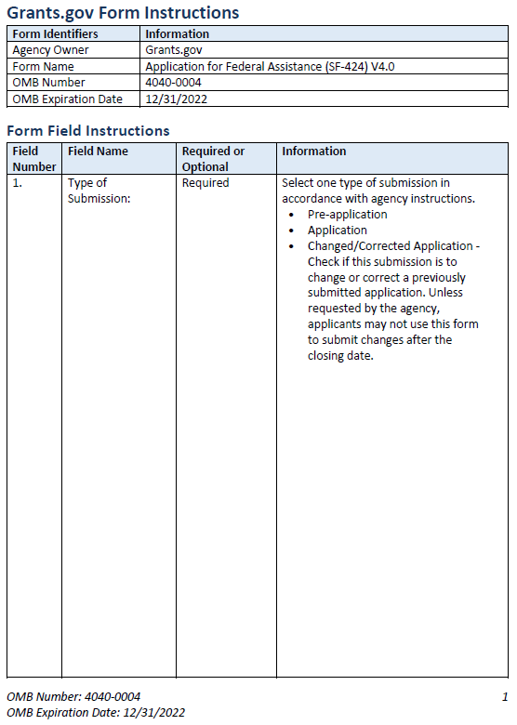

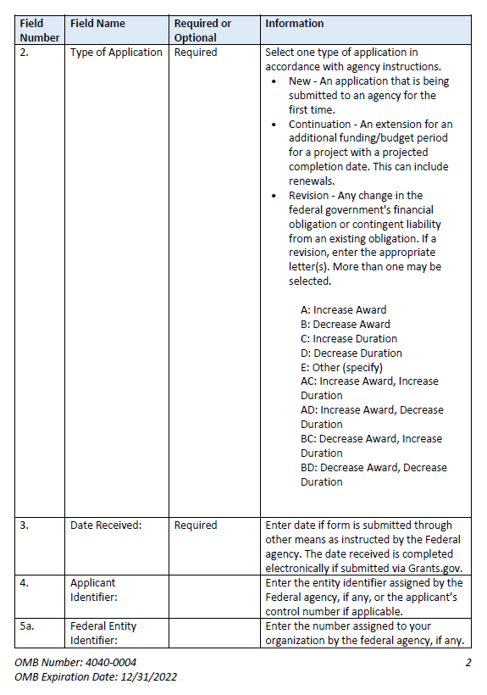 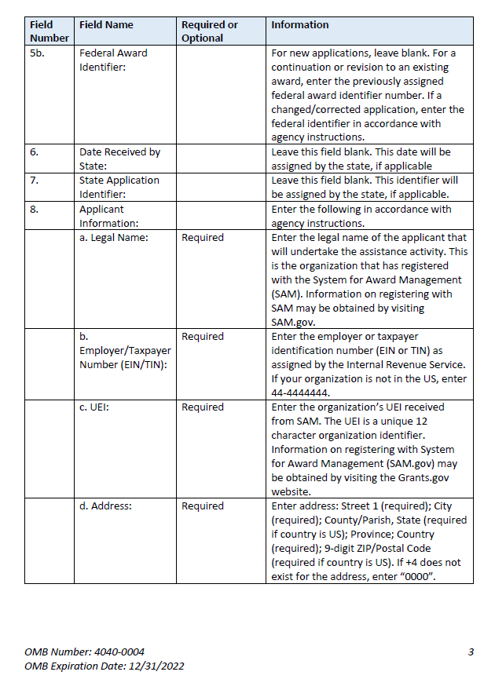 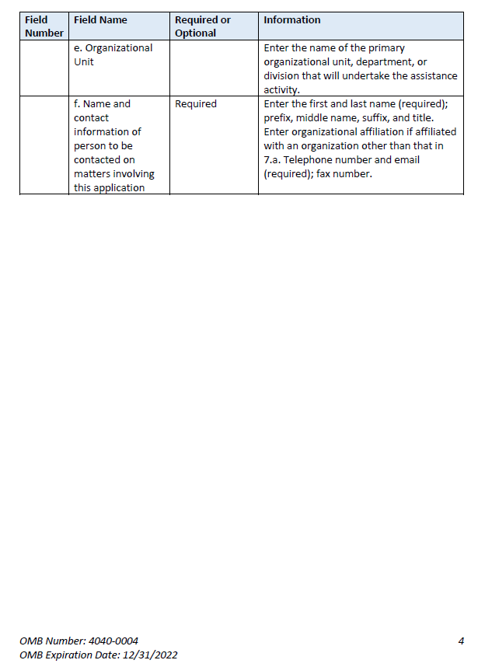 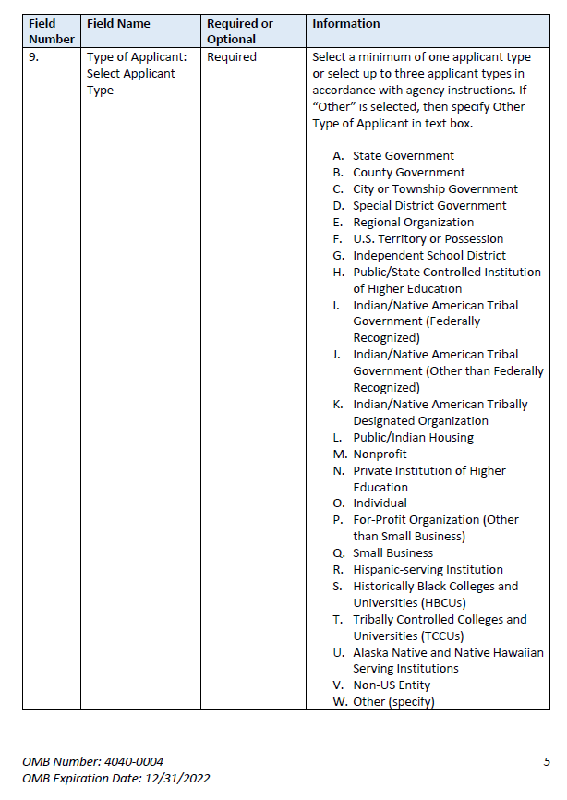 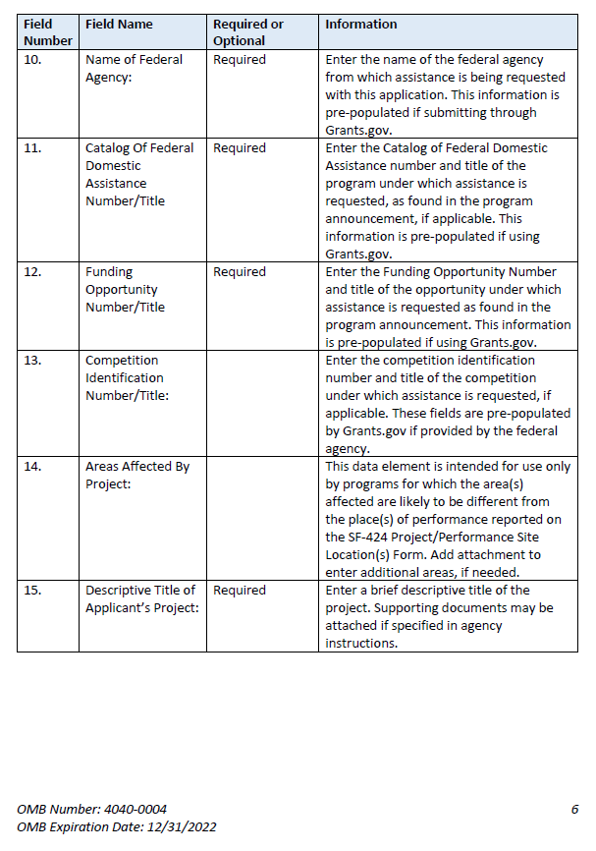 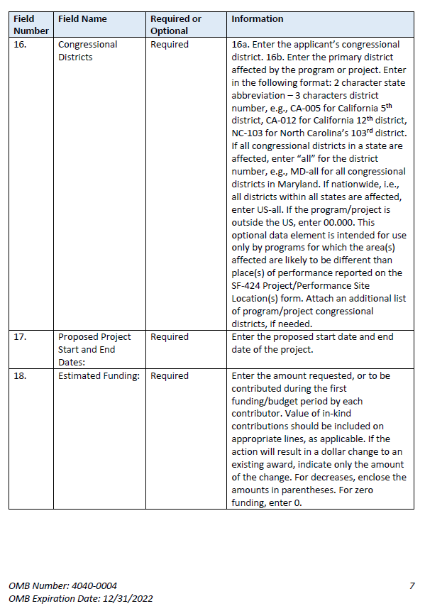 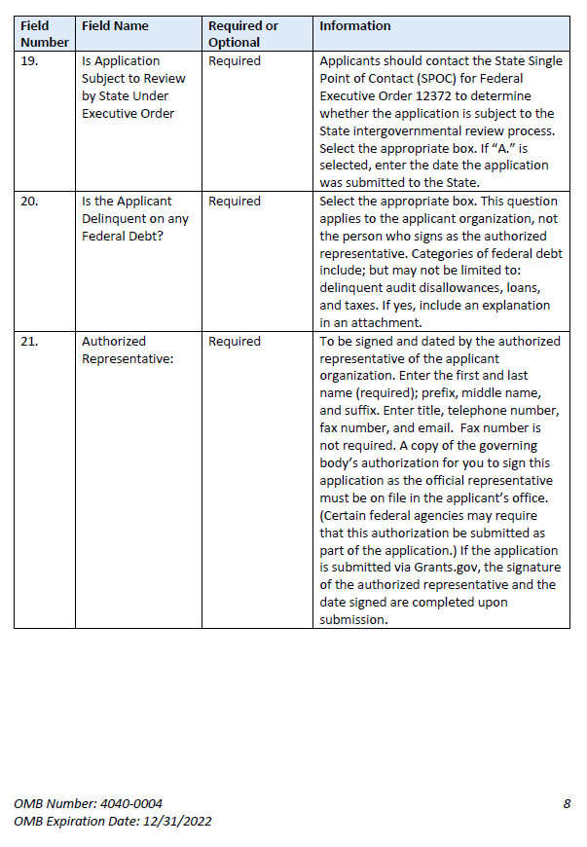

**Instructions for U.S. Department of Education  
Supplemental Information for the SF-424 Application for Federal Assistance**

1. **Project Director.** Name, address, telephone and fax numbers, and e-mail and alternate email addresses of the Project Director to be contacted on matters involving this application. Enter Project Director’s level of effort (the percentage of time devoted to the grant). Items marked with an asterisk (*) are mandatory.
2. **New Potential Grantee or Novice Applicant.** If applicable, for (a), check “**Yes**” if you meet the definition for new potential grantees or novice applicants specified in the program competition’s notice inviting applications (NIA) and included on the attached page entitled “Definitions for U.S. Department of Education Supplemental Information for the SF-424”. By checking “Yes” the applicant certifies that it meets the new potential grantee or novice applicant requirements. Check “**No**” if you do not meet the definition for new potential grantees or novice applicants.For (b), if the program competition NIA is giving competitive preference points for new potential grantees or novice applicants, indicate how many points you are claiming for your application. The NIA will indicate how many are available depending on the design of the competition. Some competitions may provide more than one category of new potential grantees with differing levels of points.
3. **Qualified Opportunity Zones.** If applicable, provide the Qualified Opportunity Zones (QOZ) census tract number(s) if the NIA includes a QOZ Priority in which you propose to either provide services in QOZ(s) or are located in a QOZ.
4. **Human Subjects Research.** (See I. A. “Definitions” in attached page entitled “Definitions for U.S. Department of Education Supplemental Information for the SF-424 form.”)
   1. **If Not Human Subjects Research.** Check “**No**” if research activities involving human subjects are notplanned at any time during the proposed project period. The remaining parts of Item 3 are then not applicable.
   2. **If Human Subjects Research.** Check “**Yes**” if research activities involving human subjects are planned at any time during the proposed project period, either at the applicant organization or at any other performance site or collaborating institution. Check “**Yes**” even if the research is exempt from the regulations for the protection of human subjects. (See I. B. “Exemptions” in attached page entitled “Definitions for U.S. Department of Education Supplemental Information for the SF-424 Application for Federal Assistance.”)
   3. **If Human Subjects Research is Exempt from the Human Subjects Regulations.** Check “**Yes**” if all the research activities proposed are designated to be exempt from the regulations. Check the exemption number(s) corresponding to one or more of the eight exemption categories (Regulation revisedin 2018 and became effective in 2019)listed in I. B. “Exemptions.” In addition, follow the instructions in II. A. “Exempt Research Narrative” in the attached page entitled “Definitions for U.S. Department of Education Supplemental Information for the SF-424 Application for Federal Assistance.”
   4. **If Human Subjects Research is Not Exempt from Human Subjects Regulations.** Check “**No**” if some or all of the planned research activities are covered (not exempt). In addition, follow the instructions in II. B. “Nonexempt Research Narrative” in the attached page entitled “Definitions for U.S. Department of Education Supplemental Information for the SF-424 Application for Federal Assistance.”
   5. **Human Subjects Assurance Number.** If the applicant has an approved Federal Wide Assurance (FWA) on file with the Office for Human Research Protections (OHRP), U.S. Department of Health and Human Services, that covers the specific activity, insert the number in the space provided. **(A list of current FWAs is available at:**[**http://ohrp.cit.nih.gov/search/search.aspx?styp=bsc**](http://ohrp.cit.nih.gov/search/search.aspx?styp=bsc)**.)** If the applicant does not have an approved assurance on file with OHRP, enter “None.” In this case, the applicant, by signature on the SF-424, is declaring that it will comply with 34 CFR part 97 and proceed to obtain the human subjects assurance upon request by the designated ED official. If the application is recommended/selected for funding, the designated ED official will request that the applicant obtain the assurance within 30 days after the specific formal request.
   6. If applicable, please attach your “Exempt Research” or “Nonexempt Research” narrative to your submission of the U.S. Department of Education Supplemental Information for the SF-424 form as instructed in item II, “Instructions for Exempt and Nonexempt Human Subjects Research Narratives” in the attached page entitled “Definitions for U.S. Department of Education Supplemental Information for the SF-424 Application for Federal Assistance.”

**Note about Institutional Review Board Approval.** ED does not require certification of Institutional Review Board approval with the application. However, if an application that involves non-exempt human subjects research is recommended/selected for funding, the designated ED official will request that the applicant obtain and send the certification to ED within 30 days after the formal request.

**No covered human subjects research can be conducted until the study has ED clearance for protection of human subjects in research.**

**Public Burden Statement:**

According to the Paperwork Reduction Act of 1995, no persons are required to respond to a collection of information unless such collection displays a valid OMB control number. Public reporting burden for this collection of information is estimated to average 20 minutes per response, including time for reviewing instructions, searching existing data sources, gathering and maintaining the data needed, and completing and reviewing the collection of information. The obligation to respond to this collection is required to obtain or retain benefit (20 USC 3474 General Education Provisions Act). Send comments regarding the burden estimate or any other aspect of this collection of information, including suggestions for reducing this burden, to the U.S. Department of Education, 400 Maryland Ave., SW, Washington, DC 20210-4537 or email [ICDocketMgr@ed.gov](mailto:ICDocketMgr@ed.gov) and reference the OMB Control Number 1894-0007. Note: Please do not return the completed ED SF 424 Supplemental Form to this address.

# Definitions for U.S. Department of Education Supplemental Information for the SF-424 Application for Federal Assistance

## Definitions:

### NEW POTENTIAL GRANTEE OR NOVICE APPLICANT

New Potential Grantee: The definition of New Potential Grantee is set in the program competition’s Notice Inviting Applications (NIA). The New Potential Grantee priority is from the Department’s *Administrative Priorities for Discretionary Grant Programs* published in the *Federal Register* March 9, 2020 ([85 FR 13640](https://www.federalregister.gov/d/2020-04761)).

Novice Applicant: For discretionary grant programs, novice applicant means any applicant for a grant from ED that—

* Has never received a grant or subgrant under the program from which it seeks funding;
* Has never been a member of a group application, submitted in accordance with 34 CFR 75.127-75.129, that received a grant under the program from which it seeks funding; and
* Has not had an active discretionary grant from the Federal government in the five years before the deadline date for applications under the program. For the purposes of this requirement, a grant is active until the end of the grant’s project or funding period, including any extensions of those periods that extend the grantee’s authority to obligate funds.

In the case of a group application submitted in accordance with 34 CFR 75.127-75.129, a group includes only parties that meet the requirements listed above. The Novice Applicant priority is from 34 CFR 75.225, and it must be included in the program competition NIA to be claimed on the form.

### QUALIFIED OPPORTUNITY ZONES

Definition: From 26 USC section 1400Z–1 of the Internal Revenue Code, which, in relevant part, defines “qualified opportunity zone” as “a population census tract that is a low-income community that is designated as a qualified opportunity zone.”

The Qualified Opportunity Zones priority is from the Department’s *Final Priority for Discretionary Grant Programs* published in the *Federal Register* November 27, 2019 ([84 FR 65300](https://www.federalregister.gov/d/2019-25819)).

Note: The Treasury Department has created a website of Opportunity Zones Resources that includes a searchable map: <https://www.cdfifund.gov/​Pages/​Opportunity-Zones.aspx>.

### PROTECTION OF HUMAN SUBJECTS IN RESEARCH

#### I. Definitions and Exemptions

##### A. Definitions.

A research activity involves human subjects if the activity is research, as defined in the Department’s regulations, and the research activity will involve use of human subjects, as defined in the regulations.

###### —Research

The ED Regulations for the Protection of Human Subjects, Title 34, Code of Federal Regulations, Part 97, define research as “a systematic investigation, including research development, testing and evaluation, designed to develop or contribute to generalizable knowledge. Activities which meet this definition constitute research whether or not they are conducted or supported under a program that is considered research for other purposes. For example, some demonstration and service programs may include research activities.”

###### —Human Subject

The regulations define human subject as “a living individual about whom an investigator (whether professional or student) conducting research obtains (i) information or biospecimens through intervention or interaction with the individual and uses, studies, or analyzes the information or biospecimens, or (ii ) obtains, uses, studies, analyzes, or generate identifiable private information or identifiable biospecimens.”

*If an activity involves obtaining information about a living person by manipulating that person or that person’s environment, as might occur when a new instructional technique is tested, or by communicating or interacting with the individual, as occurs with surveys and interviews, the definition of human subject is met. If an activity involves obtaining private information about a living person in such a way that the information can be* ***directly or indirectly*** *linked to that individual, the definition of human subject is met.*

Private information includes information about behavior that occurs in a context in which an individual can reasonably expect that no observation or recording is taking place, and information which has been provided for specific purposes by an individual and which the individual can reasonably expect will not be made public (for example, a school health record).

##### B. Exemptions.

Research activities in which the **only** involvement of human subjects will be in one or more of the following eight categories of ***exemptions*** are not covered by the regulations:

1. Research conducted in established or commonly accepted educational settings, that specifically involves normal educational practices that are not likely to adversely impact students’ opportunity to learn required educational content or the assessment of educators who provide instruction. This includes most research on regular and special education instructional strategies, and research on the effectiveness of or the comparison among instructional techniques, curricula, or classroom management methods. ***If an educational practice is being introduced to the site and is not widely used for similar populations, it is not covered by this exemption****.*
2. Research that only includes interactions involving educational tests (cognitive, diagnostic, aptitude, achievement), survey procedures, interview procedures or observation of public behavior (including visual or auditory recordings) if at least one of the following criteria is met: (i) the information obtained is recorded by the investigator in such a manner that the identity of the human subjects cannot readily be ascertained, directly or through identifiers linked to the subjects; (ii) Any disclosure of the human subjects’ responses outside the research would not reasonably place the subjects at risk of criminal or civil liability or be damaging to the subjects’ financial standing, employability, educational advancement or reputation; or (iii) the information obtained is recorded by the investigator in such a manner that the identity of the human subjects can readily be ascertained, directly or through identifiers linked to the subjects, and an Institutional Review Board (IRB) conducts a “limited IRB review” to make the determinations required by 34 CFR 97.111(a)(7).

***If the subjects are children, exemption 2 applies only to research involving educational tests and observations of public behavior when the investigator(s) do not participate in the activities being observed.***

***Exemption 2 does not apply if children are surveyed or interviewed or if the research involves observation of public behavior and the investigator(s) participate in the activities being observed.*** Children are defined as persons who have not attained the legal age for consent to treatments or procedures involved in the research, under the applicable law or jurisdiction in which the research will be conducted.

1. Research involving benign behavioral interventions in conjunction with the collection of information from an adult subject through verbal or written responses (including data entry) or audiovisual recording if the subject prospectively agrees to the intervention and information collection and at least one of the following criteria is met: (A) The information obtained is recorded by the investigator in such a manner that the identity of the human subjects cannot readily be ascertained directly or through identifiers linked to the subjects; (B) Any disclosure of the human subjects’ responses outside the research would not reasonably place the subjects at risk of criminal or civil liability or be damaging to the subject’ financial standing, employability, educational advancement or reputation; or (C) The information obtained is recorded by the investigator in such a manner that the identity of the human subjects can readily be ascertained, directly or through identifiers linked to the subjects, and an IRB conducts a limited IRB review to make the determination required by 34 CFR 97.111(a)(7).

For the purpose of this provision, benign behavioral interventions are brief in duration, harmless, painless, not physically invasive, not likely to have a significant adverse lasting impact on the subjects, and the investigator has no reason to think the subjects will find the interventions offensive or embarrassing. Provided all such criteria are met, examples of such benign behavioral interventions would include having the subject play an online game, having them solve puzzles under various noise conditions, or having them decide how to allocate a nominal amount of received cash between themselves and someone else.

If the research involves deceiving the subjects regarding the nature or purposes of the research, this exemption is not applicable unless the subject authorizes the deception through a prospective agreement to participate in research in circumstances in which the subject is informed that he or she will be unaware of or misled regarding the nature or purposes of the research.

1. Secondary Research for which Consent is not required. Secondary research uses of identifiable private information or identifiable biospecimens, if at least one of the following criteria is men: (i) The identifiable private information or identifiable biospecimens are publicly available; (ii) Information, which may include information about biospecimens, is recorded by the investigator in such a manner that the identity of the human subjects cannot readily be ascertained directly or through identifiers linked to the subjects, the investigator does not contact the subjects, and the investigator will not re-identify subjects; (iii) the research involves only information collection and analysis involving the investigators’ use of identifiable health information when that use is regulated under 45 CFR parts 160 and 164, subparts A and E, for the purposes of “health care operations” or “research” as those terms are defined at 45 CFR 164.501 or for “public health activities and purposes” as described under 45 CFR 164.512 (b); or (iv) The research is conducted by, or on behalf of, a Federal department or agency using government-generated or government-collected information obtained for nonresearch activities, if the research generates identifiable private information that is or will be maintained on information technology that is subject to and in compliance with section 208(b) of the E-Government Act of 2002, 44 USC 3501 note, if all of the identifiable private information collected, used or generated as part of the activity will be maintained in systems of records subject to the Privacy Act of 1974, 5 USC 552a, and, if applicable, the information used in the research was collected subject to the Paperwork Reduction Act of 1995, 44 USC 3501 et seq.
2. Research and demonstration projects that are conducted or supported by a Federal department or agency, or otherwise subject to the approval of department or agency heads (or the approval of the heads of bureaus or other subordinate agencies that have been delegated authority to conduct the research and demonstration projects), and that are designed to study, evaluate, improve, or otherwise examine public benefit or service programs, including procedures for obtaining benefits or services under those programs, possible changes in or alternative to those programs or procedures, or possible changes in methods or levels of payment for benefits or services under those programs. Such projects include, but are not limited to, internal studies by Federal employees, and studies under contracts or consulting arrangements, cooperative agreements, or grants. Exempt projects also include waivers of otherwise mandatory requirements using authorities such as sections 1115 and 1115A of the Social Security Act as amended.

Each Federal department or agency conducting or supporting the research and demonstration projects must establish, on a publicly accessible Federal website or in such other manner as the department or agency head may determine, a list of the research and demonstration projects that the Federal department or agency conducts or supports under this provision. The research or demonstration project must be published on this list prior to commencing the research involving human subjects.

1. Taste and food quality evaluation and consumer acceptance studies, (a) if wholesome foods without additives are consumed or (b) if a food is consumed that contains a food ingredient at or below the level and for a use found to be safe, or agricultural chemical or environmental contaminant at or below the level found to be safe, by the Food and Drug Administration or approved by the Environmental Protection Agency or the Food Safety and Inspection Service of the U.S. Department of Agriculture.
2. Storage or Maintenance for Secondary Research for which Broad Consent is required. Storage or maintenance of identifiable private information or identifiable biospecimens for potential secondary research use if an IRB conducts a limited IRB review and makes the determinations requires by 34 CFR 97.111(a)(8).
3. Secondary Research for which Broad Consent is Required. Research involving the use of identifiable private information or identifiable biospecimens for secondary research use if the following criteria are met: (i) Broad Consent for the storage, maintenance and secondary research use of the identifiable private information or identifiable biospecimens was obtained in accordance with 34 CFR 97.116(a) (1)-(4), (a) (6) and (d); (ii) Documentation of informed consent or waiver of documentation of consent was obtained in accordance with 34 CFR 97.117. (iii) an IRB conducts a limited IRB review and makes the determination that the research to be conducted is within the scope of the broad consent referenced in paragraph (d)(8)(i) of this section; and (iv) The investigator does not prevent an investigator from abiding by any legal requirements to return individual research results.

#### II. Instructions for Exempt and Nonexempt Human Subjects Research Narratives

If the applicant marked “Yes” for Item 3.b. of the U.S. Department of Education Supplemental Information for the SF-424 form, the applicant must attach a human subjects “exempt research” or “nonexempt research” narrative to the U.S. Department of Education Supplemental Information for the SF-424 form. If you have multiple projects, include information about each, labeling the responses as to the project they address. For applications that include multiple research projects this can be done in a single narrative or in more than one narrative as appropriate.

##### A. Exempt Research Narrative.

If you marked “Yes” for item 3.b. and designated exemption numbers(s), attach the “exempt research” narrative to the U.S. Department of Education Supplemental Information for the SF-424 form. The narrative must contain sufficient information about the involvement of human subjects in the proposed research to allow a determination by ED that the designated exemption(s) are appropriate. The narrative must be succinct.

##### B. Nonexempt Research Narrative.

If you marked “No” for item 3.b. you must attach the “nonexempt research” narrative to the U.S. Department of Education Supplemental Information for the SF-424 form. The narrative must address the following seven points. Although no specific page limitation applies to this section of the application, be succinct.

1. **Human Subjects Involvement and Characteristics**: Provide a detailed description of the proposed involvement of human subjects. Describe the characteristics of the subject population, including their anticipated number, age range, and health status. Identify the criteria for inclusion or exclusion of any subpopulation. Explain the rationale for the involvement of special classes of subjects, such as children, children with disabilities, adults with disabilities, persons with mental disabilities, pregnant women, prisoners, institutionalized individuals, or others who are likely to be vulnerable
2. **Sources of Materials**: Identify the sources of research material obtained from individually identifiable living human subjects in the form of specimens, records, or data. Indicate whether the material or data will be obtained specifically for research purposes or whether use will be made of existing specimens, records, or data.
3. **Recruitment and Informed Consent**: Describe plans for the recruitment of subjects and the consent procedures to be followed. Include the circumstances under which consent will be sought and obtained, who will seek it, the nature of the information to be provided to prospective subjects, and the method of documenting consent. State if the IRB has authorized a modification or waiver of the elements of consent or the requirement for documentation of consent.
4. **Potential Risks**: Describe potential risks (physical, psychological, social, legal, or other) and assess their likelihood and seriousness. Where appropriate, describe alternative treatments and procedures that might be advantageous to the subjects.
5. **Protection Against Risk**: Describe the procedures for protecting against or minimizing potential risks, including risks to confidentiality, and assess their likely effectiveness. Where appropriate, discuss provisions for ensuring necessary medical or professional intervention in the event of adverse effects to the subjects. Also, where appropriate, describe the provisions for monitoring the data collected to ensure the safety of the subjects.
6. **Importance of the Knowledge to be Gained**: Discuss the importance of the knowledge gained or to be gained as a result of the proposed research. Discuss why the risks to subjects are reasonable in relation to the anticipated benefits to subjects and in relation to the importance of the knowledge that may reasonably be expected to result.
7. **Collaborating Site(s)**: If research involving human subjects will take place at collaborating site(s) or other performance site(s), name the sites and briefly describe their involvement or role in the research.

***Copies of the Department of Education’s Regulations for the Protection of Human Subjects, 34 CFR part 97 and other pertinent materials on the protection of human subjects in research are available from the Office of the Chief Financial Officer, U.S. Department of Education, Washington, D.C. 20202-4331, telephone: (202) 245-8090, and on the U.S. Department of Education’s Protection of Human Subjects in Research Web Site:*** [***https://www2.ed.gov/about/offices/list/ocfo/humansub.html***](https://www2.ed.gov/about/offices/list/ocfo/humansub.html)

NOTE: The **State Applicant Identifier** on the SF-424 form is for State Use only. Please complete it on the SF-424 form in the upper right corner of the form (if applicable).

## Part 2: Budget Information

* ED Budget Information Non-Construction Programs (ED Form 524)

This part of your application contains information about the Federal funding you are requesting. Remember that you must provide all requested budget information for each year of the project (up to 60 months) and the total column in order to be considered for Federal funding. Specific instructions for completing the budget forms are provided within this application package.

*Instructions for completing ED Form 524 Section A:*

Name of Institution/Organization: Enter the name of the applicant in the space provided.

Personnel (line 1): Enter project personnel salaries and wages only. Include fees and expenses for consultants on line 6.

Fringe Benefits (line 2): The institution’s normal fringe benefits contribution may be charged to the program. Leave this line blank if fringe benefits applicable to direct salaries and wages are treated as part of the indirect cost.

Travel (line 3): Indicate the travel costs of employees and participants only. Include travel of persons such as consultants on line 6.

Equipment (line 4): Indicate the cost of tangible, non-expendable personal property that has a usefulness greater than one year and acquisition costs that are the lesser of the capitalization level established by the applicant entity for financial statement purposes or $5,000 per article. Lower limits may be established to maintain consistency with the applicant’s policy.

Supplies (line 5): Show all tangible, expendable personal property. Direct supplies and materials differ from equipment in that they are consumable, expendable, and of a relatively low unit cost. *Supplies purchased with grant funds should directly benefit the grant project and be necessary for achieving the goals of the project.*

Contractual (line 6): The contractual category should include all costs specifically incurred with actions that the applicant takes in conjunction with an established internal procurement system. Include consultant fees, expenses, and travel costs in this category if the consultant’s services are obtained through a written binding agreement or contract.

Construction (line 7): Not applicable.

Other (line 8): Indicate all direct costs not covered on lines 1-6. For example, include costs such as space rental, required fees, honoraria and travel (where a contract is not in place for services), training, and communication and printing costs. *Do not include costs that are included in the indirect cost rate.*

Total Direct Costs (line 9): The sum of lines 1-8.

Indirect Costs (line 10): Indicate the applicant’s approved indirect cost rate, per sections 75.560-75.564 of EDGAR. If an applicant does not have an approved indirect cost rate agreement with a cognizant Federal agency, the applicant must apply to the Department for a temporary indirect cost rate if it wishes to charge indirect costs to the grant. For more information, go to the Department's website at: <http://www.ed.gov/about/offices/list/ocfo/fipao/icgindex.html>.

Training Stipends (line 11): This line item is not applicable to this program. The training stipend line item only pertains to costs associated with long term training programs and college or university coursework, not workshops or short-term training supported by this program.

*Salary stipends paid to teachers and other school personnel for participating in short-term professional development should be reported in Personnel (line 1)*.

Total Cost (line 12): This should equal to sum of lines 9-11 (total direct costs + indirect + stipends). The sum for column one, labeled *Project Year 1* (a), should also be equal to item 15a on the application cover sheet (SF Form 424).

**Instructions for ED 524**

## General Instructions

This form is used to apply to individual U.S. Department of Education (ED) discretionary grant programs. Unless directed otherwise, provide the same budget information for each year of the multi-year funding request. Pay attention to applicable program specific instructions, if attached. You may access the Education Department General Administrative Regulations cited within these instructions at:

<https://www.ecfr.gov/cgi-bin/text-idx?SID=0b63ce6f20caccbf480e5596fdf289e3&mc=true&tpl=/ecfrbrowse/Title34/34cfr75_main_02.tpl>. You may access requirements from 2 CFR 200, “Uniform Administrative Requirements, Cost Principles, and Audit Requirements for Federal Awards” cited within these instructions at: <https://www.ecfr.gov/cgi-bin/text-idx?SID=6214841a79953f26c5c230d72d6b70a1&tpl=/ecfrbrowse/Title02/2cfr200_main_02.tpl>. .

## You must consult with your Business Office prior to submitting this form.

## Section A - Budget Summary

## U.S. Department of Education Funds

All applicants must complete Section A and provide a break-down by the applicable budget categories shown in lines 1-11.

Lines 1-11, columns (a)-(e): For each project year for which funding is requested, show the total amount requested for each applicable budget category.

Lines 1-11, column (f): Show the multi-year total for each budget category. If funding is requested for only one project year, leave this column blank.

Line 13, columns (a)-(e): Show the total budget request for each project year for which funding is requested.

Line 13, column (f): Show the total amount requested for all project years. If funding is requested for only one year, leave this space blank.

**Indirect Cost Information**: If you are requesting reimbursement for indirect costs on line 10 the indirect cost rate to be charged to the grant must be entered in the applicable field on line 10, and the following information is to be completed by your Business Office.

(1): Indicate whether or not your organization has an Indirect Cost Rate Agreement that was approved by the Federal government. If you checked “no,” ED generally will authorize grantees to use a temporary rate of 10 percent of budgeted salaries and wages (**complete (4) of this section when using the temporary rate**) subject to the following limitations:

(a) The grantee must submit an indirect cost proposal to its cognizant agency within 90 days after ED issues a grant award notification; and

(b) If after the 90-day period, the grantee has not submitted an indirect cost proposal to its cognizant agency, the grantee may not charge its grant for indirect costs until it has negotiated an indirect cost rate agreement with its cognizant agency.

(2): If you checked “yes” in (1), provide a copy of your Indirect Cost Rate Agreement and indicate in (2) the beginning and ending dates covered by the Indirect Cost Rate Agreement. In addition, indicate whether ED, another Federal agency (Other) or State agency issued the approved agreement. If you check “Other,” specify the name of the Federal or other agency that issued the approved agreement.

(3): If you check “no” in (1), indicate in (3) if you want to use the de minimis rate of 10 percent of MTDC (see 2CFR § 200.68). If you use the de minimis rate, you are subject to the provisions in 2 CFR § 200.414(f). Note, you may only use the 10 percent de minimis rate if you are a first-time Federal grant recipient, and you do not have an Approved Indirect Cost Rate Agreement. You may not use the de minimis rate if you are a State, Local government, or Indian Tribe, or if your grant is funded under a training rate or restricted rate program.

(5): If you are applying for a grant under a Restricted Rate Program (34 CFR 75.563 or 76.563), indicate whether you are using a restricted indirect cost rate that is included on your approved Indirect Cost Rate Agreement, or whether you are using a restricted indirect cost rate that complies with 34 CFR 76.564(c)(2). Note: State or Local government agencies may not use the provision for a restricted indirect cost rate specified in 34 CFR 76.564(c)(2). Check only one response. Leave blank, if this item is not applicable.

(6): For Training Rate Programs, ED regulations limit **non-governmental entities** to the recovery of indirect costs on training grants to the grantee’s actual indirect costs, as determined by its negotiated rate agreement, or 8 percent of a MTDC, whichever is lower (see EDGAR § 75.562(c)(4)). The 8 percent limit also applies to cost-type contracts under grants, if these contracts are for training as defined in EDGAR § 75.562(a). If a n**on-governmental entity** that receives a grant under a training grant program does not have an approved indirect cost rate and wants to recover indirect costs, it may use a temporary rate of 10 percent of budgeted direct salaries and wages, but it must submit an indirect cost rate proposal to its cognizant agency for indirect costs within 90 days after ED issues the GAN. After the 90-day period, the government entity may not charge its grant for indirect costs until it has negotiated an indirect cost rate agreement.

## Section B - Budget Summary

## Non-Federal Funds

If you are required to provide or volunteer to provide cost-sharing or matching funds or other non-Federal resources to the project, these should be shown for each applicable budget category on lines 1‑11 of Section B.

Lines 1-11, columns (a)-(e): For each project year, for which matching funds or other contributions are provided, show the total contribution for each applicable budget category.

Lines 1-11, column (f): Show the multi-year total for each budget category. If non-Federal contributions are provided for only one year, leave this column blank.

Line 12, columns (a)-(e): Show the total matching or other contribution for each project year.

Line 12, column (f): Show the total amount to be contributed for all years of the multi-year project. If non-Federal contributions are provided for only one year, leave this space blank.

## Section C - Budget Narrative [Attach separate sheet(s)]

## Pay attention to applicable program specific instructions, if attached.

1. Provide an itemized budget breakdown, and justification by project year, for each budget category listed in Sections A and B. For grant projects that will be divided into two or more separately budgeted major activities or sub-projects, show for each budget category of a project year the breakdown of the specific expenses attributable to each sub-project or activity.
2. For non-Federal funds or resources listed in Section B that are used to meet a cost-sharing or matching requirement or provided as a voluntary cost-sharing or matching commitment, you must include:

a. The specific costs or contributions by budget category;

b. The source of the costs or contributions; and

c. In the case of third-party in-kind contributions, a description of how the value was determined for the donated or contributed goods or services.

[Please review cost sharing and matching regulations found in 2 CFR 200.306.]

1. If applicable to this program, provide the rate and base on which fringe benefits are calculated.
2. If you are requesting reimbursement for indirect costs on line 10, this information is to be completed by your Business Office. Specify the estimated amount of the base to which the indirect cost rate is applied and the total indirect expense. Depending on the grant program to which you are applying and/or your approved Indirect Cost Rate Agreement, some direct cost budget categories in your grant application budget may not be included in the base and multiplied by your indirect cost rate. For example, you must multiply the indirect cost rates of “Training grants" (34 CFR 75.562) and grants under programs with “Supplement not Supplant” requirements ("Restricted Rate" programs) by a “modified total direct cost” (MTDC) base (34 CFR 75.563 or 76.563). Please indicate which costs are included and which costs are excluded from the base to which the indirect cost rate is applied.

When calculating indirect costs (line 10) for "Training grants" or grants under "Restricted Rate" programs, you must refer to the information and examples on ED’s website at: http://www.ed.gov/fund/grant/apply/appforms/appforms.html.

You may also contact (202) 377-3838 for additional information regarding calculating indirect cost rates or general indirect cost rate information.

1. Provide other explanations or comments you deem necessary.

## If Applicable Section D - Budget Summary

## Limitation on Administrative Expenses.

If your program is subject to an administrative cost cap (as indicated Section III.2.C of the program’s Notice Inviting Applications (NIA)), fill out this form as follows:

1. On the top of the page, list the percentage cap on administrative costs, and indicate whether your administrative cost cap applies to both indirect and direct costs, or only direct costs (from Section III.2.C of the program’s NIA).
2. IF the cost cap applies to both indirect and direct costs:
3. Fill out the entire table noting your administrative costs, including line 8. Line 8 is taken from Section A, line 10. For lines 1-6, these are only direct administrative costs; do not include in lines 1-6 any costs included in your indirect cost rate. If your program has a matching requirement (see NIA), include in lines 1-6 the administrative portions of the applicable rows from both Section A and Section B. If there is no program matching requirement, only use Section A.
4. Ensure that the line 10 percentage DOES NOT EXCEED the percentage cap on administrative costs. If your program does not have a matching requirement, divide line 9 by Section A line 12. If your program does have a matching requirement, to calculate line 10, divide line 9 by the sum of Section A line 12 and Section B line 12.
5. IF the cost cap applies ONLY to direct costs:
6. Fill out the entire table noting your administrative costs, EXCLUDING line 8.

Ensure that the line 10 percentage DOES NOT EXCEED the percentage cap on administrative costs. If your program does not have a matching requirement, divide line 7 by Section A line 9. If your program does have a matching requirement, to calculate line 10, divide line 7 by the sum of Section A line 9 and Section B line 9).

## Paperwork Burden Statement

According to the Paperwork Reduction Act of 1995, no persons are required to respond to a collection of information unless such collection displays a valid OMB control number. The valid OMB control number for this information collection is **1894-0008**. The time required to complete this information collection is estimated to vary from 13 to 22 hours per response, with an average of 17.5 hours per response, including the time to review instructions, search existing data sources, gather the data needed, and complete and review the information collection. If you have any comments concerning the accuracy of the time estimate(s) or suggestions for improving this form, please write to U.S. Department of Education, Washington, D.C. 20202-4537. If you have comments or concerns regarding the status of your individual submission of this form, write directly to the Office of Finance and Operations, Office of Acquisitions and Grants Administration, Grants Policy and Training Division, U.S. Department of Education, 400 Maryland Avenue, S.W., Washington, D.C. 20202.

## Part 3: ED Abstract Form

*This section should be attached as a single document to the ED Abstract Form in accordance with the instructions found on Grants.gov and should be organized in the following manner and include the following parts in order to expedite the review process.*

*Ensure that you only attach the Department-approved file types detailed in the Federal Register application notice (read-only, non-modifiable .pdf files). Also, do not upload any password-protected files to your application.*

*Please note that Grants.gov cannot process an application that includes two or more files that have the same name within a grant submission.*

*When attaching files, applicants should limit the size of their file names. Lengthy file names could result in difficulties with opening and processing your application. We recommend your file names be less than 50 characters.*

* **Project Abstract**

The project abstract should not exceed **two** double spaced pagesandshouldinclude a concise description of the following information:

* Project objectives and activities
* Applicable priorities
* Proposed project outcomes
* Number of participants to be served
* Location of proposed site

Note: Grants.gov may include a note that indicates that the project abstract may not exceed one page; however, an abstract of more than one page may be uploaded.

## Part 4: Project Narrative Attachment Form

*This section should be attached as a* ***single*** *document to the Project Narrative Attachment Form in accordance with the instructions found on* [*Grants.gov*](http://grants.gov/) *and should be organized in the following manner and include the following parts in order to expedite the review process.*

*Ensure that you only attach the Department-approved file types detailed in the common instructions. Also, do not upload any password-protected files to your application.*

*When attaching files, applicants should limit the size of their file names. Lengthy file names could result in difficulties with opening and processing your application. We recommend your file names be less than 50 characters.*

* Table of Contents

The Table of Contents shows where and how the important sections of your proposal are organized and should not exceed **one** double spaced page.

* Application Narrative

The Application Narrative responds to the selection criteria found in this application package and should follow the order of the selection criteria.

Applicants applying for CSP grant funds must address the application requirements and the selection criteria. In addition, they may respond to the competitive preference priority and the invitational priority. An applicant may choose to respond to the application requirements in the context of its responses to the selection criteria but should note its location accordingly.

**Priorities**

The FY 2022 Developer Grants Competition includes one competitive preference priority and one invitational priority. The competitive preference priority applies to applicants under both ALN 84.282B and 84.282E. The priority will apply to grants awarded under this competition in FY 2022 and any subsequent year in which we make awards from the list of unfunded applications from this competition. **While the Priorities information on the next page is provided for applicants’ convenience, applicants should be sure to review the full NIA for this competition in the Federal Register.** The priorities are explained in detail in the NIA.

**Selection Criteria**

The Project Narrative should describe the project that an applicant would carry out if funded and include the eligible applicant’s response to the selection criteria since the application will be evaluated and scored against these criteria. The maximum possible score for each criterion is indicated in the NIA.

**Application Requirements**

The FY 2022 Developer Grants Competition NIA includes numerous application requirements. Applicants are required to respond to all application requirements within the project narrative. These Application Requirements are explained in detail in the NIA.

**Formatting**

A “page” is 8.5" x 11", on one side only, with 1" margins at the top, bottom, and both sides. Page numbers and an identifier may be within the 1” margin. Double-space (no more than three lines per vertical inch) all text in the application narrative, including titles, headings, footnotes, quotations, and references. Use a font size that is either 12-point or larger or no smaller than 10 pitch. Use one of the following fonts: Times New Roman, Courier, Courier New, or Arial.

### Page Limits

We recommend that applicants limit the Project Narrative to **50 pages, double-spaced, and number the pages consecutively**. Please provide any charts, graphs, citations, or examples in the project narrative. Refer to the Federal Register Notice for additional application submission requirements. The Table of Contents and attachments do not count against the recommended page limit.

To facilitate the review of the application, please organize your Project Narrative in the following order and include a Table of Contents.

* **Competitive Preference Priority (optional)**
* **Selection Criteria**
* **Application Requirements**

**Competitive Preference Priority**

*In order to receive preference under the competitive preference priority, the applicant must identify the priority that it believes it meets and provide documentation supporting its claims. The maximum total competitive preference points an application can receive for this competition under 84.282B or 84.282E is 5.*

**Promoting High-Quality Educator- and Community-Centered Charter Schools to Support Underserved Students** (Up to 5 points under ALNs 84.282B and 84.282E)

(a) Under this priority, an applicant must propose to open a new charter school, or to replicate or expand a high-quality charter school, that is developed and implemented--

(1) With meaningful and ongoing engagement with current or former teachers and other educators (0 or 1 point); and

(2) Using a community-centered approach that includes an assessment of community assets, informs the development of the charter school, and includes the implementation of protocols and practices designed to ensure that the charter school will use and interact with community assets on an ongoing basis to create and maintain strong community ties. (Up to 2 points).

(b) In its application, an applicant must provide a high-quality plan that demonstrates how its proposed project would meet the requirements in paragraph (a) of this priority, accompanied by a timeline for key milestones that span the course of planning, development, and implementation of the charter school. (Up to 2 points). (2022 NFP)

**Invitational Priority**

*The Department is also interested in projects that address this invitational priority. Under 34 CFR 75.105(c)(1), we do not give an application that meets this invitational priority a competitive or absolute preference over other applications.*

**Collaborations between Charter Schools and Traditional Public Schools or Districts that Benefit Students and Families across Schools** (0 points under ALNs 84.282B and 84.282E)

(a) Under this priority, an applicant must propose a new collaboration, or the continuation of an existing collaboration, with at least one traditional public school or traditional school district that is designed to benefit students or families served by at least one member of the collaboration, is designed to lead to increased or improved educational opportunities for students served by at least one member of the collaboration, and includes implementation of one or more of the following--

(1) Co-developed or shared curricular and instructional resources or academic course offerings.

(2) Professional development opportunities for teachers and other educators, which may include professional learning communities, opportunities for teachers to earn additional certifications, such as in a high-need area or national board certification, and partnerships with educator preparation programs to support teaching residencies.

(3) Evidence-based (as defined in section 8101 of the ESEA) practices to improve academic performance for underserved students.

(4) Policies and practices to create safe, supportive, and inclusive learning environments, such as systems of positive behavioral intervention and support.

(5) Transparent enrollment and retention practices and processes that include clear and consistent disclosure to families of policies and requirements (e.g., discipline policies, purchasing and wearing specific uniforms and other fees, or family participation), and any services that are or are not provided, that could impact a family’s ability to enroll or remain enrolled in the school (e.g., transportation services or participation in the National School Lunch Program).

(6) A shared transportation plan and system that reduces transportation costs for at least one member of the collaboration and takes into consideration various transportation options, including public transportation and district-provided or shared transportation options, cost-sharing or free or reduced-cost fare options, and any distance considerations for prioritized bus services.

(7) A shared special education collaborative designed to address a significant barrier or challenge faced by participating charter schools or traditional public schools in improving academic and developmental outcomes and services for students with disabilities (as defined in section 8101 of the ESEA).

(8) A shared English learner (as defined in section 8101 of the ESEA) collaborative designed to address a significant barrier or challenge faced by participating charter schools or traditional public schools in providing educational programs to improve academic outcomes for English learners.

(9) Other collaborations, such as the sharing of innovative and best practices, designed to address a significant barrier or challenge faced by participating charter schools or traditional public schools in providing educational programs to improve academic outcomes for all students served by members of the collaboration.

(b) In its application, an applicant must provide a description of the collaboration that—-

(1) Describes each member of the collaboration and whether the collaboration would be a new or existing commitment;

(2) States the purpose and duration of the collaboration;

(3) Describes the anticipated roles and responsibilities of each member of the collaboration;

(4) Describes how the collaboration will benefit one or more members of the collaboration, including how it will benefit students or families affiliated with such member and lead to increased educational opportunities for students, and meet specific and measurable, if applicable, goals;

(5) Describes the resources members of the collaboration will contribute; and

(6) Contains any other relevant information.

(c) Within 120 days of receiving a grant award or within 120 days of the date the collaboration is scheduled to begin, whichever is later, provide evidence of participation in the collaboration (which may include, but is not required to include, a memorandum of understanding (MOU)). (2022 NFP)

### Selection Criteria

The maximum score for all selection criteria under both ALN 84.282B and 84.282E is 100 points. The points or weights assigned to each criterion are indicated in parentheses. Non-Federal peer reviewers will review each application. They will be asked to evaluate and score each program narrative against the following selection criteria below. ***Applicants should review the NIA for the full text of each criterion.***

**Selection Criteria for Grants to Charter School Developers for Opening New Charter Schools (ALN 84.282B)**

(1) Quality of the Charter School’s Management Plan (up to 40 points).

The Secretary considers the quality of the management plan for the proposed project. In determining the quality of the management plan for the proposed project, the Secretary considers the following factors:

(i) The adequacy of the management plan to achieve the objectives of the proposed project on time and within budget, including clearly defined responsibilities, timelines, and milestones for accomplishing project tasks (up to 10 points). (34 CFR 75.210(g)(2)(i))

(ii) The extent to which the costs are reasonable in relation to the objectives, design, and potential significance of the proposed project (up to 5 points). (34 CFR 75.210(f)(2)(iv))

(iii) The extent to which the time commitments of the project director and principal investigator and other key project personnel are appropriate and adequate to meet the objectives of the proposed project (up to 5 points). (34 CFR 75.210(g)(2)(iv))

(iv) The qualifications, including relevant training and experience, of key project personnel (up to 5 points). (34 CFR 75.210(e)(3)(ii))

(v) The adequacy of the applicant's plan to maintain control over all CSP grant funds (up to 5 points). (2022 NFP)

(vi) The adequacy of the applicant's plan to make all programmatic decisions (up to 5 points). (2022 NFP)

(vii) The adequacy of the applicant’s plan to administer or supervise the administration of the grant, including maintaining management and oversight responsibilities over the grant (up to 5 points). (2022 NFP)

(2) Quality of the Continuation Plan (up to 20 points).

In determining the quality of the continuation plan, the Secretary considers the extent to which the eligible applicant is prepared to continue to operate the charter school that would receive grant funds in a manner consistent with the eligible applicant’s application once the grant funds under this program are no longer available. (2019 NFP)

(3) Quality of the Project Design (up to 10 points).

The Secretary considers the quality of the design of the proposed project. In determining the quality of the design of the proposed project, the Secretary considers the following factors:

(i) The extent to which the proposed project demonstrates a rationale (as defined in 34 CFR 77.1(c)) (up to 5 points). (34 CFR 75.210(c)(2)(xxix))

(ii) The extent to which the goals, objectives, and outcomes to be achieved by the proposed project are clearly specified and measurable (up to 5 points). (34 CFR 75.210(c)(2)(i))

(4) Need for the Project (up to 30 points).

The Secretary considers the need for the proposed project. In determining the need for the proposed project, the Secretary considers one or more of the following factors:

(i) The magnitude or severity of the problem to be addressed by the proposed project (up to 15 points). (34 CFR 75.210(a)(2)(i))

(ii) The magnitude of the need for the services to be provided or the activities to be carried out by the proposed project (up to 15 points). (34 CFR 75.210(a)(2)(ii))

**Selection Criteria for Grants to Charter School Developers for the Replication and Expansion of High-Quality Charter Schools (ALN 84.282E)**

(1) Quality of the Eligible Applicant (up to 20 points).

In determining the quality of the eligible applicant, the Secretary considers the following factors:

(i) The extent to which the academic achievement results (including annual student performance on statewide assessments and annual student attendance and retention rates and where applicable and available, student academic growth, high school graduation rates, postsecondary enrollment and persistence rates, including in college or career training programs, employment rates, earnings and other academic outcomes) for educationally disadvantaged students served by the charter schools operated or managed by the applicant have exceeded the average academic achievement results for such students served by other public schools in the State (up to 5 points). (2019 NFP)

(ii) The extent to which one or more charter schools operated or managed by the applicant have closed; have had a charter revoked due to noncompliance with statutory or regulatory requirements; or have had their affiliation with the applicant revoked or terminated, including through voluntary disaffiliation (up to 5 points). (2019 NFP)

(iii) The extent to which one or more charter schools operated or managed by the applicant have had any significant issues in the area of financial or operational management or student safety, or have otherwise experienced significant problems with statutory or regulatory compliance that could lead to revocation of the school’s charter (up to 5 points). (2019 NFP)

(iv) The extent to which the schools operated or managed by the applicant demonstrate strong results on measurable outcomes in non-academic areas such as, but not limited to, parent satisfaction, school climate, student mental health, civic engagement, and crime prevention and reduction (up to 5 points). (2019 NFP)

(2) Quality of the Charter School’s Management Plan (up to 35 points).

The Secretary considers the quality of the management plan for the proposed project. In determining the quality of the management plan for the proposed project, the Secretary considers the following factors:

(i) The adequacy of the management plan to achieve the objectives of the proposed project on time and within budget, including clearly defined responsibilities, timelines, and milestones for accomplishing project tasks (up to 5 points). (34 CFR 75.210(g)(2)(i))

(ii) The extent to which the costs are reasonable in relation to the objectives, design, and potential significance of the proposed project (up to 5 points). (34 CFR 75.210(f)(2)(iv))

(iii) The extent to which the time commitments of the project director and principal investigator and other key project personnel are appropriate and adequate to meet the objectives of the proposed project (up to 5 points). (34 CFR 75.210(g)(2)(iv))

(iv) The qualifications, including relevant training and experience, of key project personnel (up to 5 points). (34 CFR 75.210(e)(3)(ii))

(v) The adequacy of the applicant's plan to maintain control over all CSP grant funds (up to 5 points). (2022 NFP)

(vi) The adequacy of the applicant's plan to make all programmatic decisions (up to 5 points). (2022 NFP)

(vii) The adequacy of the applicant’s plan to administer or supervise the administration of the grant, including maintaining management and oversight responsibilities over the grant (up to 5 points). (2022 NFP)

(3) Quality of the Continuation Plan (up to 10 points).

In determining the quality of the continuation plan, the Secretary considers the extent to which the eligible applicant is prepared to continue to operate the charter school that would receive grant funds in a manner consistent with the eligible applicant’s application once the grant funds under this program are no longer available. (2019 NFP)

(4) Quality of the Project Design (up to 10 points).

The Secretary considers the quality of the design of the proposed project. In determining the quality of the design of the proposed project, the Secretary considers the following factors:

(i) The extent to which the proposed project demonstrates a rationale (as defined in 34 CFR 77.1(c)) (up to 5 points). (34 CFR 75.210(c)(2)(xxix))

(ii) The extent to which the goals, objectives, and outcomes to be achieved by the proposed project are clearly specified and measurable (up to 5 points). (34 CFR 75.210(c)(2)(i))

(5) Need for the Project (up to 25 points).

The Secretary considers the need for the proposed project. In determining the need for the proposed project, the Secretary considers one or more of the following factors:

(i) The magnitude or severity of the problem to be addressed by the proposed project (up to 15 points). (34 CFR 75.210(a)(2)(i))

(ii) The magnitude of the need for the services to be provided or the activities to be carried out by the proposed project (up to 10 points). (34 CFR 75.210(a)(2)(ii))

Review and Selection Process: We remind potential applicants that in reviewing applications in any discretionary grant competition, the Secretary may consider, under 34 CFR 75.217(d)(3), the past performance of the applicant in carrying out a previous award, such as the applicant’s use of funds, achievement of project objectives, and compliance with grant conditions. The Secretary may also consider whether the applicant failed to submit a timely performance report or submitted a report of unacceptable quality.

In addition, in making a competitive grant award, the Secretary requires various assurances, including those applicable to Federal civil rights laws that prohibit discrimination in programs or activities receiving Federal financial assistance from the Department (34 CFR 100.4, 104.5, 106.4, 108.8, and 110.23).

Risk Assessment and Special Conditions: Consistent with 2 CFR 200.205, before awarding grants under this competition the Department conducts a review of the risks posed by applicants. Under 2 CFR 3474.10, the Secretary may impose special conditions and, in appropriate circumstances, high-risk conditions on a grant if the applicant or grantee is not financially stable; has a history of unsatisfactory performance; has a financial or other management system that does not meet the standards in 2 CFR part 200, subpart D; has not fulfilled the conditions of a prior grant; or is otherwise not responsible.

Integrity and Performance System: If you are selected under this competition to receive an award that over the course of the project period may exceed the simplified acquisition threshold (currently $250,000), under 2 CFR 200.206(a)(2) we must make a judgment about your integrity, business ethics, and record of performance under Federal awards--that is, the risk posed by you as an applicant--before we make an award. In doing so, we must consider any information about you that is in the integrity and performance system (currently referred to as the Federal Awardee Performance and Integrity Information System (FAPIIS)), accessible through the System for Award Management. You may review and comment on any information about yourself that a Federal agency previously entered and that is currently in FAPIIS.

Please note that, if the total value of your currently active grants, cooperative agreements, and procurement contracts from the Federal Government exceeds $10,000,000, the reporting requirements in 2 CFR part 200, Appendix XII, require you to report certain integrity information to FAPIIS semiannually. Please review the requirements in 2 CFR part 200, Appendix XII, if this grant plus all the other Federal funds you receive exceed $10,000,000.

**Suggested Point Ranges for Rating Applicant Responses to the Selection Criteria**

*\*\*This document will be provided to peer reviewers to assist in the reviewing and scoring of the eligible applicant’s response to the selection criteria. It is included here for the applicants’ reference.*

All applicants are required to respond to each of the selection criteria in the NIA published in the Federal Register on [Insert Date], 2022. Please assess applications based on the selection criteria. No outside factors, such as personal knowledge of past performance, or subjective judgments about what an application should contain may be considered. The application should be a comprehensive design for the proposed project and desired outcomes. Therefore, it is imperative that reviewers read the application in its entirety to determine the overall quality of the proposed project and the quality of the applicant’s response to each selection criterion.

The numerical scores assigned to an applicant’s response to the Selection Criteria must be consistent with the comments written. Comments and scores should reflect the same overall assessment of the quality of the response. It is important that you do not pair a negative comment with a positive score and vice versa. Comments indicate why the applicant’s response to each selection criterion is fully developed, well developed, adequately developed, poorly developed, or not addressed. Scores indicate how well or poorly the applicant responded to a selection criterion. Shown below are ***suggested*** point ranges for an evaluation of fully developed, well developed, adequately developed, poorly developed, or not addressed, for each of the selection criteria.

|  |  |  |  |  |  |
| --- | --- | --- | --- | --- | --- |
| **Maximum Point Value** | **Quality of Applicant’s Response** | | | | |
|  | **Not Addressed** | **Poorly Developed** | **Adequately Developed** | **Well- Developed** | **Fully Developed** |
| 5 | 0 | 1-2 | 3 | 4 | 5 |
| 10 | 0 | 1-5 | 6-7 | 8-9 | 10 |
| 15 | 0 | 1-8 | 9-11 | 12-14 | 15 |
| 20 | 0 | 1-10 | 11-15 | 16-19 | 20 |
| 25 | 0 | 1-12 | 13-18 | 19-24 | 25 |
| 30 | 0 | 1-15 | 16-23 | 24-29 | 30 |
| 35 | 0 | 1-18 | 19-28 | 29-34 | 35 |
| 40 | 0 | 1-21 | 22-31 | 32-39 | 40 |

### Application Requirements

Applications for CSP Developer Grant funds must address the following application requirements. These requirements are from section 4303(f) of the ESEA and the 2019 and 2022 NFPs. The source of each requirement is provided in parentheses following each requirement. Except as otherwise provided, an applicant may choose to respond to each requirement separately or in the context of the applicant’s responses to the selection criteria.

**Grants to Charter School Developers for the Opening of New Charter Schools (ALN 84.282B) and for the Replication and Expansion of High-Quality Charter Schools (ALN 84.282E).**

Applicants for grants under ALN 84.282B or 84.282E must address the following application requirements. An applicant must respond to the requirements in paragraph (a) in a stand-alone section of the application or in an appendix.

(a) Describe the eligible applicant’s objectives in running a quality charter school program and how the objectives of the program will be carried out, including--

(1) How the eligible applicant will ensure that charter schools receiving funds under this program meet the educational needs of their students, including children with disabilities and English learners (Section 4303(f)(1)(A)(x) of the ESEA);

(2) The roles and responsibilities of eligible applicants, partner organizations, and charter management organizations, including the administrative and contractual organizations, including the administrative and contractual roles and responsibilities of such partners (Section 4303(f)(1)(C)(i)(I) of the ESEA);

(3) The quality controls agreed to between the eligible applicant and the authorized public chartering agency involved, such as a contract or performance agreement, how a school’s performance in the State’s accountability system and impact on student achievement (which may include student academic growth) will be one of the most important factors for renewal or revocation of the school’s charter, and how the authorized public chartering agency involved will reserve the right to revoke or not renew a school’s charter based on financial, structural, or operational factors involving the management of the school (Section 4303(f)(1)(C)(i)(II) of the ESEA);

(4) How the autonomy and flexibility granted to a charter school is consistent with the definition of a charter school in section 4310 of the ESEA (Section 4303(f)(1)(C)(i)(III) of the ESEA);

(5) How the eligible applicant will solicit and consider input from parents and other members of the community on the implementation and operation of each charter school that will receive funds under the grant (Section 4303(f)(1)(C)(i)(IV));

(6) The eligible applicant’s planned activities and expenditures of grant funds to support the activities described in section 4303(b)(1) of the ESEA, and how the eligible applicant will maintain financial sustainability after the end of the grant period (Section 4303(f)(1)(C)(i)(V) of the ESEA);

(7) How the eligible applicant will support the use of effective parent, family, and community engagement strategies to operate each charter school that will receive funds under the grant (Section 4303(f)(1)(C)(i)(VI) of the ESEA); and

(8) How the eligible applicant will ensure that each charter school receiving funds under this program has considered and planned for the transportation needs of the school’s students (Section 4303(f)(1)(E) of the ESEA).

(b) Describe the educational program that the applicant will implement in the charter school receiving funding under this program, including--

(1) Information on how the program will enable all students to meet the challenging State academic standards;

(2) The grade levels or ages of students who will be served; and

(3) The instructional practices that will be used. (2019 NFP)

(c) Describe how the applicant will ensure that the charter school that will receive funds will recruit, enroll, and retain students, including educationally disadvantaged students, which include children with disabilities and English learners. (2019 NFP)

(d) Describe the lottery and enrollment procedures that the applicant will use for the charter school if more students apply for admission than can be accommodated and, if the applicant proposes to use a weighted lottery, how the weighted lottery complies with section 4303(c)(3)(A) of the ESEA. (2019 NFP)

(e) Provide a complete logic model (as defined in 34 CFR 77.1) for the grant project. The logic model must include the applicant’s objectives for implementing a new charter school or replicating or expanding a high-quality charter school with funding under this competition. (2019 NFP)

(f) Provide a budget narrative, aligned with the activities, target grant project outputs, and outcomes described in the logic model, that outlines how grant funds will be expended to carry out planned activities. (2019 NFP)

(g) If the applicant proposes to open a new charter school (ALN 84.282B) or proposes to replicate or expand a high-quality charter school (ALN 84.282E) that provides a single-sex educational program, demonstrate that the proposed single-sex educational programs are in compliance with the title IX of the Education Amendments of 1972 (20 U.S.C. 1681, et seq.) (“Title IX”) and its implementing regulations, including 34 CFR 106.34. (2019 NFP)

(h) Provide the applicant’s most recent available independently audited financial statements prepared in accordance with generally accepted accounting principles. (2019 NFP)

(i) Provide--

(1) A request and justification for waivers of any Federal statutory or regulatory provisions that the eligible entity believes are necessary for the successful operation of the charter school to be opened or to be replicated or expanded; and

(2) A description of any State or local rules, generally applicable to public schools, that will be waived or otherwise not apply to the school that will receive funds. (2019 NFP)

(j) Describe how each school that will receive funds meets the definition of charter school under section 4310(2) of the ESEA. (2019 NFP)

(k) For any existing or proposed contract with a for-profit management organization (including a nonprofit management organization operated by or on behalf of a for-profit entity), without regard to whether the management organization or its related entities exercise full or substantial administrative control over the charter school or the CSP project, the applicant must provide the following information or equivalent information that the applicant has submitted to the authorized public chartering agency—

(1) A copy of the existing contract with the for-profit management organization or a description of the terms of the contract, including the name and contact information of the management organization; the cost (i.e., fixed costs and estimates of any ongoing costs), including the amount of CSP funds proposed to be used toward such cost, and the percentage such cost represents of the school’s total funding; the duration; roles and responsibilities of the management organization; and steps the applicant will take to ensure that it pays fair market value for any services or other items purchased or leased from the management organization, makes all programmatic decisions, maintains control over all CSP funds, and directly administers or supervises the administration of the grant in accordance with 34 CFR 75.701;

(2) A description of any business or financial relationship between the charter school developer and the management organization, including payments, contract terms, and any property owned, operated, or controlled by the management organization or related individuals or entities that will be used by the charter school;

(3) The name and contact information for each member of the governing board of the charter school and list of the management organization’s officers, chief administrator, and other administrators, and any staff involved in approving or executing the management contract; and a description of any actual or perceived conflicts of interest, including financial interests, and how the applicant resolved or will resolve any actual or perceived conflicts of interest to ensure compliance with 2 CFR 200.318(c);

(4) A description of how the applicant will ensure that members of the governing board of the charter school are not selected, removed, controlled, or employed by the for-profit management organization and that the charter school’s legal, accounting, and auditing services will be procured independently from the for-profit management organization);

(5) An explanation of how the applicant will ensure that the management contract is severable, severing the management contract will not cause the proposed charter school to close, the duration of the management contract will not extend beyond the expiration date of the school’s charter, and renewal of the management contract will not occur without approval and affirmative action by the governing board of the charter school; and

(6) A description of the steps the applicant will take to ensure that it maintains control over all student records and has a process in place to provide those records to another public school or school district in a timely manner upon the transfer of a student from the charter school to another public school, including due to closure of the charter school, in accordance with section 4308 of the ESEA. (2022 NFP)

(l) Each applicant must provide—

(1) The name and address of the authorized public chartering agency that issued the applicant’s approved charter or, in the case of an applicant that has not yet received an approved charter, the authorized public chartering agency to which the applicant has applied;

(2) A copy of the approved charter or, in the case of an applicant that has not yet received an approved charter, a copy of the charter application that was submitted to the authorized public chartering agency, including the date the application was submitted, and an estimated date by which the authorized public chartering agency will issue its final decision on the charter application;

(3) Documentation that the applicant has provided notice to the authorized public chartering agency that it has applied for a CSP grant; and

(4) A proposed budget, including a detailed description of any post-award planning costs and, for an applicant that does not yet have an approved charter, any planning costs expected to be incurred prior to the date the authorized public chartering agency issues a decision on the charter application. (2022 NFP)

**Grants for the Replication and Expansion of High-Quality Charter Schools (ALN 84.282E).**

In addition to the preceding application requirements, applicants for grants under ALN 84.282E must—

(a) For each charter school currently operated or managed by the applicant, provide—

(1) Information that demonstrates that the school is treated as a separate school by its authorized public chartering agency and the State, including for purposes of accountability and reporting under title I, part A of the ESEA;

(2) Student assessment results for all students and for each subgroup of students described in section 1111(c)(2) of the ESEA;

(3) Attendance and student retention rates for the most recently completed school year and, if applicable, the most recent available four-year adjusted cohort graduation rates and extended year adjusted cohort graduation rates; and

(4) Information on any significant compliance and management issues encountered within the last three school years by the existing charter school being operated or managed by the eligible entity, including in the areas of student safety and finance. (2019 NFP)

## Part 5: Budget Narrative

*This section should be attached as a* ***single*** *document to the Budget Narrative Attachment Form in accordance with the instructions found on* [*Grants.gov*](http://e-grants.ed.gov)*. It should be organized in the following manner and include the following parts in order to expedite the review process.*

*Ensure that you only attach the Department-approved file types detailed in the common instructions. Also, do not upload any password-protected files to your application.*

*When attaching files, applicants should limit the size of their file names. Lengthy file names could result in difficulties with opening and processing your application. We recommend your file names be less than 50 characters.*

Before preparing the budget narrative, **applicants should review the Federal Register notice inviting applications**, the instructions for ED 524 Section C, Budget Narrative and the program statute for specific guidance and requirements. Note that applications will be evaluated according to the specific selection criteria specified in the Federal Register notice. **Attachments must be in .PDF format.**

The Budget Narrative Form should include the eligible applicant’s itemized budget breakdown, and justification by project year, aligned with the budget included on the ED 524 form. If applicable to this program, provide the rate and base on which fringe benefits are calculated. Please check all figures and combined totals in the budget narrative and compare the amounts with those reflected on the ED 524.

The budget should include only costs that are allowable, reasonable, and necessary for carrying out the objectives of the grant project. Rules about allowability of costs are contained both in EDGAR and in the Uniform Administrative Requirements, Cost Principles, and Audit Requirements for Federal Awards (Uniform Guidance) at 2 CFR. § 200. The Uniform guidance streamlines and consolidates government requirements for receiving and using federal awards so as to reduce administrative burden and improve outcomes. It was published in the Federal Register (79 Fed. Reg. 75871) on December 19, 2014, and became effective for new and continuation awards issued on or after December 26, 2014. Additional Information can be found in the following link: <http://www2.ed.gov/policy/fund/guid/uniform-guidance/index.html>

Applicants must complete ED 524 (in the standard forms section) for all budget years of the proposed project. Applicants must also provide a budget narrative that describes their proposed multiyear project activities and the costs associated with those activities as well as all costs associated with carrying out the proposed project. Section 75.112(b) of EDGAR requires applicants to present “a narrative that describes how and when, in each budget period of the project, the applicant plans to meet each objective of the project.” EDGAR may be accessed at: <http://www.ed.gov/policy/fund/reg/edgarReg/edgar.html>

For each line item of Sections A (Federal costs) of the Budget Form (ED 524), provide detailed costs (in dollars) accompanied by a narrative justification to support your request.

**Note: There is no matching requirement under this program. If an applicant shows funding in Section B, they must meet this voluntary match if awarded.**

Please check all figures and combined totals in the budget narrative and compare the amounts with those reflected on the ED 524.

Funding Restrictions: Grantees must use the grant funds to open and prepare for the operation of a new charter school; to open and prepare for the operation of a replicated high-quality charter school; or to expand a high-quality charter school, as applicable. Grant funds must be used to carry out allowable activities, described in section 4303(h) of the ESEA, which are described fully in the NIA. Please review the NIA for complete information.

Each application must also provide a Budget Narrative (which serves to meet the requirements of ED Form 524, Section C) for requested Federal funds. The Budget Narrative for requested Federal funds should provide a justification of how the money requested for each budget item will be spent.

This section requires an **itemized budget breakdown** for each project year and the **basis for estimating the costs** of personnel salaries, benefits, project staff travel, materials and supplies, consultants and subcontracts, indirect costs and any other projected expenditures. Be sure to complete an itemized budget breakdown and narrative for each year of the proposed project (up to 60 months)*.*

The Budget Narrative provides an opportunity for the applicant to identify the nature and amount of the proposed expenditures. The applicant should provide sufficient detail to enable reviewers and project staff to understand how requested funds will be used, how much will be expended, and the relationship between the requested funds and project activities and outcomes.

**Suggested Guidelines for the Budget Narrative**

In accordance with 34 CFR 75.232, Department staff perform a cost analysis of each recommended project to ensure that costs relate to the activities and objectives of the project, are reasonable, allowable and allocable. We may delete or reduce costs from the budget during this review.

To facilitate the review of your Budget Narrative, we encourage each applicant to include the following information for each year of the project:

**1. Personnel**

* Provide the title and duties of each position to be compensated under this project.
* Provide the salary for each position under this project.
* Provide the amounts of time, such as hours or percentage of time to be expended by each position under this project.
* Explain the importance of each position to the success of the project.
* Provide the basis for cost estimates or computations.

**2. Fringe Benefits**

* Give the fringe benefit percentages of all personnel included under Personnel.
* Provide the rate and base on which fringe benefits are calculated.
* Leave this line blank if fringe benefits applicable to direct salaries and wages are treated as part of the indirect costs.

**3. Travel**

* Explain the purpose of the travel, how it relates to project success, how it aligns with the project goals and objectives and which program participants or staff will participate.
* Submit an estimate for the number of trips, points of origin and destination, and purpose of travel.
* Submit an itemized estimate of transportation and/or subsistence costs for each trip.
* Provide the basis for cost estimates or computations.
* Include costs for at least one project staff person (project director) to attend an annual 2-day project directors meeting in Washington, DC.

**4. Equipment**

* Indicate the estimated unit cost for each item to be purchased that has usefulness greater than one year and acquisition costs that are the lesser of the capitalization level established by the applicant entity for financial statement purposes or $5,000 per article.
* Identify each type of equipment.
* Provide adequate justification of the need for items of equipment to be purchased.
* Explain the purpose of the equipment, and how it relates to project success.
* Provide the basis for cost estimates or computations.

**5. Supplies**

* Provide an itemized estimate of materials and supplies by nature of expense or general category (e.g., instructional materials, office supplies, etc.).
* Explain the purpose of the supplies and how they relate to project success.
* Provide the basis for cost estimates or computations.

**6. Contractual**

* Provide the purpose and relation to project success. The contractual category should include all costs specifically incurred with actions that the applicant takes in conjunction with an established procurement system. Include consultant fees, expenses, and travel costs in this category if the consultant’s services are obtained through a written binding agreement or contract. Identify who is being contracted with, the amount of the contract (this should include a breakdown of the major service components of the contract and the costs of each portion) and an explanation of what the services are being provided by the contractor.
* Describe the products to be acquired, and/or the professional services to be provided.
* Provide a brief justification for the use of the contractors selected.
* Identify the name(s) of the contracting party, including consultants, if available.
* Provide the cost per contractor.
* Provide the amount of time that the project will be working with the contractor(s).
* For professional services contracts, provide the amounts of time to be devoted to the project, including the costs to be charged to this proposed grant award.
* Provide a brief statement that you have followed the procedures for procurement under 2 CFR 200.317-200.326.
* Provide the basis for cost estimates or computations.

**7. Construction**

* Not applicable.

**8. Other**

* Indicate all direct costs not covered on lines 1-6. This includes a breakdown of number of subgrants per year as well as the amount of each award or range, if applicable, per year. In addition, this line also could include costs such as space rental, required fees, training, and communication and printing costs. *Do not include costs that are included in the indirect cost rate.*
* List and identify items by major type or category (e.g., communications, printing, postage, equipment rental, etc.).
* Provide the cost per item (printing = $500, postage = $750).
* Provide the purpose for the expenditures and relation to project success.
* Provide the basis for cost estimates or computations.

**9. Total Direct Costs**

* The amount that is the sum of expenditures, per budget category, of lines 1-8.

**10. Indirect Costs**

* Identify indirect cost rate (if the applicant will charge indirect costs to the grant)
* Note: remember to provide a copy of the most recent approved indirect cost agreement in the Other Attachments form section of the application.

**11. Training Stipends**

* Indicate the amount of stipend, the number of grant participants receiving the stipends and the justification for the stipend. Please make sure that training stipends are placed under this line item and not under “Personnel” or “Other.”

**12. Total Costs**

* Sum total of direct costs, indirect costs, and stipends.
* Please provide total costs for each year of the project as well as grand total cost for the entire project (up to 60 months).

### Important Information Regarding Indirect Costs

The Department reimburses grantees for its portion of indirect costs that a grantee incurs in projects funded by the CSP Grants to Charter School Developers for the Opening of New Charter Schools (ALN 84.282B) and for the Replication and Expansion of High-Quality Charter schools (ALN 84.282E). Any grantee charging indirect costs to a grant from this program must use the indirect cost rate negotiated with its *cognizant agency for indirect costs.*

Note: Applicants should pay special attention to specific questions on the application budget form (U.S. Department of Education Budget Information Non-Construction Programs Form 524 Sections A, B and C) about their cognizant agency and the indirect cost rate they are using in their budget.

If an applicant selected for funding under this program has not already established a current indirect cost rate with its cognizant agency, the Department generally will authorize the grantee to use a temporary rate of 10 percent of budgeted direct salaries and wages, or a de minimis rate of 10 percent of modified total direct costs (MTDC), as defined in 2 CFR 200.68.

Use of the temporary rate of 10 percent of budgeted direct salaries and wages is subject to the following limitations:

1. The grantee must submit an indirect cost rate proposal to its cognizant agency within 90 days after the Department issues the GAN.
2. If after the 90-day period, the grantee has not submitted an indirect cost rate proposal to its cognizant agency, the grantee may not charge its grant for indirect costs (except when ED finds exceptional circumstances) until it has negotiated an indirect cost rate agreement with its cognizant agency.
3. The grantee may only recover indirect costs incurred on or after the date it submitted its indirect cost rate proposal to its cognizant agency or at the start of the of the project period, whichever of the two occurs later.
4. The total amount of funds recovered by the grantee under the federally recognized indirect cost rate is reduced by the amount of indirect costs previously recovered under the temporary indirect cost rate.
5. The grantee must obtain prior approval from the Secretary to shift direct costs to indirect costs in order to recover indirect costs at a higher negotiated indirect cost rate.
6. The grantee may not request additional funds to recover indirect costs that it cannot recover by shifting direct costs to indirect costs.

Use of the de minimis rate of 10 percent of MTDC is subject to the following limitations:

1. In accordance with 2 CFR 200.414(f), State and local governments may not use the de minimis rate; thus, this rate may only be used by institutions of higher education (IHE) and non-profit organizations.
2. A grantee that decides to use the de minimis rate of 10 percent of MTDC must use the rate for at least one fiscal year for all of its Federal awards, and may continue to use the rate indefinitely thereafter until it decides to negotiate an agreement with its cognizant agency. MTDC consists of all direct salaries and wages, applicable fringe benefits, materials and supplies, services, travel, and subawards and subcontracts up to the first $25,000 of each subaward (i.e., subgrant or subcontract). Once a grantee obtains a federally recognized indirect cost rate that is applicable to its grant, the grantee may use that indirect cost rate to claim indirect cost reimbursement; however, the grantee is subject to the same recovery limitations identified for the 10 percent temporary rate in items (3) through (6) of this grant attachment.

Applicants should be aware that the Department is very often not the cognizant agency for its own grantees. Rather, the Department accepts, for the purpose of funding its awards, the current indirect cost rate established by the appropriate cognizant agency.

Applicants are encouraged to have an accountant calculate a proposed indirect cost rate using current information from its audited financial statements, actual cost data, or IRS Form 990. Applicants should use this proposed rate in their application materials and describe which of these methods they used to calculate the rate. Guidance related to calculating an indirect cost rate can be found on the Department’s website at:

<http://www.ed.gov/about/offices/list/ocfo/fipao/icgindex.html>.

Applicants with questions about using indirect cost rates under this program should contact the program contact person shown elsewhere in this application package or in the *Federal Register* application notice of (to be updated).

## Part 6: Other Attachment Form

*Attach one or more documents to the Other Attachments Form in accordance with the instructions found on Grants.gov. You may provide all of the required information in a single document, or in multiple documents.*

*Ensure that you only attach the Education-approved file types detailed in the common instructions. Also, do not upload any password-protected files to your application.*

*Please note that Grants.gov cannot process an application that includes two or more files that have the same name within a grant submission.*

*When attaching files, applicants should limit the size of their file names. Lengthy file names could result in difficulties with opening and processing your application. We recommend your file names be less than 50 characters.*

* **Appendix A—Charter Schools Program Assurances:** Include a signed copy of the Charter Schools Program Assurances – Grants to Charter School Developers for the Opening of New Charter Schools and for the Replication and Expansion of High-Quality Charter Schools included on page 64 of this document.
* **Appendix B—Resumes/Curriculum Vitae:** Provide resumes/curriculum vitae for the project director as well as any key personnel identified in the application.
* **Appendix C—Letters of Support:** If applicable, provide letters of support for the project.
* **Appendix D—Proof of Non-Profit Status, or Not For-Profit Status**

According to EDGAR 75.51(b), an applicant may show that it is a nonprofit organization by any of the following means:

a) Proof that the Internal Revenue Service currently recognizes the applicant as an organization to which contributions are tax deductible under section 501(c)(3) of the Internal Revenue Code;

b) A statement from a State taxing body or the State attorney general certifying that:

a) The organization is a nonprofit organization operating within the State; and

b) No part of its net earnings may lawfully benefit any private shareholder or individual;

c) A certified copy of the applicant’s certificate of incorporation or similar document if it clearly establishes the nonprofit status of the applicant; or

d) Any item described previously if that item applies to a State or national parent organization, together with a statement by the State or parent organization that the applicant is a local nonprofit affiliate.

* **Appendix E**—**Schools Operated by Applicant:** For applicants under 84.282E, provide information to show which school(s) the applicant operates or manages. Information should include school name, grade levels, location, whether the school holds a separate charter, and authorizer for each charter school operated or managed by the applicant. Application Requirement (a) under 84.282E states that, for each charter school currently operated or managed by the applicant, the applicant must provide: (1) Information that demonstrates that the school is treated as a separate school by its authorized public chartering agency and the State, including for purposes of accountability and reporting under Title I, Part A of the ESEA; (2) Student assessment results for all students and for each subgroup of students described in section 1111(c)(2) of the ESEA; (3) Attendance and student retention rates for the most recently completed school year and, if applicable, the most recent available four-year adjusted cohort graduation rates and extended-year adjusted cohort graduation rates; and (4) Information on any significant compliance and management issues encountered within the last three school years by the existing charter school being operated or managed by the eligible entity, including in the areas of student safety and finance.
* **Appendix F—Supplemental Organizational Budgets and Financial Information**
* **Appendix G**—**Additional Information:** Provide any additional information needed and label Appendix G Additional Information when uploading.

**Charter Schools Program Assurances** – Exanding Opportunity Through Quality Charter Schools Program (CSP)—Grants to Charter School Developers for the Opening of New Charter Schools and for the Replication and Expansion of High-Quality Charter Schools

Applicants for CSP Grants to Charter School Developers for the Opening of New Charter Schools and for the Replication and Expansion of High-Quality Charter Schools must provide the following assurances. These assurances are from section 4303(f) of the ESEA and the notice of final priorities, requirements, definitions, and selection criteria for this program, published in the *Federal Register* on [insert date] (2022 NFP). The source of each assurance is provided in parentheses following each assurance.

As the duly authorized representative of the applicant, I assure that:

1. Each charter school receiving funds through this program will have a high degree of autonomy over budget and operations, including autonomy over personnel decisions (Section 4303(f)(2)(A) of the ESEA);
2. The eligible applicant will support charter schools in meeting the educational needs of their students, as described in section 4303(f)(1)(A)(x) of the ESEA (Section 4303(f)(2)(B) of the ESEA); and
3. Each charter school receiving funds under this program makes publicly available, consistent with the dissemination requirements of the annual State report card under section 1111(h) of the ESEA, including on the website of the school, information to help parents make informed decisions about the education options available to their children, including—
   1. Information on the educational program;
   2. Student support services;
   3. Parent contract requirements (as applicable), including any financial obligations or fees;
   4. Enrollment criteria (as applicable); and
   5. Annual performance and enrollment data for each of the subgroups of students, as defined in section 1111(c)(2) of the ESEA, except that such disaggregation of performance and enrollment data shall not be required in a case in which the number of students in a group is insufficient to yield statistically reliable information or the results would reveal personally identifiable information about an individual student. (Section 4303(f)(2)(G) of the ESEA)
4. The applicant has not and will not enter into a contract with a for-profit management organization, including a nonprofit management organization operated by or on behalf of a for-profit entity, under which the management organization or its related entities exercises full or substantial administrative control over the charter school and, thereby, the CSP project. (2022 NFP)
5. Any management contract between the charter school and a for-profit management organization, including a nonprofit CMO operated by or on behalf of a for-profit entity, guarantees or will guarantee that—
   1. The charter school maintains control over all CSP funds, makes all programmatic decisions, and directly administers or supervises the administration of the grant or subgrant;
   2. The management organization does not exercise full or substantial administrative control over the charter school (and, thereby, the CSP project), except that this does not limit the ability of a charter school to enter into a contract with a management organization for the provision of services that do not constitute full or substantial control of the charter school project funded under the CSP (e.g., food or payroll services) and that otherwise comply with statutory and regulatory requirements;
   3. The charter school's governing board has access to financial and other data pertaining to the charter school, the management organization, and any related entities; and
   4. The charter school is in compliance with applicable Federal and State laws and regulations governing conflicts of interest, and there are no actual or perceived conflicts of interest between the charter school and the management organization. (2022 NFP)
6. The applicant will post on its website, on an annual basis, a copy of any management contract between the charter school and a for-profit management organization, including a nonprofit management organization operated by or on behalf of a for-profit entity, and report information on such contract to the Department, including--
   1. A copy of the existing contract with the for-profit management organization or description of the terms of the contract, including the name and contact information of the management organization, the cost (i.e., fixed costs and estimates of any ongoing costs), including the amount of CSP funds proposed to be used toward such costs, and the percentage such cost represents of the charter school's total funding, the duration, roles and responsibilities of the management organization, the steps the charter will take to ensure that it pays fair market value for any services or other items purchased or leased from the management organization, and the steps the charter school is taking to ensure that it makes all programmatic decisions, maintains control over all CSP funds, and directly administers or supervises the administration of the grant or subgrant in accordance with 34 CFR 75.701 and 76.701;
   2. A description of any business or financial relationship between the charter school developer or CMO and the management organization, including payments, contract terms, and any property owned, operated, or controlled by the management organization or related individuals or entities to be used by the charter school;
   3. The names and contact information for each member of the governing boards of the charter school and a list of management organization’s officers, chief administrator, and other administrators, and any staff involved in approving or executing the management contract; and a description of any actual or perceived conflicts of interest, including financial interests, and how the applicant resolved or will resolve any actual or perceived conflicts of interest to ensure compliance with 2 CFR 200.318(c); and
   4. A description of how the charter school ensured that such contract is severable and that a change in management companies will not cause the proposed charter school to close. (2022 NFP)
7. The applicant will disclose, as part of the enrollment process, any policies or requirements (e.g., purchasing and wearing specific uniforms and other fees, or requirements for family participation), and any services that are or are not provided, that could impact a family's ability to enroll or remain enrolled in the school (e.g., transportation services or participation in the National School Lunch Program). (2022 NFP)
8. The applicant will hold or participate in a public hearing in the local community in which the proposed charter school would be located to obtain information and feedback regarding the potential benefit of the charter school, which shall at least include how the proposed charter school will increase the availability of high-quality public school options for underserved students, promote racial and socio-economic diversity in such community or have an educational mission to serve primarily underserved students, and not increase racial or socio-economic segregation or isolation in the school districts from which students would be drawn to attend the charter school (consistent with applicable laws). Applicants must ensure that the hearing (and notice thereof) is accessible to individuals with disabilities and limited English proficient individuals as required by law, actively solicit participation in the hearing (i.e., provide widespread and timely notice of the hearing), make good faith efforts to accommodate as many people as possible (e.g., hold the hearing at a convenient time for families or provide virtual participation options), and submit a summary of the comments received as part of the application. The hearing may be conducted as part of the charter authorizing process, provided it meets the requirements above. (2022 NPP)
9. The applicant will not use any implementation funds for a charter school until after the charter school has received a charter from an authorized public chartering agency and has a contract, lease, mortgage, or other documentation indicating that it has a facility in which to operate. Consistent with sections 4303(b)(1), 4303(h)(1)(B), and 4310(6) of the ESEA, an eligible applicant may use CSP planning funds for post-award planning and design of the educational program of a proposed new or replicated high-quality charter school that has not yet opened, which may include hiring and compensating teachers, school leaders, and specialized instructional support personnel; providing training and professional development to staff; and other critical planning activities that need to occur prior to the charter school opening when such costs cannot be met from other sources. (2022 NFP)

Note: The Department recognizes that the charter approval process may exceed the 18-month planning period for CSP grants, as prescribed under section 4303(d)(1)(B) of the ESEA. In such a case, applicants may request approval from the Department to amend their application to request an extension of the 18-month planning period. Under section 4303(d)(5) of the ESEA, the Secretary, in his discretion, may waive any statutory or regulatory requirement over which he exercises administrative authority, except the requirements related to the definition of “charter school” in section 4310(2), provided that the waiver is requested in an approved application and the Secretary determines that granting the waiver will promote the purposes of the CSP. It is also worth noting that a grantee may request approval from the Department, as appropriate, to amend its approved application and budget to cover additional planning costs that it may incur due to an unexpected delay in the charter approval process.

__________________________________________________________________

NAME OF AUTHORIZED OFFICIAL, TITLE

__________________________________________________________________

SIGNATURE OF AUTHORIZED OFFICIAL

_____________________________________ _____________________________

APPLICANT ORGANIZATION DATE SUBMITTED

## Part 7: Assurances and Certifications

*Be certain to complete all required assurances and certifications in* [*Grants.gov*](http://e-grants.ed.gov)*, and include all required information in the appropriate place on each form. The assurances and certifications required for this application are:*

* Assurances for Non-Construction Programs (SF 424B Form)
* Disclosure of Lobbying Activities (SF LLL Form)
* Certification Regarding Lobbying (ED 80-0013 Form)
* General Education Provisions Act (GEPA) Requirements – Section 427

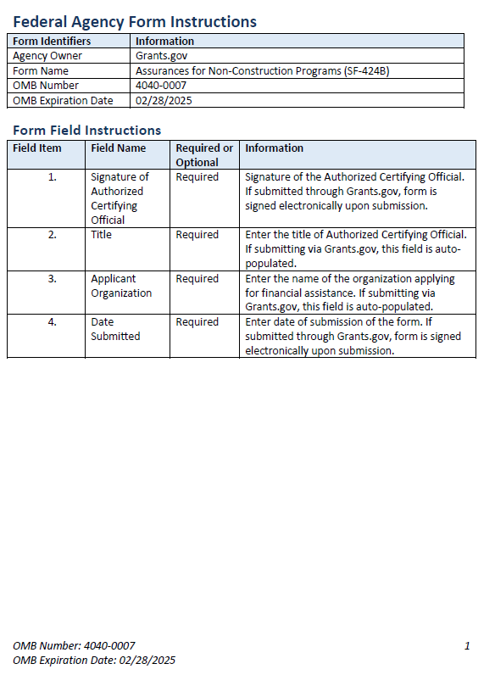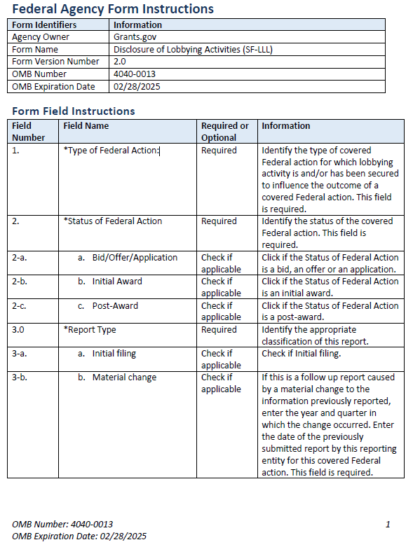

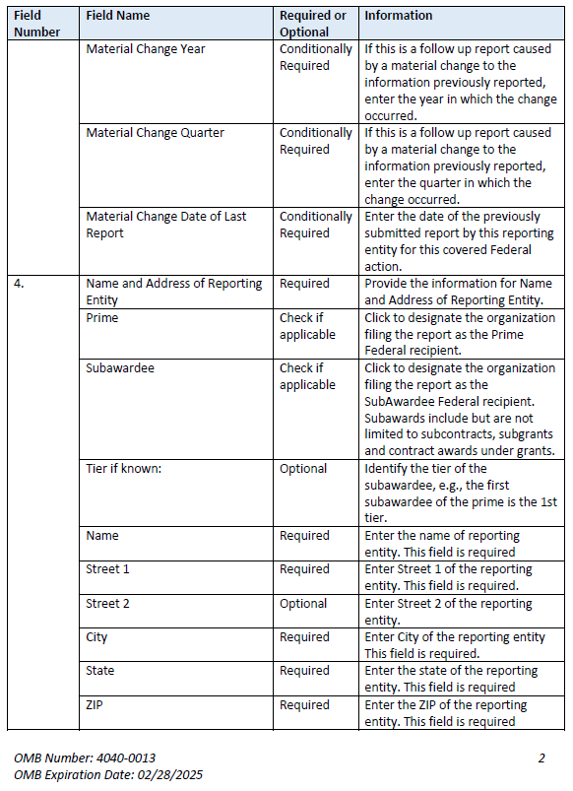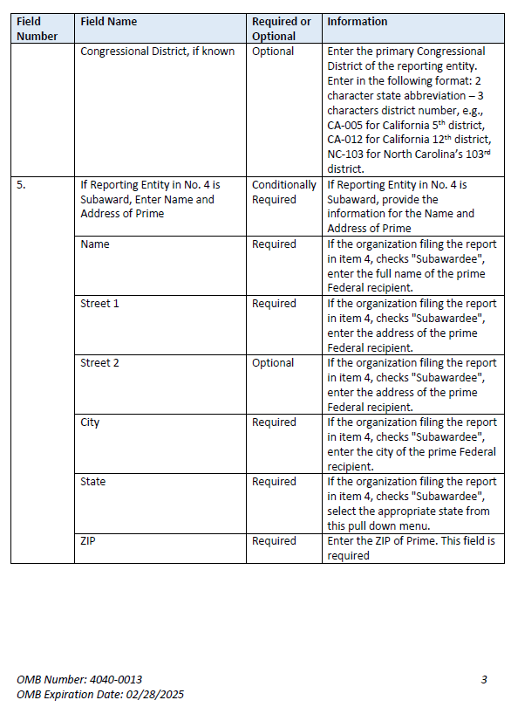

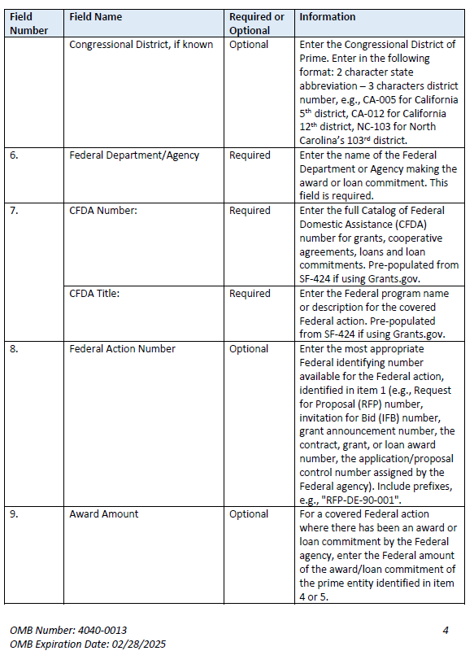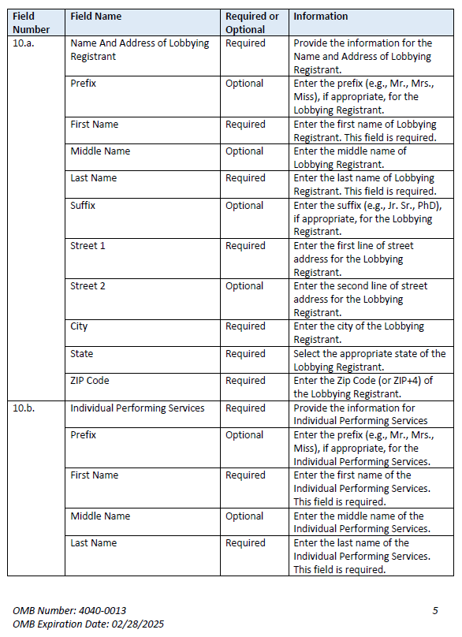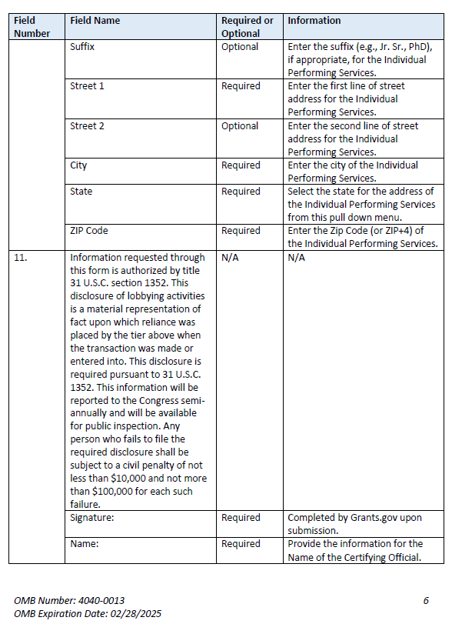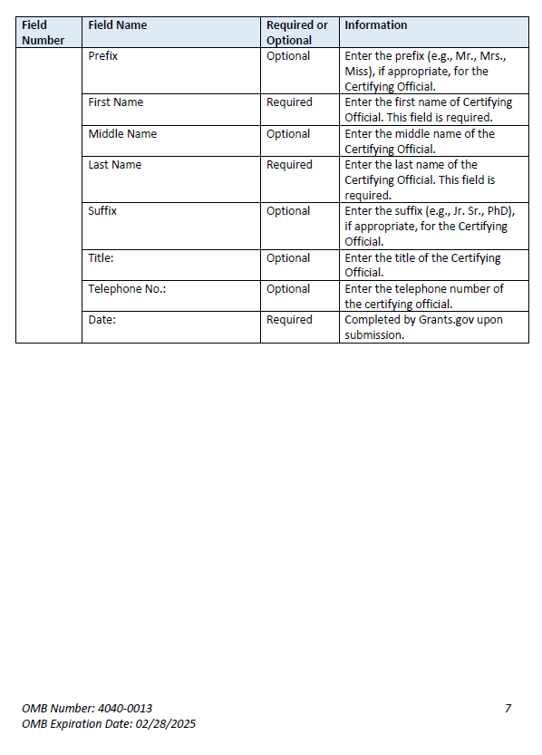

**Instructions for Meeting the General Education Provisions Act (GEPA) Section 427 Requirements**

All applicants for new awards **must** include information in their applications to address this new provision in order to receive funding under this program.

Section 427 **requires** each applicant for funds (other than an individual person) to include in its application a description of the steps the applicant proposes to take to ensure equitable access to, and participation in, its Federally-assisted program for students, teachers, and other program beneficiaries with special needs.

This provision allows applicants discretion in developing the required description. The statute highlights six types of barriers that can impede equitable access or participation: gender, race, national origin, color, disability, or age.

A general statement of an applicant’s nondiscriminatory hiring policy is **not** sufficient to meet this requirement. Applicants must identify potential barriers and explain steps they will take to overcome these barriers.

Please review the Notice to all Applicants (included in the electronic application package in Grants.gov) for further information on meeting the provisions in the Department's General Education Provisions Act (GEPA).

Applicants are **required** to address this provision by attaching a statement (not to exceed three pages) to the **ED GEPA427 form** that is included in the electronic application package in Grants.gov.

## Part 8: Intergovernmental Review of Federal Programs (Executive Order 12372)

This program falls under the rubric of Executive Order 12372 (Intergovernmental Review of Federal Programs) and the regulations in 34 CFR Part 79. One of the objectives of the Executive order is to strengthen federalism--or the distribution of responsibility between localities, States, and the Federal government--by fostering intergovernmental partnerships. This idea includes supporting processes that State or local governments have devised for coordinating and reviewing proposed Federal financial grant applications.

The process for doing this requires grant applicants to contact State Single Points of Contact for information on how this works. Multi-state applicants should follow procedures specific to each state.

Further information about the State Single Point of Contact (SPOC) process and a list of names by State can be found at:

<https://www.whitehouse.gov/wp-content/uploads/2017/11/Intergovernmental_-Review-_SPOC_01_2018_OFFM.pdf>

Absent specific State review programs, applicants may submit comments directly to the Department. All recommendations and comments must be mailed or hand-delivered by the date indicated in the actual application notice to the following address: The Secretary, EO 12372--ALN# 84.282B/E, U.S. Department of Education, room 7E200, 400 Maryland Avenue, SW., Washington, DC 20202.

Proof of mailing will be determined on the same basis as applications (see 34 CFR §75.102). Recommendations or comments may be hand-delivered until 11:59:59 p.m. Eastern Time on the closing date indicated in this notice.

**Important note:** The above address is not the same address as the one to which the applicant submits its completed applications. ***Do not send applications to the above address.***

Not all states have chosen to participate in the intergovernmental review process, and therefore do not have a SPOC. If you are located in a State that does not have a SPOC, you may send application materials directly to the Department as described in the *Federal Register* notice.

# Reporting and Accountability

Successful applicants with multi-year grants must submit **annual performance reports** demonstrating their progress in meeting approved project objectives. Grantees must also provide the most current financial and performance measure data for each year of the project.

At the end of the project period, applicants will also be required to submit a **final performance report**.

#### Reporting:

(a) If you apply for a grant under this competition, you must ensure that you have in place the necessary processes and systems to comply with the reporting requirements in 2 CFR part 170 should you receive funding under the competition. This does not apply if you have an exception under 2 CFR 170.110(b).

(b) At the end of your project period, you must submit a final performance report, including financial information, as directed by the Secretary. If you receive a multiyear award, you must submit annual performance reports that provides the most current performance and financial expenditure information as directed by the Secretary under 34 CFR 75.118. The Secretary may also require more frequent performance reports under 34 CFR 75.720(c). For specific requirements on reporting, please go to <http://www.ed.gov/fund/grat/apply/appforms/appforms.html>.

(c) Under 34 CFR 75.250(b), the Secretary may provide a grantee with additional funding for data collection analysis and reporting. In this case the Secretary establishes a data collection period.

#### Performance Measures:

(a) The Secretary has two performance indicators to measure progress toward achieving the purposes of the program, which are discussed in the NIA. The performance indicators are: (1) the number of charter schools in operation around the Nation and (2) the percentage of fourth- and eighth-grade charter school students who are achieving at or above the proficient level on State assessments in mathematics and reading/language arts. Additionally, the Secretary has established the following measure to examine the efficiency of the CSP: the Federal cost per student in implementing a successful school (defined as a school in operation for three or more consecutive years).

(b) Project-Specific Performance Measures. Applicants must propose project-specific performance measures and performance targets consistent with the objectives of the proposed project. Applications must provide the following information as directed under 34 CFR 75.110(b) and (c):

(1) Performance measures. How each proposed performance measure would accurately measure the performance of the project and how the proposed performance measure would be consistent with the performance measures established for the program funding the competition.

(2) Baseline data. (i) Why each proposed baseline is valid; or (ii) if the applicant has determined that there are no established baseline data for a particular performance measure, an explanation of why there is no established baseline and of how and when, during the project period, the applicant would establish a valid baseline for the performance measure.

(3) Performance targets. Why each proposed performance target is ambitious yet achievable compared to the baseline for the performance measure and when, during the project period, the applicant would meet the performance target(s).

(4) Data collection and reporting. (i) The data collection and reporting methods the applicant would use and why those methods are likely to yield reliable, valid, and meaningful performance data; and (ii) the applicant’s capacity to collect and report reliable, valid, and meaningful performance data, as evidenced by high-quality data collection, analysis, and reporting in other projects or research.

All grantees must submit annual performance reports with information that is responsive to these performance measures.

# Legal and Regulatory Information

## Notice Inviting Applications

The full text of the NIA for the FY 2022 CSP Grants to Charter School Developers for the Opening of New Charter Schools (ALN 84.282B) and for the Replication and Expansion of High-Quality Charter schools (ALN 84.282E) competition can be found on the Federal Register at the following URL:

[[Insert](https://www.federalregister.gov/documents/2019/07/03/2019-14267/applications-for-new-awards-expanding-opportunity-through-quality-charter-schools-program---grants) link]

## 