U.S. Department of Education

Office of Elementary and Secondary Education

Charter School Programs

Washington, D.C. 20202-5970

**Fiscal Year 2022**

**Application for New Awards Under**

**the Expanding Opportunity Through Quality Charter Schools Program - Grants to State Entities**

**ALN 84.282A**



**Dated Material - Open Immediately**

**Closing Date: August 5, 2022**

**Approved OMB Number:** **1810-0767**

**Expiration Date: 1/31/2023**

Paperwork Burden Statement

According to the Paperwork Reduction Act of 1995, no persons are required to respond to a collection of information unless such collection displays a valid OMB control number. The valid OMB control number for this information collection is: 1810-0767. Public reporting burden for this collection of information is estimated to average 60 hours per response, including the time for reviewing instructions, searching existing data resources, gathering and maintaining the data needed, and completing and reviewing the collection of information. The obligation to respond to this collection is *required to obtain or retain benefit* (Elementary and Secondary Education Act of 1965, as amended by the Every Student Succeeds Act (ESEA) (20 U.S.C. 7221-7221j)). If you have any comments concerning the accuracy of the time estimate, suggestions for improving this individual collection, or if you have comments or concerns regarding the status of your individual form, application or survey, please contact (Charter Schools Programs, U.S. Department of Education, OESE, 400 Maryland Ave SW Washington, DC [20202/charterschools@ed.gov](mailto:20202/charterschools@ed.gov)) directly.

**If you have comments or concerns regarding the status of your individual submission of this form, write directly to:** Stephanie Jones, Charter School Programs, U.S. Department of Education, 400 Maryland Avenue, SW, 3E311, Washington D.C. 20202-5970.

Table of Contents

Dear Colleague Letter 6

Program Background Information 8

Program Overview 8

Competition Highlights 10

Application Submission Procedures 12

Application Transmittal Instructions 12

Submitting Applications with Adobe Reader Software 14

Grants.gov Submission Procedures and Tips for Applicants 15

Submission Problems – What should you do? 18

Helpful Hints When Working with Grants.gov 19

Dial-Up Internet Connections 19

Application Instructions 21

Electronic Application Format 21

Electronic Application Submission Checklist 21

Part 1: Preliminary Documents 24

Part 2: Budget Information 39

Part 4: Project Narrative Attachment Form 45

Part 5: Budget Narrative 82

Part 6: Project Objectives and Performance Measures Information Form 87

Part 7: Other Attachment Form 90

Part 8: Assurances and Certifications 95

Part 9: Intergovernmental Review of Federal Programs (Executive Order 12372) 104

Reporting and Accountability 105

Legal and Regulatory Information 108

Notice Inviting Applications 108

**United States Department of Education**

Office of Elementary and Secondary Education

Charter School Programs

# Dear Colleague Letter

Dear Colleague:

Thank you for your interest in the Expanding Opportunity Through Quality Charter Schools Program (CSP) – Grants to State Entities (State Entity or SE) program, administered by the Office of Elementary and Secondary Education of the U.S. Department of Education (Department). The CSP is authorized under Title IV, Part C of the Elementary and Secondary Education Act of 1965, as amended by the Every Student Succeeds Act (ESEA) (20 U.S.C. 7221-7221j).

The purpose of the State Entity grant competition (ALN 84.282A) is to award grants to State entities to enable them to award subgrants to eligible applicants to enable such eligible applicants to open and prepare for the operation of new charter schools and to replicate and expand high-quality charter schools. Grant funds may also be used to provide technical assistance to eligible applicants and authorized public chartering agencies in opening and preparing for the operation of new charter schools, or replicating or expanding high-quality charter schools; and working with authorized public chartering agencies to improve authorizing quality, including developing capacity for, and conducting, fiscal oversight and auditing of charter schools.

Please take the time to review the applicable priorities, selection criteria, and all of the application instructions thoroughly. An application will not be evaluated for funding if the applicant does not comply with all of the procedural rules that govern the submission of the application or the application does not contain the information required under the program (34 CFR §75.216 (b) and (c)).

The Notice Inviting Applications (NIA) for this competition was published in the *Federal Register* on July 6, 2022 (87 FR 40204), and includes one absolute priority, five competitive preference priorities, and one invitational priority. In accordance with 34 CFR 75.105(b)(2)(iv), the Absolute Priority and Competitive Preference Priorities 1-5 are from section 4303(g)(2) of the ESEA. . In accordance with 34 CFR 75.105(c)(1), the Department does not give an application that meets the invitational priority any preference over other applications. In addition to the NIA, on July 6, 2022, the Department published in the *Federal Register* a notice of final priorities, requirements, definitions, and selection criteria for use in this and future State Entity program competitions (87 FR 40204).

For this competition, it is **mandatory** for applicants to use the government-wide website, Grants.gov (<http://www.grants.gov>), to apply. Please note that the Grants.gov site works differently than the U.S. Department of Education’s e-Application System. We strongly encourage you to familiarize yourself with Grants.gov and strongly recommend that you register *and* submit early.

Applications submitted to Grants.gov for the Department will be posted using Adobe forms. Therefore, applicants will need to download a compatible version of Adobe reader. Please review the **Submitting Applications with Adobe Reader Software**and**Education Submission Procedures and Tips for Applicants**forms found within this package for further information and guidance related to this requirement. The electronic submission of applications is required; therefore, you must submit an electronic application unless you follow the procedures in the Common Instructions for Applicants to Department of Education Discretionary Grant Programs (common instructions) that was published in the Federal Register on December 27, 2021 (Common Instructions), and is available at <https://www.federalregister.gov/documents/2021/12/27/2021-27979/common-instructions-for-applicants-to-department-of-education-discretionary-grant-programs>.

Using Fiscal Year 2022 funds, the Department expects to award $73 million for new grants under this competition. We will award discretionary grants on a competitive basis for a project period of up to 60 months.

Please visit our program website at <https://oese.ed.gov/offices/office-of-discretionary-grants-support-services/charter-school-programs/state-entities/application-info-and-eligibility/> for further information. If you have any questions about the program after reviewing the application package, please send an email with your question(s) to: [fy2022_se_competition@ed.gov](mailto:fy2022_se_competition@ed.gov).

/s/

Anna Hinton, PhD

Director

Charter School Programs

# Program Background Information

## Program Overview

**Program Office:** Office of Elementary and Secondary Education (OESE)

Expanding Opportunity Through Quality Charter Schools Program (CSP), Grants to State Entities

**ALN Number:** ALN 84.282A (Grants to State Entities)

**Program Type:** Discretionary/Competitive Grants

**Also Known As:** Grants to State Entities, Public Charter Schools Program, State Entity Grants

**Program Description:** The purpose of the CSP Grant to State Entities (State Entity) competition (ALN 84.282A) is to award grants to State entities to enable them to award subgrants to eligible applicants to enable such eligible applicants to open and prepare for the operation of new charter schools and to replicate and expand high-quality charter schools. Grant funds may also be used to provide technical assistance to eligible applicants and authorized public chartering agencies in opening and preparing for the operation of new charter schools, or replicating or expanding high-quality charter schools; and working with authorized public chartering agencies to improve authorizing quality, including developing capacity for, and conducting, fiscal oversight and auditing of charter schools.

**Eligible Applicants:** State entities in States with a State statute specifically authorizing the establishment of charter schools.

Under section 4303(e)(1) of the ESEA, no State entity may receive a grant under this competition for use in a State in which a State entity is currently using a CSP State Entity grant. Accordingly, State entities in States in which a State entity has a current CSP State Entity grant that is not in its final budget period (nor operating under a no-cost extension in accordance with 34 CFR 75.261) are ineligible to apply for a CSP State Entity grant under this competition. State entities in States in which a State entity has a current CSP State Entity grant that is operating under a no-cost extension, or that is not operating under a no-cost extension but is in its final budget period and has notified the Department that it does not intend to request a no-cost extension, however, are eligible to apply for a new CSP State Entity grant under this competition.

Consistent with section 4303(e)(1), if a State entity is approved for a new CSP State Entity grant under this competition for use in a State in which a State entity has a current CSP State Entity grant that is operating under a no-cost extension (or that is in its final budget period and does not request a no-cost extension at least 10 calendar days before the end of the performance period specified in the Federal award in accordance with 2 CFR 200.308(e)(2)), the current State entity grantee must obligate all grant funds prior to the end of the current (i.e., final) budget period. In other words, the current State entity grantee must complete all grant activities and begin the grant closeout process (i.e., liquidating the grant and not incurring new costs) prior to the expiration date of the no-cost extension (or the end of the performance period for a grantee that is in its final budget period and did not request a no-cost extension). Likewise, if multiple State entities in a State submit applications that receive high enough scores to be recommended for funding under this competition, only the highest-scoring application among such State entities would be funded.

State entities in States in which a State educational agency (SEA) has a current CSP Grant for SEAs that was awarded under the Elementary and Secondary Education Act of 1965, as amended by the No Child Left Behind Act of 2001 (i.e., prior to FY 2017) are eligible to apply for a CSP State Entity grant under this competition, so long as no other State entity in the State has a current CSP State Entity grant that is not in its final budget period nor operating under a no-cost extension. **Please note:** No applicant may receive a new award to conduct the ***same activities*** that are approved under the existing active SEA grant; newly proposed activities must be outside the scope of currently funded activities.

*State entity* means --

* 1. A State educational agency;
  2. A State charter school board;
  3. A Governor of a State; or
  4. A charter school support organization.

*Eligible applicant*, when used with respect to subgrants made by a State entity, means a developer that has--

(a) Applied to an authorized public chartering authority to operate a charter school; and

(b) Provided adequate and timely notice to that authority.

**Funding Restrictions:** A State entity receiving a grant under this program shall use ***not less*** than 90 percent of the grant funds to award subgrants to eligible applicants for activities related to opening and preparing for the operation of new charter school or to replicate or expand high-quality charter schools; reserve ***not less*** than seven percent of funds to provide technical assistance to eligible applicants and authorized public chartering agencies in opening and preparing for the operation of new charter schools or to replicate or expand high-quality charter schools and in improving authorizing quality, including developing capacity for, and conducting, fiscal oversight and auditing of charter schools; and reserve ***not more*** than three percent of funds for administrative costs, which may include technical assistance. A State entity may use a grant received under this program to carry out technical assistance activities authorized under this program directly or through grants, contracts, or cooperative agreements.

Additional information on funding restrictions, including limitations on subgrants, can be found in the Notice Inviting Applications (NIA) for this competition.

## Competition Highlights

**Expanding Opportunity Through Quality Charter Schools Program -- Grants to State Entities (84.282A)**

**Applications available:** July 6, 2022  
**Deadline for transmitting applications:** August 5, 2022  
**Awards expected to be announced by:** September 30, 2022

**FY 2022 CSP Grants to State Entities Application**

The full text of the Notice Inviting Applications (NIA) for New Awards for FY 2022 under the Grants to State Entities competition was published in the *Federal Register* on July 6, 2022 (87 FR 40204). In the same issue of the *Federal Register*, the Department published a notice of final priorities, requirements, definitions, and selection criteria (2022 NFP) for use in this and future State Entity program competitions (87 FR 40204). The FY 2022 NIA and 2022 NFP can be found on the Federal Register website at the following URLs:

https://www.govinfo.gov/content/pkg/FR-2022-07-06/pdf/2022-14442.pdf (PDF)

https://www.federalregister.gov/documents/2022/07/06/2022-14442/application-for-new-awards-expanding-opportunity-through-quality-charter-schools-program-csp-grants (Text)

**Eligibility:**

**Electronic Submission:**

Allapplications for grants under this competition must be received on or before **11:59:59 p.m., Washington, DC time, on August 5, 2022.** Your application must be fully uploaded and submitted and must be date and time stamped by the Grants.gov system no later than 11:59:59 p.m., Washington, DC time, on the application deadline date. Late applications will not be accepted. The Department is required to enforce the established deadline to ensure fairness to all applicants. No changes or additions to an application will be accepted after the deadline date and time.

An applicant may check the status of its application(s), any time after submission, by using the "Track My Application" feature available from the upper navigation on the Grants.gov site. Applicants may also check the status of a submission by logging into their Grants.gov account using the [Applicant Login](http://grants.gov/applicants/applicant_profile.jsp). After logging in, an applicant should click on the "Check Application Status" link on the left-hand menu. **Applicants should be careful that they download the correct application package for CSP Grants to State Entities and that they submit their application under the correct CSP grant competition (84.282A).** Your application will be reviewed for the competition under which it is submitted, and only applications that are successfully submitted in the required PDF format by the established deadline will be submitted for peer review.

[**FY 2022 CSP State Entity**](http://www.grants.gov/web/grants/applicants/download-application-package.html?p_p_id=grantsdownloadpackage_WAR_grantsdownloadpackageportlet&p_p_lifecycle=0&p_p_state=normal&p_p_mode=view&p_p_col_id=column-1&p_p_col_pos=1&p_p_col_count=2&_grantsdownloadpackage_WAR_grantsdownloadpackageportlet_mvcPath=%2Fdownload.jsp&id=203626) **Application Package:**

Please note that the application package for FY 2022 CSP Grants to State Entities is for applicants to download and use as a guide only. Unless the applicant qualifies for an exception to the electronic submission requirement (see Electronic Submission Policy below and in the FY 2022 Notice), all applications for this competition must be submitted electronically via Grants.gov.

**Pre-application Technical Assistance Webinar:** The Department will hold a webinar to provide technical assistance to interested applicants. Detailed information regarding this webinar will be provided on the Charter School Programs, State Entities’ webpage at: <https://oese.ed.gov/offices/office-of-discretionary-grants-support-services/charter-school-programs/state-entities/>. A recording of this webinar will also be available on this webpage following the session. Pre-recorded technical assistance webinars on various topics (e.g., budget, logic models, performance, etc.) will also be posted to this webpage.

**Apply: All applications must be submitted electronically via** [**Grants.gov**](http://www.grants.gov/web/grants/home.html)**.**

To submit an application on the [Grants.gov](http://www.grants.gov/web/grants/home.html) website, hover over the “Applicant” tab. Select the “Apply for Grants” option, then click on “Download a Grant Application Package.” Type in the ALN (formerly CFDA) (84.282A) or the Funding Opportunity Number (ED-GRANTS-070622-001). Click “Download Package.” For assistance with the use of the Grants.gov system, please contact the Grants.gov help desk, at (800)518-4726, or email [support@grants.gov](mailto:support@grants.gov).

# Application Submission Procedures

**The deadline for submission of Charter Schools Program CSP State Entity Program applications through Grants.gov is August 5, 2022.**

## Application Transmittal Instructions

Attention Electronic Applicants: This program **requires** the electronic submission of applications--specific requirements and instructions can be found in the Federal Register notice. Please note that you **must** follow the Application Procedures as described in the Federal Register notice announcing the grant competition.

We will reject your application if you submit it in paper format unless, as described in the Federal Register notice for this competition, you qualify for one of the exceptions to the electronic submission requirement and submit, no later than two weeks before the application deadline date, a written statement to the Department that you qualify for one of these exceptions.

Applications Submitted Electronically

Applications for grants under this program must be submitted electronically using the Governmentwide Grants.gov Apply site at <http://www.Grants.gov>. Through this site, you will be able to download a copy of the application package, complete it offline, and then upload and submit your application. You may **not** e-mail an electronic copy of a grant application to us.

Your application must be fully uploaded and submitted and must be date and time stamped by the Grants.gov system **no later than 11:59:59 p.m., Eastern Time, on the application deadline date.** Except as otherwise noted in Federal Register notice for this competition, we will not consider your application if it is date and time stamped by the Grants.gov system later than 11:59:59 p.m., Eastern Time, on the application deadline date.

You should review and follow the Education Submission Procedures for submitting an application through Grants.gov that are included in this application package to ensure that you submit your application in a timely manner to the Grants.gov system.

On December 31, 2017, *Grants.gov* retired the Legacy PDF format for submitting grant applications. A *Grants.gov* applicant must apply online using Workspace, a shared environment where members of a grant team may simultaneously access and edit different web forms within an application. An applicant can create an individual Workspace for each application notice and establish for that application a collaborative application package that allows more than one person in the applicant’s organization to work concurrently on an application. The *Grants.gov* system also enables the applicant to reuse forms from previous submissions, check them in and out to complete them, and submit the application package. For access to further instructions on how to apply using *Grants.gov*, refer to: *www.grants.gov/web/grants/applicants/apply-for-grants.html.*

You may access the electronic grant applications at *www.Grants.gov.* You must search for the downloadable application package for this competition by the ALN number. Do not include the ALN number’s alpha suffix in your search (*e.g.,* search for 84.XXX not 84.XXXA).

**Please note the following:**

* You must attach any narrative sections of your application as files in either **.pdf** (Portable Document Format) or Microsoft Word. Although applicants have the option of uploading any narrative sections and all other attachments to their application in either PDF or Microsoft Word, we recommend applicants submit all documents as **read-only flattened PDFs**, meaning any fillable PDF files must be saved and submitted as non-fillable PDF files and not as interactive or fillable PDF files, to better ensure applications are processed in a more timely, accurate, and efficient manner. If you choose to submit your application in Microsoft Word, you may do so using any version of Microsoft Word (i.e., a document ending in a .doc or .docx extension).
* Grants.gov cannot process an application that includes two or more files that have the same name within a grant submission.
* When attaching files, applicants should limit the size of their file names. Lengthy file names could result in difficulties with opening and processing your application. We recommend your file names be less than 50 characters. The amount of time it can take to upload an application will vary depending on a variety of factors, including the size of the application and the speed of your Internet connection. Therefore, we strongly recommend that you do not wait until the application deadline date to begin the submission process through Grants.gov.
* If you are experiencing problems submitting your application through Grants.gov, please contact the Grants.gov Support Desk, toll free, at 1-800-518-4726. You must obtain a Grants.gov Support Desk Case Number and must keep a record of it.

**According to the instructions found in the Federal Register notice, only those requesting and qualifying for an exception to the electronic submission requirement may submit an application via U.S. mail, commercial carrier or by hand delivery.**

Submission of Paper Applications by Mail:

If you qualify for an exception to the electronic submission requirement, you may mail (through the U.S. Postal Service or a commercial carrier) your application to the Department. You must mail the original and two copies of your application, on or before the application deadline date, to the Department at the following address:

U.S. Department of Education

OFO/G5 Functional Application Team

Mail Stop 5C231

Attention: (ALN 84.282B/E)

400 Maryland Avenue, SW

Washington, DC 20202-4260

You must show proof of mailing consisting of one of the following:

(1) A legibly dated U.S. Postal Service postmark.

(2) A legible mail receipt with the date of mailing stamped by the U.S. Postal Service.

(3) A dated shipping label, invoice, or receipt from a commercial carrier.

(4) Any other proof of mailing acceptable to the Secretary of the U.S. Department of Education.

If you mail your application through the U.S. Postal Service, we do not accept either of the following as proof of mailing:

(1) A private metered postmark.

(2) A mail receipt that is not dated by the U.S. Postal Service.

If your application is postmarked after the application deadline date, we will not consider your application.

Note: The U.S. Postal Service does not uniformly provide a dated postmark. Before relying on this method, you should check with your local post office.

Note for Mail Delivery of Paper Applications:

If you mail your application to the Department--

(1) You must indicate on the envelope and in Item 11 of the SF 424 the ALN, including suffix letter, if any, of the competition under which you are submitting your application; and

(2) The G5 Functional Application Team will mail to you a notification of receipt of your grant application. If you do not receive this notification within 15 business days from the application deadline date, you should contact the person listed in the FOR FURTHER INFORMATION CONTACT section of the NIA.

## Submitting Applications with Adobe Reader Software

The Department of Education, working with Grants.gov, is currently using Adobe Reader software exclusively and applications submitted to Grants.gov for the Department of Education will be posted using Adobe forms.

**Please note:** The compatible version of Adobe Reader is **required** for viewing, editing and submitting PDF forms through Grants.gov. Applicants should confirm the compatibility of their Adobe Reader version **before** downloading the application. To ensure applicants have a version of Adobe Reader on their computer that is compatible with Grants.gov, applicants are encouraged to use the test package provided by Grants.gov that can be accessed at http://www.grants.gov/web/grants/applicants/adobe-software-compatibility.html.

**Important issues to consider**:

* If the applicant opened or edited the application package with any software other than a compatible version of Adobe Reader, the application package may contain errors that will be transferred to the new package even if you later download the compatible Adobe Reader version.
* Applicants **cannot** copy and paste data from a package initially opened or edited with an incompatible version of Adobe Reader and will need to download an **entirely** **new** **package** using the compatible version of Adobe Reader.
* Some applicants using an incompatible version of Adobe Reader **may have trouble** opening and viewing the application package while others may find they can open, view and complete the application package but **may not be able to submit** the application package through Grants.gov.
* Grants.gov **does not** guarantee to support versions of Adobe Reader that are not compatible with Grants.gov.
* Any and all edits made to the Adobe Reader application package **must** be made with a compatible version of Adobe Reader.
* If more than one person is entering text into a Workspace PDF form, the same version of Adobe Reader software should be used by each person. Check the version number of the Adobe software on each user's computer to make sure the versions match. Using different versions of Adobe Reader may cause submission and/or save errors – even if each version is individually compatible with Grants.gov.

**For your convenience, a compatible version of Adobe Reader is available for free download at** <http://www.grants.gov/web/grants/applicants/adobe-software-compatibility.html>.

We strongly recommend that you review the information on computer and operating system compatibility with Adobe available at http://www.grants.gov/web/grants/applicants/adobe-software-compatibility.html **before** downloading, completing or submitting your application.

Applicants are reminded that they should submit their application a day or two in advance of the closing date as detailed in the Federal Register Notice. If you have any questions regarding this matter please email the Grants.gov Contact Center at [support@grants.gov](mailto:support@grants.gov) or call 1-800-518-4726.

Grants.gov Submission Procedures and Tips for Applicants

To facilitate your use of Grants.gov, this document includes important submission procedures you need to be aware of to ensure your application is received in a timely manner and accepted by the Department of Education.

**Browser Support**

The latest versions of Microsoft Internet Explorer (IE), Mozilla Firefox, Google Chrome, and Apple Safari are supported for use with Grants.gov. However, these web browsers undergo frequent changes and updates, so we recommend you have the latest version when using Grants.gov. Legacy versions of these web browsers may be functional, but you may experience issues.

For additional information or updates, please see the Grants.gov Browser information in the Applicant FAQs: <http://www.grants.gov/web/grants/applicants/applicant-faqs.html#browser>

**ATTENTION – Workspace, Adobe Forms and PDF Files Required**

Grants.gov applicants can apply online using Workspace. Workspace is a shared, online environment where members of a grant team may simultaneously access and edit different web forms within an application. For each funding opportunity announcement (FOA), you can create individual instances of a workspace.

Below is an overview of applying on Grants.gov. For access to complete instructions on how to apply for opportunities, refer to: <https://www.grants.gov/web/grants/applicants/workspace-overview.html>

1. Create a Workspace: Creating a workspace allows you to complete it online and route it through your organization for review before submitting.

2) Complete a Workspace: Add participants to the workspace to work on the application together, complete all the required forms online or by downloading PDF versions, and check for errors before submission. The Workspace progress bar will display the state of your application process as you apply. As you apply using Workspace, you may click the blue question mark icon near the upper-right corner of each page to access context-sensitive help.

a. Adobe Reader: If you decide not to apply by filling out web forms you can download individual PDF forms in Workspace. The individual PDF forms can be downloaded and saved to your local device storage, network drive(s), or external drives, then accessed through Adobe Reader. NOTE: Visit the Adobe Software Compatibility page on Grants.gov to download the appropriate version of the software at: <https://www.grants.gov/web/grants/applicants/adobe-software-compatibility.html>.

b. Mandatory Fields in Forms: In the forms, you will note fields marked with an asterisk and a different background color. These fields are mandatory fields that must be completed to successfully submit your application.

c. Complete SF-424 Fields First: The forms are designed to fill in common required fields across other forms, such as the applicant name, address, and UEI Number. Once it is completed, the information will transfer to the other forms.

1. Submit a Workspace: An application may be submitted through workspace by clicking the Sign and Submit button on the Manage Workspace page, under the Forms tab. Grants.gov recommends submitting your application package at least 24-48 hours prior to the close date to provide you with time to correct any potential technical issues that may disrupt the application submission.
2. Track a Workspace Submission: After successfully submitting a workspace application, a Grants.gov Tracking Number (GRANTXXXXXXXX) is automatically assigned to the application. The number will be listed on the Confirmation page that is generated after submission. Using the tracking number, access the Track My Application page under the Applicants tab or the Details tab in the submitted workspace.

For additional training resources, including video tutorials, refer to <https://www.grants.gov/web/grants/applicants/applicant-training.html>.

**Helpful Reminders**

1. **REGISTER EARLY** – Grants.gov registration involves many steps including registration on SAM ([www.sam.gov](http://www.sam.gov)) which may take approximately one week to complete, but could take upwards of several weeks to complete, depending upon the completeness and accuracy of the data entered into the SAM database by an applicant. You may begin working on your application while completing the registration process, but you cannot submit an application until all of the Registration steps are complete. Please note that once your SAM registration is active, it will take 24-48 hours for the information to be available in Grants.gov, and before you can submit an application through Grants.gov. For detailed information on the Registration Steps, please go to: <http://www.grants.gov/web/grants/register.html> [Note: Your organization will need to update its SAM registration annually.]

Primary information about SAM is available at [www.sam.gov](http://www.sam.gov) . However, to further assist you with obtaining and registering your UEI number and TIN in SAM or updating your existing SAM account the Department of Education has prepared a SAM.gov Tip Sheet which you can find at: <http://www2.ed.gov/fund/grant/apply/sam-faqs.html>.

1. **SUBMIT EARLY** – **We strongly recommend that you do not wait until the last day to submit your application. Grants.gov will put a date/time stamp on your application and then process it after it is fully uploaded.** The time it takes to upload an application will vary depending on a number of factors including the size of the application and the speed of your Internet connection, and the time it takes Grants.gov to process the application will vary as well. If Grants.gov rejects your application (see step three below), you will need to resubmit successfully to Grants.gov before 11:59:59 p.m. Eastern Time on the deadline date.

**Note: To submit successfully, you must provide the UEI number on your application that was used when you registered as an Authorized Organization Representative (AOR) on Grants.gov. This UEI number is typically the same number used when your organization registered with the SAM . If you do not enter the same UEI number on your application as the UEI you registered with, Grants.gov will reject your application.**

1. **VERIFY SUBMISSION IS OK** – You will want to verify that Grants.gov received your application submission on time and that it was validated successfully. To see the date/time your application was received, login to Grants.gov and click on the Track My Application link. For a successful submission, the date/time received should be earlier than 11:59:59 p.m. Eastern Time, on the deadline date, AND the application status should be: Validated, Received by Agency, or Agency Tracking Number Assigned. Once the Department of Education receives your application from Grants.gov, an Agency Tracking Number (PR/award number) will be assigned to your application and will be available for viewing on Grants.gov’s Track My Application link.

If the date/time received is later than 11:59:59 p.m. Eastern Time, on the deadline date, your application is late. If your application has a status of “Received” it is still awaiting validation by Grants.gov. Once validation is complete, the status will either change to “Validated” or “Rejected with Errors.” If the status is “Rejected with Errors,” your application has not been received successfully. Some of the reasons Grants.gov may reject an application can be found on the Grants.gov site: <http://www.grants.gov/web/grants/applicants/encountering-error-messages.html>. For more detailed information on troubleshooting Adobe errors, you can review the Adobe Software Tip Sheet at: <http://www.grants.gov/web/grants/applicants/adobe-software-compatibility.html> If you discover your application is late or has been rejected, please see the instructions below. Note: You will receive a series of confirmations both online and via e-mail about the status of your application. Please do not rely solely on e-mail to confirm whether your application has been received timely and validated successfully.

# Submission Problems – What should you do?

If you have problems submitting to Grants.gov before the closing date, please contact Grants.gov Customer Support at 1-800-518-4726 or email at: <mailto:support@grants.gov> or access the Grants.gov Self-Service Knowledge Base web portal at: <https://grants-portal.psc.gov/Welcome.aspx?pt=Grants>

If electronic submission is required, you must submit an electronic application before 11:59:59 p.m., unless you follow the procedures in the Federal Register notice and qualify for one of the exceptions to the electronic submission requirement and submit, no later than two weeks before the application deadline date, a written statement to the Department that you qualify for one of these exceptions. If electronic submission is optional and you have problems that you are unable to resolve before the deadline date and time for electronic applications, please follow the transmittal instructions for hard copy applications in the Federal Register notice and get a hard copy application postmarked by midnight on the deadline date. (See the Federal Register notice for detailed instructions.)

# Helpful Hints When Working with Grants.gov

Please note, once you download an application from Grants.gov, you will be working offline and saving data on your computer. Please be sure to note where you are saving the Grants.gov file on your computer. You will need to logon to Grants.gov to upload and submit the application. **You must provide the UEI number on your application that was used when you registered as an Authorized Organization Representative (AOR) on Grants.gov.**

Please go to <http://www.grants.gov/web/grants/support.html> for help with Grants.gov. For additional tips related to submitting grant applications, please refer to the Grants.gov Applicant FAQs found at this Grants.gov link: <http://www.grants.gov/web/grants/applicants/applicant-faqs.html>.

# Dial-Up Internet Connections

When using a dial up connection to upload and submit your application, it can take significantly longer than when you are connected to the Internet with a high-speed connection, e.g., cable modem/DSL/T1. While times will vary depending upon the size of your application, it can take a few minutes to a few hours to complete your grant submission using a dial up connection.  **If you do not have access to a high-speed connection and electronic submission is required, you may want to consider following the instructions in the Federal Register notice to obtain an exception to the electronic submission requirement no later than two weeks before the application deadline date.** (See the Federal Register notice for detailed instructions.)

**Attaching Files – Additional Tips**

Please note the following tips related to attaching files to your application, especially the requirement that applicants **only include read-only, flattened .PDF files** or Microsoft Word documents in their application:

Ensure that you attach ***.PDF files only*** or Microsoft Word files for any attachments to your application, and any PDFs must be in a **read-only, flattened format** (meaning any fillable documents must be saved and submitted as non-fillable PDF files). PDF files and Microsoft Word files are the only Education approved file type accepted as detailed in the Common Instructions for Applicants to Department of Education Discretionary Grant Programs that was published in the *Federal Register* on December 27, 2021, and is available at <https://www.federalregister.gov/documents/2021/12/27/2021-27979/common-instructions-for-applicants-to-department-of-education-discretionary-grant-programs>.

* Applicants must submit individual .PDF files only when attaching files to their application. Specifically, the Department will not accept any attachments that contain files within a file, such as PDF Portfolio files, or an interactive or fillable .PDF file. Any attachments uploaded that are not .PDF files or are password protected files will not be read.
* Grants.gov cannot process an application that includes two or more files that have the same name within a grant submission. Therefore, each file uploaded to your application package should have a unique file name.
* When attaching files, applicants should follow the guidelines established by Grants.gov on the size and content of file names. Uploaded file names must be fewer than 50 characters, and, in general, applicants should not use any special characters. However, Grants.gov does allow for the following UTF-8 characters when naming your attachments: A-Z, a-z, 0-9, underscore, hyphen, space, period, parenthesis, curly braces, square brackets, ampersand, tilde, exclamation point, comma, semi colon, apostrophe, at sign, number sign, dollar sign, percent sign, plus sign, and equal sign. Applications submitted that do not comply with the Grants.gov guidelines will be rejected at Grants.gov and not forwarded to the Department.
* Applicants should limit the size of their file attachments. Documents submitted that contain graphics and/or scanned material often greatly increase the size of the file attachments and can result in difficulties opening the files. For reference, the average discretionary grant application package with all attachments is less than 5 MB. Therefore, you may want to check the total size of your package before submission.

# Application Instructions

## Electronic Application Format

Applications for grants under this competition must be submitted electronically, unless you qualify for an exception to the electronic submission requirement in accordance with the procedures in the Common Instructions for Applicants to Department of Education Discretionary Grant Programs (common instructions) that was published in the Federal Register on December 27, 2021 (Common Instructions), and is available at <https://www.federalregister.gov/documents/2021/12/27/2021-27979/common-instructions-for-applicants-to-department-of-education-discretionary-grant-programs>.

In accordance with the Education Department General Administrative Regulations (EDGAR) at 34 CFR §75.216 (b) and (c), an application will not be evaluated for funding if the applicant does not comply with all of the procedural rules that govern the submission of the application or the application does not contain the information required under the program.

*Important Note***:** Applications submitted to Grants.gov for the Department of Education will be posted using Adobe forms. Therefore, applicants will need to download a compatible version of Adobe reader (see Grants.gov for compatible versions).

Information on computer and operating system compatibility with Adobe and links to download the latest version is available on Grants.gov. Also, please review the **Submitting Applications with Adobe Reader Software**and**Education Submission Procedures and Tips for Applicants**forms found within this package for further information and guidance related to this requirement.

We strongly recommend that you review these details on [www.Grants.gov](http://www.grants.gov/) before completing and submitting your application. In addition, applicants should submit their application a day or two in advance of the closing date as detailed below. If you have any questions regarding this matter please email the Grants.gov Contact Center at [support@grants.gov](mailto:support@grants.gov) or call 1-800-518-4726.

**Note: Please do not attach any narratives, supporting files, or application components to any forms unless it is specifically required by the instructions for the individual section of the application. Although several forms accept attachments, the Department of Education will only review materials/files attached in accordance with the instructions provided within this application package.**

## Electronic Application Submission Checklist

It is recommended that your electronic application be organized in the following manner and include the following parts in order to expedite the review process. Instructions for all parts and forms of the application are found either on the following pages of the application package or individually for each form on Grants.gov.

*Review your electronic application to ensure you have completed the following forms and sections:*

**Part 1: Preliminary Documents**

* Application for Federal Assistance (form SF 424)
* ED Supplemental Information for SF 424

**Part 2: Budget Information**

* ED Budget Information Non-Construction Programs (ED Form 524)

**Part 3: ED Abstract Form**

* Project Abstract

**Part 4: Project Narrative Attachment Form**

* Application Narrative

**Part 5: Budget Narrative Attachment Form**

* Budget Narrative

**Part 6: Project Objectives and Performance Measures Information Form**

* Project Objective and Performance Measures

**Part 7: Other Attachments Form**

* Appendix A Charter School Programs Assurances
* Appendix B Resumes/Curriculum Vitae
* Appendix C Letters of Support
* Appendix D Proof of Nonprofit Status (if applicable)
* Appendix E Proprietary Information
* Appendix F Additional Information:

**Part 8: Assurances and Certifications**

* Disclosure of Lobbying Activities (Standard Form LLL)
* Grants.gov Lobbying Form
* General Education Provisions Act (GEPA) Requirements – Section 427 (ED GEPA427 form)

**Part 9: Intergovernmental Review (Executive Order 12372)**

* State Single Point of Contact (SPOC) List

## Part 1: Preliminary Documents

* Application for Federal Assistance (Form SF 424)
* ED Supplemental Information for SF 424

These forms require basic identifying information about the applicant and the application. Please provide all requested applicant information (including name, address, e-mail address and UEI number).

**When applying electronically via Grants.gov, you will need to ensure that the UEI number you enter on your application is the same as the UEI number your organization used when it registered with the System for Award Management.**

Applicants are advised to complete the Application for Federal Assistance (Form SF 424) first. Grants.gov will automatically insert the correct ALN and program name automatically wherever needed on other forms.

*NOTE: Please do not attach any narratives, supporting files, or application components to the Standard Form (SF 424). Although this form accepts attachments, the Department of Education will only review materials/files attached in accordance with the instructions provided within this application.*

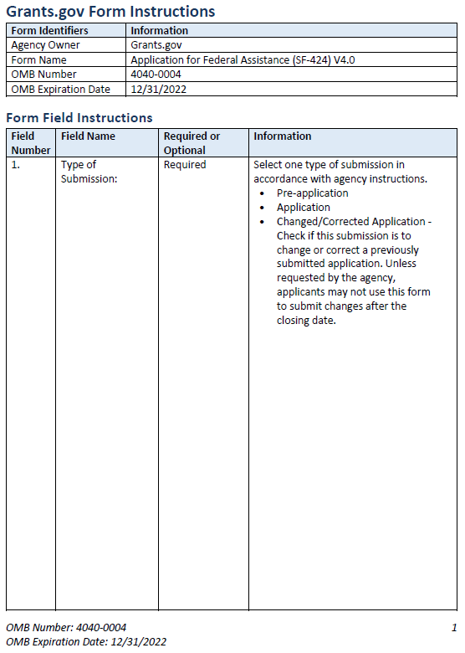

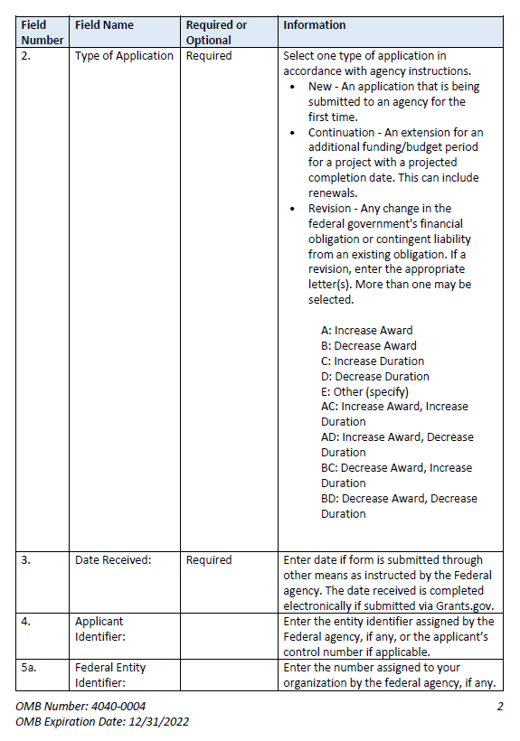 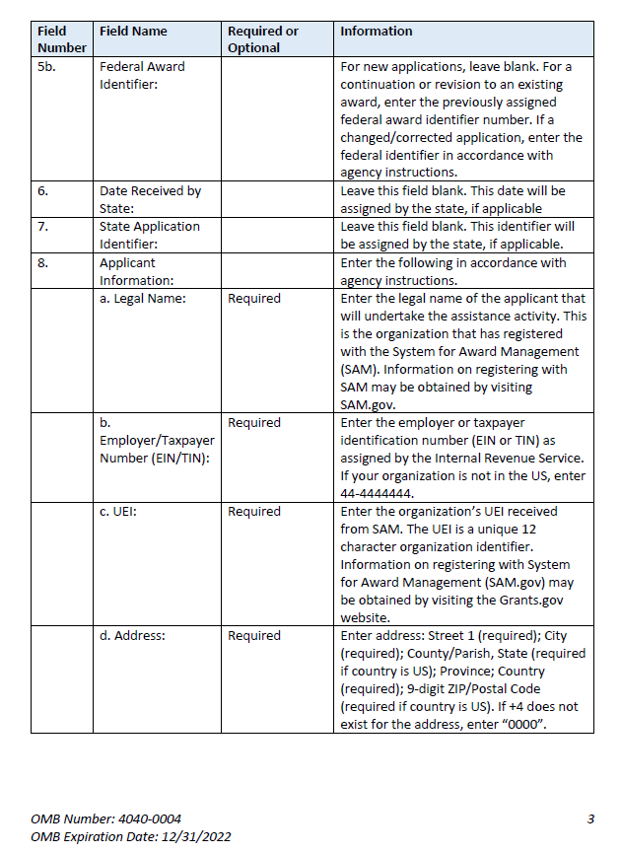 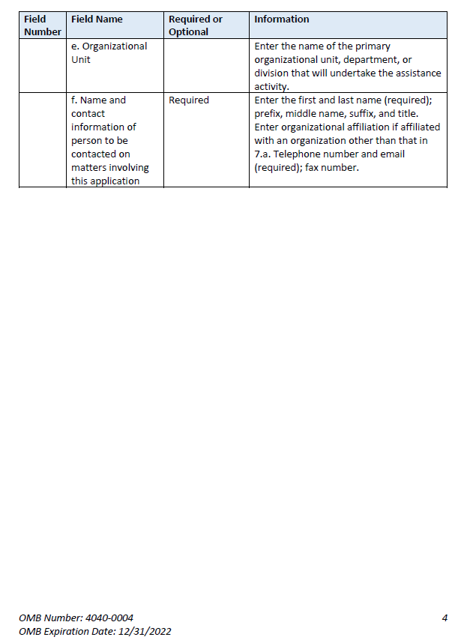 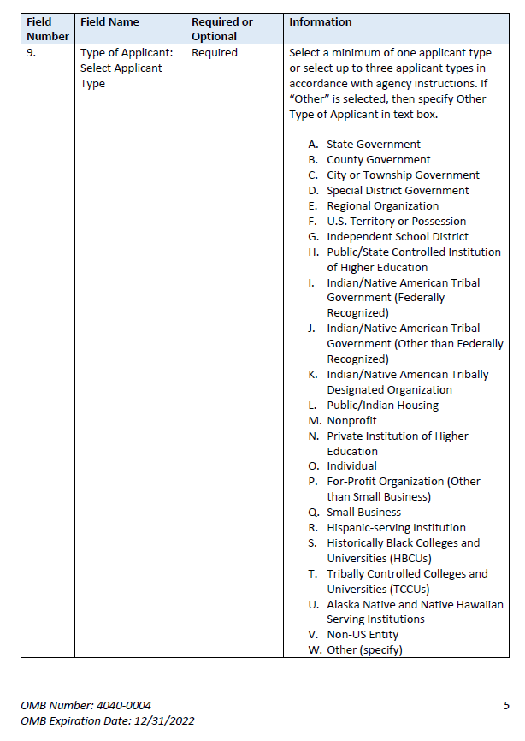 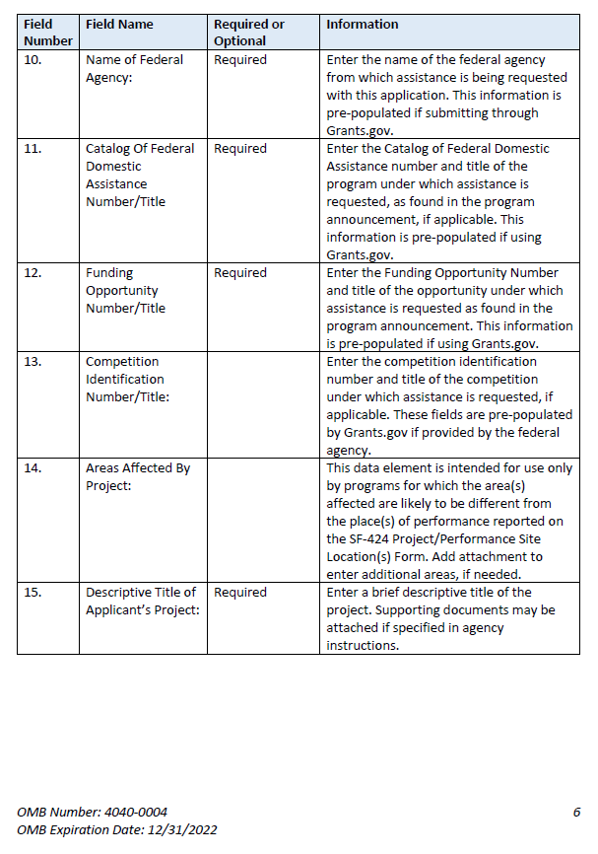 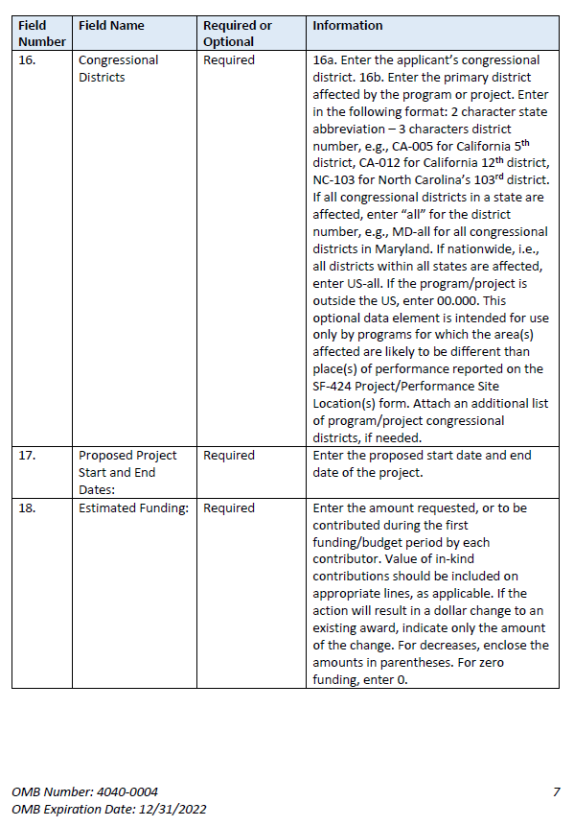 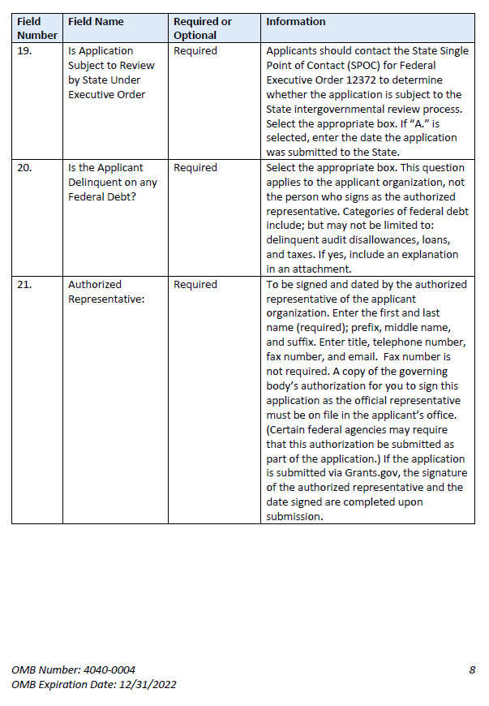

**Instructions for U.S. Department of Education  
Supplemental Information for the SF-424 Application for Federal Assistance**

1. **Project Director.** Name, address, telephone and fax numbers, and e-mail and alternate email addresses of the Project Director to be contacted on matters involving this application. Enter Project Director’s level of effort (the percentage of time devoted to the grant). Items marked with an asterisk (*) are mandatory.
2. **New Potential Grantee or Novice Applicant.** If applicable, for (a), check “**Yes**” if you meet the definition for new potential grantees or novice applicants specified in the program competition’s notice inviting applications (NIA) and included on the attached page entitled “Definitions for U.S. Department of Education Supplemental Information for the SF-424”. By checking “Yes” the applicant certifies that it meets the new potential grantee or novice applicant requirements. Check “**No**” if you do not meet the definition for new potential grantees or novice applicants.For (b), if the program competition NIA is giving competitive preference points for new potential grantees or novice applicants, indicate how many points you are claiming for your application. The NIA will indicate how many are available depending on the design of the competition. Some competitions may provide more than one category of new potential grantees with differing levels of points.
3. **Qualified Opportunity Zones.** If applicable, provide the Qualified Opportunity Zones (QOZ) census tract number(s) if the NIA includes a QOZ Priority in which you propose to either provide services in QOZ(s) or are located in a QOZ.
4. **Human Subjects Research.** (See I. A. “Definitions” in attached page entitled “Definitions for U.S. Department of Education Supplemental Information for the SF-424 form.”)
   1. **If Not Human Subjects Research.** Check “**No**” if research activities involving human subjects are notplanned at any time during the proposed project period. The remaining parts of Item 3 are then not applicable.
   2. **If Human Subjects Research.** Check “**Yes**” if research activities involving human subjects are planned at any time during the proposed project period, either at the applicant organization or at any other performance site or collaborating institution. Check “**Yes**” even if the research is exempt from the regulations for the protection of human subjects. (See I. B. “Exemptions” in attached page entitled “Definitions for U.S. Department of Education Supplemental Information for the SF-424 Application for Federal Assistance.”)
   3. **If Human Subjects Research is Exempt from the Human Subjects Regulations.** Check “**Yes**” if all the research activities proposed are designated to be exempt from the regulations. Check the exemption number(s) corresponding to one or more of the eight exemption categories (Regulation revisedin 2018 and became effective in 2019)listed in I. B. “Exemptions.” In addition, follow the instructions in II. A. “Exempt Research Narrative” in the attached page entitled “Definitions for U.S. Department of Education Supplemental Information for the SF-424 Application for Federal Assistance.”
   4. **If Human Subjects Research is Not Exempt from Human Subjects Regulations.** Check “**No**” if some or all of the planned research activities are covered (not exempt). In addition, follow the instructions in II. B. “Nonexempt Research Narrative” in the attached page entitled “Definitions for U.S. Department of Education Supplemental Information for the SF-424 Application for Federal Assistance.”
   5. **Human Subjects Assurance Number.** If the applicant has an approved Federal Wide Assurance (FWA) on file with the Office for Human Research Protections (OHRP), U.S. Department of Health and Human Services, that covers the specific activity, insert the number in the space provided. **(A list of current FWAs is available at:**[**http://ohrp.cit.nih.gov/search/search.aspx?styp=bsc**](http://ohrp.cit.nih.gov/search/search.aspx?styp=bsc)**.)** If the applicant does not have an approved assurance on file with OHRP, enter “None.” In this case, the applicant, by signature on the SF-424, is declaring that it will comply with 34 CFR part 97 and proceed to obtain the human subjects assurance upon request by the designated ED official. If the application is recommended/selected for funding, the designated ED official will request that the applicant obtain the assurance within 30 days after the specific formal request.
   6. If applicable, please attach your “Exempt Research” or “Nonexempt Research” narrative to your submission of the U.S. Department of Education Supplemental Information for the SF-424 form as instructed in item II, “Instructions for Exempt and Nonexempt Human Subjects Research Narratives” in the attached page entitled “Definitions for U.S. Department of Education Supplemental Information for the SF-424 Application for Federal Assistance.”

**Note about Institutional Review Board Approval.** ED does not require certification of Institutional Review Board approval with the application. However, if an application that involves non-exempt human subjects research is recommended/selected for funding, the designated ED official will request that the applicant obtain and send the certification to ED within 30 days after the formal request.

**No covered human subjects research can be conducted until the study has ED clearance for protection of human subjects in research.**

**Public Burden Statement:**

According to the Paperwork Reduction Act of 1995, no persons are required to respond to a collection of information unless such collection displays a valid OMB control number. Public reporting burden for this collection of information is estimated to average 20 minutes per response, including time for reviewing instructions, searching existing data sources, gathering and maintaining the data needed, and completing and reviewing the collection of information. The obligation to respond to this collection is required to obtain or retain benefit (20 USC 3474 General Education Provisions Act). Send comments regarding the burden estimate or any other aspect of this collection of information, including suggestions for reducing this burden, to the U.S. Department of Education, 400 Maryland Ave., SW, Washington, DC 20210-4537 or email [ICDocketMgr@ed.gov](mailto:ICDocketMgr@ed.gov) and reference the OMB Control Number 1894-0007. Note: Please do not return the completed ED SF 424 Supplemental Form to this address.

**Definitions for U.S. Department of Education  
Supplemental Information for the SF-424 Application for Federal Assistance**

***Definitions:***

**NEW POTENTIAL GRANTEE OR NOVICE APPLICANT**

New Potential Grantee: The definition of New Potential Grantee is set in the program competition’s Notice Inviting Applications (NIA). The New Potential Grantee priority is from the Department’s *Administrative Priorities for Discretionary Grant Programs* published in the *Federal Register* March 9, 2020 ([85 FR 13640](https://www.federalregister.gov/d/2020-04761)).

Novice Applicant: For discretionary grant programs, novice applicant means any applicant for a grant from ED that—

* Has never received a grant or subgrant under the program from which it seeks funding;
* Has never been a member of a group application, submitted in accordance with 34 CFR 75.127-75.129, that received a grant under the program from which it seeks funding; and
* Has not had an active discretionary grant from the Federal government in the five years before the deadline date for applications under the program. For the purposes of this requirement, a grant is active until the end of the grant’s project or funding period, including any extensions of those periods that extend the grantee’s authority to obligate funds.

In the case of a group application submitted in accordance with 34 CFR 75.127-75.129, a group includes only parties that meet the requirements listed above. The Novice Applicant priority is from 34 CFR 75.225, and it must be included in the program competition NIA to be claimed on the form.

**QUALIFIED OPPORTUNITY ZONES**

Definition: From 26 USC section 1400Z–1 of the Internal Revenue Code, which, in relevant part, defines “qualified opportunity zone” as “a population census tract that is a low-income community that is designated as a qualified opportunity zone.”

The Qualified Opportunity Zones priority is from the Department’s *Final Priority for Discretionary Grant Programs* published in the *Federal Register* November 27, 2019 ([84 FR 65300](https://www.federalregister.gov/d/2019-25819)).

Note: The Treasury Department has created a website of Opportunity Zones Resources that includes a searchable map: <https://www.cdfifund.gov/​Pages/​Opportunity-Zones.aspx>.

**PROTECTION OF HUMAN SUBJECTS IN RESEARCH**

***I. Definitions and Exemptions***

***A. Definitions.***

A research activity involves human subjects if the activity is research, as defined in the Department’s regulations, and the research activity will involve use of human subjects, as defined in the regulations.

***—Research***

The ED Regulations for the Protection of Human Subjects, Title 34, Code of Federal Regulations, Part 97, define research as “a systematic investigation, including research development, testing and evaluation, designed to develop or contribute to generalizable knowledge. Activities which meet this definition constitute research whether or not they are conducted or supported under a program that is considered research for other purposes. For example, some demonstration and service programs may include research activities.”

***—Human Subject***

The regulations define human subject as “a living individual about whom an investigator (whether professional or student) conducting research obtains (i) information or biospecimens through intervention or interaction with the individual and uses, studies, or analyzes the information or biospecimens, or (ii ) obtains, uses, studies, analyzes, or generate identifiable private information or identifiable biospecimens.”

*If an activity involves obtaining information about a living person by manipulating that person or that person’s environment, as might occur when a new instructional technique is tested, or by communicating or interacting with the individual, as occurs with surveys and interviews, the definition of human subject is met. If an activity involves obtaining private information about a living person in such a way that the information can be* ***directly or indirectly*** *linked to that individual, the definition of human subject is met.*

Private information includes information about behavior that occurs in a context in which an individual can reasonably expect that no observation or recording is taking place, and information which has been provided for specific purposes by an individual and which the individual can reasonably expect will not be made public (for example, a school health record).

***B. Exemptions.***

Research activities in which the **only** involvement of human subjects will be in one or more of the following eight categories of ***exemptions*** are not covered by the regulations:

1. Research conducted in established or commonly accepted educational settings, that specifically involves normal educational practices that are not likely to adversely impact students’ opportunity to learn required educational content or the assessment of educators who provide instruction. This includes most research on regular and special education instructional strategies, and research on the effectiveness of or the comparison among instructional techniques, curricula, or classroom management methods. ***If an educational practice is being introduced to the site and is not widely used for similar populations, it is not covered by this exemption****.*
2. Research that only includes interactions involving educational tests (cognitive, diagnostic, aptitude, achievement), survey procedures, interview procedures or observation of public behavior (including visual or auditory recordings) if at least one of the following criteria is met: (i) the information obtained is recorded by the investigator in such a manner that the identity of the human subjects cannot readily be ascertained, directly or through identifiers linked to the subjects; (ii) Any disclosure of the human subjects’ responses outside the research would not reasonably place the subjects at risk of criminal or civil liability or be damaging to the subjects’ financial standing, employability, educational advancement or reputation; or (iii) the information obtained is recorded by the investigator in such a manner that the identity of the human subjects can readily be ascertained, directly or through identifiers linked to the subjects, and an Institutional Review Board (IRB) conducts a “limited IRB review” to make the determinations required by 34 CFR 97.111(a)(7).

***If the subjects are children, exemption 2 applies only to research involving educational tests and observations of public behavior when the investigator(s) do not participate in the activities being observed.***

***Exemption 2 does not apply if children are surveyed or interviewed or if the research involves observation of public behavior and the investigator(s) participate in the activities being observed.*** Children are defined as persons who have not attained the legal age for consent to treatments or procedures involved in the research, under the applicable law or jurisdiction in which the research will be conducted.

1. Research involving benign behavioral interventions in conjunction with the collection of information from an adult subject through verbal or written responses (including data entry) or audiovisual recording if the subject prospectively agrees to the intervention and information collection and at least one of the following criteria is met: (A) The information obtained is recorded by the investigator in such a manner that the identity of the human subjects cannot readily be ascertained directly or through identifiers linked to the subjects; (B) Any disclosure of the human subjects’ responses outside the research would not reasonably place the subjects at risk of criminal or civil liability or be damaging to the subject’ financial standing, employability, educational advancement or reputation; or (C) The information obtained is recorded by the investigator in such a manner that the identity of the human subjects can readily be ascertained, directly or through identifiers linked to the subjects, and an IRB conducts a limited IRB review to make the determination required by 34 CFR 97.111(a)(7).

For the purpose of this provision, benign behavioral interventions are brief in duration, harmless, painless, not physically invasive, not likely to have a significant adverse lasting impact on the subjects, and the investigator has no reason to think the subjects will find the interventions offensive or embarrassing. Provided all such criteria are met, examples of such benign behavioral interventions would include having the subject play an online game, having them solve puzzles under various noise conditions, or having them decide how to allocate a nominal amount of received cash between themselves and someone else.

If the research involves deceiving the subjects regarding the nature or purposes of the research, this exemption is not applicable unless the subject authorizes the deception through a prospective agreement to participate in research in circumstances in which the subject is informed that he or she will be unaware of or misled regarding the nature or purposes of the research.

1. Secondary Research for which Consent is not required. Secondary research uses of identifiable private information or identifiable biospecimens, if at least one of the following criteria is men: (i) The identifiable private information or identifiable biospecimens are publicly available; (ii) Information, which may include information about biospecimens, is recorded by the investigator in such a manner that the identity of the human subjects cannot readily be ascertained directly or through identifiers linked to the subjects, the investigator does not contact the subjects, and the investigator will not re-identify subjects; (iii) the research involves only information collection and analysis involving the investigators’ use of identifiable health information when that use is regulated under 45 CFR parts 160 and 164, subparts A and E, for the purposes of “health care operations” or “research” as those terms are defined at 45 CFR 164.501 or for “public health activities and purposes” as described under 45 CFR 164.512 (b); or (iv) The research is conducted by, or on behalf of, a Federal department or agency using government-generated or government-collected information obtained for nonresearch activities, if the research generates identifiable private information that is or will be maintained on information technology that is subject to and in compliance with section 208(b) of the E-Government Act of 2002, 44 USC 3501 note, if all of the identifiable private information collected, used or generated as part of the activity will be maintained in systems of records subject to the Privacy Act of 1974, 5 USC 552a, and, if applicable, the information used in the research was collected subject to the Paperwork Reduction Act of 1995, 44 USC 3501 et seq.
2. Research and demonstration projects that are conducted or supported by a Federal department or agency, or otherwise subject to the approval of department or agency heads (or the approval of the heads of bureaus or other subordinate agencies that have been delegated authority to conduct the research and demonstration projects), and that are designed to study, evaluate, improve, or otherwise examine public benefit or service programs, including procedures for obtaining benefits or services under those programs, possible changes in or alternative to those programs or procedures, or possible changes in methods or levels of payment for benefits or services under those programs. Such projects include, but are not limited to, internal studies by Federal employees, and studies under contracts or consulting arrangements, cooperative agreements, or grants. Exempt projects also include waivers of otherwise mandatory requirements using authorities such as sections 1115 and 1115A of the Social Security Act as amended.

Each Federal department or agency conducting or supporting the research and demonstration projects must establish, on a publicly accessible Federal website or in such other manner as the department or agency head may determine, a list of the research and demonstration projects that the Federal department or agency conducts or supports under this provision. The research or demonstration project must be published on this list prior to commencing the research involving human subjects.

1. Taste and food quality evaluation and consumer acceptance studies, (a) if wholesome foods without additives are consumed or (b) if a food is consumed that contains a food ingredient at or below the level and for a use found to be safe, or agricultural chemical or environmental contaminant at or below the level found to be safe, by the Food and Drug Administration or approved by the Environmental Protection Agency or the Food Safety and Inspection Service of the U.S. Department of Agriculture.
2. Storage or Maintenance for Secondary Research for which Broad Consent is required. Storage or maintenance of identifiable private information or identifiable biospecimens for potential secondary research use if an IRB conducts a limited IRB review and makes the determinations requires by 34 CFR 97.111(a)(8).
3. Secondary Research for which Broad Consent is Required. Research involving the use of identifiable private information or identifiable biospecimens for secondary research use if the following criteria are met: (i) Broad Consent for the storage, maintenance and secondary research use of the identifiable private information or identifiable biospecimens was obtained in accordance with 34 CFR 97.116(a) (1)-(4), (a) (6) and (d); (ii) Documentation of informed consent or waiver of documentation of consent was obtained in accordance with 34 CFR 97.117. (iii) an IRB conducts a limited IRB review and makes the determination that the research to be conducted is within the scope of the broad consent referenced in paragraph (d)(8)(i) of this section; and (iv) The investigator does not prevent an investigator from abiding by any legal requirements to return individual research results.

***II. Instructions for Exempt and Nonexempt Human Subjects Research Narratives***

If the applicant marked “Yes” for Item 3.b. of the U.S. Department of Education Supplemental Information for the SF-424 form, the applicant must attach a human subjects “exempt research” or “nonexempt research” narrative to the U.S. Department of Education Supplemental Information for the SF-424 form. If you have multiple projects, include information about each, labeling the responses as to the project they address. For applications that include multiple research projects this can be done in a single narrative or in more than one narrative as appropriate.

***A. Exempt Research Narrative.***

If you marked “Yes” for item 3.b. and designated exemption numbers(s), attach the “exempt research” narrative to the U.S. Department of Education Supplemental Information for the SF-424 form. The narrative must contain sufficient information about the involvement of human subjects in the proposed research to allow a determination by ED that the designated exemption(s) are appropriate. The narrative must be succinct.

***B. Nonexempt Research Narrative.***

If you marked “No” for item 3.b. you must attach the “nonexempt research” narrative to the U.S. Department of Education Supplemental Information for the SF-424 form. The narrative must address the following seven points. Although no specific page limitation applies to this section of the application, be succinct.

1. **Human Subjects Involvement and Characteristics**: Provide a detailed description of the proposed involvement of human subjects. Describe the characteristics of the subject population, including their anticipated number, age range, and health status. Identify the criteria for inclusion or exclusion of any subpopulation. Explain the rationale for the involvement of special classes of subjects, such as children, children with disabilities, adults with disabilities, persons with mental disabilities, pregnant women, prisoners, institutionalized individuals, or others who are likely to be vulnerable
2. **Sources of Materials**: Identify the sources of research material obtained from individually identifiable living human subjects in the form of specimens, records, or data. Indicate whether the material or data will be obtained specifically for research purposes or whether use will be made of existing specimens, records, or data.
3. **Recruitment and Informed Consent**: Describe plans for the recruitment of subjects and the consent procedures to be followed. Include the circumstances under which consent will be sought and obtained, who will seek it, the nature of the information to be provided to prospective subjects, and the method of documenting consent. State if the IRB has authorized a modification or waiver of the elements of consent or the requirement for documentation of consent.
4. **Potential Risks**: Describe potential risks (physical, psychological, social, legal, or other) and assess their likelihood and seriousness. Where appropriate, describe alternative treatments and procedures that might be advantageous to the subjects.
5. **Protection Against Risk**: Describe the procedures for protecting against or minimizing potential risks, including risks to confidentiality, and assess their likely effectiveness. Where appropriate, discuss provisions for ensuring necessary medical or professional intervention in the event of adverse effects to the subjects. Also, where appropriate, describe the provisions for monitoring the data collected to ensure the safety of the subjects.
6. **Importance of the Knowledge to be Gained**: Discuss the importance of the knowledge gained or to be gained as a result of the proposed research. Discuss why the risks to subjects are reasonable in relation to the anticipated benefits to subjects and in relation to the importance of the knowledge that may reasonably be expected to result.
7. **Collaborating Site(s)**: If research involving human subjects will take place at collaborating site(s) or other performance site(s), name the sites and briefly describe their involvement or role in the research.

***Copies of the Department of Education’s Regulations for the Protection of Human Subjects, 34 CFR part 97 and other pertinent materials on the protection of human subjects in research are available from the Office of the Chief Financial Officer, U.S. Department of Education, Washington, D.C. 20202-4331, telephone: (202) 245-8090, and on the U.S. Department of Education’s Protection of Human Subjects in Research Web Site:*** [***https://www2.ed.gov/about/offices/list/ocfo/humansub.html***](https://www2.ed.gov/about/offices/list/ocfo/humansub.html)

NOTE: The **State Applicant Identifier** on the SF-424 form is for State Use only. Please complete it on the SF-424 form in the upper right corner of the form (if applicable).

## Part 2: Budget Information

* ED Budget Information Non-Construction Programs (ED Form 524)

This part of your application contains information about the Federal funding you are requesting. Remember that you must provide all requested budget information for each year of the project (up to 60 months) and the total column in order to be considered for Federal funding. Specific instructions for completing the budget forms are provided within this application package.

*Instructions for completing ED Form 524 Section A:*

Name of Institution/Organization: Enter the name of the applicant in the space provided.

Personnel (line 1): Enter project personnel salaries and wages only. Include fees and expenses for consultants on line 6.

Fringe Benefits (line 2): The institution’s normal fringe benefits contribution may be charged to the program. Leave this line blank if fringe benefits applicable to direct salaries and wages are treated as part of the indirect cost.

Travel (line 3): Indicate the travel costs of employees and participants only. Include travel of persons such as consultants on line 6.

Equipment (line 4): Indicate the cost of tangible, non-expendable personal property that has a usefulness greater than one year and acquisition costs that are the lesser of the capitalization level established by the applicant entity for financial statement purposes or $5,000 per article. Lower limits may be established to maintain consistency with the applicant’s policy.

Supplies (line 5): Show all tangible, expendable personal property. Direct supplies and materials differ from equipment in that they are consumable, expendable, and of a relatively low unit cost. *Supplies purchased with grant funds should directly benefit the grant project and be necessary for achieving the goals of the project.*

Contractual (line 6): The contractual category should include all costs specifically incurred with actions that the applicant takes in conjunction with an established internal procurement system. Include consultant fees, expenses, and travel costs in this category if the consultant’s services are obtained through a written binding agreement or contract.

Construction (line 7): Not applicable.

Other (line 8): Indicate all direct costs not covered on lines 1-6. For example, include costs such as space rental, required fees, honoraria and travel (where a contract is not in place for services), training, and communication and printing costs. *Do not include costs that are included in the indirect cost rate.*

Total Direct Costs (line 9): The sum of lines 1-8.

Indirect Costs (line 10): Indicate the applicant’s approved indirect cost rate, per sections 75.560 – 75.564 of EDGAR. If an applicant does not have an approved indirect cost rate agreement with a cognizant Federal agency, the applicant must apply to the Department for a temporary indirect cost rate if it wishes to charge indirect costs to the grant. For more information, go to the Department's website at: <http://www.ed.gov/about/offices/list/ocfo/fipao/icgindex.html>.

Training Stipends (line 11): This line item is not applicable to this program. The training stipend line item only pertains to costs associated with long term training programs and college or university coursework, not workshops or short-term training supported by this program.

*Salary stipends paid to teachers and other school personnel for participating in short-term professional development should be reported in Personnel (line 1)*.

Total Cost (line 12): This should equal to sum of lines 9-11 (total direct costs + indirect + stipends). The sum for column one, labeled *Project Year 1* (a), should also be equal to item 15a on the application cover sheet (SF Form 424).

**Instructions for ED 524**

***General Instructions***

This form is used to apply to individual U.S. Department of Education (ED) discretionary grant programs. Unless directed otherwise, provide the same budget information for each year of the multi-year funding request. Pay attention to applicable program specific instructions, if attached. You may access the Education Department General Administrative Regulations cited within these instructions at:

<https://www.ecfr.gov/cgi-bin/text-idx?SID=0b63ce6f20caccbf480e5596fdf289e3&mc=true&tpl=/ecfrbrowse/Title34/34cfr75_main_02.tpl>. You may access requirements from 2 CFR 200, “Uniform Administrative Requirements, Cost Principles, and Audit Requirements for Federal Awards” cited within these instructions at: <https://www.ecfr.gov/cgi-bin/text-idx?SID=6214841a79953f26c5c230d72d6b70a1&tpl=/ecfrbrowse/Title02/2cfr200_main_02.tpl>. .

***You must consult with your Business Office prior to submitting this form.***

Section A - Budget Summary

***U.S. Department of Education Funds***

All applicants must complete Section A and provide a break-down by the applicable budget categories shown in lines 1-11.

Lines 1-11, columns (a)-(e): For each project year for which funding is requested, show the total amount requested for each applicable budget category.

Lines 1-11, column (f): Show the multi-year total for each budget category. If funding is requested for only one project year, leave this column blank.

Line 13, columns (a)-(e): Show the total budget request for each project year for which funding is requested.

Line 13, column (f): Show the total amount requested for all project years. If funding is requested for only one year, leave this space blank.

**Indirect Cost Information**: If you are requesting reimbursement for indirect costs on line 10 the indirect cost rate to be charged to the grant must be entered in the applicable field on line 10, and the following information is to be completed by your Business Office.

(1): Indicate whether or not your organization has an Indirect Cost Rate Agreement that was approved by the Federal government. If you checked “no,” ED generally will authorize grantees to use a temporary rate of 10 percent of budgeted salaries and wages (**complete (4) of this section when using the temporary rate**) subject to the following limitations:

(a) The grantee must submit an indirect cost proposal to its cognizant agency within 90 days after ED issues a grant award notification; and

(b) If after the 90-day period, the grantee has not submitted an indirect cost proposal to its cognizant agency, the grantee may not charge its grant for indirect costs until it has negotiated an indirect cost rate agreement with its cognizant agency.

(2): If you checked “yes” in (1), provide a copy of your Indirect Cost Rate Agreement and indicate in (2) the beginning and ending dates covered by the Indirect Cost Rate Agreement. In addition, indicate whether ED, another Federal agency (Other) or State agency issued the approved agreement. If you check “Other,” specify the name of the Federal or other agency that issued the approved agreement.

(3): If you check “no” in (1), indicate in (3) if you want to use the de minimis rate of 10 percent of MTDC (see 2CFR § 200.68). If you use the de minimis rate, you are subject to the provisions in 2 CFR § 200.414(f). Note, you may only use the 10 percent de minimis rate if you are a first-time Federal grant recipient, and you do not have an Approved Indirect Cost Rate Agreement. You may not use the de minimis rate if you are a State, Local government, or Indian Tribe, or if your grant is funded under a training rate or restricted rate program.

(5): If you are applying for a grant under a Restricted Rate Program (34 CFR 75.563 or 76.563), indicate whether you are using a restricted indirect cost rate that is included on your approved Indirect Cost Rate Agreement, or whether you are using a restricted indirect cost rate that complies with 34 CFR 76.564(c)(2). Note: State or Local government agencies may not use the provision for a restricted indirect cost rate specified in 34 CFR 76.564(c)(2). Check only one response. Leave blank, if this item is not applicable.

(6): For Training Rate Programs, ED regulations limit **non-governmental entities** to the recovery of indirect costs on training grants to the grantee’s actual indirect costs, as determined by its negotiated rate agreement, or 8 percent of a MTDC, whichever is lower (see EDGAR § 75.562(c)(4)). The 8 percent limit also applies to cost-type contracts under grants, if these contracts are for training as defined in EDGAR § 75.562(a). If a n**on-governmental entity** that receives a grant under a training grant program does not have an approved indirect cost rate and wants to recover indirect costs, it may use a temporary rate of 10 percent of budgeted direct salaries and wages, but it must submit an indirect cost rate proposal to its cognizant agency for indirect costs within 90 days after ED issues the GAN. After the 90-day period, the government entity may not charge its grant for indirect costs until it has negotiated an indirect cost rate agreement.

***Section B - Budget Summary***

***Non-Federal Funds***

If you are required to provide or volunteer to provide cost-sharing or matching funds or other non-Federal resources to the project, these should be shown for each applicable budget category on lines 1‑11 of Section B.

Lines 1-11, columns (a)-(e): For each project year, for which matching funds or other contributions are provided, show the total contribution for each applicable budget category.

Lines 1-11, column (f): Show the multi-year total for each budget category. If non-Federal contributions are provided for only one year, leave this column blank.

Line 12, columns (a)-(e): Show the total matching or other contribution for each project year.

Line 12, column (f): Show the total amount to be contributed for all years of the multi-year project. If non-Federal contributions are provided for only one year, leave this space blank.

***Section C - Budget Narrative [Attach separate sheet(s)]***

***Pay attention to applicable program specific instructions, if attached.***

1. Provide an itemized budget breakdown, and justification by project year, for each budget category listed in Sections A and B. For grant projects that will be divided into two or more separately budgeted major activities or sub-projects, show for each budget category of a project year the breakdown of the specific expenses attributable to each sub-project or activity.
2. For non-Federal funds or resources listed in Section B that are used to meet a cost-sharing or matching requirement or provided as a voluntary cost-sharing or matching commitment, you must include:

a. The specific costs or contributions by budget category;

b. The source of the costs or contributions; and

c. In the case of third-party in-kind contributions, a description of how the value was determined for the donated or contributed goods or services.

[Please review cost sharing and matching regulations found in 2 CFR 200.306.]

1. If applicable to this program, provide the rate and base on which fringe benefits are calculated.
2. If you are requesting reimbursement for indirect costs on line 10, this information is to be completed by your Business Office. Specify the estimated amount of the base to which the indirect cost rate is applied and the total indirect expense. Depending on the grant program to which you are applying and/or your approved Indirect Cost Rate Agreement, some direct cost budget categories in your grant application budget may not be included in the base and multiplied by your indirect cost rate. For example, you must multiply the indirect cost rates of “Training grants" (34 CFR 75.562) and grants under programs with “Supplement not Supplant” requirements ("Restricted Rate" programs) by a “modified total direct cost” (MTDC) base (34 CFR 75.563 or 76.563). Please indicate which costs are included and which costs are excluded from the base to which the indirect cost rate is applied.

When calculating indirect costs (line 10) for "Training grants" or grants under "Restricted Rate" programs, you must refer to the information and examples on ED’s website at: http://www.ed.gov/fund/grant/apply/appforms/appforms.html.

You may also contact (202) 377-3838 for additional information regarding calculating indirect cost rates or general indirect cost rate information.

1. Provide other explanations or comments you deem necessary.

***If Applicable Section D - Budget Summary***

***Limitation on Administrative Expenses.***

If your program is subject to an administrative cost cap (as indicated Section III.2.C of the program’s Notice Inviting Applications (NIA)), fill out this form as follows:

1. On the top of the page, list the percentage cap on administrative costs, and indicate whether your administrative cost cap applies to both indirect and direct costs, or only direct costs (from Section III.2.C of the program’s NIA).
2. IF the cost cap applies to both indirect and direct costs:
3. Fill out the entire table noting your administrative costs, including line 8. Line 8 is taken from Section A, line 10. For lines 1-6, these are only direct administrative costs; do not include in lines 1-6 any costs included in your indirect cost rate. If your program has a matching requirement (see NIA), include in lines 1-6 the administrative portions of the applicable rows from both Section A and Section B. If there is no program matching requirement, only use Section A.
4. Ensure that the line 10 percentage DOES NOT EXCEED the percentage cap on administrative costs. If your program does not have a matching requirement, divide line 9 by Section A line 12. If your program does have a matching requirement, to calculate line 10, divide line 9 by the sum of Section A line 12 and Section B line 12.
5. IF the cost cap applies ONLY to direct costs:
6. Fill out the entire table noting your administrative costs, EXCLUDING line 8.

Ensure that the line 10 percentage DOES NOT EXCEED the percentage cap on administrative costs. If your program does not have a matching requirement, divide line 7 by Section A line 9. If your program does have a matching requirement, to calculate line 10, divide line 7 by the sum of Section A line 9 and Section B line 9).

***Paperwork Burden Statement***

According to the Paperwork Reduction Act of 1995, no persons are required to respond to a collection of information unless such collection displays a valid OMB control number. The valid OMB control number for this information collection is **1894-0008**. The time required to complete this information collection is estimated to vary from 13 to 22 hours per response, with an average of 17.5 hours per response, including the time to review instructions, search existing data sources, gather the data needed, and complete and review the information collection. If you have any comments concerning the accuracy of the time estimate(s) or suggestions for improving this form, please write to U.S. Department of Education, Washington, D.C. 20202-4537. If you have comments or concerns regarding the status of your individual submission of this form, write directly to the Office of Finance and Operations, Office of Acquisitions and Grants Administration, Grants Policy and Training Division, U.S. Department of Education, 400 Maryland Avenue, S.W., Washington, D.C. 20202.

Part 3: ED Abstract Form

*This section should be attached as a single document to the ED Abstract Form in accordance with the instructions found on Grants.gov and should be organized in the following manner and include the following parts in order to expedite the review process.*

*Ensure that you only attach the Department approved file types detailed in the Federal Register application notice (read-only, non-modifiable .pdf files). Also, do not upload any password-protected files to your application.*

*Please note that Grants.gov cannot process an application that includes two or more files that have the same name within a grant submission.*

*When attaching files, applicants should limit the size of their file names. Lengthy file names could result in difficulties with opening and processing your application. We recommend your file names be less than 50 characters.*

* Project Abstract

The project abstract should not exceed **two** double spaced pagesandshouldinclude a concise description of the following information:

* Project objectives and activities
* Applicable priorities
* Proposed project outcomes
* Number of participants to be served

Note: Grants.gov may include a note that indicates that the project abstract may not exceed one page; however, an abstract of more than one page may be uploaded.

## Part 4: Project Narrative Attachment Form

*This section should be attached as a* ***single*** *document to the Project Narrative Attachment Form in accordance with the instructions found on* [*Grants.gov*](http://grants.gov/) *and should be organized in the following manner and include the following parts in order to expedite the review process.*

*Ensure that you only attach the Department approved file types detailed in the Common Instructions. Also, do not upload any password-protected files to your application.*

*When attaching files, applicants should limit the size of their file names. Lengthy file names could result in difficulties with opening and processing your application. We recommend your file names be less than 50 characters.*

* Table of Contents

The Table of Contents shows where and how the important sections of your proposal are organized and should not exceed **one** double spaced page.

* Application Narrative

*The application narrative responds to the selection criteria found in this application package and should follow the order of the selection criteria.*

We encourage applicants to limit this section of the application to the equivalent of no more than 60 pages and adhere to the following guidelines:

* A “page” is 8.5" x 11", on one side only, with 1" margins at the top, bottom, and both sides.
* Double-space (no more than three lines per vertical inch) all text in the application narrative, including titles, headings, footnotes, quotations, references, and captions, as well as all text in charts, tables, figures, and graphs.
* Use a font that is either 12 point or larger or no smaller than 10 pitch (characters per inch).
* Use one of the following fonts: Times New Roman, Courier, Courier New, or Arial.

Applications must be in English, and peer reviewers will only consider supporting documents submitted with the application that are in English.

The recommended page limit does not apply to Part I, the cover sheet; Part II, the budget section, including the narrative budget justification; Part IV, the assurances and certifications; or the one-page abstract, the resumes, the bibliography, or the letters of support. However, the recommended page limit does apply to all of the application narrative.

##### Absolute Priority for the Project Narrative

Absolute Priority: For FY 2022 and any subsequent year in which we make awards from the list of unfunded applications from this competition, this priority is an absolute priority. Under 34 CFR 75.105(c)(3), we consider only applications that meet the absolute priority. The Absolute Priority is:

Best Practices for Charter School Authorizers.

To meet this priority, an applicant must demonstrate that the State entity has taken steps to ensure that all authorized public chartering agencies implement best practices for charter school authorizing.

##### Competitive Preference Priorities for the Project Narrative

Competitive preference priorities are optional. Applicants must identify on the abstract form and in the project narrative section of its application the priority or priorities it wishes the Department to consider for purposes of earning the competitive preference priority points. The Department will not review or award points to any competitive preference priority for an application that fails to clearly identify the competitive preference priority or priorities it wishes the Department to consider for purposes of earning the competitive preference priority points. An application may receive a total of up to 10 additional points under the competitive preference priorities.

The points or weights assigned to each criterion are indicated in parentheses. Non-Federal peer reviewers will be asked to evaluate and score each response against the competitive preference priorities. While the information below is provided for applicants' convenience, applicants should be sure to review the full Notice Inviting Applications (NIA) for this competition that was published in the **Federal Register** on July 6, 2022 (87 FR 40204).

Competitive Preference Priority 1--At Least One Authorized Public Chartering Agency Other than a Local Educational Agency, or an Appeals Process (0 or 1 points).

To meet this priority, an applicant must demonstrate that it is located in a State that--

(a) Allows at least one entity that is not a local educational agency (LEA) to be an authorized public chartering agency for developers seeking to open a charter school in the State; or

(b) In the case of a State in which LEAs are the only authorized public chartering agencies, the State has an appeals process for the denial of an application for a charter school.

Competitive Preference Priority 2--Equitable Financing (Up to 2 points).

To be eligible to receive points under this priority, an applicant must demonstrate the extent to which the State in which the State entity is located ensures equitable financing, as compared to traditional public schools, for charter schools and students in a prompt manner.

Competitive Preference Priority 3--Best Practices to Improve Struggling Schools and LEAs (0 or 1 point).

To meet this priority, an applicant must demonstrate that the State entity is located in a State that uses best practices from charter schools to help improve struggling schools and LEAs.

Competitive Preference Priority 4--Charter School Facilities (up to 3 points).

To be eligible to receive points under this priority, an applicant must demonstrate the extent to which the State in which the State entity is located provides charter schools one or more of the following:

(a) Funding for facilities.

(b) Assistance with facilities acquisition.

(c) Access to public facilities.

(d) The ability to share in bonds or mill levies.

(e) The right of first refusal to purchase public school buildings.

(f) Low- or no-cost leasing privileges.

Competitive Preference Priority 5--Serving At-Risk Students (up to 3 points).

##### To be eligible to receive points under this priority, an applicant must demonstrate the extent to which the State entity supports charter schools that serve at-risk students through activities such as dropout prevention, dropout recovery, or comprehensive career counseling services.

##### Invitational Priority for the Project Narrative

*Under 34 CFR 75.105(c)(1), we do not give an application that meets this invitational priority any preference over other applications.*

Invitational Priority—Collaborations between Charter Schools and Traditional Public Schools or Districts that Benefit Students and Families across Schools.

(a) The Secretary is particularly interested in funding applications that propose to encourage, but not require, eligible applicants to propose projects that include a new collaboration, or the continuation of an existing collaboration, with at least one traditional public school or traditional school district that is designed to benefit students or families served by at least one member of the collaboration, is designed to lead to increased and improved educational opportunities for students served by at least one member of the collaboration, and includes implementation of one or more of the following—

(1) Co-developed or shared curricular and instructional resources or academic course offerings.

(2) Professional development opportunities for teachers and other educators, which may include professional learning communities, opportunities for teachers to earn additional certifications, such as in a high-need area or national board certification, and partnerships with educator preparation programs to support teaching residencies.

(3) Evidence-based (as defined in section 8101(21) of the ESEA) practices to improve academic performance for underserved students.

(4) Policies and practices to create safe, supportive, and inclusive learning environments, such as systems of positive behavioral intervention and support.

(5) Transparent enrollment and retention practices and processes that include clear and consistent disclosure to families of policies or requirements (e.g., discipline policies, purchasing and wearing specific uniforms and other fees, or family participation), and any services that are or are not provided that could impact a family’s ability to enroll or remain enrolled (e.g., transportation services or participation in the National School Lunch Program).

(6) A shared transportation plan and system that reduces transportation costs for members of the collaboration and takes into consideration various transportation options, including public transportation and district-provided or shared transportation options, cost-sharing or free or reduced-cost fare options, and any distance considerations for prioritized bus services.

(7) A shared special education collaborative designed to address a significant barrier or challenge faced by participating charter schools and traditional public schools in improving academic or developmental outcomes and services for students with disabilities (as defined in section 8101 of the ESEA);

(8) A shared English learner collaborative designed to address a significant barrier or challenge faced by participating charter schools or traditional public schools in improving academic outcomes for English learners (as defined in section 8101 of the ESEA); or

(9) Other collaborations, such as the sharing of innovative and best practices, designed to address a significant barrier or challenge faced by participating charter schools or traditional public schools and designed to improve academic outcomes for all students served by members of the collaboration.

(b) The State entity certifies that it will ask each eligible applicant that proposes a project that includes such a collaboration to provide in its subgrant application a description of the collaboration that—

(1) Describes each member of the collaboration and whether the collaboration would be a new or existing commitment;

(2) States the purpose and duration of the collaboration;

(3) Describes the anticipated roles and responsibilities of each member of the collaboration;

(4) Describes how the collaboration will benefit one or more members of the collaboration, including how it will benefit students or families affiliated with a member and lead to increased or improved educational opportunities for students, and meet specific and measurable, if applicable, goals;

(5) Describes the resources members of the collaboration will contribute; and

(6) Contains any other relevant information; and

(c) Within 120 days of receiving a subgrant award or within 120 days of the date the collaboration is scheduled to begin, whichever is later, provide evidence of participation in the collaboration (which may include, but is not required to include, an MOU).

##### Selection Criteria for Project Narrative

The maximum score for all selection criteria is 100 points. The points or weights assigned to each criterion are indicated in parentheses. Non-Federal peer reviewers will review each application. They will be asked to evaluate and score each program narrative against the selection criteria. While the information below is provided for applicants' convenience, applicants should be sure to review the full NIA for this competition in the **Federal Register.**

**(a) Quality of the Project Design (up to 35 points).** The Secretary considers the quality of the design of the proposed project. In determining the quality of the design of the proposed project, the Secretary considers:

(1) The extent to which the proposed project demonstrates a rationale (34 CFR 75.210(c)(2)(xxix)) (up to 5 points);

(2) The extent to which the methods of evaluation include the use of objective performance measures that are clearly related to the intended outcomes of the project and will produce quantitative and qualitative data to the extent possible (34 CFR 75.210(h)(2)(iv)) (up to 5 points);

(3) The ambitiousness of the State entity’s objectives for the quality charter school program carried out under the CSP State Entities program (section 4303(g)(1)(B) of the ESEA (20 U.S.C. 7221b(g)(1)(B))) (up to 5 points); and

(4) The extent to which the projected number of subgrant awards for each grant project year is supported by evidence of demand and need, and the proposed average subgrant award amount is supported by evidence of the need of applicants (up to 20 points).

**(b) Quality of Eligible Applicants Receiving Subgrants (up to 15 points):** The likelihood that the eligible applicants receiving subgrants under the program will meet the State entity’s objectives for the quality charter school program and improve educational results for students (section 4303(g)(1)(C) (20 U.S.C. 7221b(g)(1)(C))).

**(c) State Plan (up to 35 points):** The State entity’s plan to--

(1) Adequately monitor the eligible applicants receiving subgrants under the State entity’s program (section 4303(g)(1)(D)(i) (20 U.S.C. 7221b(g)(1)(D)(i))) (up to 10 points);

(2) Work with the authorized public chartering agencies involved to avoid duplication of work for the charter schools and authorized public chartering agencies (section 4303(g)(1)(D)(ii) (20 U.S.C. 7221b(g)(1)(D)(ii))) (up to 5 points);

(3) Provide technical assistance and support for--

(i) The eligible applicants receiving subgrants under the State entity’s program; and

(ii) Quality authorizing efforts in the State (section 4303(g)(1)(D)(iii) of ESEA (20 U.S.C. 7221b(g)(1)(D)(iii))) (up to 10 points);

(4) The State entity’s plan to solicit and consider input from parents and other members of the community on the implementation and operation of charter schools in the State (section 4303(g)(1)(E) of ESEA (20 U.S.C. 7221b(g)(1)(E))) (up to 5 points); and

(5) The degree of flexibility afforded by the State’s charter school law and how the State entity will work to maximize the flexibility provided to charter schools under such law (section 4303(g)(1)(A) of ESEA (20 U.S.C. 7221b(g)(1)(A))) (up to 5 points).

**(d) Quality of the Management Plan (up to 15 points).** The Secretary considers the quality of the management plan for the proposed project. In determining the quality of the management plan for the proposed project, the Secretary considers:

(1) The adequacy of the management plan to achieve the objectives of the proposed project on time and within budget, including clearly defined responsibilities, timelines, and milestones for accomplishing project tasks (34 CFR 75.210(g)(2)(i)) (up to 10 points);

(2) The adequacy of procedures for ensuring feedback and continuous improvement in the operation of the proposed project (34 CFR 75.210(g)(2)(ii)) (up to 3 points); and

(3) The extent to which the time commitments of the project director and principal investigator and other key project personnel are appropriate and adequate to meet the objectives of the proposed project (34 CFR 75.210(g)(2)(iv)) (up to 2 points).

##### FY 2022 STATE ENTITY COMPETITION RUBRIC

###### SELECTION CRITERIA:

###### Selection Criterion (a): Quality of the Project Design (up to 35 points)

The Secretary considers the quality of the design of the proposed project. In determining the quality of the design of the proposed project, the Secretary considers:

(a) 1. The extent to which the proposed project demonstrates a rationale. (up to 5 points)

|  |  |  |
| --- | --- | --- |
| **Category** | **Points Earned** | **Indicators of Quality of Response** |
| Fully Developed | 5 | Applicant presents a research-backed logic model with at least one key project element that is strongly informed by research and evaluation findings that suggest the project element is highly likely to realize the relevant outcomes.  The project components must address all the key priorities in detail by explaining what activities the applicant will execute to achieve these priorities:   1. support the opening of new charter schools, and if applicable, the replication and expansion of high-quality charter schools (the applicant must include the proposed number of schools to open, or number of seats, to be added and a rationale); 2. activities to develop or strengthen a cohesive statewide system that supports the opening of new charter schools and/or the replication and expansion of high-quality charter schools; 3. explain how the applicant will support charter schools in LEAs with a significant number of schools identified by the State for comprehensive support and improvement; 4. how the applicant will support the use of charter schools to improve struggling schools or to turn around struggling schools (both charter and other public schools); and 5. activities to develop or strengthen a cohesive statewide strategy to encourage collaboration and share best practices and promising practices between charter schools, other public schools and LEAs. |
| Well Developed | 4 | Applicant presents a research-backed logic model with at least one key project element informed by research or evaluation findings that suggest the project element is likely to help realize the relevant outcomes.  The applicant addresses in some detail all the project components and how the applicant will address key priorities:   1. support the opening of new charter schools, and if applicable, the replication and expansion of high-quality charter schools (the applicant must include the proposed number of schools to open, or number of seats, to be added and a rationale); 2. activities to develop or strengthen a cohesive statewide system that supports the opening of new charter schools and/or the replication and expansion of high-quality charter schools; 3. explain how the applicant will support charter schools in LEAs with a significant number of schools identified by the State for comprehensive support and improvement; 4. how the applicant will support the use of charter schools to improve struggling schools or to turn around struggling schools (both charter and other public schools); and 5. activities to develop or strengthen a cohesive statewide strategy to encourage collaboration and share best practices and promising practices between charter schools, other public schools and LEAs. |
| Adequately Developed | 3 | Applicant presents a logic model with at least one key element which is informed by research and evaluation findings that suggest the project element possibly could help realize the objectives and relevant outcomes, but the justification lacks sufficient explanation for how positive outcomes will be achieved.  The applicant does not provide a detailed plan or data points to show how they will achieve the required priorities. The applicant provides some information around activities for each priority, but does not explain why these activities will produce results.   1. support the opening of new charter schools, and if applicable, the replication and expansion of high-quality charter schools (the applicant must include the proposed number of schools to open, or number of seats, to be added and a rationale); 2. activities to develop or strengthen a cohesive statewide system that supports the opening of new charter schools and/or the replication and expansion of high-quality charter schools; 3. explain how the applicant will support charter schools in LEAs with a significant number of schools identified by the State for comprehensive support and improvement; 4. how the applicant will support the use of charter schools to improve struggling schools or to turn around struggling schools (both charter and other public schools); and 5. activities to develop or strengthen a cohesive statewide strategy to encourage collaboration and share best practices and promising practices between charter schools, other public schools and LEAs. |
| Poorly Developed | 1-2 | Applicant presents a logic model, but it is not informed by research. The applicant addresses all of the key priorities but does not provide a list of detailed activities, data points (particularly around the growth of charter schools), a rationale for why these activities will produce results, or how these activities will impact charter schools across the State. |
| Not Addressed | 0 | Applicant did not address. |

1. 2. The extent to which the methods of evaluation include the use of objective performance measures that are clearly related to the intended outcomes of the project and will produce quantitative and qualitative data to the extent possible. (up to 5 points)

|  |  |  |
| --- | --- | --- |
| **Category** | **Points Earned** | **Indicators of Quality of Response** |
| Fully Developed | 5 | Applicant presents performance measures that are specific, measurable, achievable, relevant and timely. The performance measures are clearly related to the intended project outcomes and include both qualitative and quantitative measures. Each objective includes at least one performance measure that can be reported on annually. |
| Well Developed | 4 | Applicant presents performance measures that are largely specific, measurable, achievable, relevant and timely. The performance measures are clearly related to the intended project outcomes and include both qualitative and quantitative measures. Most objectives include at least one performance measure that can be reported on annually. |
| Adequately Developed | 3 | Applicant presents performance measures that are loosely related to the intended outcomes of the project. Some performance measures are not measurable, or the performance measures do not include both qualitative and quantitative measures |
| Poorly Developed | 1-2 | Applicant presents unmeasurable performance measures or performance measures that are not tied to the intended outcomes. |
| Not Addressed | 0 | Applicant did not address. |

1. 3. The ambitiousness of the State entity’s objectives for the quality charter school program carried out under the CSP State Entities program. (up to 5 points)

|  |  |  |
| --- | --- | --- |
| **Category** | **Points Earned** | **Indicators of Quality of Response** |
| Fully Developed | 5 | Applicant clearly articulated ambitious, yet attainable objectives explicitly tied to a high-quality project. The applicant provides a strong rationale for why the objectives are ambitious yet attainable, that may include charter school growth data, enrollment records, student achievement, or other similar data points. |
| Well Developed | 4 | Applicant presents objectives tied to the project, but they are either not ambitious or not attainable. The rationale and data provided is comprehensive, however there are some questions as to the reasonableness of the project objectives. |
| Adequately Developed | 3 | Applicant presents objectives that are loosely tied to the project and easily attainable or not ambitious. Alternatively, the objectives are overly ambitious without adequate explanation for how the project would achieve these objectives. It is unclear whether meeting these objectives would ensure the success of the overall project. Some data and an explanation for the objectives is provided, but the objectives of the project are not attainable and/or not ambitious. |
| Poorly Developed | 1-2 | Applicant presents objectives but they are unclear or easily attainable/not ambitious. The objectives are not measurable or specific and little to no data is given to explain the rationale for the chosen objectives. |
| Not Addressed | 0 | Applicant did not address. |

1. 4. The extent to which the projected number of subgrant awards for each grant project year is supported by evidence of demand and need, and the proposed average subgrant award amount is supported by evidence of the need of applicants. (up to 20 points)

|  |  |  |
| --- | --- | --- |
| **Category** | **Points Earned** | **Indicators of Quality of Response** |
| Fully Developed | 20 | Applicant provides a proposed number of subgrants by each project year and proposed average funding amounts per subgrant supported by a detailed explanation. The applicant includes supporting documentation regarding the methodology and calculations used to determine the number of proposed subgrant awards and the average and maximum subgrant award amount. The documentation includes evidence of a needs assessment. |
| Well Developed | 14-19 | Applicant provides a proposed number of subgrants by each project year and average funding amounts per subgrant supported by explanation. The applicant includes supporting documentation regarding the methodology and calculations used to determine the number of proposed subgrant awards and the average subgrant award amount. |
| Adequately Developed | 7-13 | Applicant provides a proposed number of subgrants by each project year and funding amounts per subgrant supported by an explanation. The applicant includes some supporting documentation regarding the methodology and calculations used to determine the number of proposed subgrant awards and the average subgrant award amount. |
| Poorly Developed | 1-6 | Applicant provides a proposed number of subgrants by each project year and funding amounts per subgrant but provides insufficient explanation for how the number and amounts were determined. |
| Not Addressed | 0 | Applicant did not address. |

###### Selection Criterion (b) Quality of Eligible Applicants Receiving Subgrants (up to 20 points)

The likelihood that the eligible applicants receiving subgrants under the program will meet the State entity’s objectives for the quality charter school program and improve educational results for students.

|  |  |  |
| --- | --- | --- |
| **Category** | **Points Earned** | **Indicators of Quality of Response** |
| Fully Developed | 20 | Applicant provides a fully developed plan that includes detailed descriptions of activities, timelines and/or processes for all the required components to the subgrant application. The applicant describes in detail how the subgrant process will support diverse charter models, including models that serve rural communities as well as prioritize the opening of high schools. There is extensive information about how the applicant will publicize the availability of subgrants, the requirements, and the process. The applicant gives a comprehensive description of the subgrant application requirements, which should at a minimum include: roles and responsibilities of all parties; role of authorizer in reviewing charter school performance and operations; family and community engagement activities; flexibilities afforded to charter schools; expenditures and activities as part of a sustainability plan; and a needs assessment. The applicant will provide how it will encourage projects that include a community-centered approach that includes meaningful engagement. The process for selecting peer reviewers and the process for determining eligibility, reviewing and awarding subgrants is fully described in detail. The applicant provides information about how it will ensure each subgrantee will plan for student transportation needs. It is clear through the description of this plan that the subgrant program will support high-quality charter schools that will improve educational results for children. |
| Well Developed | 14-19 | Applicant presents a well-developed plan to award subgrants. All of the components to a successful subgrant competition are included, although some components may be missing detail or sufficient context.  The applicant’s plan contains key activities and details around the process for applying and receiving a subgrant. The applicant describes in detail how the subgrant process will support diverse charter models, including models that serve rural communities and as well as prioritize the opening of high schools. There is sufficient information about how the applicant will publicize the availability of subgrants, the requirements, and the process. The applicant gives a comprehensive description of the subgrant application requirements, which should at a minimum include: roles and responsibilities of all parties; role of authorizer in reviewing charter school performance and operations; family and community engagement activities; flexibilities afforded to charter schools; expenditures and activities as part of a sustainability plan; and a needs assessment. The applicant will provide how it will encourage projects that include a community-centered approach that includes meaningful engagement. The process for selecting peer reviewers and the process for determining eligibility, reviewing, and awarding subgrants is described in sufficient detail. The applicant explains how it will ensure each subgrantee will plan for student transportation needs. It is relatively apparent through the description of this plan that the subgrant program should support high-quality charter schools that will improve educational results for children. |
| Adequately Developed | 7-13 | The applicant’s plan has an adequate description of the activities and details around the process for applying and receiving a subgrant, but some critical information is missing. The applicant does not describe in detail how the subgrant process will support diverse charter models, including models that serve rural communities as well as prioritize the opening of high schools. The applicant does explain how they will publicize the availability of subgrants, the requirements, the process, and the timeline, but some specifics around activities are missing. The applicant does discuss all the subgrant application requirements, but the explanation lacks specifics. At a minimum the description includes: roles and responsibilities of all parties; role of authorizer in reviewing charter school performance and operations; family and community engagement activities; flexibilities afforded to charter schools; expenditures and activities as part of a sustainability plan; and a needs assessment. The applicant will provide a nondetailed plan of how it will encourage projects that include a community-centered approach. The process for selecting peer reviewers and the process or reviewing and awarding subgrants is not described in detail. The applicant does not describe in detail how it will ensure each subgrantee will plan for student transportation needs. While all of the components to the subgrant application are mentioned by the applicant, it is still unclear how successful the subgrant application process will be in supporting the increase of high-quality charter school options that will improve educational results for children. |
| Poorly Developed | 1-6 | The applicant’s plan is missing key activities, requirements, and critical details around the process for applying and receiving a subgrant. The applicant does not describe or omits how the subgrant process will support diverse charter models, including models that serve rural communities as well as prioritize the opening of high schools. There is insufficient or missing information about how the applicant will publicize the availability of subgrants, the requirements, the process and the timeline. The applicant does not give a comprehensive description, or fails to mention some of the subgrant application requirements, which should at a minimum include: roles and responsibilities of all parties; role of authorizer in reviewing charter school performance and operations; family and community engagement activities; flexibilities afforded to charter schools; expenditures, activities, sustainability plan, a needs assessment. The process for selecting peer reviewers and the process or reviewing and awarding subgrants is not described in detail or omitted. The applicant fails to provide how it will encourage projects that include a community-centered approach. The applicant minimally describes or omits information about how it will ensure each subgrantee will plan for student transportation needs. It is unclear through the description of this plan whether the subgrant program will support the increase of high-quality charter schools that will improve educational results for children. |
| Not Addressed | 0 | Applicant did not address. |

###### Selection Criterion (c): State Plan (up to 35 points)

The State entity’s plan to --

1. 1. Adequately monitor the eligible applicants receiving subgrants under the State entity’s program. (up to 10 points)

|  |  |  |
| --- | --- | --- |
| **Category** | **Points Earned** | **Indicators of Quality of Response** |
| Fully Developed | 10 | Applicant presents a comprehensive monitoring plan that addresses in detail how the applicant will monitor subgrantees regularly, identify risk quickly, and address any deficiencies found in the subgrantee promptly. Included in the monitoring plan is a description of all activities and systems the applicant and subgrantee will use to ensure effective monitoring. A complete monitoring timeline is also included, including how deficiencies will be addressed by the subgrantee. The applicant provides how it will monitor subgrantee expenditures with clear processes. The applicant provides how monitors will be thoroughly trained. The applicant is clear that monitoring will ensure that subgrantees are using the funds for activities to help meet the educational needs of their students, specifically including students with disabilities and English learners. The applicant also clearly explains their processes to evaluate the subgrantees’ plans for sustainability once the funds are no longer available. The applicant will explain clearly how it will ensure transparency so that the monitoring findings and corrective action plans are available to families and the public. |
| Well Developed | 8-9 | Applicant presents a detailed monitoring plan that addresses how the applicant will monitor subgrantees regularly, identify risk, and address any deficiencies found in the subgrantee. Included in the monitoring plan is a description of most of the activities and systems the applicant and subgrantee will use to ensure effective monitoring. A monitoring timeline is included, which may include how deficiencies will be addressed by the subgrantee. The applicant provides how it will monitor subgrantee expenditures. The applicant will provide how monitors will be trained. The applicant is clear that monitoring will ensure that subgrantees are using the funds for activities to help meet the educational needs of their students, specifically including students with disabilities and English learners. The applicant also explains their process to evaluate the subgrantees’ plans for sustainability once the funds are no longer available. The applicant will explain how it will ensure transparency so that the monitoring findings and corrective action plans are available to families and the public |
| Adequately Developed | 5-7 | Applicant’s monitoring plan contains some description of activities, processes, or timelines, but lacks critical details to ascertain whether the monitoring plan will quickly identify and address any risks found in the subgrantee’s project. The applicant does not provide clear evidence that the monitoring will ensure that subgrantees are using the funds for activities to help meet the educational needs of their students, specifically including students with disabilities and English learners. The applicant does not provide sufficient detail as to how they will evaluate the subgrantees’ sustainability plan. The applicant does not sufficiently explain clearly how it will ensure transparency so that the monitoring findings and corrective action plans are available to families and the public |
| Poorly Developed | 1-4 | Applicant’s monitoring plan does not contain sufficient details of activities, processes, or timelines. It is unclear how the monitoring process will quickly identify and address any risks found in the subgrantee’s project. The applicant does not provide clear evidence that the monitoring will ensure that subgrantees are using the funds for activities to help meet the educational needs of their students. The monitoring plan does not provide a clear plan for ensuring subgrantees are using the funders for activities that meet the needs of students with disabilities and English learners. The applicant does not address how they will evaluate the subgrantees’ sustainability plan. The applicant does not address how it will ensure transparency so that the monitoring findings and corrective action plans are available to families and the public |
| Not Addressed | 0 | Applicant did not address. |

1. 2. Work with the authorized public chartering agencies involved to avoid duplication of work for the charter schools and authorized public chartering agencies. (up to 5 points)

|  |  |  |
| --- | --- | --- |
| **Category** | **Points Earned** | **Indicators of Quality of Response** |
| Fully Developed | 5 | Applicant presents a detailed plan of how to avoid the duplication of work for charter schools and authorized public chartering agencies and reduce the burden for both in a significant way. |
| Well Developed | 4 | Applicant presents a detailed plan to avoid the duplication of work for charter schools and authorized public chartering agencies but will not reduce the burden for both significantly. |
| Adequately Developed | 3 | Applicant presents a plan to avoid the duplication of work for charter schools and authorized public chartering agencies. The plan only reduces the burden of work for either charter schools or authorized public chartering agencies. |
| Poorly Developed | 1-2 | The plan presented by the applicant to avoid the duplication of work for charter schools and authorized public chartering agencies does not make clear how the burden will be reduced for either group. |
| Not Addressed | 0 | Applicant does not address. |

1. 3. Provide technical assistance and support for--
   * 1. *The eligible applicants receiving subgrants under the State entity’s program; and*
     2. *Quality authorizing efforts in the State.**(up to 10 points)*

Note: For criteria that are split into factors or factors that are split into subfactors, if specific point breakouts are not assigned, then the points are split evenly, and the two scores are added together to assign an evaluative score.

*(c)(3)i. The eligible applicants receiving subgrants under the State entity’s program*

|  |  |  |
| --- | --- | --- |
| **Category** | **Points Earned** | **Indicators of Quality of Response** |
| Fully Developed | 5 | Applicant presents a comprehensive plan to provide technical assistance to support subgrantees in opening and operating new charter schools, and in replicating and expanding high-quality charter schools. The applicant describes in detail a variety of activities and modalities to help subgrantees in all of the following areas: student recruitment, enrollment, and retention that promotes the inclusion of all students, including educationally disadvantaged students, and reducing the overuse of discipline practices that remove students from the classroom. The plan is directly related to the needs of the subgrant recipients. |
| Well Developed | 4 | Applicant presents a well-developed plan to provide technical assistance to support subgrantees in opening and operating new charter schools, and in replicating and expanding high-quality charter schools. The applicant describes some activities and modalities to help subgrantees in all of the following areas: student recruitment, enrollment, and retention that promotes the inclusion of all students, including educationally disadvantaged students, and reducing the overuse of discipline practices that remove students from the classroom. While the plan contains some detail, it is still weak in its overall design, comprehensiveness of TA activities offered and rationale for providing the specific TA activities to subgrantees. |
| Adequately Developed | 3 | Applicant presents an adequate plan for providing technical assistance to subgrantees in opening and operating new charter schools, and in replicating and expanding high-quality charter schools. The plan does list, and briefly describes some activities or modalities that would be used to provide TA, but the support provided to subgrantees is not fully linked to a clear need. |
| Poorly Developed | 1-2 | Applicant presents an insufficient plan for providing technical assistance to subgrantees in opening and operating new charter schools, and in replicating and expanding high-quality charter schools. The plan does not explore in detail the activities or modalities that would be used to provide TA in the required areas, and it is unclear how the technical assistance will strengthen the knowledge or practices of the subgrantees. |
| Not Addressed | 0 | Applicant did not address. |

*(c)(3)ii. Quality authorizing efforts in the State*

|  |  |  |
| --- | --- | --- |
| **Category** | **Points Earned** | **Indicators of Quality of Response** |
| Fully Developed | 5 | Applicant provides a comprehensive plan to support quality authorizing efforts by authorized public chartering agencies in the State. The plan describes, in detail, a variety of TA topics, activities and modalities to deliver assistance to address all of the following areas: assessing annual performance data of the schools; financial review and assistance with annual audits; holding charter schools accountable to their performance agreements; reviewing processes related to renewal, non-renewal, or revocation of the school’s charter; and establishing clear plans and procedures to assist students enrolled in a charter school that closes to attend other high-quality charter schools. The need for the technical assistance is clearly established and serves all public chartering agencies. |
| Well Developed | 4 | Applicant provides a well thought-out plan to support quality authorizing efforts by authorized public chartering agencies in the State. The plan describes a variety of TA topics, activities and modalities to deliver assistance to address most of the following areas: assessing annual performance data of the schools; financial review and assistance with annual audits; holding charter schools accountable to their performance agreements; reviewing processes related to renewal, non-renewal, or revocation of the school’s charter; and establishing clear plans and procedures to assist students enrolled in a charter school that closes to attend other high-quality charter schools. The need for the technical assistance is clearly established but does not serve all public chartering agencies. |
| Adequately Developed | 3 | Applicant provides a plan to support quality authorizing efforts to authorized public chartering agencies in the State. The plan lists, but does not explore in detail, TA topics, activities, and modalities to deliver assistance to address some of the following areas: assessing annual performance data of the schools; financial review and assistance with annual audits; holding charter schools accountable to their performance agreements; reviewing processes related to renewal, non-renewal, or revocation of the school’s charter; and establishing clear plans and procedures to assist students enrolled in a charter school that closes to attend other high-quality charter schools. The plan to provide technical assistance to authorizers is not fully linked to the need and it is unclear if the technical assistance will strengthen authorizing practices in the State. |
| Poorly Developed | 1-2 | Applicant presents an insufficient plan for providing technical assistance to public chartering agencies. The plan provides minimal information about TA activities or does not address specific TA needs. It is unclear how the technical assistance will strengthen authorizing practices in the State. The TA plan does not serve all public chartering agencies. |
| Not Addressed | 0 | Applicant did not address. |

1. 4. The State entity’s plan to solicit and consider input from parents and other members of the community on the implementation and operation of charter schools in the State (up to 5 points)

|  |  |  |
| --- | --- | --- |
| **Category** | **Points Earned** | **Indicators of Quality of Response** |
| Fully Developed | 5 | Applicant presents a comprehensive plan for soliciting input from the parents and other members of the community. The plan includes various activities to engage the community, a timeline of activities, a description of how data will be collected and shared, and how the data will be used by the applicant when implementing and operating charter schools in the State. |
| Well Developed | 4 | Applicant presents a detailed plan soliciting input from the parents and other members of the community. The plan includes some of the following elements or lacks a thorough description of the following: activities to engage the community, a timeline of activities, a description of how data will be collected and shared, and how the data will be used by the applicant when implementing and operating charter schools. |
| Adequately Developed | 3 | Applicant presents a moderately detailed plan for soliciting input from the parents and other members of the community. The plan does not contain a variety of activities, limiting the engagement possibility for the community, and it is unclear how the applicant will use this information when implementing or operating charter schools. |
| Poorly Developed | 1-2 | Applicant presents a weak plan without specifics for soliciting input from the parents and other members of the community. Applicant does not specify how the applicant will take into consideration the input from the community when implementing and operating charter schools. |
| Not Addressed | 0 | Applicant does not address. |

1. 5. The degree of flexibility afforded by the State’s charter school law and how the State entity will work to maximize the flexibility provided to charter schools under such law. (up to 5 points)

|  |  |  |
| --- | --- | --- |
| **Category** | **Points Earned** | **Indicators of Quality of Response** |
| Fully Developed | 5 | The applicant clearly demonstrates the flexibility offered by the State’s charter law and a comprehensive plan of how the applicant will work to continue to maximize the flexibility allowed by law to greatly support charter schools. |
| Well Developed | 4 | Applicant presents a detailed description of the flexibility offered by the State’s charter law and a plan of how the applicant will work to maximize the flexibility allowed by law. |
| Adequately Developed | 3 | Applicant presents a description of the flexibility offered by the State’s charter law. The plan of how the applicant will work to maximize the flexibility allowed by law lacks specificity and it is unclear if the plan will produce results. |
| Poorly Developed | 1-2 | Applicant presents a description of the flexibility offered by the State’s charter law. The applicant does not provide a description of how it will work to maximize flexibility for charter schools. |
| Not Addressed | 0 | Applicant does not address. |

###### Selection Criterion (d): Quality of the Management Plan (up to 15 points)

The Secretary considers the quality of the management plan for the proposed project. In determining the quality of the management plan for the proposed project, the Secretary considers:

1. 1. The adequacy of the management plan to achieve the objectives of the proposed project on time and within budget, including clearly defined responsibilities, timelines, and milestones for accomplishing project tasks. (up to 10 points)

|  |  |  |
| --- | --- | --- |
| **Category** | **Points Earned** | **Indicators of Quality of Response** |
| Fully Developed | 10 | Applicant presents a management plan with a clear timeline and milestones that are realistic and appropriate for the objectives of the grant. The proposed budget aligns with the management of the grant and provides adequate resources for all project tasks. The responsibilities and milestones are adequate to ensure project success. All key project personnel have demonstrated qualifications to contribute to the project’s success. The management plan includes a detailed description for managing the work of any external partners. |
| Well Developed | 8-9 | Applicant presents a management plan which includes a timeline and milestones that are realistic and appropriate for the objectives of the grant. The proposed budget aligns with the management of the grant. Most key project personnel have demonstrated adequate qualifications to contribute to the project’s success, and their responsibilities are mostly adequate and relevant to the project’s tasks. The management plan includes adequate resources and description for managing the work of any external partners. |
| Adequately Developed | 5-7 | Applicant presents a management plan that includes a timeline and milestones that are realistic and appropriate for the objectives of the grant. The proposed management plan lacks specificity around either responsibilities or milestones, or the detail provided does not align with the project’s tasks or budget. Qualifications of key project personnel are not demonstrated. The management plan does not include sufficient detail around the management of external partners. |
| Poorly Developed | 1-4 | Applicant presents a management plan that is not realistic and is not appropriate for the objectives of the grant. The proposed management plan lack specificity around either responsibilities or milestone, or the detail provided does not align with the project’s tasks or budget. |
| Not Addressed | 0 | Applicant does not address. |

1. 2. The adequacy of procedures for ensuring feedback and continuous improvement in the operation of the proposed project. (up to 3 points)

|  |  |  |
| --- | --- | --- |
| **Category** | **Points Earned** | **Indicators of Quality of Response** |
| Fully Developed | 3 | The applicant provides a detailed plan on how they will receive and document feedback to make improvements to the project. The plan will include a comprehensive list of who they will receive feedback from, how they will receive feedback, the type of data and feedback collected, and how the project personnel will use this feedback to make improvements in subsequent years. |
| Adequately Developed | 2 | The applicant provides a plan on how they will collect, analyze and use feedback to improve the proposed project. The plan lacks significant details about the steps to collect feedback and how it will be analyzed to adjust the proposed project. |
| Poorly Developed | 1 | The applicant provides little information about their plan to collect, analyze and use feedback for continuous improvement to their proposed project. |
| Not Addressed | 0 | Applicant does not address. |

1. 3. The extent to which the time commitments of the project director and principal investigator and other key project personnel are appropriate and adequate to meet the objectives of the proposed project. (up to 2 points)

|  |  |  |
| --- | --- | --- |
| **Category** | **Points Earned** | **Indicators of Quality of Response** |
| Fully Developed | 2 | Applicant presents detailed information on the time commitments of the project director and other key personnel including the percentage of time each staff member plans to spend on the project. The time dedicated to the project is appropriate and adequate to meet the goals and objectives of the grant. |
| Adequately Developed | 1 | Applicant presents some information on the time commitments of the project director and other key personnel, but it is not possible to determine if they are appropriate or adequate to meet the goals and objectives of the grant. Information, such as the percentage of time dedicated to the project was not included. |
| Not Addressed | 0 | Applicant does not address. |

##### COMPETITIVE PREFERENCE PRIORITIES:

***Competitive Preference Priority 1: At Least One Authorized Public Chartering Agency Other than a Local Educational Agency, or an Appeals Process (0 or 1 points).***

This priority is binary; one points is awarded to applicants who demonstrate they meet this priority.

##### Competitive Preference Priority 2: Equitable Financing (up to 2 points)

To be eligible to receive points under this priority, an applicant must demonstrate the extent to which the State in which the State entity is located ensures equitable financing, as compared to traditional public schools, for charter schools and students in a prompt manner.

|  |  |  |
| --- | --- | --- |
| **Category** | **Points Earned** | **Indicators of Quality of Response** |
| Fully Developed | 2 | Applicant demonstrates the State fully ensures charter schools receive equitable financing in comparison to traditional public schools in a prompt manner. This can be demonstrated with both an explanation of the type and amount of financing available to charter schools, and the flow of monies to charter schools in comparison with traditional public schools. |
| Poorly Developed | 1 | Applicant minimally demonstrates that the State attempts to ensure equitable financing in comparison to traditional public schools in a prompt manner. However, the explanation fails to provide evidence that charter schools are receiving equitable financing from the same flow of monies in a timely fashion with no barriers as compared with traditional public schools. |
| Not Addressed | 0 | Applicant does not respond or fails to demonstrate in any way that the State ensures equitable financing in comparison to traditional public schools in a prompt manner. |

***Competitive Preference Priority 3: Best Practices to Improve Struggling Schools and Local Educational Agencies (0 or 1 point)***

To meet this priority, an applicant must demonstrate that the State entity is located in a State that uses best practices from charter schools to help improve struggling schools and LEAs.

|  |  |  |
| --- | --- | --- |
| **Category** | **Points Earned** | **Indicators of Quality of Response** |
| Fully Developed | 1 | Applicant demonstrates the State is using best practices to help improve struggling schools, both charter and traditional public, and local education agencies. Specific examples are provided that concretely show how the applicant is disseminating best practices throughout schools in the State. |
| Not Addressed | 0 | Applicant does not respond or fails to demonstrate in any way that the State is using best practices from charter schools to help improve struggling schools (both charter and traditional public) and LEAs. |

***Competitive Preference Priority 4: Charter School Facilities (up to 3 points)***

To be eligible to receive points under this priority, an applicant must demonstrate the extent to which the State in which the State entity is located provides charter schools one or more of the following:

1. Funding for facilities;
2. Assistance with facilities acquisition;
3. Access to public facilities;
4. The ability to share in bonds or mill levies;
5. The right of first refusal to purchase public school buildings; or
6. Low- or no-cost leasing privileges.

|  |  |  |
| --- | --- | --- |
| **Category** | **Points Earned** | **Indicators of Quality of Response** |
| Fully Developed | 3 | The State is actively working to provide charter schools with facilities access through at least one of the listed methods and clear examples are provided. |
| Adequately Developed | 2 | Applicant somewhat demonstrates that the State, through at least one of the listed methods, attempts to assist charter schools in obtaining facilities. However, the assistance provided by the State is not comprehensive enough to fully help charter schools access facilities. |
| Poorly Developed | 1 | Applicant minimally demonstrates that the State, through at least one of the listed methods, attempts to assist charter schools in obtaining facilities. However, the State’s activities fail to improve charter schools’ access to facilities. |
| Not Addressed | 0 | Applicant does not respond or fails to demonstrate in any way that the State, through at least one of the listed methods, assists charter schools in obtaining facilities. For example, the method discussed is not funded, therefore inhibiting the likelihood that policy would be implemented with fidelity. |

***Competitive Preference Priority 5: Serving At-Risk Students (up to 3 points)***

To be eligible to receive points under this priority, an applicant must demonstrate the extent to which the State entity supports charter schools that serve at-risk students through activities such as dropout prevention, dropout recovery, or comprehensive career counseling services.

|  |  |  |
| --- | --- | --- |
| **Category** | **Points Earned** | **Indicators of Quality of Response** |
| Fully Developed | 3 | Applicant demonstrates that the applicant fully supports or will fully support charter schools that serve at-risk students through activities such as dropout prevention, dropout recovery, or comprehensive career counseling services. Clear examples of multiple activities are presented in the application. The application demonstrates a plan for ensuring equitable access to these supports. |
| Adequately Developed | 2 | Applicant demonstrates that the applicant supports or will attempt to support charter schools that serve at-risk students through activities such as dropout prevention, dropout recovery, or comprehensive career counseling services, but the support is not adequate nor complete. The application demonstrates a plan for attempting to ensure equitable access to these supports. |
| Poorly Developed | 1 | Applicant does not sufficiently demonstrate that the applicant attempts to support or will attempt to support charter schools that serve at-risk students through activities such as dropout prevention, dropout recovery, or comprehensive career counseling services. The description of activities does not contain sufficient details to ascertain whether they will truly support at-risk students. |
| Not Addressed | 0 | Applicant does not respond or fails to demonstrate in any way that the applicant supports or will support charter schools that serve at-risk students through activities such as dropout prevention, dropout recovery, or comprehensive career counseling services. |

***APPLICATION REQUIREMENTS***

In addressing the application requirements, applicants must clearly identify which application requirement they are addressing. As stated in the NIA, an applicant must address requirements (a)(1)(i), (a)(1)(vii), (a)(1)(ix), (a)(2)(ii), and (a)(2)(iii), in its response to paragraph (a)(1) of the Quality of the Project Design selection criterion, and requirement (a)(8) in response to paragraph (a)(4) of the Quality of the Project Design selection criterion; requirements (a)(1)(ii), (a)(1)(xiii), (a)(3)(i), (a)(3)(ii), (a)(3)(iii) , (a)(5), and (a)(7) in its response to the Quality of Eligible Subgrant Applicants Receiving Subgrants selection criterion; requirements (a)(1)(vi), (a)(1)(x), and (a)(9) in its response to paragraph (c)(1) of the State Plan selection criterion; requirements (a)(1)(iii), (a)(1)(iv), (a)(1)(viii), and (a)(1)(xi) in its response to paragraph (c)(3) of the State Plan selection criterion; and requirement (a)(4) in its response to paragraph (d)(1) of the Quality of the Management Plan selection criterion. An applicant must respond to the application requirements in paragraph “(a) Description of Program” in the Application Requirements section of the NIA that are not listed above in the Project Narrative.

|  |  |  |  |
| --- | --- | --- | --- |
| **Application Requirements Crosswalk** | | | |
| **State Entities – 84.282A Selection Criteria** | **Application Requirements** | | |
| ***Quality of the Project Design*** | | | |
| * *Demonstrates a rationale (EDGAR)* | (1)(i) | | Support the opening of charter schools through the startup of new charter schools and, if applicable, the replication of high-quality charter schools, and the expansion of high-quality charter schools (including the proposed number of new charter schools to be opened, high-quality charter schools to be opened as a result of the replication of a high-quality charter school, or high-quality charter schools to be expanded under the State entity’s program) |
| (1)(vii) | | Support--  (a) Charter schools in LEAs with a significant number of schools identified by the State for comprehensive support and improvement under section 1111(c)(4)(D)(i) of the ESEA; and  (b) The use of charter schools to improve struggling schools, or to turn around struggling schools; |
| (1)(ix) | | Share best and promising practices between charter schools and other public schools; |
| (2)(ii) | | Is working to develop or strengthen a cohesive statewide system to support the opening of new charter schools and, if applicable, the replication of high-quality charter schools, and the expansion of high-quality charter schools; |
| (2)(iii) | | Is working to develop or strengthen a cohesive strategy to encourage collaboration between charter schools and LEAs on the sharing of best practices; |
| * *Methods of evaluation use objective performance measures (EDGAR)* |  | | |
| * *The ambitiousness of the objectives (section 4303 of ESSA)* |  | | |
| * *The extent to which the number of subgrant awards anticipated for each grant project year is supported by evidence of demand and need, and the proposed average subgrant award amount is supported by evidence of the need of applicants (NFP)* | (8) | | Evidence to support the requested funds and projected enrollment, such as explanations regarding the methodology and calculations. |
| ***Quality of Eligible Subgrant Applicants (section 4303 of ESEA)*** | (1) (ii) | | Inform eligible charter schools, developers, and authorized public chartering agencies of the availability of funds under the program |
| (1)(xiii) | | Work with eligible applicants receiving a subgrant under the State entity’s program to support the opening of new charter schools or charter school models described in application requirement (1)(A) that are high schools; |
| (3)(i) | | (i) A description of how the State entity will review applications from eligible applicants, including –  (A) How eligibility will be determined;  (B) How peer reviewers will be recruited and selected, including efforts the applicant will make to recruit peer reviewers from diverse backgrounds and underrepresented groups;  (C)How subgrant application will be reviewed and evaluated;  (D) How cost analyses and budget reviews will be conducted to ensure that costs are necessary, reasonable, and allocable to the subgrant;  (E) How applicants will be assessed for risk (i.e., fiscal, programmatic, compliance); and  (F) How funding decisions will be made; |
| (3)(ii) | | (ii) A description of the application each eligible applicant desiring to receive a subgrant will be required to submit, which application must include the following:  (A) A description of the roles and responsibilities of eligible applicants, partner organizations, and charter management organizations (CMO), including the administrative and contractual roles and responsibilities of such partners;  (1) For any existing or proposed contract between a charter and a for-profit management organization (including a nonprofit management organization operated by or on behalf of a for-profit entity), without regard to whether the management organization or its related entities exercises full or substantial administrative control over the charter school or the CSP project, the applicant must provide the following information or equivalent information that the applicant has submitted to the authorized public chartering agency—  (*A*) A copy of the existing contract with the for-profit management organization or a description of the terms of the contract, including the name and contact information of the management organization; the cost (i.e., fixed costs and estimates of any ongoing costs or fees), including the amount of CSP funds proposed to be used toward such cost, and the percentage such cost represents of the school’s overall funding; the duration; roles and responsibilities of the management organization; and steps the applicant will take to ensure that it pays fair market value for any services or other items purchased or leased from the management organization, makes all programmatic decisions, maintains control over all CSP funds, and directly administers or supervises the administration of the grant in accordance with 34 CFR 75.701;  (*B*) A description of any business or financial relationship between the charter school developer and the management organization, including payments, contract terms, and any property owned, operated, or controlled by the management organization or related individuals or entities that will be used by the charter school;  (*C*) The name and contact information for each member of the governing board of the charter school and a list of the management organization’s officers, chief administrator, or other administrators, and any staff involved in approving or executing the management contract; and a description of any actual or perceived conflicts of interest, including financial interests, and how the applicant will resolve any actual or perceived conflicts of interest to ensure compliance with 2 CFR 200.318(c);  (*D*) A description of how the applicant will ensure that members of the governing board of the charter school are not selected, removed, controlled, or employed by the management organization and that the charter school’s legal, accounting, and auditing services will be procured independently from the management organization;  (*E*) An explanation of how the applicant will ensure that the management contract is severable, severing the management contract will not cause the proposed charter school to close, the duration of the management contract will not extend beyond the expiration date of the school’s charter, and renewal of the management contract will not occur without approval and affirmative action by the governing board of the charter school; and  (*F*) A description of the steps the applicant will take to ensure that it maintains control over all student records and has a process in place to provide those records to another public school or school district in a timely manner upon the transfer of a student from the charter school to another public school, including due to closure of the charter school, in accordance with section 4308 of the ESEA.  (B) A description of the quality controls agreed to between the eligible applicant and the authorized public chartering agency involved, such as a contract or performance agreement, how a school’s performance in the State’s accountability system and impact on student achievement (which may include student academic growth) will be one of the most important factors for renewal or revocation of the school’s charter, and how the State entity and the authorized public chartering agency involved will reserve the right to revoke or not renew a school’s charter based on financial, structural, or operational factors involving the management of the school;  (C) A description of how the autonomy and flexibility granted to a charter school is consistent with the definition of charter school in section 4310 of the ESEA;  (D) A description of how the eligible applicant will solicit and consider input from parents and other members of the community on the implementation and operation of each charter school that will receive funds under the State entity's program;  (E) A description of the eligible applicant’s planned activities and expenditures of subgrant funds to support opening and preparing for the operation of new charter schools, opening and preparing for the operation of replicated high-quality charter schools, or expanding high-quality charter schools, and how the eligible applicant will maintain financial sustainability after the end of the subgrant period;  (F) A description of how the eligible applicant will support the use of effective parent, family, and community engagement strategies to operate each charter school that will receive funds under the State entity's program); and  (G) A needs analysis and description of the need for the proposed project, including how the proposed project would serve the interests and meet the needs of students and families in the communities the charter school intends to serve. The needs analysis, which may consist of information and documents previously submitted to an authorized public chartering agency to address need, must include, but is not necessarily limited to, the following:  (*1*) Descriptions of the local community support, including information that demonstrates interest in, and need for, the charter school; benefits to the community; and other evidence of demand for the charter school that demonstrates a strong likelihood the charter school will achieve and maintain its enrollment projections. Such information may include information on waiting lists for the proposed charter school or existing charter schools or traditional public schools; data on access to seats in high-quality public schools in the districts from which the charter school expects to draw students; and family interest in specialized instructional approaches proposed to be implemented at the charter school.  (*2*) Information on the proposed charter school’s projected student enrollment, and evidence to support the projected enrollment based on the needs analysis and other relevant data and factors, such as the methodology and calculations used.  (*4*) A robust family and community engagement plan designed to ensure the active participation of families and the community that includes the following:  (*A*) How families and the community were, are, or will be engaged in determining the vision and design for the charter school, including specific examples of how families’ and the community’s input was, is, or is expected to be incorporated into the vision and design for the charter school.  (*B*) How the charter school will meaningfully engage with both families and the community to create strong and ongoing partnerships.  (*C*) How the charter school will foster a collaborative culture that involves the families of all students, including underserved students, in ensuring their ongoing input in school decision-making.  (*D*) How the charter school’s recruitment, admissions, enrollment, and retention processes will engage and accommodate families from various backgrounds, including English learners, students with disabilities, and students of color, including by holding enrollment and recruitment events on weekends or during non-standard work hours, making interpreters available, and providing enrollment and recruitment information in widely accessible formats (e.g., hard copy and online in multiple languages; as appropriate, large print or braille for visually-impaired individuals) through widely available and transparent means (e.g., online and at community locations).  (*E*) How the charter school has engaged or will engage families and the community to develop an instructional model to best serve the targeted student population and their families, including students with disabilities and English learners.  (*5*) How the plans for the operation of the charter school will support and reflect the needs of students and families in the community, including consideration of district or community assets and how the school’s location, or anticipated location if a facility has not been secured, will facilitate access for the targeted student population (e.g., access to public transportation or other transportation options, the demographics of neighborhoods within walking distance of the school, and transportation plans and costs for students who are not able to walk or use public transportation to access the school). |
| (3)(iii) | | (iii)(A) A description of how the State entity, in awarding subgrants to eligible applicants, will give priority to eligible applicants that propose projects that include the creation, replication, or expansion of a high-quality charter school that is developed and implemented—  (*1*) With meaningful and ongoing engagement with current or former teachers and other educators; and  (*2*) Using a community-centered approach that includes an assessment of community assets, informs the development of the charter school, and includes the implementation of protocols and practices designed to ensure that the charter school will use and interact with community assets on an ongoing basis to create and maintain strong community ties.  (B) In its application, an applicant must provide a high-quality plan that demonstrates how its proposed project would meet the requirements in paragraph (iii)(A) of the Promoting High-Quality Educator- and Community-Centered Charter Schools to Support Underserved Students priority, accompanied by a timeline for key milestones that span the course of planning, development, and implementation of the charter school. |
| (5) | | A description of how the State entity will ensure that each charter school receiving funds under the State entity’s program has considered and planned for the transportation needs of the school’s students; |
| (7) | | A description of how the State entity will support diverse charter school models, including models that serve rural communities |
| ***State Plan*** | | | |
| * *Monitor applicants receiving subgrants (section 4303 of ESEA)* | (1)(vi) | | Ensure that each eligible applicant that receives a subgrant under the State entity’s program  (A) is using funds provided under this program for one of the activities described in section 4303(b)(1) of the ESEA; and  (B) Is prepared to continue to operate charter schools funded under section 4303 of the ESEA in a manner consistent with the eligible applicant’s application for such subgrant once the subgrant funds under this program are no longer available; |
| (1)(x) | | Ensure that charter schools receiving funds under the State entity’s program meet the educational needs of their students, including children with disabilities and English learners; |
| (9) | | A description, including a timeline, of how the State entity will monitor and report on subgrant performance in accordance with 2 CFR 200.329, and address and mitigate subgrantee risk, including--  (i) How subgrantees will be selected for in-depth monitoring, including factors that indicate higher risk (e.g., charter schools that have management contracts with for-profit EMOs, virtual charter schools, and charter schools with a history of poor performance);  (ii) How identified subgrantee risk will be addressed;  (iii) How subgrantee expenditures will be monitored;  (iv) How monitors will be trained;  (v) How monitoring findings will be shared with subgrantees;  (vi) How corrective action plans will be used to resolve monitoring findings; and  (vii) How the State entity will ensure transparency so that monitoring findings and corrective action plans are available to families and the public.  (viii) How the State entity will work with authorized public chartering agencies to share information regarding the monitoring of subgrantees, including in areas related to fiscal protocols and organizational governance, for the purpose of reducing the reporting burden on charter schools |
| * *Work with authorizers to avoid duplication of work (section 4303 of ESEA)* |  | | |
| * *Provide technical assistance and support for eligible applicants receiving subgrants and quality authorizing efforts in the State (section 4303 of ESEA)* | (1)(iii) | Work with eligible applicants to ensure that the eligible applicants access all Federal funds that such applicants are eligible to receive, and help the charter schools supported by the applicants and the students attending those charter schools—  (A) Participate in the Federal programs in which the schools and students are eligible to participate;  (B) Receive the commensurate share of Federal funds the schools and students are eligible to receive under such programs; and  (C) Meet the needs of students served under such programs, including students with disabilities and English learners | |
| (1)(iv) | Ensure that authorized public chartering agencies, in collaboration with surrounding LEAs where applicable, establish clear plans and procedures to assist students enrolled in a charter school that closes or loses its charter to attend other high-quality schools; | |
| (1)(viii) | Work with charter schools on--  (A) Recruitment and enrollment practices to promote inclusion of all students, including by eliminating any barriers to enrollment for educationally disadvantaged students (who include foster youth and unaccompanied homeless youth); and  (B) Supporting all students once they are enrolled to promote retention, including by reducing the overuse of discipline practices that remove students from the classroom; | |
| (1)(xi) | Support efforts to increase charter school quality initiatives, including meeting the quality authorizing elements described in section 4303(f)(2)(E) of the ESEA; | |
| * *Parent and Community involvement (section 4303 of ESEA)* |  | | |
| * *Flexibility (section 4303 of ESEA)* |  | | |
| ***Quality of the Management Plan (EDGAR)*** |  | | |
| * *Adequacy of the management plan to achieve the objectives of the proposed project* | (4) | In the case of a State entity that partners with an outside organization to carry out the State entity’s quality charter school program, in whole or in part, a description of the roles and responsibilities of the partner | |
| * *Adequacy of feedback* |  | | |
| * *Time commitments of the project director and other key personnel are appropriate and adequate to meet the objectives* |  | | |

**The remaining application requirements that must be answered are listed below:**

1. (a)(1)(v) In the Case of a State entity that is not a State educational agency (SEA), a description of how the State entity will --
2. Work with the SEA and charter schools in the State to maximize charter school participation in Federal and State programs for which charter schools are eligible; and
3. Work with the SEA to operate the State entity’s program under section 4303 of the ESEA, if applicable.

2) (a)(1)(xii) Please answer a or b depending on the type of State entity applying:

1. In the case of a State entity that is not a charter school support organization, a description of how the State entity will provide oversight of authorizing activity, including how the State will help ensure better authorizing, such as by establishing authorizing standards that may include approving, monitoring, and re-approving or revoking the authority of an authorized public chartering agency based on the performance of the charter schools authorized by such agency in the areas of student achievement, student safety, financial and operational management, and compliance with all applicable statutes and regulations; and
2. In the case of a State entity that is a charter school support organization, a description of how the State entity will work with the State to support the State’s system of technical assistance and oversight, as described a) above, of the authorizing activity of authorized public chartering agencies.

3) (a)(3)(ii)(G) A needs analysis and description of the need for the proposed project, including how the proposed project would serve the interests and meet the needs of students and families in the communities the charter school intends to serve. The needs analysis, which may consist of information and documents previously submitted to an authorized public chartering agency to address need, must include, but is not necessarily limited to, the following:

(*3*) An analysis of the proposed charter school’s projected student demographics and a description of the demographics of students attending public schools in the local community in which the charter school would be located and the school districts from which the students are, or would be, drawn to attend the charter school; a description of how the applicant plans to establish and maintain a racially and socio-economically diverse student body, including proposed strategies (that are consistent with applicable legal requirements) to recruit, admit, enroll, and retain a diverse student body. An applicant that is unlikely to establish and maintain a racially and socio-economically diverse student body at the proposed charter school because the charter school would be located in a racially or socio-economically segregated or isolated community, or due to the charter school’s specific education mission, must describe-

(*A*) Why it is unlikely to be able to establish and maintain a racially and socio-economically diverse student body at the proposed charter school;

(*B*) How the anticipated racial and socio-economic makeup of the student body would promote the purposes of the CSP to provide high-quality educational opportunities to all students, which may include a specialized educational program or mission; and

(*C*) The anticipated impact of the proposed charter school on the racial and socio-economic diversity of the public schools and school districts from which students would be drawn to attend the charter school.

(*6*) A description of the steps the applicant has taken or will take to ensure that the proposed charter school (*A)* would not hamper, delay, or negatively affect any desegregation efforts in the community in which the charter school would be located and the public school districts from which students are, or would be, drawn to attend the charter school, including efforts to comply with a court order, statutory obligation, or voluntary efforts to create and maintain desegregated public schools; and (*B*) to ensure that the proposed charter school would not otherwise increase racial or socio-economic segregation or isolation in the schools from which the students are, or would be, drawn to attend the charter school. (2022 NFP).

4) (a)(2)(ii) A description of the extent to which the State entity is able to meet and carry out competitive preference priorities 1 through 5.

5) (a)(5) A description of how the State in which the State entity is located addresses charter schools in the State’s open meetings and open records laws.

**Application Requirements section 4303(f) of the Elementary and Secondary Education Act and NFP :**

Applications for funding under the CSP State Entity program must contain the following:

(a) Description of Program--A description of the State entity’s objectives in running a quality charter school program and how the objectives of the program will be carried out, including--

(1) A description of how the State entity will--

(i) Support the opening of charter schools through the startup of new charter schools and, if applicable, the replication of high-quality charter schools, and the expansion of high-quality charter schools (including the proposed number of new charter schools to be opened, high-quality charter schools to be opened as a result of the replication of a high-quality charter school, or high-quality charter schools to be expanded under the State entity’s program) (4303(f));

(ii) Inform eligible charter schools, developers, and authorized public chartering agencies of the availability of funds under the program (4303(f));

(iii) Work with eligible applicants to ensure that the eligible applicants access all Federal funds that such applicants are eligible to receive, and help the charter schools supported by the applicants and the students attending those charter schools--

(A) Participate in the Federal programs in which the schools and students are eligible to participate;

(B) Receive the commensurate share of Federal funds the schools and students are eligible to receive under such programs; and

(C) Meet the needs of students served under such programs, including students with disabilities and English learners (4303(f));

(iv) Ensure that authorized public chartering agencies, in collaboration with surrounding LEAs where applicable, establish clear plans and procedures to assist students enrolled in a charter school that closes or loses its charter to attend other high-quality schools (4303(f));

(v) In the case of a State entity that is not a State educational agency (SEA)--

(A) Work with the SEA and charter schools in the State to maximize charter school participation in Federal and State programs for which charter schools are eligible; and

(B) Work with the SEA to operate the State entity’s program under section 4303 of the ESEA, if applicable (4303(f));

(vi) Ensure that each eligible applicant that receives a subgrant under the State entity’s program--

(A) Is using funds provided under this program for one of the activities described in section 4303(b)(1) of the ESEA; and

(B) Is prepared to continue to operate charter schools funded under section 4303 of the ESEA in a manner consistent with the eligible applicant’s application for such subgrant once the subgrant funds under this program are no longer available (4303(f));

(vii) Support--

(A) Charter schools in LEAs with a significant number of schools identified by the State for comprehensive support and improvement under section 1111(c)(4)(D)(i) of the ESEA; and

(B) The use of charter schools to improve struggling schools, or to turn around struggling schools (4303(f));

(viii) Work with charter schools on--

(A) Recruitment and enrollment practices to promote inclusion of all students, including by eliminating any barriers to enrollment for educationally disadvantaged students (who include foster youth and unaccompanied homeless youth); and

(B) Supporting all students once they are enrolled to promote retention, including by reducing the overuse of discipline practices that remove students from the classroom (4303(f));

(ix) Share best and promising practices between charter schools and other public schools (4303(f));

(x) Ensure that charter schools receiving funds under the State entity’s program meet the educational needs of their students, including children with disabilities and English learners (4303(f));

(xi) Support efforts to increase charter school quality initiatives, including meeting the quality authorizing elements described in section 4303(f)(2)(E) of the ESEA (4303(f));

(xii)(A) In the case of a State entity that is not a charter school support organization, a description of how the State entity will provide oversight of authorizing activity, including how the State will help ensure better authorizing, such as by establishing authorizing standards that may include approving, monitoring, and re-approving or revoking the authority of an authorized public chartering agency based on the performance of the charter schools authorized by such agency in the areas of student achievement, student safety, financial and operational management, and compliance with all applicable statutes and regulations; and

(B) In the case of a State entity that is a charter school support organization, a description of how the State entity will work with the State to support the State’s system of technical assistance and oversight, as described in paragraph (xii)(A), of the authorizing activity of authorized public chartering agencies (4303(f)); and

(xiii) Work with eligible applicants receiving a subgrant under the State entity’s program to support the opening of new charter schools or charter school models described in application requirement (a)(1)(i) that are high schools (4303(f));

(2) A description of the extent to which the State entity--

(i) Is able to meet and carry out Competitive Preference Priorities 1 through 5[1];

(ii) Is working to develop or strengthen a cohesive statewide system to support the opening of new charter schools and, if applicable, the replication of high-quality charter schools, and the expansion of high-quality charter schools; and

(iii) Is working to develop or strengthen a cohesive strategy to encourage collaboration between charter schools and LEAs on the sharing of best practices (4303(f));

(3) A description of how the State entity will award subgrants, on a competitive basis, including--

(i) A detailed description of how the State entity will review applications from eligible applicants, including –

(A) How eligibility will be determined;

(B) How peer reviewers will be recruited and selected, including efforts the applicant will make to recruit peer reviewers from diverse backgrounds and underrepresented groups;

(C) How subgrant applications will be reviewed and evaluated;

(D) How cost analyses and budget reviews will be conducted to ensure that costs are necessary, reasonable, and allocable to the subgrant;

(E) How applicants will be assessed for risk (i.e., fiscal, programmatic, compliance); and

(F) How funding decisions will be made (2022 NFP);

(ii) A description of the application each eligible applicant desiring to receive a subgrant will be required to submit, which application must include the following:

(A) A description of the roles and responsibilities of eligible applicants, partner organizations, and charter management organizations (CMO), including the administrative and contractual roles and responsibilities of such partners (4303(f));

(*1)* For any existing or proposed contract between a charter and a for-profit management organization (including a nonprofit management organization operated by or on behalf of a for-profit entity), without regard to whether the management organization or its related entities exercises full or substantial administrative control over the charter school or the CSP project, the applicant must provide the following information or equivalent information that the applicant has submitted to the authorized public chartering agency—

(*A*) A copy of the existing contract with the for-profit management organization or a description of the terms of the contract, including the name and contact information of the management organization; the cost (i.e., fixed costs and estimates of any ongoing costs or fees), including the amount of CSP funds proposed to be used toward such cost, and the percentage such cost represents of the school’s overall funding; the duration; roles and responsibilities of the management organization; and steps the applicant will take to ensure that it pays fair market value for any services or other items purchased or leased from the management organization, makes all programmatic decisions, maintains control over all CSP funds, and directly administers or supervises the administration of the grant in accordance with 34 CFR 75.701;

(*B*) A description of any business or financial relationship between the charter school developer and the management organization, including payments, contract terms, and any property owned, operated, or controlled by the management organization or related individuals or entities that will be used by the charter school;

(*C*) The name and contact information for each member of the governing board of the charter school and a list of the management organization’s officers, chief administrator, or other administrators, and any staff involved in approving or executing the management contract; and a description of any actual or perceived conflicts of interest, including financial interests, and how the applicant will resolve any actual or perceived conflicts of interest to ensure compliance with 2 CFR 200.318(c);

(*D)* A description of how the applicant will ensure that members of the governing board of the charter school are not selected, removed, controlled, or employed by the management organization and that the charter school’s legal, accounting, and auditing services will be procured independently from the management organization;

(*E)* An explanation of how the applicant will ensure that the management contract is severable, severing the management contract will not cause the proposed charter school to close, the duration of the management contract will not extend beyond the expiration date of the school’s charter, and renewal of the management contract will not occur without approval and affirmative action by the governing board of the charter school; and

(*F*) A description of the steps the applicant will take to ensure that it maintains control over all student records and has a process in place to provide those records to another public school or school district in a timely manner upon the transfer of a student from the charter school to another public school, including due to closure of the charter school, in accordance with section 4308 of the ESEA (2022 NFP).

(B) A description of the quality controls agreed to between the eligible applicant and the authorized public chartering agency involved, such as a contract or performance agreement, how a school’s performance in the State’s accountability system and impact on student achievement (which may include student academic growth) will be one of the most important factors for renewal or revocation of the school’s charter, and how the State entity and the authorized public chartering agency involved will reserve the right to revoke or not renew a school’s charter based on financial, structural, or operational factors involving the management of the school (4303(f));

(C) A description of how the autonomy and flexibility granted to a charter school is consistent with the definition of charter school in section 4310 of the ESEA (4303(f));

(D) A description of how the eligible applicant will solicit and consider input from parents and other members of the community on the implementation and operation of each charter school that will receive funds under the State entity's program (4303(f));

(E) A description of the eligible applicant’s planned activities and expenditures of subgrant funds to support opening and preparing for the operation of new charter schools, opening and preparing for the operation of replicated high-quality charter schools, or expanding high-quality charter schools, and how the eligible applicant will maintain financial sustainability after the end of the subgrant period (4303(f));

(F) A description of how the eligible applicant will support the use of effective parent, family, and community engagement strategies to operate each charter school that will receive funds under the State entity's program (4303(f)); and

(G) A needs analysis and description of the need for the proposed project, including how the proposed project would serve the interests and meet the needs of students and families in the communities the charter school intends to serve. The needs analysis, which may consist of information and documents previously submitted to an authorized public chartering agency to address need, must include, but is not necessarily limited to, the following:

(*1*) Descriptions of the local community support, including information that demonstrates interest in, and need for, the charter school; benefits to the community; and other evidence of demand for the charter school that demonstrates a strong likelihood the charter school will achieve and maintain its enrollment projections. Such information may include information on waiting lists for the proposed charter school or existing charter schools or traditional public schools; data on access to seats in high-quality public schools in the districts from which the charter school expects to draw students; and family interest in specialized instructional approaches proposed to be implemented at the charter school.

(*2*) Information on the proposed charter school’s projected student enrollment, and evidence to support the projected enrollment based on the needs analysis and other relevant data and factors, such as the methodology and calculations used.

(*3*) An analysis of the proposed charter school’s projected student demographics and a description of the demographics of students attending public schools in the local community in which the charter school would be located and the school districts from which the students are, or would be, drawn to attend the charter school; a description of how the applicant plans to establish and maintain a racially and socio-economically diverse student body, including proposed strategies (that are consistent with applicable legal requirements) to recruit, admit, enroll, and retain a diverse student body. An applicant that is unlikely to establish and maintain a racially and socio-economically diverse student body at the proposed charter school because the charter school would be located in a racially or socio-economically segregated or isolated community, or due to the charter school’s specific education mission, must describe-

(*A*) Why it is unlikely to be able to establish and maintain a racially and socio-economically diverse student body at the proposed charter school;

(*B*) How the anticipated racial and socio-economic makeup of the student body would promote the purposes of the CSP to provide high-quality educational opportunities to all students, which may include a specialized educational program or mission; and

(*C*) The anticipated impact of the proposed charter school on the racial and socio-economic diversity of the public schools and school districts from which students would be drawn to attend the charter school.

*(4)* A robust family and community engagement plan designed to ensure the active participation of families and the community that includes the following:

(*A*) How families and the community were, are, or will be engaged in determining the vision and design for the charter school, including specific examples of how families’ and the community’s input was, is, or is expected to be incorporated into the vision and design for the charter school.

(*B*) How the charter school will meaningfully engage with both families and the community to create strong and ongoing partnerships.

(*C*) How the charter school will foster a collaborative culture that involves the families of all students, including underserved students, in ensuring their ongoing input in school decision-making.

(*D*) How the charter school’s recruitment, admissions, enrollment, and retention processes will engage and accommodate families from various backgrounds, including English learners, students with disabilities, and students of color, including by holding enrollment and recruitment events on weekends or during non-standard work hours, making interpreters available, and providing enrollment and recruitment information in widely accessible formats (e.g., hard copy and online in multiple languages; as appropriate, large print or braille for visually-impaired individuals) through widely available and transparent means (e.g., online and at community locations).

(*E*) How the charter school has engaged or will engage families and the community to develop an instructional model to best serve the targeted student population and their families, including students with disabilities and English learners.

(*5*) How the plans for the operation of the charter school will support and reflect the needs of students and families in the community, including consideration of district or community assets and how the school’s location, or anticipated location if a facility has not been secured, will facilitate access for the targeted student population (e.g., access to public transportation or other transportation options, the demographics of neighborhoods within walking distance of the school, and transportation plans and costs for students who are not able to walk or use public transportation to access the school).

(*6*) A description of the steps the applicant has taken or will take to ensure that the proposed charter school (*A)* would not hamper, delay, or negatively affect any desegregation efforts in the community in which the charter school would be located and the public school districts from which students are, or would be, drawn to attend the charter school, including efforts to comply with a court order, statutory obligation, or voluntary efforts to create and maintain desegregated public schools; and (*B*) to ensure that the proposed charter school would not otherwise increase racial or socio-economic segregation or isolation in the schools from which the students are, or would be, drawn to attend the charter school. (2022 NFP).

(iii)(A) A description of how the State entity, in awarding subgrants to eligible applicants, will give priority to eligible applicants that propose projects that include the creation, replication, or expansion of a high-quality charter school that is developed and implemented--

(*1*) With meaningful and ongoing engagement with current or former teachers and other educators; and

(*2*) Using a community-centered approach that includes an assessment of community assets, informs the development of the charter school, and includes the implementation of protocols and practices designed to ensure that the charter school will use and interact with community assets on an ongoing basis to create and maintain strong community ties.

(B) In its application, an applicant must provide a high-quality plan that demonstrates how its proposed project would meet the requirements in paragraph (iii)(A) of the Promoting High-Quality Educator- and Community-Centered Charter Schools to Support Underserved Students priority, accompanied by a timeline for key milestones that span the course of planning, development, and implementation of the charter school.

(4) In the case of a State entity that partners with an outside organization to carry out the State entity’s quality charter school program, in whole or in part, a description of the roles and responsibilities of the partner (4303(f));

(5) A description of how the State entity will ensure that each charter school receiving funds under the State entity’s program has considered and planned for the transportation needs of the school’s students (4303(f));

(6) A description of how the State in which the State entity is located addresses charter schools in the State’s open meetings and open records laws (4303(f));

(7) A description of how the State entity will support diverse charter school models, including models that serve rural communities (4303(f));

(8) Evidence to support the requested funds and projected enrollment, such as explanations regarding the methodology and calculations (2022 NFP); and

(9) A description, including a timeline, of how the State entity will monitor and report on subgrant performance in accordance with 2 CFR 200.329, and address and mitigate subgrantee risk, including—

(i) How subgrantees will be selected for in-depth monitoring, including factors that indicate higher risk (e.g., charter schools that have management contracts with for-profit EMOs, virtual charter schools, and charter schools with a history of poor performance);

(ii) How identified subgrantee risk will be addressed;

(iii) How subgrantee expenditures will be monitored;

(iv) How monitors will be trained;

(v) How monitoring findings will be shared with subgrantees;

(vi) How corrective action plans will be used to resolve monitoring findings;

(vii) How the State entity will ensure transparency so that monitoring findings and corrective action plans are available to families and the public; and

(viii) How the State entity will work with authorized public chartering agencies to share information regarding the monitoring of subgrantees, including in areas related to fiscal protocols and organizational governance, for the purpose of reducing the reporting burden on charter schools (2022 NFP).

## Part 5: Budget Narrative

*This section should be attached as a* ***single*** *document to the Budget Narrative Attachment Form in accordance with the instructions found on* [*Grants.gov*](http://e-grants.ed.gov)*. It should be organized in the following manner and include the following parts in order to expedite the review process.*

*Ensure that you only attach the Department approved file types detailed in the Common Instructions. Also, do not upload any password-protected files to your application.*

*When attaching files, applicants should limit the size of their file names. Lengthy file names could result in difficulties with opening and processing your application. We recommend your file names be less than 50 characters.*

Each application must also provide a Budget Narrative (which serves to meet the requirements of ED Form 524, Section C) for requested Federal funds. The Budget Narrative for requested Federal funds should provide a justification of how the money requested for each budget item will be spent.

This section requires an **itemized budget breakdown** for each project year and the **basis for estimating the costs** of personnel salaries, benefits, project staff travel, materials and supplies, consultants and subcontracts, indirect costs and any other projected expenditures. Be sure to complete an itemized budget breakdown and narrative for each year of the proposed project (up to 60 months)*.*

The Budget Narrative provides an opportunity for the applicant to identify the nature and amount of the proposed expenditures. The applicant should provide sufficient detail to enable reviewers and project staff to understand how requested funds will be used, how much will be expended, and the relationship between the requested funds and project activities and outcomes.

The budget should include only costs that are allowable, reasonable, and necessary for carrying out the objectives of the grant project. Rules about allowability of costs are contained both in EDGAR and in the Uniform Administrative Requirements, Cost Principles, and Audit Requirements for Federal Awards (Uniform Guidance) at 2 C.F.R. § 200). The Uniform Guidance streamlines and consolidates government requirements for receiving and using Federal awards so as to reduce administrative burden and improve outcomes. It was published in the Federal Register (79 Fed. Reg. 75871) on December 19, 2014, and became effective for new and continuation awards issued on or after December 26, 2014. Additional Information can be found in the following link: <http://www2.ed.gov/policy/fund/guid/uniform-guidance/index.html>.

Applicants must complete ED 524 (in the standard forms section) for all budget years of the proposed project. Applicants must also provide a budget narrative that describes their proposed multiyear project activities and the costs associated with those activities as well as all costs associated with carrying out the proposed project. Section 75.112(b) of EDGAR (34 CFR 75.112(b)) requires applicants to present “a narrative that describes how and when, in each budget period of the project, the applicant plans to meet each objective of the project.” EDGAR may be accessed at: <http://www.ed.gov/policy/fund/reg/edgarReg/edgar.html>.

For each line item of Sections A (Federal costs) of the Budget Form (ED 524), provide detailed costs (in dollars) accompanied by a narrative justification to support your request.

Please check all figures and combined totals in the budget narrative, and compare the amounts with those reflected on the ED 524. Note: The total amount budgeted per year should not include cents.

Funding Restrictions. Grantees under this program:

i. Must award subgrants to eligible applicants to enable eligible applicants to --

a. Open and prepare for the operation of new charter schools;

b. Open and prepare for the operation of replicated high-quality charter schools; or

c. Expand high-quality charter schools; and

ii. Provide technical assistance to eligible applicants and authorized public chartering agencies in carrying out the activities described in (i), and work with authorized public chartering agencies in the State to improve authorizing quality, including developing capacity for, and conducting, fiscal oversight and auditing of charter schools.

iii. May use not less than 90 percent of the grant funds to award subgrants to eligible applicants, in accordance with the quality charter school program described in the State entity's application pursuant to section 4303(f) of the ESEA, for activities related to opening and preparing for the operation of new charter schools or to replicate or expand high-quality charter schools.

iv. May reserve not less than 7 percent of such funds to provide technical assistance to eligible applicants and authorized public chartering agencies in opening and preparing for the operation of new charter schools or to replicate or expand high-quality charter schools and in improving authorizing quality, including developing capacity for, and conducting, fiscal oversight and auditing of charter schools.

v. May reserve not more than 3 percent of such funds for administrative costs, which may include technical assistance.

vi. Must attend a two-day meeting for project directors at a location in the continental U.S. during each year of the project. Applicants are encouraged to include the administrative cost of attending this meeting in their proposed budget.

vii. May support charter schools that serve elementary and secondary school students in a given State. Charter schools receiving funds under the CSP State Entity program also may serve students in early childhood education programs or postsecondary students.

viii. Subgrantees may must also use grant funds for one or more of the following:

a. Preparing teachers, school leaders, and specialized instructional support personnel, including through paying the costs associated with --

i. Providing professional development; and

ii. Hiring and compensating, during the eligible applicant's planning period specified in the application for subgrant funds that is required under this program, one or more of the following:

1. Teachers.

2. School leaders

3. Specialized instructional support personnel.

b. Acquiring supplies, training, equipment (including technology), and educational materials (including developing and acquiring instructional materials).

c. Carrying out necessary renovations to ensure that a new school building complies with applicable statutes and regulations, and minor facilities repairs (excluding construction).

d. Providing one-time, startup costs associated with providing transportation to students to and from the charter school.

e. Carrying out community engagement activities, which may include paying the cost of student and staff recruitment.

f. Providing for other appropriate, non-sustained costs related to the activities described in (i) and (ii) above when such costs cannot be met from other sources.

All charter schools receiving CSP funds, as outlined in section 4310(1)(G) of the ESEA, must comply with various non-discrimination Federal civil rights laws, including the Age Discrimination Act of 1975, title VI of the Civil Rights Act of 1964, title IX of the Education Amendments of 1972, section 504 of the Rehabilitation Act of 1973, and part B of the Individuals with Disabilities Education Act (specifies rights afforded to students with disabilities and their parents), and applicable State laws.

***Instructions for Completing the Budget Narrative***

In accordance with 34 CFR 75.232, Department of Education staff perform a cost analysis of each recommended project to ensure that costs relate to the activities and objectives of the project, are reasonable, allowable and allocable. We may delete or reduce costs from the budget during this review.

Provide an itemized budget breakdown, and justification by project year, for each budget category and item listed in Section A of the ED 524 (and Section B, if applicable). In the itemized breakdown, please clearly note which costs are administrative and which are for technical assistance, as described in section 4303 (b)(2) of the ESEA. Each year budgeted should meet the statutory provision of no more than 3% administrative costs and at least 7% technical assistance costs. Please clearly note what the proposed costs that are administrative and what the proposed costs that are technical assistance. In addition, provide other budget explanations or comments deemed necessary to ensure program staff can determine the allowable, allocable, and reasonable nature of each cost; and please ensure that the total amount budgeted per year does **NOT** include cents.

Personnel (Line 1): Provide each project personnel’s base salary and wages and FTE. If Personnel are splitting responsibilities with administrative duties and technical assistance this should be clearly delineated and adequately described.

Fringe Benefits (Line 2): If applicable to this program, provide the rate and base on which fringe benefits are calculated and identify the staff who are receiving the benefits. Leave this line blank if fringe benefits applicable to direct salaries and wages are treated as part of the indirect costs. If personnel costs are splitting responsibilities with administrative duties and technical assistance, the fringe associated with these salaries should be allocated in the same manner within the budget narrative.

Travel (Line 3): Indicate the travel costs of employees and participants only. Provide a breakdown of the costs associated with each trip and justification for the costs. In addition, eligible applicants should include administrative costs for at least one project staff person (project director) to attend an annual 2-day project directors meeting in Washington, DC.

Equipment (Line 4): Indicate the cost of tangible, non-expendable personal property that has usefulness greater than one year and acquisition costs that are the lesser of the capitalization level established by the applicant entity for financial statement purposes or $5,000 per article. Lower limits may be established to maintain consistency with the applicant’s policy. Indicate the amount of equipment that is being purchased, the cost per unit, and the justification of purchases that links to the project narrative.

Supplies (Line 5): Show all tangible, expendable personal property. Direct supplies and materials differ from equipment in that they are consumable, expendable, and of a relatively low unit cost. Supplies purchased with grant funds should directly benefit the grant project and be necessary for achieving the goals of the project. Applicants should provide a breakdown of how supplies costs are determined.

Contractual (Line 6): The contractual category should include all costs specifically incurred with actions that the applicant takes in conjunction with an established procurement system. Include consultant fees, expenses, and travel costs in this category if the consultant’s services are obtained through a written binding agreement or contract. Identify who is being contracted with, the amount of the contract (this should include a breakdown of the major service components of the contract and the costs of each portion) and an explanation of what the services are being provided by the contractor. **Note: Subgrantee awards should be included in the “Other” budget category.**

Construction (Line 7): Not applicable.

Other (Line 8): Indicate a breakdown of number of subgrants per year as well as the amount of each award or range, if applicable, per year. *Do not include costs that are included in the indirect cost rate.*

Total Direct Costs (Line 9): The sum of lines 1-8.

Indirect Costs (Line 10): Indicate the applicant’s approved indirect cost rate, per sections 75.560 – 75.564 of EDGAR. Please note, an applicant that that does not have a federally recognized indirect cost rate agreement may, if awarded a grant, charge indirect costs at a temporary rate of 10 percent of budgeted direct salaries and wages.  See 34 CFR 75.560(c).  In addition, under 2 CFR 200.414, certain grantees that have never received a negotiated indirect cost rate may elect to charge a de minimis rate of 10% of modified total direct costs (MTDC) which may be used indefinitely. If including indirect costs, please be aware those costs are administrative.

Training Stipends (Line 11): Indicate the amount of stipend, the number of grant participants receiving the stipends and the justification for the stipend. Please make sure that training stipends are placed under this line item and not under “Personnel” or “Other.”

Total Cost (Line 12): This should equal to sum of lines 9-11 (total direct costs + indirect + training stipends).

*Please note that a budget justification should be provided for both Federal costs and non-Federal costs (if applicable).*

***Important Information Regarding Indirect Costs***

If you have questions about obtaining an approved Indirect Cost Rate or applying your Indirect Cost Rate, you may contact a cost negotiator using the information provided at the following URL: <http://www2.ed.gov/about/offices/list/ocfo/fipao/icgreps.html>.

## Part 6: Project Objectives and Performance Measures Information Form

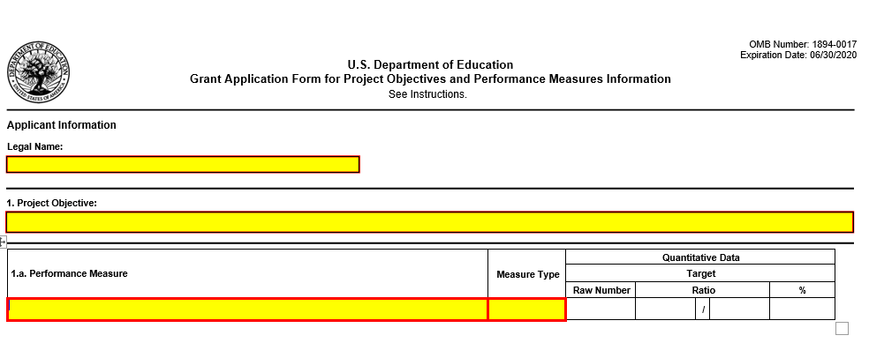

OMB Number: 1894-0017

Expiration Date: 07/31/2023

**INSTRUCTIONS**

**GRANT APPLICATION FORM FOR**

**PROJECT OBJECTIVES AND PERFORMANCE MEASURES INFORMATION**

**PURPOSE**

Applicants must submit a **GRANT APPLICATION FORM FOR PROJECT OBJECTIVES AND PERFORMANCE**

**MEASURES INFORMATION** via Grants.gov or in G5 when instructed to submit applications in G5. This form collects project objectives and quantitative and/or qualitative performance measures at the time of application submission for the purpose of automatically prepopulating this information into the U.S. Department of Education's (ED) automated Grant Performance Report form (ED 524B), which is completed by ED grantees prior to the awarding of continuation grants.

Additionally, this information will prepopulate into ED's automated ED 524B that may be required by program offices of grant recipients that are awarded front loaded grants for their entire multi-year project up-front in a single grant award, and will also be prepopulated into ED's automated ED 524B for those grant recipients that are required to use the ED 524B to submit their final performance reports.

**GENERAL INSTRUCTIONS**

**Applicant Information**

* + **Legal Name:** The legal name of the applicant that will undertake the assistance activity will prepopulate from the Application Form for Federal Assistance (SF 424 Form). This is the organization that has registered with the System for Award Management (SAM). Information on registering with SAM may be obtained by visiting [www.Grants.gov.](http://www.Grants.gov/)

**Project Objectives Information and Related Performance Measures Data**

Your grant application establishes project objectives stating what you hope to achieve with your funded grant project. Generally, one or more performance measures are also established for each project objective that will serve to demonstrate whether you have met or are making progress towards meeting each project objective.

* + **Project Objective:** Enter each project objective that is included in your grant application. When completing this form in Grants.gov, a maximum of 26 project objectives may be entered. Only one project objective should be entered per row. Project objectives should be numbered sequentially, i.e., 1., 2., 3., etc. If applicable, project objectives may be entered for each project year; however, the year to which the project objective applies must be clearly identified as is presented in the following examples:

1. **Year 1.** Provide two hour training to teachers in the Boston school district that focuses on improving test scores.
2. **Year 2.** Provide two hour training to teachers in the Washington D.C. school district that focuses on improving test scores.
   * **Performance Measure:** For each project objective, enter each associated quantitative and/or qualitative performance measure. When completing this form in Grants.gov, a maximum of 26 quantitative and/or qualitative performance measures may be entered. There may be multiple quantitative and/or qualitative performance measures associated with each project objective. Enter only one quantitative or qualitative performance measure per row. Each quantitative or qualitative performance measure that is associated with a particular project objective should be labeled using an alpha indicator. Example: The first quantitative or qualitative performance measure associated with project objective "1" should be labeled "1.a.," the second quantitative or qualitative performance measure for project objective "1" should be labeled "1.b.," etc. If applicable, quantitative and/or qualitative performance measures may be entered for each project year; however, the year to which the quantitative and/or qualitative performance measures apply must be clearly identified as is presented in the

following examples:

1.a. **Year 1.** By the end of year one, 125 teachers in the Boston school district will receive a two hour training program that focuses on improving test scores.

2.a. **Year 2.** By the end of year two, 125 teachers in the Washington D.C. school district will receive a two hour training program that focuses on improving test scores.

* + **Measure Type:** For each performance measure, select the appropriate type of performance measure from the drop down menu. There are two types of measures that **ED** may have established for the grant program:

1. **GPRA:** Measures established for reporting to Congress under the Government Performance and Results Act; and
2. **PROGRAM:** Measures established by the program office for the particular grant competition.

In addition, you will be required to report on any project-specific performance measures **(PROJECT)** that you established in your grant application to meet your project objectives.

In the **Measure Type** field, select one (1) of the following measure types**: GPRA; PROGRAM; or PROJECT.**

* + **Quantitative Target Data:** For quantitative performance measures with established quantitative targets, provide the target you established for meeting each performance measure. Only quantitative (numeric) data should be entered in the Target boxes. If the collection of quantitative data is not appropriate for a particular performance measure (i.e., for **qualitative** performance measures), please leave the target data boxes blank.

The Target Data boxes are divided into three columns: **Raw Number; Ratio, and Percentage (%).**

For performance measures that are stated in terms of a single number (e.g., the number of workshops that will be conducted or the number of students that will be served), the target data should be entered as a single number in the **Raw Number column** (e.g., **10** workshops or **80** students). Please leave the **Ratio and Percentage (%) columns** blank.

For performance measures that are stated in terms of a percentage (e.g., percentage of students that attain proficiency), complete the **Ratio column,** and leave the **Raw Number and Percentage (%) columns** blank. The **Percentage (%)** will automatically calculate based on the entered ratio. In the **Ratio column** (e.g., **80/100**), the numerator represents the numerical target (e.g., the number of students that are expected to attain proficiency), and the denominator represents the universe (e.g., all students served).

## Part 7: Other Attachment Form

*Attach one or more documents to the Other Attachments Form in accordance with the instructions found on Grants.gov. You may provide all of the required information in a single document, or in multiple documents.*

*Ensure that you only attach the Education approved file types detailed in the Common Instructions. Also, do not upload any password-protected files to your application.*

*Please note that Grants.gov cannot process an application that includes two or more files that have the same name within a grant submission.*

*When attaching files, applicants should limit the size of their file names. Lengthy file names could result in difficulties with opening and processing your application. We recommend your file names be less than 50 characters.*

**Appendix A** **Charter Schools Program Assurances**: Include a signed copy of the Charter School Program Assurances – State Entities included on page 52 of this document.

**Appendix B Resumes/Curriculum Vitae:** Provide resumes/curriculum vitae for the project director as well as any key personnel identified in the application.

**Appendix C** **Letters of Support:** If applicable, provide letters of support for the project.

**Appendix D** **Proof of Nonprofit Status:** Nonprofit 501(c)(3) status (if applicable)

**Appendix E** **Proprietary Information:** Applicant’s list of proprietary information found in the application, if applicable. Applicants should identify the specific information and page numbers in the application where it can be found.

**Appendix F** **Additional Information:** Provide any additional information needed and label Appendix F Additional Information when uploading.

Appendix A - Expanding Opportunity Through Quality Charter Schools Program (CSP) Grants to State Entities   
**Charter Schools Program Assurances**

Pursuant to section 4303(f)(2) of the Elementary and Secondary Education Act of 1965, as amended by the Every Student Succeeds Act (ESEA), and sections 200.302(a) and 200.331(d) of the Uniform Administrative Requirements, Cost Principles, and Audit Requirements for Federal Awards (Uniform Guidance), recipients of CSP Grants to State Entities must provide the assurances described below.

As the duly authorized representative of the grantee, I certify to the following:

(1) Each charter school receiving funds through the State entity’s program will have a high degree of autonomy over budget and operations, including autonomy over personnel decisions (4303(f));

(2) The State entity will support charter schools in meeting the educational needs of their students, including children with disabilities and English learners (4303(f));

(3) The State entity will ensure that the authorized public chartering agency of any charter school that receives funds under the State entity’s program adequately monitors each charter school under the authority of such agency in recruiting, enrolling, retaining, and meeting the needs of all students, including children with disabilities and English learners (4303(f));

(4) The State entity will provide adequate technical assistance to eligible applicants to meet the objectives described in application requirement (a)(1)(8) (4303(f));

(5) The State entity will promote quality authorizing, consistent with State law, such as through providing technical assistance to support each authorized public chartering agency in the State to improve such agency’s ability to monitor the charter schools authorized by the agency, including by--

(i) Assessing annual performance data of the schools, including, as appropriate, graduation rates, student academic growth, and rates of student attrition;

(ii) Reviewing the schools’ independent, annual audits of financial statements prepared in accordance with generally accepted accounting principles and ensuring that any such audits are publicly reported; and

(iii) Holding charter schools accountable to the academic, financial, and operational quality controls agreed to between the charter school and the authorized public chartering agency involved, such as renewal, non-renewal, or revocation of the school’s charter (4303(f));

(6) The State entity will work to ensure that charter schools are included with the traditional public schools in decision-making about the public school system in the State (4303(f));

(7) The State entity will ensure that each charter school receiving funds under the State entity’s program makes publicly available, consistent with the dissemination requirements of the annual State report card under section 1111(h) of the ESEA, including on the website of the school, information to help parents make informed decisions about the education options available to their children, including--

(i) Information on the educational program;

(ii) Student support services;

(iii) Parent contract requirements (as applicable), including any financial obligations or fees;

(iv) Enrollment criteria (as applicable); and

(v) Annual performance and enrollment data for each of the subgroups of students, as defined in section 1111(c)(2) of the ESEA, except that such disaggregation of performance and enrollment data shall not be required in a case in which the number of students in a group is insufficient to yield statistically reliable information or the results would reveal personally identifiable information about an individual student (4303(f)).

(8) The State Entity will ensure that each charter school receiving CSP funding has not and will not enter into a contract with a for-profit management organization, including a nonprofit management organization operated by or on behalf of a for-profit entity, under which the management organization, or its related entities, exercises full or substantial administrative control over the charter school and, thereby, the CSP project (2022 NFP).

(9) Each charter school receiving CSP funding will provide an assurance that any management contract between the charter school and a for-profit management organization, including a nonprofit CMO operated by or on behalf of a for-profit entity, guarantees or will guarantee that--

(i) The charter school maintains control over all CSP funds, makes all programmatic decisions, and directly administers or supervises the administration of the subgrant;

(ii) The management organization does not exercise full or substantial administrative control over the charter school (and, thereby, the CSP project), except that this does not limit the ability of a charter school to enter into a contract with a management organization for the provision of services that do not constitute full or substantial control of the charter school project funded under the CSP (e.g., food services or payroll services) and that otherwise comply with statutory and regulatory requirements;

(iii) The charter school’s governing board has access to financial and other data pertaining to the charter school, the management organization, and any related entities; and

(iv) The charter school is in compliance with applicable Federal and State laws and regulations governing conflicts of interest, and there are no actual or perceived conflicts of interest between the charter school and the management organization (2022 NFP).

(10) Each charter school receiving CSP funding will post on its website, on an annual basis, a copy of any management contract between the charter school and a for-profit management organization, including a nonprofit management organization operated by or on behalf of a for-profit entity, and report information on such contract to the State entity, including--

(i) A copy of the existing contract with the for-profit organization or a detailed description of the terms of the contract, including the name and contact information of the management organization, the cost (i.e., fixed costs and estimates of any ongoing cost), including the amount of CSP funds proposed to be used toward such cost, and the percentage such cost represents of the charter school’s total funding, the duration, roles and responsibilities of the management organization, and the steps the charter school is taking to ensure that it makes all programmatic decisions, maintains control over all CSP funds, and directly administers or supervises the administration of the grant or subgrant in accordance with 34 CFR 76.701;

(ii) A description of any business or financial relationship between the charter school developer or CMO and the management organization, including payments, contract terms, and any property owned, operated, or controlled by the management organization or related individuals or entities to be used by the charter school;

(iii) The names and contact information for each member of the governing boards of the charter school and a list of management organization’s officers, chief administrator, and other administrators, and any staff involved in approving or executing the management contract; and a description of any actual or perceived conflicts of interest, including financial interests, and how the applicant resolved or will resolve any actual or perceived conflicts of interest to ensure compliance with 2 CFR 200.318(c); and

(iv) A description of how the charter school ensured that such contract is severable and that a change in management companies will not cause the proposed charter school to close (2022 NFP).

(11) Each charter school receiving CSP funding will disclose, as part of the enrollment process, any policies and requirements (e.g., purchasing and wearing specific uniforms and other fees, or requirements for family participation), and any services that are or are not provided, that could impact a family’s ability to enroll or remain enrolled in the school (e.g., transportation services or participation in the National School Lunch Program) (2022 NFP).

(12) Each charter school receiving CSP funding will hold or participate in a public hearing in the local community in which the proposed charter school would be located to obtain information and feedback regarding the potential benefit of the charter school, which shall at least include information about how the proposed charter school will increase the availability of high-quality public school options for underserved students, promote racial and socio-economic diversity in such community or have an educational mission to serve primarily underserved students, and not increase racial or socio-economic segregation or isolation in the school districts from which students would be drawn to attend the charter school (consistent with applicable laws). Applicants must ensure that the hearing (and notice thereof) is accessible to individuals with disabilities and limited English proficient individuals as required by law, actively solicit participation in the hearing (i.e., provide widespread and timely notice of the hearing), make good faith efforts to accommodate as many people as possible (e.g., hold the hearing at a convenient time for families or provide virtual participation options), and submit a summary of the comments received as part of the application. The hearing may be conducted as part of the charter authorizing process, provided that it meets the requirements above. (2022 NFP).

(13) No eligible applicant receiving funds under the State entity’s program will use implementation funds for a charter school until after the charter school has received a charter from an authorized public chartering agency and has a contract, lease, mortgage, or other documentation indicating that it has a facility in which to operate. Consistent with sections 4303(b)(1), 4303(h)(1)(B), and 4310(6) of the ESEA, an eligible applicant may use CSP planning funds for post-award planning and design of the educational program of a proposed new or replicated high-quality charter school that has not yet opened, which may include hiring and compensating teachers, school leaders, and specialized instructional support personnel; providing training and professional development to staff; and other critical planning activities that need to occur prior to the charter school opening when such costs cannot be met from other sources. (2022 NFP).

_____________________________________ _____________________________

NAME OF AUTHORIZED OFFICIAL TITLE

_____________________________________ _____________________________

SIGNATURE OF AUTHORIZED OFFICIAL DATE

_____________________________________ _____________________________

APPLICANT ORGANIZATION DATE SUBMITTED

## Part 8: Assurances and Certifications

*Be certain to complete all required assurances and certifications in* [*Grants.gov*](http://e-grants.ed.gov)*, and include all required information in the appropriate place on each form. The assurances and certifications required for this application are:*

* Disclosure of Lobbying Activities (SF LLL Form)
* Certification Regarding Lobbying (ED 80-0013 Form)
* General Education Provisions Act (GEPA) Requirements – Section 427

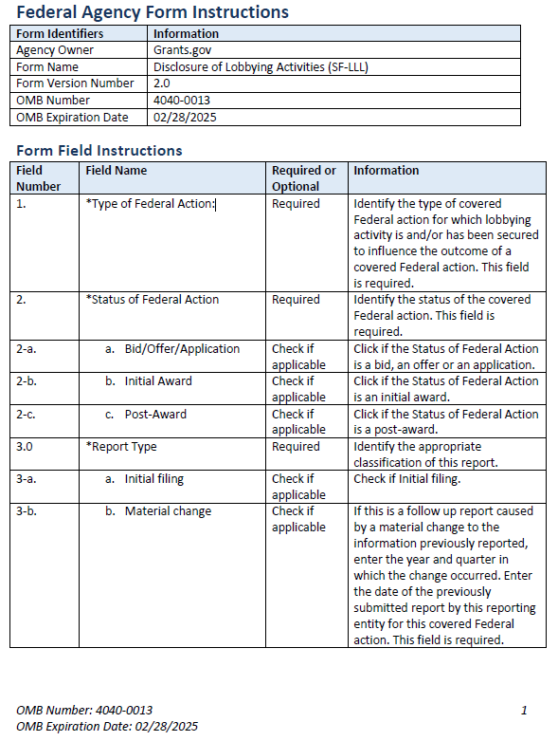

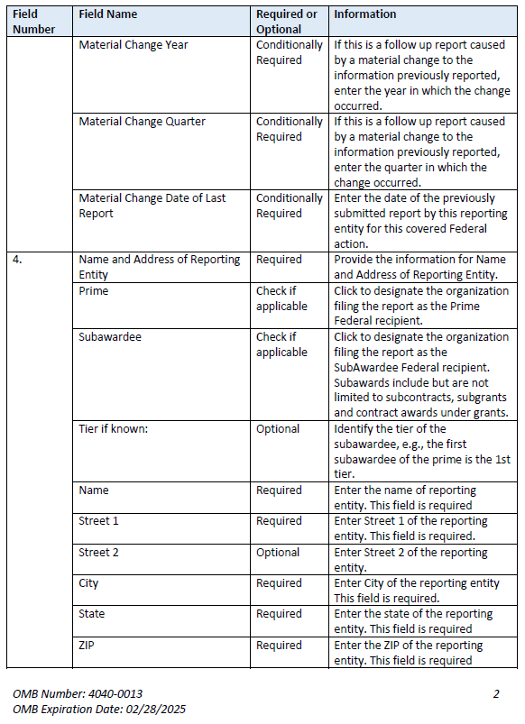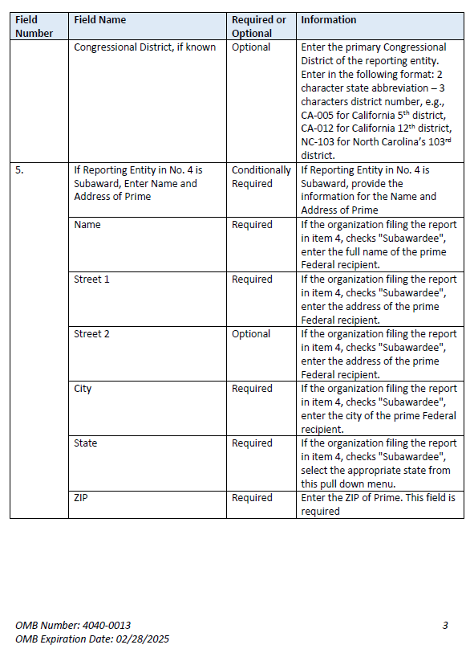

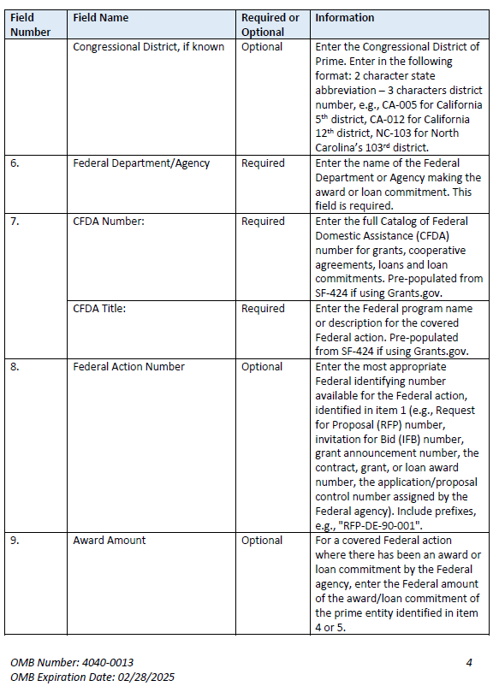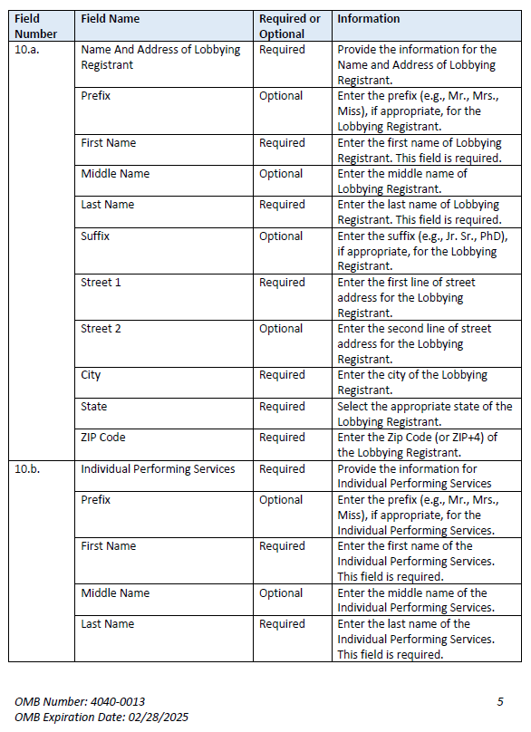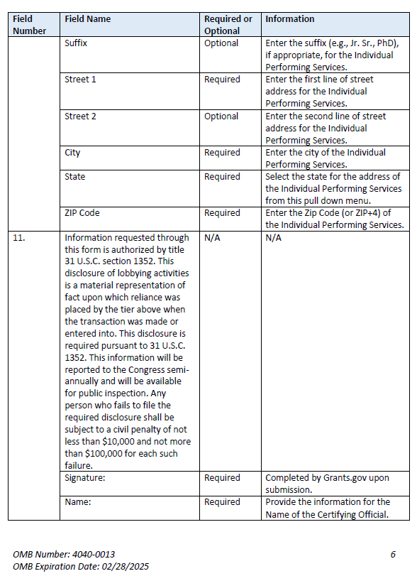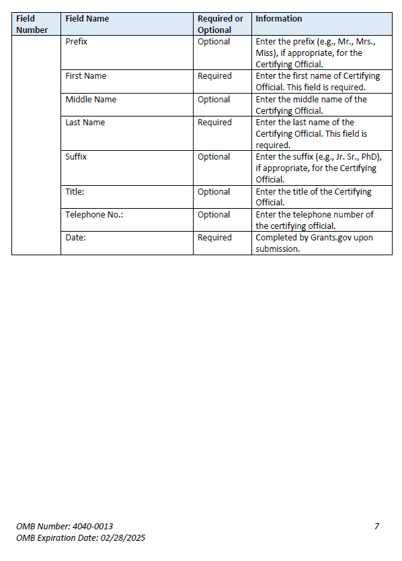

**Instructions for Meeting the General Education Provisions Act (GEPA) Section 427 Requirements**

All applicants for new awards **must** include information in their applications to address this new provision in order to receive funding under this program.

Section 427 **requires** each applicant for funds (other than an individual person) to include in its application a description of the steps the applicant proposes to take to ensure equitable access to, and participation in, its Federally-assisted program for students, teachers, and other program beneficiaries with special needs.

This provision allows applicants discretion in developing the required description. The statute highlights six types of barriers that can impede equitable access or participation: gender, race, national origin, color, disability, or age.

A general statement of an applicant’s nondiscriminatory hiring policy is **not** sufficient to meet this requirement. Applicants must identify potential barriers and explain steps they will take to overcome these barriers.

Please review the Notice to all Applicants (included in the electronic application package in Grants.gov) for further information on meeting the provisions in the Department of Education's General Education Provisions Act (GEPA).

Applicants are **required** to address this provision by attaching a statement (not to exceed three pages) to the **ED GEPA427 form** that is included in the electronic application package in Grants.gov.

## Part 9: Intergovernmental Review of Federal Programs (Executive Order 12372)

This program falls under the rubric of Executive Order 12372 (Intergovernmental Review of Federal Programs) and the regulations in 34 CFR Part 79. One of the objectives of the Executive order is to strengthen federalism--or the distribution of responsibility between localities, States, and the Federal government--by fostering intergovernmental partnerships. This idea includes supporting processes that State or local governments have devised for coordinating and reviewing proposed Federal financial grant applications.

The process for doing this requires grant applicants to contact State Single Points of Contact for information on how this works. Multi-state applicants should follow procedures specific to each state.

Further information about the State Single Point of Contact (SPOC) process and a list of names by State can be found at:

https://www.whitehouse.gov/wp-content/uploads/2017/11/Intergovernmental_-Review-_SPOC_01_2018_OFFM.pdf

Absent specific State review programs, applicants may submit comments directly to the Department. All recommendations and comments must be mailed or hand-delivered by the date indicated in the actual application notice to the following address: The Secretary, EO 12372--ALN# 84.282A, U.S. Department of Education, room 7E200. 400 Maryland Avenue, SW., Washington, DC 20202.

Proof of mailing will be determined on the same basis as applications (see 34 CFR §75.102). Recommendations or comments may be hand-delivered until 11:59:59 p.m. (eastern time) on the closing date indicated in this notice.

**Important note:** The above address is not the same address as the one to which the applicant submits its completed applications. ***Do not send applications to the above address.***

Not all states have chosen to participate in the intergovernmental review process, and therefore do not have a SPOC. If you are located in a State that does not have a SPOC, you may send application materials directly to the Department as described in the *Federal Register* notice.

# Reporting and Accountability

Successful applicants with multi-year grants must submit an **annual performance reports** demonstrating their progress in meeting approved project objectives. Grantees must also provide the most current financial and performance measure data for each year of the project.

At the end of the project period, applicants will also be required to submit a **final performance report**.

Under the Government Performance and Results Act (GPRA), the following performance indicators have been established to evaluate the overall effectiveness of the Expanding Opportunity Through Quality Charter Schools Program (CSP):

(a) Program Performance Measures (GPRA). The goal of the CSP is to support the creation and development of a large number of high-quality charter schools that are free from State or local rules that inhibit flexible operation, are held accountable for enabling students to reach challenging State performance standards, and are open to all students. The Secretary has set two performance indicators to measure this goal:

1. The number of charter schools in operation around the Nation;
2. The percentage of fourth-and-eighth grade charter school students who are achieving at or above the proficient level on State examinations in mathematics and reading/language arts.

Additionally, the Secretary has established the following measure to examine the efficiency of the CSP:

1. Federal cost per student in implementing a successful school (defined as a school in operation for three or more years).

All grantees will be expected to submit an annual performance reports documenting their contribution in assisting the Department in meeting these program performance measures (GPRA).

(b) Project-Specific Performance Measures. **Applicants must propose project-specific performance measures and performance targets consistent with the objectives of the proposed project.** Applications must provide the following information as directed under 34 CFR 75.110(b) and (c):

(1) Performance measures. How each proposed performance measure would accurately measure the performance of the project and how the proposed performance measure would be consistent with the performance measures established for the program funding the competition.

(2) Baseline data*.* (i) Why each proposed baseline is valid; or (ii) If the applicant has determined that there are no established baseline data for a particular performance measure, an explanation of why there is no established baseline and of how and when, during the project period, the applicant would establish a valid baseline for the performance measure.

(3) Performance targets. Why each proposed performance target is ambitious, yet achievable, compared to the baseline for the performance measure and when, during the project period, the applicant would meet the performance target(s).

Note: The Secretary encourages applicants to consider developing project-specific performance measures and targets tied to their grant activities as well as to student academic achievement during the grant period. The project-specific performance measures should be sufficient to gauge the progress throughout the grant period, show results by the end of the grant period, and be included in the ***logic model*** as referred to in Selection Criterion (a) *Quality of the Project Design*, (1) demonstrates a rationale as defined in the FY 2022 NIA.

(4) Data Collection. The applicant must also describe in the application: (i) the data collection and reporting methods the applicant would use and why those methods are likely to yield reliable, valid, and meaningful performance data, and (ii) the applicant’s capacity to collect and report reliable, valid, and meaningful performance data, as evidenced by high-quality data collection, analysis, and reporting in other projects or research.

Note: If the applicant does not have experience with collection and reporting of performance data through other projects or research, the applicant should provide other evidence of capacity to successfully carry out data collection and reporting for their proposed project. All grantees must submit an annual performance report with information that is responsive to these performance measures. ***If you will be unable to report on a measure annually it should not be identified as a project-specific performance measure.***

Note**:** For technical assistance in developing effective performance measures, applicants are encouraged to review information provided by the Department's Regional Educational Laboratories (RELs). The RELs seek to build the capacity of States and school districts to incorporate data and research into education decision-making. Each REL provides research support and technical assistance to its region but makes learning opportunities available to educators everywhere. For example, the REL Northeast and Islands has created the following resource on logic models: <http://relpacific.mcrel.org/resources/elm-app/>.

For additional guidance on creating strong application objectives and performance measures, please review the definitions in the FY 2022 NIA: Definitions.

For specific requirements on grantee reporting, please go to the ED Performance Report Form 524B at <http://www.ed.gov/fund/grant/apply/appforms/appforms.html>.

# Legal and Regulatory Information

## Notice Inviting Applications

The full text of the Notice Inviting Applications (NIA) for New Awards for FY 2022 under the Grants to State Entities competition can be found on the Federal Register website at the following URLs:

<https://www.govinfo.gov/content/pkg/FR-2022-07-06/pdf/2022-14442.pdf> (PDF)

<https://www.federalregister.gov/documents/2022/07/06/2022-14442/application-for-new-awards-expanding-opportunity-through-quality-charter-schools-program-csp-grants> (Text)

1. In accordance with 34 CFR 105(c)(2)(i), applications are not required to address competitive preference priorities but may receive additional points if they do so. However, to meet this application requirement, the *State entity* must describe the extent to which it is able to meet and carry out competitive preference priorities 1 through 5. If the *State entity* is unable to meet and carry out one or more of these competitive preference priorities, the description for that priority should state that the *State entity* is unable to meet or carry out the priority.