Warning Banner Page:
- Users are presented with the below “Warning Banner” page after entered www.gasatraq.com. Users will need to click on “OK” button to continue to the Login Page
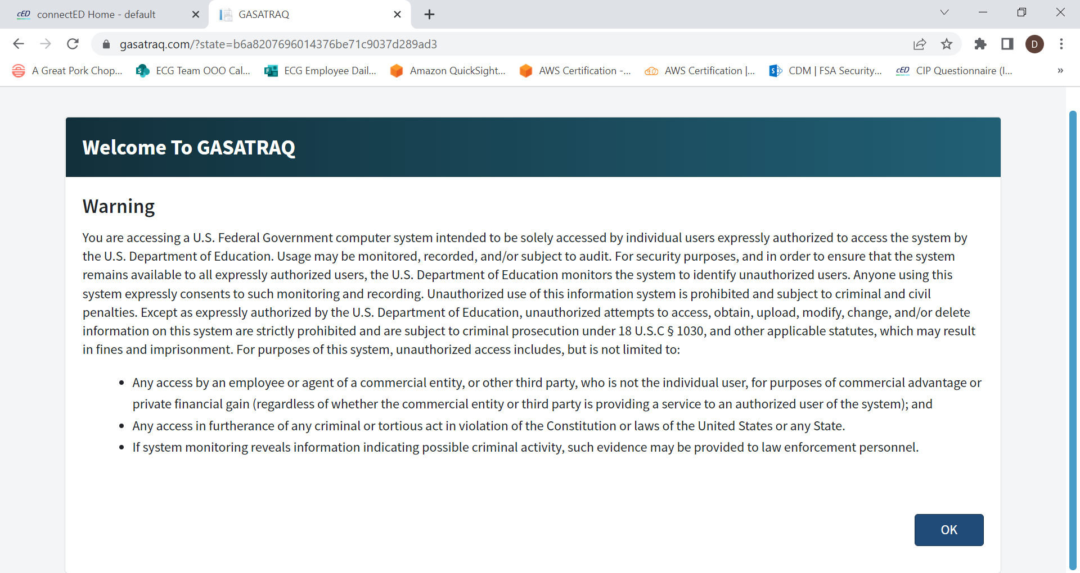

Login Page:
- All users are required to provide a valid “Username and Password” to access the online tool.
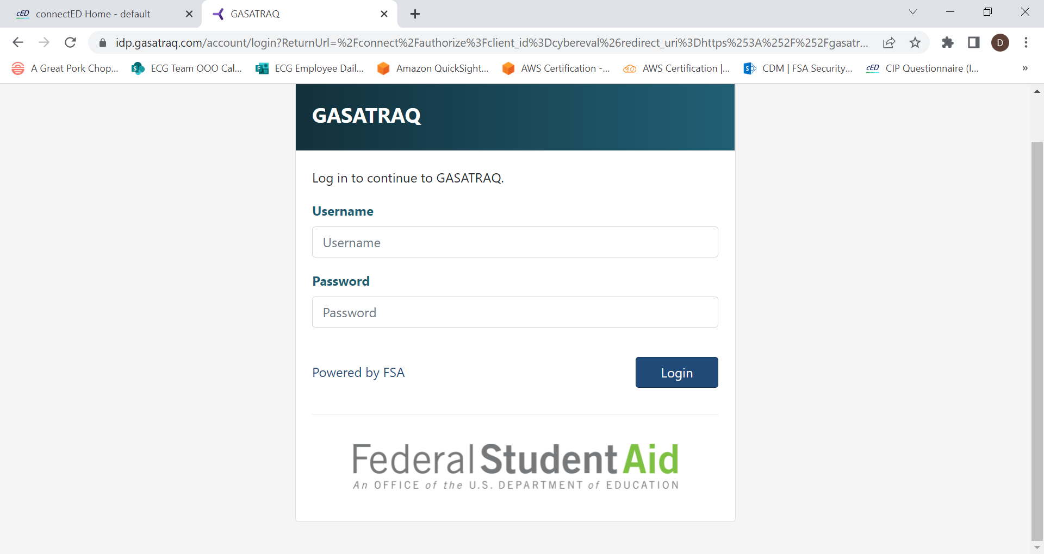

Home/Landing Page:
- After logged in, users will be presented with a homepage to make the appropriate “Evaluation Types” selections.
- Note: Sample below logged in as “FSA Administrator User”
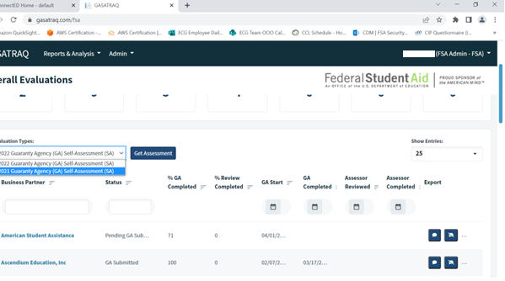
GA can select desire type

- Once users made the desire “Evaluation Types” selection from the dropdown box, users will be presented with a PRA Burden Statement page
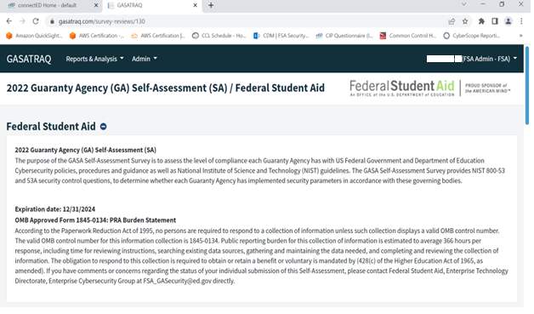
- After users selected the desire “Evaluation Types”, users will be presented with the list of the NIST SP 800-53, Rev 4 security control to complete
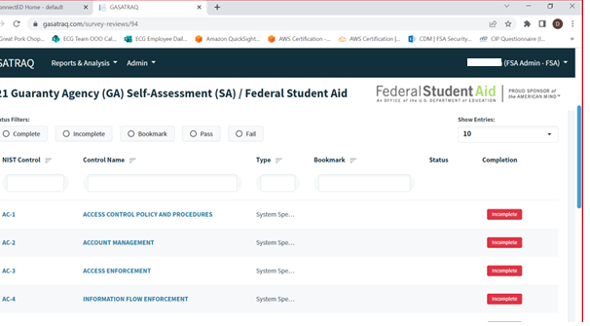

- By selecting AC-1 security control, users will be able to see the appropriate security questions relating to AC-1 control
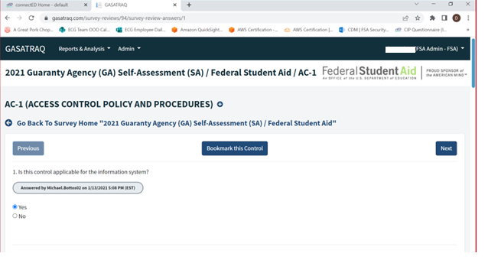
AC-1, Question 1

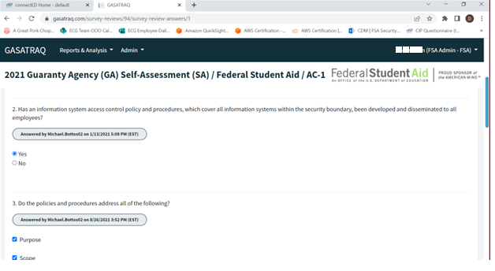
AC-1, Question 2 & Question 3

