July 8, 2022

**MEMORANDUM**

To: Robert Sivinski, OMB

From: Pat Etienne, NCES

Through: Carrie Clarady, NCES

Re: National Assessment of Educational Progress (NAEP) 2022 Materials Update #3   
(OMB# 1850-0928 v.27)

The National Assessment of Educational Progress (NAEP), conducted by the National Center for Education Statistics (NCES), is a federally authorized survey of student achievement at grades 4, 8, and 12 in various subject areas, such as mathematics, reading, writing, science, U.S. history, civics, and technology and engineering literacy (TEL). The National Assessment of Educational Progress Authorization Act (Public Law 107-279 Title III, section 303) requires the assessment to collect data on specified student groups and characteristics, including information organized by race/ethnicity, gender, socio-economic status, disability, and limited English proficiency. It requires fair and accurate presentation of achievement data and permits the collection of background, noncognitive, or descriptive information that is related to academic achievement and aids in fair reporting of results. The intent of the law is to provide representative sample data on student achievement for the nation, the states, and subpopulations of students and to monitor progress over time. The nature of NAEP is that burden alternates from a relatively low burden in national-level administration years to a substantial burden increase in state-level administration years when the sample has to allow for estimates for individual states and some of the large urban districts.

The request to conduct NAEP 2022 was approved in April 2022 (OMB# 1850-0928 v.26). This request updates Appendix I4 (MyNAEP screens LTT Age 13) with text updates to one MyNAEP email, and adds three additional emails to the communications stream that are intended to make the login process more secure. The added text, “To preview the school questionnaire, select the link here,” will allow school administrators to preview the LTT Age 13 school items and identify the necessary data they will need to have prepared in advance of completing the questionnaire.

The table below provides a summary of the changes that were made to the documents included in this submission as compared to the documents approved in April 2022 (OMB# 1850-0928 v.26).

# Summary of All Changes

| **Document** | **Changes** |
| --- | --- |
| Appendix I4 | * One MyNAEP email (Manage Questionnaires Reminder) for LTT Age 13 was updated to include the text “To preview the school questionnaire, select the link here.” * The hyperlink will direct the participant here to the NAEP website where the LTT Age 13 SQs will be posted, along with other SQs: <https://nces.ed.gov/nationsreportcard/experience/survey_questionnaires.aspx>. * Three MyNAEP emails (Manage Questionnaires – NAEP School Questionnaire – Link; Manage Questionnaires – NAEP School Questionnaire – Password; and Manage Questionnaires Reminder Password) for LTT Age 13 were added to make it easier for schools to respond. |

# Appendix I4

~~This new Appendix I4 LTT Age 13 MyNAEP System document has been added to mirror the Appendix I3 LTT Age 9 MyNAEP System document. All changes from the previous approved amendment are identified throughout the document under the heading “Summary of Changes from OMB #1850-0928 v. 25”.~~

~~At the time of this submission, the MyNAEP system is live and collecting information on LTT Age 9, and therefore screenshots included in this appendix are representative of age 9 rather than age 13. Changes to the system detailed below will be completed prior to LTT Age 13 fall administration.~~

~~The following areas will need to be updated from OMB #1850-0928 v. 25:~~

* ~~Update year/date~~
* ~~Update assessment window~~
* ~~Update ages to be assessed~~
* ~~Update calendar year and schedule~~

This Appendix now includes four revised screenshots of MyNAEP emails as of Amendment v.27. The revision to the email text allows school administrators to preview the LTT Age 13 school SQs prior to completing the questionnaires and identify what data they will need to complete the items.

The following areas have been updated since v.26. These changes begin on p. 101 of this document.

* Manage Questionnaires – NAEP School Questionnaire - Link
* Manage Questionnaires – NAEP School Questionnaire - Password
* Manage Questionnaires Reminder Email
* Manage Questionnaires Reminder Password

## Manage Questionnaires – NAEP School Questionnaire – Link **(new)**

## Manage Questionnaires – NAEP School Questionnaire - Password **(new)**

## Manage Questionnaires Reminder Email **(edited)**

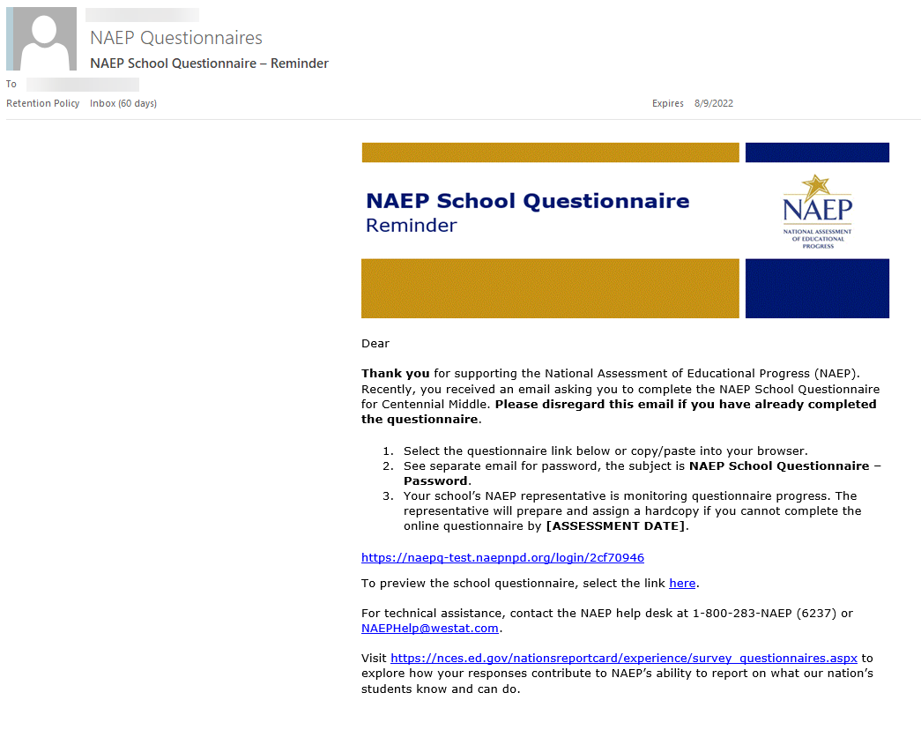

## Manage Questionnaires Reminder Password **(new)**

