International Computer and Information Literacy Study (ICILS 2023)

Main Study

OMB #1850-0929 v.10

Appendix A

Recruitment Materials

Submitted by

National Center for Education Statistics

U.S. Department of Education

November 2021

Revised July 2022

Table of Contents

Appendix A1 ICILS 2023 State Recruitment Letter 4

Appendix A2 Endorsement Letter Template 5

Appendix A3 Request for Letter of Support from Endorsing Organizations 6

Appendix A4 ICILS 2023 District Recruitment Letter 7

Appendix A5 ICILS 2023 Main Study School Letter 9

Appendix A6 ICILS 2023 Study Brochure Content: 8 ½ X 11in Tri-fold 10

Appendix A7 ICILS 2023 Main Study FAQ 12

Appendix A8 Summary of School Activities: ICILS 2023 Main Study 14

Appendix A9 Sample Recruitment Telephone Script 15

Appendix A10 ICILS 2023 Main Study School Email Follow-up 18

Appendix A11 ICILS 2023 Main Study School Engagement Emails 19

Appendix A12 Email to School Coordinator (SC) for ICILS 2023 Main Study Registration 21

Appendix A13 ICILS 2023 Main Study Registration and Provide School Information (PSI) Guide 23

Appendix A14 ICILS 2023 Main Study Automated Email for School Coordinator registrant 27

Appendix A15 ICILS 2023 Main Study Portal Login Page 28

Appendix A16 ICILS 2023 Main Study Portal Home Page 29

Appendix A17 ICILS 2023 Main Study Provide School Information (PSI) Page 31

Appendix A18 ICILS 2023 Email to School Coordinator to Submit Class Lists 34

Appendix A18a Instructions for Submitting Class and Teacher Lists 35

Appendix A19 ICILS 2023 Email to School Coordinator for submitting the student listing forms 39

Appendix A20 Instructions for Submitting Student Listing Forms 40

Appendix A21 ICILS 2023 Main Study Prepare for Assessment Page 42

Appendix A22 ICILS 2023 Main Study Student Tracking Form (STF) Email to SC 43

Appendix A23 Instructions for ICILS 2023 Main Study Student Tracking Form (STF) 44

Appendix A24 School Principal Questionnaire Login Email 45

Appendix A25 Teacher Questionnaire Login Email 46

Appendix A26 ICT Coordinator Selection Email 47

Appendix A27 Principal Questionnaire Reminder Email 48

Appendix A28 Teacher Questionnaire Reminder Email 49

Appendix A29 ICT Coordinator Questionnaire Reminder Email 50

Appendix A29A School Staff Questionnaire Letter 51

Appendix A30 Online Questionnaire Login Screen Text 52

Appendix A31 ICILS 2023 Main Study Resources Page 53

Appendix A32 ICILS 2023 Main Study Findings and Contact Us Pages 54

Appendix A33 Student Login Card 56

Appendix A33a ICILS 2023 Teacher, ICT Coordinator and Administrator Reminder Card 56

Appendix A34 Student Certificate of Completion 57

Appendix A35 School Certificate of Completion 58

Appendix A36 ICILS 2023 Main Study COVID-19 Protocols 59

Appendix A37 ICILS 2023 Main Study Sample Notification Letter 60

Appendix A38 ICILS 2023 Main Study Sample Implicit Consent Letter 61

Appendix A39 ICILS 2023 Main Study Implicit Consent Form 62

Appendix A40 ICILS 2023 Main Study Sample Explicit Consent Letter 63

Appendix A41 ICILS 2023 Main Study Explicit Consent Form 64

Appendix A42 ICILS Facts for Parents About the ICILS 2023 Main Study 65

Appendix A43 ICILS 2023 School Posters 67

Appendix A44 Multi-translation Notice for Parents 69

## Appendix A1 ICILS 2023 State Recruitment Letter

<Title First Name Last Name> <Date>

<National Education Organization Official’s Title>

<National Education Organization>

ICILS data measures 8th grade students’ computer and information literacy and computational thinking proficiency. Findings can be used to identify persisting & new challenges with young people’s development of these essential 21st century digital skills.

<Address>

<City, State Zip>

Dear <Name>:

ear <Name>:

The United States is participating in an important international study: the International Computer and Information Literacy Study 2023 (ICILS). The ICILS study is administered once every 5 years and provides crucial information on U.S. students’ skills and experience using technology compared with that of our peer countries around the world. Schools in your state have been selected to represent the nation in ICILS 2023.

In addition to an assessment of students’ computer and information skills, ICILS provides information on factors such as teachers’ experiences and school resources in support of computer and information literacy education. This high quality, internationally comparative study provides key information to inform education policy discussions while identifying existing educational inequalities across socioeconomic, racial/ethnic, and gender lines.

In 2018 U.S. 8th-graders scored above the international average for computer and information literacy (CIL), and on par with the international average in computational thinking (CT). With the dramatic shift to virtual learning in 2020, the results of the 2023 ICILS are more important than ever in understanding the role of technology in education within the U.S. and globally.

**Please partner with us by learning more about ICILS and encouraging participation of your states’ districts and schools that are selected to represent the U.S. in this study.** Your support can show how important this research is and increase participation and success of the study.

**Next steps:**

* Review the enclosed materials to learn more about ICILS.
* Support ICILS by providing a letter of support and sharing information about the study with your districts and schools.

We are in contact with your NAEP State Coordinator to keep them informed about ICILS. You may contact RTI International project staff with questions at (800) 611-0338 or ICILS@rti.org. You may also contact ICILS Project Officer Linda Hamilton at the National Center for Educational Statistics at Linda.Hamilton@ed.gov or (202) 245-6360. We are confident that you will see the value and importance of this research and will want to partner with us to ensure that the United States has a representative sample of schools across the country.

Sincerely,

Peggy G. Carr, Ph.D.

Commissioner, National Center for Education Statistics

Enclosures: ICILS Brochure, Endorsement Letter Template and Frequently Asked Questions (FAQs) sheet

In the United States ICILS is sponsored by the National Center for Education Statistics (NCES). NCES is a division within the Institute of Education Sciences (IES), a part of the U.S. Department of Education. IES is the nation's leading source for rigorous, independent education research, evaluation and statistics.School and student participation are voluntary. Learn more about ICILS by visiting: <https://surveys.nces.ed.gov/ICILS>.

*The National Center for Education Statistics (NCES) is authorized to conduct this study under the Education Sciences Reform Act of 2002 (ESRA 2002, 20 U.S.C. §9543), and to collect students’ education records from educational agencies or institutions for the purpose of evaluating federally supported education programs under the Family Educational Rights and Privacy Act (FERPA, 34 CFR §§ 99.31(a)(3)(iii) and 99.35). All of the information you provide may be used only for statistical purposes and may not be disclosed, or used, in identifiable form for any other purpose except as required by law (20 U.S.C. §9573 and 6 U.S.C. §151). In the United States, ICILS is conducted by NCES, part of the U.S. Department of Education, and the data are being collected by RTI International. The U.S. Office of Management and Budget has approved the data collection under OMB #1850-0929.*

## Appendix A2 Endorsement Letter Template

State Department of Education/ National Education Organization Letterhead

<Date>

<State CSSO/Executive Director/CEO Name>

<Title>

<Organization Name>

<Address>

<City, State Zip>

Dear <Organization Members>:

On behalf of the <INSERT STATE EDUCATION AGENCY OR ORGANIZATION> we are pleased to support; **International Computer and Information Literacy Study (ICILS)** being conducted by the National Center for Education Statistics (NCES) within the Institute of Education Sciences (IES) of the U.S. Department of Education (ED). We understand it is the NCES’ goal in conducting this study to provide valuable comparative information about the U.S. population’s educational performance, competencies, and skills in an international context.

This study compliments our <vision/mission/goal> of_____________________________________________ ________________________________________________________________________________________.

ICILS assesses computer information literacy and computational thinking skills at grade 8 and is designed to address challenges associated with young people’s development of essential 21st century digital skills. The results will help us understand the use of digital technologies in schools and how they are used to develop students’ digital competencies. Data compiled and collected from ICILS 2023 allows for evidence-based decisions to be made for the purposes of educational improvement.

Collection of these data is not possible without the participation of selected schools. By participating in the study, you are contributing to the international comparable indicators of students’ computer information literacy and computational thinking, as well as indicators that show how this achievement relates to demographic and curricular, school, teacher, and student factors that provide the educational context for achievement.

We strongly encourage your participation in ICILS 2023. <STATE ED AGENCY: **We are confident that schools in our state will understand the importance of this international study and will accept the invitation to participate if selected.> <**NATIONAL ED ORGANIZATION: **We are confident that our members and partners, and state and local education leadership will understand the importance of this national study and will accept the invitation to participate if selected.>**

Should you have any questions, please call the ICILS information number, (800) 611-0338, or send an email to ICILS@rti.org. You may also contact Linda Hamilton at NCES at [Linda.Hamilton@ed.gov](mailto:lydia.malley@ed.gov) (202) 245-6360 for more information.

Thank you for your dedication to education research and your help in making ICILS 2023 a success.

Sincerely,

<Name>

Education Commissioner/Superintendent/Executive Director

State Education Agency/ Organization Name

*The National Center for Education Statistics (NCES) is authorized to conduct this study under the Education Sciences Reform Act of 2002 (ESRA 2002, 20 U.S.C. §9543), and to collect students’ education records from educational agencies or institutions for the purpose of evaluating federally supported education programs under the Family Educational Rights and Privacy Act (FERPA, 34 CFR §§ 99.31(a)(3)(iii) and 99.35). All of the information you provide may be used only for statistical purposes and may not be disclosed, or used, in identifiable form for any other purpose except as required by law (20 U.S.C. §9573 and 6 U.S.C. §151). In the United States, ICILS is conducted by NCES, part of the U.S. Department of Education, and the data are being collected by RTI International. The U.S. Office of Management and Budget has approved the data collection under OMB #1850-0929.*

## Appendix A3 Request for Letter of Support from Endorsing Organizations

<Date>

Dear Executive Director:

We are writing to request support from your organization for the **International Computer and Information Literacy Study 2023 (ICILS**), which in the United States is conducted by the National Center for Education Statistics (NCES) within the Institute of Education Sciences (IES) of the U.S. Department of Education (ED).

ICILS is developed internationally as a response to the increasing use of information and communication technology (ICT) in modern society and the need for citizens to develop relevant skills to participate effectively in the digital age. The continuation of U.S. participation allows for the study of past and current education policies that have shaped the role of technologies in teaching and learning. This high quality, internationally comparative trend data provides key information to inform education policy discussions while identifying existing educational inequalities across socioeconomic, racial/ethnic, and gender lines.

*Use of ICILS data can help identify persisting and new challenges associated with young people’s development of essential 21st century digital skills*

**We are hoping you will partner with us by learning more about ICILS and encouraging participation of schools that are selected to represent the U.S. educational experience in this study.** Your support and a letter of endorsement can show how important this study is and increase participation and success of the study. Without school participation, the validity of national estimates is at risk.

**Next steps:** Support ICILS by lending your logo and name, providing a letter of endorsement, and sharing information about the study with your members and partners.

*Results from ICILS will give policymakers, researchers, and educators information they need to chart national progress against international standards and inform national discussions about students’ digital literacy.*

Should you have any questions please call the ICILS information number, (800) 611-0338, or send an email to ICILS@rti.org. You may also contact Linda Hamilton at NCES at [Linda.Hamilton@ed.gov](mailto:lydia.malley@ed.gov) or (202) 245-6360. We are confident that you will see the value and importance of this research and will want to partner with us to advance the quality of education for all our students.

Sincerely,

Peggy G. Carr, Ph.D.

Commissioner, National Center for Education Statistics

Enclosures: ICILS Brochure, Endorsement Letter Template and Frequently Asked Questions (FAQs) sheet

*The National Center for Education Statistics (NCES) is authorized to conduct this study under the Education Sciences Reform Act of 2002 (ESRA 2002, 20 U.S.C. §9543), and to collect students’ education records from educational agencies or institutions for the purpose of evaluating federally supported education programs under the Family Educational Rights and Privacy Act (FERPA, 34 CFR §§ 99.31(a)(3)(iii) and 99.35). All of the information you provide may be used only for statistical purposes and may not be disclosed, or used, in identifiable form for any other purpose except as required by law (20 U.S.C. §9573 and 6 U.S.C. §151). In the United States, ICILS is conducted by NCES, part of the U.S. Department of Education, and the data are being collected by RTI International. The U.S. Office of Management and Budget has approved the data collection under OMB #1850-0929.*

## Appendix A4 ICILS 2023 District Recruitment Letter

<Title First Name Last Name> <Date>

<DistrictName>

<Address>

<CitySTZip>

Dear <Superintendent>,

The United States is participating in an important international study: International Computer and Information Literacy Study 2023 (ICILS). The ICILS study is administered once every 5 years and provides crucial information on U.S. students’ skills and experience using technology compared with that of our peer countries around the world. In addition to an assessment of students’ computer and information skills, ICILS provides information on factors such as teachers’ experiences and school resources in support of computer and information literacy education. This high quality, internationally comparative study provides key information to inform education policy discussions while identifying existing educational inequalities across socioeconomic, racial/ethnic, and gender lines.

**One-time data collection point: spring 2023**

**On average, 1-2 classrooms per school will be selected**

**NCES will provide equipment and staff for student data collection**.

**ICILS SNAPSHOT**

One or more schools in your <district/diocese> has been selected to participate in the ICILS 2023 to occur in **spring 2023**. In 2018 U.S. 8th-graders scored above the international average for computer and information literacy (CIL), and on par with the international average in computational thinking (CT). With the dramatic shift to virtual learning in 2020, the results of the 2023 ICILS are more important than ever in understanding the role of technology in education within the U.S. and globally. We are reaching out to you now with the expectation that ICILS will take place in on-campus classroom settings in spring 2023.

**Benefits of ICILS 2023 include:**

* Schools will receive <$200/$800> or nonmonetary equivalent value
* If allowed, teachers will receive monetary compensation for completing a web-based survey
* A school-level report for schools with sufficient participation
* No-cost interactive webinars on timely topics such as social and emotional learning, project-based learning, or STEM for eligible <district/diocese> and school staff.
* Participating students and staff also receive a service certificate from the U.S. Department of Education.

Study materials will be sent to selected schools in your district, and our data collection contractor RTI International will contact them to participate. <Name>, your NAEP State Coordinator, may contact your staff with additional information. If you have any questions, please do not hesitate to call (800) 611-0338 or send an email to ICILS@rti.org.

Sincerely,

<State CSSO or Peggy G. Carr, Ph.D., Commissioner, National Center for Education Statistics>

Enclosures: ICILS Brochure, Frequently Asked Questions (FAQs) sheet, State Letter of Endorsement (if provided), List of Sampled Schools

In the United States ICILS is sponsored by the National Center for Education Statistics (NCES). NCES is a division within the Institute of Education Sciences (IES), a part of the U.S. Department of Education. IES is the nation's leading source for rigorous, independent education research, evaluation and statistics.School and student participation are voluntary. Learn more about ICILS by visiting: <https://surveys.nces.ed.gov/ICILS/>.

*The National Center for Education Statistics (NCES) is authorized to conduct this study under the Education Sciences Reform Act of 2002 (ESRA 2002, 20 U.S.C. §9543), and to collect students’ education records from educational agencies or institutions for the purpose of evaluating federally supported education programs under the Family Educational Rights and Privacy Act (FERPA, 34 CFR §§ 99.31(a)(3)(iii) and 99.35). All of the information you provide may be used only for statistical purposes and may not be disclosed, or used, in identifiable form for any other purpose except as required by law (20 U.S.C. §9573 and 6 U.S.C. §151). In the United States, ICILS is conducted by NCES, part of the U.S. Department of Education, and the data are being collected by RTI International. The U.S. Office of Management and Budget has approved the data collection under OMB #1850-0929.*

**Please partner with us by encouraging participation of your schools that are selected to represent the U.S. in ICILS.** **Your support can show the importance of this critical research.**

A representative of RTI International will contact the following school or schools in your <district/diocese> that have been selected for ICILS 2023 to discuss study logistics and answer any questions you may have.

|  |  |
| --- | --- |
| School name |  |
|  |  |
|  |  |
|  |  |

<IF APPLICABLE: We **may** also contact <LIST REPLACEMENT SCHOOLS HERE>.>

|  |  |
| --- | --- |
| School name |  |
|  |  |
|  |  |
|  |  |

## Appendix A5 ICILS 2023 Main Study School Letter

<Principal name> <Date>

Monetary incentives for school, school coordinator, and teachers, when allowed. Token of appreciation and certificate of service for students.

Opportunities for students to contribute to the educational research to help other students.

Interactive webinar for eligible district and school staff on timely topics such as social and emotional learning, project-based learning, or STEM.

**Benefits of Participation**

<school name>

<address>

<city> <state> <zip>

Dear <Principal>,

The United States is participating in an important international study: International Computer and Information Literacy Study 2023 (ICILS). The ICILS study is administered once every 5 years and provides crucial information on U.S. students’ skills and experience using technology compared with that of our peer countries around the world. In addition to an assessment of students’ computer and information skills, ICILS provides information on factors such as teachers’ experiences and school resources in support of computer and information literacy education.

I would like to invite your school to participate in the ICILS 2023 Main Study to occur in **spring 2023**. Please put this assessment window date on your 2022-2023 school calendar. The purpose of the Main Study is to measure international differences in students’ computer and information literacy (CIL) and computational thinking (CT). Students will take the assessment digitally on computers supplied by the ICILS 2023 Team.

Your district has been notified of your selection. A representative from ICILS will contact you to discuss your participation. For any participating schools, we would like to obtain the name of a school coordinator (SC) and work with you to coordinate the study logistics at your school. As a token of appreciation for participating in ICILS, your school will receive $200. Students who participate in ICILS will receive a small gift as a token of appreciation. Your school’s ICILS School Coordinator (the staff person you designate to liaise with ICILS project staff) will receive $100 for his or her time and effort coordinating ICILS activities. Sampled teachers and the ICT coordinator will receive $25 for completing a brief questionnaire.

**Next Steps:**

* Review the enclosed study materials
* Select a school coordinator (SC) for your school
* You will receive a call in the next few days to discuss the study
* If you prefer to contact us first, we can be reached at (800) 611-0338 or ICILS@rti.org

To meet the rigorous standard of ICILS data collection, we would like to work with you and support your school’s participation. Thank you for your consideration and for supporting this important international study.

Sincerely,

Peggy G. Carr, Ph.D., Commissioner, National Center for Education Statistics

cc: [District Test Coordinator]

Enclosures: ICILS Brochure, Frequently Asked Questions (FAQs) sheet, Summary of School Activities

In the United States ICILS is sponsored by the National Center for Education Statistics (NCES). NCES is a division within the Institute of Education Sciences (IES), a part of the U.S. Department of Education. IES is the nation's leading source for rigorous, independent education research, evaluation and statistics.School and student participation are voluntary. Learn more about ICILS by visiting: <https://surveys.nces.ed.gov/ICILS/>.

*The National Center for Education Statistics (NCES) is authorized to conduct this study under the Education Sciences Reform Act of 2002 (ESRA 2002, 20 U.S.C. §9543), and to collect students’ education records from educational agencies or institutions for the purpose of evaluating federally supported education programs under the Family Educational Rights and Privacy Act (FERPA, 34 CFR §§ 99.31(a)(3)(iii) and 99.35). All of the information you provide may be used only for statistical purposes and may not be disclosed, or used, in identifiable form for any other purpose except as required by law (20 U.S.C. §9573 and 6 U.S.C. §151). In the United States, ICILS is conducted by NCES, part of the U.S. Department of Education, and the data are being collected by RTI International. The U.S. Office of Management and Budget has approved the data collection under OMB #1850-0929.*

## Appendix A6 ICILS 2023 Study Brochure Content: 8 ½ X 11in Tri-fold

***Title page:***

<IES Logo>

International Computer and Information Literacy Study (ICILS) 2023

***Inside panels:***

**What is ICILS?**

The International Computer and Information Literacy Study (ICILS) is an international assessment and research project designed to measure computer and information literacy achievement at the eighth grade, as well as school and teacher practices related to instruction. ICILS is developed internationally as a response to the increasing use of information and communication technology (ICT) in modern society and the need for citizens to develop relevant skills to participate effectively in the digital age. The United States participated in ICILS in 2018 along with 13 other education systems and will participate again in 2023. ICILS 2023 will include students from approximately 30 education systems.

ICILS is sponsored by the International Association for the Evaluation of Educational Achievement (IEA) and conducted in the United States by the National Center for Education Statistics (NCES), part of the U.S. Department of Education.

**Why is ICILS important?**

ICILS provides a unique opportunity to compare the computer and information literacy of U.S. eighth-grade students with that of their peers in countries around the world. ICILS complements what we learn from national assessments by identifying the strengths and weaknesses of student performance relative to students around the world. The results inform national discussions about computer literacy as well as international competitiveness. With the dramatic shift to virtual learning in 2020, the results of the 2023 ICILS are more important than ever in understanding the role of technology in education.

ICILS provides valuable benchmark information on how U.S. students compare to students around the world, allows educators and policymakers to examine other education systems for practices that could have application to the United States, and contributes to ongoing discussions of ways to improve the quality of education of all students using technology.

**What type of assessment is ICILS?**

ICILS is a computer-based assessment developed through an international collaborative process involving input from U.S. and international experts in computer and information literacy and measurement. The assessment contains a mix of interactive computer tasks. Examples of released ICILS items may be found in the 2018 ICILS report, Preparing for Life in a Digital World, at https://www.iea.nl/publications/study-reports/preparing-life-digital-world on pp. 60-62 and pp. 94-95.

**How do the U.S. 8th graders compare internationally? Results from ICILS 2018**

There were four different levels of computer and information literacy (CIL) proficiency, ranging from Level 1 to Level 4. In the United States 25 percent of 8th-grade students reached at least Level 3, demonstrating the “capacity to work independently when using computers as information gathering and management tools”. This percent was higher than the ICILS 2018 average among all countries but lower than in 4 other education systems -- Finland, Moscow, Denmark, and Republic of Korea.

Twenty percent of U.S. eighth graders scores in the upper CT performance region. U.S. 8th-graders scored on par with the international average in CT. The U.S. ranked fifth among nine education systems, lower than Demark or Republic of Korea.

Female U.S. students demonstrated higher CIL achievement than male students, whereas CT achievement tended to be higher for U.S. male than female students. Students in the U.S. schools with less than 10 percent of students eligible for free or reduced-price lunch (FRPL) had a higher average CIL and CT scores than students in schools with higher percentages of students eligible for FRPL.

Additional ICILS 2018 results can be found at <https://nces.ed.gov/surveys/icils/icils2018/theme1.asp>.

***Back panels:***

**Countries participating in ICILS 2023**

[TBD]

*The National Center for Education Statistics (NCES) is authorized to conduct this study under the Education Sciences Reform Act of 2002 (ESRA 2002, 20 U.S.C. §9543), and to collect students’ education records from educational agencies or institutions for the purpose of evaluating federally supported education programs under the Family Educational Rights and Privacy Act (FERPA, 34 CFR §§ 99.31(a)(3)(iii) and 99.35). All of the information you provide may be used only for statistical purposes and may not be disclosed, or used, in identifiable form for any other purpose except as required by law (20 U.S.C. §9573 and 6 U.S.C. §151). In the United States, ICILS is conducted by NCES, part of the U.S. Department of Education, and the data are being collected by RTI International. The U.S. Office of Management and Budget has approved the data collection under OMB #1850-0929.*

<IES / NCES logo>

For questions about ICILS 2023, contact the ICILS Information Hotline at (800) 611-0338 or by email at ICILS@rti.org. Learn more at <https://surveys.nces.ed.gov/ICILS>

## Appendix A7 ICILS 2023 Main Study FAQ

**International Computer and Information Literacy Study**

**Frequently Asked Questions**

ICILS 2023 Main Study will occur in the spring of 2023.

**What is ICILS?**

The International Computer and Information Literacy Study (ICILS) is an international assessment and research project designed to measure computer and information literacy achievement at the eighth grade, as well as school and teacher practices related to instruction. ICILS provides a unique opportunity to compare U.S. eighth-grade students’ computer and information literacy skills and access to and use of technology with that of their peers in countries around the world. ICILS is developed internationally as a response to the increasing use of information and communication technology (ICT) in modern society and the need for citizens to develop relevant skills to participate effectively in the digital age. The United States participated in ICILS in 2018 along with 13 other education systems and will participate again in 2023. ICILS 2023 will include students from approximately 30 education systems.

**What is the Main Study for?**

ICILS 2023 plans to continue collecting and analyzing data to provide a better understanding of the modern, pervasive digital context, as well as of students’ skills in information management, communication, and computational thinking. ICILS 2023 will include more aspects related to digital citizenship, reflecting young people’s increasing opportunities for online citizenship participation and helping measure progress toward UNESCO's Sustainable Development Goal 4.4 (increasing the number of young people who have relevant skills for employment).

**Why was my school selected for participation?**

Your school was randomly selected to participate and represent our country in the study. The U.S. sample includes both public and private school representative of the nation at grade 8. Two classrooms per school will be selected where feasible. In schools containing only one class, this class will be selected.

**Why should my school and students participate?**

ICILS assesses computer information literacy and computational thinking skills at grade 8 and is designed to address challenges associated with young people’s development of essential 21st century digital skills. The results will help us understand the use of digital technologies in schools and how they are used to develop students’ digital competencies. ICILS informs national discussions about education policy as well as international competitiveness. Students’ efforts in the Main Study help ensure that the achievement of our nation’s grade 8 students can be accurately and fairly reported.

**Will all our eighth-grade students be asked to participate?**

It depends on the number of eighth-grade classrooms in the school. In schools with only one or two such classrooms, all students will be asked to participate. In schools with more than two such classrooms, only students in two randomly selected classrooms will be asked to participate. In addition, some students with special needs or limited English proficiency may be excused from the assessment.

**How many school staff will be asked to participate?**

In addition to collecting information from students, ICILS will collect questionnaire data from one school administrator and one ICT coordinator from each participating school. In addition, to understand how teachers access and use technology in the classroom, about 15 teachers from each school will be selected to form a nationally representative sample of grade 8 teachers.

**Who conducts the ICILS assessment?**

The National Center for Education Statistics (NCES), within the U.S. Department of Education, is authorized to conduct this study under the Education Sciences Reform Act of 2002 (ESRA 2002, 20 U.S.C. §9543), and approval of the U.S. Office of Management and Budget under OMB# 1850-0929. The data collection at your school will be carried out on behalf of NCES by trained staff from RTI International, a research organization under contract with NCES.

**How are the teacher, ICT coordinator, and principal questionnaires administered?**

The teacher, ICT coordinator, and principal questionnaires are administered online from a secure website. Teacher questionnaires take about 30 minutes to complete, and ask teachers questions about their experience, available resources, and instructional practices. The ICT coordinator and principal questionnaires each take about 15 minutes to complete and ask about school practices, resources and support related to information and communication technology (ICT).

**Do teachers need to help administer the assessment?**

No, RTI International field staff will visit the school on the day of the assessment, bringing with them all the materials required. These field staff will administer the assessments to students.

**Do schools need to provide computer equipment for the Main Study?**

No, RTI International field staff will bring all the equipment needed for the Main Study, including tablets and keyboards.

**When will the Main Study be conducted?**

The Main Study will be conducted in March through May 2023. RTI International will work with schools to identify an assessment date convenient for the school in that time period.

**Where will the Main Study be conducted?**

The assessment will be conducted in a classroom or area designated by the schools that participate in the test.

**How long does the Main Study take for students?**

The Main Study will take approximately 3 hours to complete. This includes time for directions, the assessment, and a questionnaire that students complete about themselves and their experiences with technology.

**What will happen with the collected data?**

All of the information provided by school staff and students may be used only for statistical purposes and may not be disclosed, or used, in identifiable form for any other purpose except as required by law (20 U.S.C. §9573 and 6 U.S.C. §151). Reports of the findings from the study will not identify participating districts, schools, students, or individual staff. Individual responses will be combined with those of other participants to produce summary statistics and reports.

**Where can I find more information about ICILS?**

Visit the ICILS website at <https://surveys.nces.ed.gov/ICILS>.

For additional information about ICILS 2023, contact the ICILS U.S. home office at (800) 611-0338 or email ICILS@rti.org

## Appendix A8 Summary of School Activities: ICILS 2023 Main Study

|  |  |  |  |  |
| --- | --- | --- | --- | --- |
| **Summary of School Activities: ICILS 2023 Main Study** | | | | |
|  | **May 2022- March 2023** | **November 2022-February 2023**  **Prior to assessment day** | **March-May 2023**  **Assessment day** | **Benefits** |
| **Principal** | * Designate a school coordinator |  | * Support assessment day activities * Encourage students to participate and do their best on the assessment * Complete a brief web-based School Questionnaire on the characteristics of the school, its enrollment, resources, policies, and learning environment. Share the importance of participation in the study with school staff | * Represent other similar U.S. schools * Receive $<200/800> check for the school * Eligible staff may register for a no-cost webinar on timely topics project-based learning, social and emotional learning, or STEM |
| **School coordinator** | * Confirm an assessment date convenient for your school | * Arrange assessment day location * Confirm date and location with the ICILS team * Provide class lists and student lists for the sample classes through the SC portal * Notify teachers, students, and students’ parents of the study and benefit of participating * Work with study staff to identify students with special needs * Coordinate the completion of the principal, teacher and ICT coordinator questionnaires (online) * Collect parental consent forms if required; submit to the ICILS team | * Confirm space for assessment is problem-free * Ensure all sampled classes attend the assessment session * Meet with the ICILS team and provide feedback about the assessment process | * If permitted, receive a $100 check or gift card for school supplies |
| **Selected Teachers** |  | * Distribute parental permission forms and track permission status | * Complete a brief web-based survey on teacher classroom use of technology | * If permitted, receive a $25 or gift card for school supplies |
| **ICT Coordinators** |  |  | * Complete a brief questionnaire on ICT practices | * If permitted, receive a $25 or gift card for school supplies |
| **Selected Students** |  |  | * Attend the assessment sessions, complete the assessment and student questionnaire | * Receive a small thank-you gift and community service certificate * Represent the United States in the international study |
| **ICILS team at RTI International** | * Work with the school to set an assessment date * Help school coordinator with assessment details and logistics * Protect school and student information | * Call the school coordinator to discuss assessment day location and student participation * Select classroom sample and notify school of selected classes | * Administer student session * Furnish all equipment * Administer a brief debriefing interview with the school coordinator at the end of the session * Maintain security of all materials | * Ensure quality and uniformity of data collected across the United States |

## 

## Appendix A9 Sample Recruitment Telephone Script

**Information Literacy Study (ICILS 2023) Main Study ( Eye-See-Eye-Ell-Ess) Phone Script**

***[Call can be made either before or after email sent or introductory call made.]***

“Hello. This is __________________. I'm calling regarding the U.S. Department of Education’s

**International Computer and Information Literacy Study (ICILS 2023) Main Study**. May I speak to [NAME OF PRINCIPAL]?”

IF LEAVING A VOICEMAIL OR MESSAGE:

“Hello, this is ____________________. I’m calling on behalf of the U.S. Department of Education’s **International Computer and Information Literacy Study (ICILS 2023) Main Study.**

I would appreciate the opportunity to speak with you about this study. At your earliest convenience, please call me back at (xxx) xxx-xxx. Thank you, and I look forward to hearing from you”

IF YOU HAVE REACHED THE CORRECT PERSON:

“I am calling about the **International Computer and Information Literacy Study (ICILS 2023)** I'm calling to speak with you about your school’s possible participation in the study. Have you had an opportunity to review the materials in the email sent to you?”

YES – “Do you have any questions about the study?”

NO – “The email was sent from [email address of recruiter] on [date sent]. It describes the study and contains materials explaining the purpose of this main study. I'll be happy to explain the study to you and answer any questions you may have.

OR “I am happy to resend the information to you again; do you mind if I give you a high-level overview now while I have you on the phone?” (VERIFY NAME, EMAIL ADDRESS).

CONTINUE IF EMAIL WAS RECEIVED AND QUESTIONS HAVE BEEN ANSWERED OR IF THERE WERE NO QUESTIONS

“First of all, I need to make sure that your school is eligible for the study.” “Do you have 8th Grade classrooms at your school?” (IF NO, SCHOOL IS INELIGIBLE) “Thank you for your time, your school is not eligible to participate in the study.”

IF ANSWERS INDICATE AN INELIGIBLE SCHOOL, CODE AS “PENDING INELIGIBLE” AND NOTE EXACTLY WHICH CONDITION RENDERS SCHOOL INELIGIBLE). SUPERVISORS WILL MAKE FINAL ELIGIBILITY DECISIONS.

STUDY INFORMATION:

As described in the email sent to you earlier, The United States is participating in an important international study: The International Computer and Information Literacy Study 2023 (ICILS). This study provides a unique opportunity to compare U.S. eighth-grade students’ computer and information literacy skills and access to and use of technology with that of their peers in countries around the world. ICILS was developed internationally as a response to the increasing use of information and communication technology (ICT) in modern society and the need for citizens to develop relevant skills in order to participate effectively in the digital age. With the increased reliance on the use of technology during COVID-19, this study is occurring at a critical time in the field of U.S. education.

Timeline for data collection is scheduled for March-May 2023. The primary goal will be to test the operational aspects of survey administration in several (3-5) schools that **volunteer** to participate. RTI International, is contracted to administer the study.

**PARTICIPATION INVOLVES** a **one-time 2 1/2 hour** in-school student data collection by:

* 1 or 2 8th grade classrooms for student session
* A sample of 6 8th grade teachers from participating schools to complete brief (approx. 30 mins) web-based questionnaires.
* One (15 min) web-based school administrator questionnaire and;
* One (15 min) web-based questionnaire for the staff person most knowledgeable about information and computer technology at the school (ICT Coordinator)
* Students will take the assessment on tablets provided by the ICILS study team, including tablets and keyboards.
* Designating a study coordinator to assist ICILS study team to plan logistics for study and

to assist with in-school session activities.

* BENEFITS: $200 TO SCHOOLS, 100$ TO SC, $25 FOR COMPLETED TEACHER AND (ICT) COORDINATOR SURVEYS and small token of appreciation to students and a certificate of service for participating for students and staff.
* Principals may designate staff who can register for a no-cost webinar on timely topics such as: project-based learning, social and emotional learning, or STEM.

IF YOU ARE ASKED IF THIS STUDY IS MANDATORY

“Your participation is completely voluntary. ICILS assesses computer information literacy and computational thinking skills at grade 8 and is designed to address challenges associated with young people’s development of essential 21st century digital skills. The results will help us understand the use of digital technologies in schools and how they are used to develop students’ digital competencies. ICILS informs national discussions about education policy as well as international competitiveness. Students’ efforts in the Main Study help ensure that the achievement of our nation’s grade 8 students can be accurately and fairly reported.”

IF SCHOOL AGREES TO PARTICIPATE:

“Thank you for your willingness to participate. The next step is to identify a person at your school who can serve as the study coordinator. The coordinator would act as the main contact person for the study. He/she will coordinate the collection of classroom student lists and will work with us on Test Administration Day and if needed, a Make-Up Day to coordinate student attendance and participation.

Upon completion of student data collection, we will provide $100 incentive to the individual at the school identified to serve as the school coordinator, plus we will also provide the school with a $200 check. Upon completion of web-based surveys, teachers and ICT coordinators will receive $25 and certificates of service for participation in the study. Who would you like to appoint as school coordinator? Is there another person that should serve in the role of ICT coordinator, or will it be the same person?

RECORD COORDINATOR INFORMATION

STUDY INFO:

The student *Computer Information Literacy (CIL*) assessment is composed of modules which include three types of tasks: (i) multiple-choice or constructed response items based on realistic stimulus material; (ii) software simulations of generic applications requiring students to complete an action in response to an instruction; and (iii) authentic tasks that require students to modify and create information products using 'live' computer software applications. In ICILS 2018, the assessment included 3 trend modules (used in the 2013 administration of ICILS) and 4 new modules (2 of the new modules fell under the *Computational Thinking (CT)* dimension), which were expected to take 30 minutes each to complete. To reduce burden on individual students, each student completed 4 assessment modules according to a module rotation design, for a total of 120 minutes, covering both CIL and CT, plus the student questionnaire for a total of 2 ½ hours.

The teacher, ICT coordinator, and principal questionnaires are administered online from a secure website. Teacher questionnaires take about 30 minutes to complete, and ask teachers questions about their experience, available resources, and instructional practices. The ICT coordinator and principal questionnaires each take about 15 minutes to complete and ask about school practices and resources related to information and communication technology (ICT).

## Appendix A10 ICILS 2023 Main Study School Email Follow-up

Dear <Principal>:

Thank you for talking with us about your school’s participation in the International Computer and Information Literacy Study (ICILS) main study. We are excited to work with your students and staff. ICILS is an international assessment and research project designed to measure computer and information literacy achievement at the eighth grade. This is a friendly reminder that the ICILS team at RTI International will be contacting your school coordinator (SC) in the coming weeks to coordinate the logistics for the main study at your school.

If you have not chosen someone to serve as the study SC, please identify someone in the next few days to work with us. You may send an email to ICILS@rti.org with the name of your school and the SC’s name and contact information. We will work to minimize the burden on school staff and resources.

We realize these are unprecedented times, and we are very aware of the strain the coronavirus pandemic has put on schools’ plans. We are reaching out to you now with the expectation that ICILS will take place in on-campus classroom settings in spring 2023. We have multiple ways to conduct the student assessment to be responsive to each school’s unique COVID protocol and instruction schedule.

Students in one or two of your 8th grade classes will be selected to participate. The ICILS study team will work with you to schedule a convenient date between March and May 2023About 15teachers at your school will be randomly selected to complete a web-based questionnaire. You and one staff person knowledgeable about information and computer technology (designated as the ICT coordinator) will also be asked to complete online questionnaires.

As a token of appreciation for participating in ICILS, your school will receive $200. Students who participate in ICILS will receive a small gift as a token of appreciation. Your school’s ICILS SC, (the staff person you designate to liaise with ICILS project staff) will receive $100 for his or her time and effort coordinating ICILS activities. Sampled teachers and the ICT coordinator will receive $25 for completing their questionnaires.

If you have any questions, please do not hesitate to contact the ICILS team at (800) 611-0338 or email ICILS@rti.org. Further information about ICILS may be found by visiting the ICILS website at <https://surveys.nces.ed.gov/ICILS.>

Thank you for your time and for supporting this important international study.

Sincerely,

Debbie Herget

ICILS 2023 Project Director, RTI International

*The National Center for Education Statistics (NCES) is authorized to conduct this study under the Education Sciences Reform Act of 2002 (ESRA 2002, 20 U.S.C. §9543), and to collect students’ education records from educational agencies or institutions for the purpose of evaluating federally supported education programs under the Family Educational Rights and Privacy Act (FERPA, 34 CFR §§ 99.31(a)(3)(iii) and 99.35). All of the information you provide may be used only for statistical purposes and may not be disclosed, or used, in identifiable form for any other purpose except as required by law (20 U.S.C. §9573 and 6 U.S.C. §151). In the United States, ICILS is conducted by NCES, part of the U.S. Department of Education, and the data are being collected by RTI International. The U.S. Office of Management and Budget has approved the data collection under OMB #1850-0929.*

## Appendix A11 ICILS 2023 Main Study School Engagement Emails

*These emails may be sent to schools that agree to participate to keep the study fresh in their minds in the time between recruitment and data collection.*

**School Engagement Email 1**

We are writing to say **THANK YOU!** By participating in research studies like International Computer and Information Literacy Study (ICILS) you are contributing information that will help our country understand students’ computer and information literacy skills. This knowledge will inform policymakers, researchers, and educators at all levels to improve outcomes for youth today and for years to come.

**Did you know**…

U.S. 8th-grade students’ average score in CIL was higher than the ICILS 2018 average, while the U.S. average score in CT was not significantly different from the ICILS 2018 average. In the United States, female 8th-grade students outperformed their male peers in CIL, but male 8th-grade students outperformed female students in CT. Also, U.S. 8th-grade students with 2 or more computers at home performed better in both CIL and CT than their U.S. peers with fewer computers. Among U.S. 8th-grade students, 72 percent reported using the Internet to do research every school day or at least once a week, and 65 percent reported teaching themselves how to find information on the Internet.

Here are some resources you may be interested in.

Check out <https://nces.ed.gov/nationsreportcard/subject/tel/pdf/tel_icils_study.pdf>

Check out ICILS 2018 U.S. Results: <https://nces.ed.gov/surveys/icils/icils2018/theme1.asp>

**The ICILS 2023 Study Team**

(800) 611-0338

ICILS@rti.org

<IES logo>

*The National Center for Education Statistics (NCES) is authorized to conduct this study under the Education Sciences Reform Act of 2002 (ESRA 2002, 20 U.S.C. §9543), and to collect students’ education records from educational agencies or institutions for the purpose of evaluating federally supported education programs under the Family Educational Rights and Privacy Act (FERPA, 34 CFR §§ 99.31(a)(3)(iii) and 99.35). All of the information you provide may be used only for statistical purposes and may not be disclosed, or used, in identifiable form for any other purpose except as required by law (20 U.S.C. §9573 and 6 U.S.C. §151). In the United States, ICILS is conducted by NCES, part of the U.S. Department of Education, and the data are being collected by RTI International. The U.S. Office of Management and Budget has approved the data collection under OMB #1850-0929.*

**School Engagement Email 2**

This is just a quick email to say THANK YOU! By participating in research like the International Computer and Information Literacy Study (ICILS) Main Study in the spring of 2023, you are helping to improve digital learning for students today and years to come. Check out the digital learning guides for school leaders and teachers. Click on the image or follow the links below.

**School Leader Digital Learning Guide:** <https://tech.ed.gov/publications/digital-learning-guide/school-leader/>

**Teacher Digital Learning Guide:** <https://tech.ed.gov/publications/digital-learning-guide/teacher/>

We look forward to talking to you again soon!

**The ICILS 2023 Study Team**

(800) 611-0338

ICILS@rti.org

<IES logo>

*The National Center for Education Statistics (NCES) is authorized to conduct this study under the Education Sciences Reform Act of 2002 (ESRA 2002, 20 U.S.C. §9543), and to collect students’ education records from educational agencies or institutions for the purpose of evaluating federally supported education programs under the Family Educational Rights and Privacy Act (FERPA, 34 CFR §§ 99.31(a)(3)(iii) and 99.35). All of the information you provide may be used only for statistical purposes and may not be disclosed, or used, in identifiable form for any other purpose except as required by law (20 U.S.C. §9573 and 6 U.S.C. §151). In the United States, ICILS is conducted by NCES, part of the U.S. Department of Education, and the data are being collected by RTI International. The U.S. Office of Management and Budget has approved the data collection under OMB #1850-0929.*

## Appendix A12 Email to School Coordinator (SC) for ICILS 2023 Main Study Registration

Dear <School Coordinator Name>,

We hope that this finds you well and enjoying another terrific school year! We are following up to remind you to put the *International Computer and Information Literacy Study (ICILS) 2023* Main Study assessment date, [date], on your school calendar at [school name]. We appreciate your commitment to ICILS, and we know your students will be excited and proud to represent U.S. students in this important international assessment. The ICILS 2023 team looks forward to working with you to coordinate the ICILS Main Study in your school.

A sample of your grade 8 classes will be taking ICILS. In most schools, ICILS will randomly select about two classes to participate in the assessment.

You will have a few responsibilities critical to making the ICILS Main Study a success. Please review the attached *Summary of School Activities: ICILS 2023* for an overview of these responsibilities. It will assist you with these responsibilities and provide information about the assessment. You can refer to the attached *ICILS Registration and Provide School Information (PSI) Guide* to assist you through the immediate next steps. For more information about ICILS, visit the ICILS website <https://surveys.nces.ed.gov/icils>.

Please register on ICILS using this **registration ID**: [ICILS school registration ID].

Once you have registered, please make sure to complete the questions on the **Provide School Information** page on the ICILS website.

The timeline below provides an overview of these activities:

• **Today** – Register on ICILS website and answer the questions on the ICILS **Provide School Information** page.

• **November through** **January** – Prepare and submit a list of classes on the Submit Class List. Once classes are submitted, the ICILS team will inform you of the selected classes and will email you to submit the list of students in selected classes on the Student List page of ICILS. The ICILS 2023 team will contact you in January with directions for submitting the class and student lists.

• **January through March** –

* Receive a packet of ICILS materials, including an ICILS 2023 Parent FAQ, and sample parent/guardian notification letters. These materials will also be available on the ICILS website.
* Review lists of students in the sampled classes and sampled teachers.
* An assigned ICILS representative will contact you to discuss test logistics.
* Notify parents/guardians that their children’s class have been selected for the main study. A sample parent/guardian notification letter will be available on the ICILS website for you to customize and print on your school letterhead.
* Notify teachers of the sampled class that their classes have been selected for the main study.
* **One week before the assessment** –Remind teachers of the sampled classes so they know when to release students. Remind sampled teacher(s) of completing the online ICILS Teacher Questionnaire, survey login information should have been emailed to them by the ICILS Team. Request that the school principal and ICT coordinator complete the ICILS Questionnaires as well.

Thank you in advance for your cooperation and effort in helping to coordinate this important assessment. If you have any questions, please feel free to contact the ICILS information hotline at (800) 611-0338 or ICILS@rti.org. You may also get more information about this study by visiting the ICILS website at <https://surveys.nces.ed.gov/ICILS>.

Sincerely,

Debbie Herget

ICILS 2023 Project Director, RTI International

Attachment: *Summary of School Activities: ICILS 2023*

*ICILS Registration and PSI Guide*

*The National Center for Education Statistics (NCES) is authorized to conduct this study under the Education Sciences Reform Act of 2002 (ESRA 2002, 20 U.S.C. §9543), and to collect students’ education records from educational agencies or institutions for the purpose of evaluating federally supported education programs under the Family Educational Rights and Privacy Act (FERPA, 34 CFR §§ 99.31(a)(3)(iii) and 99.35). All of the information you provide may be used only for statistical purposes and may not be disclosed, or used, in identifiable form for any other purpose except as required by law (20 U.S.C. §9573 and 6 U.S.C. §151). In the United States, ICILS is conducted by NCES, part of the U.S. Department of Education, and the data are being collected by RTI International. The U.S. Office of Management and Budget has approved the data collection under OMB #1850-0929..*

## Appendix A13 ICILS 2023 Main Study Registration and Provide School Information (PSI) Guide

**Registration + Username/Password**

In order to prepare for the ICILS 2023 Main Study in grade 8, school coordinators must log in to the ICILS website <ICILS Website URL>. If you have never logged in to the website for the 2023 Main Study and cannot find the registration ID number provided to you by the ICILS team, please contact the ICILS hotline at ICILS@rti.org / (800) 611-0338.

1. Once you have your registration ID number, go to the https://surveys.nces.ed.gov/icils website.”
2. Enter your registration ID and click “Continue.”

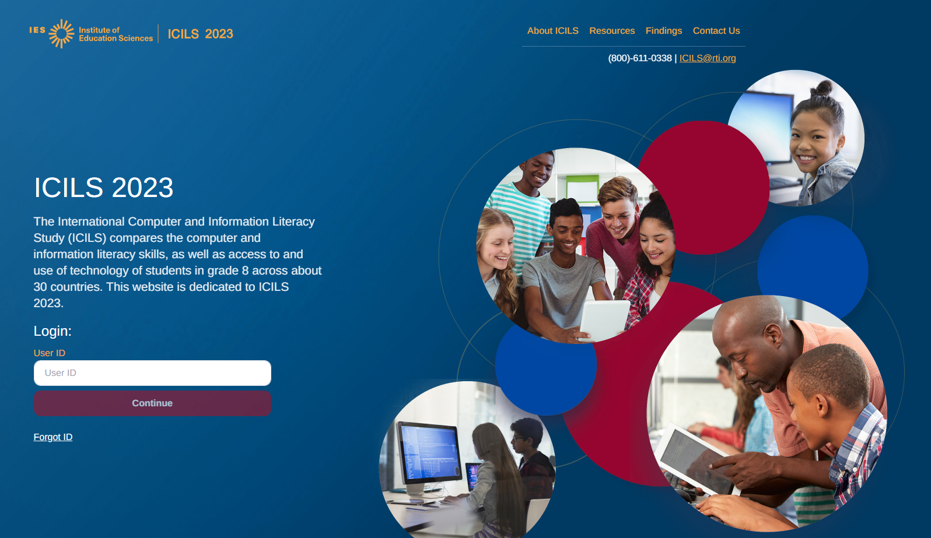

1. You will then receive an email with instructions on creating a password. After your initial login you will not need to do this step again.
2. On your first login you will see the ‘what to expect page’ which gives a brief overview of the ICILS 2023 process, then click next. 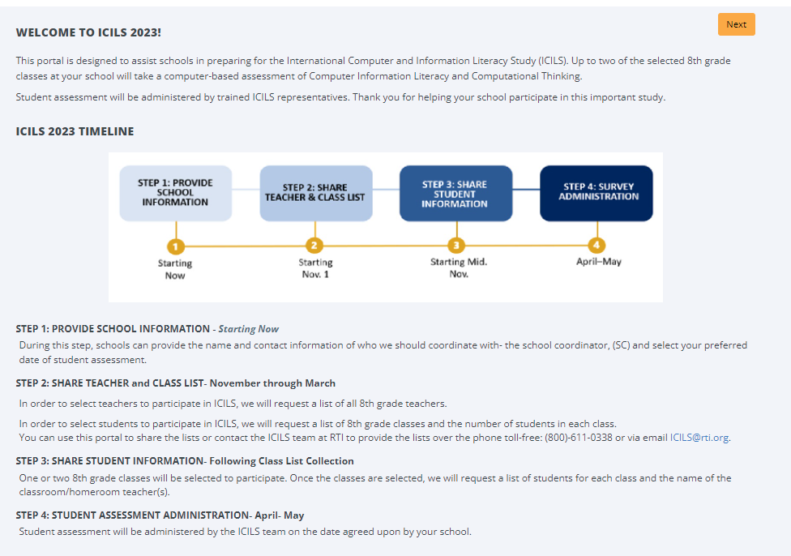

5. You will then be taken to the task menu page, that will show you the tasks you can complete (labeled as ‘In Progress”). Make sure to confirm the district and school name shown at the top of the page are correct.

Then click on the ‘Provide School Information’ task and complete the necessary information. 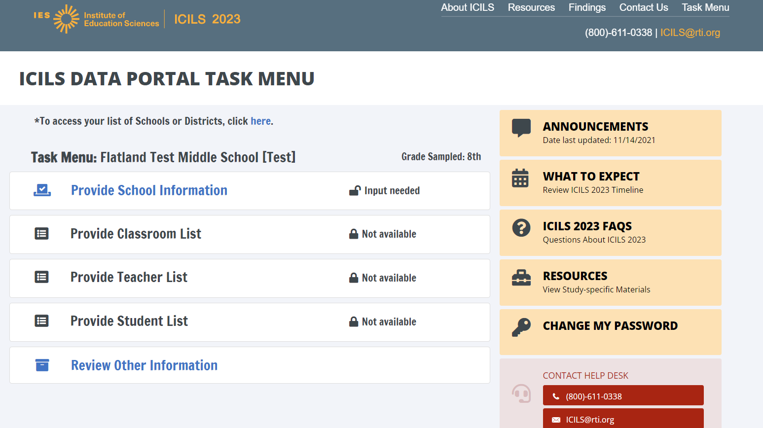

**Provide School Information (PSI)**

The first step in ICILS is to complete the **Provide School Information** page. Click the **Provide School Information** link, which is the first option on the Task Menu.

On the PSI page, there are 5 sections that you will need to either confirm the information or enter current information available for your school. Please make updates in these sections: School Address, School Principal, School Coordinator, School Assessment Date, and other Key Dates. Be sure to click submit once you fill in information for each section.

Note: You will see status: Input Needed until all required fields are filled out completely:



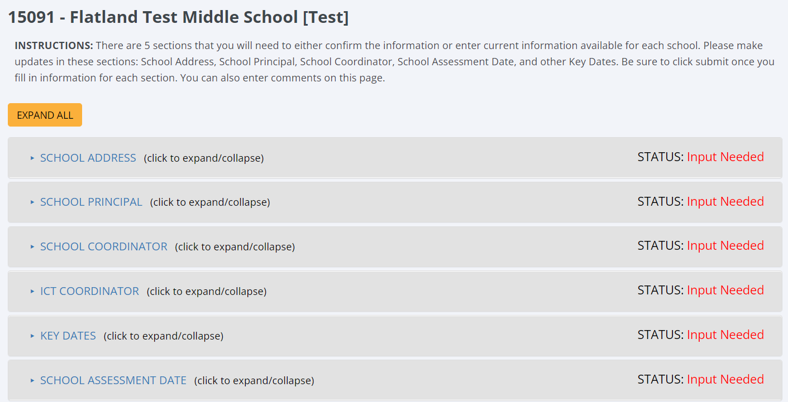

Once complete, you will see either an ‘Input Submitted’ or ‘Input Complete’ status for each section.

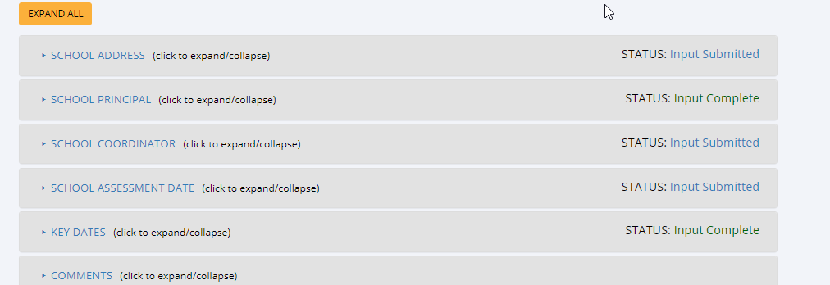

In January 2023, we will email you instructions for submitting class and teacher lists.

Thank you for you school’s participation in ICILS 2023 Main Study!

The ICILS 2023 Study Team

(800) 611-0338

ICILS@rti.org

## Appendix A14 ICILS 2023 Main Study Automated Email for School Coordinator registrant

(Yellow highlight for merge data fields; red font for customization)

Dear [school coordinator],  
  
Thank you for creating an ICILS account for the International Computer and Information Literacy Study (ICILS) Main Study on <ICILS Website URL>. ICILS is a secure website for sharing information and files related to your school’s participation in the ICILS 2023 Main Study. To access ICILS, go to <ICILS Website URL> and enter your username and password.

UserID: [usern]

Password information: You created your own password upon registering. Use the "Forgot Password" links on ICILS login page if needed. You will be prompted to change your password after 120 days.

The website’s **"What to Expect"** menu will guide you through the upcoming ICILS Main Study activities.  
  
The first step is to complete the **Provide School Information** page. If you have not already done so, please go to <https://surveys.nces.ed.gov/icils/ProvideSchoolInformation.aspx>.

In January, you will need to provide a complete and current list of **all of your school’s eighth-grade classes** for the ICILS team to randomly select one or two classes to participate in the ICILS 2023 Main Study. You will then be asked to submit lists of **all students in the selected classes**. ICILS also needs a list of **all of your school’s eighth-grade science teachers** in order to randomly select up to six teachers to complete a teacher questionnaire. We will email you in early January with instructions about how to submit the class list and teacher list through https://surveys.nces.ed.gov/icils.   
  
Please see the **attached** Summary of School Activities for a complete list of activities associated with your school’s participation in the ICILS 2023 Main Study.  
  
Thank you very much for participating in ICILS, and for playing a key role in making the assessment a success in [school name]! If you have questions or need help accessing the website, please contact the ICILS hotline at ICILS@rti.org or at (800) 611-0338 Monday through Friday between 9 a.m. and 5:00 p.m. ET.  
  
Sincerely,  
  
The ICILS 2023 Study Team  
  
*The National Center for Education Statistics (NCES) is authorized to conduct this study under the Education Sciences Reform Act of 2002 (ESRA 2002, 20 U.S.C. §9543), and to collect students’ education records from educational agencies or institutions for the purpose of evaluating federally supported education programs under the Family Educational Rights and Privacy Act (FERPA, 34 CFR §§ 99.31(a)(3)(iii) and 99.35). All of the information you provide may be used only for statistical purposes and may not be disclosed, or used, in identifiable form for any other purpose except as required by law (20 U.S.C. §9573 and 6 U.S.C. §151). In the United States, ICILS is conducted by NCES, part of the U.S. Department of Education, and the data are being collected by RTI International. The U.S. Office of Management and Budget has approved the data collection under OMB #1850-0929.*

## Appendix A15 ICILS 2023 Main Study Portal Login Page

ICILS 2023 Main Study

**Login**

The International Computer and Information Literacy Study (ICILS) compares computer and information literacy achievement at the eighth grade around the world. This website is dedicated to the ICILS 2023 U.S. data collection.

Login:

**User ID:**

User Name:

Password:

Forgot Password | Having trouble logging in?

Log In

*The National Center for Education Statistics (NCES) is authorized to conduct this study under the Education Sciences Reform Act of 2002 (ESRA 2002, 20 U.S.C. §9543), and to collect students’ education records from educational agencies or institutions for the purpose of evaluating federally supported education programs under the Family Educational Rights and Privacy Act (FERPA, 34 CFR §§ 99.31(a)(3)(iii) and 99.35). All of the information you provide may be used only for statistical purposes and may not be disclosed, or used, in identifiable form for any other purpose except as required by law (20 U.S.C. §9573 and 6 U.S.C. §151). In the United States, ICILS is conducted by NCES, part of the U.S. Department of Education, and the data are being collected by RTI International. The U.S. Office of Management and Budget has approved the data collection under OMB #1850-0929.*

**Notice: You are accessing a U.S. Government information system.**

This warning banner provides privacy and security notices consistent with applicable federal laws, directives, and other federal guidance for accessing this Government system, which includes all devices/storage media attached to this system. This system is provided for Government-authorized use only. Unauthorized or improper use of this system is prohibited and may result in disciplinary action and/or civil and criminal penalties.



## Appendix A16 ICILS 2023 Main Study Portal Home Page

Welcome to the ICILS 2023 Main Study!

This portal is designed to assist schools in preparing for the International Computer and Information Literacy Study (ICILS) Main Study, which will be conducted in 2023 at grade 8. Up to two of the selected classes at your school will take a computer-based assessment of Computer Information Literacy and Computational Thinking.

This website will help prepare for the upcoming ICILS Main Study. Student assessment will be administered by trained ICILS representatives. Thank you for helping your school participate in this important study.

ICILS 2023 TIMELINE

**STEP 1: PROVIDE SCHOOL INFORMATION: Fall, 2022**

During this step, schools can provide the name and contact information of who we should coordinate with (the school coordinator, SC) and select your preferred date of student assessment.

**STEP 2: SHARE TEACHER and CLASS LISTs- • November 2022 through January 2023**

In order to select teachers to participate in ICILS, we will request a list of all 8th grade teachers for the 2022-23 school year.

In order to select students to participate in ICILS, we will request a list of 8th grade classes and the number of students in each class. You can use this portal to share the lists or contact the ICILS team at RTI to provide the lists over the phone toll-free: (800) 611-0338 or via email ICILS@rti.org.

**STEP 3: SHARE STUDENT INFORMATION- Late January 2023**

One or two 8th grade classes will be selected to participate. Once the classes are selected, we will request a list of students for each class and the name of the classroom/homeroom teacher(s).

**STEP 4: STUDENT ASSESSMENT ADMINISTRATION- March- May 2023**

Student assessment will be administered by the ICILS team on the date agreed upon by your school.

Study screen shot:

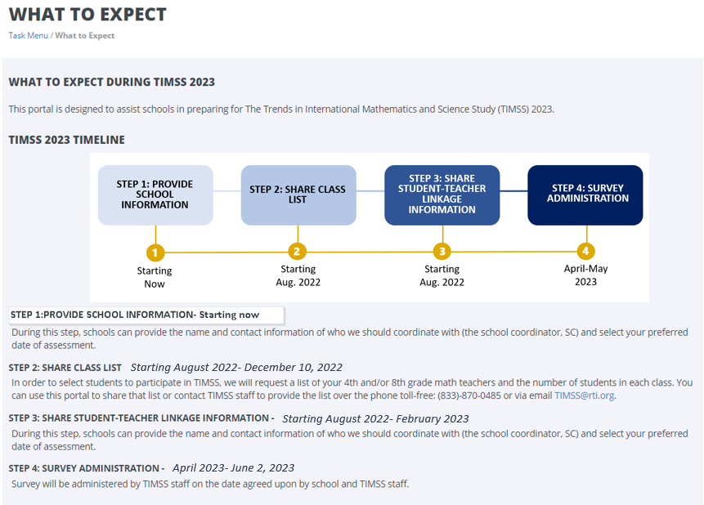



## Appendix A17 ICILS 2023 Main Study Provide School Information (PSI) Page

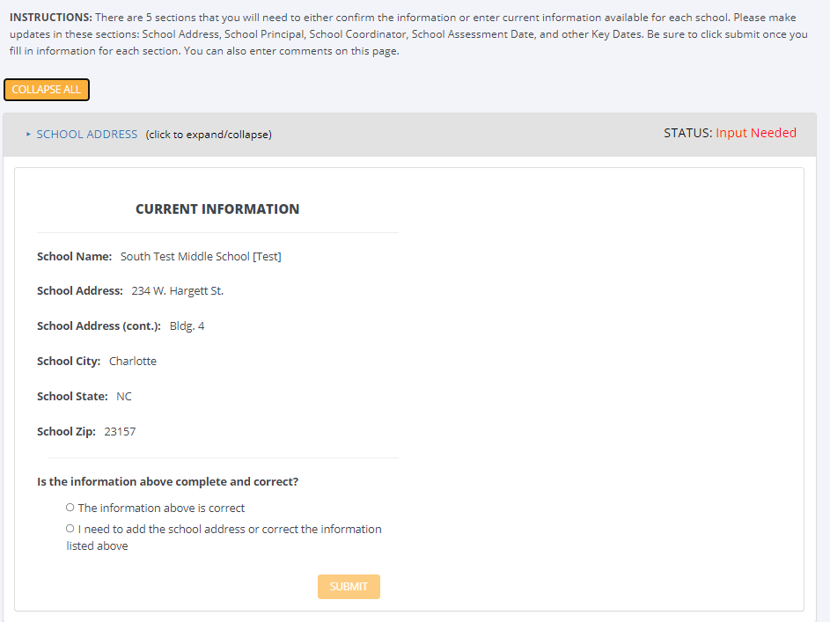

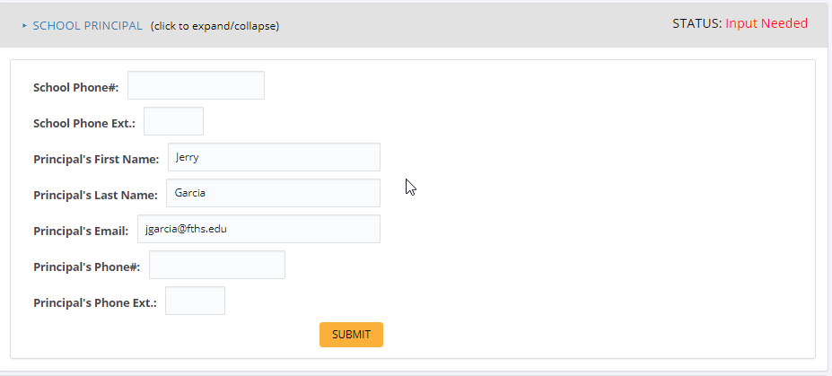

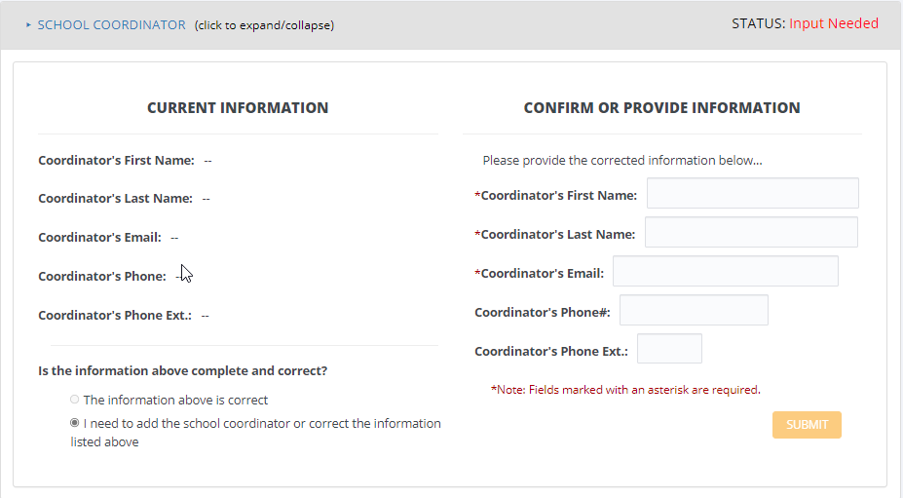

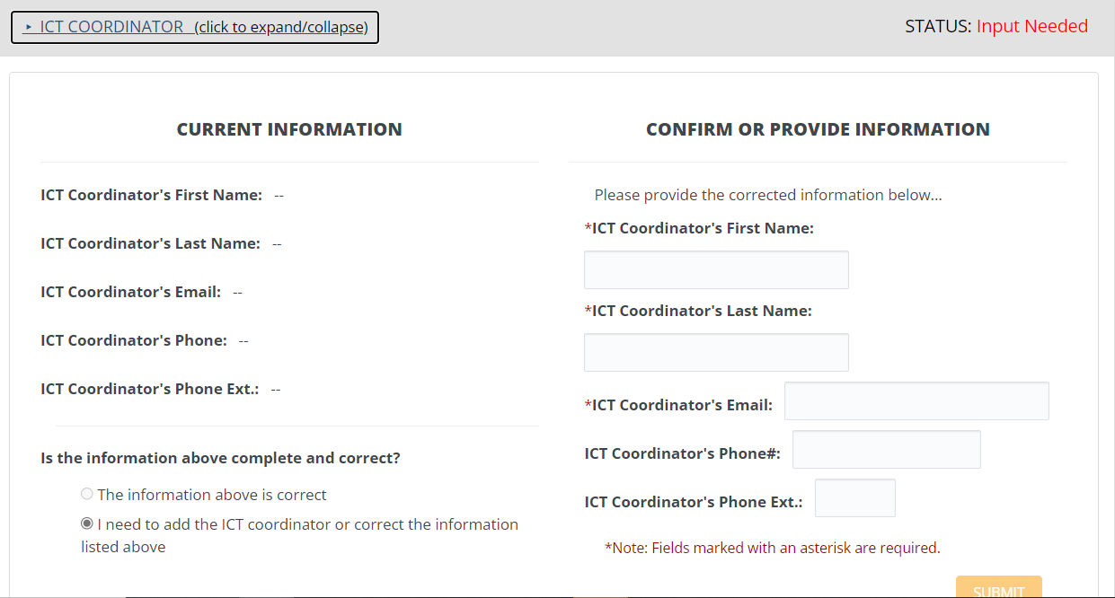

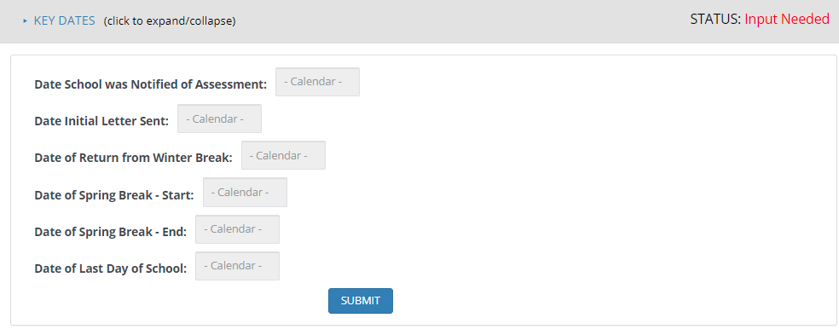 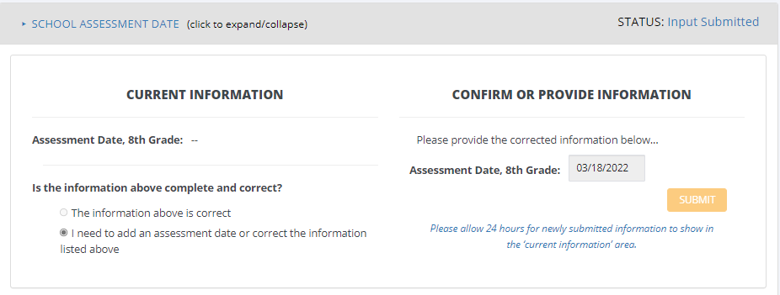

## Appendix A18 ICILS 2023 Email to School Coordinator to Submit Class Lists

Dear <School Coordinator>,

It was a pleasure speaking with you regarding ICILS 2023; thank you again for your time.

To randomly sample the 8th grade classrooms, we first need the below table completed for each of your school’s 8th grade mathematics classes. If there are multi-grade classes (i.e., students from more than one grade level in the same class), only the eight-gradestudents should be counted as a class in the list. For example, if three Grade 7 students, five Grade 8 students, and ten Grade 9 students form a multi-grade class and the target grade is 8, then the School Coordinator should record one Grade 8 class with five students in that class list.

We have 3 options for you to provide this information:

1. Go to https://surveys.nces.ed.gov/icils to submit your class list. If you have forgotten your login ID please contact the ICILS helpdesk at ICILS@rti.org or (800) 611-0338. If you have forgotten your password, you can request a new password on the ICILS login page.
2. Send your class list to [email]@rti.org
3. Call (800) 611-0338 and provide

Instructions for **Submit Class List** are attached.

If you have any questions about submitting your list, please email or call the ICILS Help Desk at ICILS@rti.org or (800) 611-0338. ​

Please submit your class list by <date>**.** ICILS will process your submission and select the sample of eighth-grade classes to be assessed. You will be informed of the classes selected within a few weeks of submitting your lists, at which time we will request the list of students in the selected classrooms.

Thank you very much for participating in ICILS, and for submitting your school's class list!

Sincerely,

The ICILS 2023 Study Team

Attachments: Instructions for submitting Grade 8 Class List

*The National Center for Education Statistics (NCES) is authorized to conduct this study under the Education Sciences Reform Act of 2002 (ESRA 2002, 20 U.S.C. §9543), and to collect students’ education records from educational agencies or institutions for the purpose of evaluating federally supported education programs under the Family Educational Rights and Privacy Act (FERPA, 34 CFR §§ 99.31(a)(3)(iii) and 99.35). All of the information you provide may be used only for statistical purposes and may not be disclosed, or used, in identifiable form for any other purpose except as required by law (20 U.S.C. §9573 and 6 U.S.C. §151). In the United States, ICILS is conducted by NCES, part of the U.S. Department of Education, and the data are being collected by RTI International. The U.S. Office of Management and Budget has approved the data collection under OMB #1850-0929.*

## Appendix A18a Instructions for Submitting Class and Teacher Lists

**ICILS Main Study: Instructions for Grade 8 Submit Class List**

ICILS needs a complete and current list of all of your school’s eighth-grade classes in order to randomly select classes to be assessed. Typically, one or two classes are sampled in each school, and all students in the selected classes will be assessed.

You can provide this information in 3 ways:

1. Complete Table A (below) and email it to ICILS@rti.org
2. Complete Table A and call the ICILS teams to provide the information over the phone
3. Login to [website], select **Submit Class List** from the navigation menu. Enter information for each eight-grade math class in the web form.

**Table A. Example Class List**

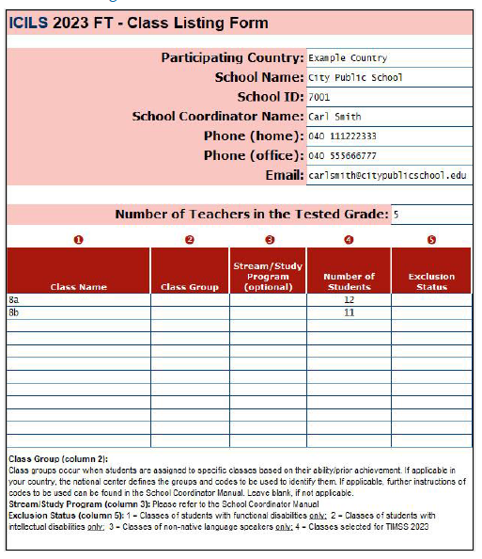

**Additional Information on Submitting Class List Online.**

**Step 1 – Enter information about all eighth-grade classes**

On https://surveys.nces.ed.gov/icils, select **Provide Class List** from the task menu. Download the class list template and complete the form. After you have completed information for each class, save the file and upload the completed form.

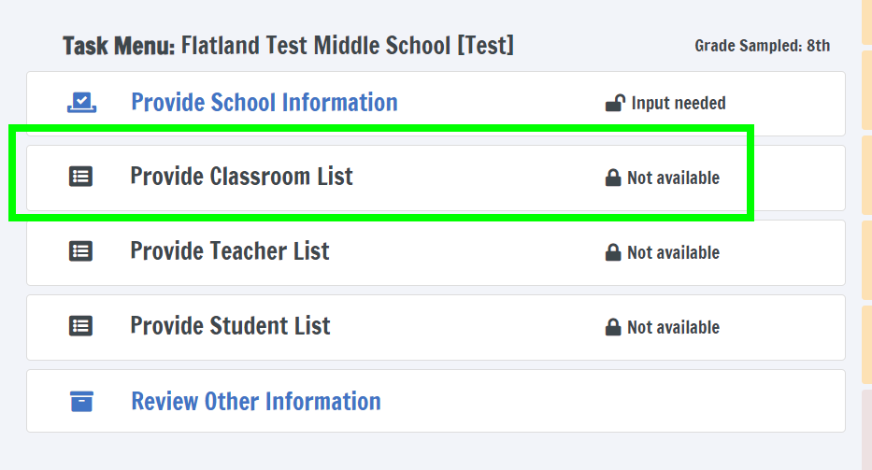

Include the following information for each class:

• *Class Name*

• *Number of Students*

• *Class Exclusion Status* (If applicable)

• *Name of Teacher*

When you have entered information for eighth-grade classes, and eighth-grade teachers, in your school, click on ‘step 2 Upload File’.

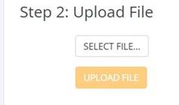

Next Step. Enter information about your eighth-grade teachers.

From https://surveys.nces.ed.gov/icils, select **provide teacher list** from the task menu and download the teach list template.

Include the following information for each teacher:

* Teacher name
* Year of birth
* Gender
* Subject domain

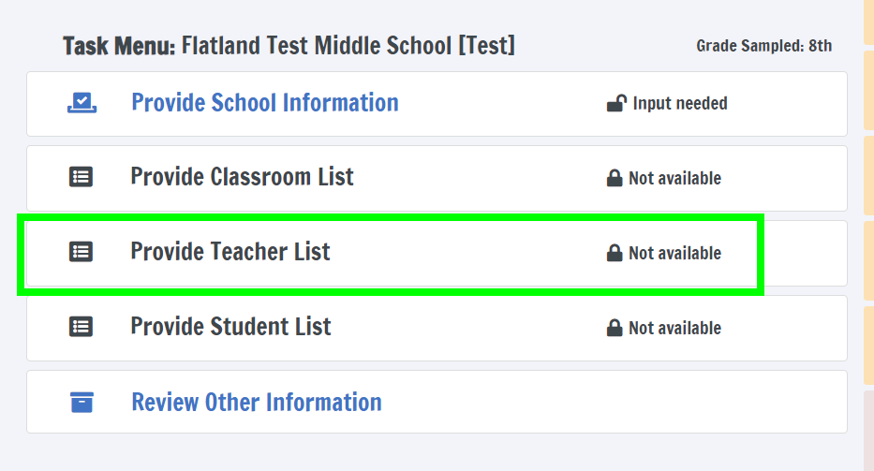

**Sample Teacher Listing Form**

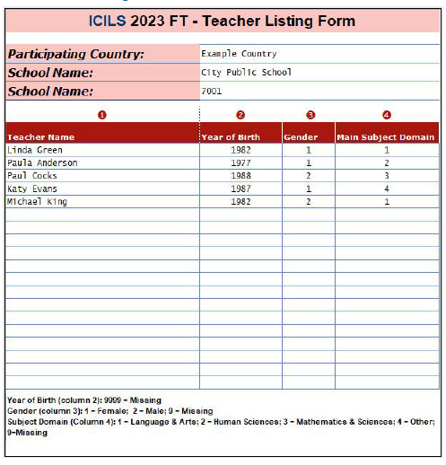

Once you have competed the teacher list, save the file and upload the completed file by selecting ‘upload file’ and navigating to your newly saved files.



**Additional tips for submitting information about your eighth-grade classes and teachers:**

• Record the Class Name in the following format, Subject_TeacherLast_Period#.

• For classes with students from more than one grade level, include in *Number of Students* only those students in grade 8. For example, if the class has 5 seventh-graders, 6 eighth- graders, and 4 ninth-graders, enter “6” as the *Number of Students* in this class.

• Use the most current enrollment information.

• Include all classes, even if they typically are excluded from your state testing program, or all students take alternate assessments. You can indicate information about the class in *Class Exclusion Status*.

* Include all teachers who teach eighth grade core subjects (English, Mathematics, Social Studies, Science).
* Save a list of the classes and teachers you included for your future reference.

**If you need assistance, email**  [**ICILS@rti.org**](mailto:%20icils@rti.org%20) **or call (800) 611-0338.**

## Appendix A19 ICILS 2023 Email to School Coordinator for submitting the student listing forms

Dear <<School Coordinator>>,

Thank you for providing the complete list of 8th grade classrooms; thank you again for your time. We have sampled <fill number of classrooms> of your school’s 8th grade classrooms.

**Sampled Classrooms**

* <fill classroom 2>
* <fill classroom 3>
* <fill classroom 5>

We will now need the Student List Form of these sampled classrooms. In order to ensure data security, this information needs to be submitted through our secure website. Go to https://surveys.nces.ed.gov/icils to submit your Student List Form. If you have forgotten your login ID please contact the ICILS helpdesk at ICILS@rti.org or (800) 611-0338. If you have forgotten your password, you can request a new password on the ICILS login page.

Instructions for **Provide Student-Listing Form** are attached. These instructions and Excel templates can also be found on the **Provide Student List Task** of <https://surveys.nces.ed.gov/ICILS>.

If you have any questions about submitting your list, please email or call the ICILS Help Desk at [ICILS@rti.org](mailto:icils@rti.org) or (800) 611-0338. ​

Please provide your Student List Form by <<date>>**.** ICILS will process your submission and will be in touch to coordinate the session and schedule the session date.

Thank you very much for participating in ICILS, and for submitting your school's Class, Teacher, and Student-Listing Forms!

Sincerely,

ICILS 2023 Study Team

Attachments: Instructions for submitting the Grade 8 Student List Form

*The National Center for Education Statistics (NCES) is authorized to conduct this study under the Education Sciences Reform Act of 2002 (ESRA 2002, 20 U.S.C. §9543), and to collect students’ education records from educational agencies or institutions for the purpose of evaluating federally supported education programs under the Family Educational Rights and Privacy Act (FERPA, 34 CFR §§ 99.31(a)(3)(iii) and 99.35). All of the information you provide may be used only for statistical purposes and may not be disclosed, or used, in identifiable form for any other purpose except as required by law (20 U.S.C. §9573 and 6 U.S.C. §151). In the United States, ICILS is conducted by NCES, part of the U.S. Department of Education, and the data are being collected by RTI International. The U.S. Office of Management and Budget has approved the data collection under OMB #1850-0929.*

## Appendix A20 Instructions for Submitting Student Listing Forms

**ICILS 2023 Main Study: Instructions for Grade 8 Submit Student Listing Form**

After classes are sampled, ICILS needs a complete and current list of **all students** in those classes to prepare for their participation in the assessment.

You may use the **ICILS Grade 8 Excel Templates** (located on the Provide Student List Taskon <https://surveys.nces.ed.gov/icils> and described below) or you may provide an Excel file with the same information. If you cannot submit your student data with this information in an Excel file, please call or email the ICILS File Help Desk at [ICILS@rti.org](mailto:icils@rti.org) or (800) 611-0338.

**Step 1 – Compile Data in an Excel File**

For each selected class, prepare an Excel file with the following data elements for all students in the selected grade 8 classroom

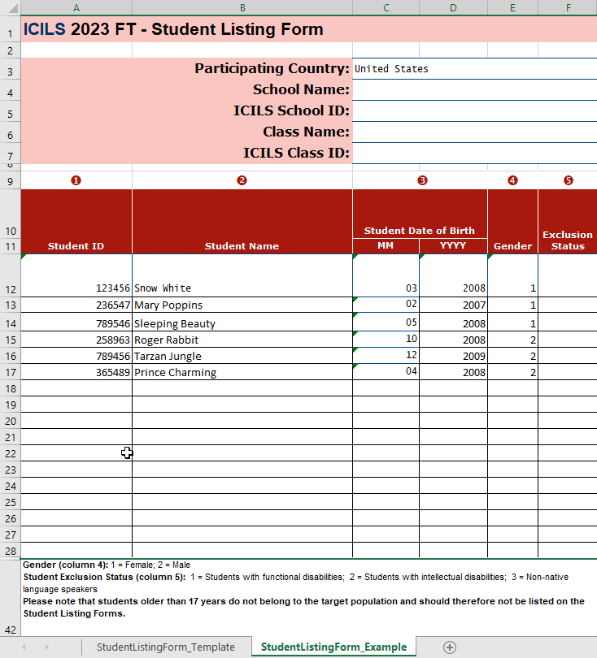

You may use the templates provided or create your own Excel file with these data for each student. It is preferred that you include column headers as the first row in your E-File, as in these templates. However, Files without column headers will be accepted.

Tips for ensuring the File process goes smoothly:

• Use the template or provide column headers.

* There should be no empty rows within the student data.

• Be sure to give your file a unique, descriptive name. Within Excel, click on *File*, then *Save As*,

and give your file a name such as “Your School Name Grade 8.xls.”

• The first row of data in your file will be read as the column header unless you indicate otherwise on the **Submit Student List** webpage. Each succeeding row will be considered a student record.

• There should be only one worksheet with data in the Excel file. If there are other worksheets, they must not contain any data.

**Step 2 – Upload Your Excel File**

Once your file is prepared and checked for accuracy and completeness, login to https://surveys.nces.ed.gov/icils and select “Provide Student List” from the task menu.

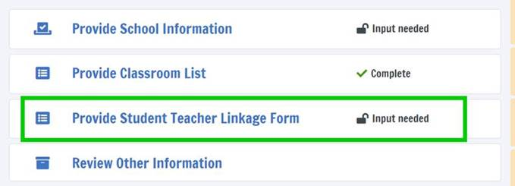



**Step 3 –RTI Staff will review**

Once you have uploaded your file RTI staff will be notified and will review your file. Should there be any questions about the column headings or values, a RTI staff member will reach out to you.

**If you need assistance, please contact the ICILS File Help Desk at**  [**ICILS@rti.org**](mailto:%20icils@rti.org%20) **or (800) 611-0338.**

## Appendix A21 ICILS 2023 Main Study Prepare for Assessment Page

**Prepare for Assessment**

Thank you for providing information about all the eighth-grade classes in your school! After submitting the class and teacher lists, you will receive an email telling you that one or two of the classes has been selected. Please upload a student list for each sampled class.

**You will receive the following documents:**

**Student Tracking Form (STF)–**The forms list the students in the sampled classes and will participate in the assessment at your school. Instructions on how to access and review the forms are in the Documents section on this website. The STF will become available about a week after the student list for each sample class has been posted.

**Sample Parent Notification Letter and Facts for Parents about ICILS**. You will receive a packet of sample parent/guardian notification letter and an ICILS Parent FAQ

A sample parent/guardian notification letter is in the Documents section for you to customize and print on your school letterhead. Please distribute the parent notification letter and the Parent FAQ (from our FedEx mailing to you) to the parents of the selected classes prior to the assessment. You can also share the Parent FAQ link available here: <https://surveys.nces.ed.gov/icils/Home/Resources>.

As your assessment date approaches, the ICILS team will be contacting you to finalize the assessment day activities.

## Appendix A22 ICILS 2023 Main Study Student Tracking Form (STF) Email to SC

Dear <School Coordinator>,

Thank you for providing information about all the eighth-grade classes in your school! The list of students and teachers selected to participate in ICILS 2023 Main Study is now available in the Student Tracking Forms (STF) available on the ICILS website. Please see below for more details about the forms and parent notification.

* Student Tracking Form (STF) –The forms list the students who are in the sampled classes and will participate in the assessment at your school. Instructions on how to access and review the forms are attached.
* Sample Parent Notification Letter and Facts for Parents about ICILS 2023 Main Study (Parent FAQ) – A sample parent/guardian notification letter is attached for you to customize and print on your school letterhead. Please distribute the parent notification letter and the *Facts for Parents about ICILS 2023 Main Study* to the parents of the selected students prior to the assessment.
* FedEx Shipment
  + Within a week, a FedEx shipment of hard-copies of the *Facts for Parents* *about ICILS 2023 Main Study (Parent FAQ)* will be delivered to you. You can also distribute them electronically or share the Parent FAQ link available here: <https://surveys.nces.ed.gov/icils/Home/Resources>
  + As your assessment date approaches, the ICILS team will be contacting you to finalize the assessment day activities and discuss accommodations, if necessary.

If you have any questions, please do not hesitate to call (800) 611-0338 or send an email to [ICILS@rti.org](mailto:icils@rti.org). You may also get more information about this study by visiting the ICILS website at <https://surveys.nces.ed.gov/ICILS>.

Thank you for your assistance with this study!

Sincerely,

The ICILS 2023 Study Team

Attachments:

Sample Parent Notification Letter

Facts for Parents about ICILS 2023 Main Study (Parent FAQ)

STF Instructions

*The National Center for Education Statistics (NCES) is authorized to conduct this study under the Education Sciences Reform Act of 2002 (ESRA 2002, 20 U.S.C. §9543), and to collect students’ education records from educational agencies or institutions for the purpose of evaluating federally supported education programs under the Family Educational Rights and Privacy Act (FERPA, 34 CFR §§ 99.31(a)(3)(iii) and 99.35). All of the information you provide may be used only for statistical purposes and may not be disclosed, or used, in identifiable form for any other purpose except as required by law (20 U.S.C. §9573 and 6 U.S.C. §151). In the United States, ICILS is conducted by NCES, part of the U.S. Department of Education, and the data are being collected by RTI International. The U.S. Office of Management and Budget has approved the data collection under OMB #1850-0929.*

## Appendix A23 Instructions for ICILS 2023 Main Study Student Tracking Form (STF)

**Reviewing the Student Tracking Form (STF)**

The two **Student Tracking Form** (STF) lists the students who will participate in the assessment at your school. This list is based on the student information you submitted. You can take notes on this form in preparation for the pre-assessment call in which the ICILS team will ask you about any updates to this form over the phone. To access the STF, please login at https://surveys.nces.ed.gov/icils, then go to **Prepare for Assessment** and select **“Click here to download the STF.”**

As the first step in reviewing the Student Tracking Form, please verify the student information for accuracy after you open the excel file you just downloaded. See below for what should be reviewed. Please also make sure the school name and students match what you expect.

* Student’s name is listed in **Column 1**.
* Date of birth is listed in **Column 4.**
* Gender (using codes—1 for female and 2 for male) is listed in **Column 5**.
* Exclusion status in **Column 6.**
* Participation status in **Column 7.**

**Student Exclusions and Accommodations**

If a student is to be excluded from the assessment because he or she requires an accommodation, please make a note in column 6 using the codes at the bottom of the STF.

**Participation Status + Newly-enrolled or no-longer-enrolled students**

If many of the students listed in the STF are not enrolled in the school, please contact ICILS@rti.org ASAP, but you do not need to contact ICILS@rti.org if only 1 to 3 students are no longer enrolled or are newly enrolled. These new or no-longer-enrolled students can be discussed with the ICILS team when they call you for the pre-assessment call (usually 1-2 weeks before assessment date). You can make a note on the form regarding these students in the first column in column 7 using the status codes shown at the bottom of the STF. You can also use status codes 1 through 4 to provide more information about a student.

**Updates and Questions**

If you have updates to the STF, please have the form ready for the pre-assessment call. You can also provide the hardcopy to the ICILS team when they come to your school on assessment day. If you have any questions about completing this form, please address them with the ICILS team when they contact you. For urgent questions on the STF, you can also contact us at ICILS@rti.org. The STF is just for you to take notes on in preparation for the pre-assessment call so you know parents of which students should be notified. Please do not send the STF back to us. You can however give it to the ICILS team in person, if you would like, when they come on the assessment day.

## Appendix A24 School Principal Questionnaire Login Email

Welcome to ICILS 2023 Main Study!

Your school is participating in the Main Study for International Computer and Information Literacy Study (ICILS) 2023. This online questionnaire seeks information about schools and provides important context to understanding the achievement of students taking the assessment.

Please go to the web address (URL) given below and log in to the online principal questionnaire with your “User ID” and “Password”, which are below. Please contact the ICILS hotline ([ICILS@rti.org](mailto:icils@rti.org)) if you have problems logging on. The website link is: [hyperlink]

**User ID: [User ID]**

**Password: [Password]**

Responses are saved automatically as you go from question to question. The “Table of Contents” link on the bottom of each page provides an overview of all questions and whether you have completed them. You may leave the questionnaire at any time and log in again later. You must click “Finish” at the last page for us to receive your submission. See notes below.

NOTES

* Please use the Previous and Next buttons to navigate backward and forward
* You may exit the questionnaire at any time and log in again later— all of your responses will be saved automatically.
* The Table of Contents provides an overview of all questions and shows whether you have completed all questions.
* To exit the Table of Contents, click on any question link or section header.
* If you would like to print copy of the online questionnaire, click on the “Prepare Printer Version” link on the Table of Contents page.
* It is estimated that it will take approximately 15 minutes to complete the questionnaire.
* If you have problems accessing the online questionnaire or need assistance, please contact the ICILS hotline at (800) 611-0338 or email ICILS@rti.org.

Thank you for the thought, time, and effort you have put into completing the questionnaire!

Sincerely,

The ICILS 2023 Study Team

*The National Center for Education Statistics (NCES) is authorized to conduct this study under the Education Sciences Reform Act of 2002 (ESRA 2002, 20 U.S.C. §9543), and to collect students’ education records from educational agencies or institutions for the purpose of evaluating federally supported education programs under the Family Educational Rights and Privacy Act (FERPA, 34 CFR §§ 99.31(a)(3)(iii) and 99.35). All of the information you provide may be used only for statistical purposes and may not be disclosed, or used, in identifiable form for any other purpose except as required by law (20 U.S.C. §9573 and 6 U.S.C. §151). In the United States, ICILS is conducted by NCES, part of the U.S. Department of Education, and the data are being collected by RTI International. The U.S. Office of Management and Budget has approved the data collection under OMB #1850-0929.*

## Appendix A25 Teacher Questionnaire Login Email

Welcome to ICILS 2023 Main Study!

Your school is participating in the Main Study for the International Computer and Information Literacy Study (ICILS) 2023. You have been randomly selected to complete a 30-minute questionnaire to provide insight into school and classroom contexts for information and communication technology learning, use of information and communication technology for teaching and learning, and teacher views on and confidence in using computers. <You will receive $25 as a thank you for participating.>

Please go to the web address (URL) given below and log in to the online teacher questionnaire with your “User ID” and “Password”, which are below. Please contact the ICILS hotline ([ICILS@rti.org](mailto:TIMSS@westat.com)) if you have problems logging on.

**Website: [Web address]**

**User ID: [User ID]**

**Password: [Password]**

Responses are saved automatically as you go from question to question. The “Table of Contents” link on the bottom of each page provides an overview of all questions and whether you have completed them. You may leave the questionnaire at any time and log in again later. You must click “Finish” at the last page for us to receive your submission.

If you have problems accessing the online questionnaire or need assistance, please contact the ICILS hotline at (800) 611-0338 or email [ICILS@rti.org](mailto:TIMSS@westat.com).

Thank you for the thought, time, and effort you have put into completing the questionnaire!

Sincerely,

The ICILS 2023 Study Team

*The National Center for Education Statistics (NCES) is authorized to conduct this study under the Education Sciences Reform Act of 2002 (ESRA 2002, 20 U.S.C. §9543), and to collect students’ education records from educational agencies or institutions for the purpose of evaluating federally supported education programs under the Family Educational Rights and Privacy Act (FERPA, 34 CFR §§ 99.31(a)(3)(iii) and 99.35). All of the information you provide may be used only for statistical purposes and may not be disclosed, or used, in identifiable form for any other purpose except as required by law (20 U.S.C. §9573 and 6 U.S.C. §151). In the United States, ICILS is conducted by NCES, part of the U.S. Department of Education, and the data are being collected by RTI International. The U.S. Office of Management and Budget has approved the data collection under OMB #1850-0929.*

## Appendix A26 ICT Coordinator Selection Email

Welcome to ICILS 2023 Main Study!

Your school is participating in the Main Study for the International Computer and Information Literacy Study (ICILS) 2023. This online questionnaire takes about 15 minutes and seeks information about computer use, ICT resources, and relevant policies and practices in the school context. <You will receive $25 as a thank you for participating.>

Please go to the web address (URL) given below and log in to the online questionnaire with your “User ID” and “Password”, which are below. Please contact the ICILS hotline ([ICILS@rti.org](mailto:TIMSS@westat.com)) if you have problems logging on.

**Website: [Web address]**

**User ID: [User ID]**

**Password: [Password]**

Responses are saved automatically as you go from question to question. The “Table of Contents” link on the bottom of each page provides an overview of all questions and whether you have completed them. You may leave the questionnaire at any time and log in again later. You must click “Finish” at the last page for us to receive your submission.

If you have problems accessing the online questionnaire or need assistance, please contact the ICILS hotline at (800) 611-0338 or email [ICILS@rti.org](mailto:TIMSS@westat.com).

Thank you for the thought, time, and effort you have put into completing the questionnaire!

Sincerely,

The ICILS 2023 Study Team

*The National Center for Education Statistics (NCES) is authorized to conduct this study under the Education Sciences Reform Act of 2002 (ESRA 2002, 20 U.S.C. §9543), and to collect students’ education records from educational agencies or institutions for the purpose of evaluating federally supported education programs under the Family Educational Rights and Privacy Act (FERPA, 34 CFR §§ 99.31(a)(3)(iii) and 99.35). All of the information you provide may be used only for statistical purposes and may not be disclosed, or used, in identifiable form for any other purpose except as required by law (20 U.S.C. §9573 and 6 U.S.C. §151). In the United States, ICILS is conducted by NCES, part of the U.S. Department of Education, and the data are being collected by RTI International. The U.S. Office of Management and Budget has approved the data collection under OMB #1850-0929.*

## Appendix A27 Principal Questionnaire Reminder Email

Hello,

This is a gentle reminder to please complete the International Computer and Information Literacy Study (ICILS) 2023 Main Study online principal questionnaire. This online questionnaire takes about 15 minutes and seeks information about computer use, ICT resources, and relevant policies and practices in the school context.

Please go to the web address (URL) given below and log in to the online questionnaire with your “User ID” and “Password”, which are below. Please contact us at [ICILS@rti.org](mailto:TIMSS@westat.com) if you have problems logging on.

**Website: [Web address]**

**User ID: [User ID]**

**Password: [Password]**

Responses are saved automatically as you go from question to question. The “Table of Contents” link on the bottom of each page provides an overview of all questions and whether you have completed them. You may leave the questionnaire at any time and log in again later. You must click “Finish” at the last page for us to receive your submission. See notes below.

NOTES

* Please use the Previous and Next buttons to navigate backward and forward
* You may exit the questionnaire at any time and log in again later— all of your responses will be saved automatically.
* The Table of Contents provides an overview of all questions and shows whether you have completed all questions.
* To exit the Table of Contents, click on any question link.
* If you would like a printed copy of the online questionnaire, click on the “Prepare Printer Version” link on the Table of Contents page.
* It is estimated that it will take approximately 15 minutes to complete the questionnaire.
* You must click “Finish” at the last page for us to receive your submission.
* If you have problems accessing the online questionnaire or need assistance, please contact the ICILS hotline at (800) 611-0338 or email [ICILS@rti.org](mailto:TIMSS@westat.com).
* If you would prefer to complete a paper questionnaire, please contact your ICILS School Coordinator.

Thank you for the thought, time, and effort you have put into completing the questionnaire!

Sincerely,

The ICILS 2023 Study Team

*The National Center for Education Statistics (NCES) is authorized to conduct this study under the Education Sciences Reform Act of 2002 (ESRA 2002, 20 U.S.C. §9543), and to collect students’ education records from educational agencies or institutions for the purpose of evaluating federally supported education programs under the Family Educational Rights and Privacy Act (FERPA, 34 CFR §§ 99.31(a)(3)(iii) and 99.35). All of the information you provide may be used only for statistical purposes and may not be disclosed, or used, in identifiable form for any other purpose except as required by law (20 U.S.C. §9573 and 6 U.S.C. §151). In the United States, ICILS is conducted by NCES, part of the U.S. Department of Education, and the data are being collected by RTI International. The U.S. Office of Management and Budget has approved the data collection under OMB #1850-0929.*

## Appendix A28 Teacher Questionnaire Reminder Email

Hello,

This is a reminder to complete the International Computer and Information Literacy Study (ICILS) 2023 online teacher questionnaire. With the dramatic shift to virtual learning in 2020, the results of the 2023 ICILS are more important than ever in understanding the role of technology in education and perspectives of teachers are vital to this understanding. <You will receive $25 as a thank you for participating.>

Please go to the web address (URL) given below and log in to the online questionnaire with your “User ID” and “Password”, which are below. Please contact us at [ICILS@rti.org](mailto:TIMSS@westat.com) if you have problems logging on.

**Website: [Web address]**

**User ID: [User ID]**

**Password: [Password]**

If you have problems accessing the online questionnaire or need assistance, please contact the ICILS hotline at (800) 611-0338 or email [ICILS@rti.org](mailto:TIMSS@westat.com).

Thank you for the thought, time, and effort you have put into completing the questionnaire!

Sincerely,

The ICILS 2023 Study Team

*The National Center for Education Statistics (NCES) is authorized to conduct this study under the Education Sciences Reform Act of 2002 (ESRA 2002, 20 U.S.C. §9543), and to collect students’ education records from educational agencies or institutions for the purpose of evaluating federally supported education programs under the Family Educational Rights and Privacy Act (FERPA, 34 CFR §§ 99.31(a)(3)(iii) and 99.35). All of the information you provide may be used only for statistical purposes and may not be disclosed, or used, in identifiable form for any other purpose except as required by law (20 U.S.C. §9573 and 6 U.S.C. §151). In the United States, ICILS is conducted by NCES, part of the U.S. Department of Education, and the data are being collected by RTI International. The U.S. Office of Management and Budget has approved the data collection under OMB #1850-0929.*

## Appendix A29 ICT Coordinator Questionnaire Reminder Email

Hello,

This is a reminder to complete the International Computer and Information Literacy Study (ICILS) 2023 online ICT Coordinator questionnaire. With the dramatic shift to virtual learning in 2020, the results of the 2023 ICILS are more important than ever. As your school’s ICT Coordinator your responses to this online questionnaire are vital to understanding how computers are used as your schools, what ICT resources are available, and relevant policies and practices in the school context. <You will receive $25 as a thank you for participating.>

Please go to the web address (URL) given below and log in to the online questionnaire with your “User ID” and “Password”, which are below. Please contact us at [ICILS@rti.org](mailto:TIMSS@westat.com)) if you have problems logging on.

**Website: [Web address]**

**User ID: [User ID]**

**Password: [Password]**

If you have problems accessing the online questionnaire or need assistance, please contact the ICILS hotline at (800) 611-0338 or email [ICILS@rti.org](mailto:TIMSS@westat.com).

Thank you for the thought, time, and effort you have put into completing the questionnaire!

Sincerely,

The ICILS 2023 Study Team

*The National Center for Education Statistics (NCES) is authorized to conduct this study under the Education Sciences Reform Act of 2002 (ESRA 2002, 20 U.S.C. §9543), and to collect students’ education records from educational agencies or institutions for the purpose of evaluating federally supported education programs under the Family Educational Rights and Privacy Act (FERPA, 34 CFR §§ 99.31(a)(3)(iii) and 99.35). All of the information you provide may be used only for statistical purposes and may not be disclosed, or used, in identifiable form for any other purpose except as required by law (20 U.S.C. §9573 and 6 U.S.C. §151). In the United States, ICILS is conducted by NCES, part of the U.S. Department of Education, and the data are being collected by RTI International. The U.S. Office of Management and Budget has approved the data collection under OMB #1850-0929.*

## Appendix A29A School Staff Questionnaire Letter

<DATE>

Your login information:

Website: <insert URL>

Study ID: <ID>

Password: <Password>

< NAME>

<SCHOOL NAME>

<ADDR1>

<ADDR2>

<CITY STATE ZIP>

Dear < NAME>,

[School Name] is participating in an important international study: the International Computer and Information Literacy Study 2023 (ICILS). The ICILS study is administered once every 5 years and provides crucial information on U.S. students’ skills and experience using technology compared with that of our peer countries around the world. In addition to an assessment of students’ computer and information skills, ICILS provides information on factors such as teachers’ experiences and school resources in support of computer and information literacy education.

We are asking you to complete a <30>-minute questionnaire to provide insight into the role of technology in your school. Your participation is voluntary and very important to the success of this study. <As a token of our appreciation, you will receive [incentive] for completing the questionnaire.>

*Results from the 2018 ICILS indicated that only about 50% of 8th grade teachers used information and communications technologies in teaching. With the dramatic shift to virtual learning in 2020 the results of the 2023 ICILS are more important than ever in understanding the role of technology in education.*

To access the online questionnaire, use the web address and unique study ID and password provided at the top of this letter.

Should you have any questions, please call (800) 611-0338 or email ICILS@rti.org.

Your participation in ICILS is very important to its success. We thank you in advance for your cooperation in making this important research study a success.

Sincerely,

Peggy G. Carr, Ph.D.

Commissioner, National Center for Education Statistics

Enclosures: Study Brochure and Frequently Asked Questions

*The National Center for Education Statistics (NCES) is authorized to conduct this study under the Education Sciences Reform Act of 2002 (ESRA 2002, 20 U.S.C. §9543), and to collect students’ education records from educational agencies or institutions for the purpose of evaluating federally supported education programs under the Family Educational Rights and Privacy Act (FERPA, 34 CFR §§ 99.31(a)(3)(iii) and 99.35). All of the information you provide may be used only for statistical purposes and may not be disclosed, or used, in identifiable form for any other purpose except as required by law (20 U.S.C. §9573 and 6 U.S.C. §151). In the United States, ICILS is conducted by NCES, part of the U.S. Department of Education, and the data are being collected by RTI International. The U.S. Office of Management and Budget has approved the data collection under OMB #1850-0929.*

## Appendix A30 Online Questionnaire Login Screen Text

(for the Principal, Teachers, ICT Coordinator)

ICILS 2023 Main Study - English (United States)

You are not logged in.

Welcome to the IEA - DPC Survey System

Online Questionnaires

Please enter your user ID and password (Checksum).

User ID:

Password:

The National Center for Education Statistics (NCES), within the U.S. Department of Education, conducts ICILS in the United States as authorized by the Education Sciences Reform Act of 2002 (ESRA 2002, 20 U.S.C. §9543). All of the information you provide may be used only for statistical purposes and may not be disclosed, or used, in identifiable form for any other purpose except as required by law (20 U.S.C. §9573 and 6 U.S.C. §151).

According to the Paperwork Reduction Act of 1995, no persons are required to respond to a collection of information unless such collection displays a valid OMB control number. The valid OMB control number for this voluntary information collection is 1850-0929. The time required to complete this information collection is estimated to average 15 minutes per principal, 30 minutes per teacher, and 15 minutes per ICT Coordinator, including the time to review instructions, search existing data resources, gather the data needed, and complete and review the information collection. If you have any comments or concerns regarding the accuracy of the time estimate(s), suggestions for improving the form, or questions about the status of your individual submission of this form, write directly to: International Computer and Information Literacy Study (ICILS), National Center for Education Statistics, Potomac Center Plaza (PCP), 550 12th St., SW, 4th floor, Washington, DC 20202.

OMB No. 1850-0929, Approval Expires xx/xx/xxxx.

© IEA Online Survey System 2023 - Help

## Appendix A31 ICILS 2023 Main Study Resources Page

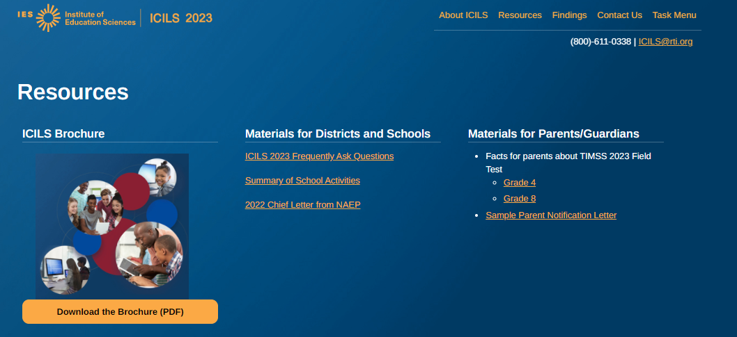

## Appendix A32 ICILS 2023 Main Study Findings and Contact Us Pages

Findings

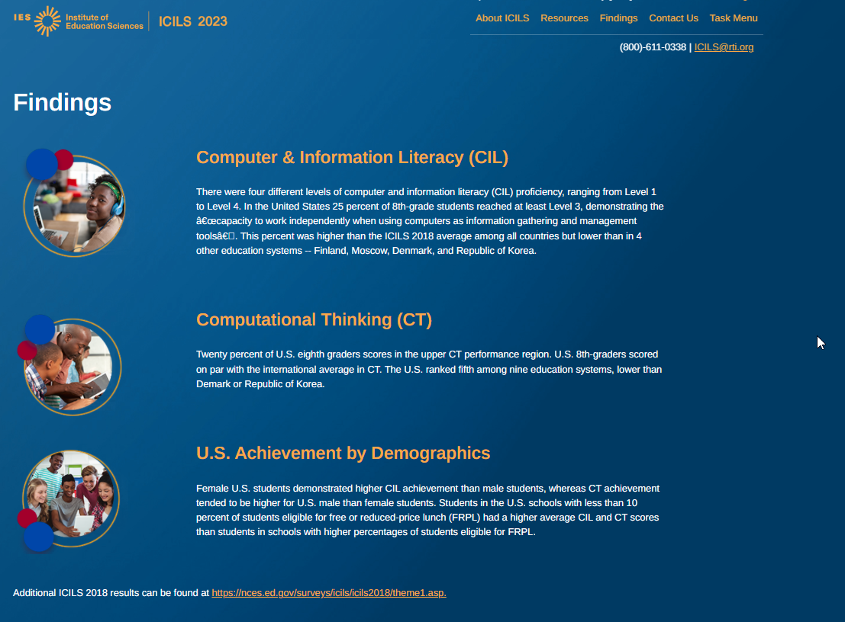

Contact us Page: 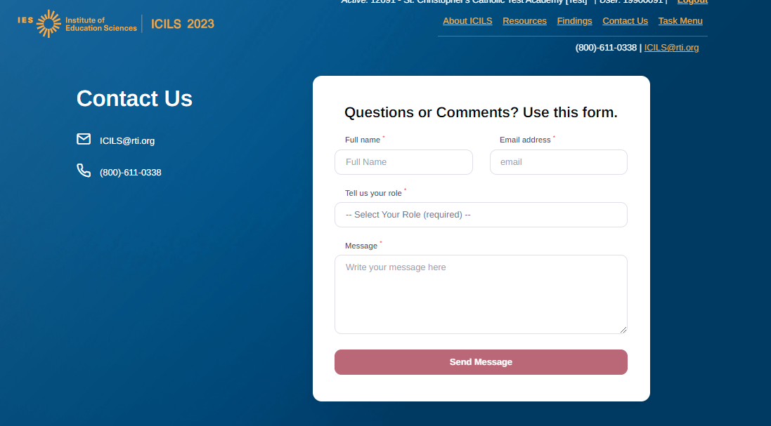

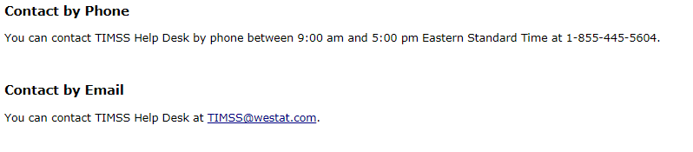

## Appendix A33 Student Login Card

(label with login information will be affixed to the card for the in-school student assessment)

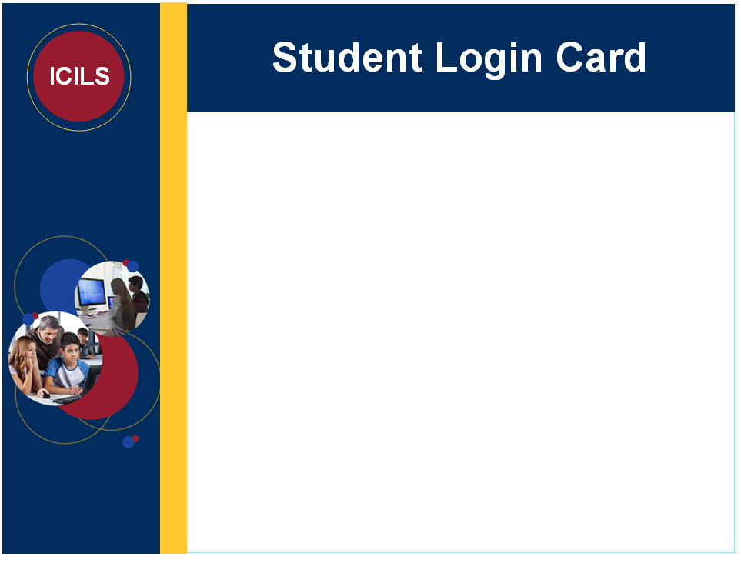

## Appendix A33a ICILS 2023 Teacher, ICT Coordinator and Administrator Reminder Card

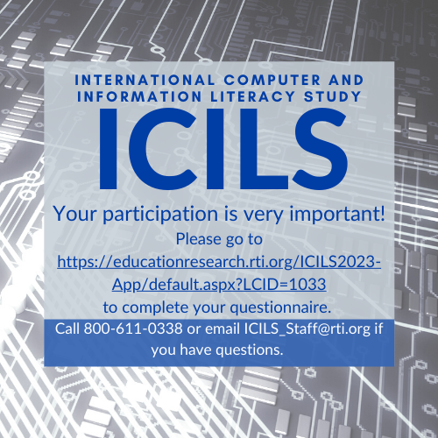

## Appendix A34 Student Certificate of Completion

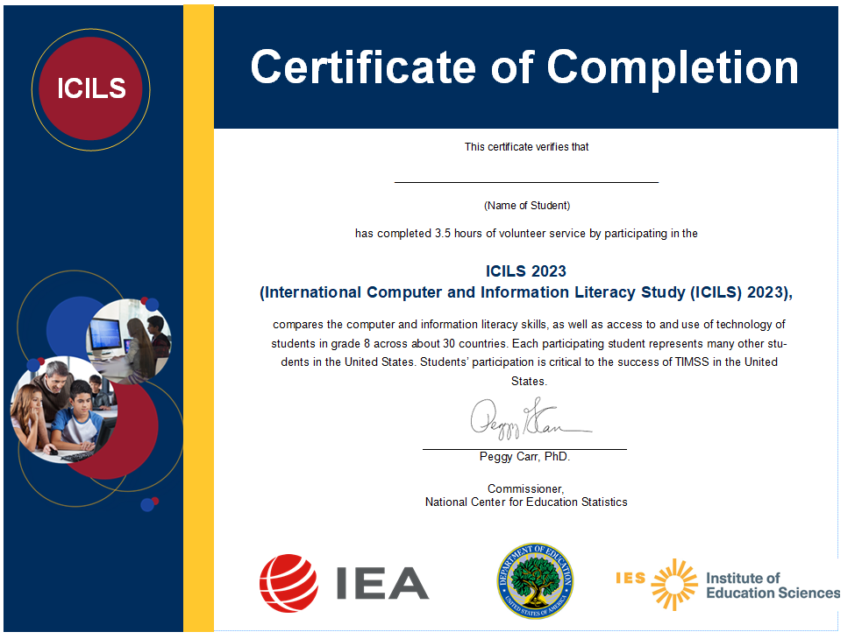

## Appendix A35 School Certificate of Completion

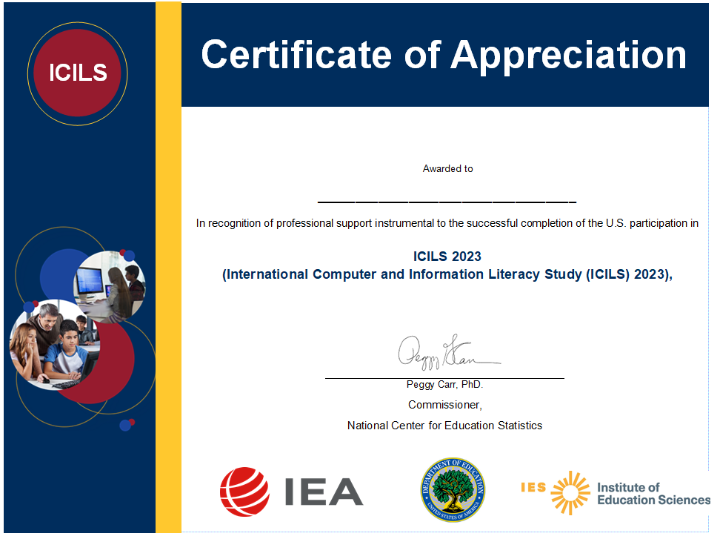

## Appendix A36 ICILS 2023 Main Study COVID-19 Protocols

(Notes: If needed at the time of data collection, protocols will be updated to reflect the most recent CDC guidelines and RTI Infectious Disease Response Teams guidance. Additionally, a graphically designed document will be created with these Protocols.)

ICILS 2023 Main Study COVID-19 Protocols

* Provide Personal Protective Equipment (PPE)
  + ICILS will provide field staff with PPE:
    - Disposable Masks
    - Disposable gloves
    - Hand Sanitizer
    - Sanitizing wipes & Spray
* Sanitizing and PPE Protocol
  + Multiple times during the assessment day, field staff will follow protocols to:
    - Sanitize testing equipment and equipment cases
    - Replace gloves and masks between assessment sessions
    - Used PPE will be discarded in ICILS-supplies Trash bags and removed from the school by field staff
* Field Staff Covid-19 Protocol training
  + All field staff will be trained on Covid-19 protocols, including:
    - Donning and removing PPE
    - Proper disposal of used PPE
    - Social Distancing Requirements
    - Sanitizing equipment and equipment cases
    - Other school protocols
* Health Monitoring
  + Field staff will be expected to perform a Covid-19 Daily Checklist of their health and symptoms before reporting for work at a school.
    - Any field staff who do not successfully pass the daily health assessment will not report to school that day, and will be required to either:
      1. Test Negative for Covid-19 in accordance with CDC guidelines
      2. Be free of Covid-19 symptoms for a 14-day period before conducting any assessment in schools
      3. Provide Written documentation from their healthcare provider releasing their return to work
  + Before entering school buildings, field staff will take their temperature using a non-contact thermometer, and acknowledge that they are symptom free
* School Protocols
  + Field Staff will follow any and all school-specific required CDC protocols, which may include but not limited to the following:
    - Temperature checks and other symptom assessments by the school upon arrival at the school
    - Social distancing guidelines of staff and students
    - Additional school required PPE
    - Additional sanitizing requirements

## Appendix A37 ICILS 2023 Main Study Sample Notification Letter

SCHOOL LETTERHEAD

Dear Parent or Guardian,

Our school has accepted an invitation from the National Center for Education Statistics (NCES), part of the U.S. Department of Education, to participate in the **International Computer and Information Literacy Study (ICILS)** Main Study. {Insert number} of our 8th-grade classes will take part. {This/One of these} is your child’s class.

**WHO**: Your child’s class is one of several 8th grade classes in the United States taking part in ICILS. To have an accurate picture of U.S. 8th graders’ skills and access to and use of technology, it is important that each student selected take part in the study. I urge you to support this effort by encouraging your child to take part; however, participation in this study is entirely voluntary.

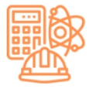**WHAT**: Students will answer questions about their information and computer literacy and complete a brief questionnaire about themselves. Previous experience suggests that students enjoy taking part, and participating students will receive a small gift.

**WHY**: ICILS provides an accurate picture of students’ skills and access to and use of technology at grade 8 in the United States against countries around the world. Since 2013, ICILS has measured worldwide trends in student knowledge of computer and information literacy.

The enclosed summary sheet provides information about ICILS, student participation, and gives a contact phone number and email address in case you have any questions.

Thank you for taking the time to learn about this important study.

Sincerely,

[School official]

*The National Center for Education Statistics (NCES) is authorized to conduct this study under the Education Sciences Reform Act of 2002 (ESRA 2002, 20 U.S.C. §9543), and to collect students’ education records from educational agencies or institutions for the purpose of evaluating federally supported education programs under the Family Educational Rights and Privacy Act (FERPA, 34 CFR §§ 99.31(a)(3)(iii) and 99.35). All of the information you provide may be used only for statistical purposes and may not be disclosed, or used, in identifiable form for any other purpose except as required by law (20 U.S.C. §9573 and 6 U.S.C. §151). In the United States, ICILS is conducted by NCES, part of the U.S. Department of Education, and the data are being collected by RTI International. The U.S. Office of Management and Budget has approved the data collection under OMB #1850-0929.*

Enclosures: Facts for Parents about the ICILS 2023 Main Study

## Appendix A38 ICILS 2023 Main Study Sample Implicit Consent Letter

SCHOOL LETTERHEAD

Dear Parent or Guardian,

Our school has accepted an invitation from the National Center for Education Statistics (NCES), part of the U.S. Department of Education, to participate in the **International Computer and Information Literacy Study (ICILS)** Main Study. {Insert number} of our 8th-grade classes will take part. {This/One of these} is your child’s class.

**WHO**: Your child’s class is one of several 8th-grade classes in the United States taking part in ICILS. To have an accurate picture of U.S. 8th graders’ skills and access to and use of technology, it is important that each student selected take part in the study. I urge you to support this effort by encouraging your child to take part; however, participation in this study is entirely voluntary.

**WHAT**: Students will answer questions about their information and computer literacy, demonstrate their skill in computational thinking, and complete a brief questionnaire about themselves. Previous experience suggests that students enjoy taking part, and participating students will receive a small gift.

**WHY**: ICILS provides an accurate picture of students’ skills and access to and use of technology at grade 8 in the United States against countries around the world. Since 2013, ICILS has measured worldwide trends in student knowledge of computer and information literacy.

The enclosed summary sheet provides information about ICILS, student participation, and gives a contact phone number and email address in case you have any questions. If you have any objection to your child joining in the ICILS activities, please let us know by completing the attached consent form and returning it to the school.

Thank you for taking the time to learn about this important study.

Sincerely,

[School official]

*The National Center for Education Statistics (NCES) is authorized to conduct this study under the Education Sciences Reform Act of 2002 (ESRA 2002, 20 U.S.C. §9543), and to collect students’ education records from educational agencies or institutions for the purpose of evaluating federally supported education programs under the Family Educational Rights and Privacy Act (FERPA, 34 CFR §§ 99.31(a)(3)(iii) and 99.35). All of the information you provide may be used only for statistical purposes and may not be disclosed, or used, in identifiable form for any other purpose except as required by law (20 U.S.C. §9573 and 6 U.S.C. §151). In the United States, ICILS is conducted by NCES, part of the U.S. Department of Education, and the data are being collected by RTI International. The U.S. Office of Management and Budget has approved the data collection under OMB #1850-0929.*

Enclosures: Facts for Parents about the ICILS 2023 Main Study, Parent/Guardian Consent Form

## Appendix A39 ICILS 2023 Main Study Implicit Consent Form

**International Computer and Information Literacy Study (ICILS)**

ICILS 2023 Main Study

**Parent/Guardian Consent Form**

Your child has been asked to participate in a Main Study of an international study of student learning called the International Computer and Information Literacy Study (ICILS). Each student who participates will receive a small gift. This assessment will be administered by a team of researchers from RTI International, who are operating under contract on behalf of the National Center for Education Statistics (NCES), within the U. S. Department of Education.

**If you grant permission for your child to participate in the ICILS** Main Study**, you do not need to return this form.**

If you do not grant permission to your child’s participation in the ICILS Main Study, please return this form to your child’s school as soon as possible.

No, I do not give permission for my child to participate in the ICILS 2023 Main Study.

____________________________________________Date of signature: _____/_____/______

(Signature of parent or guardian)

Please Print:

Student name: __________________________________________

School name: ____________________________________________

Parent name: ____________________________________________

Parent telephone: ________________________________________

Parent email: _____________________________________________

FOR OFFICE USE ONLY:

Student ID: ________________________________________________

## Appendix A40 ICILS 2023 Main Study Sample Explicit Consent Letter

SCHOOL LETTERHEAD

**Please read, sign, and return the attached consent form to your child’s school.**

Dear Parent or Guardian,

Our school has accepted an invitation from the National Center for Education Statistics (NCES), part of the U.S. Department of Education, to participate in the **International Computer and Information Literacy Study (ICILS)** Main Study. {Insert number} of our 8th-grade classes will take part. {This/One of these} is your child’s class.

**WHO**: Your child’s class is one of several 8th grade classes in the United States taking part in ICILS. To have an accurate picture of U.S. 8th graders’ skills and access to and use of technology, it is important that each student selected take part in the study. I urge you to support this effort by encouraging your child to take part; however, participation in this study is entirely voluntary.

**WHAT**: Students will answer questions about their information and computer literacy, demonstrate their computational thinking skill, and complete a brief questionnaire about themselves. Previous experience suggests that students enjoy taking part, and participating students will receive a small gift.

**WHY**: ICILS provides an accurate picture of students’ skills and access to and use of technology at grade 8 in the United States against countries around the world. Since 2013, ICILS has measured worldwide trends in student knowledge of computer and information literacy.

The enclosed summary sheet provides information about ICILS, student participation, and gives a contact phone number and email address in case you have any questions. **Before we can allow your child to join in the ICILS activities, we must have your written consent. Please complete the attached form and return it to the school.**

Thank you for taking the time to learn about this important study and for returning the attached form.

Sincerely,

[School official]

*The National Center for Education Statistics (NCES) is authorized to conduct this study under the Education Sciences Reform Act of 2002 (ESRA 2002, 20 U.S.C. §9543), and to collect students’ education records from educational agencies or institutions for the purpose of evaluating federally supported education programs under the Family Educational Rights and Privacy Act (FERPA, 34 CFR §§ 99.31(a)(3)(iii) and 99.35). All of the information you provide may be used only for statistical purposes and may not be disclosed, or used, in identifiable form for any other purpose except as required by law (20 U.S.C. §9573 and 6 U.S.C. §151). In the United States, ICILS is conducted by NCES, part of the U.S. Department of Education, and the data are being collected by RTI International. The U.S. Office of Management and Budget has approved the data collection under OMB #1850-0929.*

Enclosures: Facts for Parents about the ICILS 2023 Main Study, Parent/Guardian Consent Form

## Appendix A41 ICILS 2023 Main Study Explicit Consent Form

**International Computer and Information Literacy Study (ICILS)**

ICILS 2023 Main Study

**Parent/Guardian Consent Form**

**Please read, sign, and return this consent form to your child’s school.**

Your child has been asked to participate in a Main Study of an international study of student learning called the International Computer and Information Literacy Study (ICILS). Each student who participates will receive a small gift. This assessment will be administered by a team of researchers from RTI International, who are operating under contract on behalf of the National Center for Education Statistics (NCES), within the U. S. Department of Education.

PLEASE CHECK ONE:

Yes, I give permission for my child to participate in the ICILS 2023 Main Study.

No, I do not give permission for my child to participate in the ICILS 2023 Main Study.

PLEASE SIGN YOUR NAME BELOW:

_____________________________________________________ Date of signature: _____/_______/_______

(Signature of parent or guardian)

PLEASE PRINT:

Student name: _____________________________________________

School name: ______________________________________________

Parent name: ______________________________________________

Parent telephone: _________________________________________

Parent email: ______________________________________________

FOR OFFICE USE ONLY:

Student ID: ________________________________________________

## Appendix A42 ICILS Facts for Parents About the ICILS 2023 Main Study

**Facts for Parents**

**About the ICILS 2023 Main Study**

Between March and May of this year, your child’s school will take part in an 8th-grade Main Study to prepare for ICILS 2023. Within each school, 8th-grade student classrooms were selected randomly to represent the nation’s 8th graders. Your child’s class was among those selected to take part in the ICILS 2023 Main Study.

**What is ICILS?**

The International Computer and Information Literacy Study (ICILS) is an international assessment and research project designed to measure computer and information literacy achievement at the eighth grade, as well as school and teacher practices related to instruction. ICILS provides a unique opportunity to compare U.S. eighth-grade students’ computer and information literacy skills and access to and use of technology with that of their peers in countries around the world. ICILS is developed internationally as a response to the increasing use of information and communication technology (ICT) in modern society and the need for citizens to develop relevant skills to participate effectively in the digital age. The United States participated in ICILS in 2018 along with 13 other education systems and will participate again in 2023. ICILS 2023 will include students from approximately 30 education systems.

**What is the purpose of the ICILS 2023 Main Study?**

ICILS 2023 plans to continue collecting and analyzing data to provide a better understanding of the modern, pervasive digital context, as well as of students’ skills in information management, communication, and computational thinking. ICILS 2023 will include more aspects related to digital citizenship, reflecting young people’s increasing opportunities for online citizenship participation and helping measure progress toward UNESCO's Sustainable Development Goal 4.4 (increasing the number of young people who have relevant skills for employment).

**What is involved?**

The ICILS team at RTI International will visit the school and administer the student assessment on tablet computers that they will bring to the school. The entire assessment will take approximately 3 hours with breaks between sections. Students will complete a few computer-based interactive tasks and a questionnaire about themselves and their experience with technology. Participation in the study is voluntary.

**What are the benefits?**

The nation as a whole benefits from ICILS by having a greater understanding of how the knowledge and skills of U.S. 8th graders compare with those of 8th graders from other countries. Our country benefits from the Main Study by ensuring that the questions used are fair and appropriate for U.S. students.

**Who administers ICILS?**

ICILS is administered by the U.S. Department of Education’s National Center for Education Statistics (NCES) and its data collection contractor, RTI International, a research organization. Trained ICILS team from RTI international will visit schools and carry out the student assessment.

**How will the data be used?**

All of the information collected is safeguarded, as required by law. NCES is authorized to conduct this study under the Education Sciences Reform Act of 2002 (ESRA 2002, 20 U.S.C. §9543). All of the information provided by school staff and students may be used only for statistical purposes and may not be disclosed, or used, in identifiable form for any other purpose except as required by law (20 U.S.C. §9573 and 6 U.S.C. §151). Students and schools are never identified in any reports. All reported statistics refer to the United States as a whole.

**Where can I find out more about ICILS?**

More information about ICILS is available at the ICILS website at <https://surveys.nces.ed.gov/icils/Home/Resources>. Or if you would like to contact an ICILS team member directly, please feel free to call the ICILS hotline at (800) 611-0338 or email us at ICILS@rti.org.

## Appendix A43 ICILS 2023 School Posters

## Appendix A44 Multi-translation Notice for Parents

***Dear Parents/Guardians: This important notice concerns an upcoming activity at your child's school. If necessary, please have the notice translated.***

***Estimados padres / tutores: Este aviso importante se refiere a una próxima actividad en la escuela de su hijo. Si es necesario, haga traducir el aviso.***

