TA Provider: | <name of TA award recipient auto-populates in DRGR>
GTR (name and email): | <name and email of GTR auto-populates in DRGR>
GTM/POTAC (name, email and phone): | <not applicable in DRGR>

1st Page of Work Plan in DRGR

TA Work Plan :

Award #  <select the award #> | Work Plan Type  <select the work plan type>  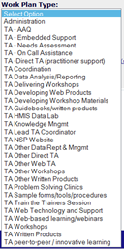 | Work Plan Category  <auto-populated based on work plan type selection>  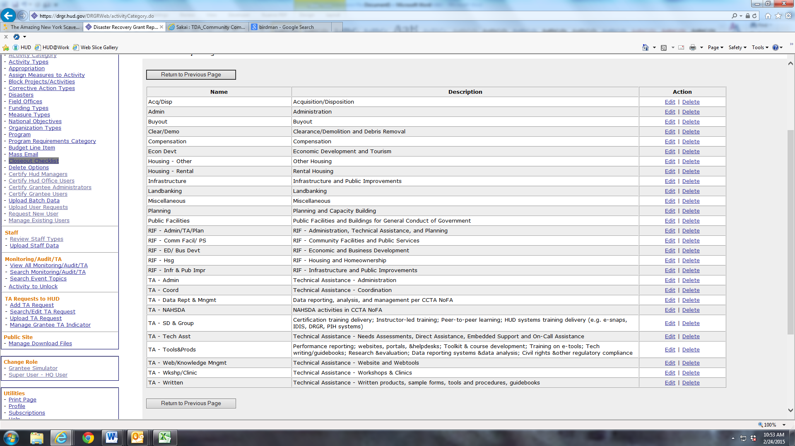
Work Plan #  <enter the work plan #> | Work Plan Status  <after completing all fields in DRGR, change status to “submitted”> | Work Plan Close Date  <leave blank until ready to close work plan>
Invoice Period:  Monthly | # of Amendments (Approved by HUD)  <auto-populated in DRGR> | Submitted Date  <auto-populated in DRGR>

Associated TA Requests:
TA Request  <leave blank> | TA Request Status  <leave blank>

Associated Work Plans:
TA Providers  <identify the TA provider associated with other, related work plans> | Work Plan #  <enter the work plan number associated with other, related work plans >

Scope:
Lead Person for Work Plan <within the Scope field, identify the lead person by name, email, and phone number>
Original scope:
<sample Scope for Administration work plan (below); award recipient should adjust the scope based on its organizational structure and costs expected to be billed to the Administration work plan; include pre-award costs in scope, if pre-award cost letter was issued by HUD to the award recipient; and add any other allowability admin costs expected for the award>

TA Provider will administer the Community Compass TA grant, including tasks such as:
- Develop and submit work plans to the HUD GTR outlining the specific TA to be undertaken and the intended accomplishments of that TA.
- Make assignments to staff and subcontractors on products approved by HUD to be developed or delivered under a work plan.
- Review the overall progress of the cooperative agreement spending and products. This will include managing product timelines and quality.
- Meet with HUD to provide periodic updates on grant management, product status and timelines.
- Develop and provide monthly status reports to HUD.
- Develop and provide monthly invoices to HUD.
- Set up and enter project, accomplishment and draw information into the DRGR system.
- Develop and submit quarterly reports via the DRGR system.
- Conduct written evaluations of the effectiveness and accomplishments of TA, workshop, written and web/technology products.
- Program audits or financial statement audits (portion associated with this award, if not included in ICR)
- Costs associated with ICR adjustment calculations (portion associated with this award, if not included in ICR)
- Pre-award costs (if pre-award approval letter was issued by Cooperative Agreement Officer)

Amendment and Modification Justification <within the Scope field, identify date of the amendment or modification, the changes made to the work plan, and the reason for the changes>

Organization Assisted:

Grantee Name  <select> | Grantee Program  <select> | Grantee State  <populated> | Grantee DUNS  <populated> | Grantee Org/Dept  <populated>

Work Plan Period of Performance:

From:  <enter award effective date> | To:  <award end date>

Tasks:

Task: | Start Date: | End Date: | Estimated  Cost: | Estimated  Hours: | Narrative:
1. Award Management | <enter award eff..date> | <enter award end date> | <estimate fully-loaded costs for award management activities charged to this award> | <estimate total hours for award management activities charged to this award> | <indicate which award management activities are estimated in the budget, based on the allowable scope>
2.
3.
4.
5.
6.
7.
8.
9.
10.
Total Budget with Amendments
Original Budget
Previously Approved Budget

Milestones:

Milestone <enter milestones associated with this award>: | Expected Date <enter date of milestones associated with this award>:

2nd Page of Work Plan in DRGR

Activity Budget:

Grant  <auto-populated>: | Work Plan Type  <auto-populated>: | Project# / Project Title <select “Administration” project>: | Total Budget (with Amendments)  <auto-populated>: | Original Budget  <auto-populated>: | Previously Approved Budget  <auto-populated>:

Proposed Staff:
Proposed Staff Budget <identify the total direct labor costs>:

Lead POC  <check the box>: | Staff Type  <select from dropdown>: | Effective  Date  <populated based on Staff Type>: | Staff  Name  <select based on Staff Type>: | Title  <populated based on Staff Name>: | Organization  <populated based on Staff Name>: | Start  Date  <enter est. start date>: | End  Date  <enter est. end date>: | Hours  <enter est. hours>: | Total  Rate  <populated given staff type>: | Total <calculated>:
 |  |  |  |  |  |  |  |  | Total <calculated>: | $0.00

Other/BLI Costs: | <identify total value of other direct costs (e.g., airfare, hotel, ground transportation, direct supplies, and include a line item for expected increases in direct labor rates)>

Budget Line Item: | Description: | Start Date: | End Date: | Cost:
 |  |  | Total: | $0.00
 |  |  | Total Travel Budget (only): | $0.00

Proposed Accomplishment(s):

Outcome(s) <select standard outcome and provide outcome description and associated outcomes to tasks>:

Task: | Expected Outcome: | Start Date:

Output(s) < select standard outputs and provide output date description and associated outputs to tasks >:

Task: | Expected Outcome: | Start Date:

Indicate Which of HUD’s Strategic Goals the Planned Work Supports | <associated goals to work plans>

Select: | Goal:
 | Strengthen the nation’s Housing Market to Bolster the Economy and Protect Consumers
 | Meet the Need for Quality Affordable Rental Homes
 | Utilize Housing as a Platform for Improving Quality of Life
 | Build Inclusive and Sustainable Communities Free from Discrimination
 | Transforming the Way HUD Does Business
 | Achieving Operational Excellence

Indicate Which Goals of the Federal Strategic Plan to Prevent and End Homelessness the Planned Work Supports | <associated goals to work plans>

Select: | Goal:
 | Promote Collaborative Leadership
 | Strengthen Capacity and Knowledge
 | Provide Affordable Housing
 | Provide Permanent Supportive Housing
 | Increase Economic Security
 | Reduce Financial Vulnerability
 | Integrate Health Care with Housing
 | Advance Health and Housing Stability for Youth
 | Advance Health and Housing Stability for Adults
 | Transform Crisis Response Systems

Certification:
I/We, the undersigned, certify under penalty of perjury that the information provided above is true and correct. WARNING: Anyone who knowingly submits a false claim or makes a false statement is subject to criminal and/or civil penalties, including confinement for up to 5 years, fines, and civil and administrative penalties. (18 U.S.C. §§ 287, 1001, 1010, 1012, 1014; 31 U.S.C. §3729, 3802).
Public reporting burden for this collection of information is estimated to average 1 hour. This includes the time for collecting, reviewing, and reporting the data. The information is being collected for HUD's Community Compass Technical Assistance and Capacity Building Program Notice of Funding Availability (NOFA) and will be used for application review. Response to this request for information is required in order to receive the benefits to be derived. This agency may not collect this information, and you are not required to complete this form unless it displays a currently valid OMB control number.

Comments regarding the accuracy of this burden estimate and any suggestions for reducing this burden can be sent to the Reports Management Officer, Office of Policy Development and Research, REE, Department of Housing and Urban Development, 451 7th St SW, Room 4176, Washington, DC 20410-5000. When providing comments, please refer to OMB Approval No. 2506-0197.

