Coordination Work Plan Template
TA Provider: | <name of TA award recipient auto-populates in DRGR>
GTR (name and email): | <name and email of GTR auto-populates in DRGR>
GTM/POTAC (name, email and phone): | <not applicable in DRGR>

1st Page of Work Plan in DRGR

TA Work Plan
Award #  <select the award #> | Work Plan Type  <select the work plan type>  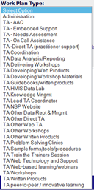 | Work Plan Category  <auto-populated based on work plan type selection>  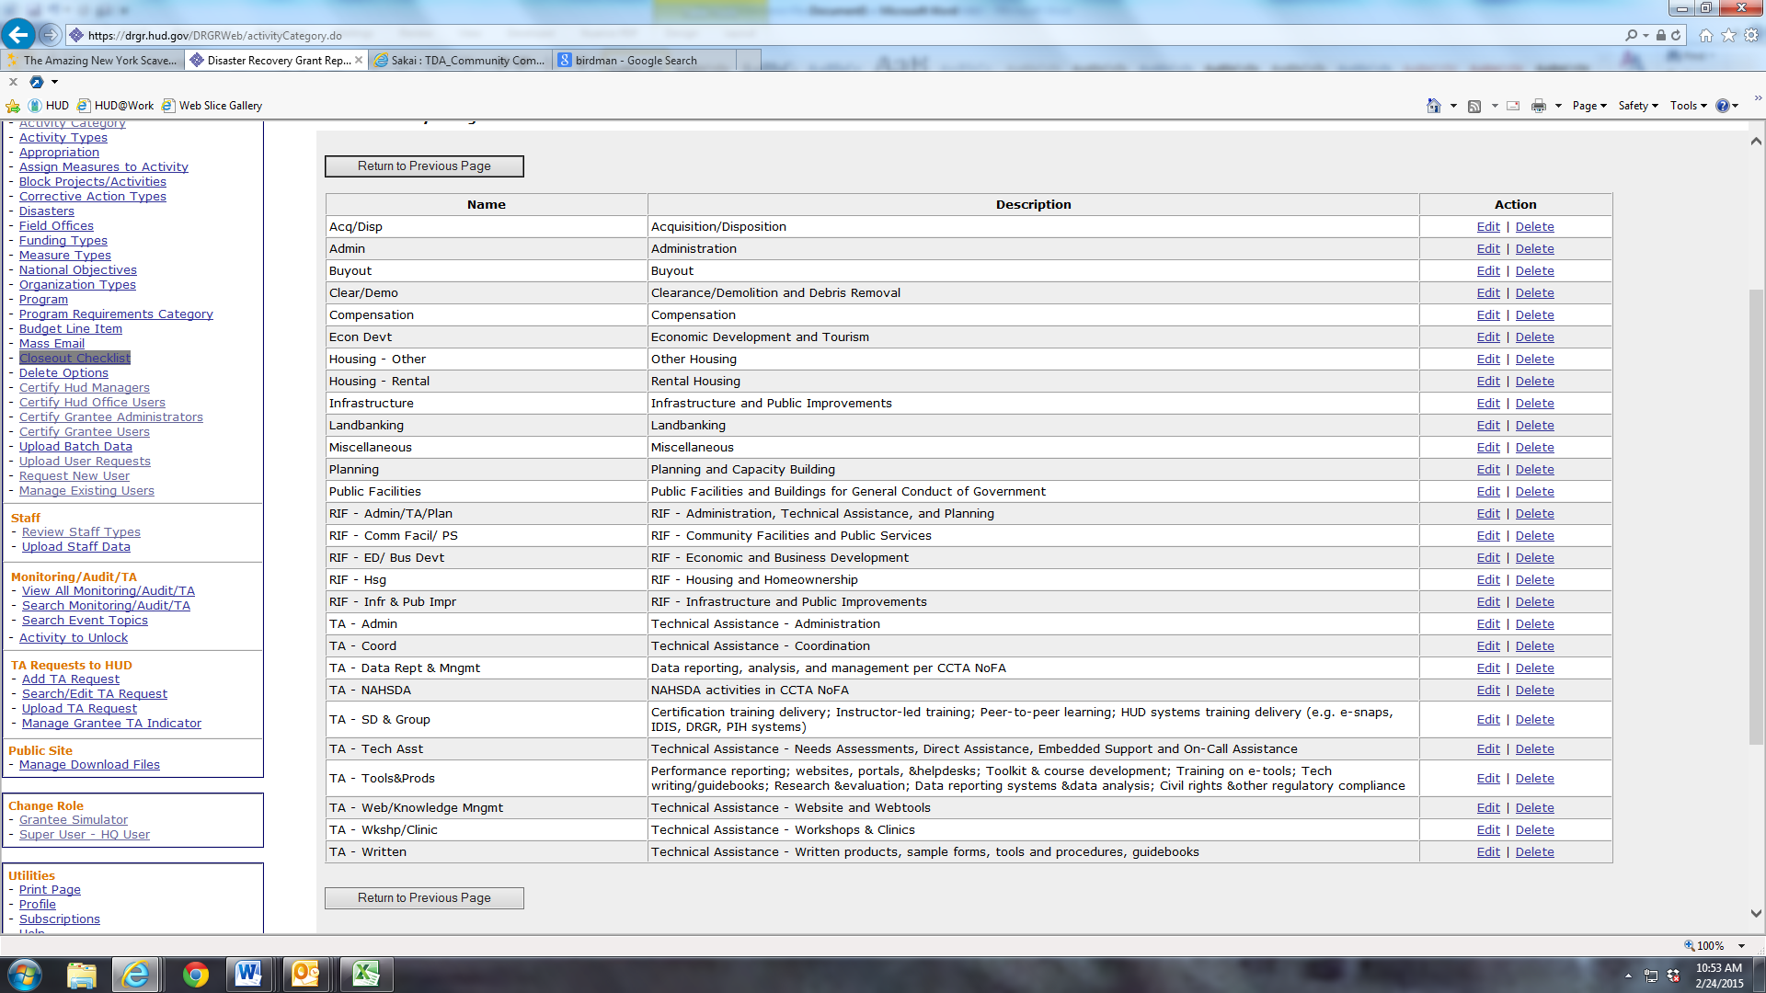
Work Plan #  <enter the work plan #> | Work Plan Status  <after completing all fields in DRGR, change status to “submitted”> | Work Plan Close Date  <leave blank until ready to close work plan>
Invoice Period:  Monthly | # of Amendments (Approved by HUD)  <auto-populated in DRGR> | Submitted Date  <auto-populated in DRGR>

Associated TA Requests:

TA Request  <leave blank> | TA Request Status  <leave blank>

Associated Work Plans:

TA Providers  <leave blank> | Work Plan #  <leave blank> | Work Plan Status  <leave blank>

Scope:
Lead Person for Work Plan <within the Scope field, identify the lead person by name, email, and phone number>
Original scope:
<sample Scope for Coordination work plan (below); Recipient should adjust the scope based on its organizational structure and costs expected and allowed to be billed to the Coordination work plan>

TA Award Recipient will coordinate with HUD and other TA Award Recipients as assigned by HUD. These activities are expected to include the following
- Participate in regular meetings with HUD and TA Award Recipients to plan TA products and schedules, including scoping conversations before a TA assignment is made.
- Participate in additional meetings and training sessions as needed with HUD and TA Award Recipients. Meetings may be conducted in person or via telephone or web conferences.
- Participate in work group meetings and activities.
- Coordinate with other TA Award Recipients to develop workshop materials, written products, and web/technology tools.
- Provide peer review of materials developed by work groups and TA Award Recipients, to include workshop material, written products, and web/technology tools.
- Coordinate with HUD Field Office to plan and conduct needs assessments, technical assistance, workshops, or other tasks to be accomplished in a certain region.
- Coordinate with other TA Award Recipients to plan and conduct needs assessments and technical assistance as assigned.
- Share information with HUD and other TA Award Recipients on previous experience working with specific grantees or grantee partners.

Amendment and Modification Justification <within the Scope field, identify date of the amendment or modification, the changes made to the work plan, and the reason for the changes>

Organization Assisted:

Grantee Name  <leave blank> | Grantee Program  <leave blank> | Grantee State  <leave blank> | Grantee DUNS  <leave blank> | Grantee Org/Dept  <leave blank>

Work Plan Period of Performance:

From:  <enter award effective date> | To:  <award end date>

Tasks:

Task: | Start Date: | End Date: | Estimated  Cost: | Estimated  Hours: | Narrative:
1. Coordination | <enter award eff.date> | <enter award end date> | <estimate fully-loaded costs for coordination activities charged to this award> | <estimate total hours for coordination activities charged to this award> | <indicate which coordination activities are estimated in the budget, based on the allowable scope; include names of travelers and number of trips by traveler expected under this award>
2.
3.
4.
5.
6.
7.
8.
9.
10.
Total Budget (with Amendments)
Original Budget
Previously Approved Budget

Milestones:

Milestone <enter milestones associated with this award>: | Expected Date <enter date of milestones associated with this award>:

2nd Page of Work Plan in DRGR

Activity Budget:

Grant  <auto-populated>: | Work Plan Type  <auto-populated>: | Project# / Project Title <select “Coordination” project>: | Total Budget (with Amendments)  <auto-populated>: | Original Budget  <auto-populated>: | Previously Approved Budget  <auto-populated>:

Proposed Staff:
Proposed Staff Budget <identify the total direct labor costs>:

Staff Type  <select from dropdown>: | Effective  Date  <populated based on Staff Type>: | Staff  Name  <select based on Staff Type>: | Title  <populated based on Staff Name>: | Organization  <populated based on Staff Name>: | Start  Date  <enter est. start date>: | End  Date  <enter est. end date>: | Hours  <enter est. hours>: | Total  Rate  <populated based on staff type>: | Total <calculated>:
 |  |  |  |  |  |  |  | Total <calculated>: | $0.00

Other/BLI Costs:
<identify total value of other direct costs (e.g., airfare, hotel, ground transportation, direct supplies, and include a line item for expected increases in direct labor rates)>

Budget Line Item: | Description: | Start Date: | End Date: | Cost:
 |  |  | Total: | $0.00

Proposed Accomplishment(s):
Outcome(s) <future enhancement; leave blank for now>:

Task: | Expected Outcome: | Start Date:
Output(s) <future enhancement; leave blank for now>:
Task: | Expected Outcome: | Start Date:

Indicate Which of HUD’s Strategic Goals the Planned Work Supports
<future enhancement; leave blank for now>

Select: | Goal:
 | Strengthen the nation’s Housing Market to Bolster the Economy and Protect Consumers
 | Meet the Need for Quality Affordable Rental Homes
 | Utilize Housing as a Platform for Improving Quality of Life
 | Build Inclusive and Sustainable Communities Free from Discrimination
 | Transforming the Way HUD Does Business
 | Achieving Operational Excellence

Indicate Which Goals of the Federal Strategic Plan to Prevent and End Homelessness the Planned Work Supports
<future enhancement; leave blank for now>

Select: | Goal:
 | Promote Collaborative Leadership
 | Strengthen Capacity and Knowledge
 | Provide Affordable Housing
 | Provide Permanent Supportive Housing
 | Increase Economic Security
 | Reduce Financial Vulnerability
 | Integrate Health Care with Housing
 | Advance Health and Housing Stability for Youth
 | Advance Health and Housing Stability for Adults
 | Transform Crisis Response Systems

Certification:
“I/We, the undersigned, certify under penalty of perjury that the information provided above is true and correct. WARNING: Anyone who knowingly submits a false claim or makes a false statement is subject to criminal and/or civil penalties, including confinement for up to 5 years, fines, and civil and administrative penalties. (18 U.S.C. §§ 287, 1001, 1010, 1012, 1014; 31 U.S.C. §3729, 3802).”
Public reporting burden for this collection of information is estimated to average 1 hour. This includes the time for collecting, reviewing, and reporting the data. The information is being collected for HUD's Community Compass Technical Assistance and Capacity Building Program Notice of Funding Availability (NOFA) and will be used for application review. Response to this request for information is required in order to receive the benefits to be derived. This agency may not collect this information, and you are not required to complete this form unless it displays a currently valid OMB control number.
Comments regarding the accuracy of this burden estimate and any suggestions for reducing this burden can be sent to the Reports Management Officer, Office of Policy Development and Research, REE, Department of Housing and Urban Development, 451 7th St SW, Room 4176, Washington, DC 20410-5000. When providing comments, please refer to OMB Approval No. 2506-0197.

