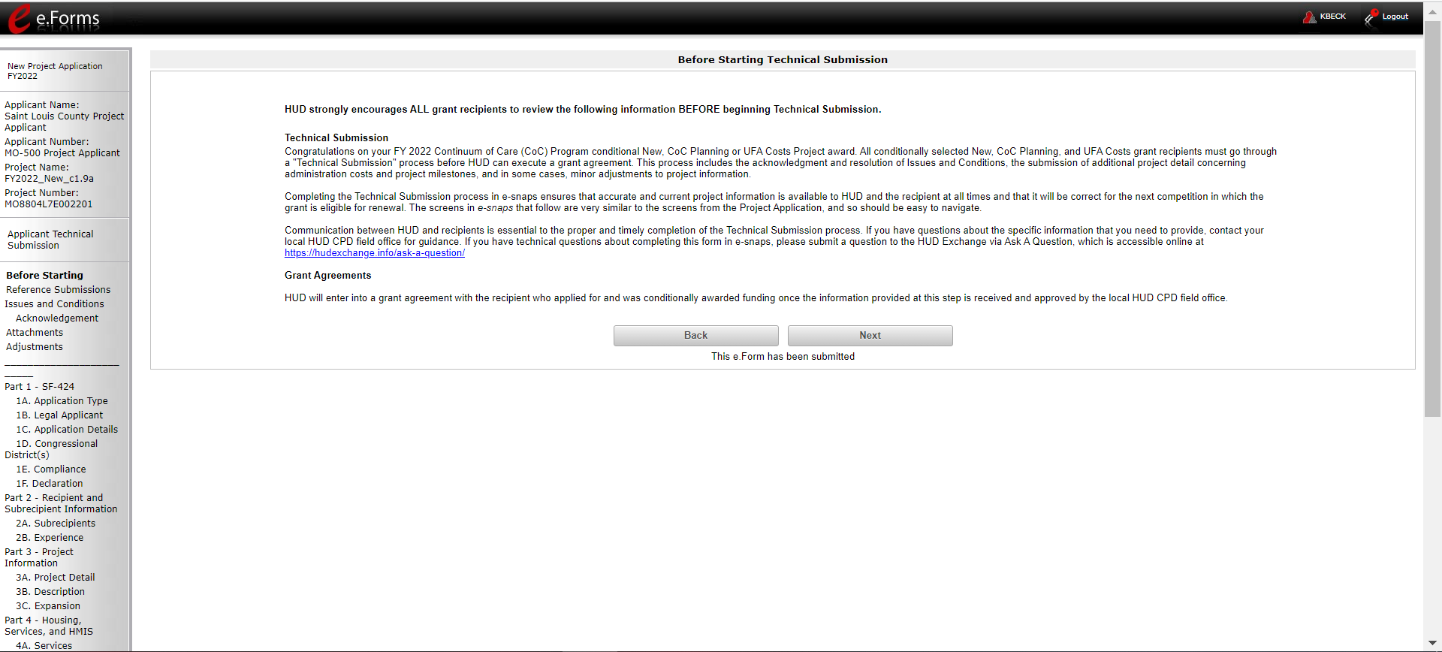

The Before Starting Screen – Gives relevant information on how to complete the Technical Submission stage and links to go to for questions.

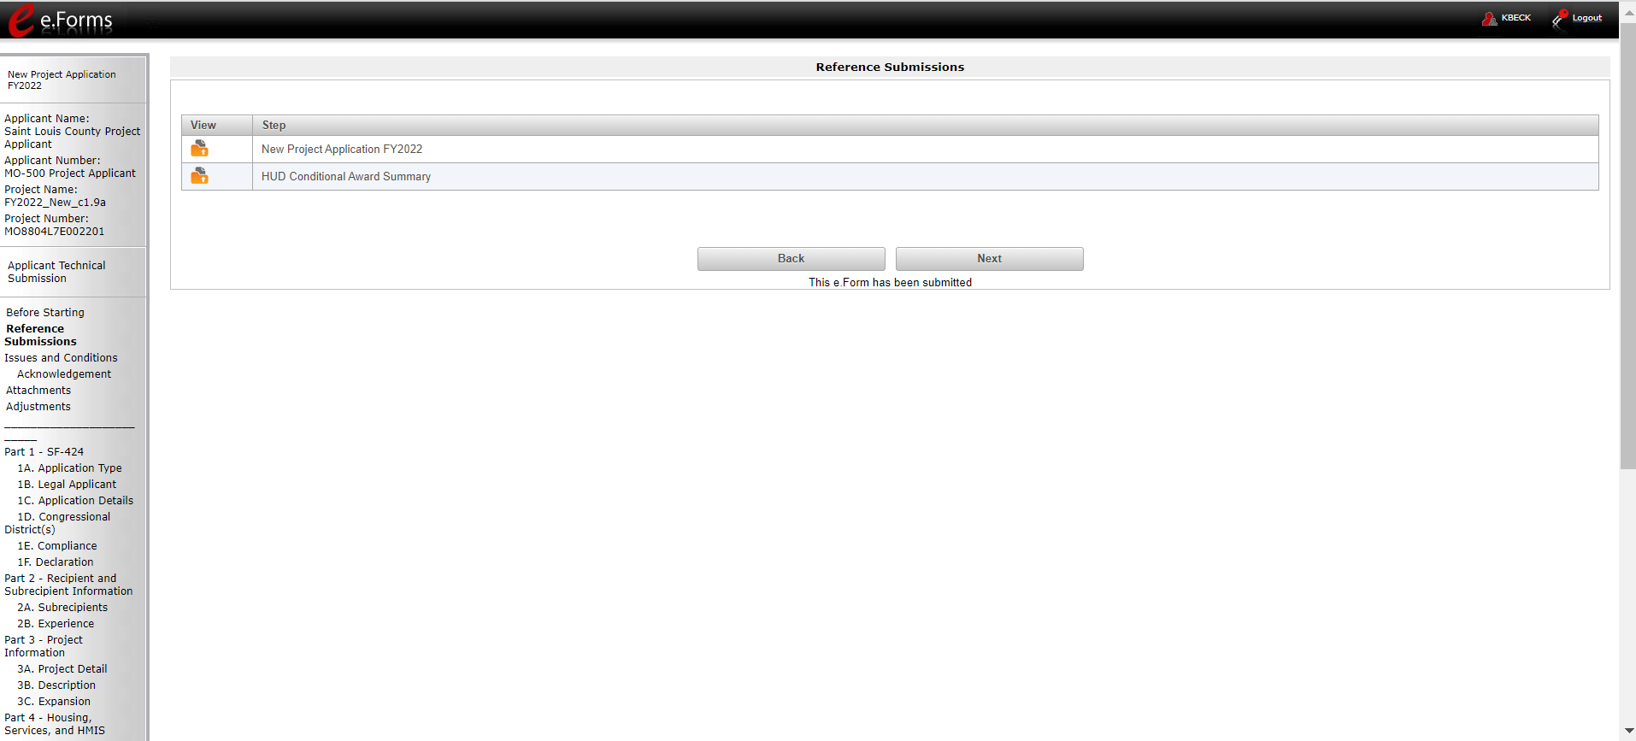

Reference Submission: Allows recipients to view their original application and a summary of their HUD conditional award

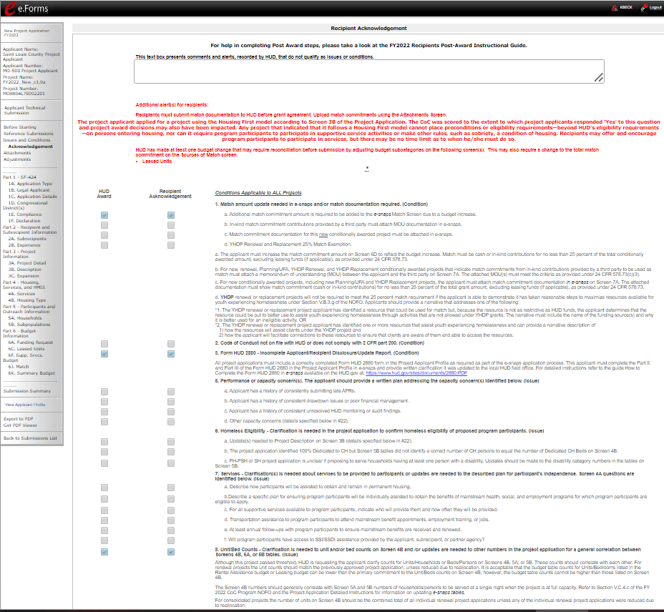

Issues and Conditions: Allows recipients to view and acknowledge the conditions (if any) placed on their grant that they must satisfy prior to grant agreement

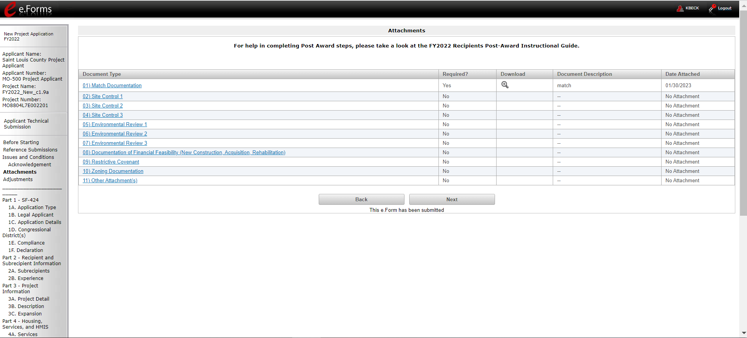

Attachments: Allows recipients to attach documentation that confirms that they meet their technical submission requirements, as applicable.

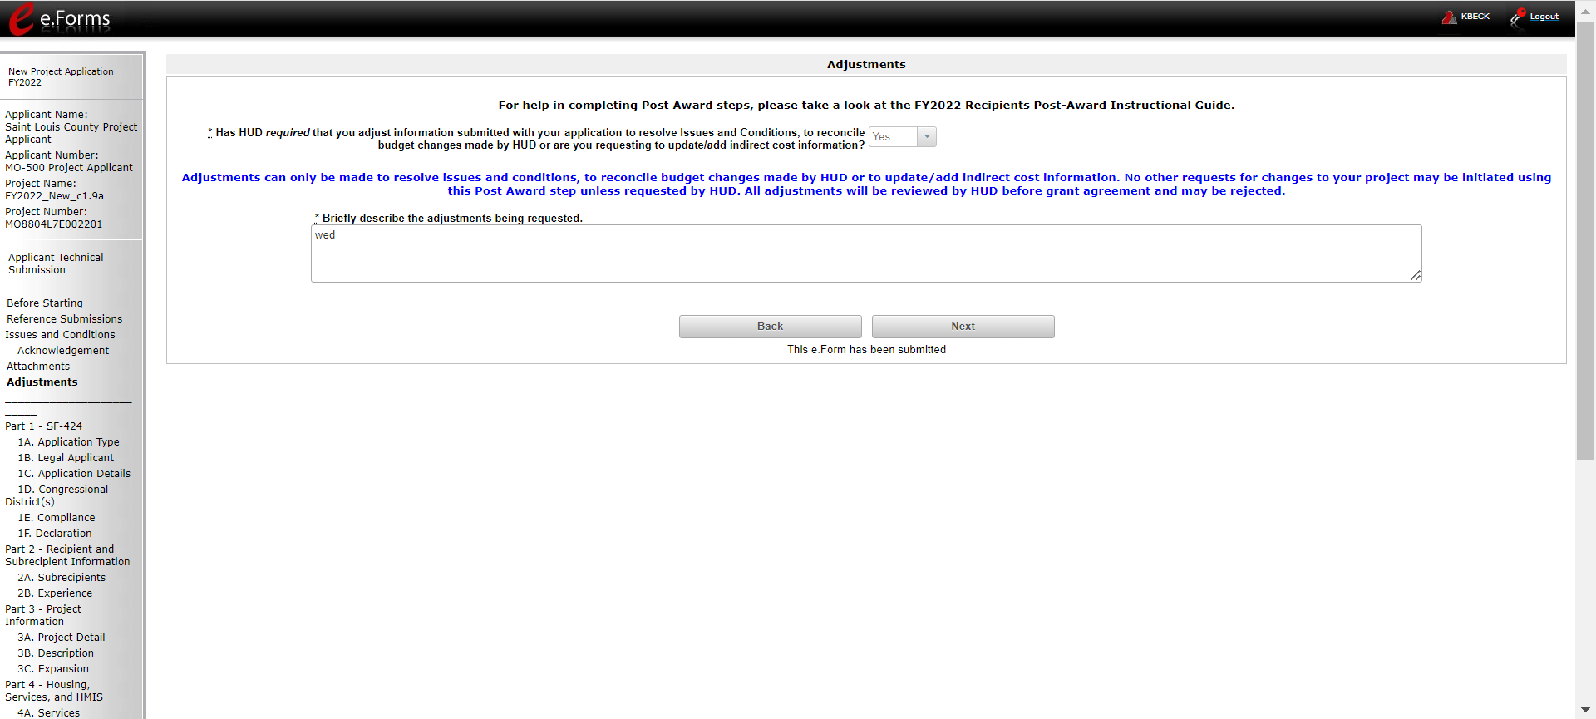

Adjustments: Allows recipients to adjust project data to meet requirements set by conditions placed on the project. Most recipients will edit little or no information.

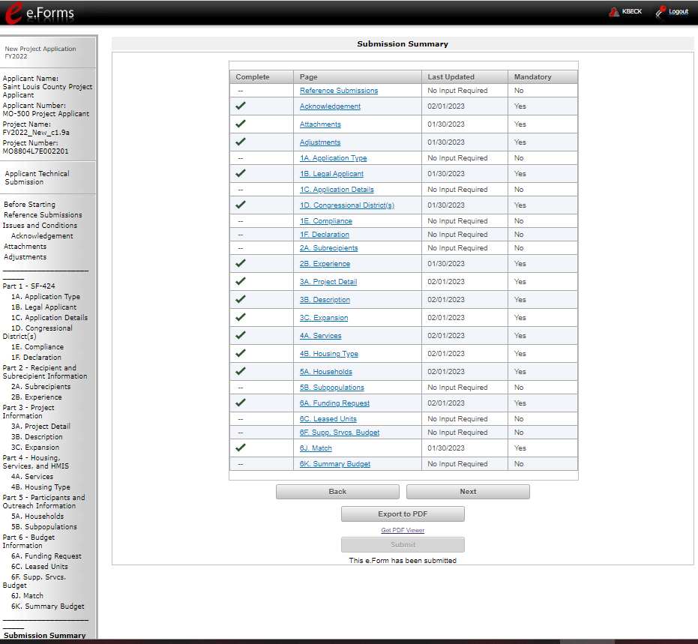

Submission Summary: Allows recipient to review their submission status and to submit the project.

