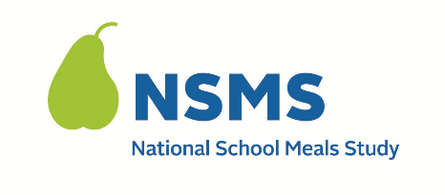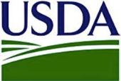

DATE: ____________________________

Dear: _____________________________
Thank you for agreeing to be part of the National School Meals Study (NSMS). We owe our success to your help. Your survey appointment is scheduled as follows:
Date: Time: (LOCAL TIME ZONE)
We will conduct the survey using the Zoom for Government platform.
Connect to meeting using the following link: <ZOOM MEETING LINK>
Meeting ID: <MEETING ID> Meeting Passcode: <CODE>
It is optional for you to turn on your video. If you prefer, you can just use the Zoom Call-In Number: <ZOOM CALL-IN NUMBER>
Completing the survey should take 30-45 minutes. If you are not able to keep this appointment or need to make a change, please let me know as soon as possible. My email address is: <INTERVIEWER EMAIL>. You can also call the study at < TOLL FREE NUMBER>.
An income worksheet is attached so you can prepare for the survey. Please complete the worksheet before the appointment and have it with you for the survey. It will help make the survey go faster. We ask that you gather the described materials to show the income received by all adult household members. I will only look at the documents, through the Zoom video option, for the needed information and will not copy or screenshot your documents. This part of the survey is optional.
You will receive a thank you Visa gift card of $40 for completing the survey. You will receive an additional $20 on the gift card if you show the income documents on the Zoom video or provide the documentation another way (i.e., by text or by email).
If you have any questions, please contact me via email: <INTERVIEWER EMAIL>. You may also contact the study’s help desk at < TOLL FREE NUMBER> or < EMAIL ADDRESS>. The study website provides additional information about the overall study: <URL>.
Thank you for your help!
Sincerely,

[INTERVIEWER NAME]
QR code

Attachment: Household Survey Income Worksheet

This information is being collected to provide the Food and Nutrition Service with key information on the annual error rates and improper payments for the school meal programs. This is a voluntary collection and FNS will use the information to examine school meal error rates and inform future APEC studies. This collection requests personally identifiable information under the Privacy Act of 1974. According to the Paperwork Reduction Act of 1995, an agency may not conduct or sponsor, and a person is not required to respond to, a collection of information unless it displays a valid OMB control number. The valid OMB control number for this information collection is 0584-0530. The time required to complete this information collection is estimated to average 0.0501 hours (3 minutes) per response, including the time for reviewing instructions, searching existing data sources, gathering and maintaining the data needed, and completing and reviewing the collection of information. Send comments regarding this burden estimate or any other aspect of this collection of information, including suggestions for reducing this burden, to: U.S. Department of Agriculture, Food and Nutrition Service, Office of Policy Support, 1320 Braddock Place, 5th Floor, Alexandria, VA 22306 ATTN: PRA (0584-0530). Do not return the completed form to this address.

