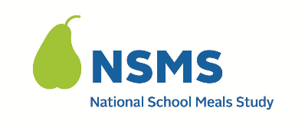

DATE: ____________________________

Dear: _____________________________
Thank you for agreeing to be part of the National School Meals Study (NSMS). We owe our success to your help. Your in-person survey is scheduled as follows:
Date: Time:
Location / Address:
If you are not able to keep this appointment or need to make a change, please let me know as soon as possible. My contact information is:
Cell Phone: Email:
Completing the survey should take 30-45 minutes.
We will ask for the same income information that we did during the telephone survey and have attached the same income worksheet to help you prepare for the survey. Please complete the worksheet before the appointment and have it with you for the survey. It will help make the survey go faster. We ask that you gather the described materials to show the income received by all adult household members. I will only look at the documents for the needed information and will not copy or keep your documents. This part of the survey is optional.
You will receive another $40 on your Visa gift card for completing the in-person survey and an additional $20 on the gift card if you provide documents to confirm your household’s income.
If you have any questions, please contact me. You may also contact the study’s help desk at <TOLL FREE NUMBER> or <EMAIL ADDRESS>. The study website provides additional information about the overall study: <URL>.
Thank you for your support!
Sincerely,
[INTERVIEWER NAME]
QR code
Attachment: Household Survey Income Worksheet, 022. Household Fact Sheet Re: In-Person Survey
This information is being collected to provide the Food and Nutrition Service with key information on the annual error rates and improper payments for the school meal programs. This is a voluntary collection and FNS will use the information to examine school meal error rates and inform future APEC studies. This collection requests personally identifiable information under the Privacy Act of 1974. According to the Paperwork Reduction Act of 1995, an agency may not conduct or sponsor, and a person is not required to respond to, a collection of information unless it displays a valid OMB control number. The valid OMB control number for this information collection is 0584-0530. The time required to complete this information collection is estimated to average 0.0501 hours (3 minutes) per response, including the time for reviewing instructions, searching existing data sources, gathering and maintaining the data needed, and completing and reviewing the collection of information. Send comments regarding this burden estimate or any other aspect of this collection of information, including suggestions for reducing this burden, to: U.S. Department of Agriculture, Food and Nutrition Service, Office of Policy Support, 1320 Braddock Place, 5th Floor, Alexandria, VA 22306 ATTN: PRA (0584-0530). Do not return the completed form to this address.

