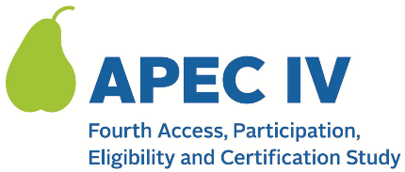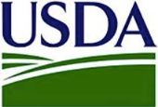

Dear <<STATE CHILD NUTRITION DIRECTOR>>:

The U.S. Department of Agriculture’s (USDA) Food and Nutrition Service (FNS) has contracted with Westat to administer the fourth Access, Participation, Eligibility and Certification Study Series (APEC IV). As the State Child Nutrition Director overseeing the National School Lunch Program (NSLP) and the School Breakfast Program (SBP), your cooperation is greatly appreciated.

APEC IV data collection will take place during school year 2023–24, with some preliminary activities beginning prior to the start of the school year. Westat selected <NUMBER> school food authorities (SFAs) in your State to participate. Similar to the prior APEC studies, the data collected will be used to generate a national estimate of the annual amount of improper payments (over and under payments) in the NSLP and SBP and explore household, school, and SFA characteristics that may contribute to or mitigate error.

All information collected will be used for research purposes only and kept private to the extent required by law. The information collected will not affect meal reimbursements or meal program benefits for any participating State agency, SFA, school, or household.

The APEC IV study team currently has two requests as part of your participation:

- Use the attached spreadsheet to provide contact information for the following individuals:
      - A member of your staff who will serve as a point of contact for APEC IV, and
- The SFA directors selected from your State to participate in APEC IV.
Please email the completed spreadsheet back to my office within 10 days.

- Contact the SFAs identified in the spreadsheet to inform them that they have been selected to participate in APEC IV, explain why their participation in the study is important, and encourage their participation. We have attached an email template that you can use.

A member of the APEC IV study team will follow up with you to answer any questions you may have and to solicit your suggestions for working effectively with your SFAs on the study.

APEC IV is a very important federally-mandated study. For more information, please read the attached study FAQ document, or visit the study’s website at <www.xxx.org>. If you have questions, please contact the study team at <Study Email> or the FNS Contracting Officer’s Representative, Amy Rosenthal, at Amy.Rosenthal@usda.gov.

Thank you in advance for your help and cooperation

Sincerely,
<FNS REGIONAL LIAISON NAME AND TITLE OF SENDER>

Attachments: 024. APEC IV FAQ (for States, SFAs and Schools), Contact Information Spreadsheet, 004. SFA Study Notification from State CN Director

This information is being collected to provide the Food and Nutrition Service with key information on the annual error rates and improper payments for the school meal programs. This is a voluntary collection and FNS will use the information to examine school meal error rates and inform future APEC studies. This collection requests personally identifiable information under the Privacy Act of 1974. According to the Paperwork Reduction Act of 1995, an agency may not conduct or sponsor, and a person is not required to respond to, a collection of information unless it displays a valid OMB control number. The valid OMB control number for this information collection is 0584-0530. The time required to complete this information collection is estimated to average 0.5 hours (30 minutes) per response, including the time for reviewing instructions, searching existing data sources, gathering and maintaining the data needed, and completing and reviewing the collection of information. Send comments regarding this burden estimate or any other aspect of this collection of information, including suggestions for reducing this burden, to: U.S. Department of Agriculture, Food and Nutrition Service, Office of Policy Support, 1320 Braddock Place, 5th Floor, Alexandria, VA 22306 ATTN: PRA (0584-0530). Do not return the completed form to this address.

