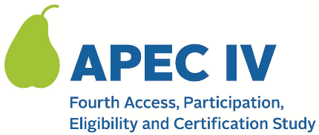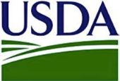

Dear <<SFA DIRECTOR>>:

The U.S. Department of Agriculture’s (USDA) Food and Nutrition Service (FNS) has contracted with Westat to administer the fourth Access, Participation, Eligibility and Certification Study Series (APEC IV). APEC is a national study that occurs with different SFAs every five years. <<SFA NAME>> has been selected to participate in this research study.

APEC IV data collection will take place during school year 2023–24, with preliminary activities starting prior to the school year. Similar to the prior APEC studies, the data collected will be used to generate a national estimate of the annual amount of improper payments (over and under payments) in the NSLP and SBP and explore household, school, and SFA characteristics that may contribute to or mitigate error.

APEC IV is a research study, not an audit of any type. All information collected will be kept private to the extent required by law and will not affect meal reimbursements or meal program benefits for any participating State agency, SFA, school, or household.

Next Steps:
A member of the APEC IV study team will follow up with you to answer any questions you may have.

I encourage you to agree to participate. APEC IV is a very important federally-mandated study, and representation from SFAs and schools like yours is key to helping Congress make informed decisions when they consider changes to the school meal programs. Please visit the study’s website at <www.xxx.org> for more information.

Thank you in advance for your cooperation

Sincerely,
< NAME AND TITLE OF STATE SENDER>

This information is being collected to provide the Food and Nutrition Service with key information on the annual error rates and improper payments for the school meal programs. This is a voluntary collection and FNS will use the information to examine school meal error rates and inform future APEC studies. This collection requests personally identifiable information under the Privacy Act of 1974. According to the Paperwork Reduction Act of 1995, an agency may not conduct or sponsor, and a person is not required to respond to, a collection of information unless it displays a valid OMB control number. The valid OMB control number for this information collection is 0584-0530. The time required to complete this information collection is estimated to average 0.0334 hours (2 minutes) per response, including the time for reviewing instructions, searching existing data sources, gathering and maintaining the data needed, and completing and reviewing the collection of information. Send comments regarding this burden estimate or any other aspect of this collection of information, including suggestions for reducing this burden, to: U.S. Department of Agriculture, Food and Nutrition Service, Office of Policy Support, 1320 Braddock Place, 5th Floor, Alexandria, VA 22306 ATTN: PRA (0584-0530). Do not return the completed form to this address.

