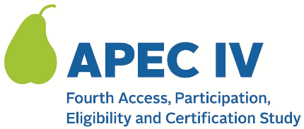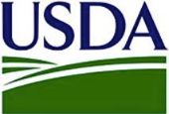

Dear <<SFA CONTACT NAME>>,

By now, you should have received notice from your State’s Child Nutrition Office that <<SFA NAME>> was randomly selected to participate in the fourth Access, Participation, Eligibility and Certification Study (APEC IV). The U.S. Department of Agriculture’s (USDA) Food and Nutrition Service (FNS) has contracted with Westat to conduct APEC IV. Your assistance is critical to ensure that the study includes the experiences of all kinds of SFAs and schools, which will inform improvements to the NSLP and SBP.

APEC IV is a research study, not an audit of any type. All information collected will be kept private to the extent required by law and will not affect meal reimbursements or meal program benefits for any participating State agency, SFA, school, or households. The attached FAQ document provides more details about the study and data collection. You can also visit the study’s website at <www.xxx.org> for more information.

We have compiled a list of all schools in your district and will randomly select some of them to participate in the study. To help us select the schools, we request that your office review our list to confirm your schools’ information or provide corrections to us. You can access the list by visiting the study’s secure web portal at the link below.

To assist you, we are attaching a guide that provides instructions on (a) how to access the web portal, (b) how to review your data, and (c) how to submit corrections.

APEC IV WEB PORTAL: <<URL>> YOUR SFA PIN: <<NUMBER>>

You may go to the web portal and begin reviewing this information at any time. If we do not hear from you, an APEC IV study team member will contact you in 1-2 weeks to ensure that you received this request, answer any questions you may have, and provide assistance.

If you have any questions, please contact the study team at << EMAIL ADDRESS>> or << TOLL-FREE NUMBER>>. You may also visit the study’s website at <URL> for more information.

Thank you in advance for your help and cooperation.

Sincerely,
<APEC IV RESEARCH TEAM>

Attachments:
024. APEC IV FAQ (for States, SFAs and Schools);
006. SFA School Data Verification Reference Guide

This information is being collected to provide the Food and Nutrition Service with key information on the annual error rates and improper payments for the school meal programs. This is a voluntary collection and FNS will use the information to examine school meal error rates and inform future APEC studies. This collection requests personally identifiable information under the Privacy Act of 1974. According to the Paperwork Reduction Act of 1995, an agency may not conduct or sponsor, and a person is not required to respond to, a collection of information unless it displays a valid OMB control number. The valid OMB control number for this information collection is 0584-0530. The time required to complete this information collection is estimated to average .0501 hours (3 minutes) per response, including the time to review the attached instructions and provide school data information via the study’s web portal. Send comments regarding this burden estimate or any other aspect of this collection of information, including suggestions for reducing this burden, to: U.S. Department of Agriculture, Food and Nutrition Service, Office of Policy Support, 1320 Braddock Place, 5th Floor, Alexandria, VA 22306 ATTN: PRA (0584-0530). Do not return the completed form to this address.

