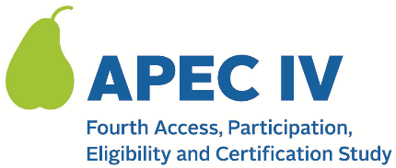

Access, Participation, Eligibility and Certification (APEC) Study Series

SFA School Data Verification Reference Guide
QR code

Thank you for your participation in the Fourth Access, Participation, Eligibility and Certification Study (APEC IV).
We have information about your schools from the National Center for Education Statistics’ Common Core Data. We need your assistance in verifying, and if needed, updating this information. The success of this important study relies on having up to date and accurate data.
This guide provides a basic overview of what we’re asking you to do and then detailed instructions on how to do so using the web portal.
Please contact us at <STUDY TOLL FREE NUMBER> or send an email to <STUDY EMAIL ADDRESS> if you need your PIN, if you have any technical questions or issues, or if you have any questions about what we’re asking for.
PLACEHOLDER FOR ADDITIONAL INSTRUCTIONS
Following the creation of the study website, the APEC IV study team will work with IT staff to develop this reference guide for SFAs. The guide will include the following:
- A summary of the SFA- and school-level data to be collected
- Detailed instructions (including screenshots) on using the APEC IV web portal to review and update the information on SFAs and schools (both CEP and non-CEP schools)
This information is being collected to provide the Food and Nutrition Service with key information on the annual error rates and improper payments for the school meal programs. This is a voluntary collection and FNS will use the information to examine school meal error rates and inform future APEC studies. This collection requests personally identifiable information under the Privacy Act of 1974. According to the Paperwork Reduction Act of 1995, an agency may not conduct or sponsor, and a person is not required to respond to, a collection of information unless it displays a valid OMB control number. The valid OMB control number for this information collection is 0584-0530. The time required to complete this information collection is estimated to average 2.9559 hours (177 minutes) per response, including the time to review the attached instructions and provide school data information via the study’s web portal. Send comments regarding this burden estimate or any other aspect of this collection of information, including suggestions for reducing this burden, to: U.S. Department of Agriculture, Food and Nutrition Service, Office of Policy Support, 1320 Braddock Place, 5th Floor, Alexandria, VA 22306 ATTN: PRA (0584-0530). Do not return the completed form to this address.

