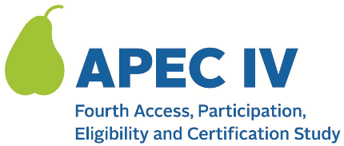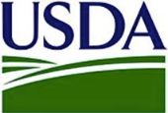

Dear <<SCHOOL PRINCIPAL>>:

I’m writing to inform you that your school has been selected for inclusion in the fourth Access, Participation, Eligilblity, and Certification Study (APEC IV). The U.S. Department of Agriculture’s (USDA) Food and Nutrition Service (FNS) has contracted with Westat, a research organization in Rockville, Maryland, to conduct the APEC IV study.

<<SFA NAME>> was selected to participate in APEC IV, and <<SCHOOL NAME>> was selected to participate as well. The goal of this federally-mandated study is to provide FNS with national estimates of improper payments (over and under payments) in the National School Lunch Program (NSLP) and the School Breakfast Program (SBP) in school year (SY) 2023-2024. This is not an audit. The research study will include <NUMBER> school districts, <NUMBER> schools, and <NUMBER> households from around the country. Schools that participate in the study receive a one-time site visit from a member of the Westat study team to observe a meal service and collect information on meals provided to students.

A member of Westat’s study team will contact you by email in the next two weeks to provide more information about the study and answer any questions you have. Your assistance is critical to ensure that the study has a diverse group of schools, which will help Congress make decisions about future improvements to the NSLP and SBP.

For more information on the study, you may visit the study’s website at < URL.> If you have additional questions, please contact the study directly at <TOLL FREE NUMBER> or <EMAIL ADDRESS>.

Thank you in advance for your help and cooperation.

Sincerely,

<SFA DIRECTOR/SFA CONTACT>
This information is being collected to provide the Food and Nutrition Service with key information on the annual error rates and improper payments for the school meal programs. This is a voluntary collection and FNS will use the information to examine school meal error rates and inform future APEC studies. This collection requests personally identifiable information under the Privacy Act of 1974. According to the Paperwork Reduction Act of 1995, an agency may not conduct or sponsor, and a person is not required to respond to, a collection of information unless it displays a valid OMB control number. The valid OMB control number for this information collection is 0584-0530. The time required to complete this information collection is estimated to average 0.0334 hours (2 minutes) per response, including the time for reviewing instructions, searching existing data sources, gathering and maintaining the data needed, and completing and reviewing the collection of information. Send comments regarding this burden estimate or any other aspect of this collection of information, including suggestions for reducing this burden, to: U.S. Department of Agriculture, Food and Nutrition Service, Office of Policy Support, 1320 Braddock Place, 5th Floor, Alexandria, VA 22306 ATTN: PRA (0584-0530). Do not return the completed form to this address.

