OMB Number: 0584-0530
Expiration Date: xx/xx/20xx

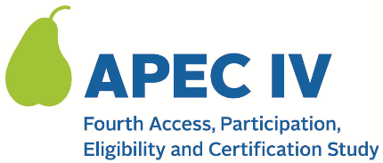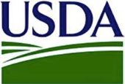

Dear <<SCHOOL CONTACT NAME>>,

As you may have already been notified, <<SFA NAME>> and <<SCHOOL NAME>> have been selected to participate in the fourth Access, Participation, Eligibility and Certification Study (APEC IV), a national study that occurs with different schools every five years. The purpose of the study is to provide national estimates of improper payments (over and under payments) in the National School Lunch Program (NSLP) and the School Breakfast Program (SBP) in school year (SY) 2023-2024. <<SFA NAME>> has already begun participating in the study.

The U.S. Department of Agriculture’s (USDA) Food and Nutrition Service (FNS) has contracted with Westat to conduct the APEC IV study. APEC IV is a research study, not an audit. All information collected will be kept private and will not affect meal reimbursements or meal program benefits for your school or students. Your assistance is critical to ensure that the study includes a diverse group of schools that will help Congress make decisions about future improvements to the NSLP and SBP.

Schools that participate in the study receive a one-time site visit from a member of the Westat study team to observe a meal service and collect information on meals provided to students. Additionally, we will contact a random sample of student households and ask them to complete a telephone survey. (Households will receive up to $60 for completing the survey.)

Next Steps

A member of the APEC IV study team will contact you within the next few days to confirm that you received this information, answer any questions you have about the study, and confirm your participation.

Please refer to the attached APEC IV FAQ document or visit the study’s website at <URL> for more information about the study. For more information on the household survey, please review the attached household survey brochure. Don’t hesitate to contact us at <TOLL FREE NUMBER> or <EMAIL ADDRESS> if you have any additional questions.

Thank you in advance for your help and cooperation.

Sincerely,

APEC IV Study Team
<NAME AND TITLE OF SENDER>
QR code

Attachment: 024. APEC IV FAQ (for States, SFAs, and Schools); 018 Household Survey Brochure

This information is being collected to provide the Food and Nutrition Service with key information on the annual error rates and improper payments for the school meal programs. This is a voluntary collection and FNS will use the information to examine school meal error rates and inform future APEC studies. This collection requests personally identifiable information under the Privacy Act of 1974. According to the Paperwork Reduction Act of 1995, an agency may not conduct or sponsor, and a person is not required to respond to, a collection of information unless it displays a valid OMB control number. The valid OMB control number for this information collection is 0584-0530. The time required to complete this information collection is estimated to average 0.0835 hours (5 minutes) per response, including the time for reviewing instructions, searching existing data sources, gathering and maintaining the data needed, and completing and reviewing the collection of information. Send comments regarding this burden estimate or any other aspect of this collection of information, including suggestions for reducing this burden, to: U.S. Department of Agriculture, Food and Nutrition Service, Office of Policy Support, 1320 Braddock Place, 5th Floor, Alexandria, VA 22306 ATTN: PRA (0584-0530). Do not return the completed form to this address.

