OMB Number: 0584-0530
Expiration Date: xx/xx/20xx
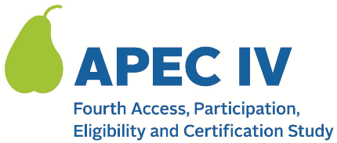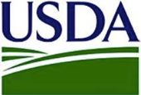

Dear <SCHOOL PRIMARY CONTACT NAME>:

We greatly appreciate your time and participation in the APEC IV study these recent months.

We are writing to let you know that we will begin to contact households to ask if they are willing to complete a telephone survey for the study. For households, we call it the “National School Meals Study” (NSMS). Households that complete the survey will receive up to a $60 gift card to thank them for their time and participation.

Households in which a student applied (or was directly certified) for school meals in school year 2023-24 are eligible to participate. We will randomly select households for participation and ask the parent/guardian to complete the telephone survey. Not all households will be eligible to participate, nor can households ask to be involved if they were not among those randomly selected. Additionally, a small number of households may be asked to complete the survey a second time, in person. That second request is part of a sub-study to help the study team understand whether the information households provide differs if they do the survey by phone or in person.

You may receive questions from families asking if the survey request is legitimate. Please reassure the household and encourage their participation in the National School Meals Study (NSMS). We also ask that you share this letter with any relevant staff whom parents may contact to verify the legitimacy of the survey (i.e. front desk staff, teachers, etc.). We are also attaching a brochure on the household survey with more information, which you can share to alert households to the study and answer any questions they may have.

You can visit the study website for more information: <URL>. Please reach out if you have any additional questions at <STUDY PHONE NUMBER> or <STUDY EMAIL>.

We appreciate your time and participation in APEC IV.

Sincerely,

The APEC IV Study Team
QR code

Attachments: 018. Household survey brochure
This information is being collected to provide the Food and Nutrition Service with key information on the annual error rates and improper payments for the school meal programs. This is a voluntary collection and FNS will use the information to examine school meal error rates and inform future APEC studies. This collection requests personally identifiable information under the Privacy Act of 1974. According to the Paperwork Reduction Act of 1995, an agency may not conduct or sponsor, and a person is not required to respond to, a collection of information unless it displays a valid OMB control number. The valid OMB control number for this information collection is 0584-0530. The time required to complete this information collection is estimated to average 0.0835 hours (5 minutes) per response, including the time for reviewing instructions, searching existing data sources, gathering and maintaining the data needed, and completing and reviewing the collection of information. Send comments regarding this burden estimate or any other aspect of this collection of information, including suggestions for reducing this burden, to: U.S. Department of Agriculture, Food and Nutrition Service, Office of Policy Support, 1320 Braddock Place, 5th Floor, Alexandria, VA 22306 ATTN: PRA (0584-0530). Do not return the completed form to this address.

