Florida Boating and Fishing Survey

We would like to know about your saltwater boating and fishing in Florida. This survey should only take about 3 minutes. Your confidential answers will help us estimate the economic effects of changes in fishing costs and regulations.

Q1. Do you own a boat?
Yes, and I use the boat (Go on to Q2)
Yes, but someone else uses the boat
No, I don't own a boat
(Survey Complete, Thank You)

Q2. Did you use your boat in the <<Gulf of Mexico>> or <<South Atlantic>> during November and December of 2018?
Yes (Skip to Q4) No (Go on to Q3)

Q3. Why didn't you use your boat in the <<Gulf of Mexico>> or <<South Atlantic>> during November and December?
I used my boat somewhere else
(After Answering this Question, Skip to Q27, On Page 4)
The boat was not working
I was too busy with other things
I did not have the money to run the boat
Other reason

Q4. Did you use your boat to fish in the <<Gulf of Mexico>> or <<South Atlantic>> during November and December of 2018?
Yes (Skip to Q6) No (Go on to Q5)

Q5. Why didn't you use your boat to fish in the <<Gulf of Mexico>> or <<South Atlantic>>
during November and December?
(After Answering this Question, Skip to Q20, On Page 4)
I don't usually fish from my boat
The species I like was not in season
I did not have the money to run the boat for fishing
Other reason

Q6. How many days did you use your boat to fish in the <<Gulf of Mexico>> or <<South Atlantic>> during
November and December?

Q7. How many people (including yourself) went on a typical fishing trip in the <<Gulf of Mexico>> or <<South Atlantic>> during November and December?

Q8. How many hours (dock-to-dock) was your typical fishing trip in the <<Gulf of Mexico>> or <<South Atlantic>> during November and December?

Q9. How much did a typical fishing trip cost in the <<Gulf of Mexico>> or <<South Atlantic>> during November and December? Please estimate the total cost paid by everyone for major items like boat fuel and bait.
$

The cost of fishing fluctuates. For example, the graph below shows how the price of fuel has changed in the last 15 years. Your answers to the next set of questions will help us predict how fishing activity might change when trip costs change.

+
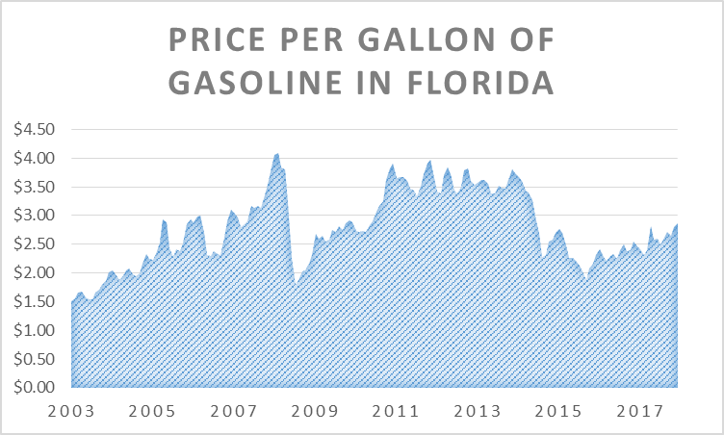

Please keep in mind your answer from Q6 when answering the following questions:

Q10. How many days would you have used your boat to fish in the <<Gulf of Mexico>> or <<South Atlantic>> during November and December if each trip cost twice as much per day as you indicated in Q9?

Q11. How many days would you have used your boat to fish in the <<Gulf of Mexico>> or <<South Atlantic>> during November and December if each trip cost half as much per day as you indicated in Q9?

If the number of days reported in Q10 is greater than zero, please answer the following question:

Q12. What is the most you would have paid for a fishing trip in the <<Gulf of Mexico>> or <<South Atlantic>> during November and December?
$

Q13. Which species did you fish for in the <<Gulf of Mexico>> or <<South Atlantic>> during November and December?
(Select all that apply)
gag grouper spotted seatrout or red drum
spanish or king mackerel yellowtail snapper
red grouper tuna or marlin
mangrove snapper other

If you did not select gag grouper in Q13, then skip to Q19 below.
Otherwise, please answer the following questions:

Q14. On how many of the days (entered in Q6) that you fished in the <<Gulf of Mexico>> or <<South Atlantic>> during November and December did you target gag grouper?

Q15. In 20XX the gag grouper season in the <<Gulf of Mexico>> or <<South Atlantic>> opened in June and the bag limit was 2 fish per person per day.

Would you have fished the same number of days in the <<Gulf of Mexico>> or <<South Atlantic>> during November and December if the gag grouper regulations were different?

Yes (Skip to Q19) Maybe No

Please keep in mind your answers from Q6 when answering the following questions:

Q16. How many days would you have fished in the <<Gulf of Mexico>> or <<South Atlantic>> during November and December if you could have kept 3 instead of 2 gag groupers?

Q17. How many days would you have fished in the <<Gulf of Mexico>> or <<South Atlantic>> during November and December if you could have kept 1 instead of 2 gag groupers?

Q18. How many days would you have fished in the <<Gulf of Mexico>> or <<South Atlantic>> during November and December if you could not have kept gag grouper at all because the season was closed?

Q19. How many days did you use your boat in the Gulf of Mexico during November
and December without fishing?
Skip to to Q27 at the bottom of page 4

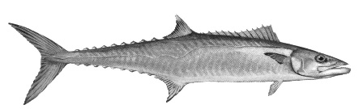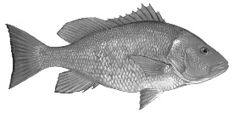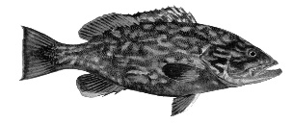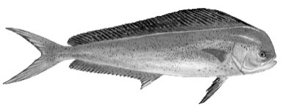

If you did not use your boat to fish, then please answer the questions in this box about boat trips in the <<Gulf of Mexico>> or <<South Atlantic>> during November and December of 2018:

Q20. How many days did you use your boat?

Q21. How many people (including yourself) went on a typical boat trip?

Q22. How many hours (dock-to-dock) was your typical boat trip?

Q23. How much did a typical boat trip cost?
Please estimate the total cost paid by everyone for major items like boat fuel.
$

The cost of boating fluctuates. For example, the graph on page 2 shows how the price of fuel has changed in the last 15 years. Your answers to the next set of questions will help us predict how boating activity might change when trip costs change.

Please keep in mind your answer from Q20 when answering the following questions:

Q24. How many days would you have boated in the <<Gulf of Mexico>> or <<South Atlantic>>
during November and December if each trip cost twice as much per day as you indicated in Q23?

Q25. How many days would you have boated in the <<Gulf of Mexico>> or <<South Atlantic>>
during November and December if each trip cost half as much per day as you indicated in Q23?

If the number of days reported in q24 is greater than zero, please answer the following question:

Q26. What is the most you would have paid for a boat trip in the <<Gulf of Mexico>> or <<South Atlantic>> during November and December?
$

Q27. Information about income is very important. Please select the category that contains the amount closest to your entire household annual income before taxes.
+
Less than $20,000 $80,000 to under $100,000
$20,000 to under $40,000 $100,000 to under $150,000
$40,000 to under $60,000 $150,000 to under $200,000
$60,000 to under $80,000 $200,000 or more
Thank You for Your Participation
Notwithstanding any other provisions of the law; no person is required to respond to, nor shall any person be subject to a penalty for failure to comply with a collection of information subject to the requirement of the Paperwork Reduction Act, unless that collection of information displays a currently valid OMB Control Number. Public reporting burden for this survey is estimated to average 3 minutes per response, including the time for reviewing instructions, searching existing data sources, gathering and maintaining the data needed, and completing and reviewing the collection of information. Send comments regarding this burden estimate or any other aspect of this collection of information, including suggestions for reducing this burden, to David Carter, NOAA SEFSC, 75 Virginia Beach Dr, Miami, FL 33149. Information submitted will be treated as confidential in accordance with NOAA Administrative Order 216-100. NMFS collects this information for the conservation and management of marine fishery resources. These data will be used to evaluate the economic effects of proposed regulations in the fishery.

