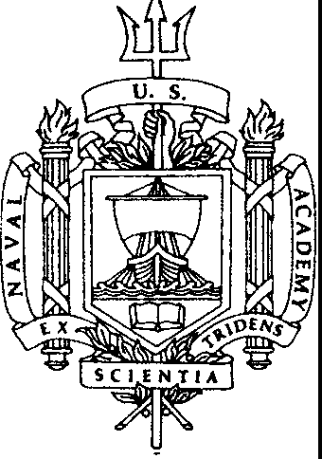**IMPORTANT NOTICE TO PROSPECTIVE MIDSHIPMEN**

Congratulations on your Offer of Appointment to the United States Naval Academy! In addition to your acceptance of our offer, we require proof of United States citizenship. Please provide the Nominations and Appointments Office with **one** of the following documents:

1. U.S. Birth Certificate
2. U.S. Passport if issued within the past two years - **DO NOT send a valid**

# U.S. passport through the mail.

1. Consular Report of Birth Abroad
2. Certificate of Citizenship
3. Certificate of Naturalization

# This document must be the original, an original copy from the issuing authority, a notarized photocopy or a certified true copy. Un-notarized or un­ certified photocopies are not acceptable.

This documentation will be made a part of your Naval Academy file and must be received prior to June 15th• Prospective Midshipmen will not be given the oath of office without proof of citizenship on file.

You may include your documentation with your acceptance of our offer. If you provide an original document, we recommend that you include a self-addressed stamped envelope to expedite the return of the document to you.