Login page for the training
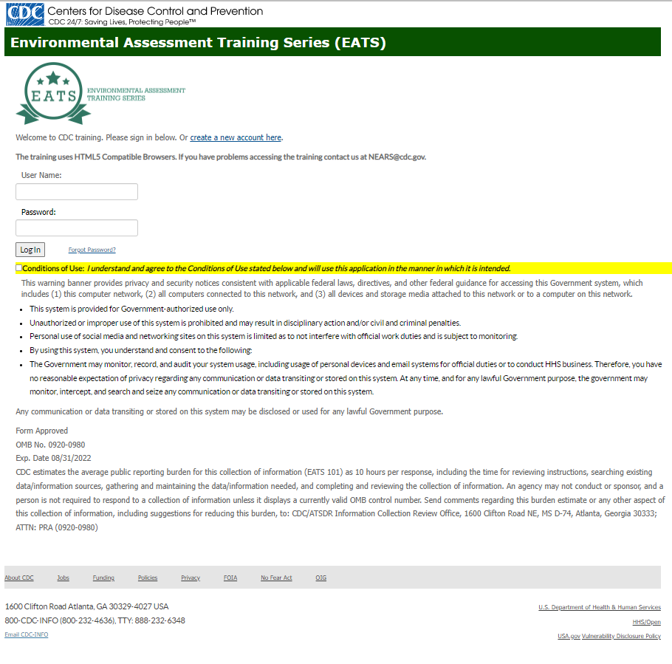

This training on conducting environmental assessments during foodborne illness outbreak investigations contains 8 lessons (Screenshot 1). NEARS participants are encouraged to take this training.
Screenshot 1
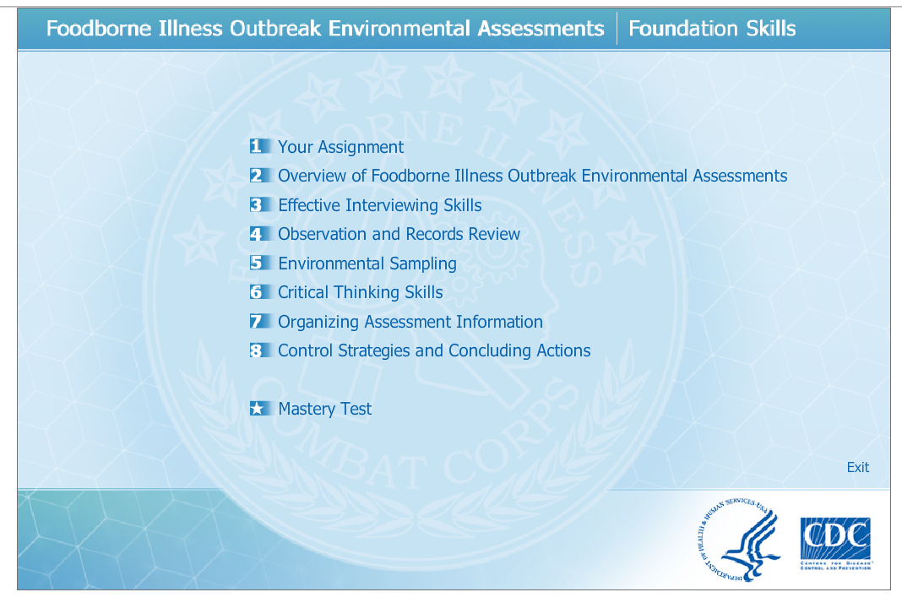
Lesson 1 provides an overview of the training (Screenshot 2).
Screenshot 2
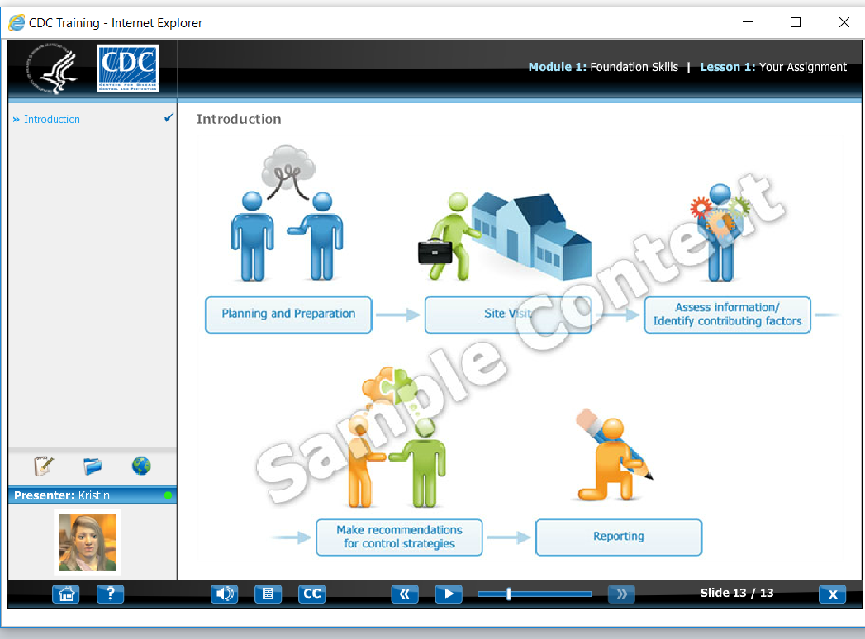

Lesson 2 provides an overview of foodborne outbreak environmental assessments (Screenshot 3).
Screenshot 3
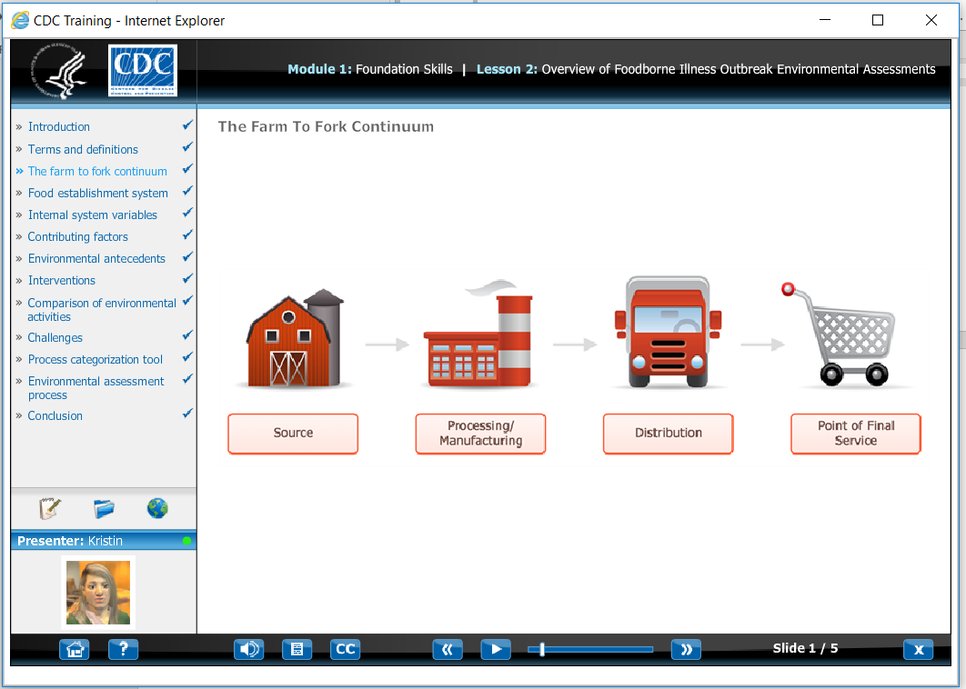
Lesson 3 provides information on conducting effective interviews to learn information from food workers and managers during an investigation (Screenshot 4).
Screenshot 4
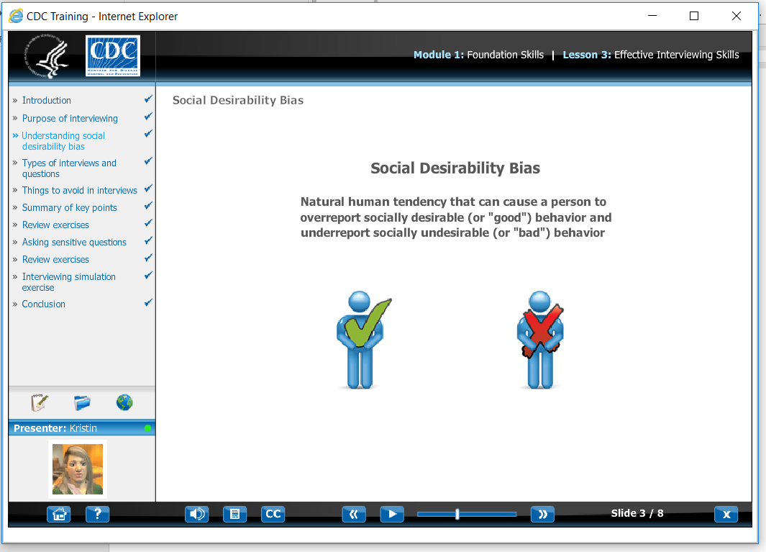

Lesson 4 provides information on conducting observations to learn information from the environment during the investigation (Screenshot 5).
Screenshot 5
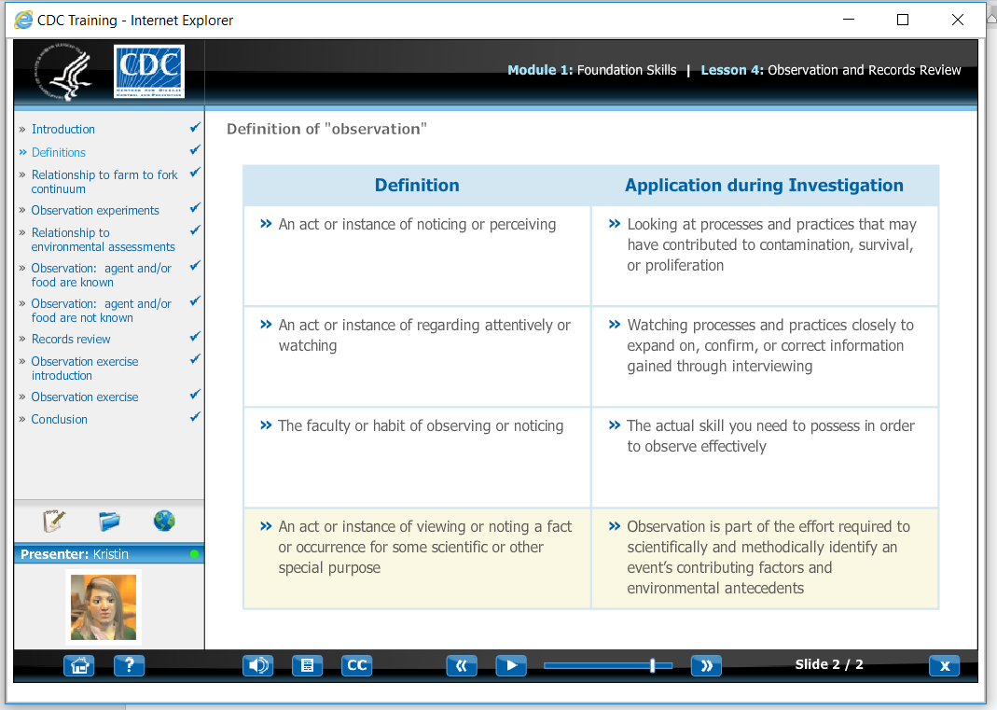
Lesson 5 provides information on when, where, and how to collect environmental samples during an investigation (Screenshot 6).
Screenshot 6
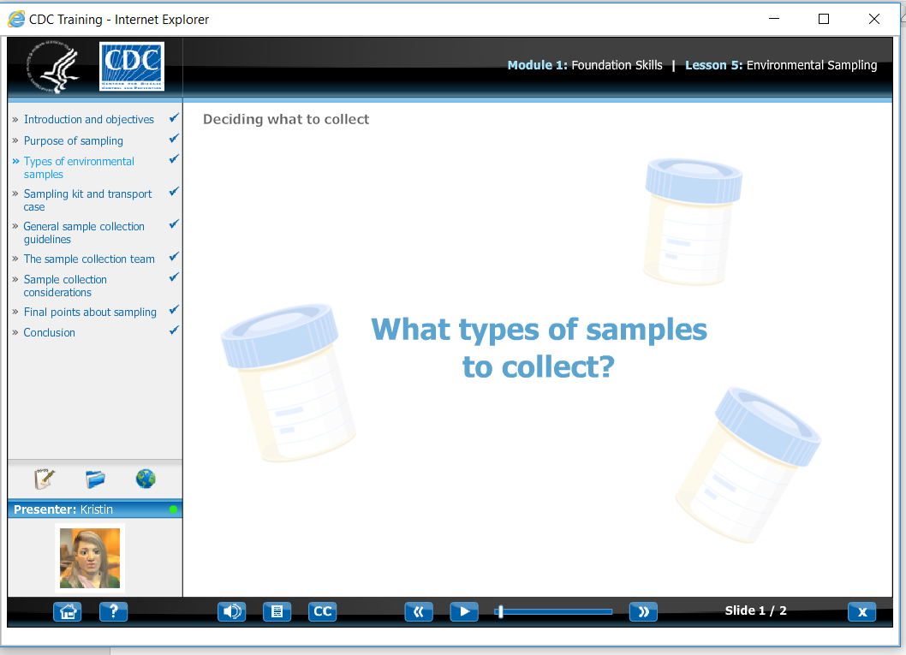

Lesson 6 provides information on the importance of critical thinking during investigations, and how to improve critical thinking skills (Screenshot 7).
Screenshot 7
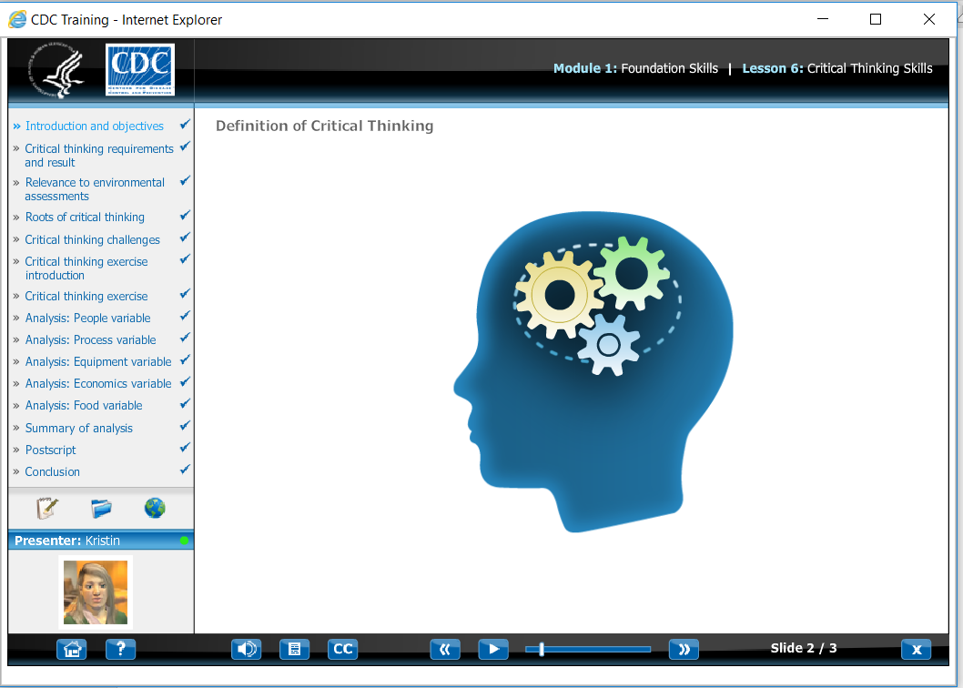
Lesson 7 provides information on how to organize environmental assessment information to complete the investigation (Screenshot 8).
Screenshot 8
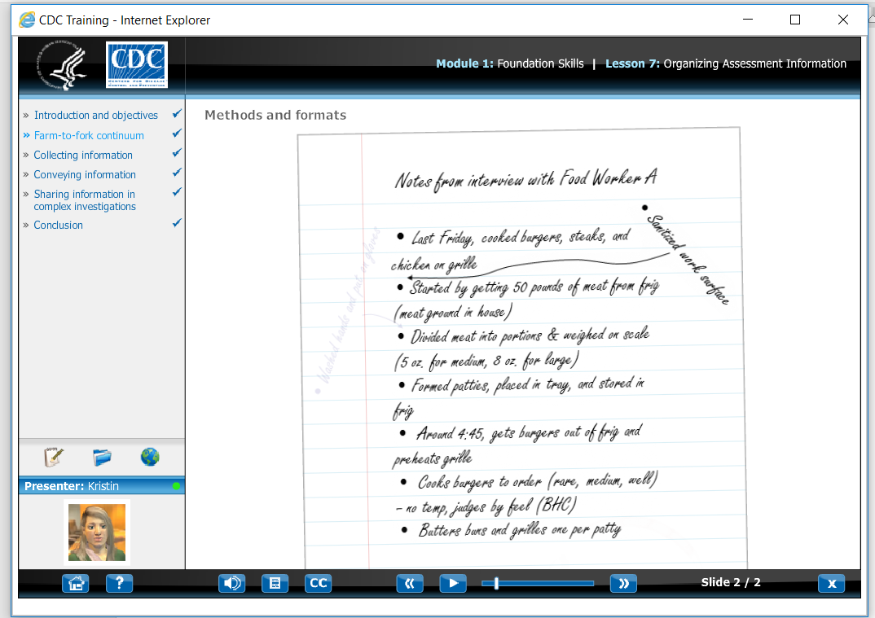
Lesson 8 provides information no implementing control strategies in the outbreak establishment to stop the current outbreak and prevent future ones (Screenshot 9).

Screenshot 9
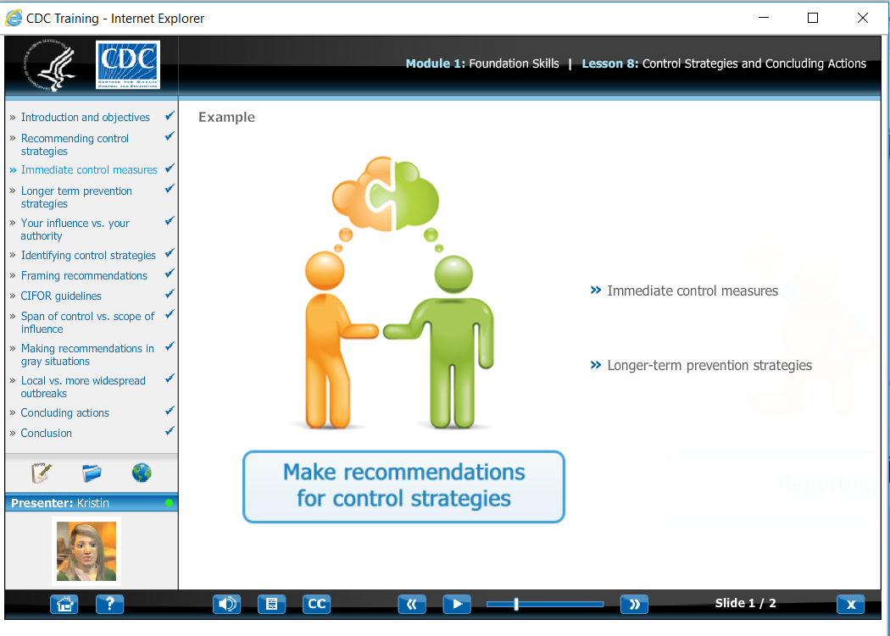
The training concludes with a 40-item test that assess mastery of the course material (Screenshot 10).
Screenshot 10
