**Note to reviewers:** This document contains screenshots of the NEARS data reporting system, with the exception of the new SVI question we are adding. Users will begin collecting this information during their investigations January 1, 2023. This question will be added to the web-based data entry system just prior to that time to accommodate programmer budgets and scheduling.

**National Environmental Assessment Reporting System (NEARS)**

Screenshot of OMB statement

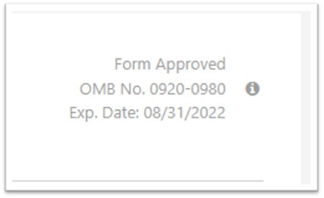

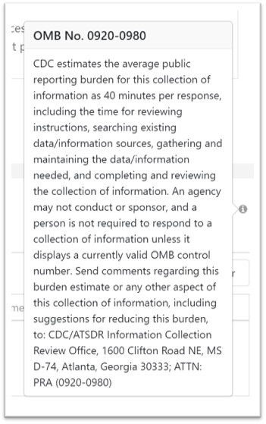

# Data Collectors

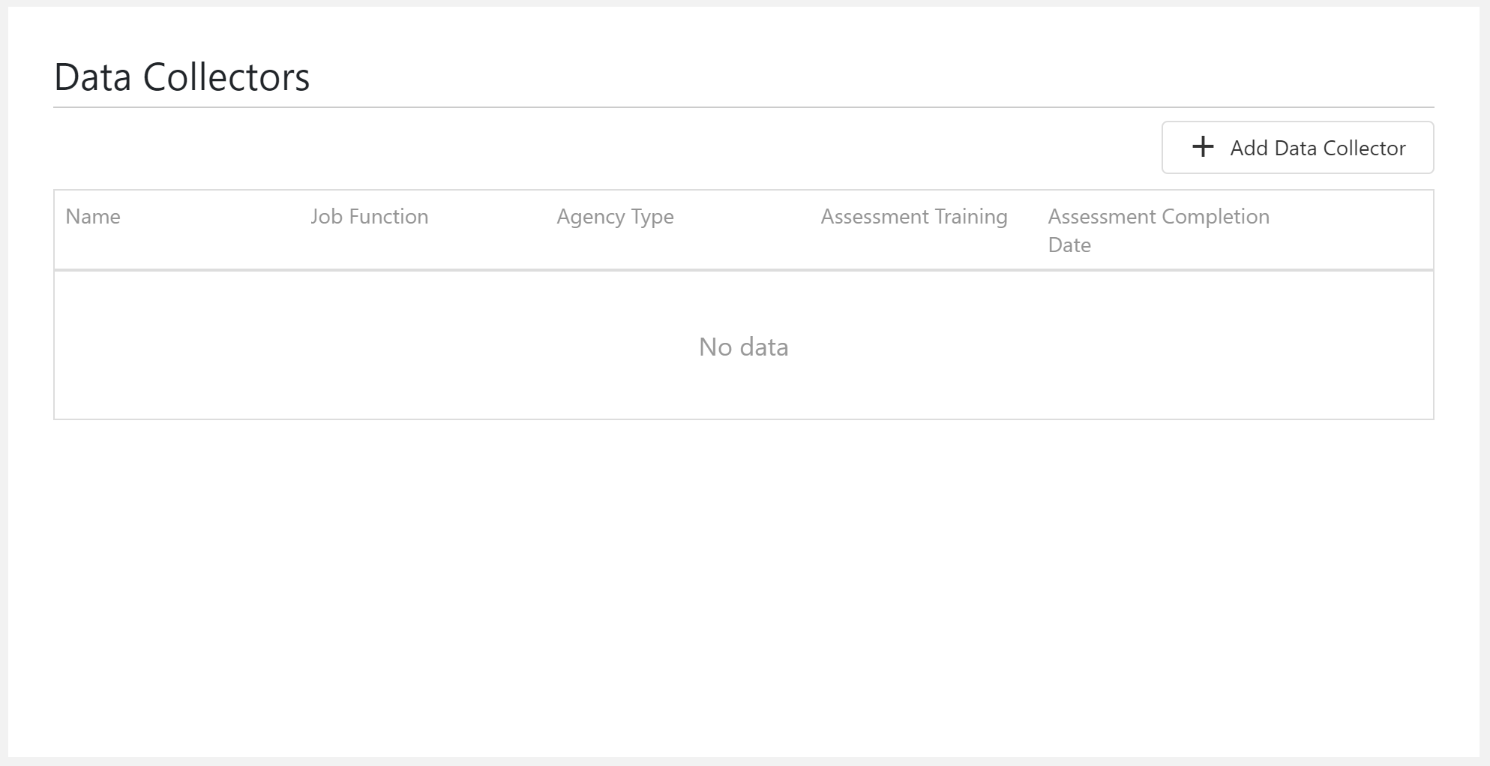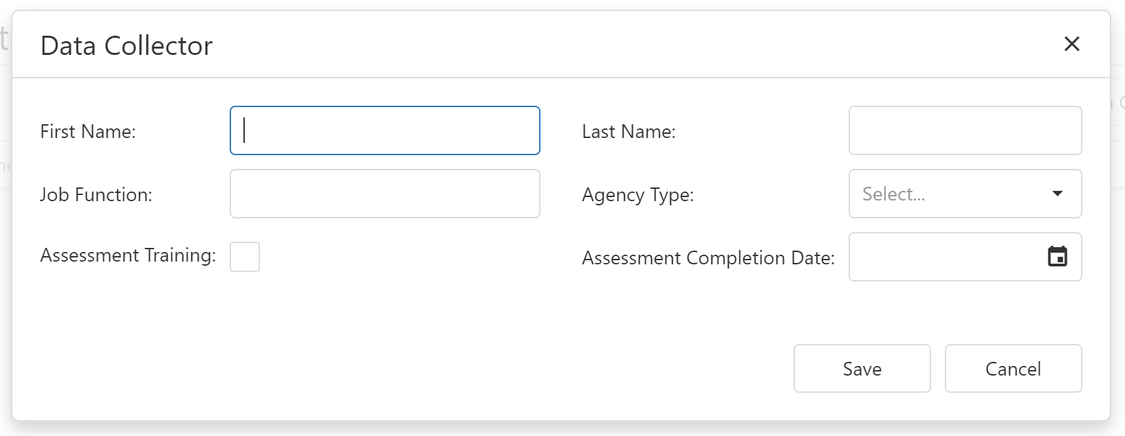

# Part I: Outbreak General Characterization

# 

# Part VII: Contributing Factors

# 

# Part II: Establishment Description

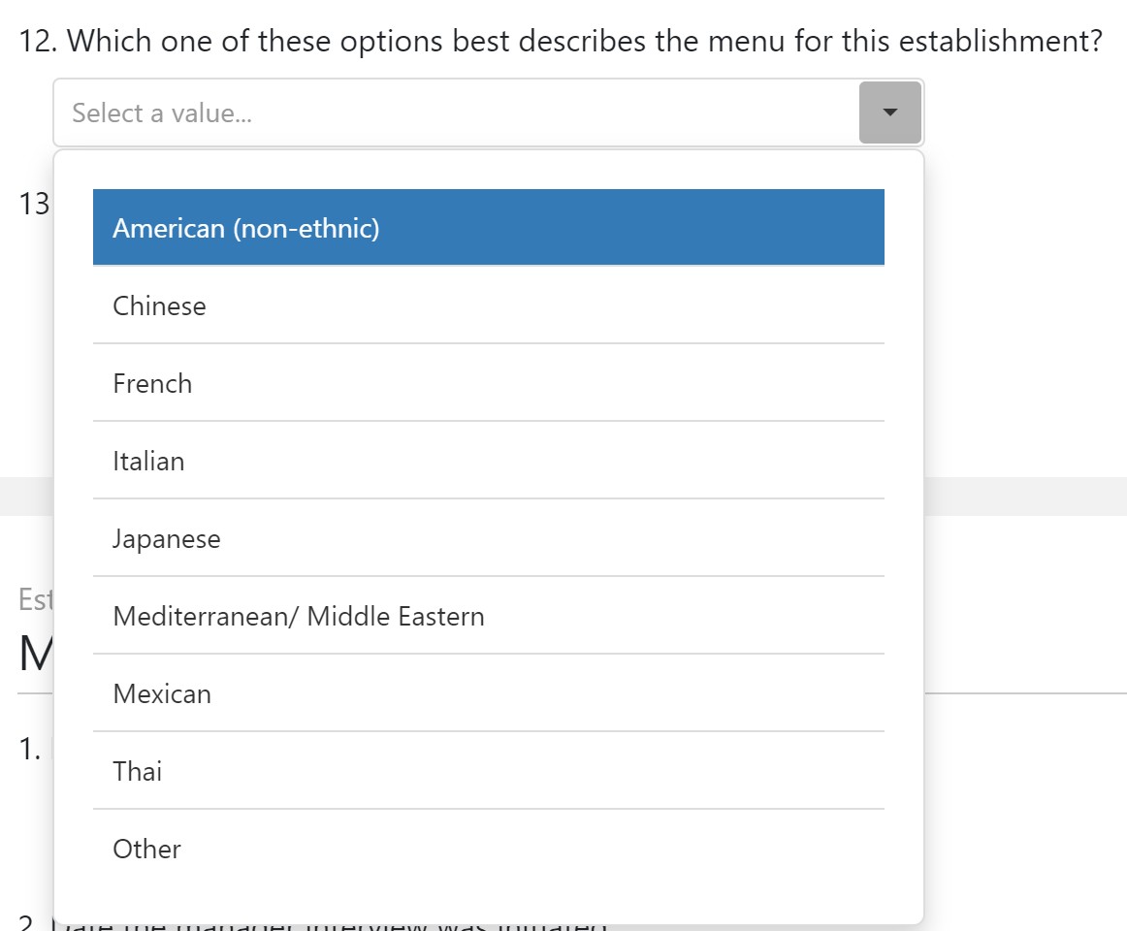 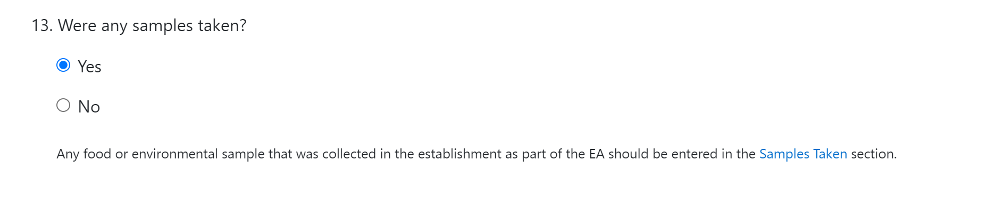

# Part III: Establishment Manager Interview

# Part IV: Establishment Observation

# Part V: Suspected/Confirmed Food

# 

# 

# 

# 

# 

# Part VI: Samples Taken

# 

# 

# Part VI: Positive Samples