Attachment 3d

Household Interview Hand Cards

TABLE OF CONTENTS

Household Sample Person Questionnaires Hand Cards 2
Household Family Questionnaires Hand Cards 9

Household Sample Person Questionnaires Hand Cards

OSQ1

Hip replacement
Knee replacement
Plates or pins to fix a broken bone
Dental implants (posts)
Metal sutures or clips
Stents
Pacemakers

AUQ1

Genetic/hereditary causes
Ear infections (including fluid in ears)
Ear diseases (otosclerosis, menieres, tumor)
Illness/infections (measles, meningitis, mumps)
Drugs/medications
Head or neck injury/trauma
Loud brief explosive noise sounds
Noise exposure, long-term (machinery, etc.)
Aging, getting older

SMQ1

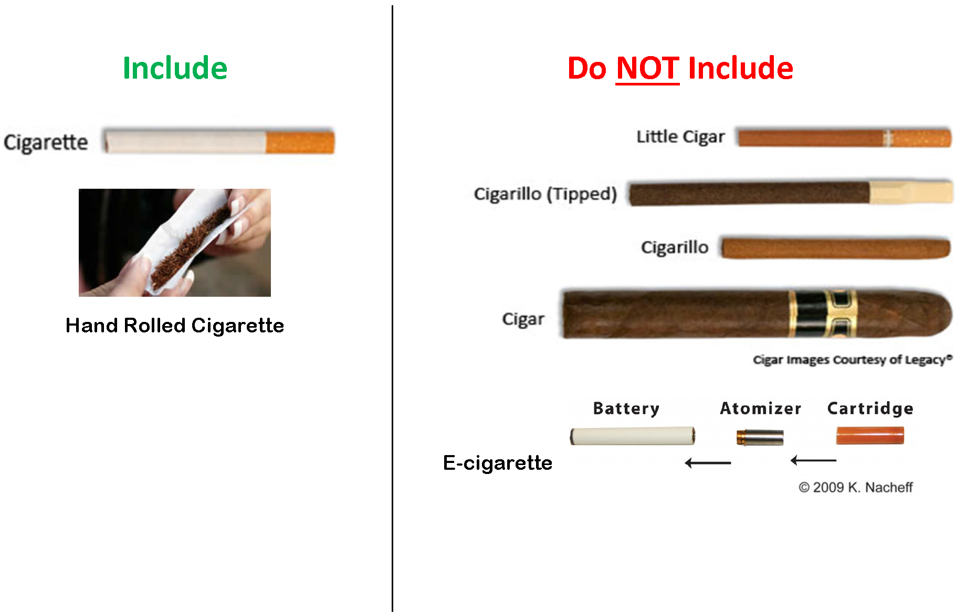

DMQ1
Never attended/kindergarten only
1st grade
2nd grade
3rd grade
4th grade
5th grade
6th grade
7th grade
8th grade
9th grade
10th grade
11th grade
12th grade, no diploma
High school graduate
GED or equivalent
Some college, no degree
Associate degree: Occupational, technical, or vocational program
Associate degree: Academic program
Bachelor’s degree (example: BA, AB, BS, BBA)
Master’s degree (example: MA, MS, MEng, MEd, MBA)
Professional school degree (example: MD, DDS, DVM, JD)
Doctoral degree (example: PhD, EdD)

DMQ2

10. Mexican
11. Puerto Rican
12. Cuban
13. Dominican (Republic)
Central American:
14. Costa Rican
15. Guatemalan
16. Honduran
17. Nicaraguan
18. Panamanian
19. Salvadoran
20. Other Central American
South American:
21. Argentinean
22. Bolivian
23. Chilean
24. Colombian
25. Ecuadorian
26. Paraguayan
27. Peruvian
28. Uruguayan
29. Venezuelan
30. Other South American
Other Hispanic or Latino:
31. Filipino
32. Spaniard
33. Spanish
34. Spanish American
35. Hispano/Hispana
36. Hispanic/Latino
41. Chicana/Chicano

HIQ1

Private health insurance

Medicare

Medi-gap

Medicaid

Children’s Health Insurance Program (CHIP)

Military Related Health Care: Tricare
(CHAMPUS)/VA HEALTH CARE/Champ-VA

Indian Health Service

State-sponsored health plan

Other government program

No coverage of any type

Household Family Questionnaires Hand Cards

DMQ1

Never attended/kindergarten only
1st grade
2nd grade
3rd grade
4th grade
5th grade
6th grade
7th grade
8th grade
9th grade
10th grade
11th grade
12th grade, no diploma
High school graduate
GED or equivalent
Some college, no degree
Associate degree: Occupational, technical, or vocational program
Associate degree: Academic program
Bachelor’s degree (example: BA, AB, BS, BBA)
Master’s degree (example: MA, MS, MEng, MEd, MBA)
Professional school degree (example: MD, DDS, DVM, JD)
Doctoral degree (example: PhD, EdD)

CBQ1

EXAMPLES OF PLACES OTHER
THAN GROCERY STORES

Convenience Stores (7-11, Mini Mart)
Wholesale Stores (Costco, Sam’s Club, BJ’s)
Target/ Wal-Mart/ Kmart
Dollar Store
Bakeries
Meat Markets
Vegetable stands
Farmer’s Markets

INQ1

U. $20,000 - $20,999
V. $21,000 - $21,999
W. $22,000 - $22,999
X. $23,000 - $23,999
Y. $24,000 - $24,999
Z. $25,000 - $25,999
AA. $26,000 - $26,999
BB. $27,000 - $27,999
CC. $28,000 - $28,999
DD. $29,000 - $29,999
EE. $30,000 - $30,999
FF. $31,000 - $31,999
GG. $32,000 - $32,999
HH. $33,000 - $33,999
II. $34,000 - $34,999
JJ. $35,000 - $39,999
KK. $40,000 - $44,999
LL. $45,000 - $49,999
MM. $50,000 - $54,999
NN. $55,000 - $59,999
OO. $60,000 - $64,999
PP. $65,000 - $69,999
QQ. $70,000 - $74,999
RR. $75,000 - $79,999
SS. $80,000 - $84,999
TT. $85,000 - $89,999
UU. $90,000 - $94,999
VV. $95,000 - $99,999
WW. $100,000 and over

INQ2

A. Less than $1,000
B. $1,000 - $1,999
C. $2,000 - $2,999
D. $3,000 - $3,999
E. $4,000 - $4,999
F. $5,000 - $5,999
G. $6,000 - $6,999
H. $7,000 - $7,999
I. $8,000 - $8,999
J. $9,000 - $9,999
K. $10,000 - $10,999
L. $11,000 - $11,999
M. $12,000 - $12,999
N. $13,000 - $13,999
O. $14,000 - $14,999
P. $15,000 - $15,999
Q. $16,000 - $16,999
R. $17,000 - $17,999
S. $18,000 - $18,999
T. $19,000 - $19,999

INQ3

Cash
Checking account
Saving accounts
CDs (Certificates of deposit)
Retirement accounts (such as IRAs, 401K, etc.)
Stocks
Bonds
Mutual funds
INQ4

A: $0 - $3,000
B: $3,001 - $5,000
C: $5,001 - $10,000
D: $10,001 - $15,000
E: $15,001 - $20,000
________________________________________
Cash
Checking account
Saving accounts
CDs (Certificates of deposit)
Retirement accounts (such as IRAs, 401K, etc.)
Stocks
Bonds
Mutual funds

FSQ1

Often true

Sometimes true

Never true

