

**2021 NHANES Dry Run Health Measurements**

You are participating in the National Health and Nutrition Examination Survey (NHANES) health examination as a dry run participant. We are pleased that you are interested in learning more about the survey by actually being examined at our Mobile Examination Center. Information collected as part of your examination will not be part of NHANES.

You will only have the test if your age falls within the ages shown in parenthesis. You may not receive all the exams or tests listed here. This can vary by the date of your appointment, type of appointment, or the study number you are assigned.

Depending on what appointment type or study number you have, you will receive the results of health measures shown with a black diamond (♦).

Two diamonds (♦♦) means you will receive the test result only if high or abnormal.

# Health Measurements

You will be weighed and measured (all) ♦

The doctor will take your blood pressure (8+) ♦

You will have a body composition test that involves low-dosage x-rays (*Pregnant women will not have this test*)

Total body scan (8-59) ♦

You will have a liver ultrasound elastography test (12+) ♦

# Private Interviews

You will be asked to answer questions about:

Reproductive history (females 12+)

Drug use (12-59)

Alcohol and tobacco use (12+)

Sexual history (14-69)

*(You will do these by yourself using a touch-*

*screen computer in privacy)*

**Lab Tests on Urine**

You will be given a clean empty cup when you arrive at the exam center. When you change into the exam clothes in a private rest room, you will provide a urine sample. The urine will be tested for:

Kidney function tests ♦

(*Urine is not tested for drug use*)

## Please turn over to see the next page.

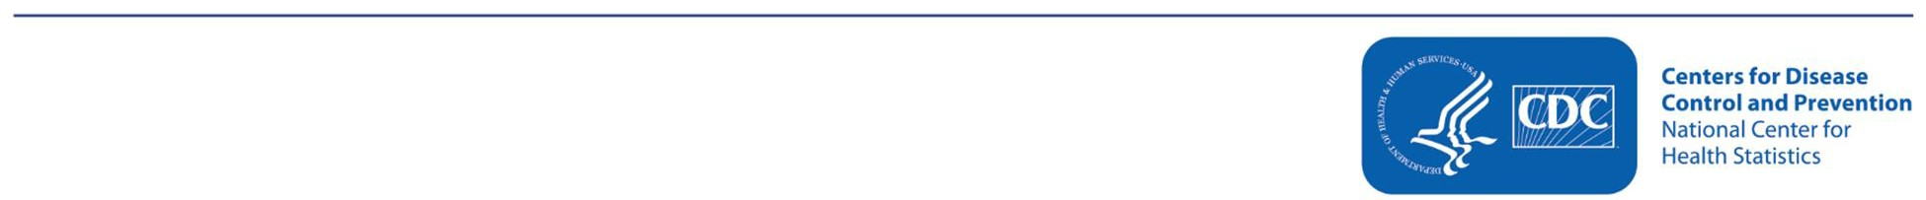

**Lab Tests on Blood**

You will have your blood drawn. The blood will be tested for: Anemia ♦

Biochemistry panel ♦

Kidney and liver function

Diabetes status ♦

Glucose

Glycohemoglobin (hemoglobin A1C)

Insulin

Exposures to environmental metals:

Lead, cadmium, mercury, selenium, manganese ♦

Exposure to environmental chemicals:

Cotinine

Acetylcholinesterase

Lipid panel♦

Total cholesterol/HDL

Triglycerides/LDL

Infectious diseases

Hepatitis B virus ♦♦ Hepatitis C virus ♦♦

Hepatitis D virus ♦♦

COVID-19 antigen and antibody (1+) ♦

Inflammation biomarkers

High sensitivity C-reactive protein (hs-CRP)

Nutrition status

Alpha-1-acid glycoprotein (AGP)

Ferritin

Folate ♦

Iron ♦

Magnesium ♦

Vitamins A, C and D ♦

Hormone panel ♦

Thyroid panel

Steroid

# Women and girls only:

Females 12-59 years old will have a urine pregnancy test, as well as girls 8-11 years old who have started their periods. Our team will tell you if you are pregnant if you did not already know it. Parents of girls younger than 14 years of age who are pregnant will also be informed of the test result. ♦♦

**NOTE:** Because you are a dry run participant, your biologic specimens will be discarded after your examination findings have been reported to you. All health data collected will be deleted from our records two years after your exam. You will not receive a cash payment for your time and effort.

## If you have questions about getting your results, please call 1-800-452-6115.