Appendix G1 – Recruitment Communications Materials

Recruitment Postcard
.

Recruitment Fact Sheet (page 1)
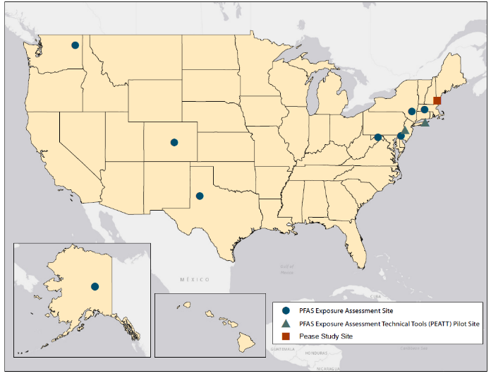
Recruitment Fact Sheet (page 2)

