Figure 1: Submit Questionnaire and Link Questionnaire to Hospital(s)
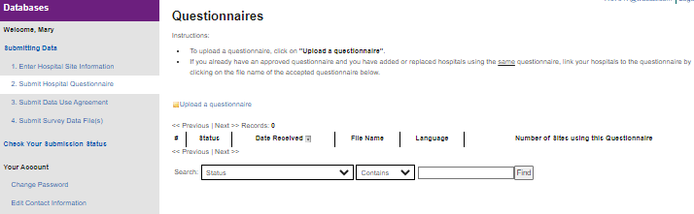

Figure 1: Submit Questionnaire and Link Questionnaire to Hospital(s), continued
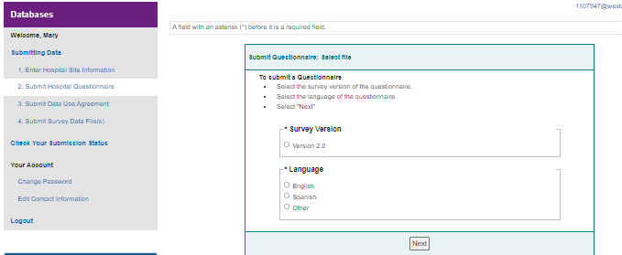

Figure 2: Upload Data for Each Participating Hospital
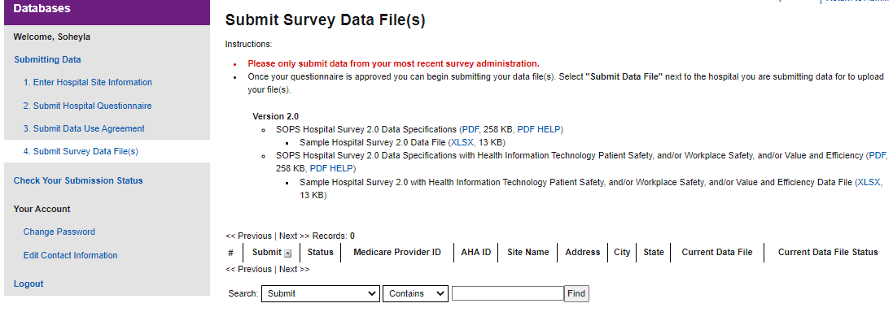

Figure 2: Upload Data for Each Participating Hospital, continued
