APPOINTED REPRESENTATIVE REGISTRATION via INTERNET

- Select “Create Log in Account”
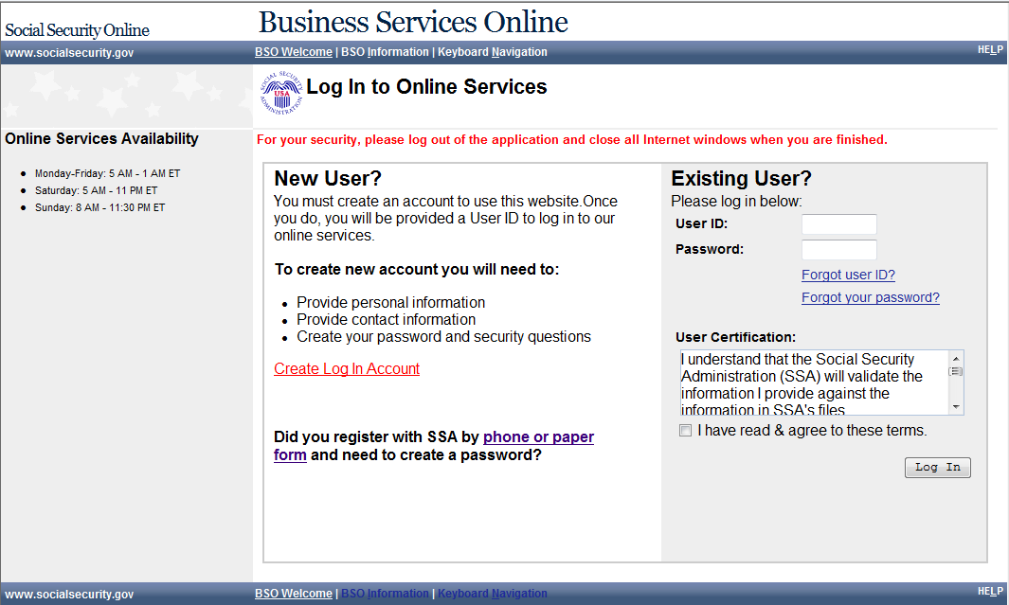
- Accept the Attestation 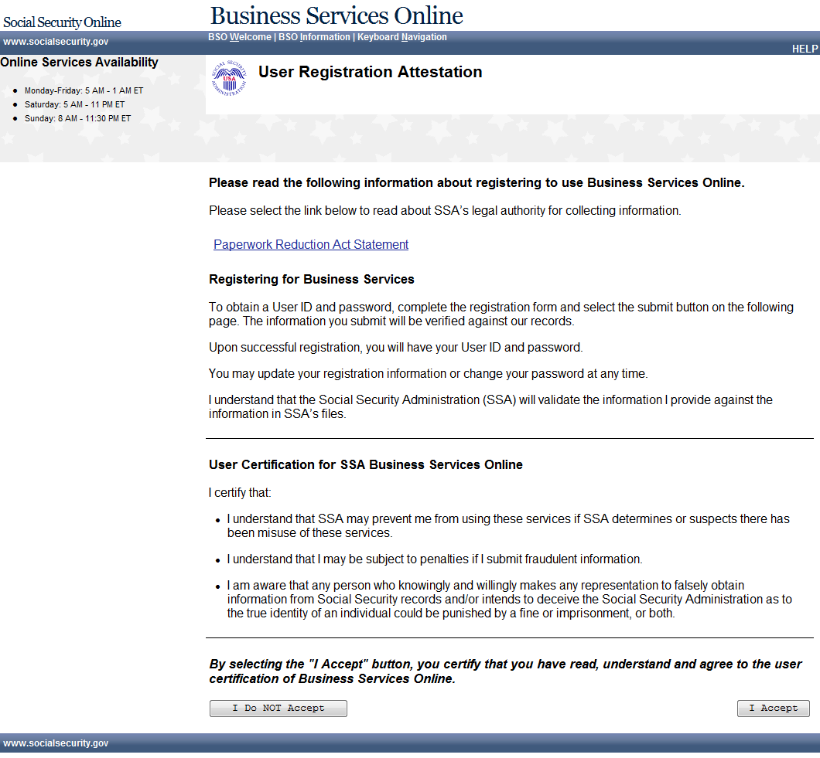

- Add user information
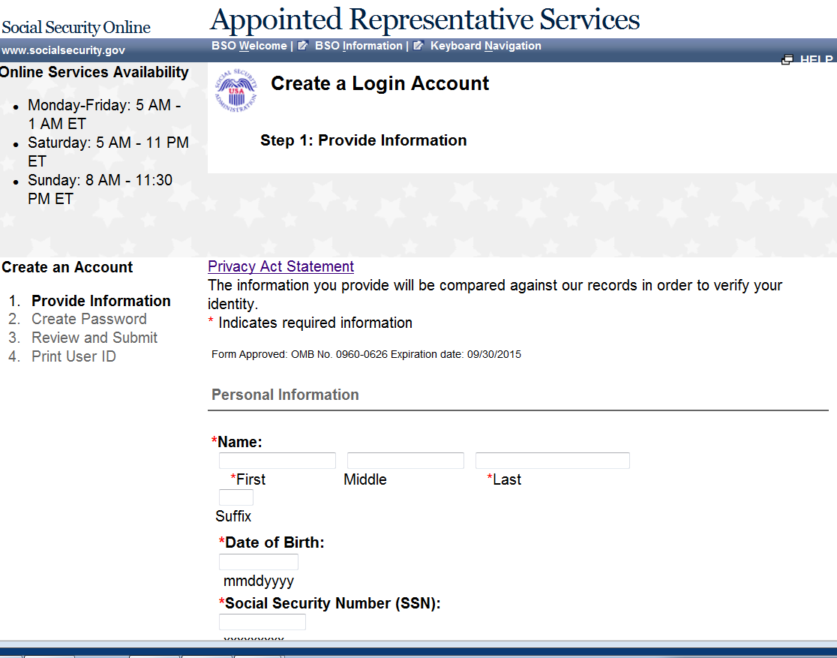
Form Approved: OMB No. 0960-0596 Expiration Date: 09/30/2015
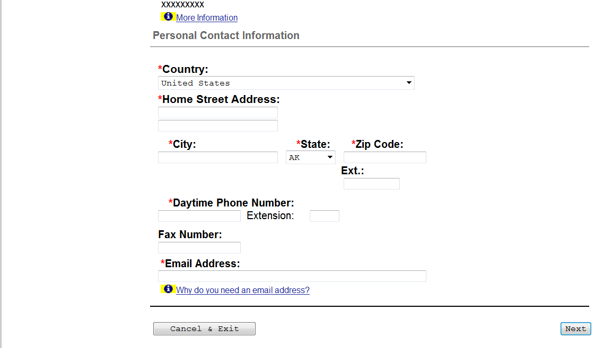

- Enter password and KBA questions and answers 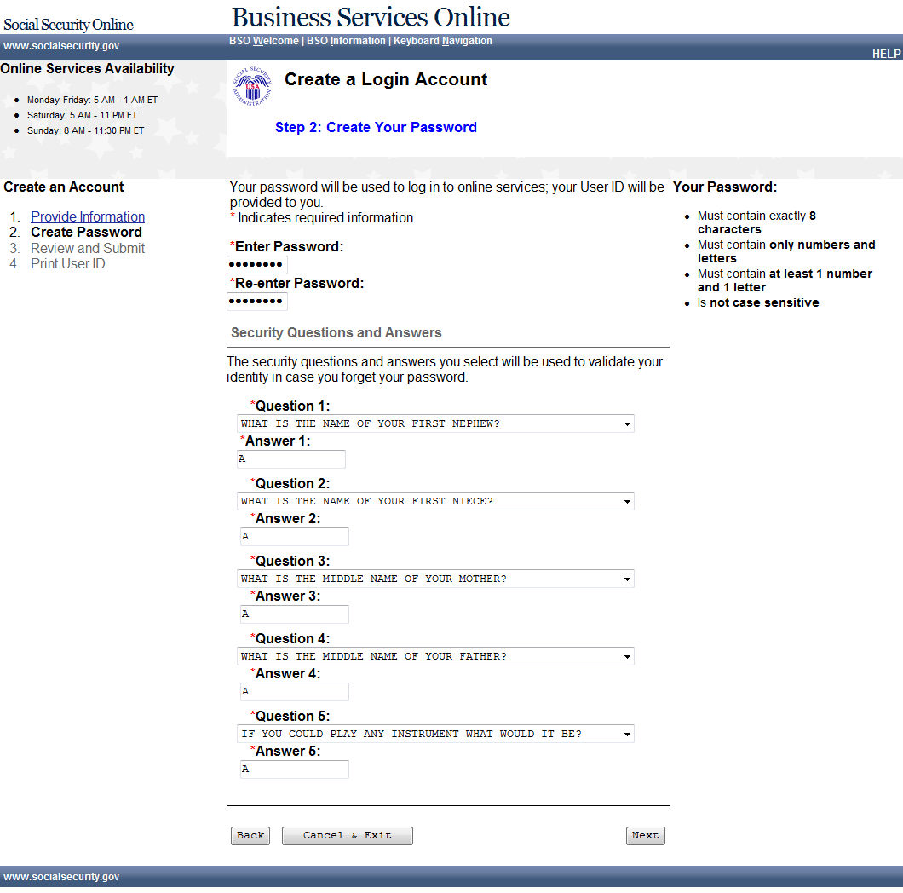
- Review your information and accept the certification 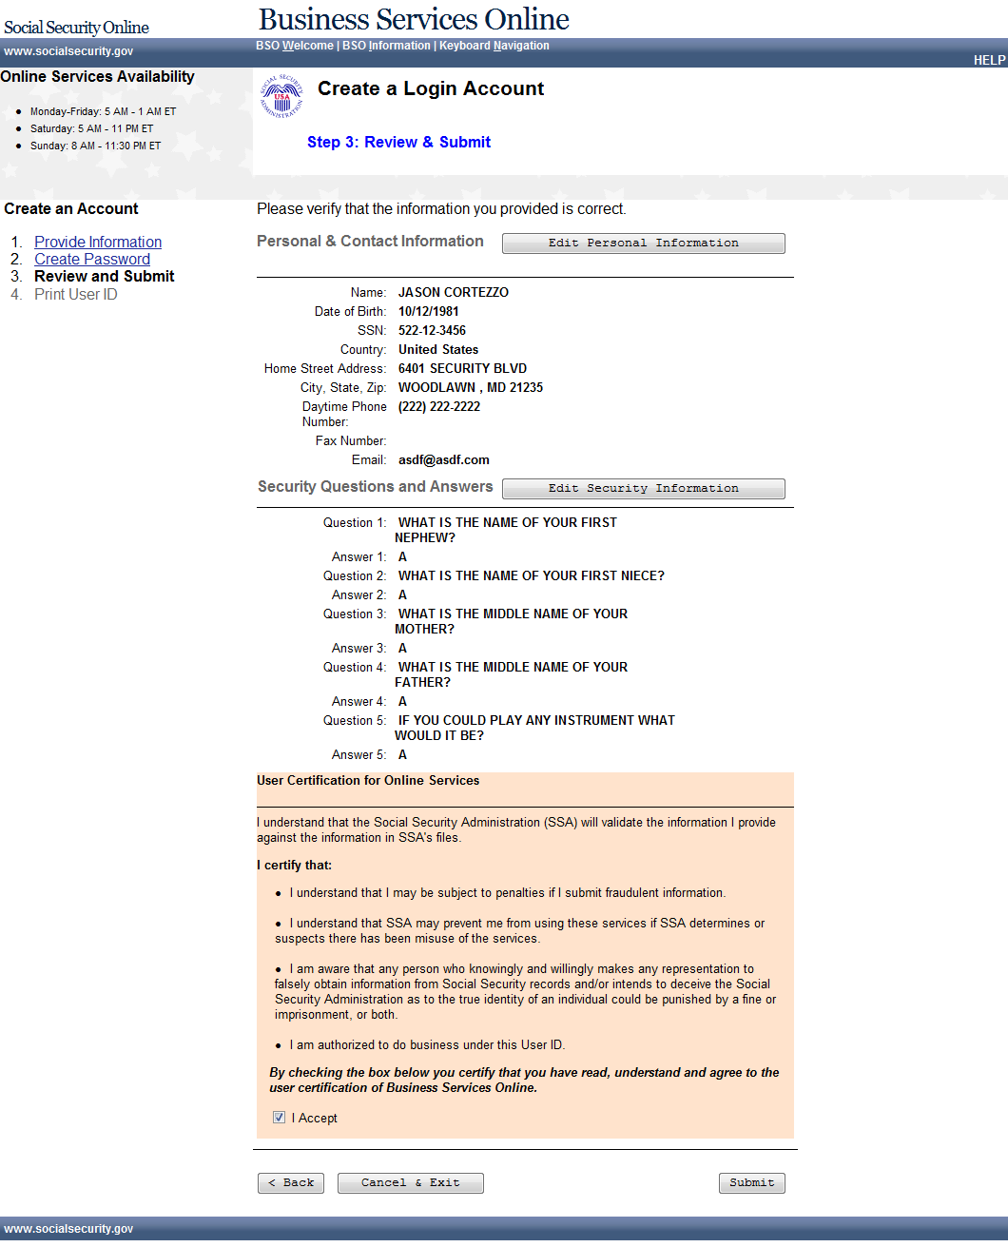
- Note down your new user id, you can print a receipt if desired 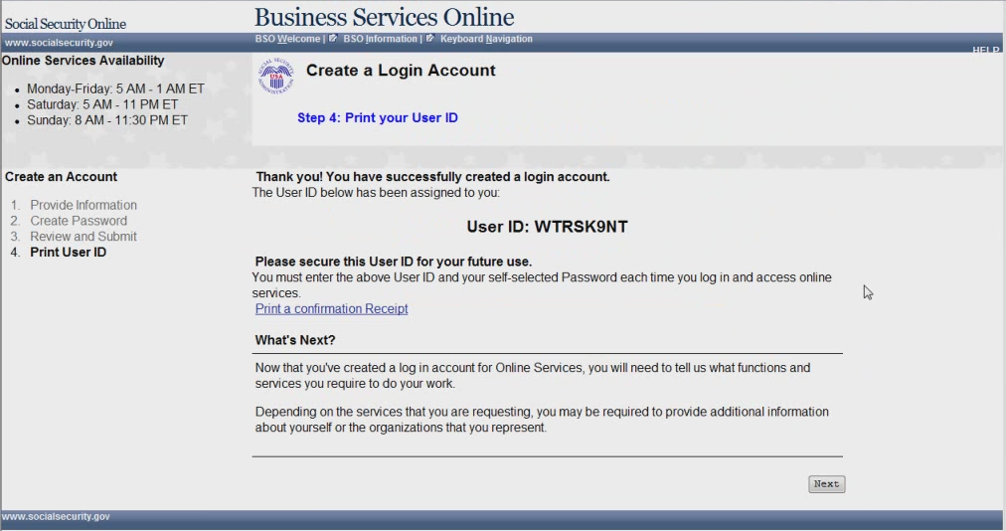
- Appointed Rep MENU - No services
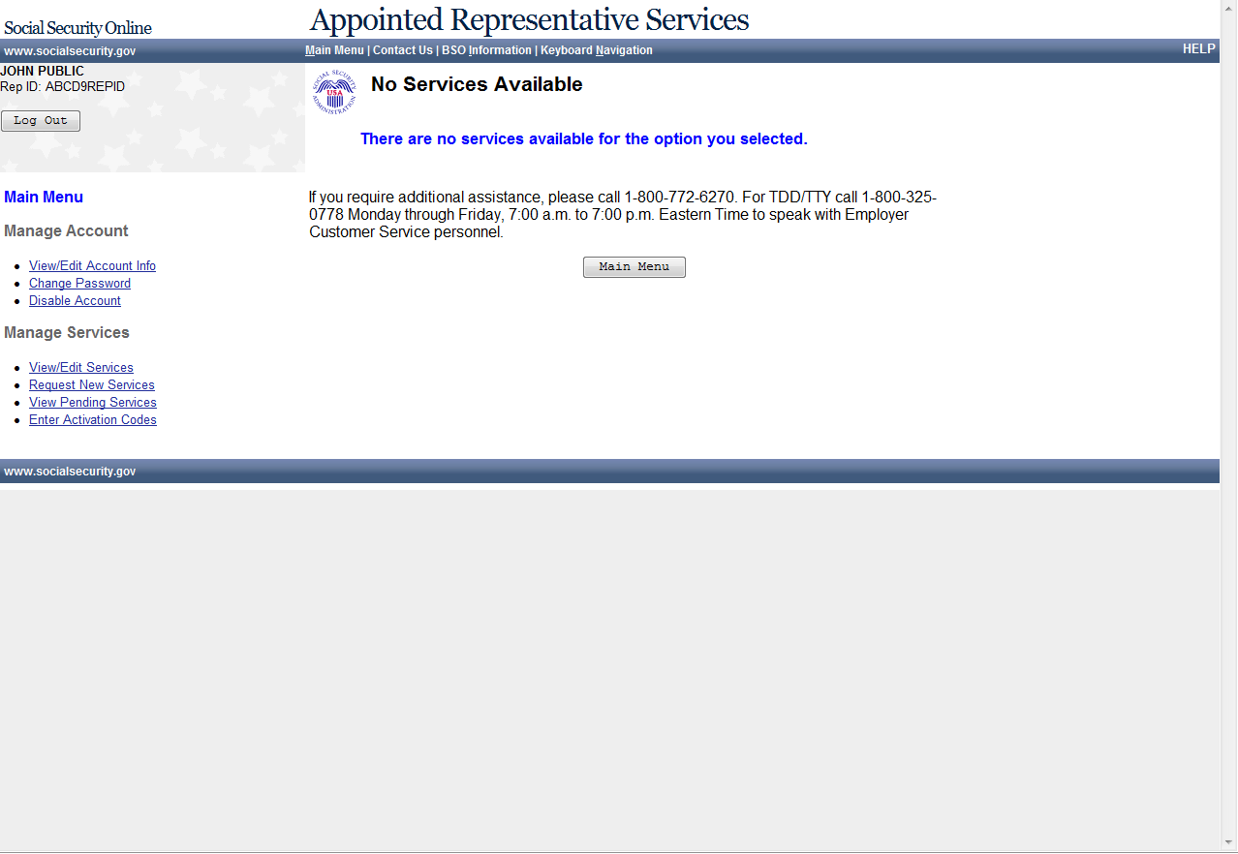

9. Appointed Rep MENU – Electronic Folder Request

10. Enter a Text-Enabled Phone Number
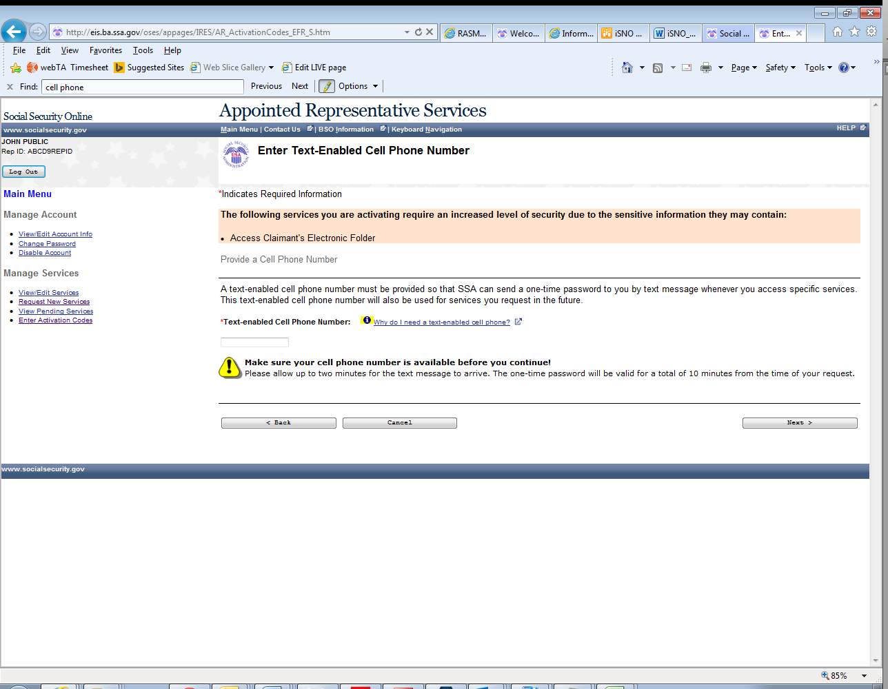
11. Enter code activation
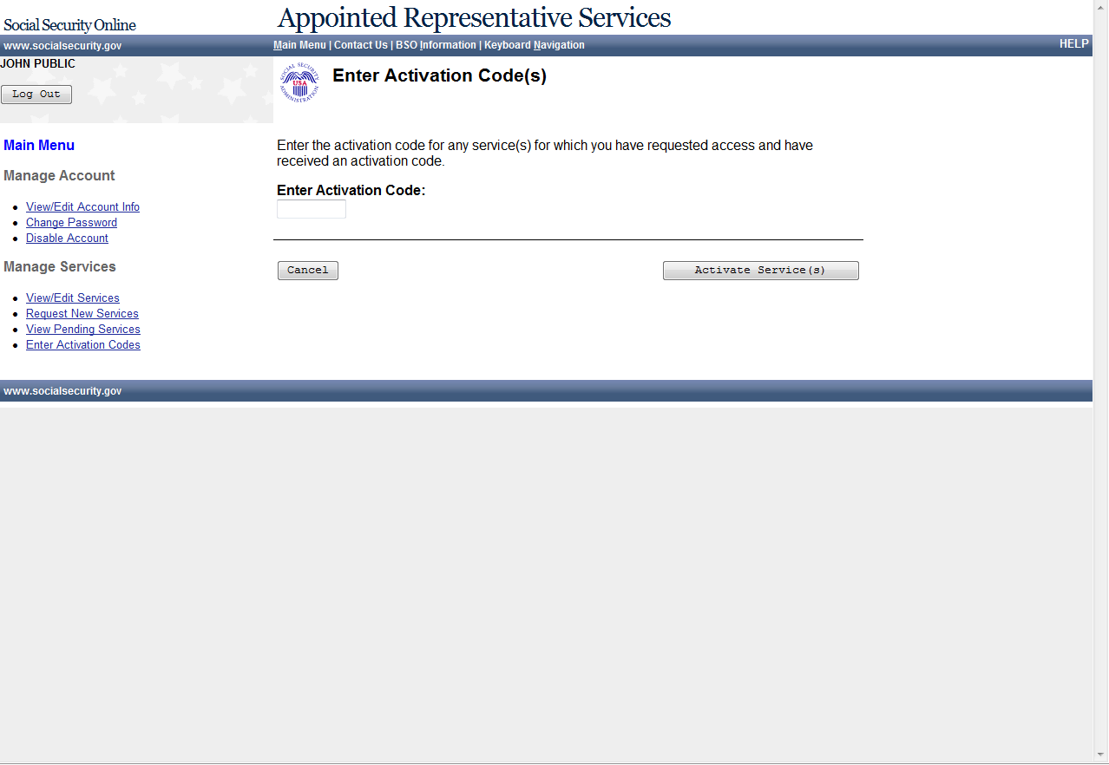
12. Enter activation confirmation
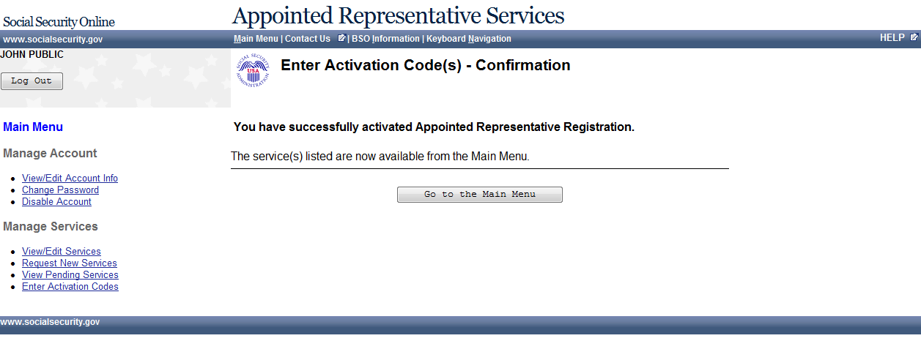

13. No service available

14. Paperwork Reduction Act Statement

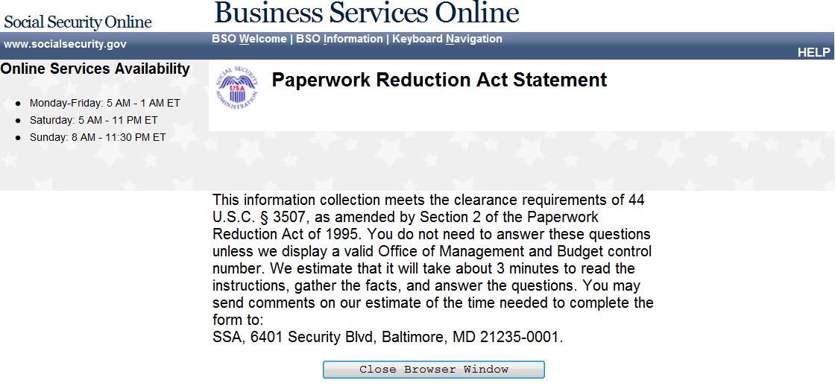

15. Privacy Act Statement
See revised Privacy Act Statement Attached

Privacy Act Statement
Collection and Use of Personal Information

Sections 205(a) and 1106 of the Social Security Act, as amended, authorize us to collect this information to allow you access to our online applications. We will use the information you provide to register you, your company, or authorized employee(s) to use our Business Services Online (BSO).
Furnishing us this information is voluntary. However, failing to provide us with all or part of the information could prevent us offering you access to our BSO suite of services.
We rarely use the information you supply for any purpose other than for registration and granting access to our BSO suite of services. However, we may use the information for the administration of our programs including sharing information:
- To comply with Federal laws requiring the release of information from our records (e.g., to the Government Accountability Office and Department of Veterans Affairs); and,
- To facilitate statistical research, audit, or investigative activities necessary to ensure the integrity and improvement of our programs (e.g., to the Bureau of the Census and to private entities under contract with us).
A list of when we may share your information with others, called routine uses, is available in our Systems of Records Notice entitled, Master Files of Social Security Number (SSN) Holders and SSN Applications (60-0058). Additional information about the BSO suite of services, routine uses of information, programs, and systems are available online at www.socialsecurity.gov or at your local Social Security office.
We may share the information you provide to other agencies through computer matching programs. Matching programs compare our records with records kept by other Federal, State, or local government agencies. We can use the information from these matching programs to establish or verify a person’s eligibility for federally funded or administered benefit programs and for repayment of payments or delinquent debts under these programs.
SSA will insert the following revised Privacy Act Statement into the form as soon as possible:
Privacy Act Statement
Collection and Use of Personal Information

Sections 205 and 1106 of the Social Security Act, as amended, allow us to collect this information. Furnishing us this information is voluntary. However, failing to provide all or part of the information may prevent us from offering you access to our telephone and online services.
We will use the information you provide us to verify your identity and register you, your company, or authorized employee(s) to use our telephone or online services. We may also share this information for the following purposes, called routine uses:
- To contractors and other Federal agencies, as necessary, to assist us in efficiently administering our programs;

- To Federal, State, and local entities to assist them with administering income maintenance and health maintenance programs, when a Federal statute authorizes them to use the SSN;

- To a congressional office in response to a request from that office made at the request of the subject of the record or a third party acting on the subject’s behalf; and

- To appropriate Federal, State, and local agencies, entities, and persons when: (a) We suspect or confirm a compromise of security or confidentiality of information; (b) We determine that as a result of the suspected or confirmed compromise there is a risk of harm to economic or property interests, risk of identity theft or fraud, or harm to the security or integrity of this system or other systems or programs that rely upon the compromised information; and (c) We determine that disclosing the information to such agencies, entities, and persons will assist us in our efforts to respond to the suspected or confirmed compromise and prevent, minimize, or remedy such harm.
In addition, we may share this information in accordance with the Privacy Act and other Federal laws. For example, where authorized, we may use and disclose this information in computer matching programs, in which our records are compared with other records to establish or verify a person’s eligibility for Federal benefit programs and for repayment of incorrect or delinquent debts under these programs.
A list of additional routine uses is available in our Privacy Act System of Records Notices (SORN) 60-0058, entitled Master Files of Social Security Number (SSN) Holders and SSN Applications, as published in the Federal Register (FR) on December 29, 2010, at 75 FR 82121, and 60-0373, entitled Repository of Electronic Authentication Data Master File, as published in the FR on December 17, 2010, at 75 FR 79065. Additional information, and a full listing of all of our SORNs, is available on our website at www.ssa.gov/privacy

