APPOINTED REPRESENTATIVE REGISTRATION via INTRANET

CSA Home – user search
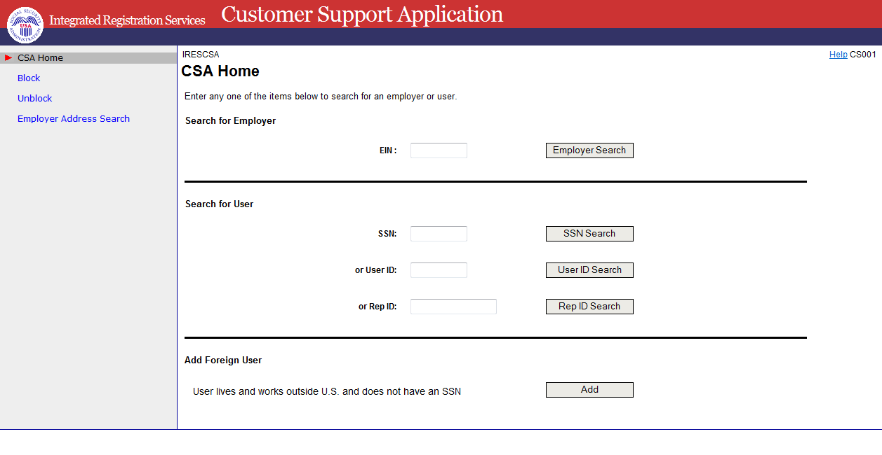
Multiple users found
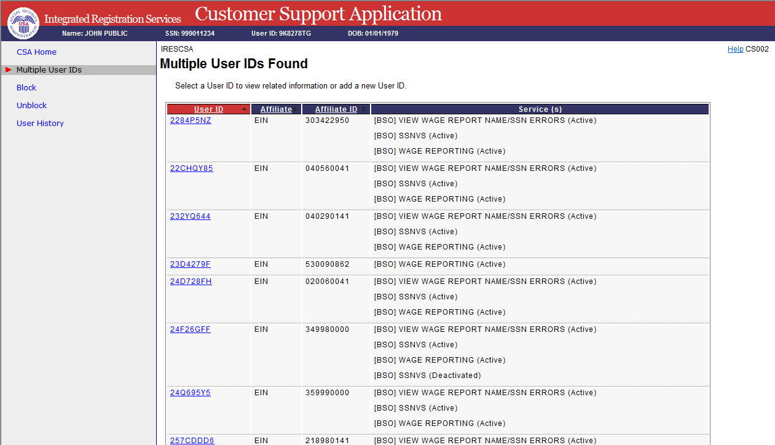

One user found or selecting a user id link above
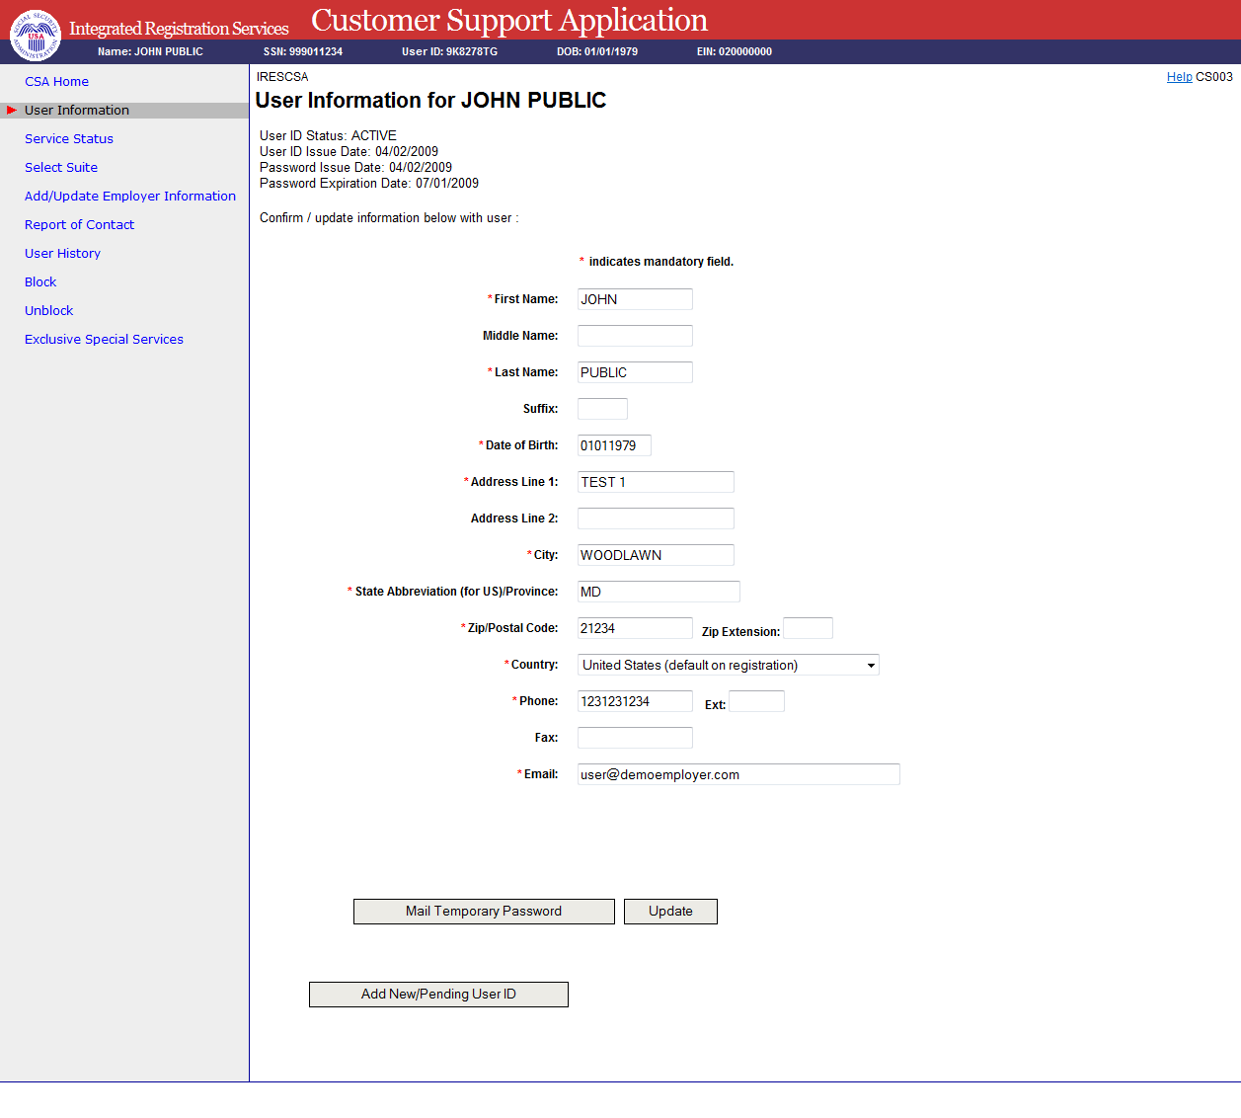

Add new user - phone registration
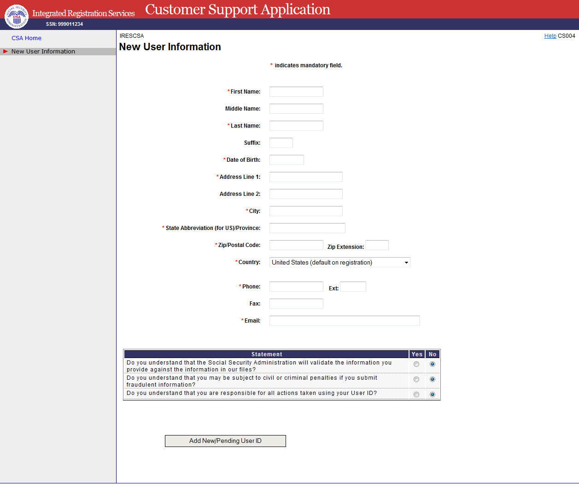

New user NUMI failed
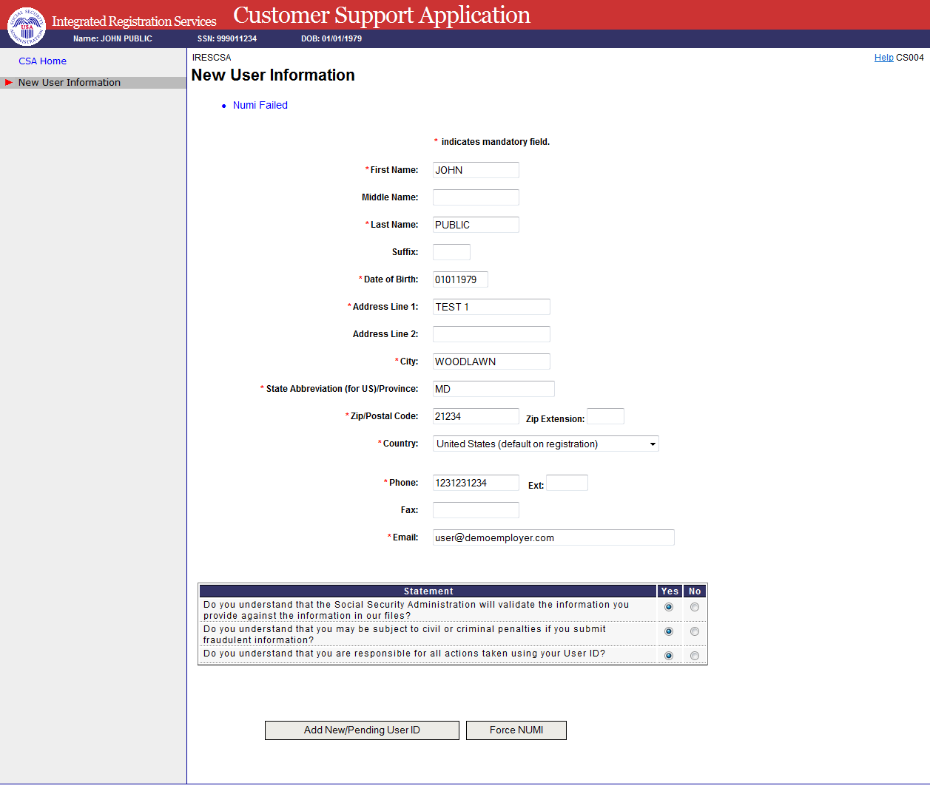

Add employer information
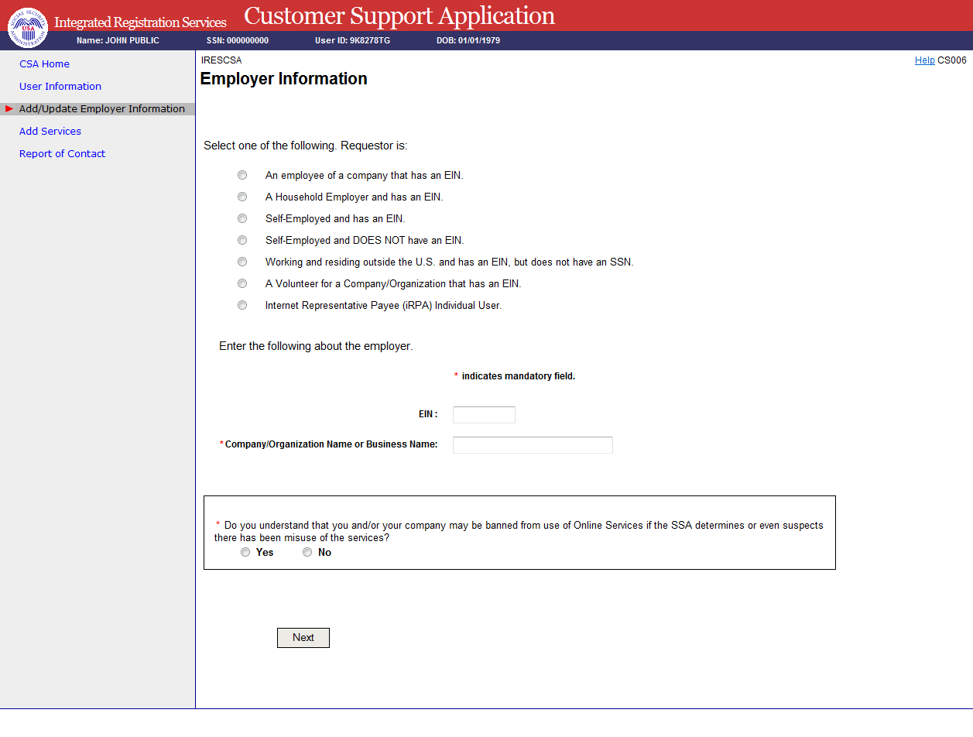

Select Suite
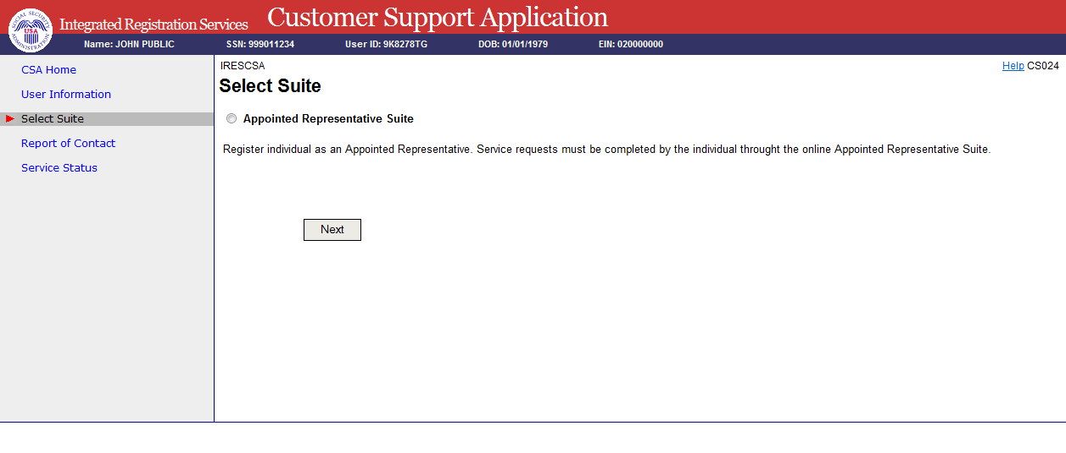

In person proofing – record information
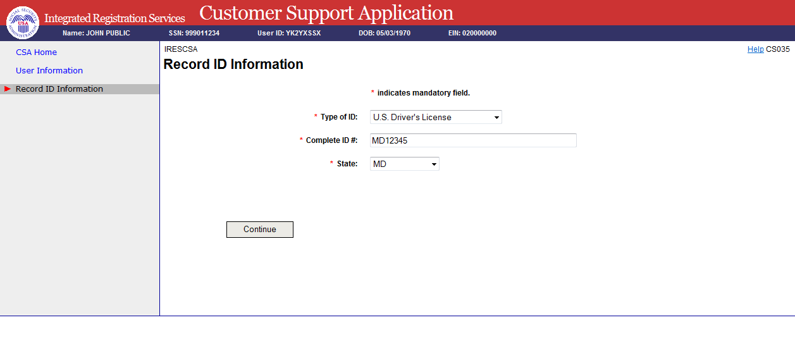

Print activation code for efolder
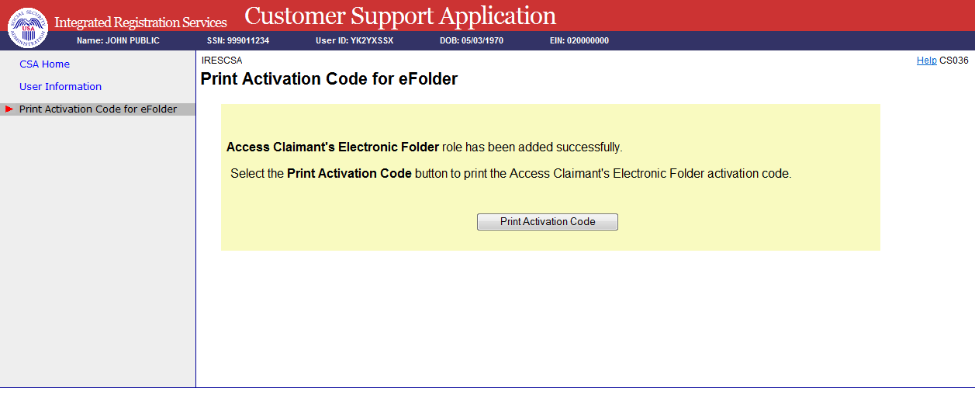
View activation code for efolder
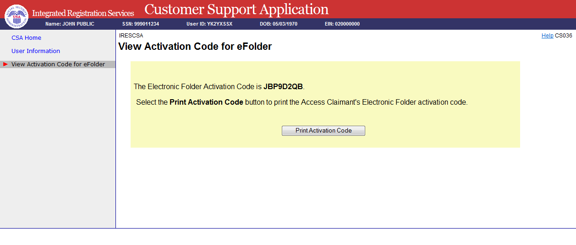

Paperwork Reduction Act Statement

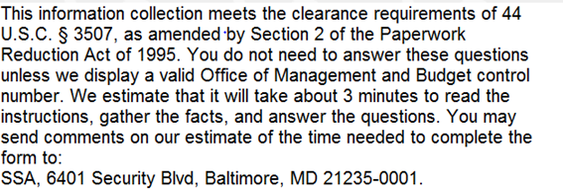

Privacy Act Statement

Privacy Act Statement

Collection and Use of Personal Information

Sections 205(a) and 1106 of the Social Security Act, as amended, authorize us to collect this information to allow you access to our online applications. We will use the information you provide to verify your identity and to register you, your company, or authorized employee(s) to use our Business Services Online (BSO) suite of services. The Privacy Act (5 U.S.C. § 552a(b)) permits us to disclose the information you provide in accordance with approved routine uses. Providing us this information is voluntary. However, failing to provide us with all or part of the information could prevent us from offering you access to our BSO suite of services. Additional information regarding your use our online applications, routine uses of information, programs, and systems are available on our Internet website, www.socialsecurity.gov, or at your local Social Security office.

