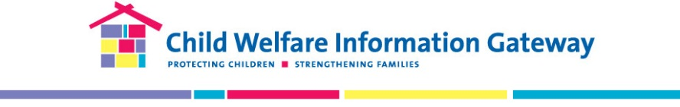
The Grantee Exchange Platform New User Survey
We are conducting this survey to better understand how you may choose to access and share information with your fellow grant recipients (formerly known as “grantees”). The feedback you provide you will be used to inform the design and implementation of efforts to better connect grant recipients to knowledge and to each other, in service of achieving grant goals. The survey is voluntary and should take about five minutes to complete. You may exit the survey at any time and are free to decline to answer any question. There are no foreseeable risks and no direct benefits from participating in this survey. Proceeding with the survey is an indication of your consent. If you have any questions or require accessibility assistance with this survey, please contact Information Gateway staff by email at info@childwelfare.gov or by phone at 800.394.3366. Thank you for providing your feedback!
- I am a…
- Family Support through Primary Prevention (FSPP) grant recipient or partner
- Federal staff
- Other (Please describe in the textbox below.)___________
- What is your role on your grant project? (If response is a FSPP grant recipient)
- Project Director/Manager
- Researcher/Evaluator
- Community Outreach Coordinator
- Demonstration Site Staff
- Legal Aid Partners
- Public Health Department
- Other (Please describe in the textbox below.)_________
- Please indicate your top three (3) topic areas that you would like to learn more about to help you with grant project planning and implementation.
- Information from or about other FSPP grant projects, other Children’s Bureau discretionary grants, or other prevention programs and initiatives
- Information about grants management tasks or activities
- Information about building and/or maintaining partnerships
- Information about funding primary prevention programs (i.e., braided and blended funding, leveraging funding from other initiatives)
- Information about data collection/evaluation of primary prevention programs
- Information about evidence-based or evidence-informed strategies or activities
- Information about incorporating racial equity strategies to and reducing disproportionality
- Information about engaging those with lived experience through your project (i.e., advisory boards, shared decision making)
- Information about communicating, branding, or marketing your program
- Other (Please describe in the textbox below.)_______
- What do you want to learn about other grant projects? (Select all that apply)
- Assessment and/or intake tools
- Implementation strategies
- Developing and maintaining community partnerships
- Evidence-based approaches/interventions
- Funding structure
- Data collection methods
- Evaluation design and tools
- Challenges, barriers, and solutions
- Family and community engagement strategies
- Family resource centers
- Concrete and economic supports
- Mandated reporting and “mandated supporting”
- Other (Please describe in the textbox below.)__________

- How would you typically approach learning what other grant projects are doing or learning on their projects? (Select all that apply)
- E-mail
- Social media
- Web search/ Google
- Meetings
- Other (Please describe in the textbox below.)__________
- How would you typically approach getting information from Federal staff about topics important to you? (e.g., grants management) (Select all that apply)
- E-mail
- Social media
- Web search/ Google
- Meetings
- Other (Please describe in the textbox below.)__________
- What is the first place you look when searching for information to use in your work?
- Personal files/folders
- Colleague
- Subject Matter Expert
- Children’s Bureau/Federal Project Officer
- Children’s Bureau website
- Child Welfare Information Gateway
- Internet search engine (e.g., Google)
- Other (Please describe in the textbox below.)__________
- In a typical work week, how much time do you spend looking for information to support your work on a grant (e.g., searching the Internet for relevant products or reports, e-mailing to ask a colleague or subject matter expert)?
  - Half an hour or less
  - Half an hour to one hour
  - Between 1 to 2 hours
  - Between 2 and 3 hours
  - More than 3 hours

- What could improve your current access to information that would support your grant project?
______________________________________________________________________
- Please indicate your disagreement or agreement with the following statements.
 | Strongly Disagree | Disagree | Agree | Strongly Agree | N/A
I know what other grant recipients are doing and learning on their projects.
I have information about what other grant recipients are doing that can inform my own work.
I can easily access information that supports my grant project.
I have made valuable connections with grant recipients outside of my grant project.
I have been able to ask questions of other grant recipients to receive real time help.
I feel like I am a member of a knowledge community where we help each other find information in service of our grant goals.
Thank you for your participation!

