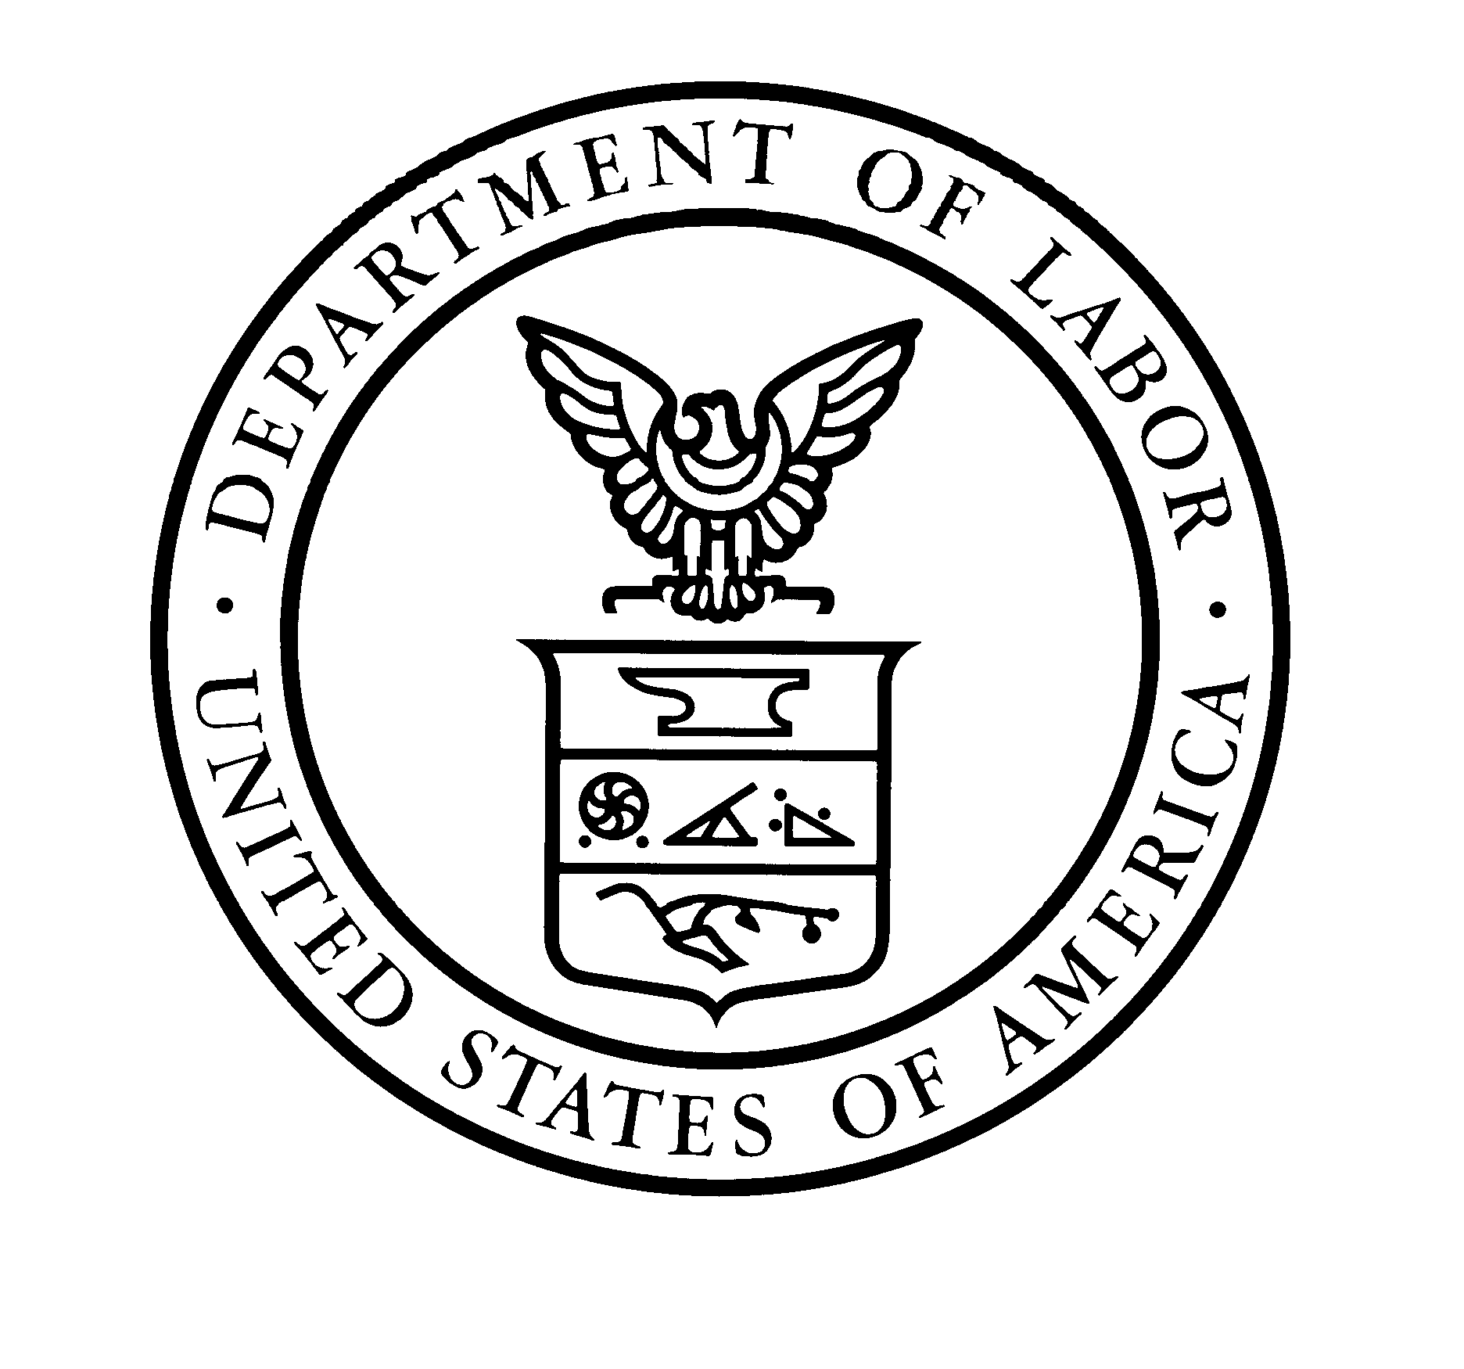
U.S. Department of Labor OMB Control No. 1205-0439
Employment and Training Administration Expiration Date: 10/31/2022

Planning Form (Dual Enrollment), ETA 9103-3
National Dislocated Worker Grant Electronic Application System

All quarterly entries are CUMULATIVE over all previous quarters.
PERFORMANCE FACTOR | PROGRAM YEAR QUARTER
 | ADMIN | PROGRAM | QTR1 | QTR2 | QTR3 | QTR4 | QTR5 | QTR6 | QTR7
PLANNED PARTICIPANTS
Receiving Career Services (NDWG Funded Only)
Receiving Training Services (NDWG Funded Only)
Participating in Work-Based Learning (NDWG Funded Only)
Receiving Supportive Services (NDWG Funded Only)
Receiving Needs-Related Payments (NRP)
Completed NDWG Services
Employed at Completion of NDWG Services
Employed in Work-based Learning at Completion of NDWG Services
Total Planned Participants
PLANNED GRANTEE EXPENDITURES
Administrative (Excluding NRP Processing)
NRP Processing
Other
Total: Program Management and Oversight
Indirect*
Total Expenditures: Grantee Level
PLANNED PROJECT OPERATOR EXPENDITURES
Career Services
Training
Work-Based Learning
Supportive Services
Needs-Related Payments
Other
Administrative (Excluding NRP Processing)
NRP Processing
Total: Program Management and Oversight
Total: Expenditures: Project Operator Level
Total: Expenditures: Grantee and Project Operator Level

Public Burden Statement:
Persons are not required to respond to this collection of information unless it displays a currently valid OMB Control number. Respondents’ obligation to complete this form is required to obtain or retain benefits (PL: 113-128 sec 170). Public reporting burden for this collection of information is estimated to average 90 minutes per response, including the time for reviewing instructions, searching existing data sources, gathering and maintaining the data needed, and completing and reviewing the collection of information. This is public information and there is no expectation of confidentiality. Send comments regarding this burden estimate to the U.S. Department of Labor, Office of National Response, Room C-5311, Washington, D.C. 20210 (Paperwork Reduction Project 1205-0439).

