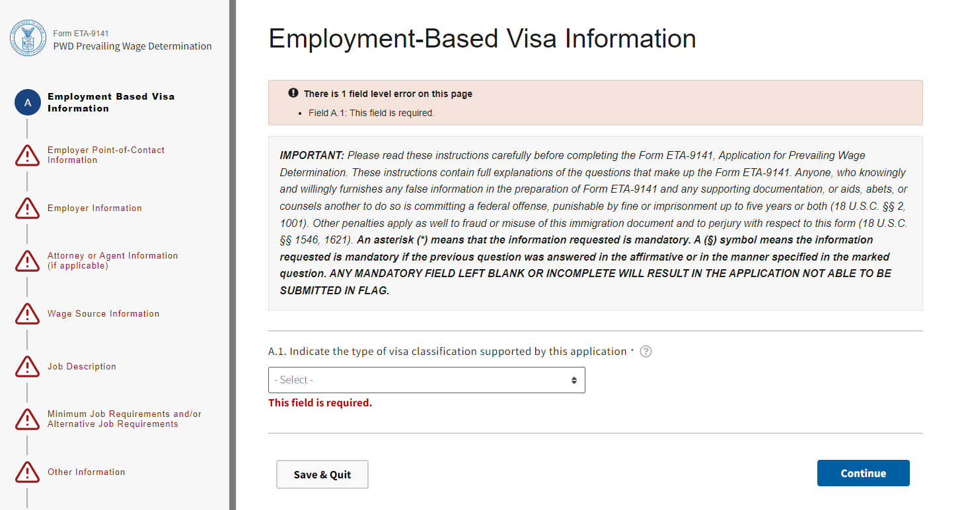

Form ETA-9141 – Section A

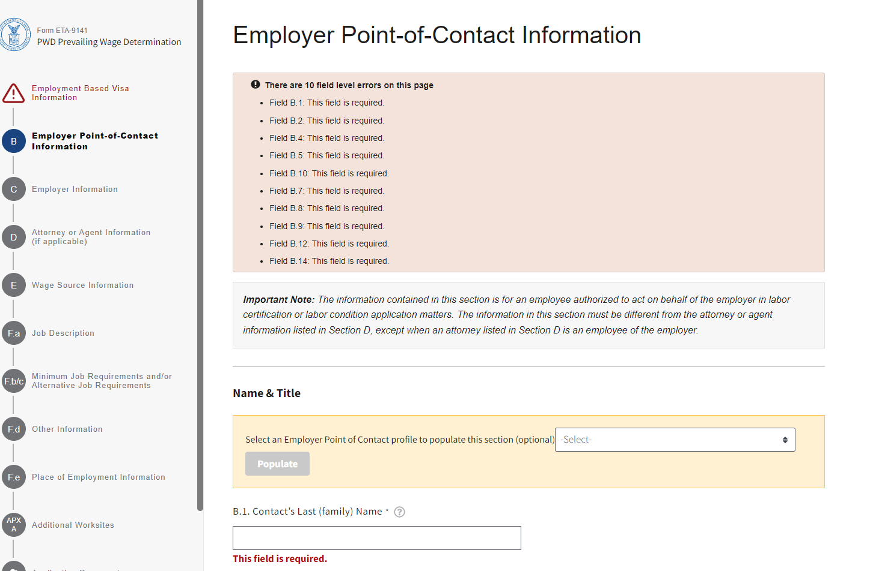
Form ETA-9141- Section B
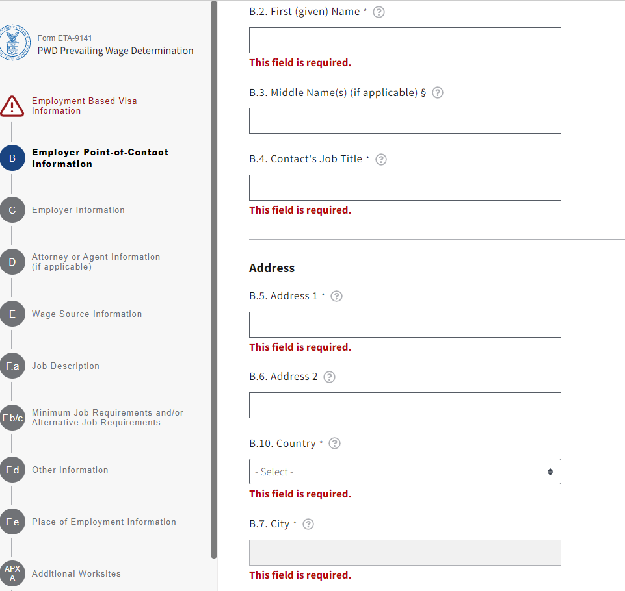
Form ETA-9141 – Section B (continued)

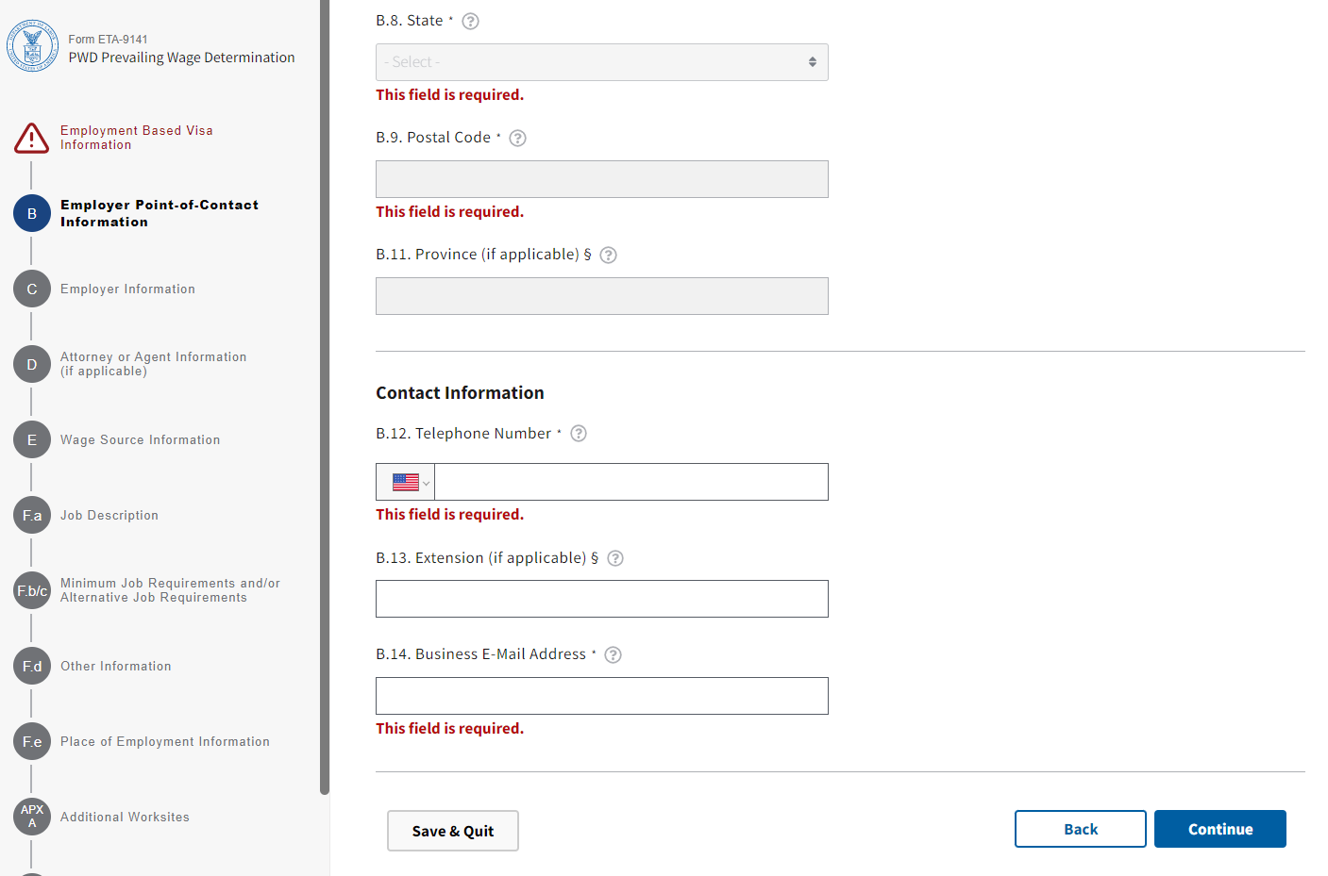
Form ETA-9141 – Section B (continued)

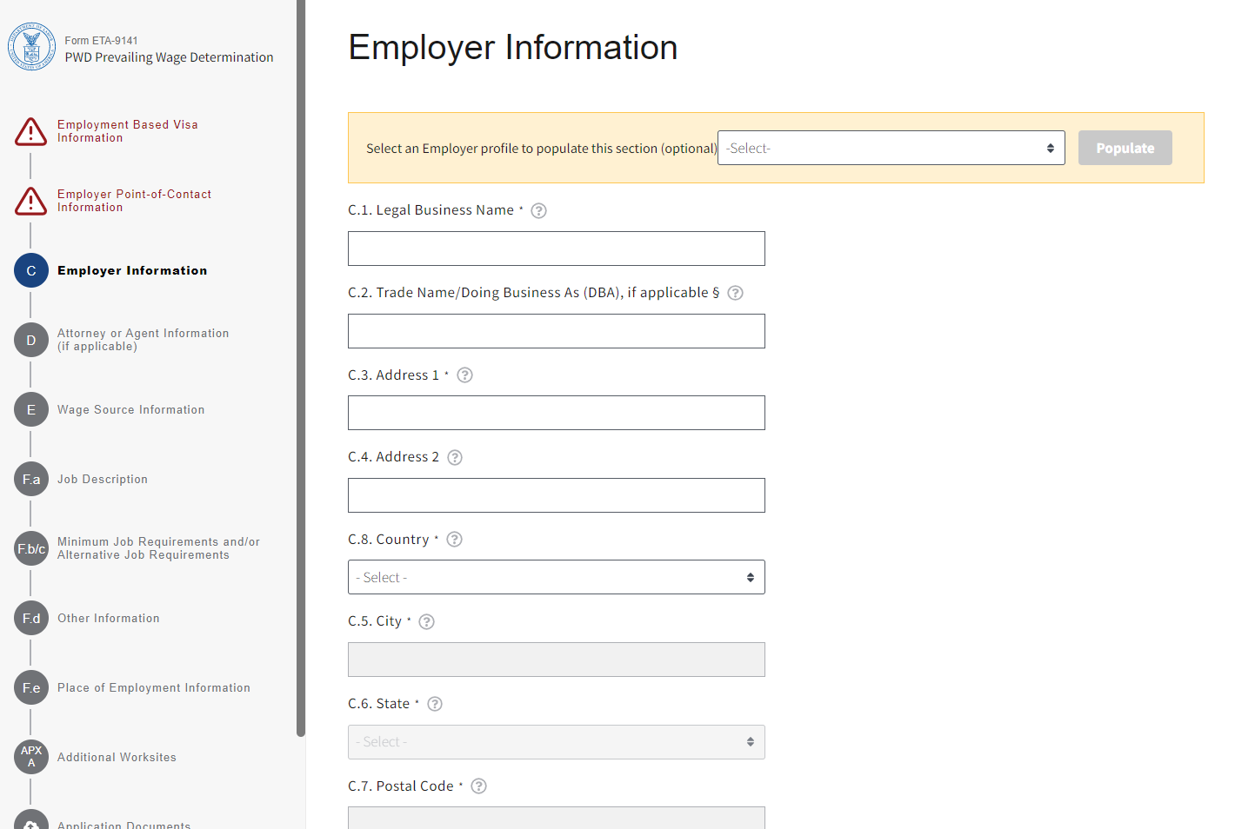
Form ETA-9141 – Section C

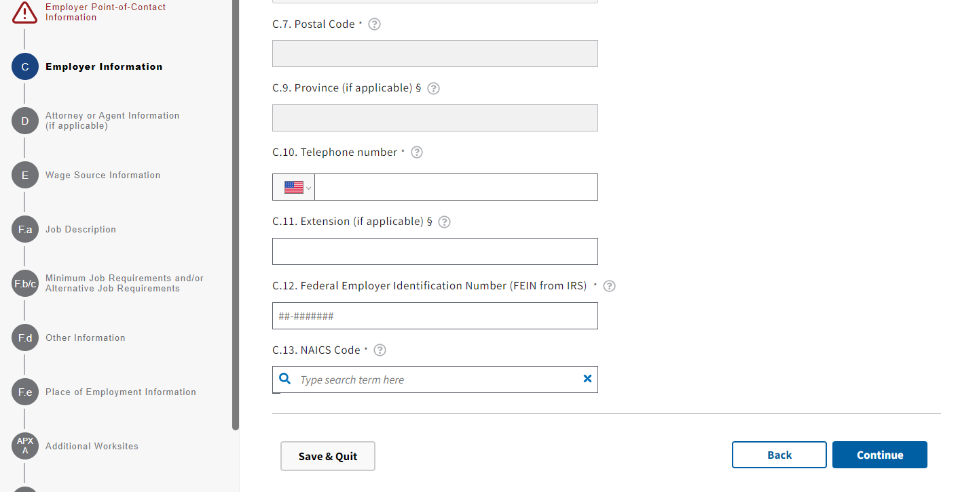
Form ETA-9141 – Section C (continued)

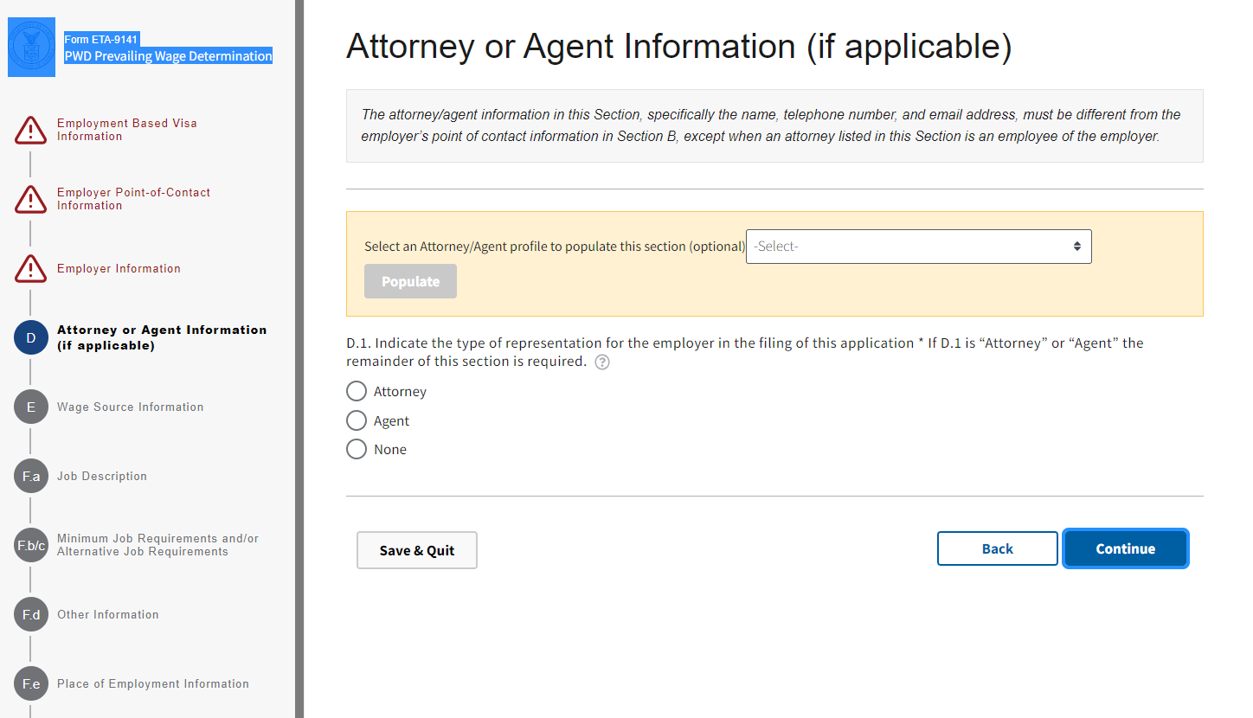
Form ETA-9141- Section D

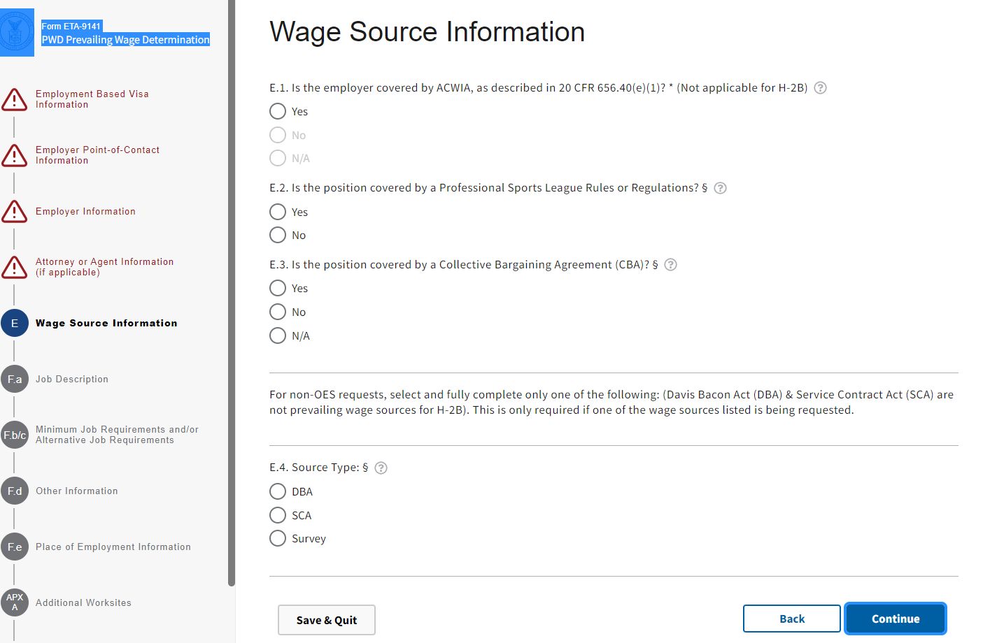
Form ETA-9141 – Section E

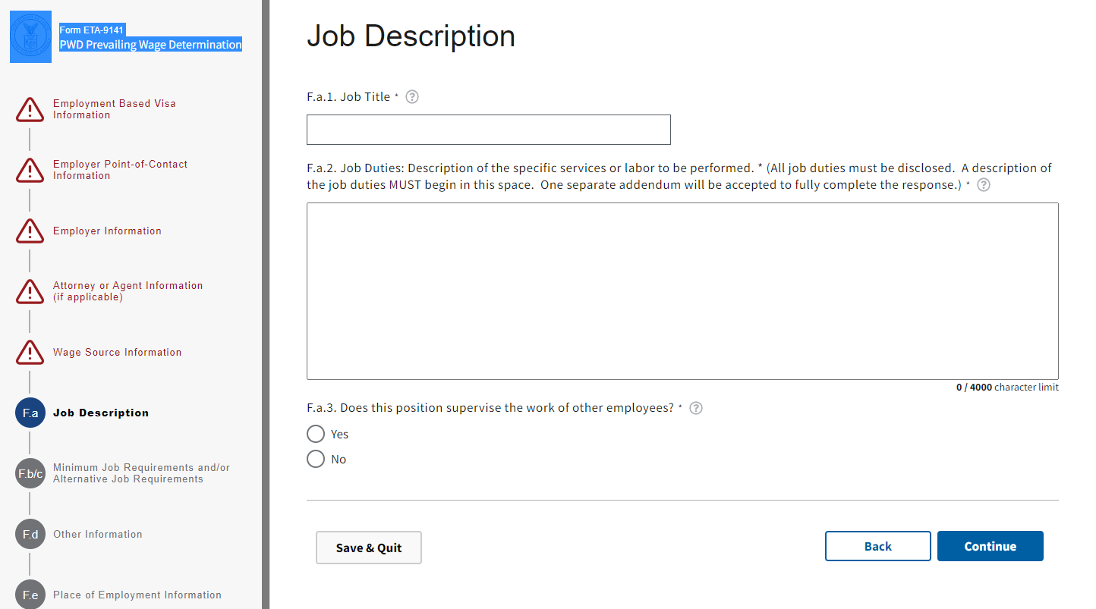
Form ETA-9141- Section F

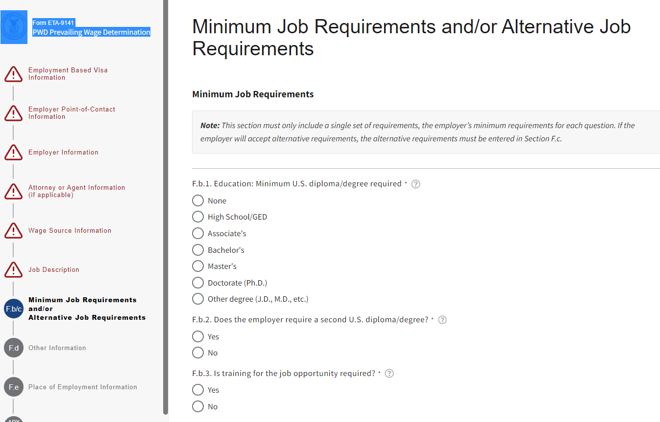
Form ETA-9141- Section F (continued)

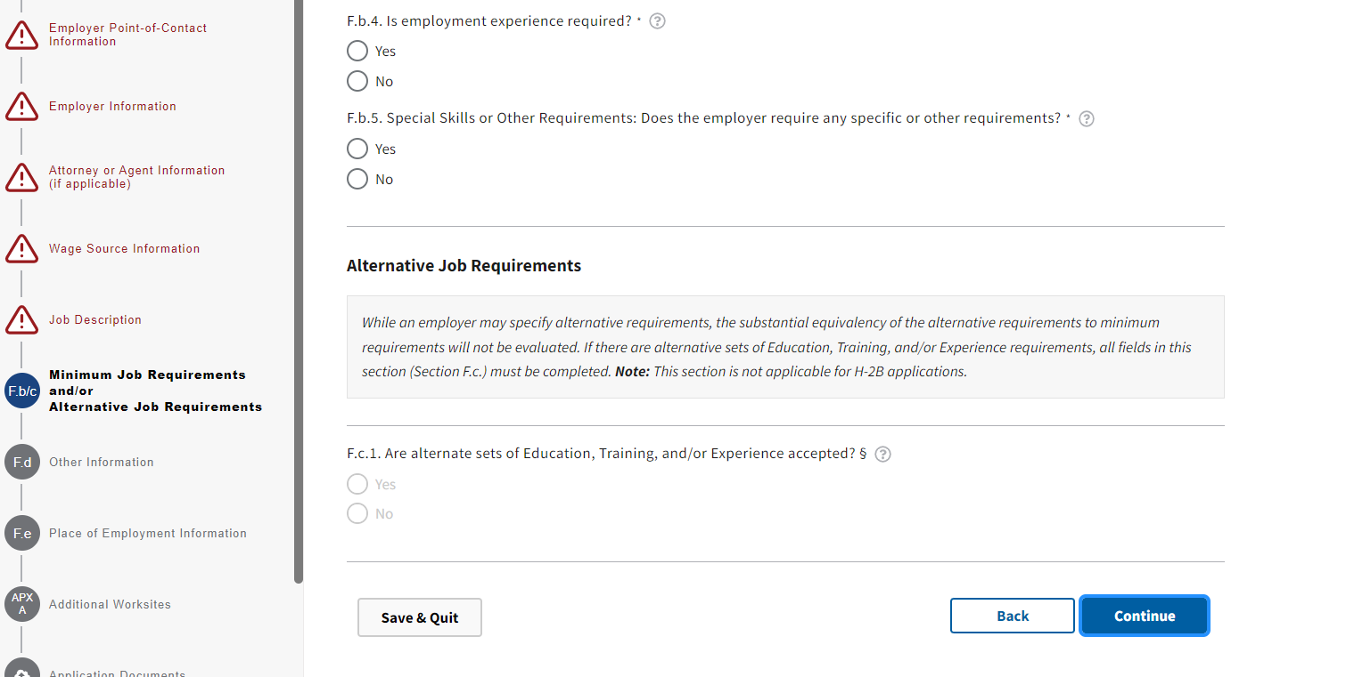
Form ETA-9141- Section F (continued)

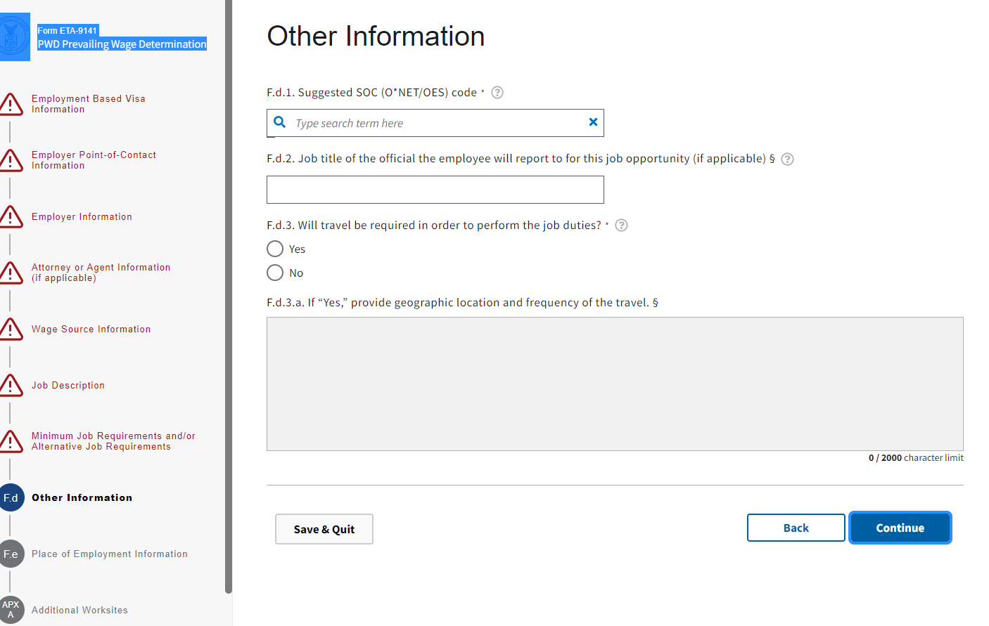
Form ETA-9141- Section F (continued)

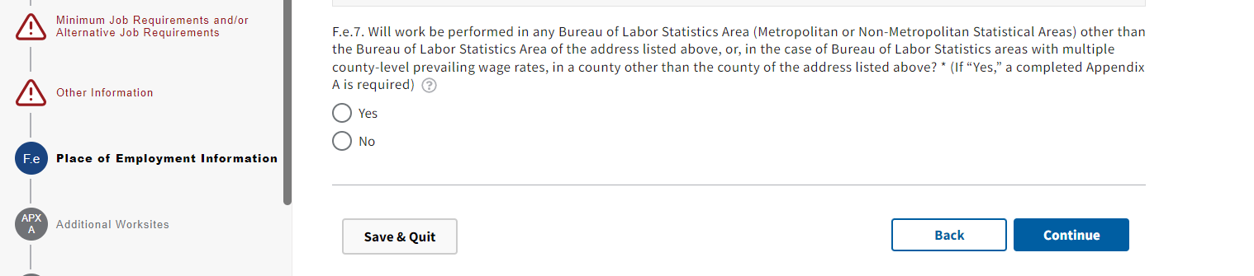
Form ETA-9141- Section F (continued)

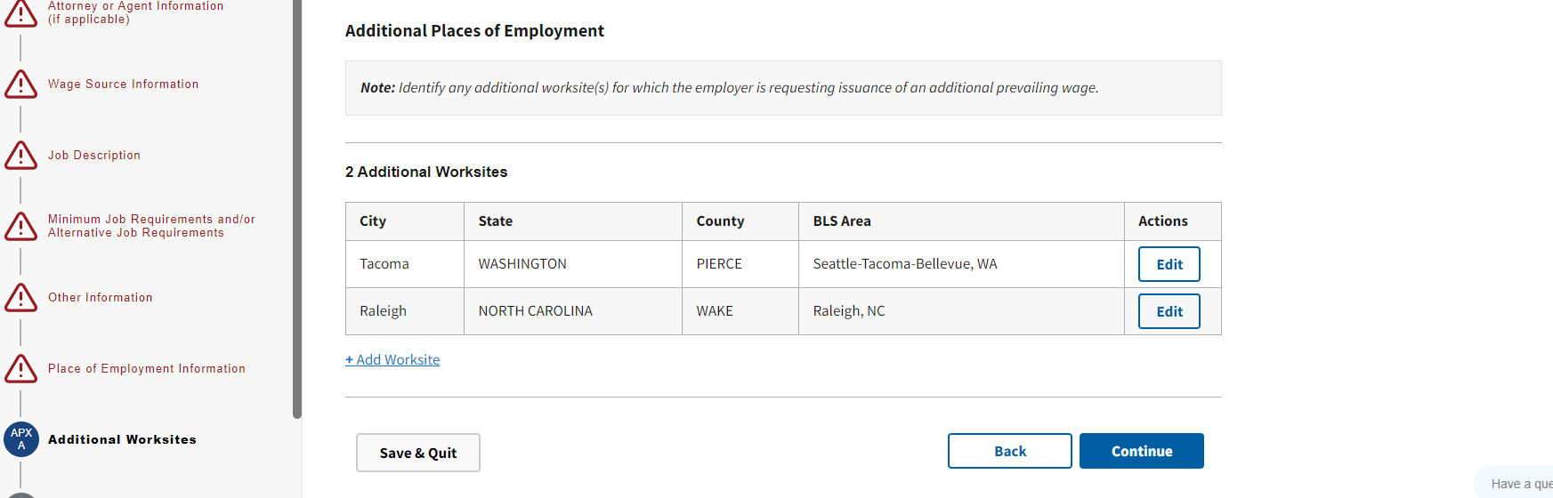
Form ETA-9141 – Appendix A

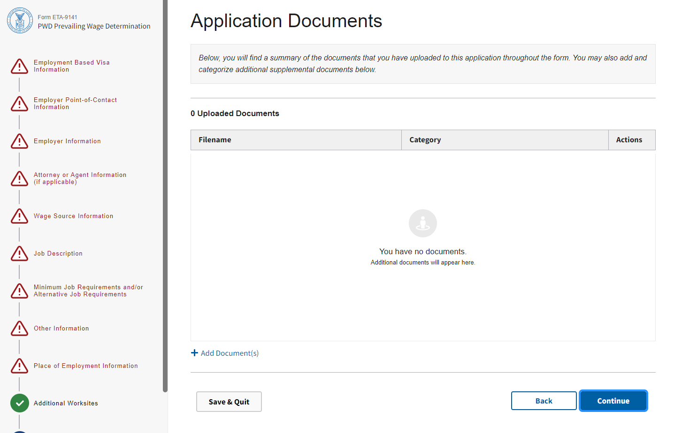
Form ETA-9141 – Application Document Summary

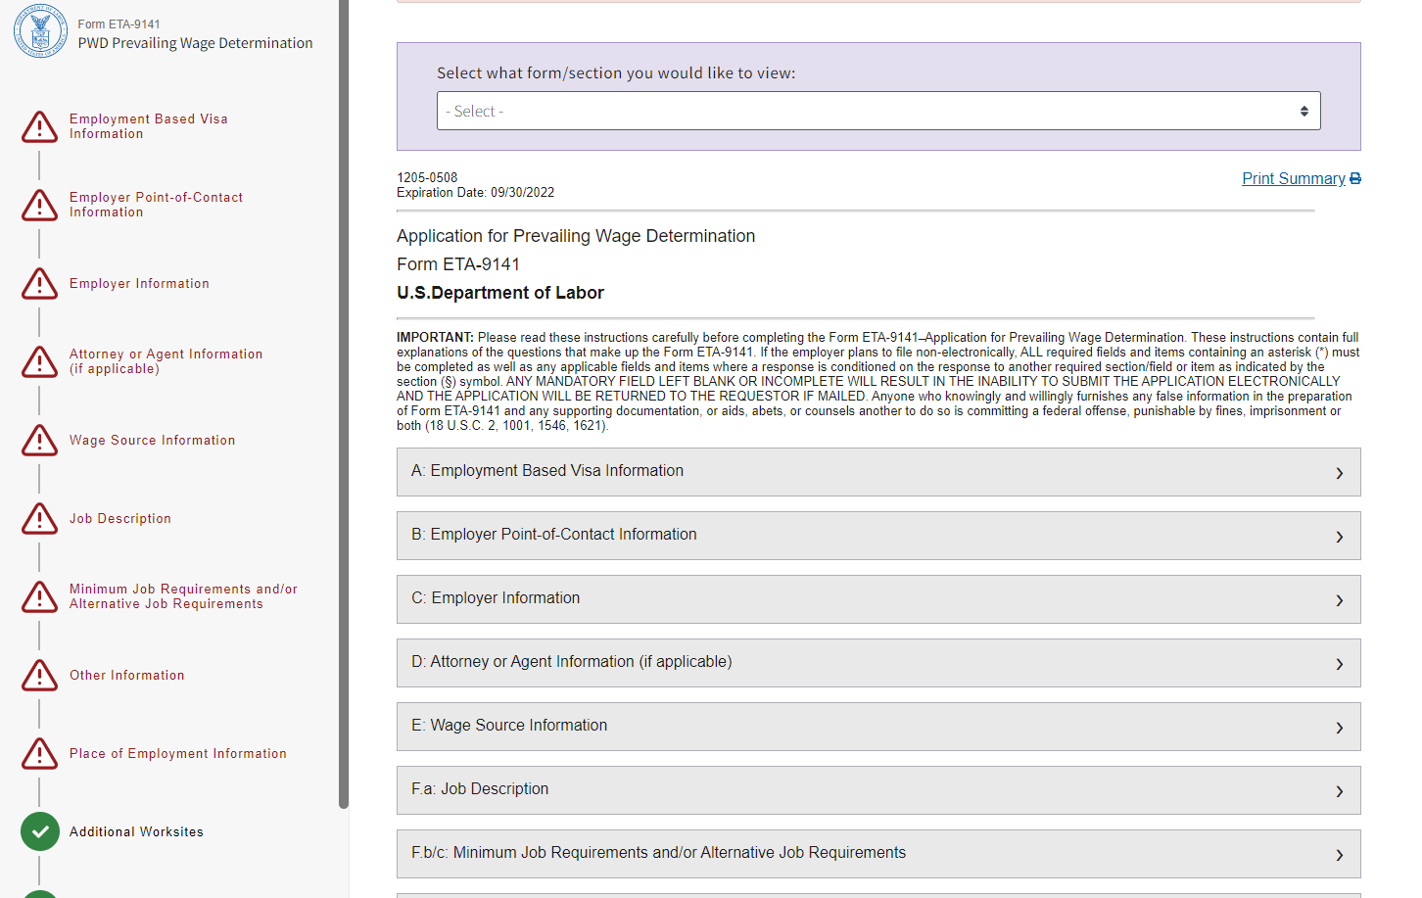
Form ETA-9141 – Application Document Summary (continued)

