**OMB Control Number: 1660-0117**

**Expiration Date: 1/31/2017**

**PAPERWORK BURDEN DISCLOSURE NOTICE**

**Biannual Strategy Implementation Report (BSIR)**

Public reporting burden for this data collection is estimated to average 15.25 hours per response. The burden estimate includes the time for reviewing instructions, searching existing data sources, gathering and maintaining the data needed, and completing and submitting this form. This collection of information is required to obtain or retain benefits. You are not required to respond to this collection of information unless a valid OMB control number is displayed on this form. Send comments regarding the accuracy of the burden estimate and any suggestions for reducing the burden to: Information Collections Management, Department of Homeland Security, Federal Emergency Management Agency, 500 C Street, SW., Washington, DC 20472-3100, Paperwork Reduction Project (1660-0117) NOTE: Do not send your completed form to this address.

# Grant Reporting Tool – Screenshots

## Log-in Screen

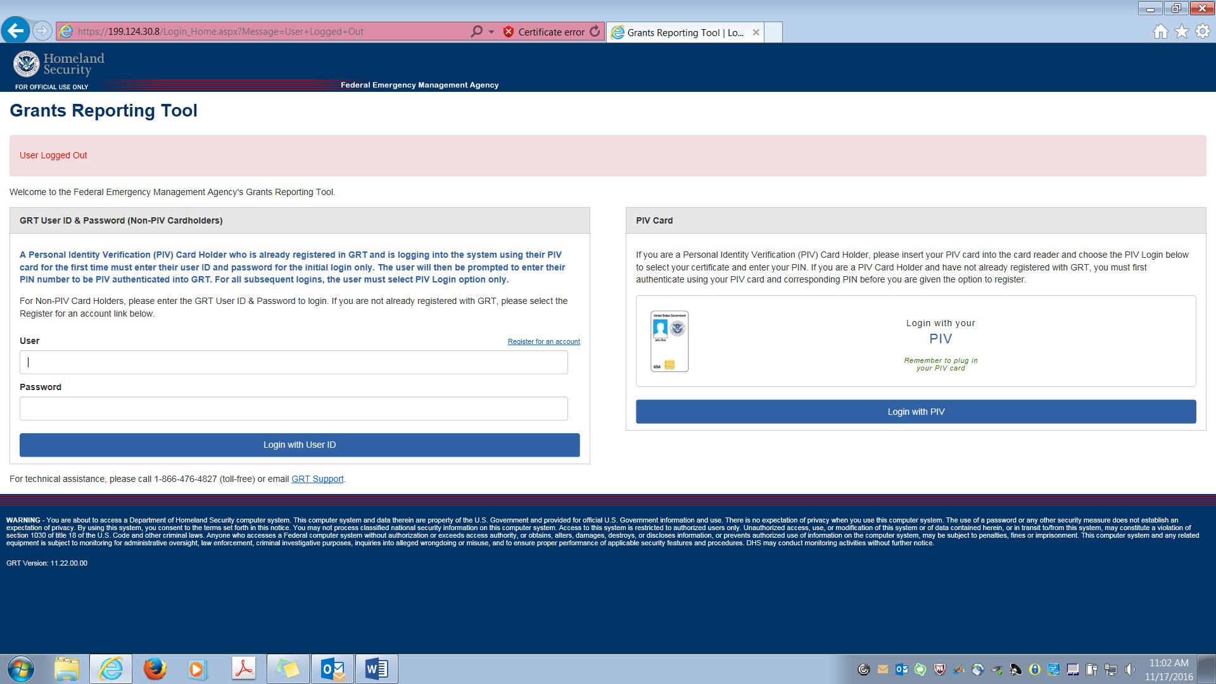

## Landing Page

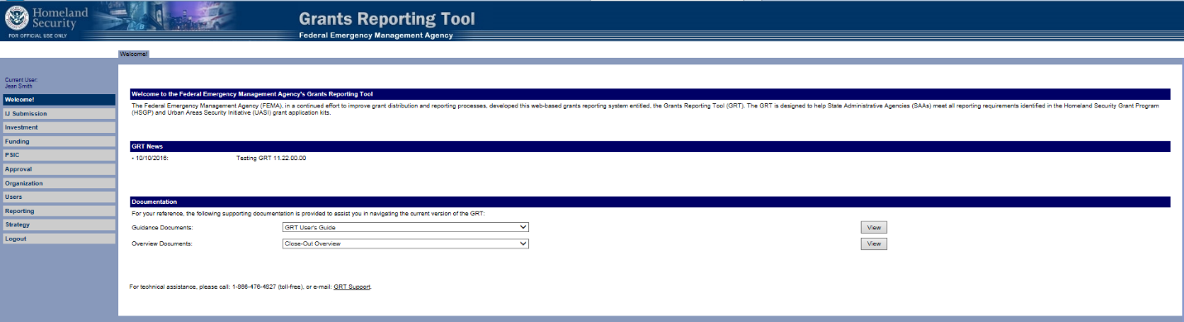

## BSIR Workflow





