**OMB Control No. 2127-xxxx**

**Expiration Date xx/xx/xxxx**

# **MMUCC Evaluation Survey B**

# **Introduction**

The National Highway Traffic Safety Administration (NHTSA) is seeking feedback from law enforcement officers on the feasibility of collecting the crash data described in the [Model Minimum Uniform Crash Criteria (MMUCC) Guideline, fifth edition (DOT HS 812 433, July 2017)](https://crashstats.nhtsa.dot.gov/Api/Public/ViewPublication/812433). As a law enforcement officer who responds to crashes and writes crash reports, your participation is important to help NHTSA identify crash data elements and concepts that can be accurately collected and others that are flawed and require revision or elimination. All responses are anonymous and will be analyzed in the aggregate. The information you provide will inform the content of the next edition of MMUCC. We estimate that it will take you approximately 60 minutes to complete the survey. NHTSA will publish a summary of this research in an appendix to the next edition of MMUCC in 2024.

This collection of information is voluntary and will be used to identify problematic crash data elements, and concepts in MMUCC. A federal agency may not conduct or sponsor, and a person is not required to respond to, nor shall a person be subject to a penalty for failure to comply with, a collection of information subject to the requirements of the Paperwork Reduction Act unless that collection of information displays a current valid OMB Control Number. The OMB Control Number for this information collection is XXXXX. Public reporting for this collection of information is estimated to be approximately 60 minutes per response, including the time for reviewing instructions, and completing and reviewing the collection of information. All responses to this collection of information are voluntary. Send comments regarding this burden estimate or any other aspect of this collection of information, including suggestions for reducing this burden, to: Information Collection Clearance Officer, National Highway Traffic Safety Administration, 1200 New Jersey Ave, S.E., Washington, DC, 20590.

## **Directions**

In the following exercises, several crash scenarios are described that relate to a set of MMUCC crash data elements. Select the most appropriate response for each identified crash data element in the scenarios. Please answer each question to the best of your ability.

### **Scenario 1:**

**Complete the data elements based on the following scenario and diagram.**

The driver of Unit 2 was standing in the roadway in front of his disabled vehicle. The driver of Unit 1 didn’t see Unit 2 until it was too late and impacted the rear of Unit 2. The impact pushed Unit 2 into the driver, causing severe injuries.

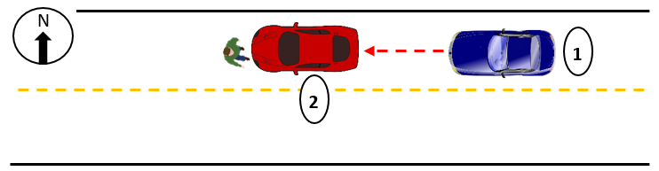

**Person Type** (Driver of Unit 2)

*Element Definition: Type of person involved in a crash.*

1. Driver
2. Passenger
3. Occupant of Motor Vehicle Not In-Transport
4. Bicyclist
5. Other Cyclist
6. Pedestrian
7. Other Pedestrian (wheelchair, person in a building, skater, personal conveyance, etc.)
8. Occupant of a Non-Motor Vehicle Transportation Device
9. Unknown Type of Non-Motorist
10. Unknown

**Motor Vehicle Unit Type** (Unit 2)

*Element Definition: Motor vehicle unit type assigned to uniquely identify each motor vehicle involved in the crash.*

1. Motor Vehicle In-Transport
2. Parked Motor Vehicle
3. Working Motor Vehicle

**Attempted Avoidance Maneuver** (Unit 1)

*Element Definition: This element identifies movements/actions taken by the driver after the driver realizes there is an impending danger. This element assesses what the driver action was in response to his/her realization.*

1. No Driver Present/Unknown if Driver Present
2. Accelerating and Steering Left
3. Accelerating and Steering Right
4. Braking and Steering Left
5. Braking and Steering Right
6. Braking (Lockup)
7. Braking (Lockup Unknown)
8. Braking (No Lockup)
9. No Avoidance Maneuver
10. Releasing Brakes
11. Steering Left
12. Steering Right
13. Lay Down Motorcycle
14. Other Actions
15. Unknown

### **Large Vehicle Questions**

Complete the data elements for the following vehicle.

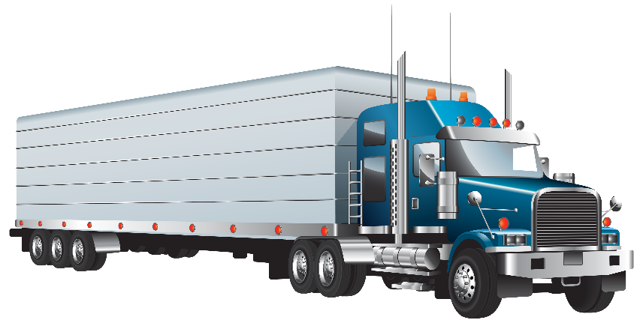

**Vehicle Configuration**

*Element Definition: Indicates the general configuration of this motor vehicle.*

1. Vehicle 10,000 lbs. or Less Placarded for Hazardous Materials
2. Bus/Large Van (seats for 9-15 occupants, including driver)
3. Bus (seats more than 15 occupants, including driver)
4. Single-Unit Truck (2-axle and GVWR > 10,000 lbs.)
5. Single-Unit Truck (3 or more axles)
6. Truck Pulling Trailer(s)
7. Truck Tractor (Bobtail)
8. Truck Tractor/Semi-Trailer
9. Truck Tractor/Double
10. Truck Tractor/Triple
11. Vehicle More Than 10,000 lbs., Other
12. Qualifying Vehicle, Unknown Configuration
13. Unknown

**Cargo Body Type**

*Element Definition: The type of body for buses and trucks more than 10,000 GVWR.*

1. No Cargo Body (bobtail, light motor vehicle with hazardous materials placard, etc.)
2. Bus
3. Auto Transporter
4. Cargo Tank
5. Concrete Mixer
6. Dump
7. Flatbed
8. Garbage/Refuse
9. Grain/Chips/Gravel
10. Intermodal Container Chassis
11. Log
12. Pole-Trailer
13. Van/Enclosed Box
14. Vehicle Towing Another Vehicle
15. Not Applicable (motor vehicle 10,000 lbs. or less, not displaying hazardous materials placard)
16. Other
17. Unknown

### Scenario 2:

**Complete the data elements based on the following scenario.**

The driver of Unit 1 was transported to the hospital before you arrived at the scene. You have confirmation from other officers that the driver was injured in the crash, but you don’t know the severity of the injury or why the person was transported to the hospital.

**Injury Status**

*Element Definition: The injury severity level for a person involved in a crash. The determination of which attribute to assign should be based on the latest information available at the time the report is completed, except as described below for fatal Injuries.*

1. (K) Fatal Injury
2. (A) Suspected Serious Injury
3. (B) Suspected Minor Injury
4. (C) Possible Injury
5. (O) No Apparent Injury

### **Scenario 3:**

**Complete the following data elements for Unit 1 in this example.**

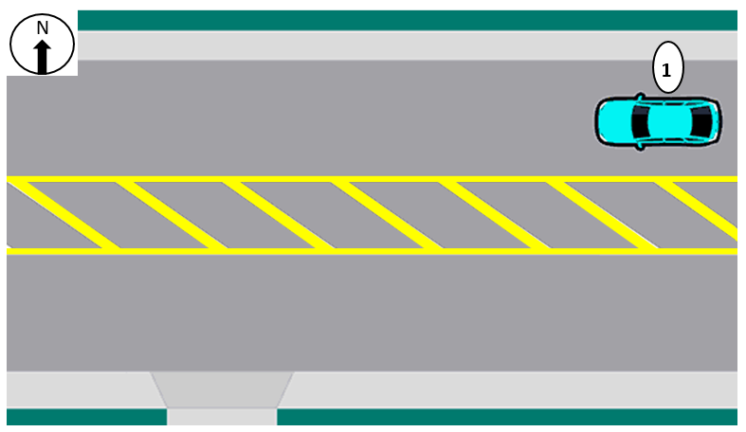

**Total Lanes in Roadway - Through Lanes**

*Element Definition: Total number of lanes in the roadway on which this Motor Vehicle was traveling. Through lanes also include shared through/turn lanes but exclude turn-only lanes’ auxiliary lanes, such as collector-distributor lanes, weaving lanes, frontage road lanes, parking lanes, acceleration/deceleration lanes, toll collection lanes, and truck climbing lanes. Total lanes are collected in two parts as total through lanes and total auxiliary lanes.*

1. 0 Lanes
2. 1 Lane
3. 2 Lanes
4. 3 Lanes
5. 4 Lanes
6. 5 or more Lanes

**Total Lanes in Roadway - Auxiliary Lanes**

*Element Definition: Total number of lanes in the roadway on which this Motor Vehicle was traveling. Through lanes also include shared through/turn lanes but exclude turn-only lanes’ auxiliary lanes, such as collector-distributor lanes, weaving lanes, frontage road lanes, parking lanes, acceleration/deceleration lanes, toll collection lanes, and truck climbing lanes. Total lanes are collected in two parts as total through lanes and total auxiliary lanes.*

1. 0 Lanes
2. 1 Lane
3. 2 Lanes
4. 3 Lanes
5. 4 Lanes
6. 5 or more Lanes

**Trafficway Description, Subfield 1: Travel Directions**

*Element Definition: Indication of whether the trafficway for this vehicle is divided, whether it serves one-way or two-way traffic, and the type of lane this vehicle was using. Subfield 1 identifies whether the trafficway associated with this vehicle serves one-way or two-way traffic.*

1. One-Way
2. Two-Way

**Trafficway Description, Subfield 2: Divided?**

*Element Definition: Indication of whether the trafficway for this vehicle is divided, whether it serves one-way or two-way traffic, and the type of lane this vehicle was using. Subfield 2 identifies whether or not the trafficway for this vehicle is divided.*

1. Not Divided
2. Not Divided, with a Continuous Left-Turn Lane
3. Divided, Flush Median (greater than 4ft wide)
4. Divided, Raised Median (curbed)
5. Divided, Depressed Median
6. Unknown

### Scenario 4:

**Complete the data elements for the following scenario and diagram.**

Time of Crash: 23:16

Light Conditions: Dark-Not Lighted

For unknown reasons, Unit 1 (Non-Motorist) was laying in the westbound lane of Route 482. The driver of Unit 2 (Vehicle) did not see Unit 1 laying in the roadway. Unit 2 ran over Unit 1 and dragged Unit 1 approximately 20 feet. The driver pulled off to the shoulder and called 911. The driver stated that Unit 1 was not visible, and he didn’t know what he had struck until he got out of the car to look.

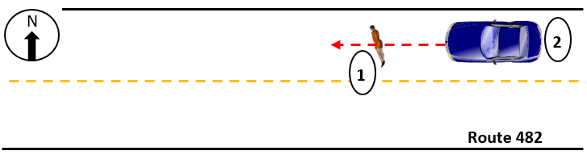

**Initial Contact Point on Non-motorist (Unit 1)**

*Element Definition: Location of the initial harmful event on the non-motorist by the motor vehicle.*

1. Front
2. Right
3. Rear
4. Left
5. Unknown

**Non-Motorist Action/Circumstance Prior to Crash (Unit 1)**

*Element Definition: The action of the non-motorist immediately prior to the crash*

1. None
2. Stationary and Adjacent to Roadway (e.g., Shoulder, Median, Sidewalk)
3. Crossing Roadway
4. In Roadway – Other
5. Waiting to Cross Roadway
6. Walking/Cycling Along Roadway Against Traffic (In or Adjacent to Travel Lane)
7. Walking/Cycling Along Roadway with Traffic (In or Adjacent to Travel Lane)
8. Walking/Cycling on Sidewalk
9. Working in Trafficway (Incident Response)
10. Other
11. Unknown

**Non-Motorist Contributing Action(s)/Circumstance(s) (Unit 1)**

*Element Definition: The actions/circumstances of the non-motorist that may have contributed to the crash. This data element is based on the judgment of the law enforcement officer investigating the crash.*

**Select up to 2**

* None (No Improper Action)
* Dart/Dash
* Failure to Obey Traffic Signs, Signals, or Officer
* Failure to Yield Right-Of-Way
* Improper Turn/Merge
* Inattentive (Talking, Eating, etc.)
* In Roadway Improperly (Standing, Lying, Working, Playing)
* Not Visible (Dark Clothing, No Lighting, etc.)
* Wrong-Way Riding or Walking
* Other
* Unknown

**Non-Motorist Location at Time of Crash** **(Unit 1)**

*Element Definition: The location of the non-motorist with respect to the roadway at the time of the crash.*

1. Intersection - Marked Crosswalk
2. Intersection - Unmarked Crosswalk
3. Intersection – Other
4. Median/Crossing Island
5. Shoulder/Roadside
6. Travel Lane - Other Location
7. Other
8. Unknown

### **Scenario 5:**

**Complete the data elements based on the following scenario and diagram.**

Unit 2, a school bus, was stopped to let children off the bus. The bus’s flashing lights and stop sign on an extended arm were employed and working properly. Unit 1 did not stop for the school bus as required by law, and struck Unit 3, a child crossing the road from the bus.

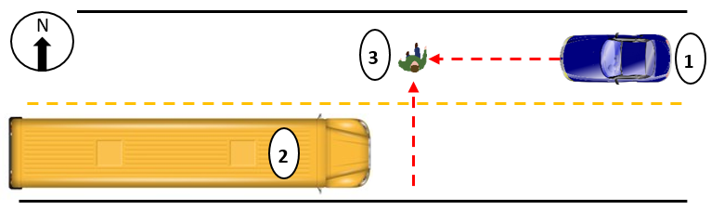

**Initial Contact Point on Non-motorist (Unit 3)**

*Element Definition: Location of the initial harmful event on the non-motorist by the motor vehicle.*

1. Front
2. Right
3. Rear
4. Left
5. Unknown

**Non-Motorist Action/Circumstance Prior to Crash (Unit 3)**

*Element Definition: The action of the non-motorist immediately prior to the crash*

1. None
2. Stationary and Adjacent to Roadway (e.g., Shoulder, Median, Sidewalk)
3. Crossing Roadway
4. In Roadway – Other
5. Waiting to Cross Roadway
6. Walking/Cycling Along Roadway Against Traffic (In or Adjacent to Travel Lane)
7. Walking/Cycling Along Roadway with Traffic (In or Adjacent to Travel Lane)
8. Walking/Cycling on Sidewalk
9. Working in Trafficway (Incident Response)
10. Other
11. Unknown

**Non-Motorist Contributing Action(s)/Circumstance(s)** **(Unit 3)**

*Element Definition: The actions/circumstances of the non-motorist that may have contributed to the crash. This data element is based on the judgment of the law enforcement officer investigating the crash.*

**Select up to 2**

* None (No Improper Action)
* Dart/Dash
* Failure to Obey Traffic Signs, Signals, or Officer
* Failure to Yield Right-Of-Way
* Improper Turn/Merge
* Inattentive (Talking, Eating, etc.)
* In Roadway Improperly (Standing, Lying, Working, Playing)
* Not Visible (Dark Clothing, No Lighting, etc.)
* Wrong-Way Riding or Walking
* Other
* Unknown

**Non-Motorist Location at Time of Crash (Unit 3)**

*Element Definition: The location of the non-motorist with respect to the roadway at the time of the crash.*

1. Intersection - Marked Crosswalk
2. Intersection - Unmarked Crosswalk
3. Intersection – Other
4. Median/Crossing Island
5. Shoulder/Roadside
6. Travel Lane - Other Location
7. Other
8. Unknown

**School Bus Related**

*Element Definition: Indicates whether a school bus or motor vehicle functioning as a school bus for a school-related purpose is involved in the crash. The “school bus,” with or without a passenger on board, must be directly involved as a contact motor vehicle or indirectly involved as a non-contact motor vehicle (children struck when boarding or alighting from the school bus, two vehicles colliding as the result of the stopped school bus, etc.).*

1. No
2. Yes, School Bus Directly Involved
3. Yes, School Bus Indirectly Involved

### Scenario 6:

**Complete the data elements based on the following scenario and diagram.**

Unit 1 (yellow vehicle) and Unit 2 (blue vehicle) were traveling on northbound June Mill Parkway, just before the overpass with Interstate 70. Unit 1 attempted to change lanes to the right and impacted the left front of Unit 2. The driver of Unit 1 claimed he did not see Unit 2 in his blind spot.

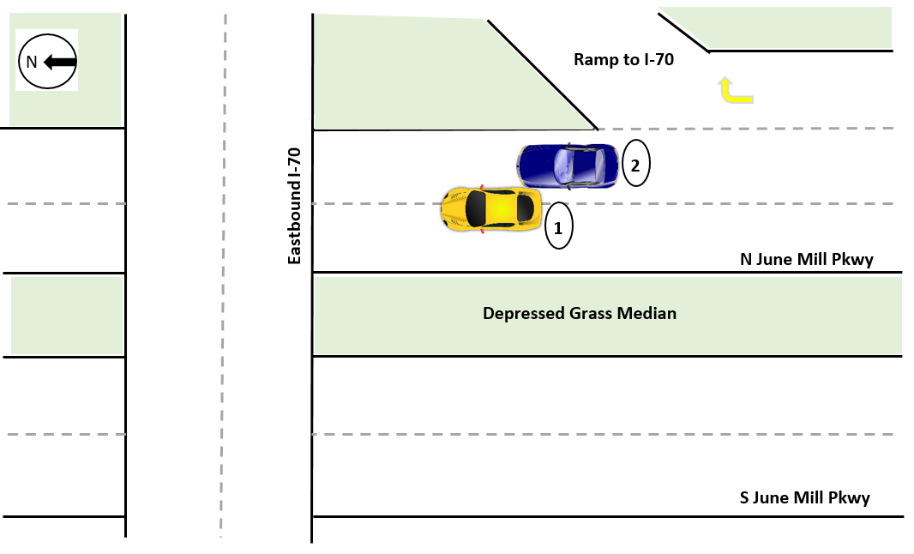

**Relation to Junction**

*Element Definition: The coding of this data element is based on the location of the First Harmful Event of the crash. It identifies the crash’s location with respect to presence in a junction or proximity to components typically in junction or interchange areas.*

1. Non-Junction
2. Acceleration/Deceleration Lane
3. Crossover-Related
4. Driveway Access or Related
5. Entrance/Exit Ramp or Related
6. Intersection or Related
7. Railway Grade Crossing
8. Shared-Use Path or Trail
9. Through Roadway
10. Other Location Not Listed Above Within an Interchange Area (median, shoulder, and roadside)
11. Unknown

**Total Lanes in Roadway - Through Lanes (Unit 1)**

*Element Definition: Total number of lanes in the roadway on which this Motor Vehicle was traveling. Through lanes also include shared through/turn lanes but exclude turn-only lanes’ auxiliary lanes, such as collector-distributor lanes, weaving lanes, frontage road lanes, parking lanes, acceleration/deceleration lanes, toll collection lanes, and truck climbing lanes. Total lanes are collected in two parts as total through lanes and total auxiliary lanes.*

1. 0 Lanes
2. 1 Lane
3. 2 Lanes
4. 3 Lanes
5. 5 or more Lanes

**Total Lanes in Roadway - Auxiliary Lanes (Unit 1)**

*Element Definition: Total number of lanes in the roadway on which this Motor Vehicle was traveling. Through lanes also include shared through/turn lanes but exclude turn-only lanes’ auxiliary lanes, such as collector-distributor lanes, weaving lanes, frontage road lanes, parking lanes, acceleration/deceleration lanes, toll collection lanes, and truck climbing lanes. Total lanes are collected in two parts as total through lanes and total auxiliary lanes.*

1. 0 Lanes
2. 1 Lane
3. 2 Lanes
4. 3 Lanes
5. 5 or more Lanes

**Trafficway Description, Subfield 1: Travel Directions (Unit 1)**

*Element Definition: Indication of whether the trafficway for this vehicle is divided, whether it serves one-way or two-way traffic, and the type of lane this vehicle was using. Subfield 1 identifies whether the trafficway associated with this vehicle serves one-way or two-way traffic.*

1. One-Way
2. Two-Way

**Trafficway Description, Subfield 2: Divided (Unit 1)**

*Element Definition: Indication of whether the trafficway for this vehicle is divided, whether it serves one-way or two-way traffic, and the type of lane this vehicle was using. Subfield 2 identifies whether or not the trafficway for this vehicle is divided.*

1. Not Divided
2. Not Divided, with a Continuous Left-Turn Lane
3. Divided, Flush Median (greater than 4ft wide)
4. Divided, Raised Median (curbed)
5. Divided, Depressed Median
6. Unknown

**Driver Actions at Time of Crash (Unit 1)**

*Element Definition: The actions by the driver that may have contributed to the crash. This data element is based on the judgment of the law enforcement officer investigating the crash and need not match Violation Codes.*

**Select up to 4**

* No Contributing Action
* Failed to Keep in Proper Lane
* Failed to Yield Right-of-Way
* Improper Passing
* Operated Motor Vehicle in Inattentive, Careless, Negligent, or Erratic Manner
* Operated Motor Vehicle in Reckless or Aggressive Manner
* Other Contributing Action

### Scenario 7:

**Complete the data elements based on the following scenario and diagram.**

Unit 1 (blue vehicle) was traveling west on Trident Rd. Unit 2 (yellow vehicle) was eastbound on Trident, and stopped for the red light at the intersection of Trident Rd. and Pine Tree Rd. Unit 3 (bicyclist) was traveling north on Pine Tree Rd., passing through the intersection with the green light. Unit 1 (blue vehicle) failed to stop at the red light, struck Unit 3 (bicyclist), then struck Unit 2 (yellow vehicle). Unit 3 (bicyclist) received major injuries. The driver of Unit 2 (yellow vehicle) also received major injuries. The driver of Unit 1 (blue vehicle) received minor injuries after the impact with Unit 2 (yellow vehicle).

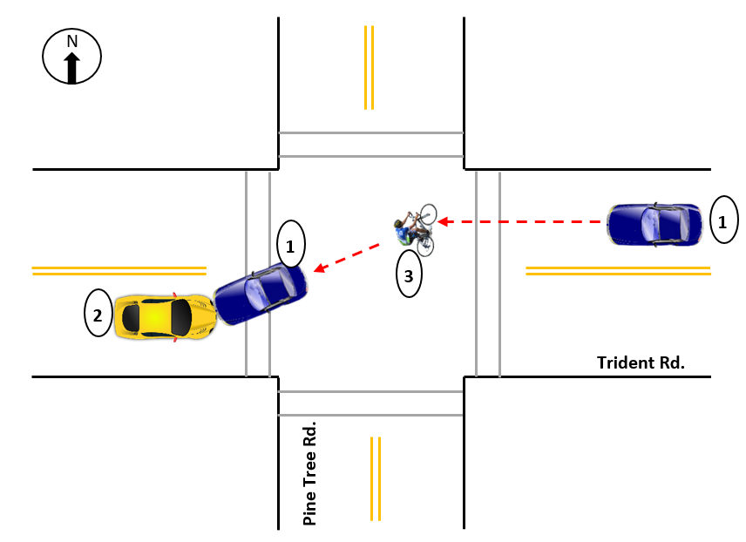

**First Harmful Event**

*Element Definition: The first harmful event is defined as the first injury- or damage-producing event of the crash.*

1. Motor Vehicle In-Transport
2. Pedalcyclist

**Manner of Collision of the First Harmful Event**

*Element Definition: The identification of the manner in which two Motor Vehicles In-Transport initially came together without regard to the direction of force. This data element refers only to crashes where the First Harmful Event involves a collision between two Motor Vehicles In-Transport.*

1. The First Harmful Event was Not a Collision Between Two Motor Vehicles In-Transport
2. Angle
3. Front to Front
4. Front to Rear
5. Rear to Rear
6. Rear to Side
7. Sideswipe, Opposite Direction
8. Sideswipe, Same Direction
9. Other
10. Unknown

**Most Harmful Event for this motor vehicle** **(Unit 1)**

*Element Definition: Event that resulted in the most severe injury or, if no injury, the greatest property damage involving this motor vehicle.*

1. Motor Vehicle In-Transport
2. Pedalcyclist

### Format Review:

**Review two different formats for the data element "Air Bag Deployed"**

*Element Definition: Deployment status of an air bag relative to the position in the vehicle for this occupant.*

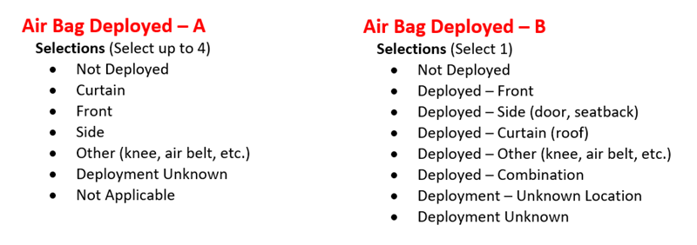

**Which format would you prefer to see on a crash report form?**

1. Air Bag Deployed – A
2. Air Bag Deployed - B

**Explain your preference**

### Scenario 8:

**Complete the data elements based on the following scenario and diagram.**

Vehicles 1 and 2 were engaged in a race on Arbor Blvd. Vehicle 1 failed to negotiate a slight curve, ran off the road, and struck a fire hydrant. The posted speed limit on this section of Arbor Blvd. is 45 MPH. A witness at the scene described the two vehicles driving in excess of 70 MPH.

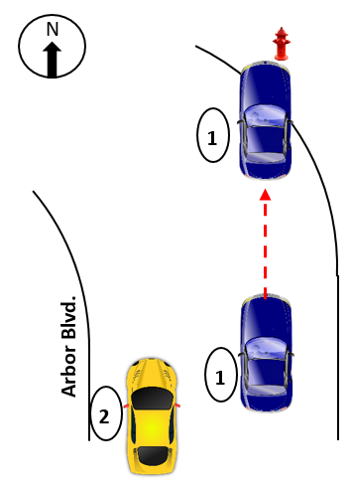

**Speeding Related** (Unit 1)

*Element Definition: Indication of whether the investigating officer suspects that the driver involved in the crash was speeding based on verbal or physical evidence and not on speculation alone.*

*Note about attribute hierarchy: If more than one condition was present at the same time, select the code with the lowest value. For example, if the driver was traveling too fast for conditions AND exceeding the speed limit, select 02 (Yes, Exceeded Speed Limit), because it has a lower value (higher on the list) than 03 (Yes, Too Fast for Conditions).*

1. 00 (No)
2. 01 (Yes, Racing)
3. 02 (Yes, Exceeded Speed Limit)
4. 03 (Yes, Too Fast for Conditions)
5. 04 (Yes, Specifics Unknown)
6. 99 (Unknown)

### Scenario 9:

**Complete the data elements based on the following scenario and diagram.**

Unit 1 was traveling eastbound through the shopping center parking lot. Unit 2 was traveling southbound through the parking lot. There are 3 stop signs in place by the property owners. The 4th stop sign for the eastbound traffic was knocked down and laying on the ground. Unit 1 did not see the knocked down stop sign and continued into the intersection without stopping. Unit 1 struck Unit 2.

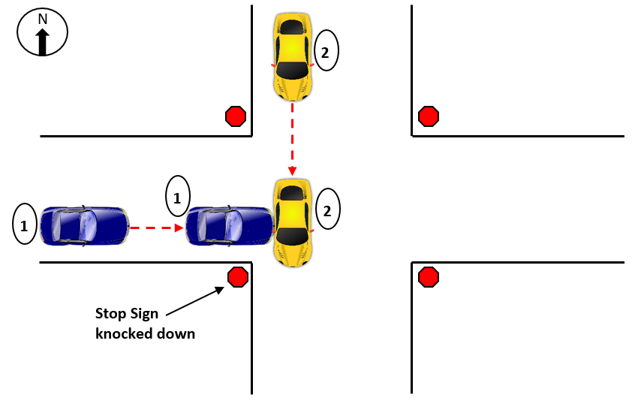

**Crash Classification, Subfield 1: Ownership**

*Element Definition: Subfield 1: Ownership is used to identify ownership of the land where the crash occurred.*

1. Public Property
2. Private Property

**Crash Classification, Subfield 2: Characteristics**

*Element Definition: Subfield 2: Characteristics of this element is used to identify the characteristics of the crash with respect to its location on or off a trafficway.*

1. Trafficway, On Road
2. Trafficway, Not on Road
3. Non-Trafficway

**Crash Classification, Subfield 3: Secondary Crash?**

*Element Definition: Subfield 3: Secondary Crash? of this element includes a motor vehicle traffic crash within a traffic incident scene or within a traffic queue in either direction resulting from a prior traffic incident.*

1. No
2. Yes

**Traffic Control Device Type, Subfield 1: Type** (Unit 1)

*Element Definition: The type of traffic control device(s) (TCD) applicable to this motor vehicle at the crash location. Subfield 2 cannot be collected through linkage to the roadway system. If a signal is not flashing, it may not necessarily be considered inoperative. The unit may still be functioning correctly, but not in the time it is supposed to be flashing (e.g., Flashing School Zone Signal during school hours).*

1. No Controls
2. Stop Sign

**Traffic Control Device Type, Subfield 2: Are any Inoperative or Missing?** (Unit 1)

*Element Definition: The type of traffic control device(s) (TCD) applicable to this motor vehicle at the crash location. Subfield 2 cannot be collected through linkage to the roadway system. If a signal is not flashing, it may not necessarily be considered inoperative. The unit may still be functioning correctly, but not in the time it is supposed to be flashing (e.g., Flashing School Zone Signal during school hours).*

1. None inoperative or missing
2. Stop Sign

### Scenario 10:

**Complete the data elements based on the following scenario and diagram.**

Vehicle 1 lost control on a patch of ice, ran into a construction zone, and struck Vehicle 2 (dump truck). The construction zone was not in operation at the time and the dump truck was unoccupied.

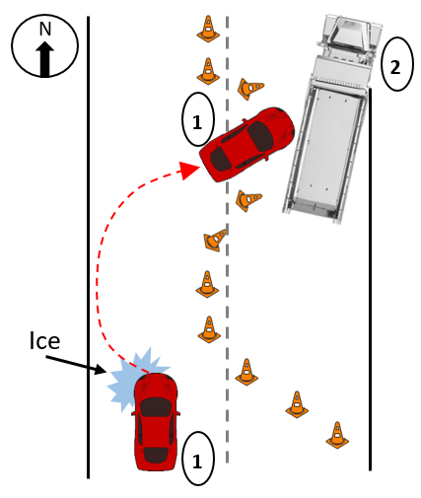

**Motor Vehicle Unit Type (Unit 2)**

*Element Definition: Motor vehicle unit type assigned to uniquely identify each motor vehicle involved in the crash.*

1. Motor Vehicle In-Transport
2. Parked Motor Vehicle
3. Working Motor Vehicle

**Work Zone-Related, Subfield 1: Was the crash in a construction, maintenance, or utility work zone or was it related to activity within a work zone?**

*Element Definition: A crash that occurs in or related to a construction, maintenance, or utility work zone, whether workers were present at the time of the crash or not. “Work zone-related” crashes may also include those involving motor vehicles slowed or stopped because of the work zone, even if the First Harmful Event occurred before the first warning sign.*

1. No
2. Yes
3. Unknown

**Work Zone-Related, Subfield 2: Location of the Crash**

*Element Definition: A crash that occurs in or related to a construction, maintenance, or utility work zone, whether workers were present at the time of the crash or not. “Work zone-related” crashes may also include those involving motor vehicles slowed or stopped because of the work zone, even if the First Harmful Event occurred before the first warning sign.*

1. Before the First Work Zone Warning Sign
2. Advance Warning Area
3. Transition Area
4. Activity Area
5. Termination Area
6. Not Applicable/Not Within or Related to a Work Zone

**Work Zone-Related, Subfield 3: Type of Work Zone**

*Element Definition: A crash that occurs in or related to a construction, maintenance, or utility work zone, whether workers were present at the time of the crash or not. “Work zone-related” crashes may also include those involving motor vehicles slowed or stopped because of the work zone, even if the First Harmful Event occurred before the first warning sign.*

1. Lane Closure
2. Lane Shift/Crossover
3. Work on Shoulder or Median
4. Intermittent or Moving Work
5. Other Type of Work Zone
6. Not Applicable/Not Within or Related to a Work Zone

### Scenario 11:

**For the data element "Emergency Motor Vehicle Use," select the most appropriate variable for each description.**

*Element Definition: Indicates operation of any motor vehicle that is legally authorized by a government authority to respond to emergencies with or without the use of emergency warning equipment, such as a police vehicle, fire truck, or ambulance while engaged in such response.*

The authorized emergency vehicle has been dispatched to an incident or has initiated operation in a non-emergency mode and is not transporting passengers, such as patients or suspects. The emergency vehicle operator is not using emergency lighting, audible siren, or emergency vehicle maneuvers.

1. Non-Emergency Transport
2. Emergency Operation, Emergency Warning Equipment Not in Use
3. Unknown
4. Emergency Operation, Emergency Warning Equipment in Use
5. Non-Emergency, Non-Transport
6. Not applicable

The authorized emergency vehicle has been dispatched to an incident or has initiated an emergency operation and is using an audible siren and/or has illuminated its emergency lighting devices. The emergency vehicle operator is using or is prepared to use emergency vehicle maneuvers as allowed by State law.

1. Non-Emergency Transport
2. Emergency Operation, Emergency Warning Equipment Not in Use
3. Unknown
4. Emergency Operation, Emergency Warning Equipment in Use
5. Non-Emergency, Non-Transport
6. Not applicable

The authorized emergency vehicle has been dispatched to an incident or has initiated an emergency operation and has no emergency lighting or audible siren in use. The emergency vehicle operator may be using emergency vehicle maneuvers as allowed under State law. Examples: a police car in the last mile approaching a bank robbery; transport of a patient in an ambulance for which lights and sirens are not used per protocol.

1. Non-Emergency Transport
2. Emergency Operation, Emergency Warning Equipment Not in Use
3. Unknown
4. Emergency Operation, Emergency Warning Equipment in Use
5. Non-Emergency, Non-Transport
6. Not applicable

The authorized emergency vehicle has been dispatched to an incident or has initiated a transport-related operation in a non-emergency mode. The emergency vehicle operator is not using emergency lighting, audible siren, or emergency vehicle maneuvers. Example: transport of a suspect from one location to another or interfacility transport of a patient in an ambulance to a nursing home.

1. Non-Emergency Transport
2. Emergency Operation, Emergency Warning Equipment Not in Use
3. Unknown
4. Emergency Operation, Emergency Warning Equipment in Use
5. Non-Emergency, Non-Transport
6. Not applicable

## **Directions**

In the following exercises you will be asked to review crash data elements and answer two questions about each.

1.) Please rate the following statements for this data element using a scale of 1-5, with 1 meaning Strongly Agree and 5 meaning Strongly Disagree.

* This data element is clearly defined and understandable.
* This data element can be collected at the scene of a crash.
* This data element can be completed based on facts, not speculation.
* This data element has a reasonable number of selections.

2.) Reflecting on your answers above, could this data element be improved? If so, how?

Please answer each question to the best of your ability. The more detailed the answer, the more helpful it will be toward improving future editions of the MMUCC guidelines.

### **Data Element Review: First Harmful Event**

Review the data element and answer the following questions.

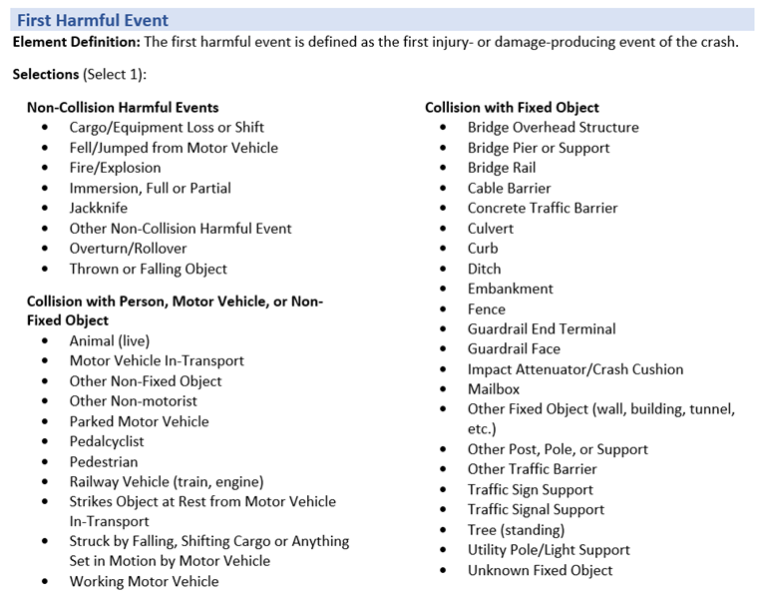

**Please rate the following statements for this data element using a scale of 1-5, with 1 meaning Strongly Agree and 5 meaning Strongly Disagree.**

|  |  |  |  |  |  |
| --- | --- | --- | --- | --- | --- |
|  | 1-Strongly Agree | 2-Agree | 3-Neutral | 4-Disagree | 5-Strongly Disagree |
| This data element is clearly defined and understandable |  |  |  |  |  |
| This data element can be collected at the scene of a crash |  |  |  |  |  |
| This data element can be completed based on facts, not speculation |  |  |  |  |  |
| This data element has a reasonable number of selections |  |  |  |  |  |

**Reflecting on your answers above, could this data element be improved? If so, how?**

### **Data Element Review: Air Bag Deployed**

Review the data element and answer the following questions.

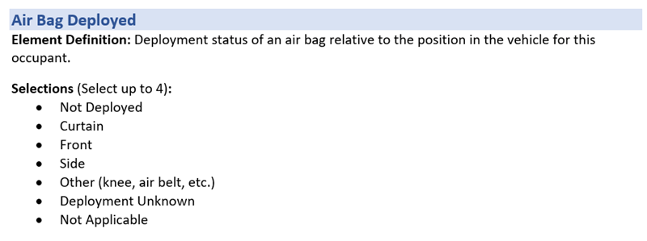

**Please rate the following statements for this data element using a scale of 1-5, with 1 meaning Strongly Agree and 5 meaning Strongly Disagree.**

|  |  |  |  |  |  |
| --- | --- | --- | --- | --- | --- |
|  | 1-Strongly Agree | 2-Agree | 3-Neutral | 4-Disagree | 5-Strongly Disagree |
| This data element is clearly defined and understandable |  |  |  |  |  |
| This data element can be collected at the scene of a crash |  |  |  |  |  |
| This data element can be completed based on facts, not speculation |  |  |  |  |  |
| This data element has a reasonable number of selections |  |  |  |  |  |

**Reflecting on your answers above, could this data element be improved? If so, how?**

### **Data Element Review: Person Type**

Review the data element and answer the following questions.

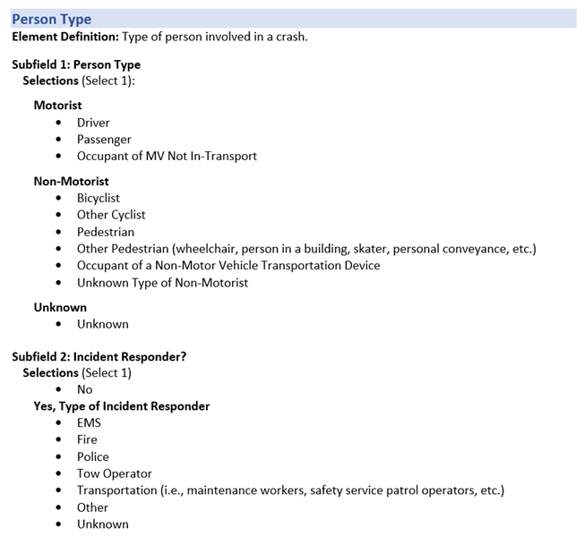

**Please rate the following statements for this data element using a scale of 1-5, with 1 meaning Strongly Agree and 5 meaning Strongly Disagree.**

|  |  |  |  |  |  |
| --- | --- | --- | --- | --- | --- |
|  | 1-Strongly Agree | 2-Agree | 3-Neutral | 4-Disagree | 5-Strongly Disagree |
| This data element is clearly defined and understandable |  |  |  |  |  |
| This data element can be collected at the scene of a crash |  |  |  |  |  |
| This data element can be completed based on facts, not speculation |  |  |  |  |  |
| This data element has a reasonable number of selections |  |  |  |  |  |

**Reflecting on your answers above, could this data element be improved? If so, how?**

### **Data Element Review: Relation to Junction**

Review the data element and answer the following questions.

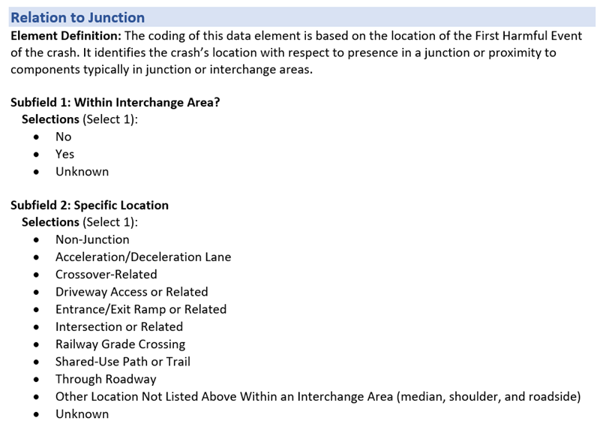

**Please rate the following statements for this data element using a scale of 1-5, with 1 meaning Strongly Agree and 5 meaning Strongly Disagree.**

|  |  |  |  |  |  |
| --- | --- | --- | --- | --- | --- |
|  | 1-Strongly Agree | 2-Agree | 3-Neutral | 4-Disagree | 5-Strongly Disagree |
| This data element is clearly defined and understandable |  |  |  |  |  |
| This data element can be collected at the scene of a crash |  |  |  |  |  |
| This data element can be completed based on facts, not speculation |  |  |  |  |  |
| This data element has a reasonable number of selections |  |  |  |  |  |

**Reflecting on your answers above, could this data element be improved? If so, how?**

### **Data Element Review: Non-Motorist Action/Circumstance Prior to Crash**

Review the data element and answer the following questions.

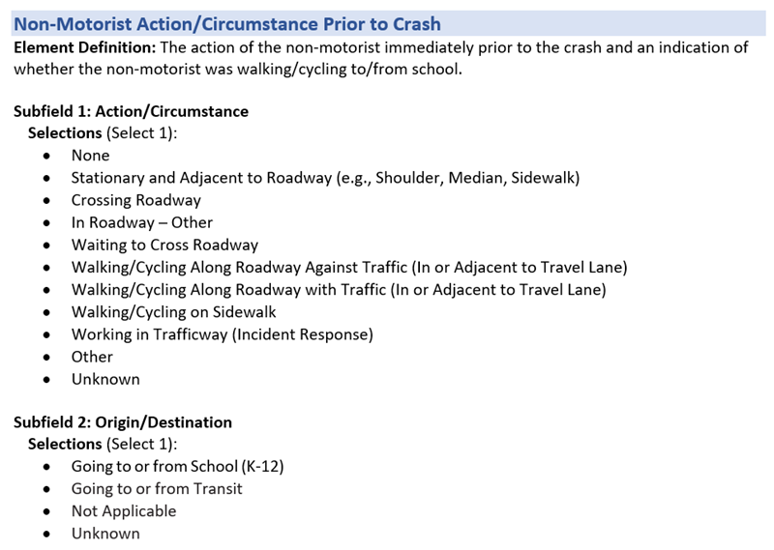

**Please rate the following statements for this data element using a scale of 1-5, with 1 meaning Strongly Agree and 5 meaning Strongly Disagree.**

|  |  |  |  |  |  |
| --- | --- | --- | --- | --- | --- |
|  | 1-Strongly Agree | 2-Agree | 3-Neutral | 4-Disagree | 5-Strongly Disagree |
| This data element is clearly defined and understandable |  |  |  |  |  |
| This data element can be collected at the scene of a crash |  |  |  |  |  |
| This data element can be completed based on facts, not speculation |  |  |  |  |  |
| This data element has a reasonable number of selections |  |  |  |  |  |

**Reflecting on your answers above, could this data element be improved? If so, how?**

### **Data Element Review: Driver Actions at Time of the Crash**

Review the data element and answer the following questions.

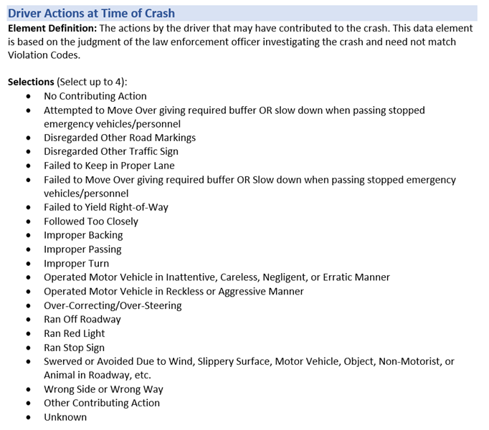

**Please rate the following statements for this data element using a scale of 1-5, with 1 meaning Strongly Agree and 5 meaning Strongly Disagree.**

|  |  |  |  |  |  |
| --- | --- | --- | --- | --- | --- |
|  | 1-Strongly Agree | 2-Agree | 3-Neutral | 4-Disagree | 5-Strongly Disagree |
| This data element is clearly defined and understandable |  |  |  |  |  |
| This data element can be collected at the scene of a crash |  |  |  |  |  |
| This data element can be completed based on facts, not speculation |  |  |  |  |  |
| This data element has a reasonable number of selections |  |  |  |  |  |

**Reflecting on your answers above, could this data element be improved? If so, how?**

### **Data Element Review: Injury Status**

Review the data element and answer the following questions.

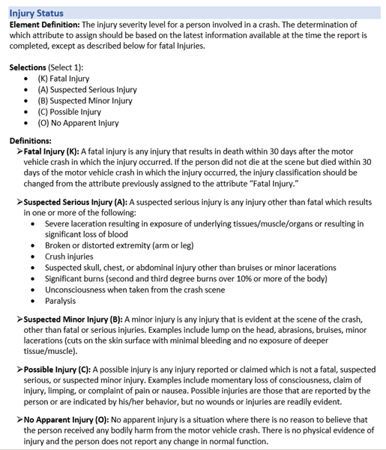

**Please rate the following statements for this data element using a scale of 1-5, with 1 meaning Strongly Agree and 5 meaning Strongly Disagree.**

|  |  |  |  |  |  |
| --- | --- | --- | --- | --- | --- |
|  | 1-Strongly Agree | 2-Agree | 3-Neutral | 4-Disagree | 5-Strongly Disagree |
| This data element is clearly defined and understandable |  |  |  |  |  |
| This data element can be collected at the scene of a crash |  |  |  |  |  |
| This data element can be completed based on facts, not speculation |  |  |  |  |  |
| This data element has a reasonable number of selections |  |  |  |  |  |

**Reflecting on your answers above, could this data element be improved? If so, how?**

### **Data Element Review: Initial Contact Point on Non-Motorist**

Review the data element and answer the following questions.

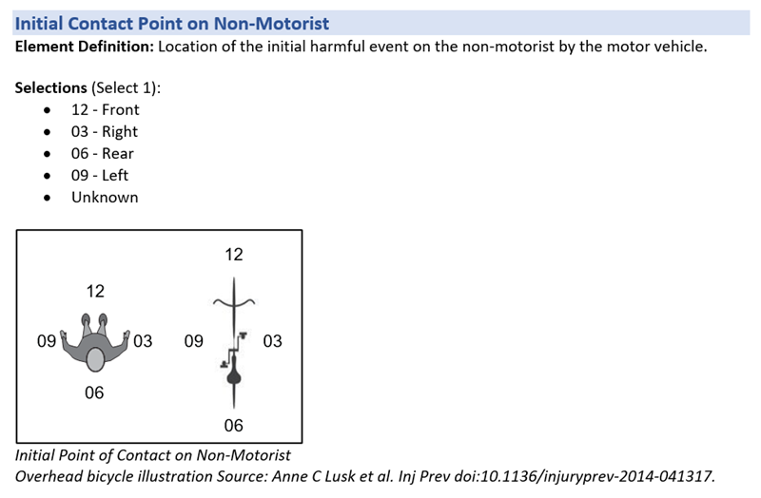

**Please rate the following statements for this data element using a scale of 1-5, with 1 meaning Strongly Agree and 5 meaning Strongly Disagree.**

|  |  |  |  |  |  |
| --- | --- | --- | --- | --- | --- |
|  | 1-Strongly Agree | 2-Agree | 3-Neutral | 4-Disagree | 5-Strongly Disagree |
| This data element is clearly defined and understandable |  |  |  |  |  |
| This data element can be collected at the scene of a crash |  |  |  |  |  |
| This data element can be completed based on facts, not speculation |  |  |  |  |  |
| This data element has a reasonable number of selections |  |  |  |  |  |

**Reflecting on your answers above, could this data element be improved? If so, how?**

### **Data Element Review: Manner of Collision of the First Harmful Event**

Review the data element and answer the following questions.

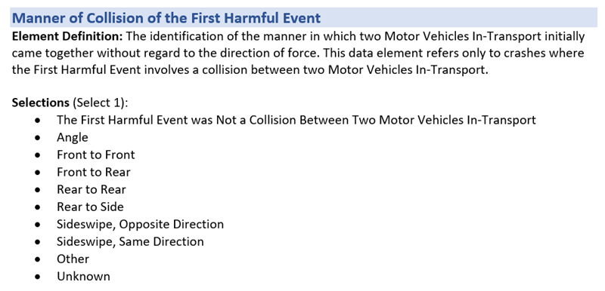

**Please rate the following statements for this data element using a scale of 1-5, with 1 meaning Strongly Agree and 5 meaning Strongly Disagree.**

|  |  |  |  |  |  |
| --- | --- | --- | --- | --- | --- |
|  | 1-Strongly Agree | 2-Agree | 3-Neutral | 4-Disagree | 5-Strongly Disagree |
| This data element is clearly defined and understandable |  |  |  |  |  |
| This data element can be collected at the scene of a crash |  |  |  |  |  |
| This data element can be completed based on facts, not speculation |  |  |  |  |  |
| This data element has a reasonable number of selections |  |  |  |  |  |

**Reflecting on your answers above, could this data element be improved? If so, how?**

### **Data Element Review: Most Harmful Event for this Motor Vehicle.**

Review the data element and answer the following questions.

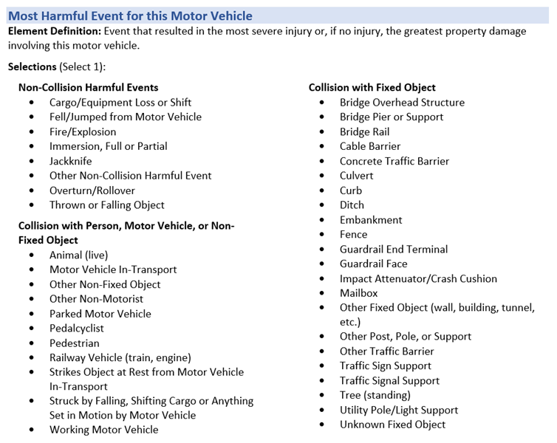

**Please rate the following statements for this data element using a scale of 1-5, with 1 meaning Strongly Agree and 5 meaning Strongly Disagree.**

|  |  |  |  |  |  |
| --- | --- | --- | --- | --- | --- |
|  | 1-Strongly Agree | 2-Agree | 3-Neutral | 4-Disagree | 5-Strongly Disagree |
| This data element is clearly defined and understandable |  |  |  |  |  |
| This data element can be collected at the scene of a crash |  |  |  |  |  |
| This data element can be completed based on facts, not speculation |  |  |  |  |  |
| This data element has a reasonable number of selections |  |  |  |  |  |

**Reflecting on your answers above, could this data element be improved? If so, how?**

### **Data Element Review: Speeding Related**

Review the data element and answer the following questions.

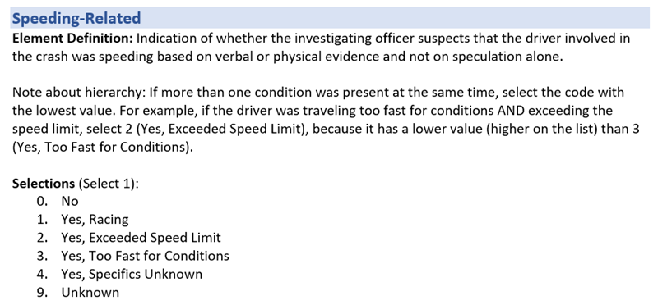

**Please rate the following statements for this data element using a scale of 1-5, with 1 meaning Strongly Agree and 5 meaning Strongly Disagree.**

|  |  |  |  |  |  |
| --- | --- | --- | --- | --- | --- |
|  | 1-Strongly Agree | 2-Agree | 3-Neutral | 4-Disagree | 5-Strongly Disagree |
| This data element is clearly defined and understandable |  |  |  |  |  |
| This data element can be collected at the scene of a crash |  |  |  |  |  |
| This data element can be completed based on facts, not speculation |  |  |  |  |  |
| This data element has a reasonable number of selections |  |  |  |  |  |

**Reflecting on your answers above, could this data element be improved? If so, how?**

### **Data Element Review: Crash Classification**

Review the data element and answer the following questions.

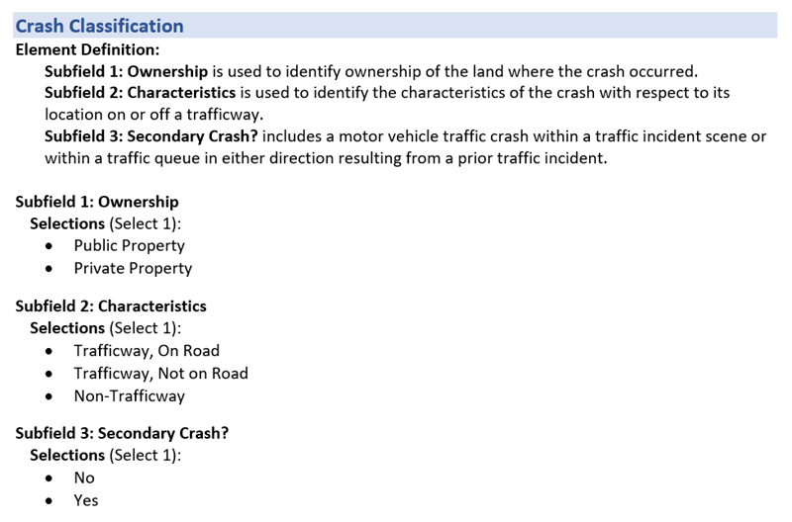

**Please rate the following statements for this data element using a scale of 1-5, with 1 meaning Strongly Agree and 5 meaning Strongly Disagree.**

|  |  |  |  |  |  |
| --- | --- | --- | --- | --- | --- |
|  | 1-Strongly Agree | 2-Agree | 3-Neutral | 4-Disagree | 5-Strongly Disagree |
| This data element is clearly defined and understandable |  |  |  |  |  |
| This data element can be collected at the scene of a crash |  |  |  |  |  |
| This data element can be completed based on facts, not speculation |  |  |  |  |  |
| This data element has a reasonable number of selections |  |  |  |  |  |

**Reflecting on your answers above, could this data element be improved? If so, how?**

### **Data Element Review: Emergency Motor Vehicle Use**

Review the data element and answer the following questions.

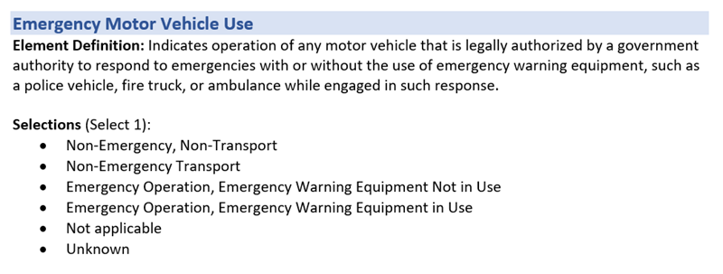

**Please rate the following statements for this data element using a scale of 1-5, with 1 meaning Strongly Agree and 5 meaning Strongly Disagree.**

|  |  |  |  |  |  |
| --- | --- | --- | --- | --- | --- |
|  | 1-Strongly Agree | 2-Agree | 3-Neutral | 4-Disagree | 5-Strongly Disagree |
| This data element is clearly defined and understandable |  |  |  |  |  |
| This data element can be collected at the scene of a crash |  |  |  |  |  |
| This data element can be completed based on facts, not speculation |  |  |  |  |  |
| This data element has a reasonable number of selections |  |  |  |  |  |

**Reflecting on your answers above, could this data element be improved? If so, how?**

### **Data Element Review: Traffic Control Device Type**

Review the data element and answer the following questions.

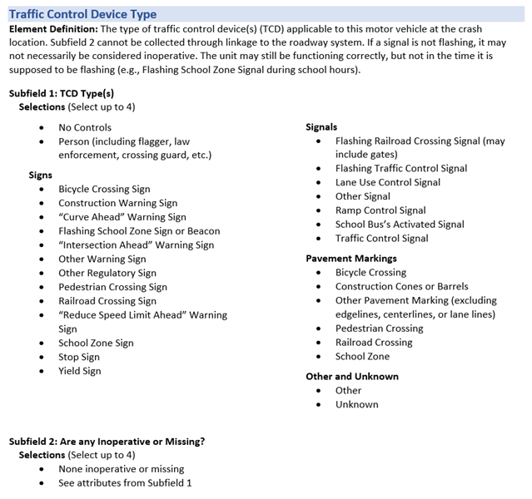

**Please rate the following statements for this data element using a scale of 1-5, with 1 meaning Strongly Agree and 5 meaning Strongly Disagree.**

|  |  |  |  |  |  |
| --- | --- | --- | --- | --- | --- |
|  | 1-Strongly Agree | 2-Agree | 3-Neutral | 4-Disagree | 5-Strongly Disagree |
| This data element is clearly defined and understandable |  |  |  |  |  |
| This data element can be collected at the scene of a crash |  |  |  |  |  |
| This data element can be completed based on facts, not speculation |  |  |  |  |  |
| This data element has a reasonable number of selections |  |  |  |  |  |

**Reflecting on your answers above, could this data element be improved? If so, how?**

### **Data Element Review: Crash Date and Time**

Review the data element and answer the following questions.

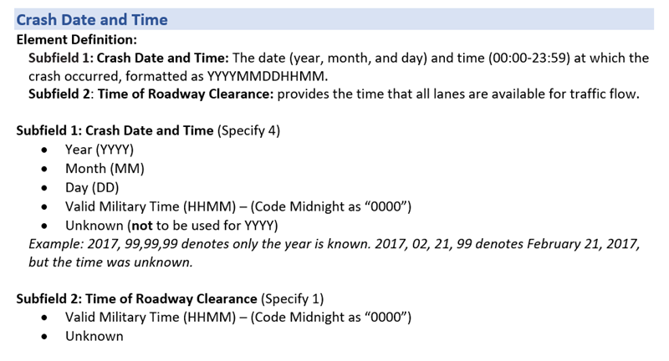

**Please rate the following statements for this data element using a scale of 1-5, with 1 meaning Strongly Agree and 5 meaning Strongly Disagree.**

|  |  |  |  |  |  |
| --- | --- | --- | --- | --- | --- |
|  | 1-Strongly Agree | 2-Agree | 3-Neutral | 4-Disagree | 5-Strongly Disagree |
| This data element is clearly defined and understandable |  |  |  |  |  |
| This data element can be collected at the scene of a crash |  |  |  |  |  |
| This data element can be completed based on facts, not speculation |  |  |  |  |  |
| This data element has a reasonable number of selections |  |  |  |  |  |

**Reflecting on your answers above, could this data element be improved? If so, how?**

### **Data Element Review: Law Enforcement Suspects Drug Use**

Review the data element and answer the following questions.

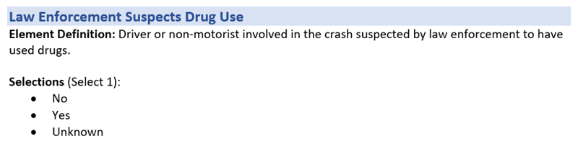

**Please rate the following statements for this data element using a scale of 1-5, with 1 meaning Strongly Agree and 5 meaning Strongly Disagree.**

|  |  |  |  |  |  |
| --- | --- | --- | --- | --- | --- |
|  | 1-Strongly Agree | 2-Agree | 3-Neutral | 4-Disagree | 5-Strongly Disagree |
| This data element is clearly defined and understandable |  |  |  |  |  |
| This data element can be collected at the scene of a crash |  |  |  |  |  |
| This data element can be completed based on facts, not speculation |  |  |  |  |  |
| This data element has a reasonable number of selections |  |  |  |  |  |

**Reflecting on your answers above, could this data element be improved? If so, how?**

### **Data Element Review: Location of First Harmful Event Relative to the Trafficway**

Review the data element and answer the following questions.

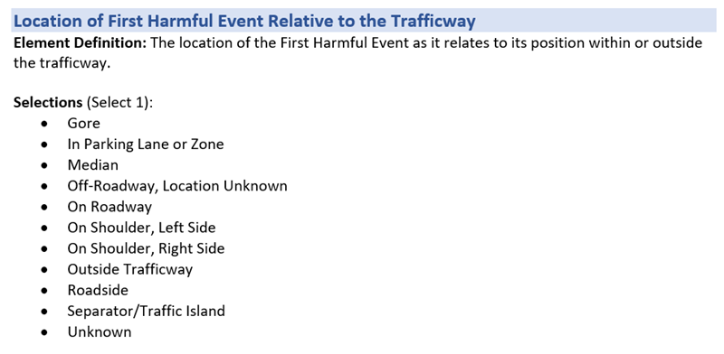

**Please rate the following statements for this data element using a scale of 1-5, with 1 meaning Strongly Agree and 5 meaning Strongly Disagree.**

|  |  |  |  |  |  |
| --- | --- | --- | --- | --- | --- |
|  | 1-Strongly Agree | 2-Agree | 3-Neutral | 4-Disagree | 5-Strongly Disagree |
| This data element is clearly defined and understandable |  |  |  |  |  |
| This data element can be collected at the scene of a crash |  |  |  |  |  |
| This data element can be completed based on facts, not speculation |  |  |  |  |  |
| This data element has a reasonable number of selections |  |  |  |  |  |

**Reflecting on your answers above, could this data element be improved? If so, how?**

### **Data Element Review: Motor Vehicle Maneuver/Action**

Review the data element and answer the following questions.

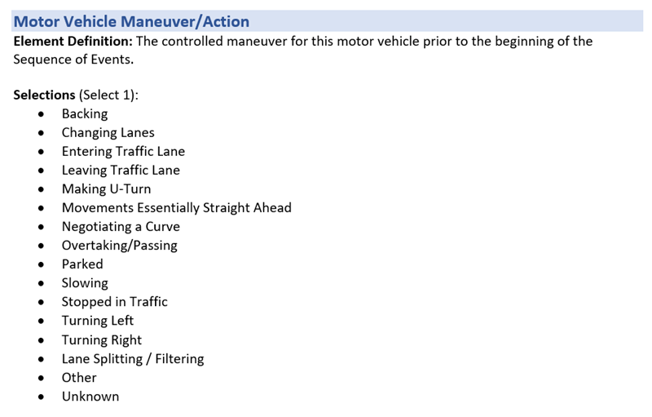

**Please rate the following statements for this data element using a scale of 1-5, with 1 meaning Strongly Agree and 5 meaning Strongly Disagree.**

|  |  |  |  |  |  |
| --- | --- | --- | --- | --- | --- |
|  | 1-Strongly Agree | 2-Agree | 3-Neutral | 4-Disagree | 5-Strongly Disagree |
| This data element is clearly defined and understandable |  |  |  |  |  |
| This data element can be collected at the scene of a crash |  |  |  |  |  |
| This data element can be completed based on facts, not speculation |  |  |  |  |  |
| This data element has a reasonable number of selections |  |  |  |  |  |

**Reflecting on your answers above, could this data element be improved? If so, how?**

### **Data Element Review: Roadway Alignment and Grade**

Review the data element and answer the following questions.

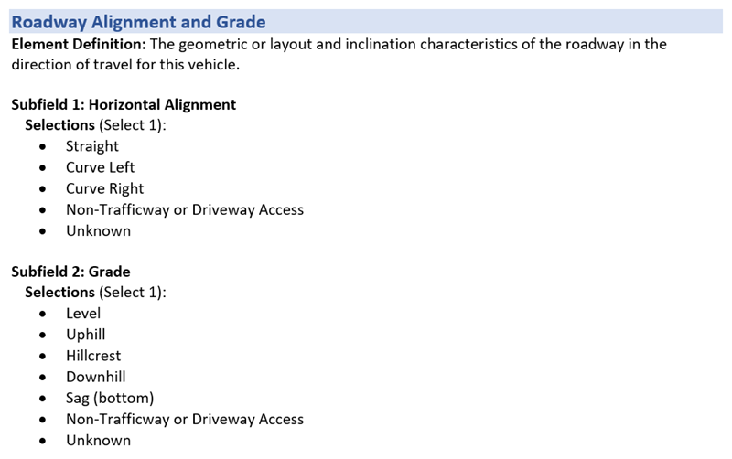

**Please rate the following statements for this data element using a scale of 1-5, with 1 meaning Strongly Agree and 5 meaning Strongly Disagree.**

|  |  |  |  |  |  |
| --- | --- | --- | --- | --- | --- |
|  | 1-Strongly Agree | 2-Agree | 3-Neutral | 4-Disagree | 5-Strongly Disagree |
| This data element is clearly defined and understandable |  |  |  |  |  |
| This data element can be collected at the scene of a crash |  |  |  |  |  |
| This data element can be completed based on facts, not speculation |  |  |  |  |  |
| This data element has a reasonable number of selections |  |  |  |  |  |

**Reflecting on your answers above, could this data element be improved? If so, how?**

### **Data Element Review: Transported to First Medical Facility By**

Review the data element and answer the following questions.

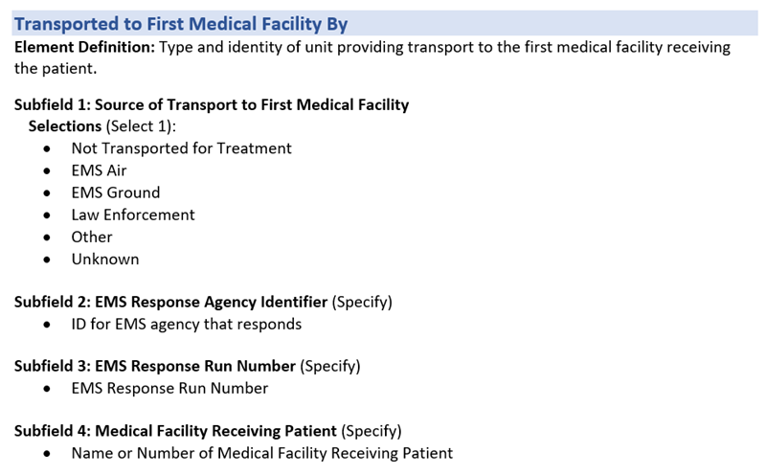

**Please rate the following statements for this data element using a scale of 1-5, with 1 meaning Strongly Agree and 5 meaning Strongly Disagree.**

|  |  |  |  |  |  |
| --- | --- | --- | --- | --- | --- |
|  | 1-Strongly Agree | 2-Agree | 3-Neutral | 4-Disagree | 5-Strongly Disagree |
| This data element is clearly defined and understandable |  |  |  |  |  |
| This data element can be collected at the scene of a crash |  |  |  |  |  |
| This data element can be completed based on facts, not speculation |  |  |  |  |  |
| This data element has a reasonable number of selections |  |  |  |  |  |

**Reflecting on your answers above, could this data element be improved? If so, how?**

### **Data Element Review: Vehicle Damage**

Review the data element and answer the following questions.

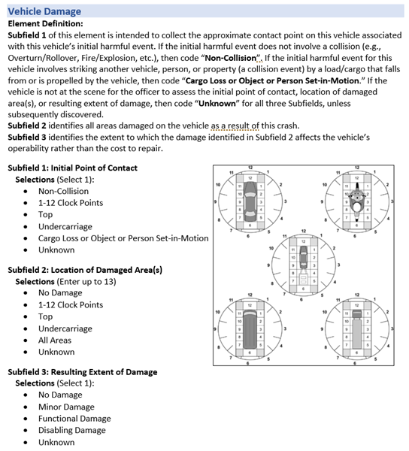

**Please rate the following statements for this data element using a scale of 1-5, with 1 meaning Strongly Agree and 5 meaning Strongly Disagree.**

|  |  |  |  |  |  |
| --- | --- | --- | --- | --- | --- |
|  | 1-Strongly Agree | 2-Agree | 3-Neutral | 4-Disagree | 5-Strongly Disagree |
| This data element is clearly defined and understandable |  |  |  |  |  |
| This data element can be collected at the scene of a crash |  |  |  |  |  |
| This data element can be completed based on facts, not speculation |  |  |  |  |  |
| This data element has a reasonable number of selections |  |  |  |  |  |

**Reflecting on your answers above, could this data element be improved? If so, how?**

# **Experience and Background**

**Number of years working as a Law Enforcement Officer writing traffic crash reports**

1. Less than 1 year
2. 1-3 years
3. 4-6 years
4. 7-9 years
5. 10 or more years

**Estimated number of crash reports completed in past 12 months**

1. 20 or Less
2. 21-40
3. 41-60
4. 61-80
5. 81 or more

**Select all the types of crashes for which you have completed reports**

* crash with property damage only (no injuries)
* crash with minor injury
* crash with serious injury
* crash with fatal injury
* crash involving released hazardous material
* crash with an alcohol-impaired driver
* crash with drug-impaired driver
* crash involving large vehicle or bus (FMCSA reportable)
* crash involving bicyclist
* crash involving pedestrian
* crash involving motorcycle

**Select the highest level of training you have received for completing traffic crash reports**

1. Police academy only
2. Additional training upon entering traffic division
3. On the job training/mentoring
4. Periodic training (less often than annual)
5. Annual training
6. Regular training (more often than annual)
7. Advanced training in crash investigation and/or reconstruction