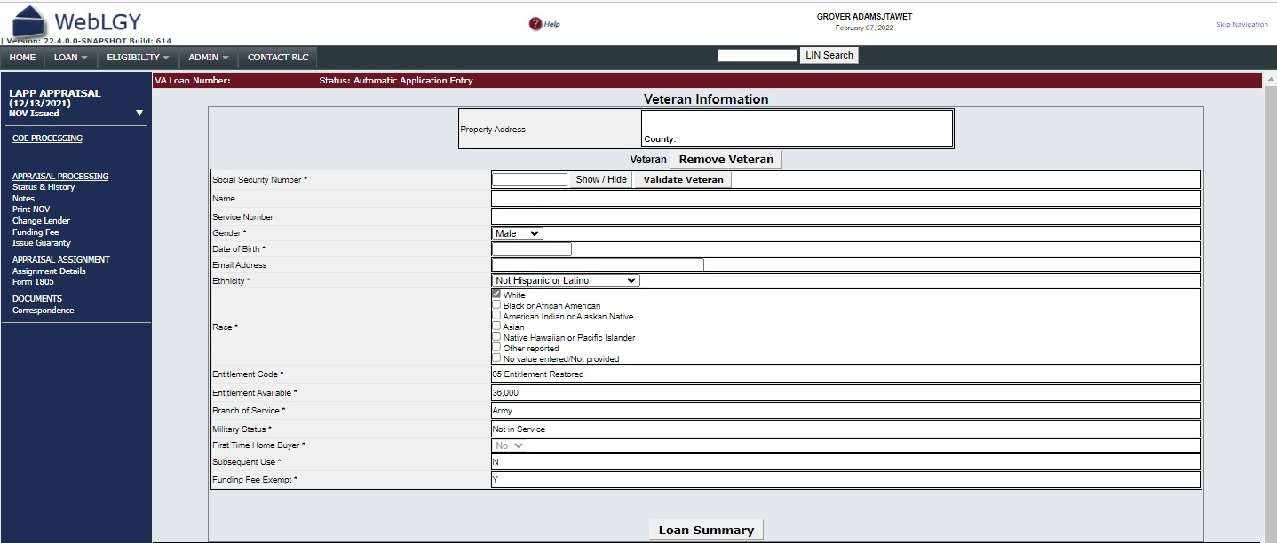
OMB Control No. 2900-XXXX
Respondent Burden: 10 minutes
Expiration Date: XX/XX/XXXX
RESPONDENT BURDEN: This information is needed to issue evidence of guaranty for a VA home loan. Title 38, U.S.C., section 3702, authorizes collection of this information. We estimate that you will need an average of 5 minutes to review the instructions, find the information, and complete this form. VA cannot conduct or sponsor a collection of information unless a valid OMB control number is displayed. You are not required to respond to a collection of information if this number is not displayed. Valid OMB control numbers can be located on the OMB Internet Page at www.reginfo.gov/public/do/PRAMain. If desired, you can call 1-800-827-1000 to get information on where to send comments or suggestions about this form.

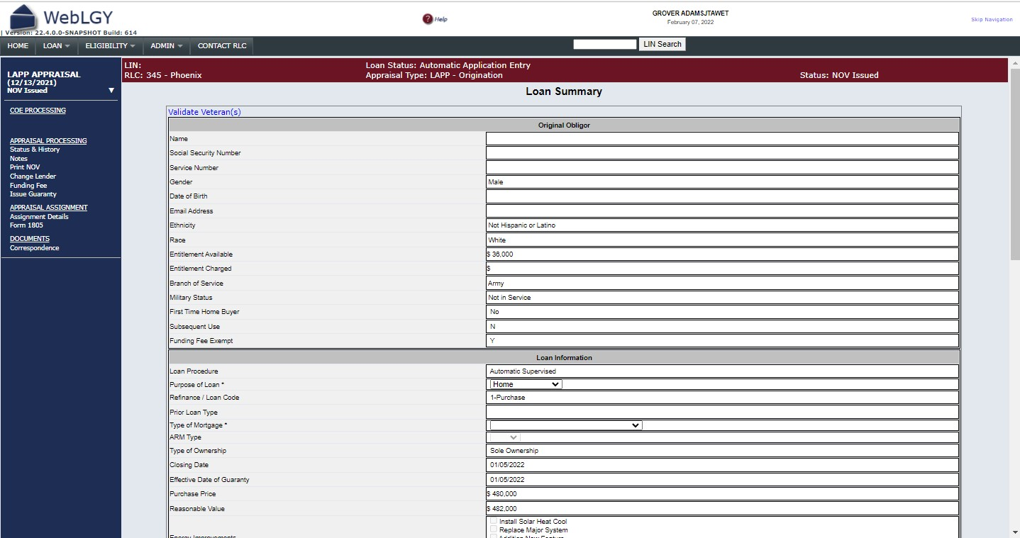
OMB Control No. 2900-XXXX
Respondent Burden: 10 minutes
Expiration Date: XX/XX/XXXX
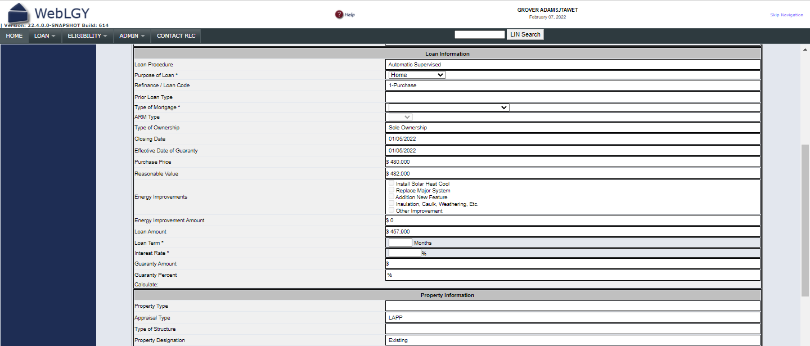
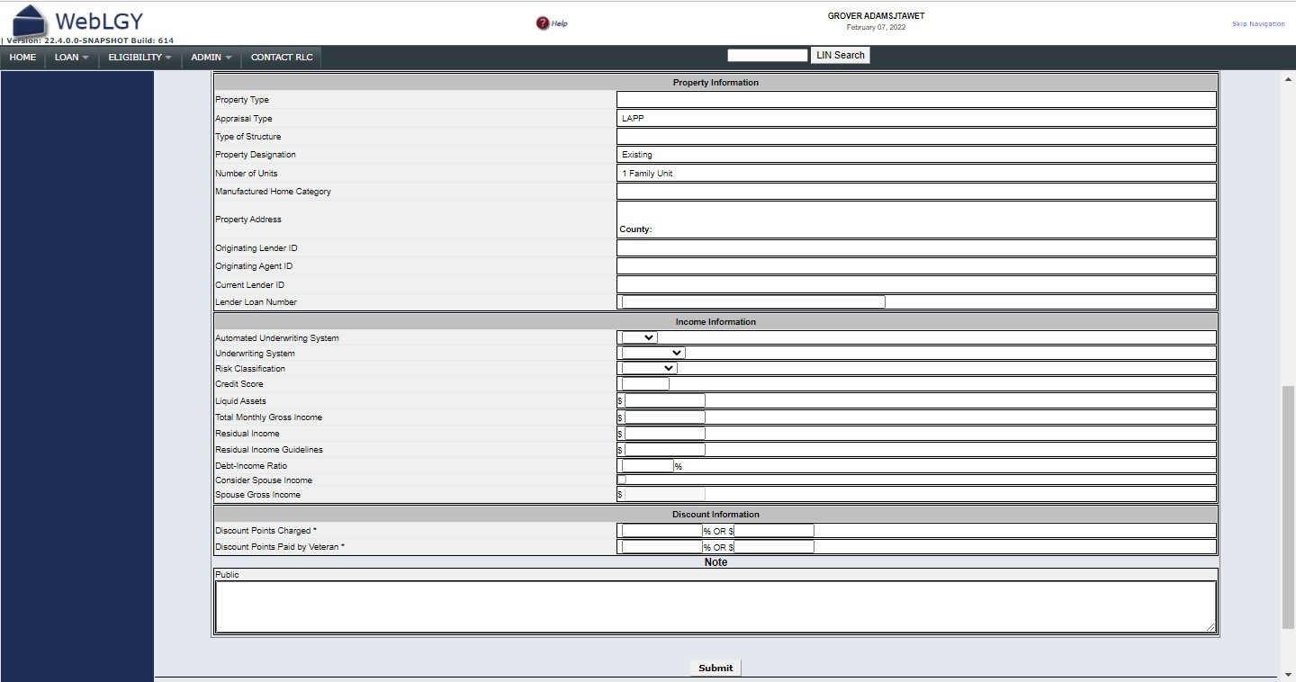
RESPONDENT BURDEN: This information is needed to issue evidence of guaranty for a VA home loan. Title 38, U.S.C., section 3702, authorizes collection of this information. We estimate that you will need an average of 10 minutes to review the instructions, find the information, and complete this form. VA cannot conduct or sponsor a collection of information unless a valid OMB control number is displayed. You are not required to respond to a collection of information if this number is not displayed. Valid OMB control numbers can be located on the OMB Internet Page at www.reginfo.gov/public/do/PRAMain. If desired, you can call 1-800-827-1000 to get information on where to send comments or suggestions about this form.

