Eligibility Office Automation System (EOAS) Update

Release 12.7 is now in production and being used by the NCA.

Below are screen shots of the system and virtual form showing compliance. All screen shots do not have any PII and they are all test data.
System:
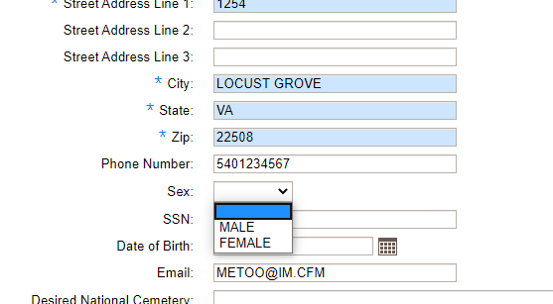
System:
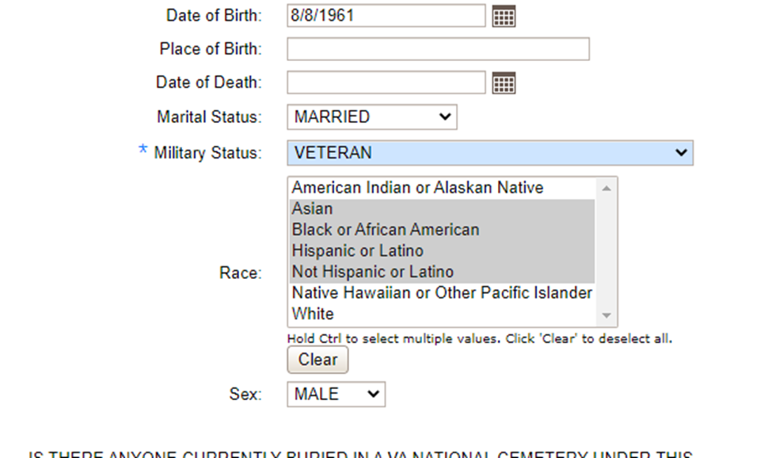
Virtual Form via va.gov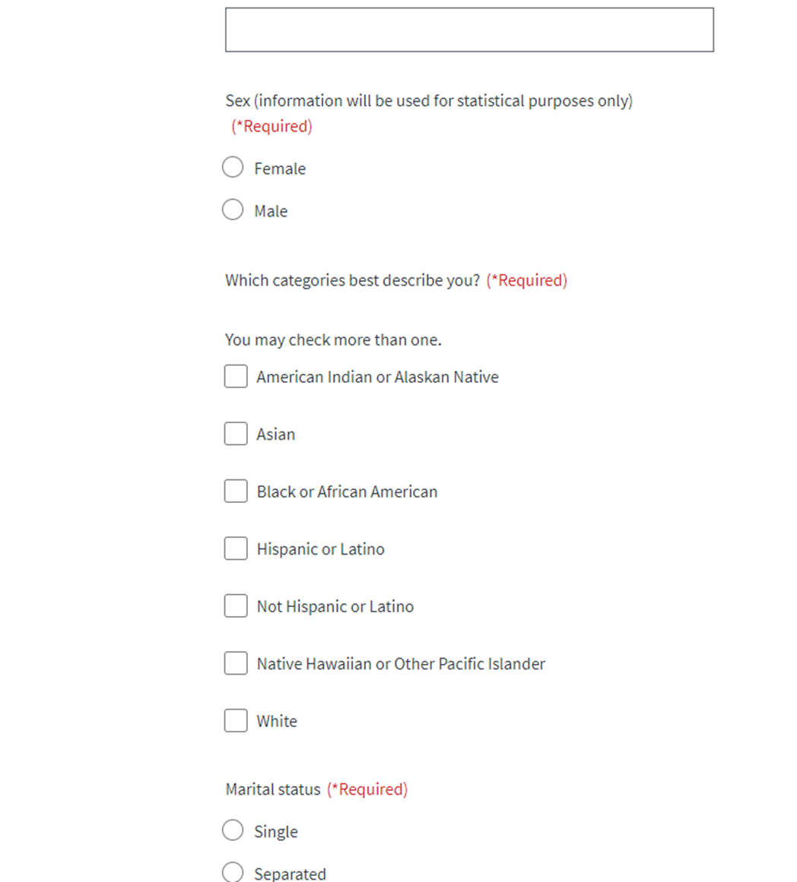

Virtual Form via va.gov
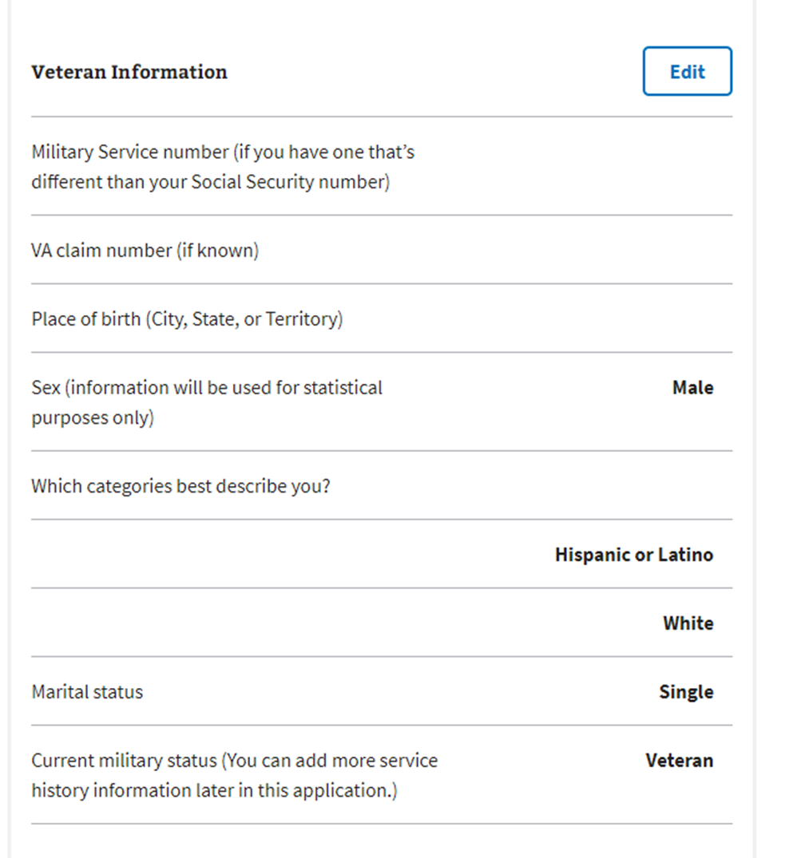

Va.gov to EOAS side by side view of intake of data:
