State Library Administrative Agency (SLAA) Survey Data Collection
Supporting Statement for PRA Submission

A | Justification
A.1. Circumstances Making the Collection of Information Necessary
Purpose of the Submission
IMLS requests approval to conduct information collection for the State Library Administrative Agency (SLAA) Survey FY2022-FY2024.
The State Library Administrative Agency (SLAA) Survey is a cooperative effort of the Institute of Museum and Library Services (IMLS), the Chief Officers of State Library Agencies (COSLA), and Research Triangle International (RTI, the current data collection agent for IMLS). The survey was developed based on the recommendation of COSLA in April 1992. The State Library Agencies Survey Steering Committee was established in November 1992 to provide continuing guidance in the design and conduct of the survey. The Steering Committee included representatives from state library agencies, the American Library Association (ALA), the former National Commission on Libraries and Information Science (NCLIS), IMLS, and the Census Bureau. In December 2008, IMLS combined the State Library Agencies Survey Steering Committee and the Public Libraries Survey (PLS) Steering Committee into one advisory group named the Library Statistics Working Group (LSWG). The LSWG serves the same function as the former steering committees and includes five members of COSLA, five State Data Coordinators (SDC), and five members who represent the library community at-large, including relevant library associations, data users, and members of the research community. The SLAA Survey was administered annually until fiscal year (FY) 2010, at which point administration was changed to biennially.
The SLAA Survey collects descriptive data about SLAAs, including information on governance; allied operations; direct library services to the public; services to libraries and library cooperatives; electronic services and resources; service outlets; public service hours; collections; service and development transactions; and staff revenue and expenditures. These data, when added to the data collected by the IMLS surveys of public libraries, combine to complete the national picture of library service.
An SLAA is the official agency of a state charged by state law with the extension and development of public library services throughout the state (20 U.S.C. § 9122). An SLAA is the governmental entity responsible for the administration and supervision of Library Services and Technology Act (LSTA) funds. SLAAs also administer the state library operations, allied operations (such as state archives, state legislative reference organizations, and state records management services), libraries for the blind and physically handicapped, and the state Centers for the Book. They provide important reference and information services to state governments and may also function as the state’s public library at large, providing library services to the general public. The statewide services provided by SLAAs to libraries and library cooperatives are not reported elsewhere. SLAA services provided to state government are not presently covered in any other data collection.
Without data on SLAAs, the IMLS data systems are incomplete. SLAAs are a central and vital component of the Nation’s library infrastructure. SLAAs play a leadership role in assisting public libraries to respond to goals of the Administration and state initiatives for libraries and library services, such as education and technology.
Legislative Authorization
IMLS is responsible for identifying national needs for and trends in museum, library, and information services. IMLS also must report on the impact and effectiveness of museum, library, and information services throughout the United States, including programs conducted with funds made available by IMLS. IMLS must identify and disseminate information on the best practices of such programs. This data collection is authorized by 20 U.S.C. § 9108 (Policy research, data collection, analysis and modeling, evaluation, and dissemination).
20 U.S.C. Section 9108. Policy research, data collection, analysis and modeling, evaluation, and dissemination
(a) In general
The Director shall regularly support and conduct, as appropriate, policy research, data collection, analysis and modeling, evaluation, and dissemination of information to extend and improve the Nation’s museum, library, and information services.
(b) Objectives
The objectives of the policy research, data collection, analysis and modeling, evaluation, and dissemination of information carried out under this section include the following:
(1) To enhance and expand the capacity of museums, libraries, and information services to anticipate, respond to, and meet the evolving needs of communities and the public, including by identifying trends and developments that may impact the need for and delivery of services.
(2) To provide information and data on the role, value, and impact of museum, library, and information resources, including the identification of trends and potential gaps in the availability and use of museum and library services by their communities and the public;
(3) To measure the effectiveness of museums, libraries, and information services throughout the United States, including the impact of Federal programs authorized under this Act.
(4) To identify indicators and outcomes that can be used to create enhancements to the efficiency and efficacy of museum, library, and information services.
(5) To promote advancement and growth in museum, library, and information services through sharing of best practices and effective strategies in order to better serve the people of the United States.
(6) To facilitate planning for, and building of, institutional capacity in order to improve—
(A) museum, library, and information services at the national, State, local, and regional levels; and
(B) international communications and cooperative networks.
(7) To support and enhance collaborative professional networks and consortia that use shared, meaningful, and actionable data analysis and modeling to advance museum, library, and information services and address community needs.
(c) Authority to contract and enter into other arrangements
The Director is authorized to enter into grants, contracts, cooperative agreements, and other arrangements with Federal agencies, public and private organizations, and other entities with expertise the Director determines appropriate, to further the objectives described in subsection (b) and to carry out the responsibilities under subsection (f).
(d) Consultation and Public Engagement
In carrying out subsection (a) and in furtherance of the objectives described in subsection (b), the Director—
(1) shall conduct ongoing collaboration (as determined appropriate by the Director) and consult with—
(A) State library administrative agencies; and
(B) National, State, tribal, and regional museum and library organizations; and
(2) may also collaborate or consult with –
(A) cooperative networks of geographic- or discipline-based museums and libraries; and
(B) Other applicable agencies, organizations (including international organizations), entities (including entities with expertise in the fields of data collection, analysis and modeling, and evaluation), and community stakeholders.
(e) Assistance to museums and libraries
The Director shall provide technical support and assistance (and other resources, to the extent practicable) to ensure consistency in data reporting and help the museum and library fields with meeting the objectives of this section.
(f) Dissemination
(1) In general –
Each year, the Director shall widely disseminate, as appropriate to further the objectives described in subsection (b) --
(A) the results, data, reports, findings, studies, surveys, and other information obtained under this section;
(B) the means and approaches by which the objectives described in subsection (b) were accomplished; and
(C) information regarding the manner and extent to which collaboration and consultation were conducted, as required by subsection (d).
(2) Formats to be used --
The information described in paragraph (1) shall be shared in formats that facilitate access and ease of use and are searchable.
(g) Authorization of appropriations
(1) In general
There are authorized to be appropriated to carry out this section $3,500,000 for each of the fiscal years 2020 through 2025.
(2) Availability of funds
Sums appropriated under paragraph (1) for any fiscal year shall remain available for obligation until expended.
As required by 20 U.S.C. § 9108, IMLS is seeking to conduct an analysis of national trends in library and information services. IMLS library survey activities will be designed to address high-priority library data needs; to provide consistent, reliable, complete, and accurate indicators of the status and trends of state and public libraries; and to report timely, useful, and high-quality data to the U.S. Congress, the States, other policymakers, practitioners, data users, and the general public.
Prior Related Studies
The SLAA survey has been conducted 22 times since 1994. The survey was administered by the National Center for Education Statistics (NCES) until October 2007, when its administration was transferred to IMLS. Beginning with undertaking the SLAA FY2007 collection, IMLS has administered the survey eight times, with the most recent having been undertaken in 2021 for FY2020.
A.2. Purposes and Uses of the Data
The purpose of the SLAA Survey is to provide state and federal policymakers and other interested users with information about state library agencies. The collected data are useful to (1) Chief Officers of SLAAs; (2) policymakers in the executive and legislative branches of federal and state governments; (3) government and library administrators at federal, state, and local levels; (4) the American Library Association and its members or customers; and (5) library and public policy researchers.
Federal and state officials use these data in planning, as they make policy decisions about legislation, appropriations, and resource allocations, and in their monitoring of federal and state grant programs for public libraries and other libraries in the state. IMLS and other federal agencies will use the data to help shape their recommendations regarding state libraries and public library services. SLAAs will use the data for state, regional, and national comparisons of library services and resources to determine the level of SLAA operations in agencies of similar size and characteristics and to plan for the effective use of funds.
The public library components of the SLAA Survey, when added to the data collected by the IMLS Public Libraries Survey, help complete the national picture of public library service. The SLAA Survey is the only survey that collects data regarding the state library services to public libraries. The data cannot be collected through the Public Library Survey, as the data reported in that survey reflect services and resources directly administered by local public libraries. Therefore, in order to provide basic descriptive data on public library service nationally, SLAAs need to be surveyed. National, state, regional, and local professional library associations need current, comprehensive public library data to develop informed policy positions on state libraries regarding their public library services and library development activities.
Researchers need these data to develop a broad picture of state library services to and funding of libraries and library cooperatives. Journalists and educators have need for these data to determine the role of SLAAs in the provision of statewide services to libraries and library cooperatives, and their contribution to the education infrastructure of the nation.
The SLAA Survey provides IMLS with data to monitor the financial and service capacity of the State Library Administrative Agencies and to analyze changes in these characteristics over time. Data elements in the survey have been used for annualized state-by-state reports and for a more detailed trend analysis:
- Institute of Museum and Library Services. 2022. State Library Administrative Agency Adaptations in the Initial Months of the COVID-19 Pandemic and Ongoing Trends. Washington, DC: Institute of Museum and Library Services. http://www.imls.gov/sites/default/files/2022-06/research-brief-slaa-covid19.pdf
- The Institute of Museum and Library Services. 2021. Functions and Roles of State Libraries: 2000 and 2020. Washington, DC: The Institute of Museum and Library Services. http://www.imls.gov/sites/default/files/2021-12/imls_slaa_functions_roles_brief.pdf
- Institute of Museum and Library Services. (2020). State Library Administrative Agencies Survey: Fiscal Year 2018. Washington, DC: Institute of Museum and Library Services. http://www.imls.gov/sites/default/files/publications/documents/state-library-administrative-agency-survey-fy2018.pdf
- Institute of Museum and Library Services. (2017). State Library Administrative Agencies Survey: Fiscal Year 2016. Washington, DC: Institute of Museum and Library Services. https://www.imls.gov/sites/default/files/publications/documents/state-library-administrative-agency-survey-fy2016.pdf
- Swan, D.W., et al. (2014). State Library Agencies Survey: Fiscal Year 2012. https://www.imls.gov/sites/default/files/publications/documents/2012-slaa-report_0.pdf
- Swan, D.W., et al. (2011). State Library Agencies Survey: Fiscal Year 2010. Washington, DC: Institute of Museum and Library Services. https://www.imls.gov/sites/default/files/publications/documents/stla2010.pdf
- Henderson, E. & Manjarrez, C. (2010). State Library Agency Service Trends: 1999-2008. Research Brief Series, No. 2 (IMLS-2010-RB-02). Washington, DC: Institute of Museum and Library Services. http://www.imls.gov/assets/1/AssetManager/Brief2010_02.pdf
Monitoring the fiscal and service conditions of these organizations is an important function for IMLS, which administers the Grants to States Program. This program provides funds to SLAAs using a population-based formula. SLAAs may use federal funds to support statewide initiatives and services. They also may distribute the funds through sub-grant competitions or cooperative agreements to public, academic, research, school, and special libraries in their state. The survey provides information necessary for State Library Administrative Agencies to benchmark their financial characteristics and services against those in other states. In addition, serving as the key agencies for administering the Library Services and Technology Act grant in their respective states, SLAAs are also important for delivering federal programs outside IMLS, including programs focused on broadband, such as the FCC E-Rate Program for Schools and Libraries.
A.3. Use of Improved Information Technology
The SLAA data are collected over the internet via a web-based reporting system. For FY2022, the instrument is being implemented in Qualtrics, a commercial off-the-shelf online data collection software platform. Documentation including a user guide, collection instructions, and edit check rules will be distributed to all respondents prior to the start of data collection. Respondents will also be offered a training webinar on how the application functions as well as access to a recording of that training. The web survey was designed to minimize the response burden, to improve the timeliness and quality of the data, and to require minimal or no edit follow-up for data problems.
To reduce the response burden, the survey is transmitted with the prior numerical data previously provided in FY2020 on the screen to help the respondent with the current fiscal year entry. The respondent is instructed to review the data and make updates in the blank fields.
Examples of Prior Year Data Presented to Respondent to Reduce Burden:
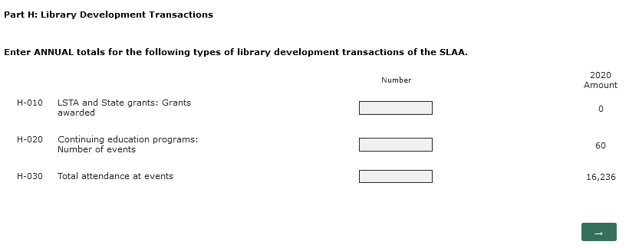

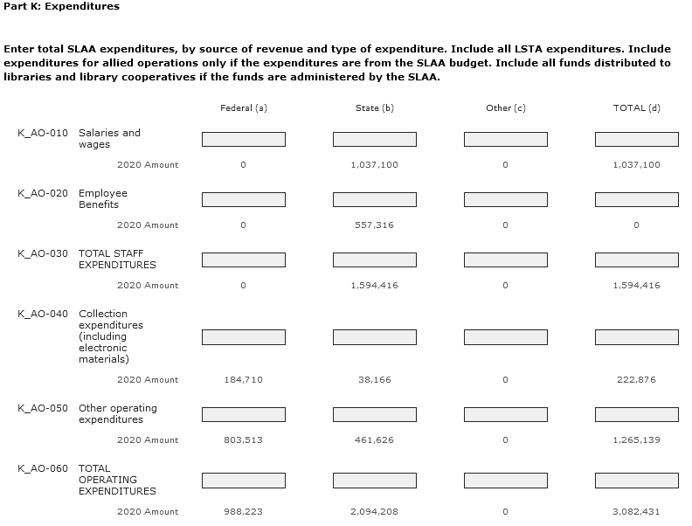
The web edit-check tool alerts the respondent to questionable data during the data entry process (via on-screen edit check warnings) and through edit check summary reports that can be viewed on-screen. The edit check feature enables the respondent to submit edited data that usually requires little or no follow-up for data problems.
The final survey data file, data documentation, and report are released on the IMLS website. IMLS disseminates links to the survey report to Chief Officers of Sate Library Agencies, survey respondents, and members of the LSWG. Data files are also uploaded to data.gov.
A.4. Efforts to Identify Duplication
There continues to be no duplication of effort between IMLS for the SLAA Survey and IMLS LSTA reporting in the collection of LSTA data from SLAAs.
As indicated previously, the LSWG provides continuing input into the design and administration of the survey and includes representatives from state library agencies, the American Library Association, IMLS, and the survey contractor. The LSWG is aware of the need to identify and avoid duplication of effort. A search has been made to confirm whether there may be other undertakings duplicating this data collection effort. IMLS finds that there is no other universe file available and no other effort duplicating the descriptive data collection undertaken by the SLAA Survey.
IMLS administers the LSTA program. IMLS distributes the LSTA funds to SLAAs, which are required by law to administer the funds and submit annual performance reports to IMLS describing LSTA grant activity. IMLS maintains state files of these reports and develops summary data for its Annual Performance Report provided to Congress.
The SLAA Survey collects some LSTA data; however, the LSTA data collected in the SLAA Survey are not directly comparable to the administrative data requested in the IMLS annual State Program Report. On the SLAA survey, all data (including federal funds) are reported on the basis of the state fiscal year for comparability and meaningful analysis. In contrast, due to specific grant requirements and deadlines incorporated into the grant-making effort, states submit interim and final financial reports to IMLS covering grant activity for different reporting periods (i.e., the funding grant period or fiscal year period). States report federal LSTA data to IMLS on a federal fiscal year basis (October 1 to September 30), and state data on a state fiscal year basis (usually July 1 to June 30). This difference in the reporting timeframes would not be acceptable for a federal agency with statistical programs such as IMLS, which needs consistent comparable data for meaningful analysis.
For its administrative data collections addressed in State Program Reports, IMLS collects LSTA data at the level of the individual sub-grant. The reported data are highly detailed, and the items differ from those collected on the SLAA Survey. For example, IMLS collects administrative data for the State Program Report concerning only the number of LSTA grants awarded, whereas the SLAA Survey (Part H) collects data on the number of both LSTA and State grants awarded. In addition, IMLS requires that states report funds “available” for the federal fiscal year for individual sub-grants, including carryover. It would not be feasible for states to report LSTA allocations received from IMLS as revenue on the SLAA Survey since many states, by law, cannot report their allotments as revenue until they expend the funds.
Further, Part L of the SLAA Survey requests total LSTA State Program expenditures during the state fiscal year covered by the survey, by type and use of expenditure. In addition, IMLS collects administrative data on different expenditure categories than what gets included in the SLAA Survey.
The SLAA Survey and IMLS’s administrative data collections have fundamentally different purposes. The SLAA Survey is conducted in fulfillment of IMLS’s duties as a federal agency with statistical programs to collect, collate, analyze, and report full and complete statistics on the condition of libraries in the United States. The SLAA Survey provides a database for operational data of SLAAs for this purpose. IMLS administrative data collections are required to monitor compliance with federal grant-making provisions (see 2 C.F.R. Part 200).
In summary, the LSTA data collected by the IMLS SLAA Survey and IMLS LSTA reporting forms differ in level of detail, reporting requirements, and reporting purposes.
A.5. Method Used to Minimize Burden on Small Businesses
There will be no impact on small businesses or other small entities. The collection of information involves only State Library Administrative Agencies.
A.6. Frequency of Data Collection
The SLAA Survey will be administered biennially. The survey had been administered annually from FY1992 to FY2010. In an effort to reduce costs, IMLS changed the frequency from an annual to a two-year, biennial cycle after the FY2010 collection.
Chief Officers of SLAAs continue to need these data on a frequent and regular basis for program planning and budget-setting. The high value that the SLAAs place on the survey is evidenced by the 100 percent response rate to this SLAA Survey since its inception in 1994.
It usually takes several years for libraries to develop administrative records systems and install staff with specialized library statistics knowledge and skills. Conducting this survey less frequently than biennially may be disruptive to library operations and may jeopardize future data collection capabilities and data quality. For example, the record systems may be allowed to degrade and trained staff may be reassigned. Indeed, these concerns, and the important value of this data collection, have been repeatedly and forcefully expressed to IMLS by COSLA and the IMLS LSWG, who, in fact, urge the annual conduct of the SLAA Survey.
A.7. Special Circumstances of Data Collection
No special circumstances require the collection to be conducted in a manner inconsistent with the guidelines in 5 C.F.R. § 1320.6.
A.8. Consultation and Feedback from Outside the Agency
A.8.1. Public comments solicited through Federal Register
IMLS published a notice in the Federal Register with a 60-day public comment period to announce this proposed information collection on May 27, 2022 (87 FR 32195). No comments were submitted.
A.8.2. Consultants Outside the Agency
The LSWG is consulted in the design and implementation of the SLAA survey. The Working Group includes staff of state library agencies (including chief officers and survey respondents), researchers, IMLS, and the survey contractor. A subcommittee of LSWG members, IMLS staff and the survey contractor reviewed the FY2020 instrument cycle and developed 10 recommended changes for the FY2022 collection cycle. These include the addition of seven items, including the conversion of one temporary COVID-19 item to a standing item; removal of two items; and one modification to simplify the type of response being collected which will impact 25 items and 125 variables.
In January 2022, the full LSWG group reviewed the changes and recommended that all 10 items move to state vote. In February 2022, IMLS and the survey vendor delivered a webinar to COSLA to introduce the proposed changes. An electronic ballot was distributed to all 51 respondents (all states and the District of Columbia) and the voting period was open for four weeks from February to March 2022. To pass state vote, at least 38 states, or 66% of respondents, needed to vote in favor. All items passed state vote with a range of 45-51 states, or 88% to 100%, voting in favor of the proposed changes.

A.9. Provision of Payments or Gifts to Respondents
There are no payments or gifts to respondents.
A.10. Assurance of Confidentiality
Personally identifiable information collected through this survey will be kept private and maintained as confidential to the extent permitted by law. Such information is not published in any of the data files.
A.11. Sensitive Questions
There are no sensitive questions on this survey.
A.12. Estimated Response Burden
The cost to survey respondents is estimated to be $37,811. This cost estimate is derived by multiplying the estimated reporting hours per respondent (25.2), by the average hourly compensation for a typical respondent ($29.42 per hour, for the combined time of a state library survey respondent (Key Holder) and a technician), by the projected number of respondents (51).
Survey | Number of respondents | Estimated response time* | Total burden hours
SLAA | 50 States and DC | 25.2 hours | 1,285
*Time per response is based on FY2020 survey results.
A.13. Estimates of Cost
There are no record-keeping or reporting costs to the survey respondents beyond those described in A12. The estimated cost burden per survey administration is $37,811 (1,285 hours total time burden times $29.42 per hour).
A.14. Annualized Cost to the Federal Government
The total cost to the Federal Government for administering the FY2022 SLAA survey is estimated to be $134,185. This includes pro-rated salaries and expenses for IMLS staff ($60,533) and the contractor ($62,301).
A.15. Reasons for Changes in Response Burden and Costs
We have corrected the calculations of (1) federal staff costs to reflect only those of staff substantially involved in the data collection effort and (2) contractor cost to reflect data collection only. We have also updated the salary per hour figure for respondents to 2021 estimates.
A.16. Publication Plans and Time Schedule
IMLS intends to release the SLAA data products to the public on the IMLS website as soon as they are completed and prepared for publication. The SLAA data products include (1) the final data file (in multiple formats, including SAS and CSV), (2) documentation for the data, including file layout and definitions of data elements, and (3) a report (in PDF format) containing selected findings from the survey and summary tables. A link to the report will be disseminated to Chief Officers of State Library Agencies, survey respondents, and members of the LSWG.
The SLAA data may be presented in descriptive, analytic, or technical reports, similar to other IMLS surveys. These reports may cover policy issues or other issues of interest to the library community, state and federal officials, and the general public. IMLS may also disseminate data to the public using online data visualization tools and other instruments which make the information more useful for the public. The SLAA FY2022 Survey has the following proposed schedule:
- Survey mail-out January 9, 2023
- Survey due date February 21, 2023
- Edit follow-up begins Upon survey receipt (on flow basis)
- SLAA Survey data files released May 31, 2023
- SLAA Survey report September 30, 2023
A.17. Approval for Not Displaying the Expiration Date for OMB Approval
No exemption from the requirements to display the expiration date for OMB approval of the information collection is being requested for the SLAA data collection. The OMB approval number and expiration date will be displayed on the web survey instrument.
A.18. Exceptions to the Certification Statement
No exceptions to the certification statement identified in “Certification for Paperwork Reduction Act Submissions” apply to the SLAA Survey.

