**Attachment A**

**Network Scale-Up Method (NSUM) Recruitment Ad**

**Platform ad**

Survey description: This survey is about estimating the size of personal networks and certain populations in the United States.

Time allowed: 12 minutes

Expires: 08/30/2023

Qualifications required: Master Turker, Resides in U.S.

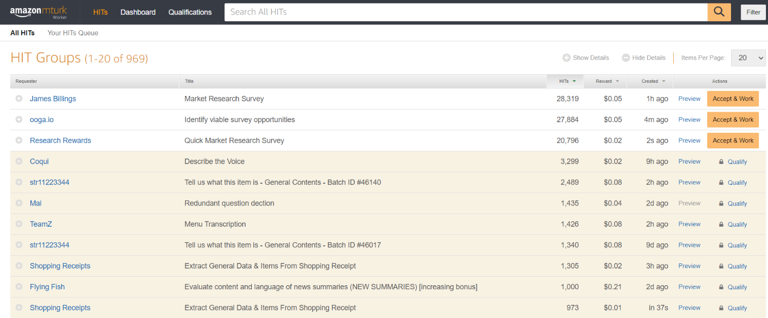

Figure 1. Example ad from previous study