Attachment A

Network Scale-Up Method (NSUM) Recruitment Ad

Platform ad
Survey description: This survey is about estimating the size of personal networks and certain populations in the United States.
Time allowed: 12 minutes
Expires: 08/30/2023
Qualifications required: Master Turker, Resides in U.S.
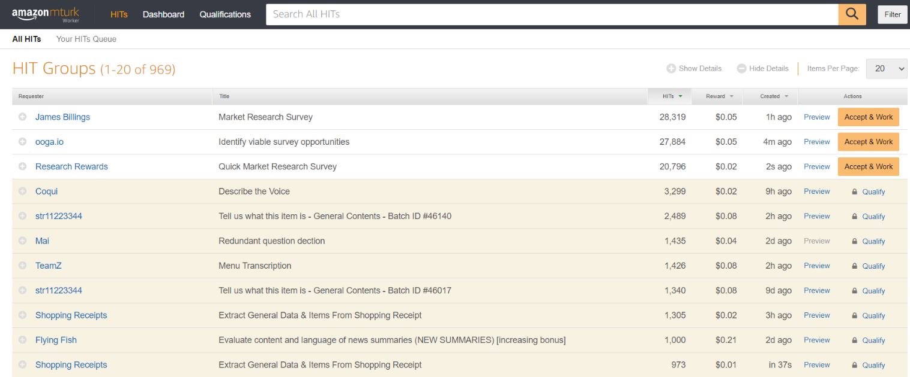
Figure 1. Example ad from previous study

