Project 141 QID 002009 |  |  | OMB No. 0535-0218 Approval Expires XX/XX/XXXX
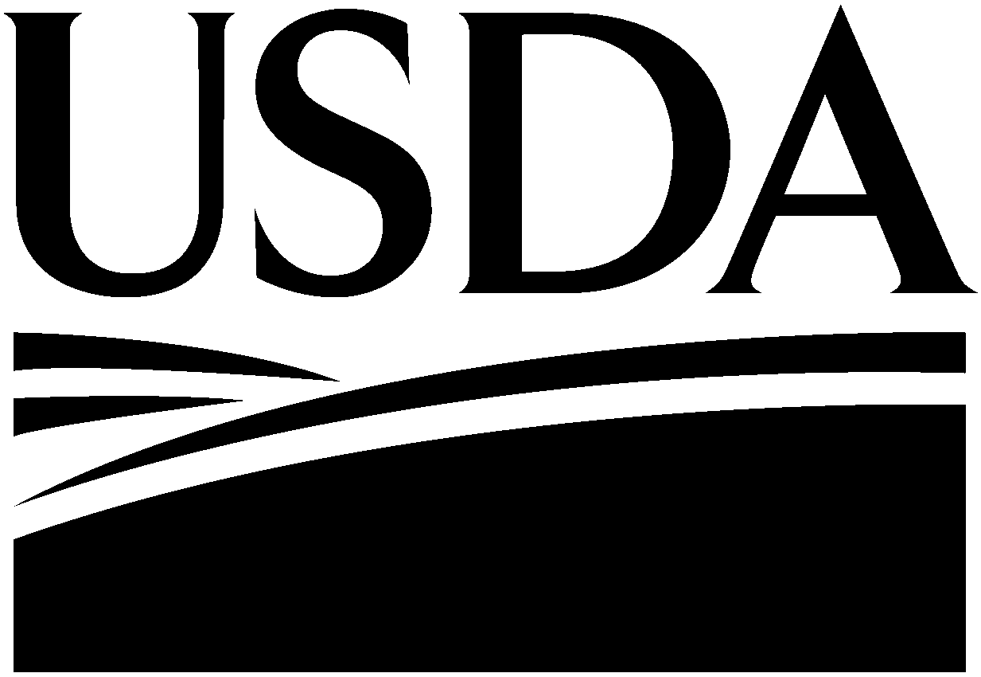 | 2019 Fruit Chemical Use Survey  Chemical Applications Consent Form |  |  |  | 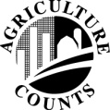 | NATIONAL  AGRICULTURAL  STATISTICS  SERVICE
U.S Department of Agriculture
Rm. 5030, South Building
1400 Independence Avenue, S.W.
Washington, D.C. 20250-2000
1-800-727-9540
Fax: 202-690-2090
Email: nass@nass.usda.gov

The National Agricultural Statistics Service (NASS) of the U.S. Department of Agriculture is conducting a survey of the Fruit Chemical Usage for the 2019 crop year. The survey will be conducted from October 2019 through January 2020.
By signing this Consent Form, the Owner agrees to allow the fruit caretaking company listed below to provide the necessary information for the completion of the Fruit Chemical Use Survey for the selected operation to the National Agricultural Statistics Service. All information provided is voluntary and held strictly confidential. Results of the survey, showing State and National level results for the selected fruit will be available at the end of July 2020.
 | Operation Name: | _____________________________________________________________________
 | Owner Name: | _____________________________________________________________________
 | Owner Address: | _____________________________________________________________________
 |  | _____________________________________________________________________
 | Owner Signature: | _____________________________________________________________________
 | Date: | _________________
 | Fruit Caretaking  Company Name: | _____________________________________________________________________
 | Fruit Caretaking  Company Address: | _____________________________________________________________________
 |  | _____________________________________________________________________
 | Phone Number: | _________________________________

NASDA Field Enumerator: ____________________________________________________

