ID: __________________________________________

State:

Enumerator:

Interview Date:

Operation Name:

Operator’s Name:

Address:

Telephone:

Survey Respondent: Current Respondent:

I am with the Agricultural Statistics Service. Recently you should have been contacted by one of our enumerators, Mr./Ms. , to obtain information about your operation. This telephone call is part of our survey quality assurance measures, to verify that personal contact was actually made with you for that purpose. Your response is voluntary and not required by law, but your cooperation will be appreciated. Facts about your farm or ranch will be kept confidential. This survey is conducted in accordance with the Confidential Information Protection and Statistical Efficiency Act of 2018, Title III of Pub. L. No. 115-435, codified in 44 U.S.C. Ch. 35 and other applicable Federal laws. For more information on how we protect your information please visit: https://www.nass.usda.gov/confidentiality. Will you help me by answering a few questions about the interview?

(If yes) Great, and are you the most knowledgeable person about the operation?
(If not most knowledgeable person) Can I speak to the most knowledgeable person of the operation?

These questions will take about 5 minutes.

Animals and products on other people’s farms under Production Contracts

All animals (and products like eggs) on your company farm(s) should be reported on the 20xx Certified Organic Production Survey questionnaire in Section 10. Do not report on the questionnaire any animal that you own but have contracted the production to someone else.

Animals and products that your company owns and is on someone else’s farm on a production contract should be reported on the next page.

Certified organic __________________________________on your production contract farms.

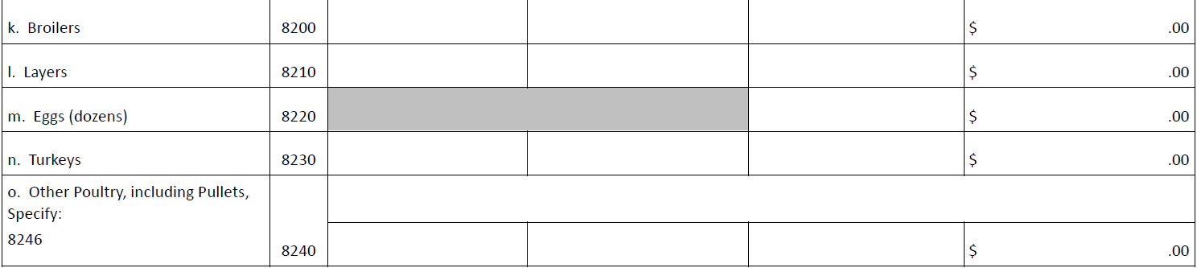

- What was the total number of certified organic ___________________________handled or controlled by your company on all farms during 20xx? _________________________

Thank you for your response.

