Attachment G.3: Study Overview Sheet for Focus Group Participants

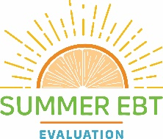
Summer Electronic Benefit Transfer for Children
Evaluation Overview for Parents/Caregivers

OMB Control No.: 0584-0524
Expiration Date: 12/31/2022

The Evaluation of the Summer Electronic Benefit Transfer (EBT) Project is a study to learn about how the Summer EBT project helps families feed children during the summer months. We are collecting information on how EBT benefits are used, and will be talking to families, project staff (SFAs and State officials), and local businesses to learn about their experiences with the project to help improve the project. The study is building on previous research that showed that Summer EBT improved access to healthy food during the summer months, when schools are closed.

What is the Summer Electronic Benefits Transfer (EBT) Project? The Summer Electronic Benefits Transfer Project offers school-aged children eligible for free and reduced priced meals during the school year with $30 per month of the summer to purchase healthy foods from local stores. To help reduce the number of children that do not have access to food during the summers, the Food Nutrition Service (FNS) of the United States Department of Agriculture (USDA) funded four States and Indian Tribal Organizations to provide food assistance to children eligible for free for free and reduced-price school meals during the summer when those school meal programs do not usually operate. The project will operate in certain parts of Michigan, Chickasaw Nation, Wisconsin and the Inter Tribal Council of Arizona (ITCA) from 2019-2022.

States/Tribal Organizations running the project use the Supplementation Nutrition Assistance Program (SNAP) or Supplemental Nutrition Program for Women, Infants and Children (WIC) EBT systems to issue benefits for the Summer EBT

Grantee | EBT System
Chickasaw Nation | WIC
Inter Tribal Council of Arizona (ITCA) | WIC
Michigan | WIC
Wisconsin | SNAP

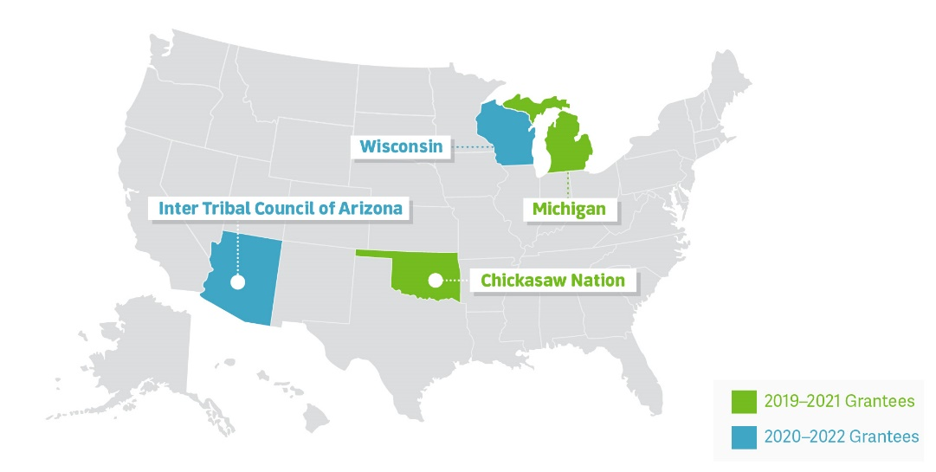
Where and when is the study taking place?
We will be talking to parents/caregivers in Chickasaw Nation and Michigan from 2019-2021 and ITCA and Wisconsin from 2020-2022.

If you would like to share your experience contact _____ at ______
or ____________.
Pandemic Note: We will participate with appropriate social distancing protocols in place, or you may choose to attend virtually

REVERSE SIDE OF FLYER

The Food and Nutrition Service (FNS) is conducting this study to obtain information about the experiences of the Summer Electronic Benefit Transfer (EBT) Project by grantees, retailers, school districts and participants. Participation in this study is voluntary and the information collected will be used to understand how Summer EBT projects are implemented in varying settings. This study does not collect personally identifiable information. Information collected in this study will be kept private to the full extent permitted by law. According to the Paperwork Reduction Act of 1995, an agency may not conduct or sponsor, and a person is not required to respond to, a collection of information unless it displays a valid OMB control number. The valid OMB control number for this information collection is 0584-0524. The time required to provide this information collection is estimated to average 1 minute per response, including the time to review instructions, search existing data resources, gather and maintain the data needed, and complete and review the collection of information. Send comments regarding this burden estimate or any other aspect of this collection of information, including suggestions for reducing this burden, to: USDA/Food and Nutrition Service, Office of Policy Support, 1320 Braddock Place, 5th Floor, Alexandria, VA 22314 ATTN: PRA (0584-0524).

