G11. Parent Confirmation of Enrollment (Infants)
This page has been left blank for double-sided copying.

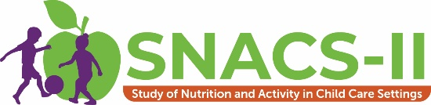
Parent Confirmation of Enrollment Letter – Parent of Infant
Thank you for agreeing to participate in the second Study of Nutrition and Activity in Child Care Settings (SNACS-II). Your participation will make a difference!
How to contact us:
WEBSITE: [study website]; enter passcode [passcode]
PHONE: [STUDY TOLL-FREE #] (toll-free)
EMAIL: [STUDY EMAIL ADDRESS]
The Food and Nutrition Service (FNS) is collecting this information to understand the nutritional quality of CACFP meals and snacks, the cost to produce them, and dietary intakes and activity levels of CACFP participants. This is a voluntary collection and FNS will use the information to examine CACFP operations. The collection does request personally identifiable information under the Privacy Act of 1974. Responses will be kept private to the extent provided by law and FNS regulations. According to the Paperwork Reduction Act of 1995, an agency may not conduct or sponsor, and a person is not required to respond to, a collection of information unless it displays a valid OMB control number. The valid OMB control number for this information collection is 0584-xxxx. The time required to complete this information collection is estimated to average 0.0167 hours (1 minute) per response, including the time for reviewing instructions, searching existing data sources, gathering and maintaining the data needed, and completing and reviewing the collection of information. Send comments regarding this burden estimate or any other aspect of this collection of information, including suggestions for reducing this burden, to: U.S. Department of Agriculture, Food and Nutrition Service, Office of Policy Support, 1320 Braddock Place, 5th Floor, Alexandria, VA 22314. ATTN: PRA (0584-xxxx). Do not return the completed form to this address.

