F11. Menu Survey

This page has been left blank for double-sided copying.

OMB Number: 0584-XXXX
Expiration Date: XX/XX/20XX

Study of Nutrition and Activity in Child Care Settings II (SNACS-II)
Menu Survey

Child Care Site ID
Target Week

The Food and Nutrition Service (FNS) is collecting this information to understand the nutritional quality of CACFP meals and snacks, the cost to produce them, and dietary intakes and activity levels of CACFP participants. This is a voluntary collection and FNS will use the information to examine CACFP operations. The collection does request personally identifiable information under the Privacy Act of 1974. Responses will be kept private to the extent provided by law and FNS regulations. According to the Paperwork Reduction Act of 1995, an agency may not conduct or sponsor, and a person is not required to respond to, a collection of information unless it displays a valid OMB control number. The valid OMB control number for this information collection is 0584-xxxx. The time required to complete this information collection is estimated to average 2.00 hours (120 minutes) per response, including the time for reviewing instructions, searching existing data sources, gathering and maintaining the data needed, and completing and reviewing the collection of information. Send comments regarding this burden estimate or any other aspect of this collection of information, including suggestions for reducing this burden, to: U.S. Department of Agriculture, Food and Nutrition Service, Office of Policy Support, 1320 Braddock Place, 5th Floor, Alexandria, VA 22314. ATTN: PRA (0584-xxxx). Do not return the completed form to this address.

This page intentionally left blank
About the Study. The second Study of Nutrition and Activity in Child Care Settings (SNACS-II) will look at the nutrition and wellness policies and activities in child care centers, family child care homes, and before and after school programs across the country. This important study will help providers, sponsors, and USDA understand how the Child and Adult Care Food Program (CACFP) operates so that it can better help children learn and grow. SNACS-II will provide an updated picture of the CACFP and examine how key outcomes have changed since updated meal pattern requirements went into effect to encourage healthier eating. Mathematica and its partner, Westat, are conducting SNACS-II for USDA.
About this Survey. The purpose of the Menu Survey is to collect information about all of the foods served to children in your child care program during the assigned target week. You will receive $50 to thank you for your time completing the Menu Survey. If your program also serves foods to infants (less than 12 months), you will also be asked to complete the Infant Menu Survey.
Protecting Privacy. Information gathered for SNACS-II is for research purposes only and will be kept private to the full extent allowed by law. Responses will be grouped together. No programs, staff, parents, or children will be identified by name. Being part of the study will not affect CACFP benefits for programs or families.
Questions. If you have questions about the study, please call us toll-free at [study phone], email us at [study email], or visit [study URL].

Thank you for participating in SNACS-II.
This page intentionally left blank
Menu Survey Overview
This survey should be completed by the person most familiar with food preparation at your child care center or home. In some child care settings, there is one person who prepares the food and a different person who provides care for the children. We would like the food preparer to complete the Menu Survey by providing information about what food is prepared and how it is prepared.
This booklet is divided into the following sections:
Tab 1: Menu Survey Instructions – Please read all the instructions before you begin completing the forms.
Tab 2: Daily Menu Forms – Each day of the target week is marked with a colored divider page for Monday, Tuesday, Wednesday, Thursday, and Friday. The section for each day includes a set of Daily Menu Forms – one page for each type of meal or snack you may serve for that day. You may not need all the pages, but we have provided them in case you do. Monday’s section also includes sample completed forms that may be useful to review before completing your own forms.
Tab 3: Foods You Prepared Forms – You will use these forms to tell us more about foods you prepare by combining two or more ingredients.
Tab 4: Food Description Guide – Please review this guidance for what details to include about each food you list on the Daily Menu Forms.

This page intentionally left blank
Menu Survey Instructions

This page intentionally left blank
Menu Survey Instructions
Please complete the Menu Survey during your specified target week, which is shown on the front of this booklet.
You will complete the Daily Menu Forms each day of your target week to describe all foods and drinks that you serve to children in meals and snacks each day.
Instructions for completing the Menu Survey are given below. Looking at examples of completed forms as you read through the instructions will make it easier to understand what you need to do when filling out the forms.
Please read all of the instructions and review the examples before you begin.
Someone from Mathematica will be calling you soon to make sure you received the survey and to answer any questions you may have before your target week begins.
Printed Menu: If available, we also ask that you provide a copy of your weekly or monthly menu that you may provide to parents. Please include this when you return your completed Menu Survey.
When you have completed your Menu Survey, please double-check your work to make sure you have provided all necessary information. Then, place your completed forms and a copy of your printed menu in the pre-addressed envelope to return the forms to Mathematica.
If you have any questions, please call our toll-free number at [insert TA study phone number] or email [insert TA email address]. We will be happy to answer your questions and to help you in any way we can.
Thank you very much for your help with this important study!

How To Fill Out The Daily Menu Forms
(Tab 2 of this booklet)
- Each day of your target week, you will fill out the pages in the section of the booklet marked with the name of that day: Monday, Tuesday, Wednesday, Thursday, and Friday (colored divider page will indicate a new day).
Each daily section within the colored dividers includes a Daily Menu Form for each meal and snack:
- Breakfast
- Morning Snack
- Lunch
- Afternoon Snack
- Supper
- You will use a separate form for each meal or snack you serve on each day. The top of each form will look like the example below, with the name of the meal or snack listed at the top (this example is for breakfast).
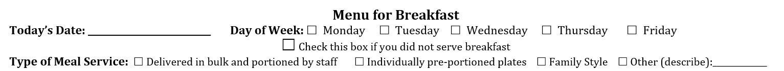

- On each form, please provide the Date and check the box for the corresponding Day of the Week.
- There is also an option to check off a box if you did not serve that meal or snack on that day. In the above example, if you did not serve breakfast that day, you would select this box and leave the rest of the form blank.

Checking this box will show us that you did not overlook filling in the daily menu for a meal.

- At the top of each page you will also specify the type of service used during that meal:

- Select Delivered in bulk and portioned by staff if large serving dishes are sent to the classroom or eating area and then staff portion the foods for children on individual plates or trays.
- Select Individually pre-portioned plates if individual plates or trays are sent to the classroom or eating area with foods already portioned for children, and staff pass out the plates or trays.
- Select Family Style if the serving dishes are placed on a community table at the beginning of the meal and children serve themselves.
- Select Other if you use a different method of service not described above. Please use the space provided to describe your meal service method.
Select the type of meal service that is used first during the meal. For example, if serving dishes are sent to the classroom or eating area and staff put food on the children’s plates at the beginning of the meal, but then children are allowed to take seconds on their own— this would be considered “Delivered in bulk and portioned by staff”.

Filling Out The Rest Of The Daily Menu Form:
For every meal and snack served each day, please fill in the form to tell us about all food and drink items that you served to children. Follow the instructions at the top of each column:
- List Each Food and Drink Served at this Meal.
- In this column, list each food and drink you served for that meal or snack.

- List each food or drink under the category it belongs to:
  - Milk
  - Fruits
  - Vegetables
  - Separate Grains/Bread
  - Meat/Meat Alternates and Mixed Component Foods
  - Other
- If you are unsure of which category a food you served belongs to, write it in the “Other” category.
- List each food or drink on a single row of the form, and be sure to list the foods as they are served to children. For example:
  - If you serve cereal and milk, you would list each item on separate rows in the appropriate sections (one row for milk and one row for cereal in the separate grains/bread section).
  - If you serve a turkey sandwich, you would list the sandwich on a single row (instead of listing out the bread and turkey on separate rows)
Do NOT include items parents bring from home.
Please only list foods and drinks provided to the majority of children in your care. If you prepare alternate meals for children with dietary restrictions, do not include these items on the Daily Menu Forms.
- Please Describe Each Food or Drink
- In this column, describe each food and drink in detail. Include details such as brand name or manufacturer and the type or flavor of the food.

- The “Food Description Guide” in Tab 4 lists the types of details that we need you to write down in this column for each food.
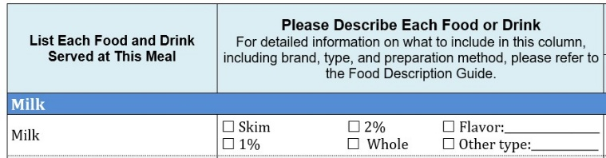
- For milk, check the box to indicate the type of milk served (skim, 1%, 2%, or whole) and list the flavor (for example, plain or chocolate). If you serve a different type of milk (for example, soy), you can check the box for “Other type” and list the type next to the checkbox.

- If any foods are whole grain-rich, check the box in addition to providing a description of the food.

- Water: If water is served specifically as a drink that goes with the meal or snack, rather than just being available in the room, please list it on the form under the “Other” category and describe how it was provided.

- If you receive foods that are prepared off-site (such as from a vendor or school district), please ask your representative if they can provide the necessary details about the foods you list on the Daily Menu Forms. We also ask that you complete the “Outside Vendor Representative: Contact Information” form (located at the beginning of Tab 2) to provide us with the representative’s contact information in case our study team needs further information during the processing of the data.
- Food Preparation: Foods You Prepared
If you made the food from scratch or prepared the food by combining two or more ingredients, check the corresponding box in this column.

- For foods where you check off the “Foods You Prepared” column, you will need to fill out a corresponding Foods You Prepared Form. More information for completing these forms is provided later in these instructions.
Please note that you do not need to complete the Foods You Prepared Form for any foods that need little or no preparation on your part, or for any foods that can be eaten as is (“ready to eat”). This includes foods that only need to be heated before serving or foods that only need to be cut, sliced, or poured before serving. For example, fresh fruits and vegetables that have been cut into pieces by staff do not require a Foods You Prepared Form.
The chart below provides examples of when to fill out a Foods You Prepared Form and when it is not needed.
Use the Foods You Prepared Form | DO NOT Use the Foods You Prepared Form
Rice prepared with butter and salt | Commercially prepared applesauce
Tacos with ground beef cooked with oil and seasonings | Frozen chicken nuggets (heated)
Leftover foods mixed with additional foods | Banana slices
Hot cereal with cinnamon and raisins | Packaged crackers
Turkey and cheese sandwich | Diced cheese
Macaroni and cheese made from scratch | Cold cereal served with milk

Important to Note:
- If you have a printed copy of the recipe, you can provide that instead of completing the Foods You Prepared Form. Please make sure the recipe includes all of the information requested on the Foods You Prepared Form. If it does not, add notes to your copy of the recipe so we have all the information that we need. If you make any changes to the recipe, write them directly on the recipe.
- If the food was prepared off-site (such as from a vendor or school district), please ask your representative if they can provide you with a copy of the recipe.
- Age Group(s) Served
- Use the checkboxes in this column to tell us the age group(s) of children that are served each food or drink. These correspond to the age groups in the CACFP meal patterns: 1-2 years, 3-5 years, 6-12 years, and 13-18 years.

- If a food or drink is served to children in multiple age groups, select all relevant groups that are served that item.
- If different types of the same food (for example, different types of cereal) were served to different age groups of children, you should list the different types of food on separate rows, and then select the age group receiving the specified type of food.
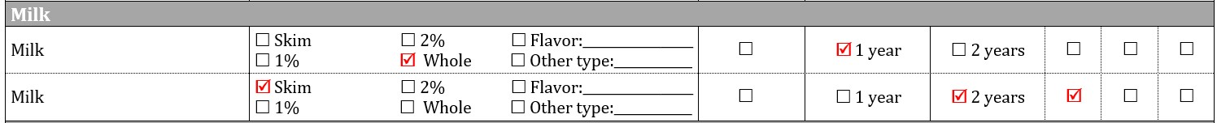
- For milk served to children in the 1-2 years age group, please check the separate boxes to tell us which milk was served to 1-year-olds versus 2-year-olds.

Examples of completed Daily Menu Forms for each meal and snack can be found in the section for Monday.
Filling Out The Foods You Prepared Form
(Tab 3 of this booklet)
Please fill out one of these forms for any food you checked off as Foods You Prepared on the Daily Menu Forms. This should include any foods you made from scratch or prepared by combining two or more foods or ingredients. Examples of completed Foods You Prepared Forms are also provided in Tab 3.
As a reminder, you can provide a printed copy of the recipe instead of completing a Foods You Prepared Form. Please make sure the copy of the recipe includes all of the information requested on the Foods You Prepared Form, including the name of the food and when it was served (both the name of the meal and the day of the week). If it does not, add notes to your copy of the recipe so we have all the information that we need. If you make any changes to the recipe when you actually prepare the food, please also note this on the copy of the recipe.
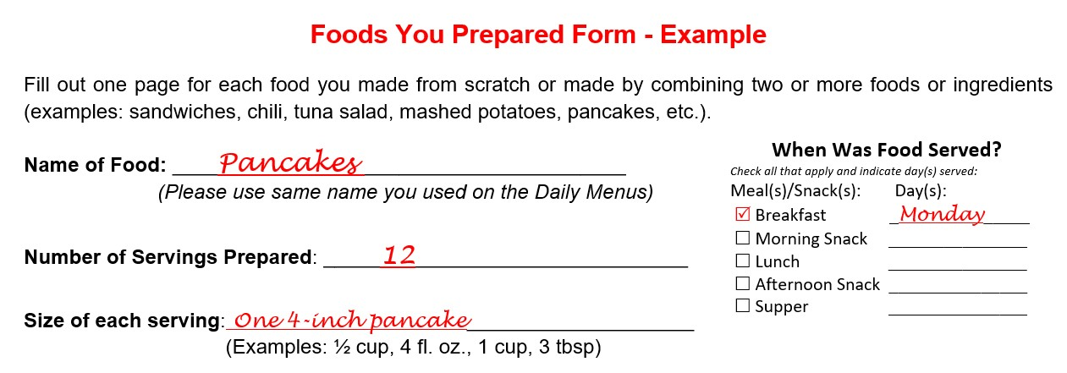
If you receive foods that are prepared off-site (such as from a vendor or school district), please ask your representative if they can provide you with a copy of their recipes for foods that they prepare from scratch or by combining two or more ingredients.
Fill out the top portion of the Foods You Prepared Form as follows:
1. Name of Food: Please use the same name for the food that you used on the Daily Menu Form.
2. Number of Servings Prepared: Write down the number of servings you prepared. In the example above, 12 servings of pancakes were prepared.
3. Size of each Serving: Write down the size of one serving (for example, ½ cup, 4 oz., 1 sandwich, etc.). In the example above, each serving was one 4-inch pancake.
4. When Was Food Served?: Check the box to indicate which meals or snacks the food was served at. Also write in the day(s) the food was served.
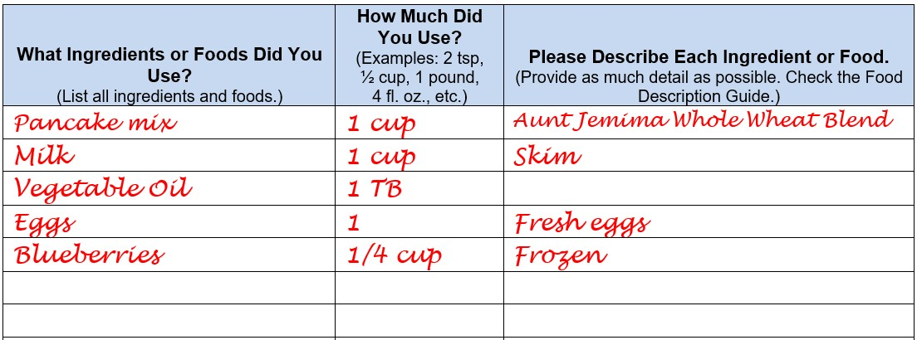
Fill in the chart using the instructions at the top of each column to describe the ingredients or foods used in the recipe.

- What Ingredients or Foods Did You Use?
- In this column, list each ingredient or food by name on a separate line. Include everything you used, including salt, water, stock, and added fats like butter, margarine, mayonnaise, and oil.
- How Much Did You Use?
- List the amount of each ingredient or food you used in the recipe. Be sure to write both the number and the type of measurement. For example:
  - 2 Tbsp. mayonnaise
  - 2 tsp. salt
  - 4 oz. shredded cheese
  - 2 lbs. lean ground beef
  - ¾ cup cooked rice
  - 1-qt. milk
- If you used an ingredient that is not measured, write down how much or many you used, or whether the item was small, regular (medium), or large. For example:
      - 1 large carrot
      - ½ large green pepper
      - 15 crackers (saltine size)
      - 3 small bananas
      - 2 regular slices of bread
      - 4 eggs

- Please Describe Each Ingredient or Food
- Use this column to describe each ingredient or food in detail. Look for the ingredient or food in the Food Description Guide to see the type of information to write for each ingredient or food (brand, type, flavor, etc.)
Fill out the bottom portion of the form as follows:
Preparation and Cooking Method (if Applicable)
- Answer questions 1, 2, and 3 if they apply to the food you prepared.
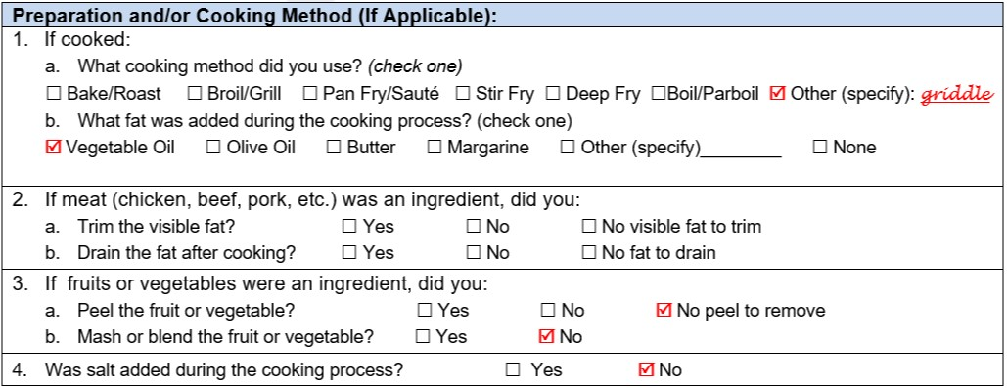
- Answer question 4 to tell us whether salt was added during the cooking process, such as salt added to cooking water, rather than as an ingredient in the recipe.

Daily Menu Forms

This page intentionally left blank
Outside Vendor Representative:
Contact Information
(If applicable)

If you receive foods that are prepared off-site (such as from a vendor or school district), please provide the vendor representative’s contact information below. We would like to collect their contact information in case our study team needs further information during the processing of the data.

Representative Name: _________________________________________________

Representative Title: __________________________________________________

Name of Company/Site/District: ________________________________________

Phone Number: ______________________________________________________

Email Address: _______________________________________________________

This page intentionally left blank
Monday
[Note: The blank Daily Menu Forms shown for Monday will repeat in the booklet for Tuesday-Friday.]

This page intentionally left blank
Example of Completed Menu Form for Breakfast
Today’s Date: __2/6/23___________ Day of Week: Monday Tuesday Wednesday Thursday Friday
Check this box if you did not serve breakfast
Type of Meal Service: Delivered in bulk and portioned by staff Individually pre-portioned plates Family Style Other (describe):_____________
List Each Food and Drink Served at This Meal | Please Describe Each Food or Drink  For detailed information on what to include in this column, including brand, type, and preparation method, please refer to the Food Description Guide. | Food Preparation | Age Group(s) Served  Select the age group(s) of children that are served the food or drink
 |  | Foods You Prepared* | 1-2  years |  | 3-5  years | 6-12  years | 13-18 years
Milk
Milk | Skim 2% Flavor:_________________  1% Whole Other type:____________ |  | 1 year | 2 years
Milk | Skim 2% Flavor:_________________  1% Whole Other type:____________ |  | 1 year | 2 years
Fruits
Applesauce | Motts: unsweetened
Orange | Fresh, slices
Vegetables
Separate Grains / Bread
Oatmeal | Quick oats, banana Whole grain-rich
Pancakes | Aunt Jemima, blueberry Whole grain-rich
 | Whole grain-rich
Meat/Meat Alternates and Mixed Component Foods
 | Whole grain-rich
 | Whole grain-rich
 | Whole grain-rich
 | Whole grain-rich
Other
 | Whole grain-rich
 | Whole grain-rich
 | Whole grain-rich

Menu for Breakfast
Today’s Date: ___________________________ Day of Week: Monday Tuesday Wednesday Thursday Friday
Check this box if you did not serve breakfast
Type of Meal Service: Delivered in bulk and portioned by staff Individually pre-portioned plates Family Style Other (describe):_____________
List Each Food and Drink Served at This Meal | Please Describe Each Food or Drink  For detailed information on what to include in this column, including brand, type, and preparation method, please refer to the Food Description Guide. | Food Preparation | Age Group(s) Served  Select the age group(s) of children that are served the food or drink
 |  | Foods You Prepared* | 1-2  years |  | 3-5  years | 6-12  years | 13-18 years
Milk
Milk | Skim 2% Flavor:_________________  1% Whole Other type:____________ |  | 1 year | 2 years
Milk | Skim 2% Flavor:_________________  1% Whole Other type:____________ |  | 1 year | 2 years
Fruits
Vegetables
Separate Grains / Bread
 | Whole grain-rich
 | Whole grain-rich
 | Whole grain-rich
Meat/Meat Alternates and Mixed Component Foods
 | Whole grain-rich
 | Whole grain-rich
 | Whole grain-rich
 | Whole grain-rich
Other
 | Whole grain-rich
 | Whole grain-rich
 | Whole grain-rich

Example of Completed Menu for Morning Snack
Today’s Date: __2/6/23____________ Day of Week: Monday Tuesday Wednesday Thursday Friday
Check this box if you did not serve a morning snack
Type of Meal Service: Delivered in bulk and portioned by staff Individually pre-portioned plates Family Style Other (describe):_____________
List Each Food and Drink Served at This Meal | Please Describe Each Food or Drink  For detailed information on what to include in this column, including brand, type, and preparation method, please refer to the Food Description Guide. | Food Preparation | Age Group(s) Served  Select the age group(s) of children that are served the food or drink
 |  | Foods You Prepared* | 1-2  years |  | 3-5  years | 6-12  years | 13-18 years
Milk
Milk | Skim 2% Flavor:_________________  1% Whole Other type:____________ |  | 1 year | 2 years
Milk | Skim 2% Flavor:_________________  1% Whole Other type:____________ |  | 1 year | 2 years
Fruits
Banana | Fresh, sliced
Vegetables
Separate Grains / Bread
 | Whole grain-rich
 | Whole grain-rich
 | Whole grain-rich
Meat/Meat Alternates and Mixed Component Foods
Yogurt | Stonyfield – whole milk, plain Whole grain-rich
 | Whole grain-rich
 | Whole grain-rich
 | Whole grain-rich
Other
 | Whole grain-rich
 | Whole grain-rich
 | Whole grain-rich

Menu for Morning Snack
Today’s Date: ___________________________ Day of Week: Monday Tuesday Wednesday Thursday Friday
Check this box if you did not serve a morning snack
Type of Meal Service: Delivered in bulk and portioned by staff Individually pre-portioned plates Family Style Other (describe):_____________
List Each Food and Drink Served at This Meal | Please Describe Each Food or Drink  For detailed information on what to include in this column, including brand, type, and preparation method, please refer to the Food Description Guide. | Food Preparation | Age Group(s) Served  Select the age group(s) of children that are served the food or drink
 |  | Foods You Prepared* | 1-2  years |  | 3-5  years | 6-12  years | 13-18 years
Milk
Milk | Skim 2% Flavor:_________________  1% Whole Other type:____________ |  | 1 year | 2 years
Milk | Skim 2% Flavor:_________________  1% Whole Other type:____________ |  | 1 year | 2 years
Fruits
Vegetables
Separate Grains / Bread
 | Whole grain-rich
 | Whole grain-rich
 | Whole grain-rich
Meat/Meat Alternates and Mixed Component Foods
 | Whole grain-rich
 | Whole grain-rich
 | Whole grain-rich
 | Whole grain-rich
Other
 | Whole grain-rich
 | Whole grain-rich
 | Whole grain-rich

Example of Completed Menu for Lunch
Today’s Date: __2/6/23____________ Day of Week: Monday Tuesday Wednesday Thursday Friday
Check this box if you did not serve lunch
Type of Meal Service: Delivered in bulk and portioned by staff Individually pre-portioned plates Family Style Other (describe):_____________
List Each Food and Drink Served at This Meal | Please Describe Each Food or Drink  For detailed information on what to include in this column, including brand, type, and preparation method, please refer to the Food Description Guide. | Food Preparation | Age Group(s) Served  Select the age group(s) of children that are served the food or drink
 |  | Foods You Prepared* | 1-2  years |  | 3-5  years | 6-12  years | 13-18 years
Milk
Milk | Skim 2% Flavor:_________________  1% Whole Other type:____________ |  | 1 year | 2 years
Milk | Skim 2% Flavor:_________________  1% Whole Other type:____________ |  | 1 year | 2 years
Fruits
Apple | Granny Smith, sliced
Vegetables
Broccoli | Spears, steamed
Separate Grains / Bread
 | Whole grain-rich
 | Whole grain-rich
 | Whole grain-rich
Meat/Meat Alternates and Mixed Component Foods
Quesadilla | Black bean and cheese Whole grain-rich
 | Whole grain-rich
 | Whole grain-rich
 | Whole grain-rich
Other
Water | From tap, in drinking cups Whole grain-rich
 | Whole grain-rich
 | Whole grain-rich

Menu for Lunch
Today’s Date: ___________________________ Day of Week: Monday Tuesday Wednesday Thursday Friday
Check this box if you did not serve lunch
Type of Meal Service: Delivered in bulk and portioned by staff Individually pre-portioned plates Family Style Other (describe):_____________
List Each Food and Drink Served at This Meal | Please Describe Each Food or Drink  For detailed information on what to include in this column, including brand, type, and preparation method, please refer to the Food Description Guide. | Food Preparation | Age Group(s) Served  Select the age group(s) of children that are served the food or drink
 |  | Foods You Prepared* | 1-2  years |  | 3-5  years | 6-12  years | 13-18 years
Milk
Milk | Skim 2% Flavor:_________________  1% Whole Other type:____________ |  | 1 year | 2 years
Milk | Skim 2% Flavor:_________________  1% Whole Other type:____________ |  | 1 year | 2 years
Fruits
Vegetables
Separate Grains / Bread
 | Whole grain-rich
 | Whole grain-rich
 | Whole grain-rich
Meat/Meat Alternates and Mixed Component Foods
 | Whole grain-rich
 | Whole grain-rich
 | Whole grain-rich
 | Whole grain-rich
Other
 | Whole grain-rich
 | Whole grain-rich
 | Whole grain-rich

Example of Completed Menu for Afternoon Snack
Today’s Date: __2/6/23____________ Day of Week: Monday Tuesday Wednesday Thursday Friday
Check this box if you did not serve an afternoon snack
Type of Meal Service: Delivered in bulk and portioned by staff Individually pre-portioned plates Family Style Other (describe):_____________
List Each Food and Drink Served at This Meal | Please Describe Each Food or Drink  For detailed information on what to include in this column, including brand, type, and preparation method, please refer to the Food Description Guide. | Food Preparation | Age Group(s) Served  Select the age group(s) of children that are served the food or drink
 |  | Foods You Prepared* | 1-2  years |  | 3-5  years | 6-12  years | 13-18 years
Milk
Milk | Skim 2% Flavor:_________________  1% Whole Other type:____________ |  | 1 year | 2 years
Milk | Skim 2% Flavor:_________________  1% Whole Other type:____________ |  | 1 year | 2 years
Fruits
Vegetables
Carrots | Baby carrots, fresh, lightly steamed
Separate Grains / Bread
Goldfish | Pepperidge Farm, cheddar Whole grain-rich
 | Whole grain-rich
 | Whole grain-rich
Meat/Meat Alternates and Mixed Component Foods
 | Whole grain-rich
 | Whole grain-rich
 | Whole grain-rich
 | Whole grain-rich
Other
Ranch dip | Kraft reduced fat Whole grain-rich
Water | From tap, in drinking cups Whole grain-rich
 | Whole grain-rich

Menu for Afternoon Snack
Today’s Date: ___________________________ Day of Week: Monday Tuesday Wednesday Thursday Friday
Check this box if you did not serve an afternoon snack
Type of Meal Service: Delivered in bulk and portioned by staff Individually pre-portioned plates Family Style Other (describe):_____________
List Each Food and Drink Served at This Meal | Please Describe Each Food or Drink  For detailed information on what to include in this column, including brand, type, and preparation method, please refer to the Food Description Guide. | Food Preparation | Age Group(s) Served  Select the age group(s) of children that are served the food or drink
 |  | Foods You Prepared* | 1-2  years |  | 3-5  years | 6-12  years | 13-18 years
Milk
Milk | Skim 2% Flavor:_________________  1% Whole Other type:____________ |  | 1 year | 2 years
Milk | Skim 2% Flavor:_________________  1% Whole Other type:____________ |  | 1 year | 2 years
Fruits
Vegetables
Separate Grains / Bread
 | Whole grain-rich
 | Whole grain-rich
 | Whole grain-rich
Meat/Meat Alternates and Mixed Component Foods
 | Whole grain-rich
 | Whole grain-rich
 | Whole grain-rich
 | Whole grain-rich
Other
 | Whole grain-rich
 | Whole grain-rich
 | Whole grain-rich

Example of Completed Menu for Supper
Today’s Date: __2/6/23____________ Day of Week: Monday Tuesday Wednesday Thursday Friday
Check this box if you did not serve supper
Type of Meal Service: Delivered in bulk and portioned by staff Individually pre-portioned plates Family Style Other (describe):_____________
List Each Food and Drink Served at This Meal | Please Describe Each Food or Drink  For detailed information on what to include in this column, including brand, type, and preparation method, please refer to the Food Description Guide. | Food Preparation | Age Group(s) Served  Select the age group(s) of children that are served the food or drink
 |  | Foods You Prepared* | 1-2  years |  | 3-5  years | 6-12  years | 13-18 years
Milk
Milk | Skim 2% Flavor:_________________  1% Whole Other type:____________ |  | 1 year | 2 years
Milk | Skim 2% Flavor:_________________  1% Whole Other type:____________ |  | 1 year | 2 years
Fruits
Grapes | Red grapes, sliced, fresh
Pear | Diced, peeled, fresh
Vegetables
Mixed vegetables | Canned, mix of carrots, peas, cauliflower
Separate Grains / Bread
Dinner roll | Bake Crafters, split top, wheat Whole grain-rich
 | Whole grain-rich
 | Whole grain-rich
Meat/Meat Alternates and Mixed Component Foods
Chicken nuggets | Tyson: Home-Style, baked Whole grain-rich
 | Whole grain-rich
 | Whole grain-rich
 | Whole grain-rich
Other
BBQ sauce | Kraft Original, served with nuggets Whole grain-rich
Water | From tap, in drinking cups Whole grain-rich
 | Whole grain-rich

Menu for Supper
Today’s Date: ___________________________ Day of Week: Monday Tuesday Wednesday Thursday Friday
Check this box if you did not serve supper
Type of Meal Service: Delivered in bulk and portioned by staff Individually pre-portioned plates Family Style Other (describe):_____________
List Each Food and Drink Served at This Meal | Please Describe Each Food or Drink  For detailed information on what to include in this column, including brand, type, and preparation method, please refer to the Food Description Guide. | Food Preparation | Age Group(s) Served  Select the age group(s) of children that are served the food or drink
 |  | Foods You Prepared* | 1-2  years |  | 3-5  years | 6-12  years | 13-18 years
Milk
Milk | Skim 2% Flavor:_________________  1% Whole Other type:____________ |  | 1 year | 2 years
Milk | Skim 2% Flavor:_________________  1% Whole Other type:____________ |  | 1 year | 2 years
Fruits
Vegetables
Separate Grains / Bread
 | Whole grain-rich
 | Whole grain-rich
 | Whole grain-rich
Meat/Meat Alternates and Mixed Component Foods
 | Whole grain-rich
 | Whole grain-rich
 | Whole grain-rich
 | Whole grain-rich
Other
 | Whole grain-rich
 | Whole grain-rich
 | Whole grain-rich

Tuesday

This page intentionally left blank
Wednesday

This page intentionally left blank
Thursday

This page intentionally left blank
Friday

This page intentionally left blank
Foods You Prepared Forms

Please fill out a Foods You Prepared Form for any food items where you placed a check mark in the “Food Preparation” column on your Daily Menu Forms. See the Menu Survey Instructions for more information.
Note: If have a printed copy of the recipe, you can provide that instead of completing the Foods You Prepared Form. Please make sure the recipe includes all of the information requested on the Foods You Prepared Form. If it does not, add notes to your copy of the recipe so we have all the information that we need. If you make any changes to the recipe, write them directly on the recipe.

This page intentionally left blank

Foods You Prepared Form - Example
Fill out one form for each food you made from scratch or made by combining two or more foods or ingredients (examples: sandwiches, chili, tuna salad, mashed potatoes, pancakes, etc.).
When Was Food Served?
Check all that apply and indicate day(s) served:
Meal(s)/Snack(s): Day(s):
Breakfast _Monday_____
Morning Snack _______________
Lunch _______________
Afternoon Snack _______________
Supper _______________
Name of Food: ____Pancakes _______________________
(Please use same name you used on the Daily Menu Forms)
Number of Servings Prepared: _____12________________________
Size of each serving: One 4-inch pancake____________________
(Examples: ½ cup, 4 fl. oz., 1 cup, 3 tbsp)
What Ingredients or Foods Did You Use?  (List all ingredients and foods.) | How Much Did You Use?  (Examples: 2 tsp, ½ cup, 1 pound,  4 fl. oz., etc.) | Please Describe Each Ingredient or Food.  (Provide as much detail as possible. Check the Food Description Guide.)
Pancake mix | 1 cup | Aunt Jemima Whole Wheat Blend
Milk | 1 cup | Skim
Vegetable Oil | 1 TB
Eggs | 1 | Fresh eggs
Blueberries | 1/4 cup | Frozen

Preparation and/or Cooking Method (If Applicable):
1. If cooked:
a. What cooking method did you use? (check one)
Bake/Roast Broil/Grill Pan Fry/Sauté Stir Fry Deep Fry Boil/Parboil Other (specify): griddle
b. What fat was added during the cooking process? (check one)
Vegetable Oil Olive Oil Butter Margarine Other (specify)________ None
2. If meat (chicken, beef, pork, etc.) was an ingredient, did you:
a. Trim the visible fat? Yes No No visible fat to trim
b. Drain the fat after cooking? Yes No No fat to drain
3. If fruits or vegetables were an ingredient, did you:
- a. Peel the fruit or vegetable? Yes No No peel to remove
- b. Mash or blend the fruit or vegetable? Yes No
4. Was salt added during the cooking process? Yes No

Foods You Prepared Form - Example
Fill out one form for each food you made from scratch or made by combining two or more foods or ingredients (examples: sandwiches, chili, tuna salad, mashed potatoes, pancakes, etc.).
When Was Food Served?
Check all that apply and indicate day(s) served:
Meal(s)/Snack(s): Day(s):
Breakfast _Monday_____
Morning Snack _______________
Lunch _______________
Afternoon Snack _______________
Supper _______________
Name of Food: ____Oatmeal _______________________
(Please use same name you used on the Daily Menu Forms)
Number of Servings Prepared: _____12____________________
Size of each serving: ________ 1/4 cup ___________________
(Examples: ½ cup, 4 fl. oz., 1 cup, 3 tbsp)
What Ingredients or Foods Did You Use?  (List all ingredients and foods.) | How Much Did You Use?  (Examples: 2 tsp, ½ cup, 1 pound,  4 fl. oz., etc.) | Please Describe Each Ingredient or Food.  (Provide as much detail as possible. Check the Food Description Guide.)
Whole grain oats | 1 1/2 cups | Quaker Oats – Old Fashioned Oats
Water | 3 cups
Salt | 1/4 tsp
Banana | 1 medium | Fresh, mashed

Preparation and/or Cooking Method (If Applicable):
1. If cooked:
a. What cooking method did you use? (check one)
Bake/Roast Broil/Grill Pan Fry/Sauté Stir Fry Deep Fry Boil/Parboil Other (specify): _______
b. What fat was added during the cooking process? (check one)
Vegetable Oil Olive Oil Butter Margarine Other (specify)________ None
2. If meat (chicken, beef, pork, etc.) was an ingredient, did you:
a. Trim the visible fat? Yes No No visible fat to trim
b. Drain the fat after cooking? Yes No No fat to drain
3. If fruits or vegetables were an ingredient, did you:
- a. Peel the fruit or vegetable? Yes No No peel to remove
- b. Mash or blend the fruit or vegetable? Yes No
4. Was salt added during the cooking process? Yes No

Foods You Prepared Form - Example
Fill out one form for each food you made from scratch or made by combining two or more foods or ingredients (examples: sandwiches, chili, tuna salad, mashed potatoes, pancakes, etc.).
When Was Food Served?
Check all that apply and indicate day(s) served:
Meal(s)/Snack(s): Day(s):
Breakfast _Monday_____
Morning Snack _______________
Lunch _______________
Afternoon Snack _______________
Supper _______________
Name of Food: ____Quesadilla ________________________
(Please use same name you used on the Daily Menu Forms)
Number of Servings Prepared: _____24________________________
Size of each serving: 1/2 of a 9-inch tortilla________________
(Examples: ½ cup, 4 fl. oz., 1 cup, 3 tbsp)
What Ingredients or Foods Did You Use?  (List all ingredients and foods.) | How Much Did You Use?  (Examples: 2 tsp, ½ cup, 1 pound,  4 fl. oz., etc.) | Please Describe Each Ingredient or Food.  (Provide as much detail as possible. Check the Food Description Guide.)
Tortillas | 12 9-inch | Mission – whole wheat original
Cheddar cheese | 2 1/2 cups | Kraft – natural cheese, Mexican style
Black beans | 1 can (15 oz.) | Goya – low sodium, drained, rinsed

Preparation and/or Cooking Method (If Applicable):
1. If cooked:
a. What cooking method did you use? (check one)
Bake/Roast Broil/Grill Pan Fry/Sauté Stir Fry Deep Fry Boil/Parboil Other (specify):_______
b. What fat was added during the cooking process? (check one)
Vegetable Oil Olive Oil Butter Margarine Other (specify)________ None
2. If meat (chicken, beef, pork, etc.) was an ingredient, did you:
a. Trim the visible fat? Yes No No visible fat to trim
b. Drain the fat after cooking? Yes No No fat to drain
3. If fruits or vegetables were an ingredient, did you:
- a. Peel the fruit or vegetable? Yes No No peel to remove
- b. Mash or blend the fruit or vegetable? Yes No
4. Was salt added during the cooking process? Yes No

Foods You Prepared Form
Fill out one form for each food you made from scratch or made by combining two or more foods or ingredients (examples: sandwiches, chili, tuna salad, mashed potatoes, pancakes, etc.).
When Was Food Served?
Check all that apply and indicate day(s) served:
Meal(s)/Snack(s): Day(s):
Breakfast _______________
Morning Snack _______________
Lunch _______________
Afternoon Snack _______________
Supper _______________
Name of Food: _____________________________________________
(Please use same name you used on the Daily Menu Forms)
Number of Servings Prepared: ________________________________
Size of each serving: ________________________________
(Examples: ½ cup, 4 fl. oz., 1 cup, 3 tbsp)
What Ingredients or Foods Did You Use?  (List all ingredients and foods.) | How Much Did You Use?  (Examples: 2 tsp, ½ cup, 1 pound,  4 fl. oz., etc.) | Please Describe Each Ingredient or Food.  (Provide as much detail as possible. Check the Food Description Guide.)

Preparation and Cooking Method (If Applicable):
1. If cooked:
a. What cooking method did you use? (check one)
Bake/Roast Broil/Grill Pan Fry/Sauté Stir Fry Deep Fry Boil/Parboil Other (specify): _______
b. What fat was added during the cooking process? (check one)
Vegetable Oil Olive Oil Butter Margarine Other (specify)________ None
2. If meat (chicken, beef, pork, etc.) was an ingredient, did you:
a. Trim the visible fat? Yes No No visible fat to trim
b. Drain the fat after cooking? Yes No No fat to drain
3. If fruits or vegetables were an ingredient, did you:
- a. Peel the fruit or vegetable? Yes No No peel to remove
- b. Mash or blend the fruit or vegetable? Yes No
4. Was salt added during the cooking process? Yes No

