F17. Infant Intake Form

This page has been left blank for double-sided copying.

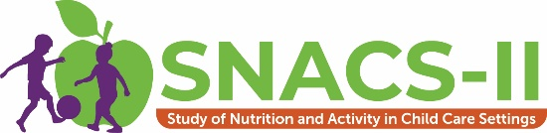
OMB Number: 0584-XXXX
Expiration Date: XX/XX/20XX

The Food and Nutrition Service (FNS) is collecting this information to understand the nutritional quality of CACFP meals and snacks, the cost to produce them, and dietary intakes and activity levels of CACFP participants. This is a voluntary collection and FNS will use the information to examine CACFP operations. The collection does request personally identifiable information under the Privacy Act of 1974. Responses will be kept private to the extent provided by law and FNS regulations. According to the Paperwork Reduction Act of 1995, an agency may not conduct or sponsor, and a person is not required to respond to, a collection of information unless it displays a valid OMB control number. The valid OMB control number for this information collection is 0584-xxxx. The time required to complete this information collection is estimated to average 0.6346 hours (38 minutes) per response, including the time for reviewing instructions, searching existing data sources, gathering and maintaining the data needed, and completing and reviewing the collection of information. Send comments regarding this burden estimate or any other aspect of this collection of information, including suggestions for reducing this burden, to: U.S. Department of Agriculture, Food and Nutrition Service, Office of Policy Support, 1320 Braddock Place, 5th Floor, Alexandria, VA 22314. ATTN: PRA (0584-xxxx). Do not return the completed form to this address.

Study on Nutrition and Activity in
Child Care Settings II (SNACS-II)
Infant Intake Forms

Please complete this booklet for the following infants:
- ___________________________ Child ID #: | | | | | | |
- ___________________________ Child ID #: | | | | | | |
- ___________________________ Child ID #: | | | | | | |
- ___________________________ Child ID #: | | | | | | |

Infant Caregiver Initials: | | |

The Food and Nutrition Service (FNS) is collecting this information to understand the nutritional quality of CACFP meals and snacks, the cost to produce them, and dietary intakes and activity levels of CACFP participants. This is a voluntary collection and FNS will use the information to examine CACFP operations. The collection does request personally identifiable information under the Privacy Act of 1974. Responses will be kept private to the extent provided by law and FNS regulations. According to the Paperwork Reduction Act of 1995, an agency may not conduct or sponsor, and a person is not required to respond to, a collection of information unless it displays a valid OMB control number. The valid OMB control number for this information collection is 0584-xxxx. The time required to complete this information collection is estimated to average 0.6346 hours (38 minutes) per response, including the time for reviewing instructions, searching existing data sources, gathering and maintaining the data needed, and completing and reviewing the collection of information. Send comments regarding this burden estimate or any other aspect of this collection of information, including suggestions for reducing this burden, to: U.S. Department of Agriculture, Food and Nutrition Service, Office of Policy Support, 1320 Braddock Place, 5th Floor, Alexandria, VA 22314. ATTN: PRA (0584-xxxx). Do not return the completed form to this address.

This page has been left blank for double-sided copying
About the Study. The second Study of Nutrition and Activity in Child Care Settings (SNACS-II) will look at the nutrition and wellness policies and activities in child care centers, family child care homes, and before-and-after-school programs across the country. This important study will help providers, sponsors, and USDA understand how the Child and Adult Care Food Program (CACFP) operates so that it can better help children learn and grow. SNACS-II will provide an updated picture of the CACFP and examine how key outcomes have changed since updated meal pattern requirements went into effect to encourage healthier eating. Mathematica and its partner, Westat, are conducting SNACS-II for USDA. We’ve obtained permission from parents/guardians to collect information about their infant.
About this Booklet. The purpose of the Infant Intake Form is to collect information for the selected infants about the foods, formula, breast milk, and drinks that they consumed in your care for one day. The forms should be filled out by the infant care provider. After completing the forms, they will receive a book as a thank you for participating. If forms are completed for 3 or more infants, multiple books will be provided.
Protecting Privacy. Information gathered for SNACS-II is for research purposes only and will be kept private to the full extent allowed by law. Responses will be grouped together. No staff, parents/guardians, or children will be identified by name. Being part of the study will not affect CACFP benefits for programs or families.
Questions. If you have questions about the study, please call us toll-free at [study phone], email us at [study email], or visit [study URL].

Thank you for participating in SNACS-II.

This page has been left blank for double-sided copying

Instructions
This page has been left blank for double-sided copying

Infant Intake Form Overview
Please complete one Infant Intake Form for each infant listed on the cover page of this booklet. On each form, you will record all the foods, formula, breast milk, and/or drinks that were fed to each of the selected infants while he/she is at your child care facility. It will be helpful to keep the form on-hand throughout the day so it can be filled in as each meal or snack is served.
Please be sure to include anything brought in from home by the parent or guardian that was fed to the infant, including breast milk.
This booklet is divided into the following sections:
- TAB 1: Instructions
- TAB 2: Example of a Completed Infant Intake Form
- TAB 3: Infant Intake Form for Infant 1
- TAB 4: Infant Intake Form for Infant 2
- TAB 5: Infant Intake Form for Infant 3
- TAB 6: Infant Intake Form for Infant 4
- TAB 7: Infant Intake Form for Infant 5
Information for each infant should be recorded on a separate form provided in Tabs 3 – 7.

This page has been left blank for double-sided copying

Infant Intake Form Instructions
Please read all of the instructions and review the example of a completed form before you begin.
You will complete one Infant Intake Form for each infant listed on the cover page of this booklet.
Filling out the top of the form:
On each form, please fill out the requested information at the top of the form:
- Date
- Day of the Week
- First Name of Infant
- Birthdate of Infant
- Gender
- Age Group for Infant
When selecting the age group for the infant, keep in mind the age groups are as follows:
- 0 (or birth) through 3 months
- 4 through 5 months
- 6 through 7 months
- 8 through 11 months
Then follow the instructions at the top of each column:
- Time of Feeding
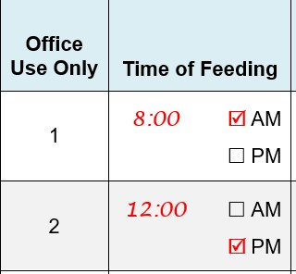
- Write down the time you started each feeding and check the box to indicate a.m. or p.m. This will help you keep track of the feedings you have recorded.

- What Did You Serve or Feed (to the Infant)?
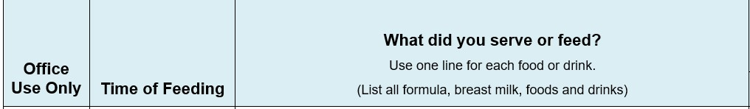
- For each feeding, write down everything you fed to the infant, including formula, breast milk, solid foods (including purees and blended/mashed foods), snacks, and any other drinks.
- Use a separate row for each item served or fed to the infant. The form continues onto the second page if you need additional space.
- On the right-hand side of this column, check the box to indicate who provided the food, formula, breast milk, or drink:
  - From home: Provided by the parent or guardian.
  - From provider: Provided by your child care facility.
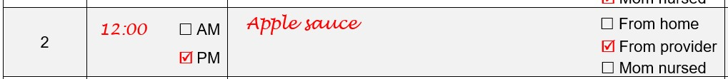
  - Mom nursed: If the mother comes to your child care facility and nursed/ breastfed the infant.
If you have any questions, please talk with the study team member that is at your program today. If you are unable to talk with the study team member while they are onsite, please call (toll-free) Mathematica at toll-free [insert TA phone number] or email [insert TA study email].
Thank you very much for your help with this important study.
This page has been left blank for double-sided copying

Example of a Completed Infant Intake Form
This page has been left blank for double-sided copying

INFANT INTAKE FORM - EXAMPLE
Today’s Date: __3__ / __7__ / __23__
Day of the Week (please circle one): Monday Tuesday Wednesday Thursday Friday
Infant’s First Name: _ John_________
Birthdate of infant: ___8__ / __21_ / __22__
Gender (circle one): Male Female
Age Group for Infant (please circle one): 0 - 3 months 4 - 5 months 6 - 7 months 8 - 11 months
Office Use Only | Time of Feeding | What did you serve or feed?  Use one line for each food or drink.  (List all formula, breast milk, foods and drinks)
1 | 8:00 AM  PM | Breast milk From home  From provider  Mom nursed
2 | 8:00 AM  PM | Apple sauce From home  From provider  Mom nursed
3 | 12:00 AM  PM | Infant oatmeal, plain From home  From provider  Mom nursed
4 | 12:00 AM  PM | Breast milk From home  From provider  Mom nursed
5 | 3:00 AM  PM | Banana, mashed From home  From provider  Mom nursed
6 | 3:00 AM  PM | Breast milk From home  From provider  Mom nursed

This page has been left blank for double-sided copying

Infant 1
INFANT INTAKE FORM

This page has been left blank for double-sided copying

INFANT INTAKE FORM
Today’s Date: ______ / ______ / ______
Day of the Week (Please circle one): Monday Tuesday Wednesday Thursday Friday
Infant’s First Name: ____________________
Birthdate of infant: ______ / ______ / ______
Gender (circle one): Male Female
Age of Infant (please circle one): 0 – 3 months 4 – 5 months 6 – 7 months 8 – 11 months
Office Use Only | Time of Feeding | What did you serve or feed?  Use one line for each food or drink.  (List all formula, breast milk, foods and drinks)
1 | AM  PM | From home  From provider  Mom nursed
2 | AM  PM | From home  From provider  Mom nursed
3 | AM  PM | From home  From provider  Mom nursed
4 | AM  PM | From home  From provider  Mom nursed
5 | AM  PM | From home  From provider  Mom nursed
6 | AM  PM | From home  From provider  Mom nursed
7 | AM  PM | From home  From provider  Mom nursed
INFANT INTAKE FORM continued

Office Use Only | Time of Feeding | What did you serve or feed?  Use one line for each food or drink.  (List all formula, breast milk, foods and drinks)
8 | AM  PM | From home  From provider  Mom nursed
9 | AM  PM | From home  From provider  Mom nursed
10 | AM  PM | From home  From provider  Mom nursed
11 | AM  PM | From home  From provider  Mom nursed
12 | AM  PM | From home  From provider  Mom nursed
13 | AM  PM | From home  From provider  Mom nursed
14 | AM  PM | From home  From provider  Mom nursed
15 | AM  PM | From home  From provider  Mom nursed
16 | AM  PM | From home  From provider  Mom nursed

INFANT INTAKE FORM continued

Office Use Only | Time of Feeding | What did you serve or feed?  Use one line for each food or drink.  (List all formula, breast milk, foods and drinks)
17 | AM  PM | From home  From provider  Mom nursed
18 | AM  PM | From home  From provider  Mom nursed
19 | AM  PM | From home  From provider  Mom nursed
20 | AM  PM | From home  From provider  Mom nursed
21 | AM  PM | From home  From provider  Mom nursed
22 | AM  PM | From home  From provider  Mom nursed
23 | AM  PM | From home  From provider  Mom nursed
24 | AM  PM | From home  From provider  Mom nursed
25 | AM  PM | From home  From provider  Mom nursed

This page has been left blank for double-sided copying

INFANT INTAKE FORM
Infant 2
This page has been left blank for double-sided copying
INFANT INTAKE FORM
Infant 3

This page has been left blank for double-sided copying
Infant 4
INFANT INTAKE FORM

This page has been left blank for double-sided copying
Infant 5
INFANT INTAKE FORM

This page has been left blank for double-sided copying

Thank you for completing the Infant Intake Forms!
Please return them to the study team member.
Please provide your contact information below in case we have any questions:
Name:
Address of Child Care Facility:

Email Address:
Phone Number:

If you aren’t able to return the forms to the study team member, please send them back in the FedEx envelope provided.

Authority: This information is being collected under the authority of the Healthy, Hunger-Free Kids Act of 2010 (P. L. 111-296), Section 305.
Purpose: The Food and Nutrition Service (FNS) is collecting this information to evaluate the nutritional quality of Child and Adult Care Food Program (CACFP) meals and snacks, the cost to produce them, and dietary intakes and activity levels of CACFP participants.
Routine Use: The records in this system may be disclosed to private firms that have contracted with FNS to collect, aggregate, analyze, or otherwise refine records for the purpose of research and reporting to Congress and appropriate oversight agencies, and/or departmental and FNS officials.
Disclosure: Disclosing the information is voluntary, and there are no consequences to you as an individual participant in the CACFP for not providing the information.
The System of Records Notice for this information collection is USDA/FNS-8, FNS Studies and Reports, which can be located at https://www.govinfo.gov/content/pkg/FR-1991-04-25/pdf/FR-1991-04-25.pdf (p. 19078).

