October 2022

TO: Laurel Havas, OMB Desk Officer
Office of Information and Regulatory Affairs
Office of Management and Budget (OMB)

THROUGH: Jamia Franklin, FNS Information Collection Officer
Planning and Regulatory Affairs
Food and Nutrition Service (FNS)

Ruth Brown, OCIO Desk Officer
Information Management Division
Office of the Chief Information Officer (OCIO)

FROM: Constance Newman, Senior Analyst
Child Nutrition Research and Evaluation Division
Office of Policy Support
Food and Nutrition Service (FNS)

SUBJECT: Justification for Non-Substantive Change to OMB Control No: 0584-0669 Study of Nutrition and Activity in Child Care Settings II (SNACS-II) to move two survey questions with a slight increase in burden.

FNS is requesting a non-substantive change to the previously approved collection, Study of Nutrition and Activity in Child Care Settings II (SNACS-II), (OMB Control No. 0584-0669, exp. 10/31/2024).

SNACS-II will provide FNS with a comprehensive assessment of the Child and Adult Care Feeding Program (CACFP) and provides a needed update to the first study, SNACS, on which SNACS-II is modeled. The assessment will examine topics such as the nutritional quality of meals and snacks provided in CACFP as well as many other aspects such as program costs and characteristics of the providers that participate in the program.

The change is needed so that we can fully assess any differences in the way CACFP providers function based on the nature of their sponsorship type. Sponsors serve many providers as the hub for administrative functions, establishing food preparation policies, monitoring, and more. In SNACS-II, we ask sponsors about costs and other administrative functions that they perform, and we ask about the nature of their organization. We had put the sponsorship type questions in the cost survey, in the survey instrument called Pre-Visit Cost Telephone Interview. However, upon review, we realized that we wanted to collect sponsorship type for all of the participating providers, not just those selected to participate in the smaller sample of sponsors that are asked to respond to the cost survey questions. Therefore, we would like to move the sponsorship type questions, with some slight changes, to the Provider Survey that will be asked of all providers.

Specifically, we first propose to delete a question about sponsorship type that was directed to sponsors only in the Pre-Visit Cost Telephone Survey. (We retain the first part of question 1 to reinforce the information collection as previously planned.) This is a screenshot of the changes proposed in the Pre-Visit Cost Telephone Survey:

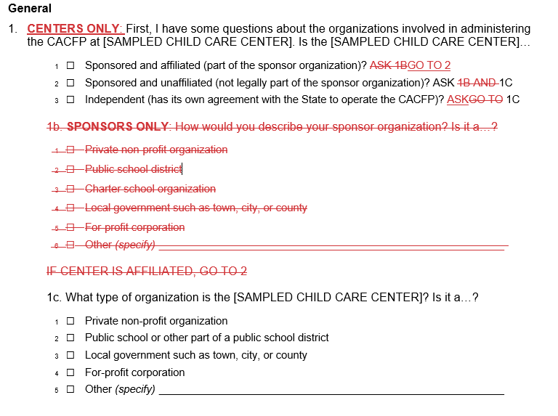

The new questions in the Provider Survey would be these:

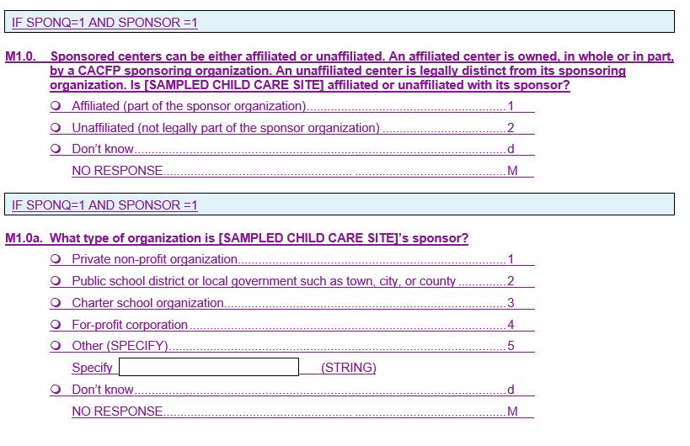
The estimated change in burden is 1.438 hours as shown in the table below. There is an estimated 239 sponsors who would have spent 45 seconds each for a total time of 2.988 hours on the three-part question. And an estimated 531 providers are expected to spend 30 seconds on the two new questions for a total of 4.425 hours. The difference is an additional 1.438 hours of burden overall.

The change will increase the total annualized cost of respondent burden by $44.08. This reflects a decrease of $104.94 for sponsors and an increase of $149.01 for providers.

The attached documents identify each of the specific locations in the SNACS-II materials where the requested changes would be made.

If you have any questions regarding this request, please contact Jamia Franklin, FNS Information Collection Clearance Officer for the Food and Nutrition Service, Planning & Regulatory Affairs Office at (703) 305-2403.

Attachments:
E1_Pre-Visit Cost Telephone Interview_2022.09.27
F7_Provider Survey_English_2022.09.27
F8_Provider Survey_Spanish_2022.09.27
SNACS-II sponsorship Q burden estimates
N_Sample Sizes Estimated Burden and Estimated Cost of Respondent Burden_2022.09.27

