State of Maryland Department of Natural Resources

Larry Hogan
Governor

Jeannie Haddaway-Riccio
Secretary

Fishing and Boating Services
580 Taylor Ave.
Annapolis, MD 21401
dnr.maryland.gov

Toll free in Maryland: 877-620-8305

Out of state call: 410-260-8305

TTY Users call via the MD Relay. This program receives Federal financial assistance from the National Oceanic and Atmospheric Administration. Under Title VI of the 1964 Civil Rights Act, Section 504 of the Rehabilitation Act of 1973, Title II of the Americans with Disabilities Act of 1990, the Age Discrimination Act of 1975, and Title IX of the Education Amendments of 1972, the U.S. Department of the Interior prohibits discrimination on the basis of race, color, national origin, age, sex, or disability.
If you believe that you have been discriminated against in any program, activity, or facility, or if you need more information,
please write to:

Office of Fair Practice
Department of Natural Resources
580 Taylor Ave., C 3
Annapolis MD 21401
Telephone: (410) 260-8058
Email: ndc.dnr@maryland.gov

National Oceanic and Atmospheric Administration
Office of Inclusion and Civil Rights Leadership
Mr. Ken Bailey - Deputy Director
Building SSMC4, Suite 7500
1305 East-West Highway
Silver Spring, MD 20910

02/2022 DNR

United States
Department of Commerce
National Oceanic and Atmospheric Administration
National Marine Fisheries Service
Office of Sustainable Fisheries
Highly Migratory Species Division

Final Report

Grantee: | Maryland Department of Natural Resources
Contract Number: | 20-0105.5
Project Title: | Maryland Catch Card Census Reporting
Period Covered: | 2021
Prepared By:
 | Angel Willey, Coastal Fisheries Program Manager | Date
Approved By:
 | Mike Luisi, Acting Director, Fishing and Boating Services | Date
Approved By:
 | Matt Fleming, Acting Assistant Secretary, Aquatic Resources | Date

Introduction
Globally, tunas, billfishes and some sharks are governed by the International Commission for the Conservation of Atlantic Tunas. In the United States, the Atlantic Tunas Convention and Magnuson Stevens acts provide the Highly Migratory Species Division of the National Marine Fisheries Service the authority to implement recommendations, such as minimum sizes and quotas.
In the late 1990’s, the National Marine Fisheries Service required all recreational anglers to report bluefin tuna (Thunnus thynnus) landings via a toll free phone number. In Maryland, that system was determined to be ineffective for accurately documenting recreational bluefin tuna landings. The Catch Card Census was implemented in 1999 as a solution to the recreational reporting problem, and the program has expanded to include billfishes (2002) and sharks (2013).

Objectives
  - Continue long-term monitoring of all recreationally landed bluefin tuna, billfishes, and sharks in Maryland and supply those data to the National Marine Fisheries Service for use in management of highly migratory species.
  - Continue development of program awareness among anglers for high compliance rates.

Materials and Methods
Information pertaining to the Catch Card Census was available on the department’s website. Letters were emailed or mailed to highly migratory species permit holders (April) reminding them of the requirements and the ability to download catch cards which can speed up the dockside tagging process. A similar letter was emailed or mailed to tournament operators.

Eight businesses signed a cooperative reporting station participation agreement to cover all species in the census (Table 1 and Appendix A). Two additional tackle shops were reporting stations specifically for sharks and signed a species specific agreement (Appendix B). The contracts required reporting stations to distribute and collect catch cards, issue tags, and return leftover supplies to the department for inventory at the conclusion of the fishing season.

Each reporting station received catch cards and tags at the start of the season. Staff contacted reporting stations twice a week, from June 6 through September 30, to maintain adequate supplies and collect completed catch cards. After September 30, staff checked reporting stations weekly. Tags and unused catch cards were collected at the end of the season from select reporting stations. Returned tags were reconciled with what was distributed (Appendix C). One self-serve kiosk was also available to anglers (Appendix D).

Anglers were responsible for completing a catch card before removing the fish from the vessel (Appendix E and F). A tag was provided from the reporting station for each completed catch card to be placed around the tail of the fish. If fishing from shore, a catch card was completed before removing a shark from the point of landing. Anglers using a self-serve kiosk were expected to complete the catch card and retain the attached receipt in place of a tag. The catch card was to be deposited into a locked box that was fastened directly to the kiosk. Trailered boats could not be pulled from the water until the tag was in place or a receipt was in hand.

Throughout the season, reporting reminders were included in the department’s fishing reports, social media posts, a flyer targeted to swordfish anglers (Appendix G), and a shark poster for remote areas in Chincoteague Bay (Appendix H). Popular fishing newspapers and social media sites were monitored for catch card compliance. Fishermen were contacted to complete a catch card if a corresponding catch card was not received.

Catch card landings were entered into a Microsoft Access database. Updates and catch card data were provided to the National Marine Fisheries Service every two weeks during the season. Microsoft Excel was utilized for proofing and descriptive statistics.

Results and Discussion

Bluefin Tuna
In 2021, 650 bluefin tuna were reported through the Catch Card Census which was higher than the previous two years (Table 2 and Figure 1). Ninety seven percent of those landings (632 bluefin tuna) were classified as school (27 to <47 inches, Figure 2). In 2021, the mean curved fork length (all classes combined) was 35.9 inches. The peak landing period was mid-May to mid-June for the past three years (Figure 3).

Charter trips landed 56.6 percent (368 tuna) of the bluefin tuna during the 2021 season (Table 3). In 2021, the percentage of non-tournament bluefin tuna landings was 99.8 percent, which is higher than the previous two years. Compliance with completing the live and dead release (158 live, 17 dead) boxes was difficult to compare to 2020 due to low landings that year, however improvement was shown compared to 2019 (92 live, three dead releases). Two bluefin tuna were reported using the kiosk and zero were reported from the Automated Landings Reporting System.

Billfishes (Blue Marlin, White Marlin, Roundscale Spearfish) and Swordfish
Ninety billfishes and swordfish were reported in 2021 through the Catch Card Census, which is lower than the previous two years (Table 4, Figure 4 and Appendix I). No undersized fish were reported in 2021. Sailfish have not been reported since the program was implemented in 1999.

Blue marlin landings reported in 2021 (14 blue marlin) were higher than 2020 (10 blue marlin; Figures 4 - 6). The 2021 blue marlin mean lower jaw fork length was 114.4 inches and the mean weight was 568.4 pounds (Table 4). Mean lower jaw fork length and mean weight were both higher than 2020. The majority of landings occurred in July and August for the past three years of which most were landed during tournaments: the HUK Big Fish Classic, the White Marlin Open, and the MidAtlantic (Table 5). Zero blue marlin catch cards were received in the kiosk or via the Automated Landings Reporting System.

White marlin landings reported in 2021 (19 white marlin) decreased from the previous year (70 white marlin; Table 4 and Figures 4 - 6). The 2021 mean lower jaw fork length (71 inches) and mean weight (73.5 pounds) was higher than the previous two years. The majority of landings occurred in August for the past three years, most of which were landed during tournaments (Table 5). Zero white marlin catch cards were received in the kiosk or via the Automated Landings Reporting System.

Roundscale spearfish landings in 2021 (21 roundscale spearfish) decreased from the previous year (66 roundscale spearfish; Table 4 and Figures 4 - 6). The 2021 mean lower jaw fork length (70.4 inches) was similar to the previous two years. The mean weight (63.2 pounds) was slightly lower than 2020 and 2019. All roundscale spearfish were landed during August fishing tournaments (Table 5). Zero roundscale spearfish catch cards were received in the kiosk or via the Automated Landings Reporting System.
Roundscale spearfish were considered eligible for white marlin rewards and were targeted the same as white marlin at tournaments. The 2021 combined landings for white marlin and roundscale spearfish were 40 fish compared to 136 for both species in 2020. This substantial decrease in white marlin and roundscale spearfish can be attributed to the proactive actions taken by tournaments that increased qualifying lengths to reduce landings.
Swordfish landings for 2021 (36 swordfish) were lower than the previous year (96 swordfish; Table 4 and Figures 7 - 8). The 2021 swordfish mean lower jaw fork length (63.9 inches) was lower than 2020, but similar to 2019. The 2021 mean weight (154.5 pounds) was higher than the previous two years. Swordfish were landed from June into December in 2021. Peak swordfish landings were similar for the past two years (September - October; Figure 8). Two swordfish catch cards were received in the kiosk and zero were submitted via the Automated Landings Reporting System.
Species-specific discards were requested but were only reported with landed fish. In 2021, anglers reported three blue marlin, 37 white marlin, one swordfish, and two longbill spearfish released alive. Dead discard reporting remained low in 2021 as no dead discards were reported for any billfishes or swordfish.

Sharks
Shark landings (28 sharks) were lower than the previous two years and consisted of seven species (Table 7 and Figures 9 - 10). Shortfin mako sharks comprised 32 percent (nine sharks) of the landings which is higher than the previous two years and related to the large decrease in Atlantic sharpnose landings (Table 8). The shark landings peaked from mid-May to mid-June, ahead of the 2020 and 2019 seasons (Figure 11). The majority of sharks were landed outside of tournaments and mostly on charters (23 sharks; Table 9). Discards were only reported with landed fish. One shark catch card was deposited in the kiosk.

Recommendations
- Continue the Catch Card Census for bluefin tuna, billfishes, swordfish, and sharks in Maryland.
- Consider adding an electronic reporting option.

List of Tables
Table 1. | List of the 2021 Maryland Catch Card Census reporting stations.
Table 2. | Maryland Catch Card Census bluefin tuna summary statistics, 2019 to 2021.
Table 3. | Maryland bluefin tunas landings by trip type and tournament participation, 2019 to 2021.
Table 4. | Maryland Catch Card Census billfish and swordfish summary statistics, 2019 to 2021.
Table 5. | Maryland Catch Card Census tournament participation by billfish species, 2019 to 2021.
Table 6. | Maryland Catch Card Census billfish and swordfish landings by trip type, 2019 to 2021.
Table 7. | Summary of the 2021 shark landings reported through the Maryland Catch Card Census, n = 28.
Table 8. | Maryland Catch Card Census summary of the 2019 to 2021 shortfin mako landings, n = 28.
Table 9. | Maryland Catch Card Census shark landings by trip type and tournament participation, 2019 to 2021.

List of Figures
Figure 1. | Maryland Catch Card Census weekly cumulative bluefin tuna landings, 2019 to 2021.
Figure 2. | Maryland Catch Card Census bluefin tuna size class frequency comparison, 2019 to 2021.
Figure 3. | Maryland Catch Card Census weekly landings of bluefin tuna, 2019 to 2021.
Figure 4. | Comparison of the frequency of billfishes and swordfish from the Maryland Catch Card Census, 2019 to 2021.
Figure 5. | Maryland Catch Card Census cumulative billfish landings, 2019 to 2021.
Figure 6. | Maryland Catch Card Census weekly billfish landings, 2019 to 2021.
Figure 7. | Maryland Catch Card Census cumulative swordfish landings, 2019 to 2021.
Figure 8. | Maryland Catch Card Census weekly swordfish landings, 2019 to 2021.
Figure 9. | Maryland Catch Card Census cumulative shark landings, 2019 to 20201
Figure 10. | Sharks reported to the Maryland Catch Card Census, 2019 to 2021.
Figure 11. | Maryland Catch Card Census weekly shark landings, 2019 to 2021.

List of Appendices
Appendix A. | Example of the 2021 Catch Card Census Reporting Station Agreement.
Appendix B. | Example of the 2021 Catch Card Census Shark Reporting Station Agreement.
Appendix C. | Maryland Catch Card Census 2021 Reporting Station Tag Summary.
Appendix D. | Photograph of the Maryland Catch Card Census Kiosk Located in Ocean City.
Appendix E. | Examples of the 5 x 7 Maryland Bluefin Tuna and Billfish Catch Cards and Tags.
Appendix F. | Example of the 5 x 7 Maryland Shark Catch Card and Tag.
Appendix G. | Maryland Catch Card Census Swordfish Flyer.
Appendix H. | Maryland Catch Card Census Shark Poster.
Appendix I. | List of the 2021 Billfishes and Swordfish Reported to the Maryland Catch Card Census.

Table 1. List of the 2021 Maryland Catch Card Census reporting stations.
Reporting Station | City /State | Phone Number | Species
Atlantic Tackle | Ocean City, MD | (410) 213-0421 | All
Bahia Marina | Ocean City, MD | (410) 289-7438 | All
Fisherman’s Marina | Ocean City, MD | (410) 213-2478 | All
Ocean City Fishing Center | Ocean City, MD | (410) 213-1121 | All
Talbot Street Pier & Marina | Ocean City, MD | (410) 289-9125 | All
White Marlin Marina | Ocean City, MD | (410) 289-6470 | All
Sunset Marina | Ocean City, MD | (410) 213-9600 | All
Pines Point Provisions and Seafood | Ocean Pines, MD | (410) 641-2248 | All
Buck’s | Berlin, MD | (443) 513-4661 | Shark
Alltackle | Ocean City, MD | (410) 213-2840 | All
Maryland Department of Natural Resources | Ocean City, MD | (410) 213-1531 | All

Table 2. Maryland Catch Card Census bluefin tuna summary statistics, 2019 to 2021.
 | 2019 |  |  |  | 2020 |  |  |  | 2021
Size Class (in.) | Count | Mean* | Mode* | Percent of Total | Count | Mean* | Mode* | Percent of Total | Count | Mean* | Mode* | Percent of Total
School (27 to <47) | 373 | 37.3 | 34 | 72.1 | 4 | 37.8 |  | 40 | 632 | 35.7 | 40 | 97.2
Large School (47 to <59) | 132 | 51.8 | 52 | 25.5 | 5 | 52.1 |  | 50 | 7 | 50.4 | 50 | 1.1
Small Medium (59 to <73) | 9 | 62.4 | 60 | 1.7 | 1 |  |  | 10
Unknown | 3 |  |  | 0.6 |  |  |  |  | 11 |  |  | 1.7
Total | 517 |  |  |  | 10 |  |  |  | 650
* Curved fork length

Table 3. Maryland bluefin tunas landings by trip type and tournament participation, 2019 to 2021.
Trip Type | Private |  | Charter |  | Headboat |  | Unknown |  | Tournament Landings
Year | Count | Percent of Landings | Count | Percent of Landings | Count | Percent of Landings | Count | Percent of Landings | Tournament | Non-Tournament
2019 | 272 | 52.6 | 232 | 44.9 | 12 | 2.3 | 1 | 0.2 | 39 | 478
2020 | 2 | 20 | 8 | 80 |  |  |  |  | 6 | 4
2021 | 261 | 40.2 | 368 | 56.6 | 12 | 1.8 | 9 | 1.4 |  | 649*
* One card had no information about tournament participation

Table 4. Maryland Catch Card Census billfish and swordfish summary statistics, 2019 to 2021.
Year | Count | Percent of Annual Billfish Total | Lower Jaw Fork Length (Inches) |  |  | Weight (Pounds)
 |  |  | Mean | Mode | Range | Mean | Range
Blue Marlin
2019 | 11 | 6.5 | 111.3 |  | 105.3 - 121.8 | 465.2 | 345 - 630
2020 | 10 | 4.1 | 107.5 |  | 88.5 - 129.5 | 470 | 322 - 815
2021 | 14 | 15.6 | 114.4 | 104 | 99.8 - 136.5 | 568.4 | 355 - 1135
White Marlin
2019 | 31 | 18.5 | 68.1 | 68 | 62 - 73 | 64 | 53 - 81
2020 | 70 | 28.9 | 69.8 | 70 | 66 -77 | 68.3 | 54 - 97
2021 | 19 | 21.1 | 71.0 | 69 | 66 - 79 | 73.5 | 60.5 - 89
Roundscale Spearfish
2019 | 28 | 16.7 | 69.4 | 68 | 66.8 - 72 | 65.3 | 56 - 79
2020 | 66 | 27.3 | 69.6 | 69 | 66.5 - 75.5 | 65.4 | 55.5 - 83.5
2021 | 21 | 23.3 | 70.4 | 70 | 68.5 - 74 | 63.2 | 57 - 70
Swordfish
2019 | 98 | 58.3 | 63.5 | 54 | 48 - 101 | 150.9 | 50 - 437
2020 | 96 | 39.7 | 65.9 | 62 | 48 - 102.5 | 153.8 | 55 - 422.5
2021 | 36 | 40 | 63.9 | 50 | 48.5 - 87 | 154.5 | 60 - 318.5

Table 5. Maryland Catch Card Census tournament participation by billfish species, 2019 to 2021.
Year | Count | Tournament | Non-Tournament
Blue Marlin
2019 | 11 | 9 | 2
2020 | 10 | 5 | 5
2021 | 14 | 13 | 1
White Marlin
2019 | 31 | 28 | 3
2020 | 70 | 62 | 8
2021 | 19 | 12 | 7
Roundscale Spearfish
2019 | 28 | 27 | 1
2020 | 66 | 66
2021 | 21 | 21
Swordfish
2019 | 98 | 8 | 90
2020 | 96 | 31 | 65
2021 | 36 | 13 | 23

Table 6. Maryland Catch Card Census billfish and swordfish landings by trip type, 2019 to 2021.
 | Private |  | Charter |  | Unknown |  | Headboat
Year | Count | Percent of Total Landings | Count | Percent of Total Landings | Count | Percent of Total Landings | Count | Percent of  Total Landings
2019 | 126 | 75 | 41 | 24.4 |  |  | 1 | 0.6
2020 | 111 | 45.9 | 40 | 16.5 | 91 | 37.6
2021 | 60 | 68.9 | 26 | 28.9 | 1 | 1.1 | 1 | 1.1

Table 7. Summary of the 2021 shark landings reported through the Maryland Catch Card Census n = 28.
Species | Count | Sex |  |  | Mean Length (Inches) | Mode (Inches) | Length Range (Inches) | Weight Range (Pounds)
 |  | M | F | U
Atlantic Sharpnose | 7 | 7 |  |  | 30.1 | 32 | 24 - 32
Blacktip | 1 |  | 1 |  |  |  | 70 | 100
Common Thresher | 5 | 3 | 2 |  | 81.3 | 81 | 80 - 84.5 | 267 - 542
Scalloped Hammerhead | 1 |  | 1 |  |  |  | 96 | 185
Shortfin Mako | 9 | 9 |  |  | 79.1 | * | 71 - 93 | 120 - 314
Smooth Dogfish | 4 | 2 | 2 |  | 18.8 | 15 | 15 - 27
Tiger | 1 | 1 |  |  |  |  | 70 | 132.5
Total | 28
*No mode as all lengths are different.

Table 8. Maryland Catch Card Census summary of the 2019 to 2021 shortfin mako landings, n = 28.
Year | Species | Count | Sex |  |  | Mean Length (Inches) | Mode (Inches) | Length Range (Inches) | Weight Range (Pounds)
 |  |  | M | F | U
2019 | Shortfin Mako | 13 | 8 | 5 |  | 82 | 74 | 72 - 106 | 133 - 487
2020 | Shortfin Mako | 6 | 4 | 2 |  | 80 | 84 | 72 - 88 | 130 - 330
2021 | Shortfin Mako | 9 | 9 |  |  | 79.1 | * | 71 - 93 | 120 - 314
 | Total | 28 | 13 | 9
*No mode as all lengths are different.

Table 9. Maryland Catch Card Census shark landings by trip type and tournament participation, 2019 to 2021.
Trip Type | Private |  | Charter |  | Unknown |  | Tournament Landings
Year | Count | Percent of Landings | Count | Percent of Landings | Count | Percent of Landings | Tournament | Non-Tournament
2019 | 18 | 18 | 81 | 82 |  |  | 1 | 98
2020 | 2 | 3 | 75 | 97 |  |  |  | 77
2021 | 8 | 29 | 20 | 71 |  |  | 5 | 23
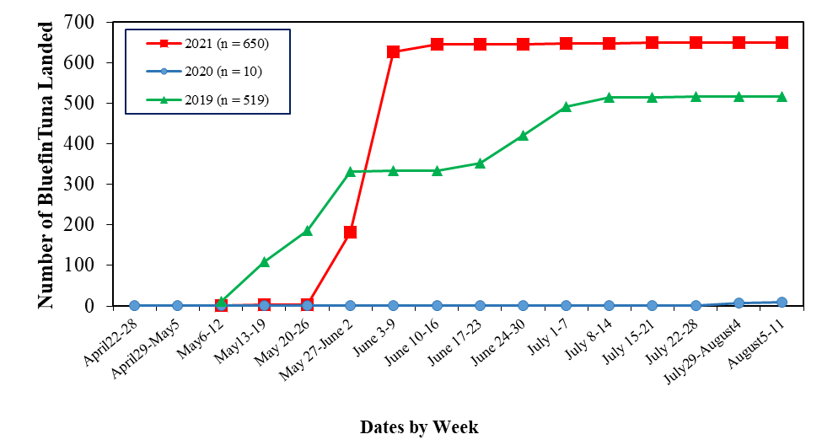

Figure 1. Maryland Catch Card Census weekly cumulative bluefin tuna landings, 2019 to 2021.

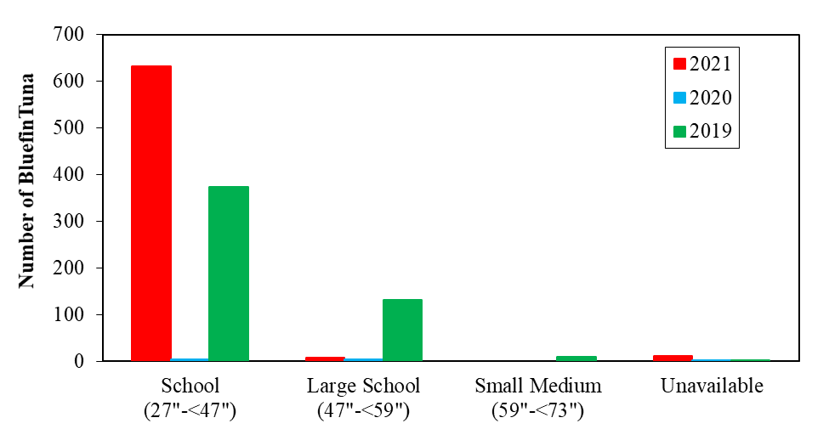

Figure 2. Maryland Catch Card Census bluefin tuna size class frequency comparison, 2019 to 2021.
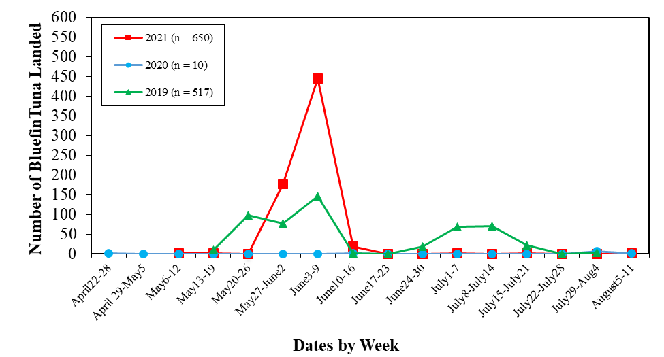

Figure 3. Maryland Catch Card Census weekly landings of bluefin tuna, 2019 to 2021.

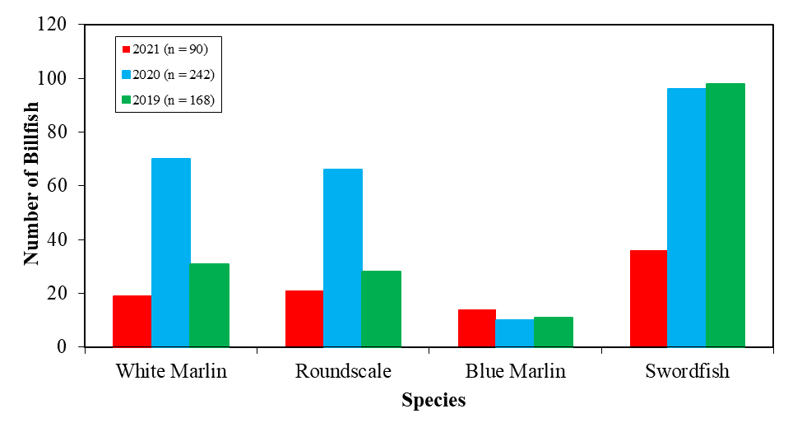

Figure 4. Comparison of the frequency of billfishes and swordfish from the Maryland Catch Card Census, 2019 to 2021.
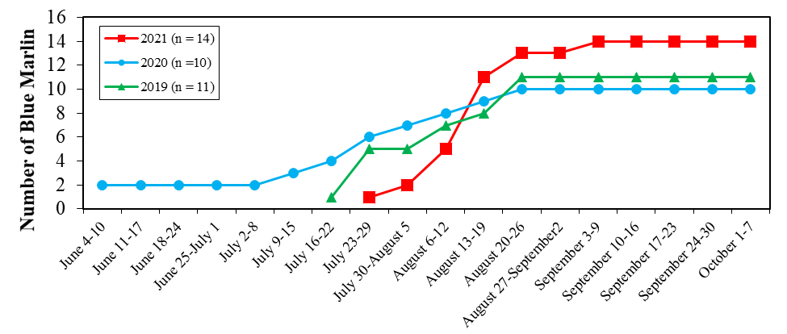
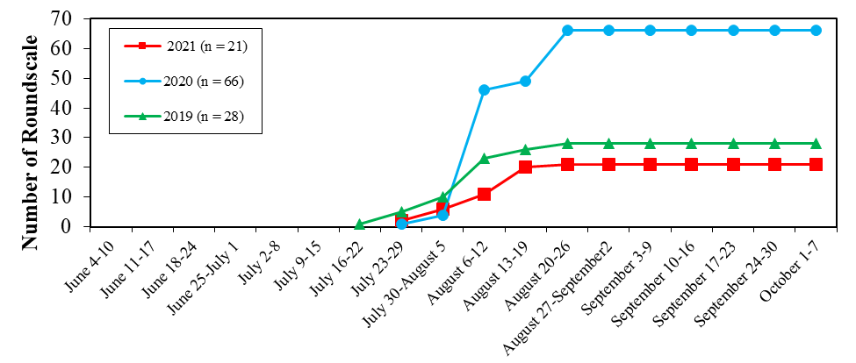
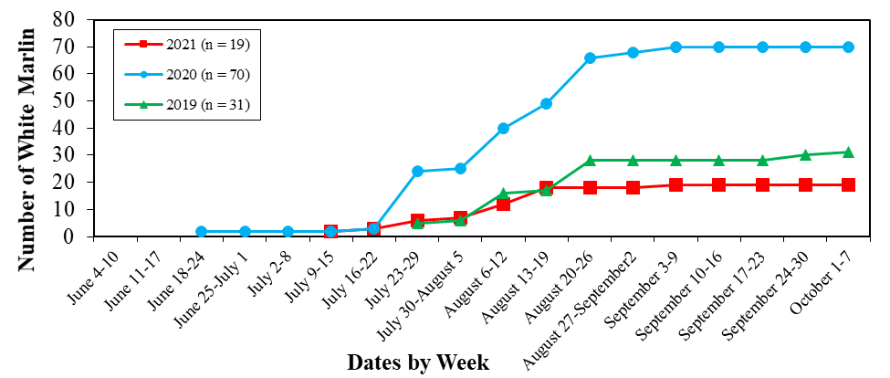

Figure 5. Maryland Catch Card Census cumulative billfish landings, 2019 to 2021.

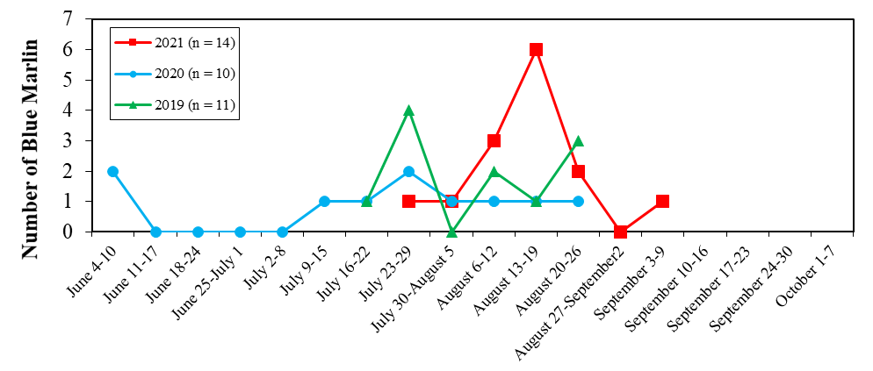
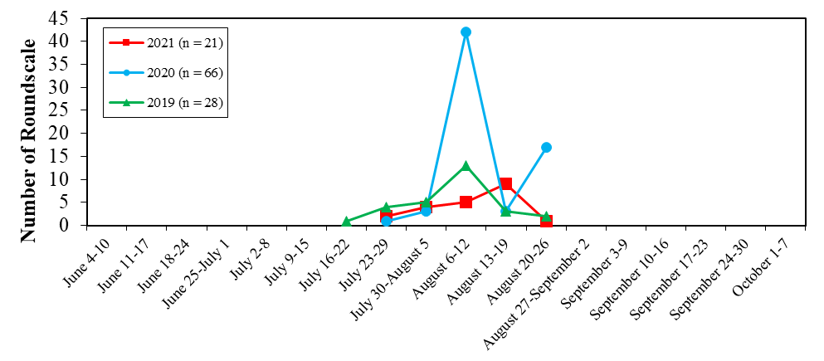
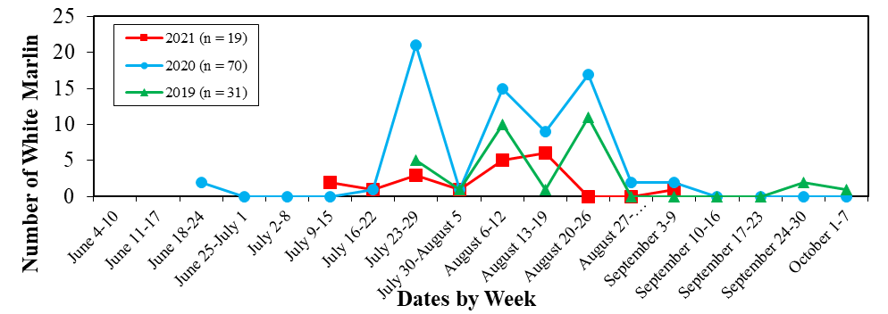

Figure 6. Maryland Catch Card Census weekly billfish landings, 2019 to 2021.

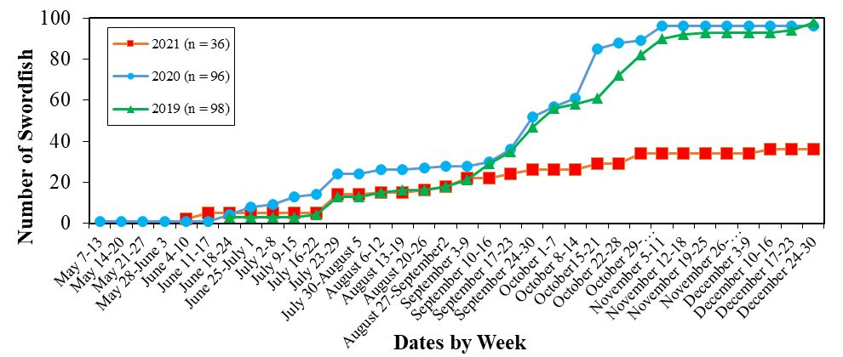

Figure 7. Maryland Catch Card Census cumulative swordfish landings, 2019 to 2021.

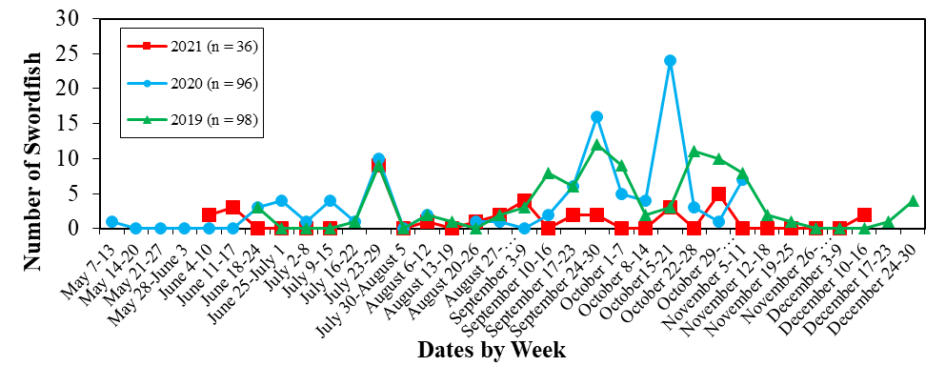

Figure 8. Maryland Catch Card Census weekly swordfish landings, 2019 to 2021.

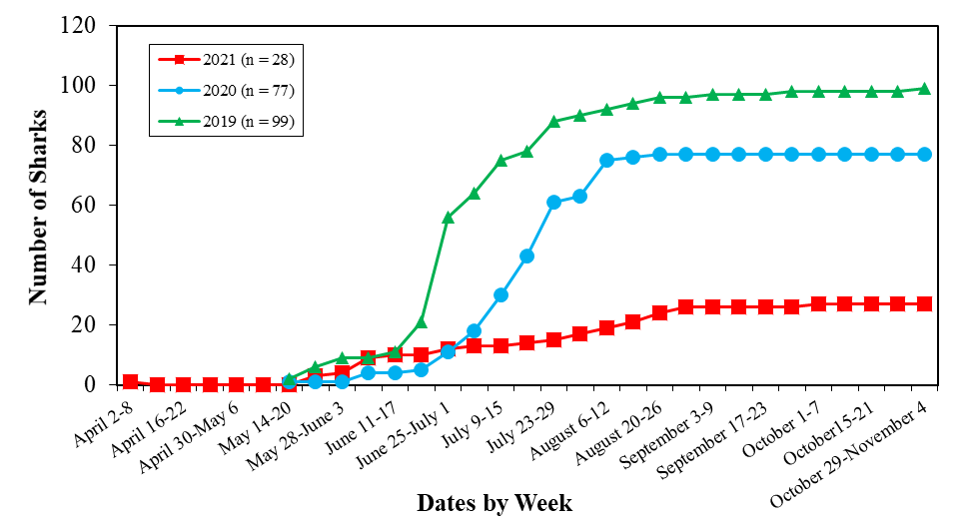

Figure 9. Maryland Catch Card Census cumulative shark landings, 2019 to 2021.

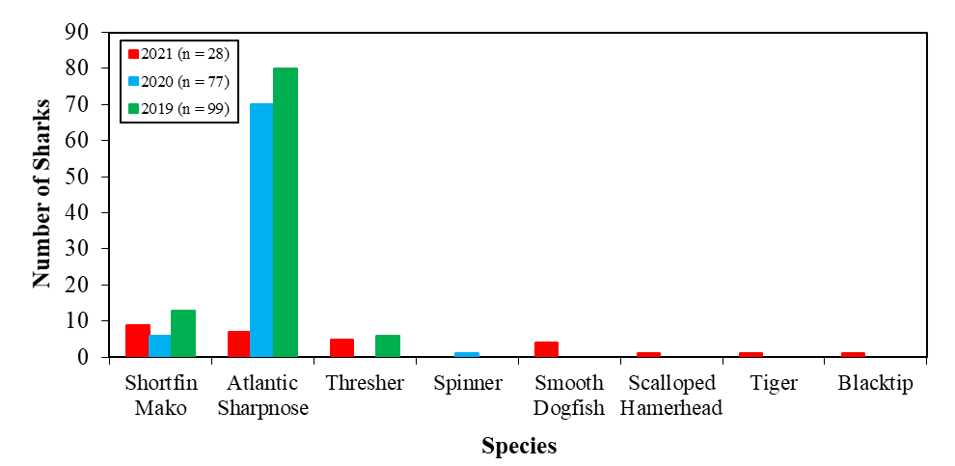

Figure 10. Sharks reported to the Maryland Catch Card Census, 2019 to 2021.

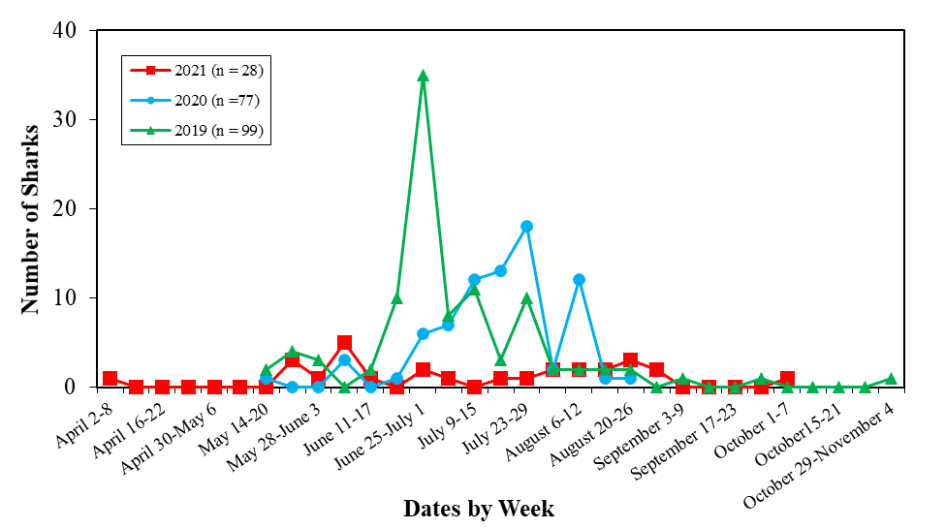

Figure 11. Maryland Catch Card Census weekly shark landings, 2019 to 2021.

Appendix A. Example of the 2021 Catch Card Census Reporting Station Agreement.
2021 Cooperative Agreement to Act as a
Recreational Atlantic Bluefin Tuna, Billfish/Swordfish and Shark Reporting Station
Between
The Maryland Department of Natural Resources
&
__________________________________________________

The signatory operates this facility as a place of business open to the public with regular posted operating hours and will act as a reporting station for recreationally harvested Atlantic bluefin tuna and billfish (white marlin, blue marlin, sailfish), swordfish, and sharks landed in the State of Maryland in accordance with the following conditions. *
On a Daily Basis:
- From bluefin tuna anglers, collect COMPLETED Maryland bluefin tuna catch cards and issue a uniquely numbered bluefin tuna tag to the angler. Tags issued only upon receipt of the COMPLETED catch card. Bluefin tuna cannot be removed from a vessel before the angler attaches the tag to the appropriate tuna.
- From billfish/swordfish anglers, collect COMPLETED Maryland billfish catch cards and issue a uniquely numbered billfish/swordfish tag to the angler. Tags are issued only upon receipt of the COMPLETED catch card. The billfish/swordfish cannot be removed from a vessel before the angler attaches the tag to the appropriate billfish/swordfish.
- From shark anglers, collect COMPLETED Maryland shark catch cards and issue a uniquely numbered shark tag to the angler. Tags are issued only upon receipt of the COMPLETED catch card. The shark cannot be removed from a vessel before the angler attaches the tag to the appropriate shark.
- The signatory, representing the reporting station, must account for all tags.
- The reporting station will allow personnel from the Maryland Department of Natural Resources to collect completed catch cards and inventory remaining tuna, billfish/swordfish and shark tags. All tags must be kept in a secure location.
Physical location address: ________________________________________________________

Business mailing address: ________________________________________________________

Telephone number: _____________________________________________________________

Hours of operation: _____________________________________________________________

Owner/Manager name: __________________________________________________________

Contact person: ________________________________________________________________

Person(s) responsible for checking catch cards & issuing tags: __________________________________________

* The Department reserves the right to terminate reporting station status for any reason including but not limited to failure to maintain inventory of bluefin tuna, billfish/swordfish and shark tags and collect completed catch cards and/or failure to cooperate with Department personnel in retrieval of said items.
Authorized signature:_____________________________ Date:_____________________

Title:______________________________________________

Appendix B. Example of the 2021 Catch Card Census Shark Reporting Station Agreement.
2021 Cooperative Agreement to Act as a
Recreational Shark Reporting Station
Between
The Maryland Department of Natural Resources
&
__________________________________________________

The signatory operates this facility as a place of business open to the public with regular posted operating hours
and will act as a reporting station for recreationally harvested sharks landed in the State of Maryland in accordance with the following conditions. *
On a Daily Basis:
1. From shark anglers, collect COMPLETED Maryland Shark Landing Cards and issue a uniquely
numbered shark tag to the angler. Tags are issued only upon receipt of the COMPLETED landing
card. The shark cannot be removed from the point of landing before the angler attaches the tag to
the appropriate shark.

2. The signatory, representing the reporting station, must account for all tags.

3. The reporting station will allow personnel from the Maryland Department of Natural Resources to
collect completed landing cards and inventory remaining shark tags. All tags must be kept in a
secure location.

Physical location address: ________________________________________________________

Business mailing address: ________________________________________________________

Telephone number: _____________________________________________________________

Hours of operation: _____________________________________________________________

Owner/Manager name: __________________________________________________________

Contact person: ________________________________________________________________

Person(s) responsible for checking catch cards & issuing tags: __________________________________________

* The Department reserves the right to terminate reporting station status for any reason including but
not limited to failure to maintain inventory of shark tags and collect completed catch cards and/or failure to cooperate with Department personnel in retrieval of said items.
Authorized signature:________________________________ Date: _____________________

Title:______________________________

Figure 5. Example of the 2013 Maryland ABT/Billfish/Shark Catch Card and Tagging Program contract between MDNR and tackle shops to act as a recreational reporting station for sharks.

Appendix C. Maryland Catch Card Census 2021 Reporting Station Tag Summary.
 | Bluefin |  |  |  |  | Billfish |  |  |  |  | Sharks
Station | Issued | Used | Returned | No Tag Number | Unsettled | Issued | Used | Returned | No Tag Number | Unsettled | Issued | Used | Returned | No Tag Number | Unsettled
Atlantic Tackle | 172 | 59 | 95 | 18 |  | 10 |  | 10 |  |  | 10 |  | 10
Bahia Marina | 50 | 16 | 33 | 1 |  | 10 | 1 | 9 |  |  | 10 | 3 | 7
Fisherman’s Marina | 111 | 39 | 70 | 2 |  | 10 | 6 | 4 |  |  | 10 | 2 | 8
O.C. Fishing Center | 366 | 199 | 144 | 23 |  | 19 | 6 | 13 |  |  | 30 | 18 | 12
Talbot Street Pier & Marina | 87 | 51 | 36 |  |  | 27 | 17 | 10 |  |  | 20 |  | 20
Sunset Marina _{a} | 359 | 187 | 159 | 13 |  | 56 | 20 | 36 |  |  | 18 | 0 | 18
Pines Point Provisions and Seafood | 21 | 7 | 14 |  |  | 8 |  | 8 |  |  | 10 |  | 10
White Marlin Marina | 53 | 28 | 25 |  |  | 6 | 1 | 5 |  |  | 11 | 2 | 9
Buck’s | N/A | N/A | N/A |  |  | N/A | N/A | N/A |  |  | 10 |  | 10
Alltackle | 19 |  | 19 |  |  | 11 | 1 | 10 |  |  | 10 |  | 10
Huk Big Fish Classic | 10 |  | 10 |  |  | 40 | 1_{b} | 39 |  |  | 10 |  | 10
White Marlin Open | 10 |  | 10 |  |  | 64 | 17_{d} | 47 |  |  | 10 | 2 | 8
MidAtlantic | 10 |  | 10 |  |  | 47 | 18 | 29 |  |  | N/A | N/A | N/A
O.C. Marlin Club | N/A | N/A | N/A |  |  | 25 |  | 25 |  |  | N/A | N/A | N/A
Kiosk (receipt) | N/A | N/A | N/A | 2 |  |  |  |  | 2 |  |  |  |  | 1
Unreported_{c} | N/A | N/A | N/A | 5
Totals | 1268 | 586 | 625 | 64 |  | 333 | 88 | 245 | 2 |  | 159 | 27 | 132
_{a} One bluefin tag used for billfish. The marina did not have the HMS permit holder’s number. Could not find vessel contact information in permit list.
_{b} Dockhands began using tags issued to the marina instead of tags issued to the tournament.
_{c} The department completed catch cards for unreported landings discovered online. The fishermen and or HMS permit holders were comtacted for these fish.
_{d} Two billfish were tagged at other marinas instead of the tournament.

Appendix D. Photograph of the Maryland Catch Card Census Kiosk Located in Ocean City.
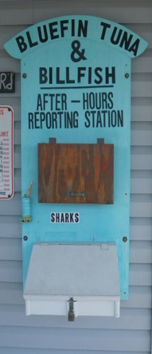

Appendix E. Examples of the 5 x 7 Maryland Bluefin Tuna and Billfish Catch Cards and Tags.

Appendix F. Example of the 5 x 7 Maryland Shark Catch Card and Tag.

Appendix G. Maryland Catch Card Census Swordfish Flyer.
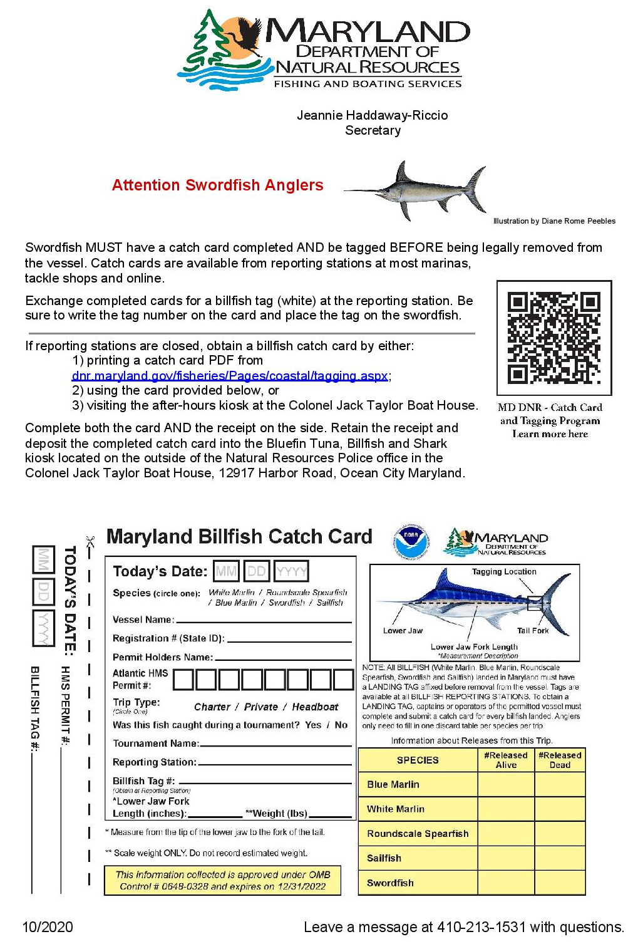

Appendix H. Maryland Catch Card Census Shark Poster.
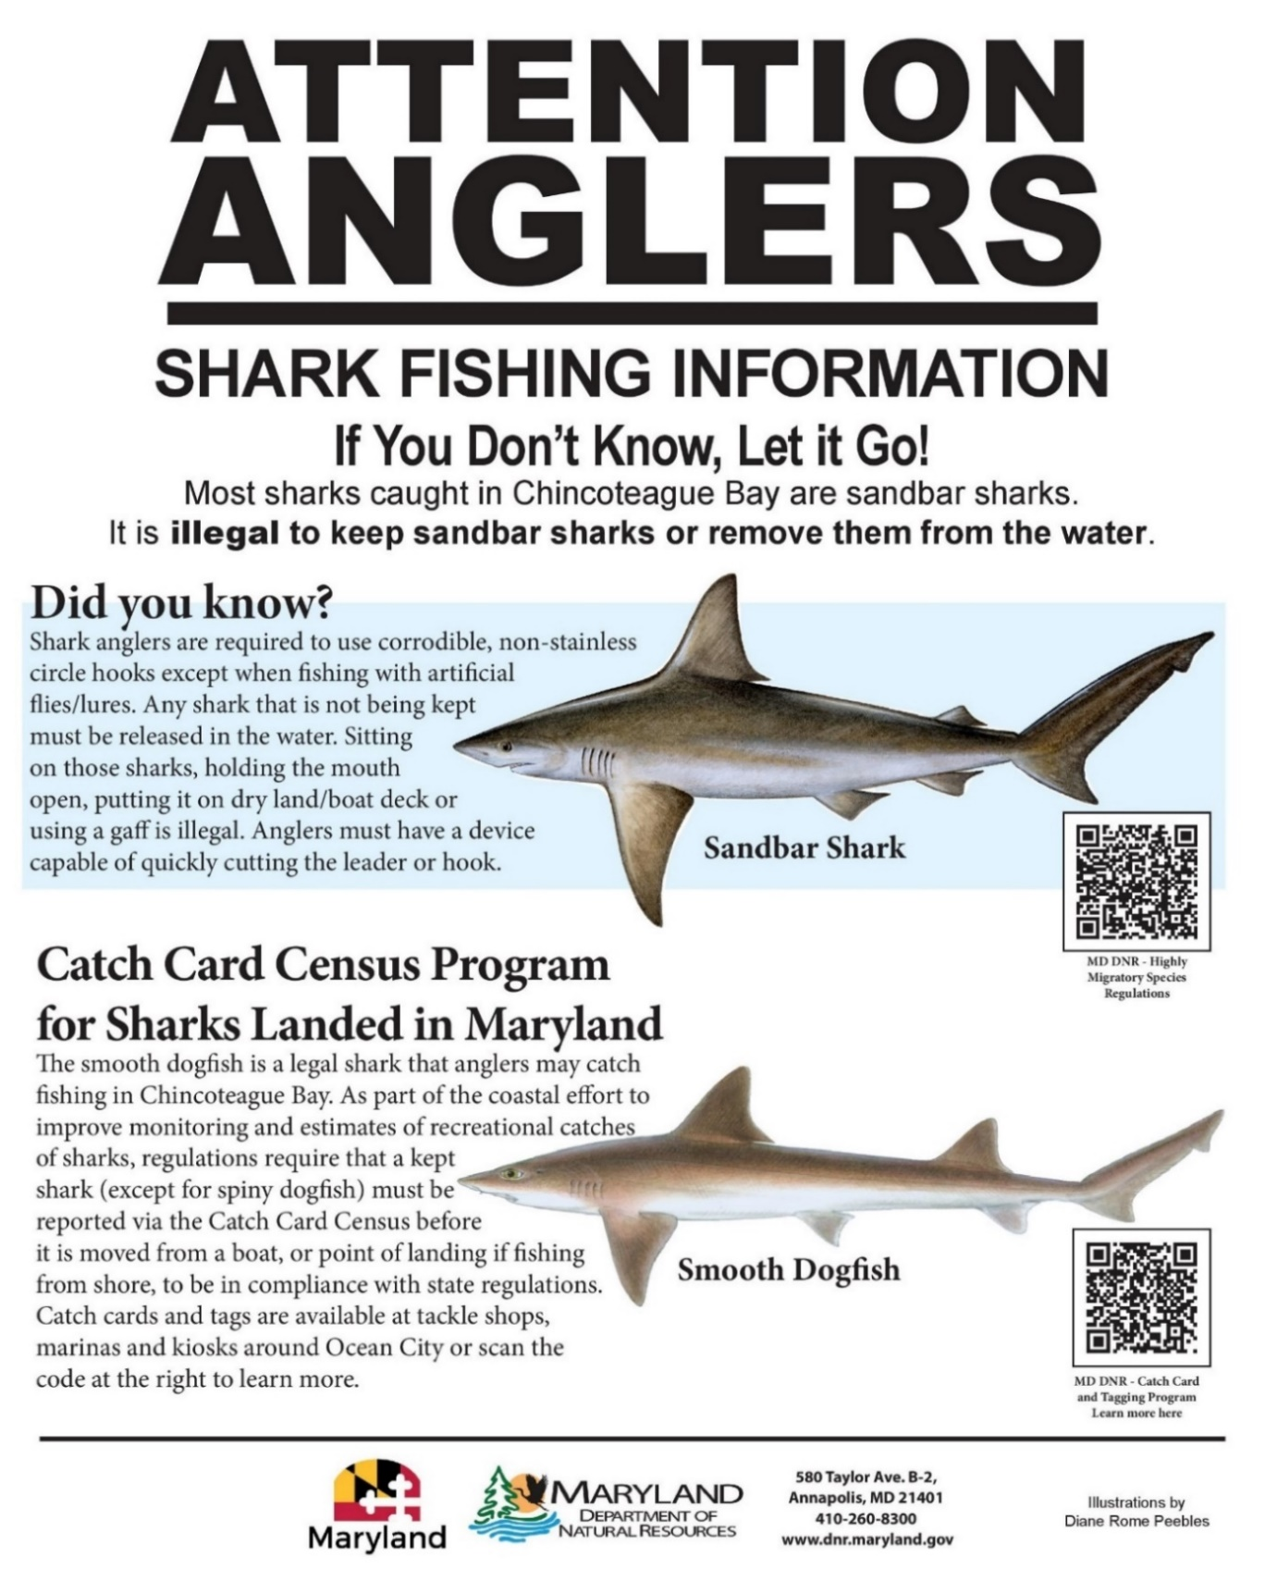

Appendix I. List of the 2021 Billfishes and Swordfish Reported to the Maryland Catch Card Census.
Date | Common Name | Length  (Inches) | Weight  (Pounds) | Trip Type | Tournament
7/23/2021 | Blue Marlin | 104.5 | 436 | Private | Huk Big Fish Classic
8/2/2021 | Blue Marlin | 116.5 | 559.5 | Private | White Marlin Open
8/6/2021 | Blue Marlin | 128 | 775 | Private | White Marlin Open
8/6/2021 | Blue Marlin | 115.5 | 511.8 | Private | White Marlin Open
8/6/2021 | Blue Marlin | 109 | 450 | Charter | White Marlin Open
8/16/2021 | Blue Marlin | 122 | 681 | Private | MidAtlantic
8/16/2021 | Blue Marlin | 112.5 | 487 | Private | MidAtlantic
8/18/2021 | Blue Marlin | 135 | 958 | Private | MidAtlantic
8/18/2021 | Blue Marlin | 104 | 383 | Private | MidAtlantic
8/18/2021 | Blue Marlin | 104 | 355 | Private | MidAtlantic
8/18/2021 | Blue Marlin | 108 | 382 | Private | MidAtlantic
8/20/2021 | Blue Marlin | 107 | 472 | Charter | MidAtlantic
8/21/2021 | Blue Marlin | 136.5 | 1135 | Private | MidAtlantic
9/7/2021 | Blue Marlin | 99.75 | 372 | Private | N/A
7/24/2021 | Roundscale Spearfish | 71.5 | 59.5 | Charter | Huk Big Fish Classic
7/24/2021 | Roundscale Spearfish | 70 | 59 | Private | Huk Big Fish Classic
8/2/2021 | Roundscale Spearfish | 72.5 | 66 | Private | White Marlin Open
8/3/2021 | Roundscale Spearfish | 70.5 | 68 | Charter | White Marlin Open
8/3/2021 | Roundscale Spearfish | 70 | 59 | Charter | White Marlin Open
8/3/2021 | Roundscale Spearfish | 69.5 | Unknown | Unknown | White Marlin Open
8/6/2021 | Roundscale Spearfish | 69 | Unknown | Private | White Marlin Open
8/6/2021 | Roundscale Spearfish | 71 | 65 | Private | White Marlin Open
8/6/2021 | Roundscale Spearfish | 73 | 66 | Private | White Marlin Open
8/6/2021 | Roundscale Spearfish | 74 | 70 | Private | White Marlin Open
8/6/2021 | Roundscale Spearfish | 71 | 57 | Private | White Marlin Open
8/16/2021 | Roundscale Spearfish | 68.75 | Unknown | Private | MidAtlantic
8/16/2021 | Roundscale Spearfish | 71.25 | 68 | Private | MidAtlantic
8/16/2021 | Roundscale Spearfish | 68.5 | Unknown | Private | MidAtlantic
8/16/2021 | Roundscale Spearfish | 69.5 | 59 | Private | MidAtlantic
8/16/2021 | Roundscale Spearfish | 70.5 | 66 | Private | MidAtlantic
8/16/2021 | Roundscale Spearfish | 70.75 | 68 | Private | MidAtlantic
8/17/2021 | Roundscale Spearfish | 69 | 60 | Private | MidAtlantic
8/18/2021 | Roundscale Spearfish | 68.5 | Unknown | Private | MidAtlantic
8/18/2021 | Roundscale Spearfish | 69.25 | 58 | Private | MidAtlantic
8/20/2021 | Roundscale Spearfish | 70.25 | 63 | Private | MidAtlantic
6/7/2021 | Swordfish | 60 | 176 | Charter | N/A
6/10/2021 | Swordfish | 54 | Unknown | Charter | N/A
6/14/2021 | Swordfish | 86 | 291 | Private | N/A
6/14/2021 | Swordfish | 0 | 195 | Private | N/A
6/17/2021 | Swordfish | 72 | 141 | Headboat | N/A
7/23/2021 | Swordfish | 68.5 | 159 | Private | Huk Big Fish Classic
7/23/2021 | Swordfish | 69 | 184 | Charter | Huk Big Fish Classic
7/24/2021 | Swordfish | 64 | 123.5 | Charter | Huk Big Fish Classic
7/24/2021 | Swordfish | 59 | 90.5 | Private | Huk Big Fish Classic
7/24/2021 | Swordfish | 68 | 159.5 | Private | Huk Big Fish Classic
7/24/2021 | Swordfish | 71 | 167.5 | Private | Huk Big Fish Classic
7/24/2021 | Swordfish | 66.8 | 142.5 | Charter | Huk Big Fish Classic
7/24/2021 | Swordfish | 85.5 | 239.5 | Private | Huk Big Fish Classic
7/24/2021 | Swordfish | 83 | 301 | Private | Huk Big Fish Classic
8/6/2021 | Swordfish | 87 | 318.5 | Charter | White Marlin Open
8/25/2021 | Swordfish | 0 | 150 | Private | N/A
8/27/2021 | Swordfish | 51 | Unknown | Charter | N/A
8/29/2021 | Swordfish | 48.5 | Unknown | Private | N/A
9/4/2021 | Swordfish | 57 | 90 | Private | N/A
9/4/2021 | Swordfish | 50 | Unknown | Private | N/A
9/5/2021 | Swordfish | 80 | 250 | Private | N/A
9/7/2021 | Swordfish | 50 | Unknown | Private | N/A
9/19/2021 | Swordfish | 80 | Unknown | Charter | N/A
9/20/2021 | Swordfish | 50 | 62 | Charter | N/A
9/27/2021 | Swordfish | 53 | 66 | Charter | N/A
9/27/2021 | Swordfish | 68 | Unknown | Private | N/A
10/15/2021 | Swordfish | 59 | 102 | Charter | Bishop Broadbill Bash
10/15/2021 | Swordfish | 78 | 218 | Charter | Bishop Broadbill Bash
10/15/2021 | Swordfish | 58 | 102 | Charter | Bishop Broadbill Bash
11/2/2021 | Swordfish | 52 | 60 | Private | N/A
11/2/2021 | Swordfish | 55 | 70 | Private | N/A
11/2/2021 | Swordfish | 70 | Unknown | Charter | N/A
11/3/2021 | Swordfish | 51.5 | 67 | Private | N/A
11/3/2021 | Swordfish | 61 | 91 | Private | N/A
12/14/2021 | Swordfish | 50 | Unknown | Private | N/A
12/14/2021 | Swordfish | 56 | Unknown | Private | N/A
7/12/2021 | White Marlin | 67 | 65 | Charter | N/A
7/14/2021 | White Marlin | 66 | Unknown | Charter | N/A
7/19/2021 | White Marlin | 76 | 75 | Charter | N/A
7/23/2021 | White Marlin | 69 | 63 | Private | Huk Big Fish Classic
7/24/2021 | White Marlin | 68 | 72 | Charter | Huk Big Fish Classic
7/24/2021 | White Marlin | 69 | 62 | Private | Huk Big Fish Classic
8/2/2021 | White Marlin | 72.5 | 82.5 | Private | White Marlin Open
8/6/2021 | White Marlin | 76 | 85.5 | Charter | White Marlin Open
8/6/2021 | White Marlin | 75 | 77 | Private | White Marlin Open
8/6/2021 | White Marlin | 70 | 60.5 | Private | White Marlin Open
8/6/2021 | White Marlin | 71 | 78.5 | Private | White Marlin Open
8/11/2021 | White Marlin | 67 | 65 | Private | N/A
8/15/2021 | White Marlin | 79 | 89 | Private | N/A
8/15/2021 | White Marlin | 69 | 68 | Private | N/A
8/16/2021 | White Marlin | 69.5 | 69 | Private | MidAtlantic
8/16/2021 | White Marlin | 74 | 80 | Private | MidAtlantic
8/17/2021 | White Marlin | 69 | 75 | Charter | MidAtlantic
8/17/2021 | White Marlin | 71 | 82 | Private | MidAtlantic
9/7/2021 | White Marlin | 71 | Unknown | Charter | N/A

