NSQAP PT Program Information Collection
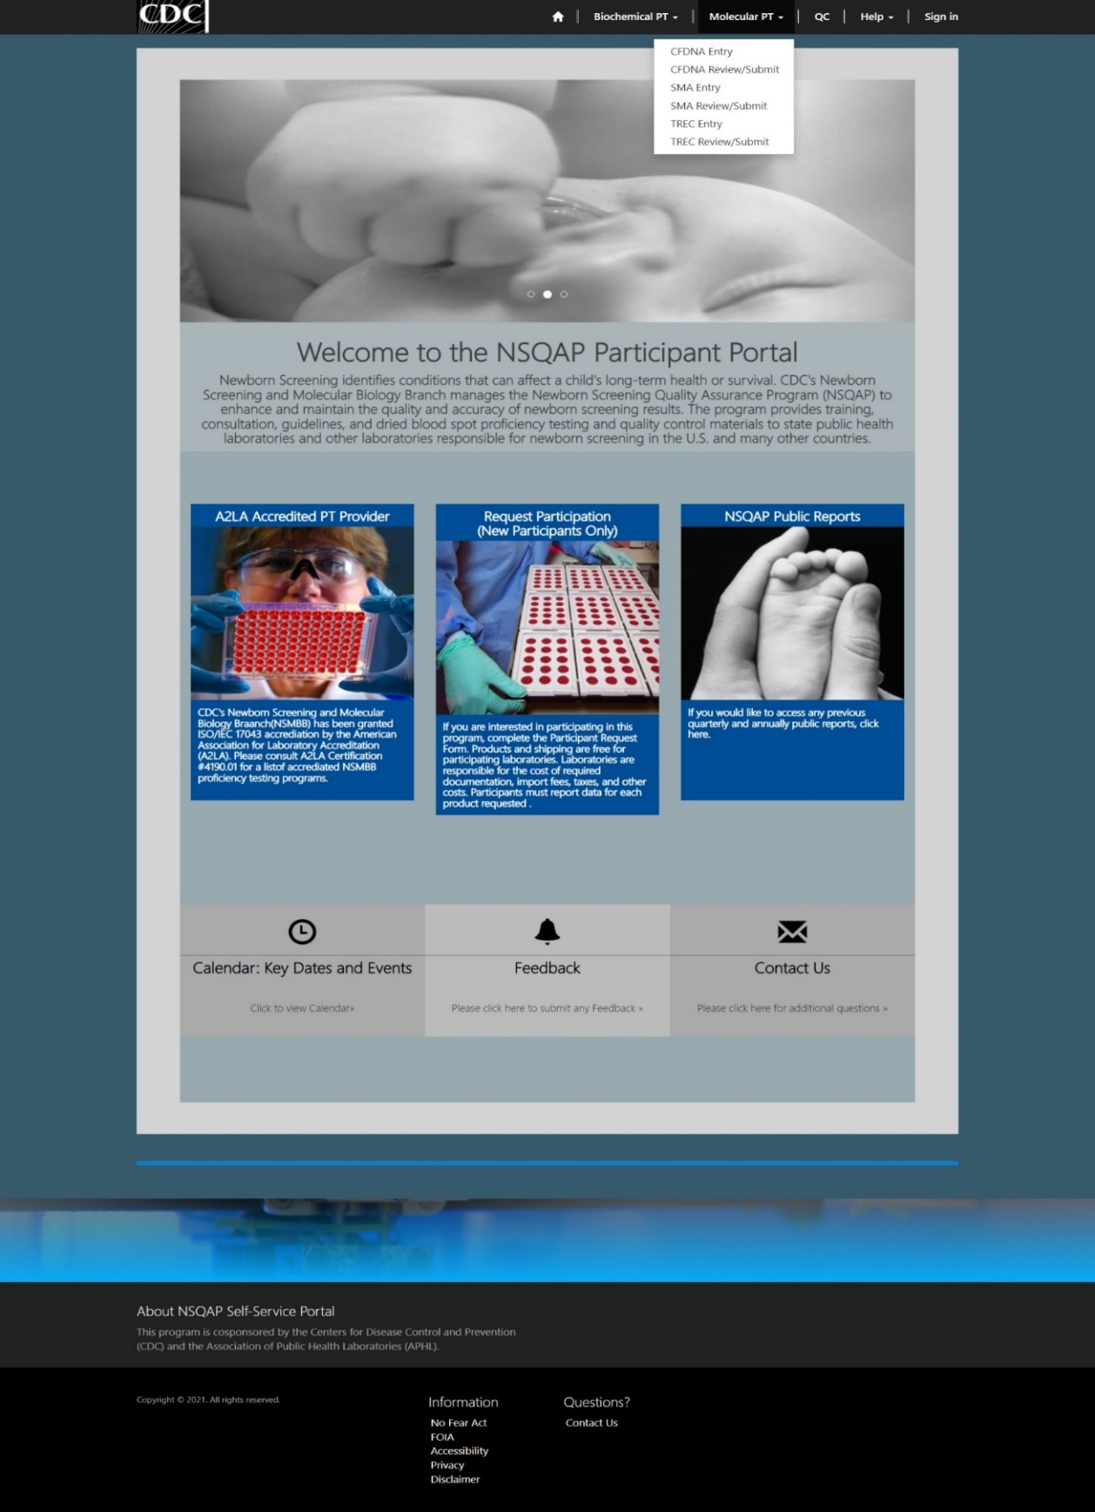
Form Approved
OMB No. 0920-xxxx
Exp. Date xx/xx/20xx

CDC estimates the average public reporting burden for this collection of information as 45 minutes per response, including the time for reviewing instructions, searching existing data/information sources, gathering and maintaining the data/information needed, and completing and reviewing the collection of information. An agency may not conduct or sponsor, and a person is not required to respond to a collection of information unless it displays a currently valid OMB Control Number. Send comments regarding this burden estimate or any other aspect of this collection of information, including suggestions for reducing this burden to CDC/ATSDR Information Collection Review Office, 1600 Clifton Road NE, MS D-74, Atlanta, Georgia 30333; ATTN: PRA (0920-xxxx).
Step 1 – Select PT Program Setup (select PT program/grouping of analytes)
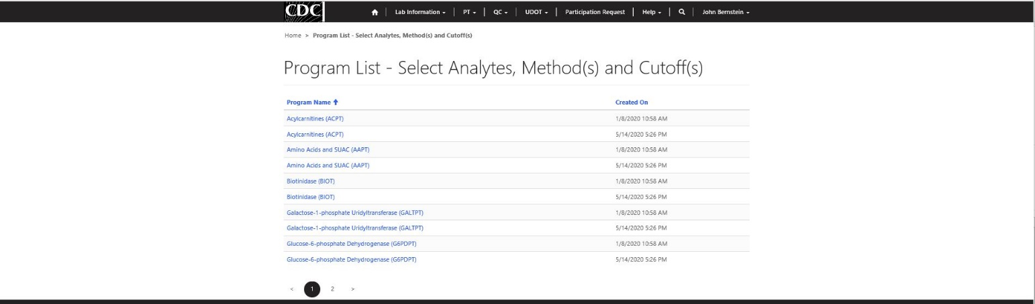

Step 2 – Selecting analytes to report, analytical method(s) and cutoffs
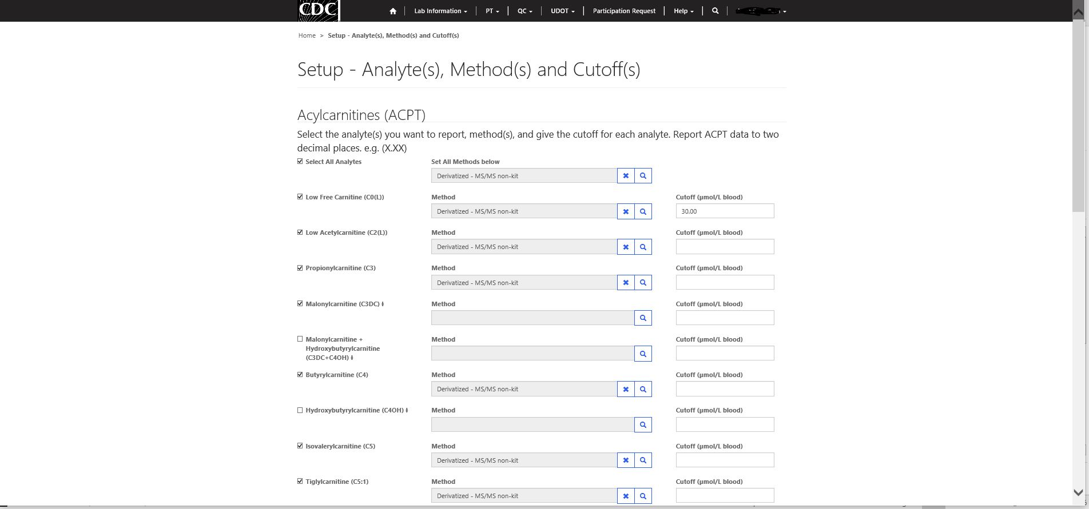
Step 3 – Select specimen for data entry
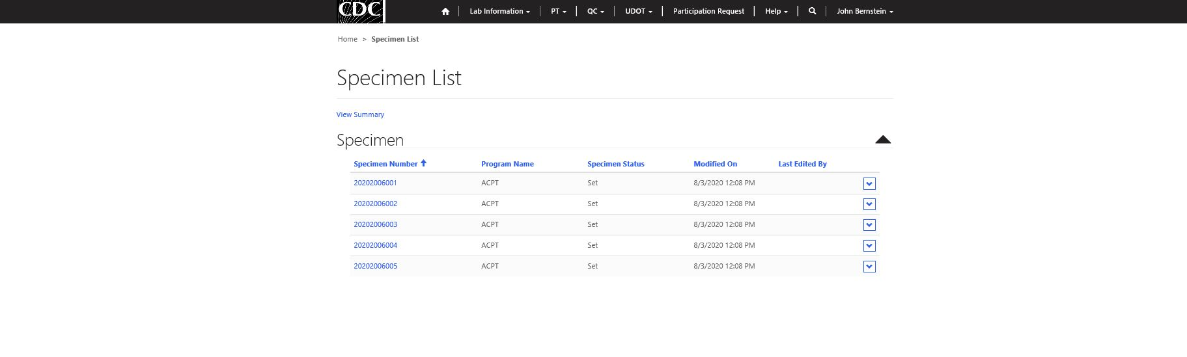

Step 4 – Analytic result and clinical assessment data entry.
